Execution pipeline

Input -lexer-> tokens
tokens -parser-> AST
AST -evaluator-> evaluated AST
evaluated AST -executor-> output
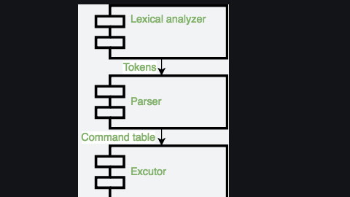

lexer

slice cmd to token:

.points-virgule / retours à la ligne (; \n)
- IO number (pour les redirections) (1>)
- mot toto if then
- mot d’assignation A=B
- nom générique 0abc
- opérateurs |
in this we also verify syntaxe error

1. “#” : IO
2. [ 1 ]?”>” : IO
3. “” : IO
5. [ 1]?”>>” : IO
6. [ 1-2]”>&”[1-2 ] : IOR
7. “|” : PIPE
8. “&” : AMPERSAND
9. [ ]”-“[a-zA-Z0-9]* : OPTION
10. [ ]”–“[a-zA-Z=a-zA-Z]* : OPTION2
11. \%\=\+\’\”\(\)\$\/\_\-\.\?\*\~a-zA-Z0-9]+ : WORD

parser

analyse token and give them a direction and transform to a tree

for parsing we can choose command table or ast

in this we specify the grammar rules,

What is Parsing?
- Taking a sequence of characters (tokens) and transforming it into a structured representation based on a set of rules (grammar).
Grammar as States:
- The grammar defines various states the parser can be in while processing tokens.
- The provided grammar defines states like q00, q1, q3, etc., each representing a specific point in the parsing process.
Parsing Process:
- Start State (q00): Parsing begins here.
- Token Stream: Tokens (e.g., keywords, arguments) are fed to the parser one by one.
- State Transitions: Based on the current state and the incoming token, the parser transitions to a new state (e.g., q1 after a command word).
- Reductions: In some states, the parser can combine tokens into a meaningful structure (e.g., combining a command word with its arguments).
- Error Handling: The grammar can specify actions for handling syntax errors (e.g., state error).
- Bottom-Up Parsing: The parsing starts with individual tokens and builds them into a larger structure (command tree).
Grammar Details:
- The provided grammar defines rules for various shell command components:
  - cmd: Command word
  - arg_list: List of arguments
  - io_modifier: Redirection operator (< or >)
  - io_descr: Filename for redirection
  - option: Optional flags for the command
  - background: Background execution (&)
Simple vs. Complex Commands:
- Simple Command: A single command with its arguments, options, and I/O redirection.
- Complex Command: Multiple simple commands connected by pipes (|) to form a more complex sequence of operations.
Output - Command Table:
- The parser builds a table based on the parsed command structure. This table holds information like:
  - Command name
  - Arguments
  - I/O redirection details (stdin, stdout, stderr)
This "command table" is then passed to an "executor" component that executes the actual commands based on the parsed structure.
Grammar Capabilities:
- The provided grammar allows parsing commands with:
  - Options
  - Arguments
  - I/O redirection
  - Background execution (&)
- It allows connecting multiple simple commands using pipes to form complex commands.
Data Structure:
- The passage suggests using a table to store information about each parsed command:
  - Command name
  - Options (potentially two separate options)
  - Arguments
  - Standard input (stdin)
  - Standard output (stdout)
  - Standard error (stderr)
Example:
- The command ls -al | sort -r would be parsed and represented as a table with two rows (one for each simple command).
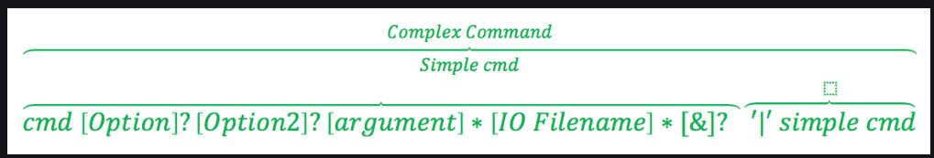

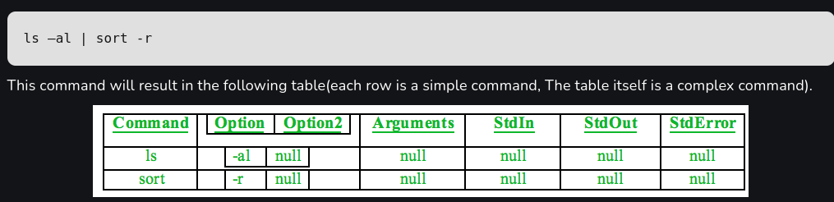

Executor
Executor's Responsibility:
- Takes the command table built by the parser.
- Creates a process for each simple command in the table.
- Handles any I/O redirection specified in the commands.
Execution Process:
- Iteration: The executor loops through each row (simple command) in the table.
- Command Preparation:
  - Arguments are assembled: command name, options, arguments.
  - execvp function is used (provided by the operating system) to replace the current shell process with the desired command.
- Redirection Handling:
  - Piping:
    - If the command has a previous command in the table, its input comes from the previous command's output via a pipe.
    - Input redirection from a file overrides input from the pipe (if both exist).
  - Non-piped Commands:
    - The command's output is sent to the next command in the table (if it exists).
    - Output redirection from a file overrides standard output.
- Background Flag:
  - Checks if the command should run in the background (&).
  - If yes, the process is forked (creating a child process) and the command executes in the child process.
- Resource Cleanup:
  - Once the command finishes, the executor cleans up any resources used.
Example:
- Command: ls -al | sort -r > file
- Command table:
  - Row 1: ls -al (standard output goes to a pipe)
  - Row 2: sort -r (input comes from the pipe, standard output goes to a file)
Execution Steps:
- First Command (ls -al):
  - Output sent to a pipe for the next command.
- Second Command (sort -r):
  - Input received from the pipe.
  - Output redirected to the file file.
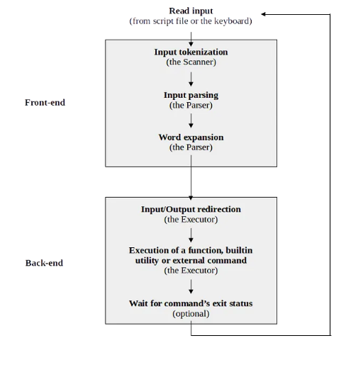

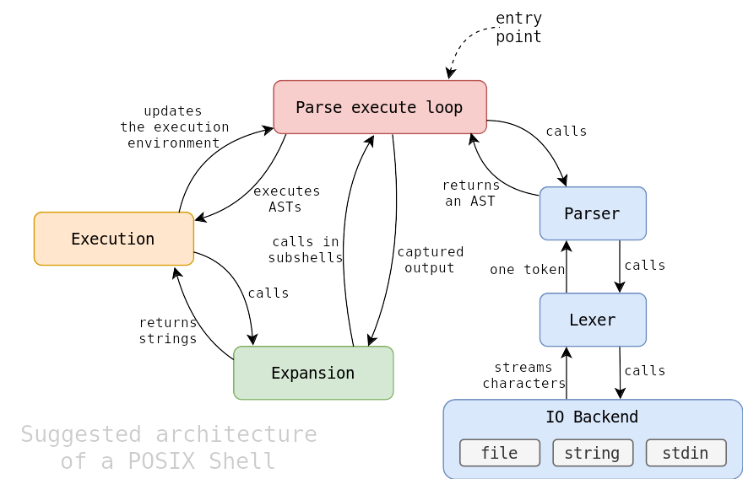

shell architecture

Core Components
The diagram depicts a shell's core components and their interactions:
- Parse Execute Loop:
  - The central control flow of the shell.
  - Continuously reads input, parses it into an Abstract Syntax Tree (AST), and executes the commands represented by the AST.
  - Updates the execution environment based on command outcomes.
- Parser:
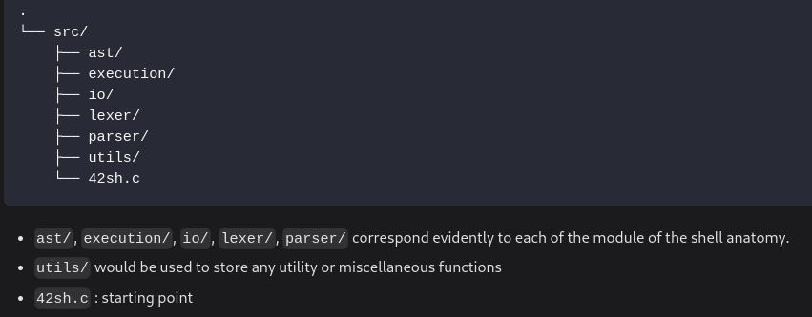
  - Takes input as a stream of characters or tokens.
  - Constructs an AST representing the shell commands.
  - Collaborates with the Lexer to break input into tokens.
- Lexer:
  - Breaks the input stream into tokens (keywords, operators, identifiers, etc.).
  - Interacts with the IO Backend to obtain characters from the input source.
- IO Backend:
  - Handles input/output operations, providing characters to the Lexer and potentially capturing output.
  - Can manage different input sources (files, stdin) and output destinations (files, stdout).
- Execution:
  - Takes the AST from the Parser and executes the commands it represents.
  - Handles process creation, termination, and environment updates.
  - May involve calling external programs or system calls.
- Expansion:
  - Handles variable expansion, command substitution, and other forms of text manipulation.
  - Typically occurs before parsing.
Data Flow
- The shell starts with an entry point, initiating the parse-execute loop.
- The Parser requests tokens from the Lexer.
- The Lexer fetches characters from the IO Backend.
- The Parser constructs an AST based on the token stream.
- The Executor processes the AST, potentially creating subprocesses and updating the environment.
- Output from commands can be captured and redirected.
Key Points
- The shell operates in a continuous loop, processing input, parsing, and executing commands.
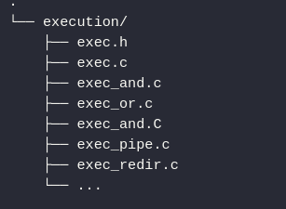
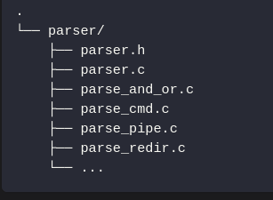
- The Parser and Lexer work together to convert input characters into a structured representation (AST).
- The Executor brings the AST to life by executing the commands it represents.
- The IO Backend handles the underlying input/output operations.
- Expansion is a crucial step in processing shell commands, occurring before parsing.
Additional Considerations
- The diagram simplifies the shell architecture for clarity. Real-world shells often have additional components like job control, history management, and signal handling.
- The exact implementation of each component can vary depending on the shell's features and performance requirements.
- Efficient memory management and error handling are essential aspects of shell implementation.
Example of file management

parser

executor

symbole table and ast relation ?

