How does parenthesis priority works
To parse operations and commands within parentheses in a shell, follow these steps:
- Tokenization: Identify and tokenize the entire expression, recognizing parentheses as operators.
- AST Construction:
  - If the parser encounters an opening parenthesis (, treat everything inside as a sub-expression or sub-command block.
  - The sub-expression becomes a node in the AST.
  - Multiple commands inside the parentheses should be parsed similarly to a standard command list or pipeline.
- Example: For the input cmd1 && (cmd2 | cmd3), the AST might look like:
markdown
AND
├── cmd1
└── PIPE
├── cmd2
└── cmd3
- Execution Order: Execute commands inside parentheses as a grouped sub-command, in the order they appear within the AST.
Would you like to delve deeper into specific parts of this process?
To parse something like cmd1 && (cmd2 | (cmd3 && (cmd4 | cmd5)) || (cmd6 | cmd7)), you need to follow a systematic approach:

1. Tokenization:
- Split the string into tokens, identifying commands, operators (&&, ||, |), and parentheses.
- Track nested parentheses to ensure proper parsing of sub-expressions.

2. Recursive Descent Parsing:
- Start parsing the main expression (cmd1 && ...).
- When encountering an opening parenthesis (, recursively parse everything inside as a sub-expression.
- Handle each sub-expression independently, following operator precedence.

3. AST Construction:
- For the expression cmd1 && (cmd2 | (cmd3 && (cmd4 | cmd5)) || (cmd6 | cmd7)), the AST would be constructed in a tree-like manner, where each operator creates a node, and commands and sub-expressions become its children.
Example AST structure:
markdown
AND
├── cmd1
└── OR
├── PIPE
│ ├── cmd2
│ └── AND
│ ├── cmd3
│ └── PIPE
│ ├── cmd4
│ └── cmd5
└── PIPE
├── cmd6
└── cmd7

4. Execution Order:
- Recursively evaluate the AST, executing commands based on operator precedence. The deepest nested commands are evaluated first.
This approach ensures that the complex combination of logical and pipeline operators, along with nested commands in parentheses, is handled correctly.

How does wildcard expansion works
How does ast work

To structure each node for an Abstract Syntax Tree (AST) in a shell parser, you need to account for commands, arguments, redirections, and control operators (&&, ||, |). Here's a basic approach:

AST Node Structure:
- Command Node:
  - Command name (cmd)
  - List of arguments (args[])
  - Input redirection (input_redirect)
  - Output redirection (output_redirect)
  - List of heredocs (heredocs[])
- Operator Node:
  - Left child (e.g., previous command)
  - Right child (e.g., next command)
  - Operator type (AND, OR, PIPE)

Example Node Structure:
c
struct ASTNode {
enum NodeType {COMMAND, OPERATOR} type;
union {
struct {
char *cmd;
char *args[];
char *input_redirect;
char *output_redirect;
char *heredocs[];
} command;
struct {
struct ASTNode *left;
struct ASTNode *right;
enum OperatorType {AND, OR, PIPE} op_type;
} operator;
} data;
};

Execution Strategy:
- Recursion: Traverse the AST recursively from the root, executing child nodes based on the operator precedence.
- Execution Example:
  - If a node is a command, execute it with its arguments and redirections.
  - If a node is an operator, execute the left child first. Based on the operator, decide whether to execute the right child (e.g., for &&, only execute the right if the left succeeds).

Example Execution Flow:
For the command cmd1 && (cmd2 | (cmd3 && (cmd4 | cmd5)) || (cmd6 | cmd7)), the execution might look like:
- Execute cmd1.
- If cmd1 succeeds (&&), evaluate (cmd2 | (cmd3 && (cmd4 | cmd5)) || (cmd6 | cmd7)).
- Inside this group, execute cmd2 and pipe its output to the next expression.
- Continue recursively processing the nested commands and operators.
This structure ensures that commands are executed in the correct order and that redirections, pipes, and control flow are handled properly.

cmd1 && (cmd2 | (cmd3 && (cmd4 | cmd5)) || (cmd6 | cmd7)) > output.txt 2>> errors.log

AND
├── CMD1
└── SUBSHELL
├── PIPE
│ ├── CMD2
│ └── SUBSHELL
│ ├── AND
│ │ ├── CMD3
│ │ └── SUBSHELL
│ │ ├── PIPE
│ │ │ ├── CMD4
│ │ │ └── CMD5
│ └── OR
│ ├── CMD6
│ └── CMD7
└── REDIRECTIONS
├── OUTPUT: output.txt
└── ERROR: errors.log

Explanation:
- AND: The top-level node represents the logical && operator connecting cmd1 with the subshell.
- CMD1: Represents the first command, cmd1.
- SUBSHELL: Encapsulates the commands inside the parentheses (cmd2 | ...).
- PIPE: Represents the pipeline connecting cmd2 and the subshell (cmd3 && ...).
- AND: Inside the subshell, cmd3 is connected to another subshell using the && operator.
- PIPE: Represents the pipeline connecting cmd4 and cmd5.
- OR: Represents the || operator connecting the pipeline and the cmd6 | cmd7 pipeline.
- REDIRECTIONS: Contains the output and error redirections > output.txt and 2>> errors.log.

Order of Execution:
- cmd1: Execute cmd1.
  - If successful (exit status 0), continue; otherwise, skip the rest.
- Subshell (cmd2 | ...):
  - Start with cmd2.
  - Pipe output to the subshell (cmd3 && ...).
  - Evaluate cmd3.
    - If cmd3 succeeds, evaluate the pipeline cmd4 | cmd5.
  - If the pipeline fails, evaluate the || branch with cmd6 | cmd7.
- Redirections: Capture standard output to output.txt and append errors to errors.log.

To create an Abstract Syntax Tree (AST) for your shell, follow these steps:

1. Identify the Root Node (Top-Level Operator):
- The root node of the AST is typically the top-level operator. This is the operator that connects the largest parts of the command.
- For example, in cmd1 && cmd2, && is the root node because it joins the two commands.

2. Parse the Command Line:
- Tokenize the input to separate commands, operators, parentheses, and redirections.
- Identify the highest-precedence operator, which will determine the root node. For example, in cmd1 && cmd2 || cmd3, the root node is ||.

3. Build Subtrees for Subshells:
- When parentheses are encountered (e.g., (cmd1 | cmd2)), treat the commands inside as a subshell.
- Parse the content within the parentheses as a separate tree, then attach it as a subtree to the main AST.
- The subshell will be treated as a single node, with its internal commands forming a subtree under that node.

4. Build the Tree Recursively:
- For each command and operator, recursively build the tree.
- The operator will be the parent node, with the commands or subtrees as its children.

Example: Parsing (((cmd1 | cmd2) && cmd3) || cmd4) && cmd5
- Tokenize: Split into commands and operators: (((cmd1 | cmd2) && cmd3) || cmd4) && cmd5.
- Parse Subshells: Start with the innermost subshell: (cmd1 | cmd2).
- Build Subtree for &&: Create a subtree for (cmd1 | cmd2) && cmd3.
- Add ||: Create a subtree for ((cmd1 | cmd2) && cmd3) || cmd4.
- Add Top-Level &&: Create the final tree for the full expression (((cmd1 | cmd2) && cmd3) || cmd4) && cmd5.

Example AST:
objectivec
AND
├── OR
│ ├── AND
│ │ └── SUBSHELL
│ │ └── AND
│ │ ├── PIPE
│ │ │ ├── CMD: cmd1
│ │ │ └── CMD: cmd2
│ │ └── CMD: cmd3
│ └── CMD: cmd4
└── CMD: cmd5

5. Execution Flow:
- The AST is executed in a depth-first, left-to-right order.
- Start with the root node (top-level operator) and recursively evaluate each subtree.
- Subshells are executed as separate processes, and their output or result is used in the parent tree.
This approach allows you to structure and execute complex command lines, including subshells, pipelines, and logical operators, in a hierarchical manner.
(((cmd1 | cmd2) && cmd3) || cmd4) && cmd5

AND
├── OR
│ ├── AND
│ │ └── SUBSHELL
│ │ └── AND
│ │ ├── PIPE
│ │ │ ├── CMD: cmd1
│ │ │ └── CMD: cmd2
│ │ └── CMD: cmd3
│ └── CMD: cmd4
└── CMD: cmd5

(cmd1 | cmd2) && (cmd3 | cmd4 | cmd5) || cmd6 && cmd7

OR
├── AND
│ ├── SUBSHELL
│ │ └── PIPE
│ │ ├── CMD: cmd1
│ │ └── CMD: cmd2
│ └── SUBSHELL
│ └── PIPE
│ ├── CMD: cmd3
│ ├── CMD: cmd4
│ └── CMD: cmd5
└── AND
├── CMD: cmd6
└── CMD: cmd7

Explanation:
- OR: The top-level operator is ||.
  - The left-hand side is an AND operation containing two subshells.
  - The right-hand side is another AND operation with cmd6 and cmd7.
- AND (Left): Represents (cmd1 | cmd2) && (cmd3 | cmd4 | cmd5).
  - SUBSHELL: (cmd1 | cmd2) encapsulates a pipeline with two commands.
  - SUBSHELL: (cmd3 | cmd4 | cmd5) encapsulates another pipeline with three commands.
- AND (Right): Represents cmd6 && cmd7.

Execution Order:
- Left AND Subshells:
  - Evaluate the first subshell pipeline (cmd1 | cmd2).
  - If successful, evaluate the second subshell pipeline (cmd3 | cmd4 | cmd5).
- OR:
  - If the left-hand side AND fails, evaluate cmd6.
  - If cmd6 succeeds, run cmd7.

Error in expand
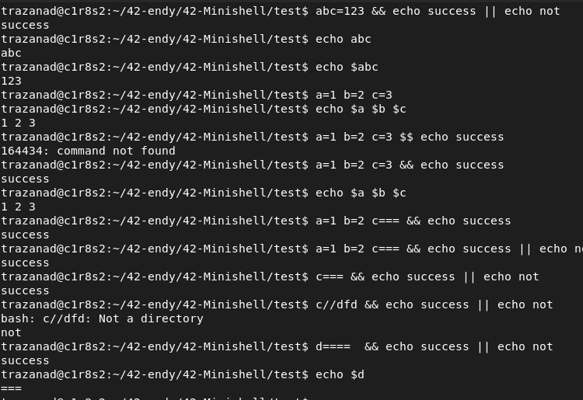

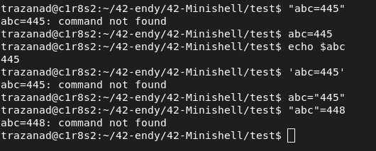

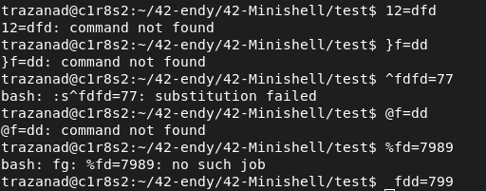

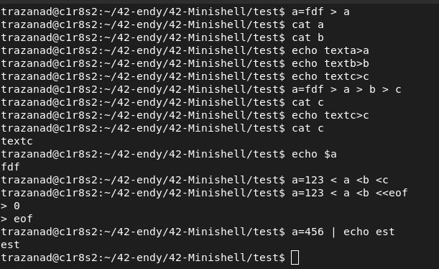
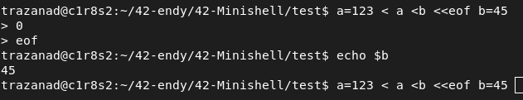
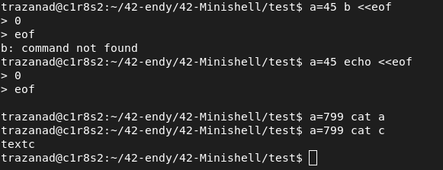
NOTE THAT A CMD can HAVE AN ASSIGNEMENT BEFORE

PARSER
Type of expression
- cmd
cmd has :
.aasignement before it list
. cmd name
. *args
. input (not that redir may have fd)
. output
. last_input
.last_ouput
. *heredoc
-variable assignement
assignement has :
. assignement list
. input
. output
.*heredoc
Note that assign can be pipe
-pipeline
pipeline has ;
. left cmd / assign
. right cmd / assign
-OR AND
has :
. combinaison of cmd / pipeline / assign left
. combinaison of cmd / pipeline / assign right
-mixture

how to descent the tree

subshell
A subshell in Unix-like operating systems is a child process launched by the shell to execute commands. Subshells are typically used in the following scenarios:
- Command Grouping: When commands are enclosed in parentheses (command1; command2), they run in a subshell.
- Pipelines: Each command in a pipeline (e.g., cmd1 | cmd2) runs in a subshell.
- Command Substitution: When using backticks or $(...) to capture the output of a command.
- Background Commands: Commands run with & are executed in a subshell.
For example, in cd .. | echo text, cd .. is run in a subshell because it's part of a pipeline, so the directory change doesn't affect the parent shell.
A subshell is a separate child process created by a shell to execute commands. When you run commands in a subshell, they are isolated from the parent shell, meaning any changes made within the subshell (like changing directories with cd) do not affect the parent shell's environment.
For example, in a command like cd .. | echo "Hello", cd .. runs in a subshell due to the pipe (|). The directory change happens only within that subshell, so the parent shell remains in the original directory.
Most of the command that alter the environement are built in

Identifying Subshell Commands
- Subshell Syntax: Typically, in many shells, subshells are created using parentheses (). For instance:
(cmd1; cmd2)
Commands inside the parentheses are executed in a subshell.
- Grouping Commands: Commands grouped together with {} are executed in the current shell environment, but {} syntax itself does not create a subshell. For example:
{ cmd1; cmd2; }
Pipelines: Commands connected by pipes | are executed in the same shell environment, but each command in the pipeline is executed in a separate process. For instance:
cmd1 | cmd2
Command Substitution: Commands enclosed in backticks ` or $() are executed in a subshell:
result=$(cmd)

How to Implement in Your Shell
- Parsing: When parsing a command, look for subshell syntax (e.g., ()). You’ll need to create a new process or context for executing commands within parentheses.
- Execution Context: For commands in a subshell, ensure that any changes to environment variables or current working directory are isolated to the subshell.
- Pipeline Execution: Each command in a pipeline should be executed in its own process, but within the same overall shell context.
- Command Substitution: For command substitution, execute the commands within $(...) or backticks in a subshell and capture their output.

Example Workflow
Here’s a simplified workflow to handle subshells:
- Detect Subshell: Identify if a command is within parentheses and mark it as a subshell.
- Create Subshell: Spawn a new process or execution context for the commands within the subshell.
- Execute Commands: Run the commands in the detected subshell or current shell context as appropriate.
- Capture Output: For command substitution, capture and return the output of the subshell execution.

For the mandatory part, pipeline is in a subshell so if pipeline no alteration of env
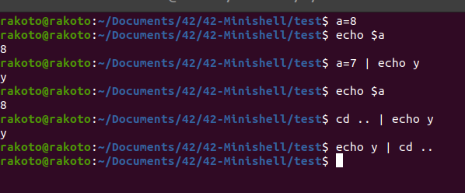

how to handle last pipe

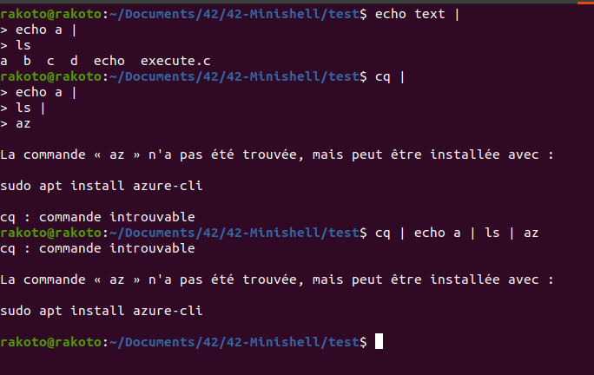

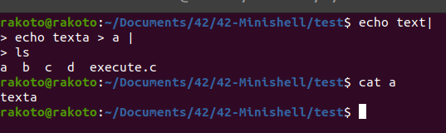

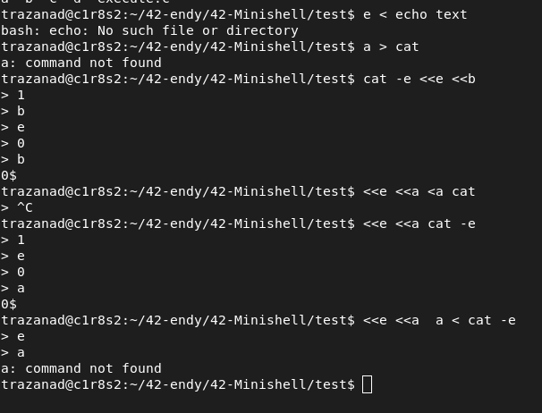
note that heredoc can be at the beginning

grammar for mandatory
Pipeline -> Command ('|' Command)*
Command -> SIMPLE_COMMAND

To handle the pipe (|) operator in a Bash-like shell using a recursive descent parser and an Abstract Syntax Tree (AST), you can follow a structured approach. The pipe operator is used to chain commands such that the output of one command becomes the input to the next.

Grammar for Handling Pipes
Let's define a simplified grammar that focuses on handling pipes:
Pipeline -> Command ('|' Command)*
Command -> SIMPLE_COMMAND

Pipeline -> Command ('|' Command)*
Command -> SIMPLE_COMMAND

