Getenv ok

doesn`t handle export T=”value”

and echo $T one char variable name



location: get_env_value

export

invalid exit code when invalid identifier ok

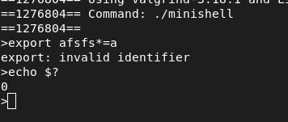

export USER doesn`t update ok

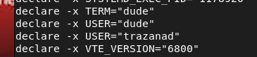

export delete the export value when export key=val then export key ok


broken pipe

when multiple pipe

get_path error

when we enter path as cmd like

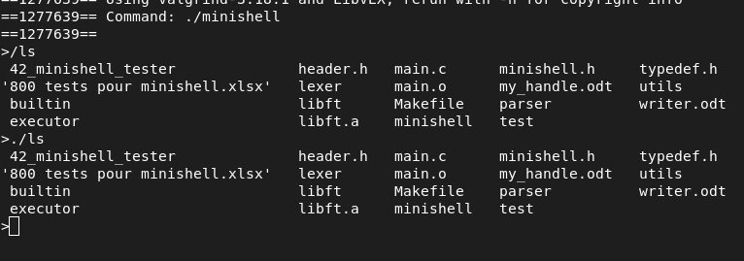

expanding error ok

extend value remains the same no delete code or other

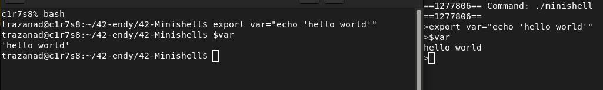

error when $”42$” → correct: 42$ but 42

cd pwd oldpwd error

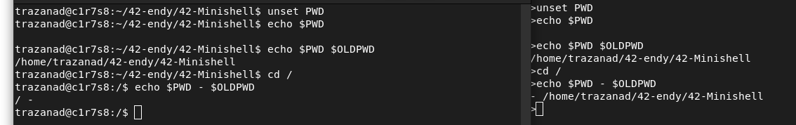

cd error

cd --

The command `cd --` in a Unix-like shell is used to change the directory back to the previous working directory. Here's a breakdown:

- **`cd -`**: Changes to the previous directory you were in. For example, if you were in `/home/user/documents`, navigated to `/var/log`, and then typed `cd -`, it would take you back to `/home/user/documents`.

- **`cd --`**: The `--` is actually a separator used to indicate the end of options and the beginning of positional parameters. However, in the case of `cd`, `--` has no additional effect because `cd` doesn’t usually take options that would require disambiguation.

So, `cd --` is effectively the same as `cd` by itself, which simply changes to the user’s home directory (`$HOME`).

In summary:
- **`cd -`**: Switches to the last directory you were in.
- **`cd --` or `cd`**: Switches to the home directory.

redir error ok

need to check if redir value is folder

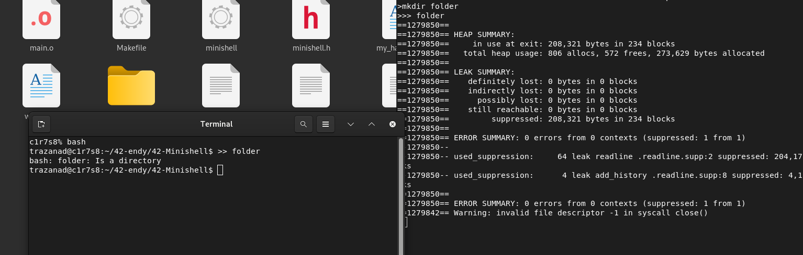

core dump

-when redirer with NULL ok

> $tsisy
>> $””
< $’’

- when word follow by redir at end ok

ls >>
cat >
echo <

- unset null like above ok

