Launch Binaries
Show prompt
handle command input
If true, execute command
else, free then new prompt

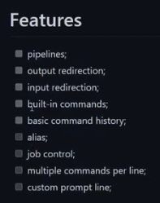

executing last command

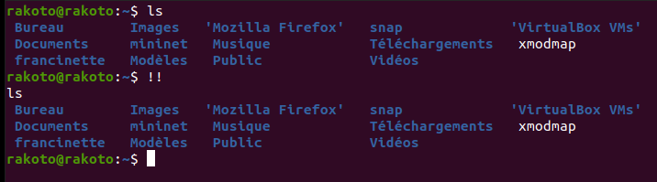
handle stored value ike $val = 0 then echo val

