Execution pipeline

Input -lexer-> tokens
tokens -parser-> AST
AST -evaluator-> evaluated AST
evaluated AST -executor-> output
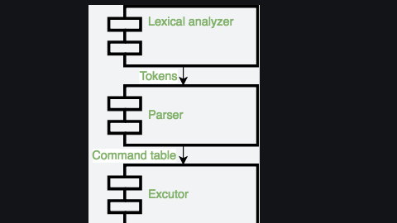

lexer

slice cmd to token:

.points-virgule / retours à la ligne (; \n)
- IO number (pour les redirections) (1>)
- mot toto if then
- mot d’assignation A=B
- nom générique 0abc
- opérateurs |
in this we also verify syntaxe error

1. “#” : IO
2. [ 1 ]?”>” : IO
3. “” : IO
5. [ 1]?”>>” : IO
6. [ 1-2]”>&”[1-2 ] : IOR
7. “|” : PIPE
8. “&” : AMPERSAND
9. [ ]”-“[a-zA-Z0-9]* : OPTION
10. [ ]”–“[a-zA-Z=a-zA-Z]* : OPTION2
11. \%\=\+\’\”\(\)\$\/\_\-\.\?\*\~a-zA-Z0-9]+ : WORD

parser

analyse token and give them a direction and transform to a tree

for parsing we can choose command table or ast

in this we specify the grammar rules,

What is Parsing?
- Taking a sequence of characters (tokens) and transforming it into a structured representation based on a set of rules (grammar).
Grammar as States:
- The grammar defines various states the parser can be in while processing tokens.
- The provided grammar defines states like q00, q1, q3, etc., each representing a specific point in the parsing process.
Parsing Process:
- Start State (q00): Parsing begins here.
- Token Stream: Tokens (e.g., keywords, arguments) are fed to the parser one by one.
- State Transitions: Based on the current state and the incoming token, the parser transitions to a new state (e.g., q1 after a command word).
- Reductions: In some states, the parser can combine tokens into a meaningful structure (e.g., combining a command word with its arguments).
- Error Handling: The grammar can specify actions for handling syntax errors (e.g., state error).
- Bottom-Up Parsing: The parsing starts with individual tokens and builds them into a larger structure (command tree).
Grammar Details:
- The provided grammar defines rules for various shell command components:
  - cmd: Command word
  - arg_list: List of arguments
  - io_modifier: Redirection operator (< or >)
  - io_descr: Filename for redirection
  - option: Optional flags for the command
  - background: Background execution (&)
Simple vs. Complex Commands:
- Simple Command: A single command with its arguments, options, and I/O redirection.
- Complex Command: Multiple simple commands connected by pipes (|) to form a more complex sequence of operations.
Output - Command Table:
- The parser builds a table based on the parsed command structure. This table holds information like:
  - Command name
  - Arguments
  - I/O redirection details (stdin, stdout, stderr)
This "command table" is then passed to an "executor" component that executes the actual commands based on the parsed structure.
Grammar Capabilities:
- The provided grammar allows parsing commands with:
  - Options
  - Arguments
  - I/O redirection
  - Background execution (&)
- It allows connecting multiple simple commands using pipes to form complex commands.
Data Structure:
- The passage suggests using a table to store information about each parsed command:
  - Command name
  - Options (potentially two separate options)
  - Arguments
  - Standard input (stdin)
  - Standard output (stdout)
  - Standard error (stderr)
Example:
- The command ls -al | sort -r would be parsed and represented as a table with two rows (one for each simple command).
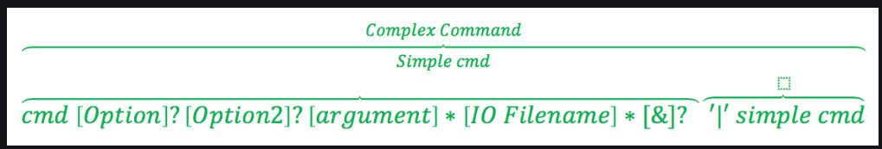

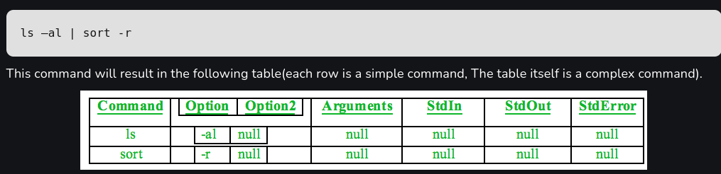

Executor

