Installation
$ apt install fail2ban

for these error
[3989]: WARNING 'allowipv6' not defined in 'Definition'. Using default one: 'auto'
[3989]: ERROR Failed during configuration: Have not found any log file for sshd jail
[3989]: ERROR Async configuration of server failed

need to change backend = systemd in jail.conf
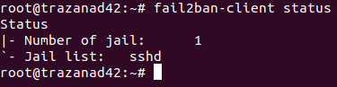

to see the jail in use

fail2ban : it will monitor for login attempt and when a certain threshold is reached it’s going to ban its person by configuring a firewall to block its ip
by default it will monitor ssh for us but it can watch for other system like apache,…

