Fail2ban
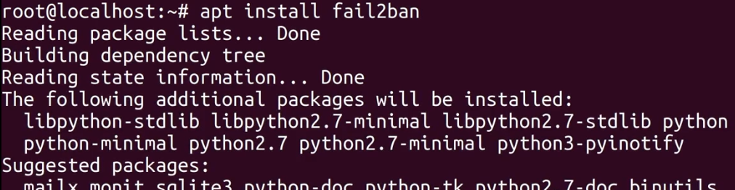

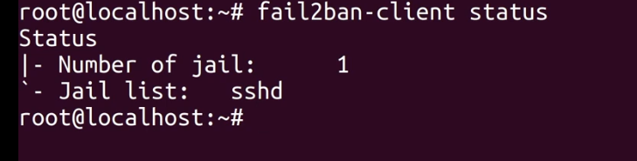
fail2ban:monitor to log in attempt and when a certain threshold of failed is reached it will ban that particular person by putting a firewall rule to there ip
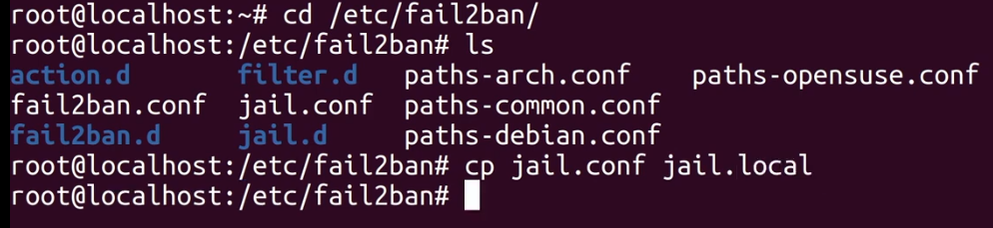
we use a copy of jail.conf named jail.local to do the configuration because when fail2ban is updated the jail.conf will be overwritten

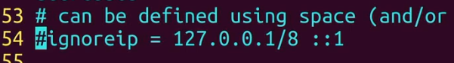
if decommented it will add an ip address that will never be blocked

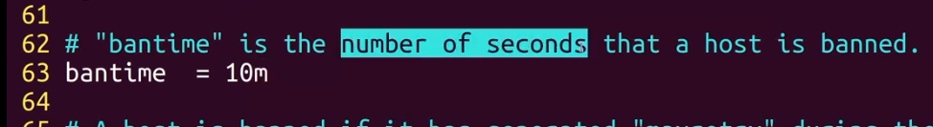
ban time in minutes with m if not (bantime = 10 → 10s)

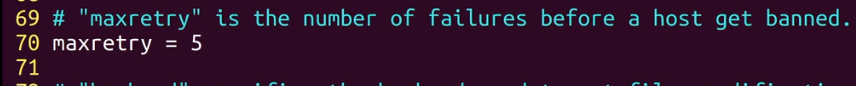
maxretry

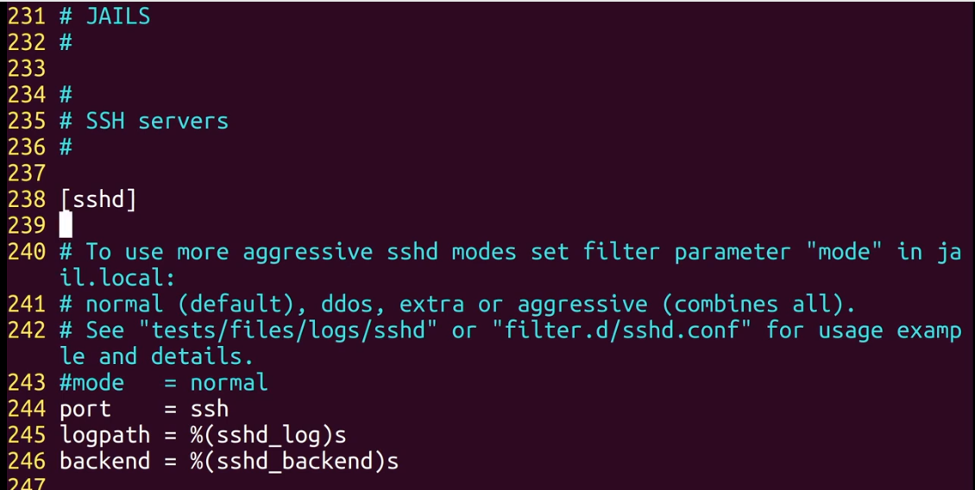
see jails

to enable it (we use enabled = true but ssh jail is enable by default even without it
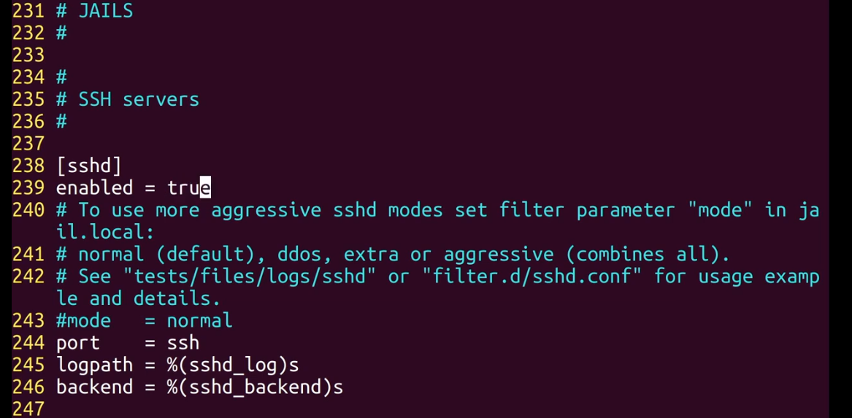
and if you change the ssh port make sure to overwritten this because it use the default ssh port (22)

