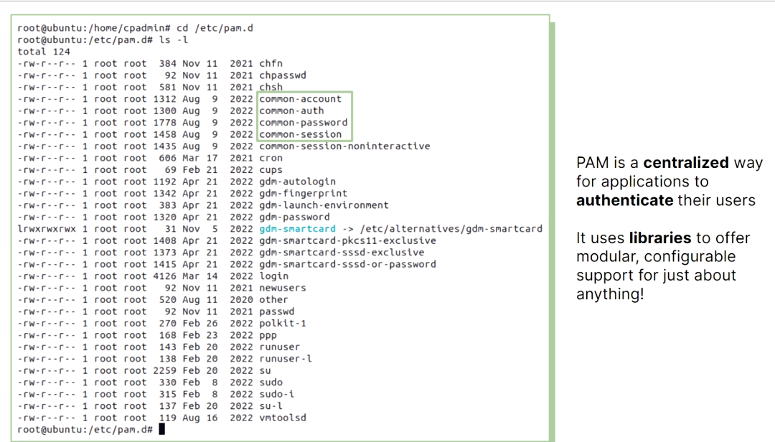
d

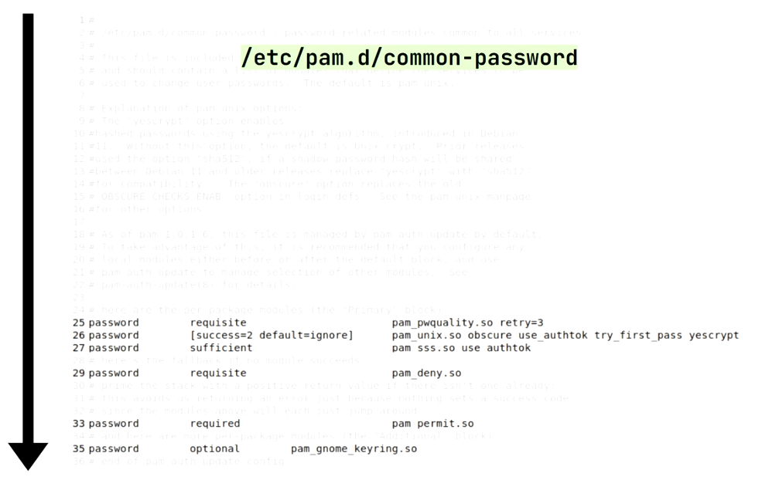
the rule in pam is executed in a sequenced order

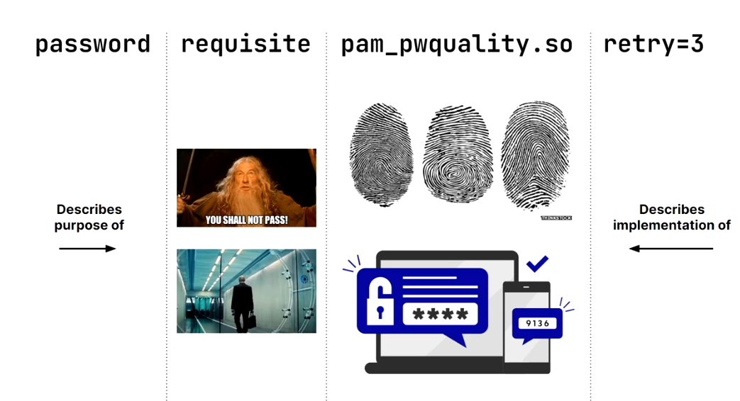
d
passwd user to change the password

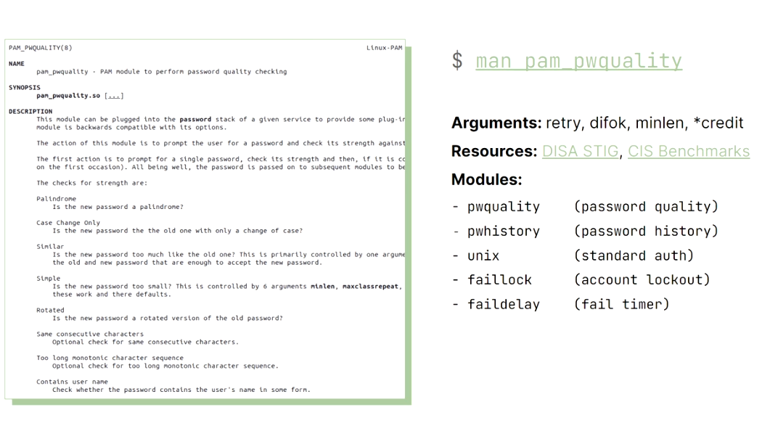
4

TTY
when we run terminal in gui it will use a terminal emulator from this gui (gnome le gui) (xterm, gnome terminal,…
we have 7 tty in our machine (ctrl+shift+f1 to f7
tty 1 ,2: return you to your gui screen
tty 3,4:cli screen

cron job

cron allows us to schedule task in advance
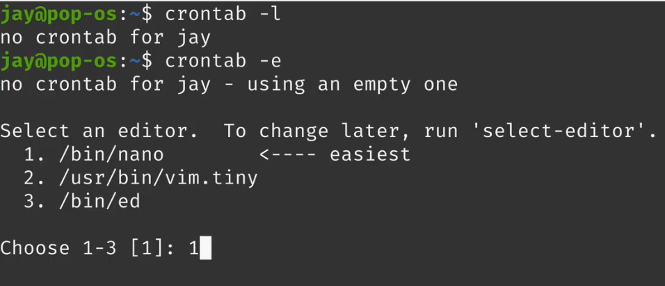
-l for see the crontab for my user
and -e to edit it

a cronjob consists of 6 fields
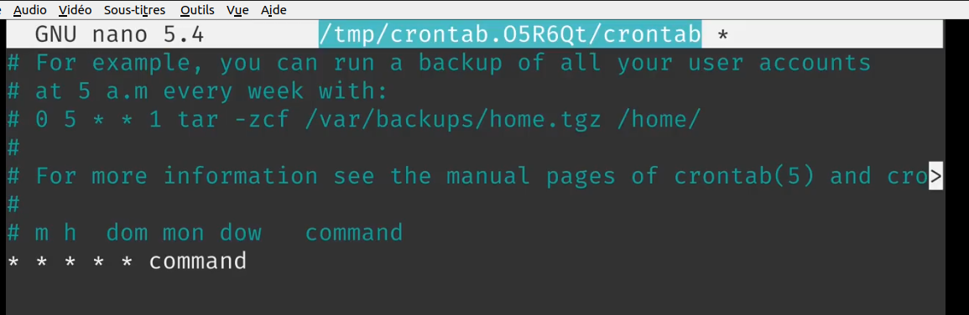
6 fields :
- minutes
- hours
-day of month
-month
-day of the week
-command

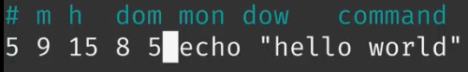
4

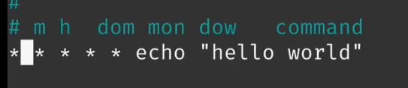
d
we can use * that means any

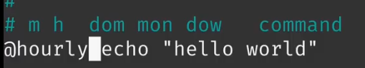
we can also use hourly to tell every hour

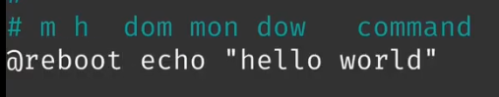
time that the server reboot

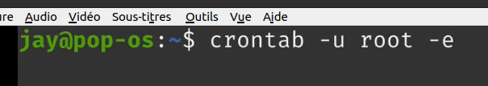
we can add crontab for a specific user
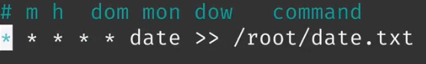
for eg saving each minute in date.txt > > for append

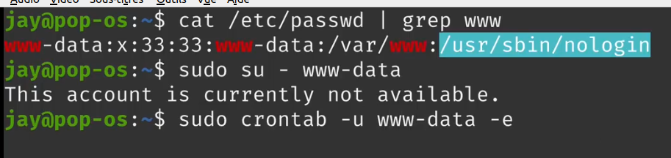
note that these in etc/psswd and we can add crontab for them

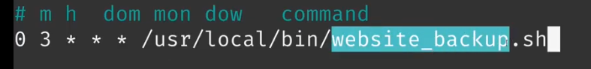
always use full path
crontab generator .org

password expiration

to use that we use the chage command

it allows us to set expiration

give expiration date for a specific user account

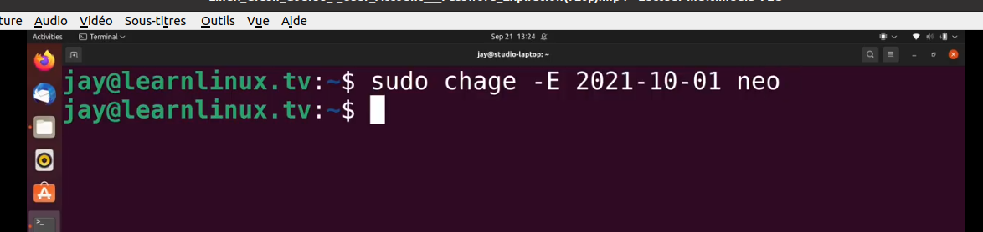
check expiration date for a user
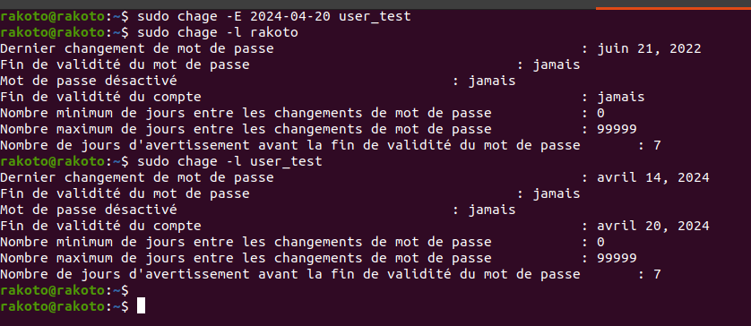
password expiration
expiration in 30 days
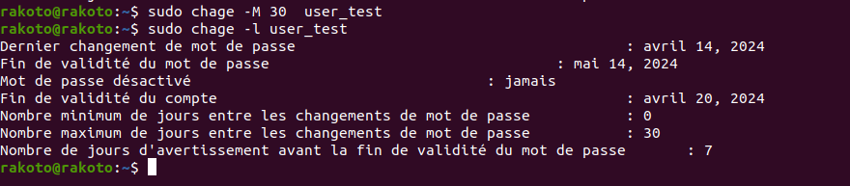
undo it
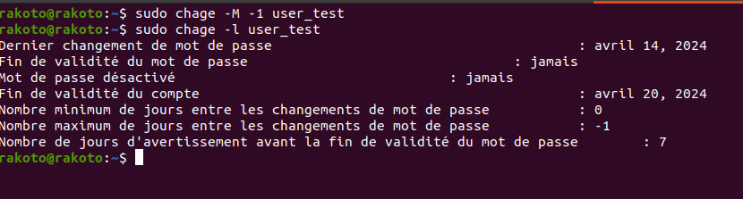
number of days the user is allowed to change the password again
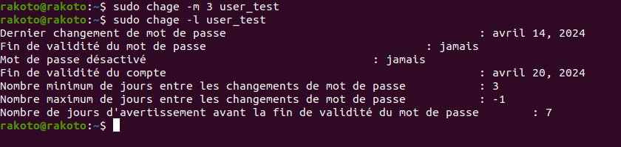
lock password account
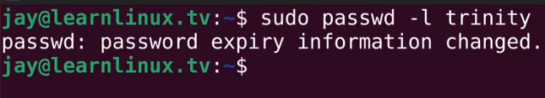
unloack acount
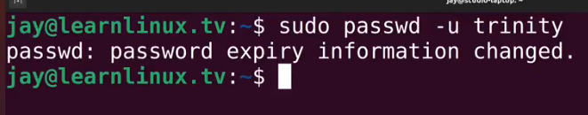
change warning days before password expiration
