Step 3

Method

A Median Filter has been used to remove the salt and pepper noise within the image. As displayed in figure 1, the filter has worked well to remove the outlier pixels whilst retaining overall image quality. How it works, in built vs. own made

Padding

Zero padding has been used. The median filter therefore has full coverage of the image including it corners and sides. Alternatively the image could be cropped. However this would reduce PPI losing image detail.

Filter Comparison

When testing a mean filter, output displays grey specks in similar positions to the salt and pepper noise. This is due to the linear filter being more sensitive to the 0 and 255 outliers. Pixels true to the original image are being influenced by outlier pixels in their neighborhood. With its trait of selecting the middle value within a pixels neighborhood a median filter is less sensitive to these outliers and therefore in this case a better choice for noise removal than the mean filter.

A Gaussian filter seems to remove the salt and pepper noise however does not preserve edges of the image as well as the median filter. In terms of speed the linear trait of the Gaussian algorithm is likely to be faster than median filter's non-linear sorting process. However maintenance of detail is crucial in later stages i.e. identifying the starfishes. As a result detail over speed is an accepted trade off.

A Wiener filter has been used to determine if the tailoring of local image variance removes more noise than a median filter. It seems when defining a 3 by 3 neighborhood, the wiener filter has relatively poor performance removing a small amount of salt and pepper noise.

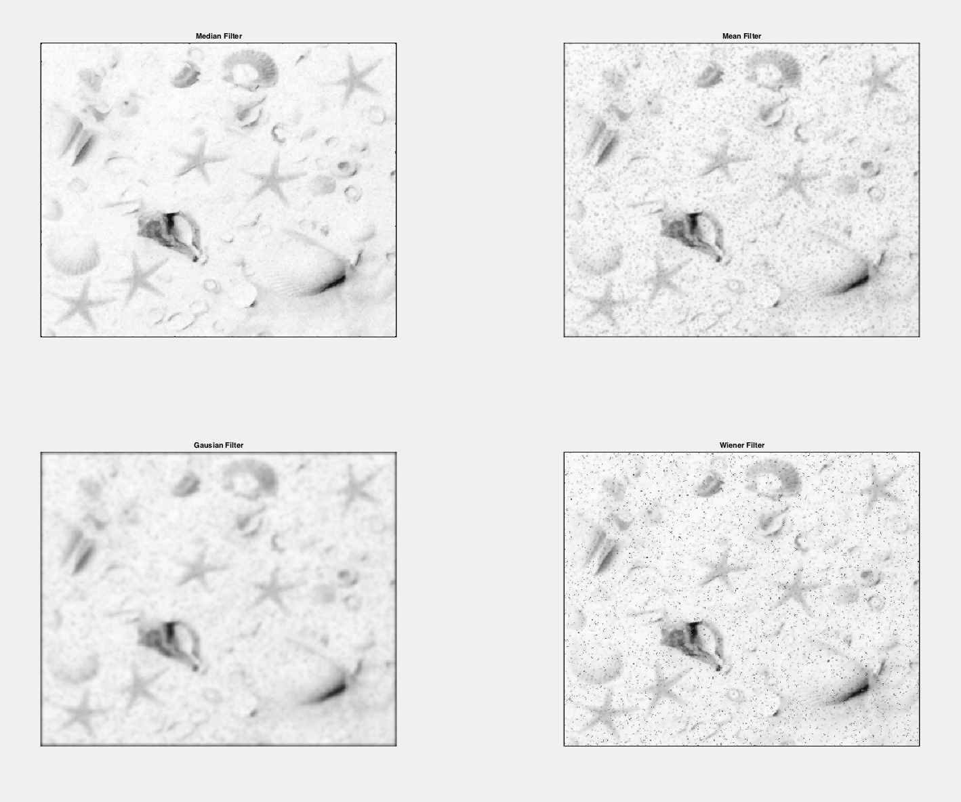

Step 4

Histogram equalisation has been used to enhance the contrast of the image. The method outputs the images intensity levels by aproximation of thier probability of occurrance. As displayed in figure 1 the orignal image has histogram components which are localised to high intensity values. As shown in the HE algorithm, the probability of the starfishes intensity is high which has made output of each starfish darker. This aids in their segmentation from the rest of the image. However because of the uniform manner in which histogram equaltion distrubtes its pixel intesites, areas around the starfish have become more deatilaid and darker in constrast.

Since the images intesity levels are narrowly localised around the higher end of the intensity spectrum, contrast stretching has subitly expanded the narrow range making the pixel intenisities subtly darker. Unlike histogram equalisation this has not aggresivly made background areas darker in contrast but has slighly increased the darkness of the starfish.

However, contrast streching has stretched already dark pixel intensities of large artifacts to darker range (lower than starfish). Although histogram equalisation atcs in a similar way, the high probability of each starfishes intenstiy leads to a their darker output. Form this, using histogram equalisation returns more definition to each starfish over contrast stretching.