|  |  |  |  |  |  |
| --- | --- | --- | --- | --- | --- |
| Macintosh HD:Users:osheadouglas:Desktop:Screen Shot 2016-10-24 at 15.25.15.png | Macintosh HD:Users:osheadouglas:Desktop:Screen Shot 2016-10-24 at 15.25.28.png | Macintosh HD:Users:osheadouglas:Desktop:Screen Shot 2016-10-24 at 15.24.48.png | Macintosh HD:Users:osheadouglas:Desktop:Screen Shot 2016-10-24 at 16.32.23.png | Macintosh HD:Users:osheadouglas:Desktop:Screen Shot 2016-10-24 at 15.25.04.png  Macintosh HD:Users:osheadouglas:Desktop:Screen Shot 2016-10-24 at 17.12.31.png | Macintosh HD:Users:osheadouglas:Desktop:Screen Shot 2016-10-24 at 15.25.39.png |
| 0 | 135 | 135 | 0.05 | 0.38 | 0 |
| 1 | 473 | 608 | 0.19 | 1.70 | 2 |
| 2 | 626 | 1234 | 0.25 | 3.46 | 3 |
| 3 | 824 | 2058 | 0.33 | 5.76 | 6 |
| 4 | 109 | 2167 | 0.04 | 6.07 | 6 |
| 5 | 108 | 2275 | 0.04 | 6.37 | 6 |
| 6 | 106 | 2381 | 0.04 | 6.67 | 7 |
| 7 | 119 | 2500 | 0.05 | 7 | 7 |

8/Row/col x sum

0.0028

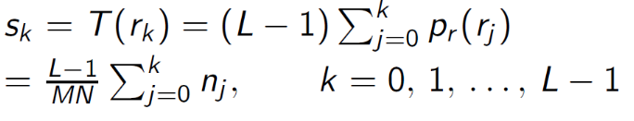

pdf = zeros(256,1); = 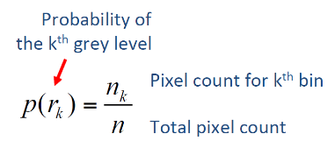

// Where there is a bigger number of pixels, there is a higher probability.