**Log**

The open source project selected is a notepad android application, ‘NoNonsense Notes’. It’s a simple note/to do list app, which has the functionality to set reminders at a certain time, password protect note content and synchronise with Google Tasks. The team has prior experience coding in java. As a result, contributing to an android app seemed feasible. The open source project also had a number of issues submitted by users, which seemed achievable to fix within the time allocated for the SCRUM. The app itself has over 100,000 downloads, suggesting implementing improvements has the potential to benefit many users.

Domain model schema has been created in order to establish a solid understanding of the system. The following section uses nouns and verbs which described the application and best depict the systems functionality.

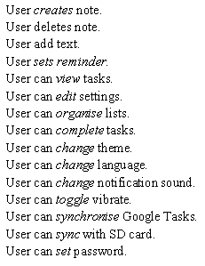

The about verb and noun analysis was helpful in constructing an object diagram.



As displays the

In using the nouns and verbs from figure 1 an object diagram has been constructed.

The system is centred on one user/actor, which can then execute a primary set of functions i.e. Create Note, Delete Note, View task and Modify Settings. The app itself is not complex, with the user being able to reach a terminus of functionality within 3 steps/taps. This suggest the apps ease of use. The limited functions also suggests ease of understanding on a lower level (code). If this project was being developed for an actual client, a high level mimic of the notepad system could be displayed using this diagram.

In viewing the data flow diagram