Support for Multiple Languages
Starting with version 1.0.3.47, MBox Viewer implements more complete support for multiple languages.
Window’s text, button’s labels, menu labels, etc of dialogues, message boxes, menus of mails, mail files and Help Files, User Guide can be configured by users to display in German, French, Spanish, Italian, Polish, Romanian, Portuguese and Portuguese-Brazil languages. More languages can be supported in the future releases, check CHANGE_LOG.md.txt and others documents.

Language Configuration
Language to be used by MBox Viewer can be configured by selecting “Language-->Select Language” main menu option. The following dialog will appear and allow users to select new language. MBox Viewer must be restarted for new language to take effect.
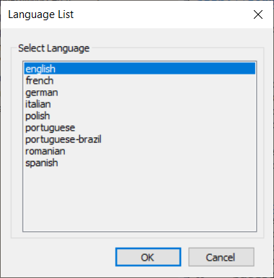

Limitations
- In many cases the text translated to other languages will not fit in the fixed template defined for English text and it will be truncated. As a work around, user can move cursor over the truncated text to activate Tool Tips with the full text.
- The English text and documents were translated to other languages by free Google Translation service and not reviewed by humans yet. Free Google Translation service is not domain specific and therefore has limitations. It is designed to translate commonly daily spoken language. Better use of Google Translation service needs to be investigated.
- There are occasional issues with WORD documents translated by free Google Translation service with regard to formatting and other issues. Translated WORD documents are later exported to PDF.

