Forward Mails directly from MBox Viewer

Overview
Users can forward single or selected group of emails directly from MBox Viewer. MBox Viewer connects to one of the preconfigured SMTP (Simple Mail Transport Protocol) Servers to forward emails. Emails can be forwarded via Gmail, Yahoo, Outlook Live mail service or user configured Mail Service.
MBox Viewer relies on a separate standalone process, ForwardEmlFile.exe, to connect to SMTP Server and to send emails using the TLS encrypted communication. MBox Viewer links proven free MailKit software library to communicate with the SMTP server. Note that ForwardEmlFile.exe can’t access user mail account data since SMTP Server can send data only.
Be aware that all Mail Services impose limits on the rate, size of sending mails and other factors, see chapter 1.3. For regular users, Gmail seems to offer better more predictable service than Yahoo or Outlook. However, Yahoo supports mails up to 39MB in size vs 35MB by Outlook and vs 25MB by Gmail.
Note that even so Yahoo can send large mails of 39MB, Outlook may ignore mails larger than 35MB. When forwarding important emails, it is good idea to ask recipient for confirmation.

User Accounts and Passwords
Mail Service providers usually require third-party applications to follow special authentication requirements in order to gain access to their services, i.e. to SMTP Server in this case.
If for whatever reasons you would rather not make changes to your main mail account, you can always create additional mail account on another mail service just to be able forward emails directly from MBox Viewer.

Yahoo Mail Service
In order for third-party SMTP client applications such as ForwardEmlFile.exe to access Yahoo SMTP Server, user must login to Yahoo mail account first and generate one time App Password that can later be used to authenticate ForwardEmlFile application to SMTP Server.
App Password is long string of 16 random characters. Using App Password is very safe since it practically can’t be guessed by hackers using brute force.
Select the below link and click on + sign next to “Generate an App Password” and follow all steps to generate globally unique password for application named ForwardEmlFile. You will need App Password and Yahoo mail user name to communicate with Yahoo SMTP Server.
https://my.help.yahoo.com/kb/account/generate-third-party-passwords-sln15241.html

Gmail Mail Service
Third-party SMTP client application such as ForwardEmlFile.exe can connect to Gmail SMTP Server and be authenticated using either 1) Gmail user name and Gmail user password, or 2) Gmail user name and Gmail App Password.
Note (Nov 2022). Authentication by user name and password is no longer supported by Gmail.

Gmail user didn’t enable 2-step verification to sign up into Gmail
In order to use Gmail user name and Gmail user password, user must login to the Gmail account and enable “Less secure app access” option, see the link:
https://myaccount.google.com/lesssecureapps?pli=1
If you are concerned about this change, you can disable “Less secure app access” option after you are done forwarding emails.

Gmail user did enable 2-step verification to sign up into Gmail
User must login to Google account and generate App Password for Gmail Account. App Password is long string of 16 random characters. Using App Password is very safe since it practically can’t be guessed by hackers using brute force.
Use the link below to generate App Password:
https://myaccount.google.com/security
Alternatively, user can login to Gmail account and the select “Manage your Google Account” by clicking Google Account icon at the top right corner. Select Security option to generate 16-character long App Password. See also helpful links below.
https://www.lifewire.com/get-a-password-to-access-gmail-by-pop-imap-2-1171882
https://www.systoolsgroup.com/gmail-backup/turn-off-two-step-verification.html

Outlook Live Mail Service
Testing was done using Outlook Live free mail account. Microsoft also offers payable Premium Outlook mail service under Office 365 and Microsoft 365 plans. These plans offer much higher sending limits but no evaluation was performed.
If a user did enable 2-step versification, user needs to generate App Password to be properly authenticated, see chapter 1.2.3.2. App Password is long string of 16 random characters. Using App Password is very safe since it practically can’t be guessed by hackers using brute force.
If a user didn’t enable 2-step versification, there is no requirement to change any security setting for Outlook Live account to be able to send mails via Outlook SMTP Server.
Creating User name and Password to gain access to Outlook SMTP is not exactly clear and can be confusing to set up.

Create Outlook Account, User Name and Password
I suggest the following steps to create valid user names and password. For more information, examine the following link.
Everything you need to know about Microsoft accounts | Windows Community
In my case I already had Microsoft and Outlook accounts but had to perform additional configuration.

You don’t have Microsoft Account (know as MSA) and you don’t have Outlook Live account
Use the following link to create Microsoft account page:
https://account.microsoft.com/account
Select “Sign in”, then select “Create one!”, then select “Get a new email address” and create your new MyName@outlook.com email address.
The below link has more details.
https://support.microsoft.com/en-us/account-billing/how-to-create-a-new-microsoft-account-a84675c3-3e9e-17cf-2911-3d56b15c0aaf
Use your new Outlook User name and Password to open SMTP Server Configuration dialog and configure user name and password. Attempt to forward one of the mails and check if all works.

You already have both Microsoft Account and Outlook Live Account
This is the case I faced. Forwarding of emails was not working properly until I created email alias and make this alias primary as described in following link:
https://support.microsoft.com/en-us/office/add-or-remove-an-email-alias-in-outlook-com-459b1989-356d-40fa-a689-8f285b13f1f2
For some reason, Outlook Account User Name and Password did not work for me but Microsoft Account User name and Password did work.

Generate App Password for Outlook
User must login to Outlook account, enable 2-step verification and generate App Password for Outlook Account. Follow the link below to generate App Password:
https://support.microsoft.com/en-us/account-billing/using-app-passwords-with-apps-that-don-t-support-two-step-verification-5896ed9b-4263-e681-128a-a6f2979a7944

Mail Sending and Size Limits
The limits are listed here to the best of our knowledge and might be changed by the mail service providers anytime without notice. For regular users, Gmail seems to offer better more predictable service than Yahoo or Outlook. However, Yahoo supports mails up to 39MB in size vs 35MB by Outlook and vs 25MB by Gmail.
Users are mainly responsible for observing sending limits. MBox Viewer will limit the sending rate to 30 mails/minute.

Gmail Mail Service
Sending can be rejected by Gmail for variety of reasons. If a user exceeds various limits, user account can be locked for up to 24 hours. User can take manual steps to restore access.
Regular users are allowed to send up to 500 mails per day.
Mails can be rejected if they are being sent too fast or to many recipients.
Mails of up to 25MB are accepted.

Yahoo Mail Service
Sending can be rejected by Yahoo for variety of reasons. If a user exceeds various limits, user account can be locked for up to 24 hours. User can take manual steps to restore access.
Yahoo does not disclose sending and size limits.
Mails of up to 39MB are accepted.

Outlook Mail Service
Sending can be rejected by Outlook for variety of reasons including suspicion of spamming. If a user exceeds various limits, user account can be locked for up to 24 hours. User can take manual steps to restore access.
Mails of up to 35MB are accepted. If you attempt to send larger mail, it will appear that the sending was successful. However, Outlook will post rejection mail into your Outlook account.
The other sending limits are not known.

SMTP Server Configuration
Select “File → SMTP Mail Server Config” to open the configuration dialog. Select one of the listed mail services, enter User Account and Password and click on the “Save” button to save the changes.
When you select “Close” button, the SMTP.ini file is created for the selected service in C:\Users\%USERNAME%\AppData\Local\MBoxViewer\MailService and used by ForwardEmlFile.exe to support forwarding of emails.
The “Cancel” button is used to clear unsaved changes made in the dialog. If you switch to different mail service, the unsaved changes in the dialog are lost.
When you exit MBox Viewer, User Password is not saved in the system for safety reasons and must be reentered before any mail can be forwarded again.

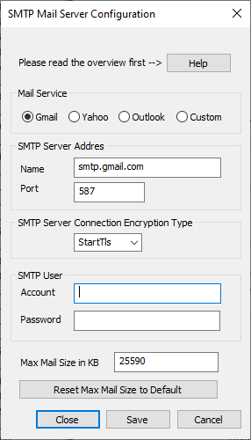

SMTP Servers Default Settings

SMTP Server Address | smtp.gmail.com | smtp.mail.yahoo.com | smtp-mail.outlook.com
SMTP Server Port | 587 | 587 | 587
SMTP Security | StartTls | StartTls | StartTls

Forwarding Mails
MBox viewer supports forwarding of a single and multiple emails.
Note that From address can be specified by a user while in Custom SMTP Configuration option only.

Forwarding a single email
Right click on any email and select “Forward Mail” option to open the dialog to forward the selected email. The dialog can be manually resized if needed.
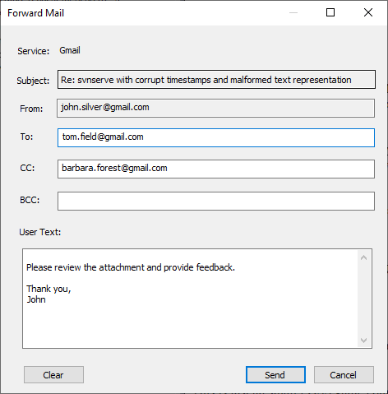
The non-empty To field is required. Other fields are optional. When you open the dialog, To, CC, BCC and User Text fields will show the values set in the last dialog. You can clear these fields by clicking on the “Clear” button.
It is important to make sure all addresses are correct and valid. If any address is not valid, a rejection email will be send by the mail service to the respective user’s mail account. MBox Viewer doesn’t have access to user’s mail accounts.

Forwarding a list of selected emails
User can select multiple email, then right click on any of the selected emails and select “Forward Mails” option to open the dialog to forward the selected email.
To avoid suspension of the user account, the user is warned if the user attempts to forward batch of emails larger than 100. User is also warned when any of the select mails to forward is larger than supported maximum size.

Error Reporting
If forwarding of a mail fails, MBox Viewer will create Message Box with relevant error text.

