Windows MBox Viewer
User Manual 1.0.3.58
Table of Contents
1 Modification History 4
2 What is new and what changed in version 1.0.3.58 5
2.1 What is new 5
2.2 What changed 5
3 LICENSE 5
4 About this document 5
5 Feedback 6
6 Overview 6
7 Known Issues 7
7.1 Running MBox Viewer 7
7.2 Folder Path Restrictions 7
7.3 Printing to PDF 7
7.4 Printing Multiple Selected Mails 7
7.5 Mail Date and Time 8
7.6 Searching 8
8 Installation 8
9 Configuration Data Store 9
10 Running MBox viewer 9
10.1 Argument List Summary 9
10.2 Setting Options from GUI 10
10.3 Basic Use Case 11
10.4 Multiple Folders Support 14
10.5 Support for Hierarchy of Folders 15
10.5.1 Select Root Folder for Merging Configuration Dialog 15
10.6 Data Folder Configuration 16
10.7 Text Font Size Configuration 16
10.7.1 Limitations 17
10.8 Hiding and Restoring Mbox Files in Mail Archive Tree Window 17
10.9 Hiding of Mail Archive Tree Window 19
10.10 Set MBox Viewer as default application to open mail archive files 20
10.11 Message Window Position 20
10.12 Preservation of Windows Placement 20
10.13 Background Color Style Customization 20
10.14 Support for Gmail Labels 23
10.14.1 Limitations 24
10.15 Expand Message Header Field List 25
10.16 Viewing raw message header 25
10.17 HTML/PDF Mail Header Customization 25
10.18 Single Mail Context Menu 26
10.18.1 File Names 27
10.19 Multiple Selected Mails Context Menu 27
10.19.1 File Names 28
10.20 Conversation Mail Group Context Menu 28
10.20.1 File Names 29
10.21 Mail Archive Context menu 29
10.21.1 Print to CSV File Dialog 30
10.22 Mail Attachments 30
10.22.1 Attachment context menu 31
10.22.2 Attachments Configuration 31
10.22.3 Exporting All Attachments of All Mails 32
10.23 Inline Image Cache 32
10.24 Export of all Mails to a Separate Eml files 32
10.25 Picture Viewer 34
10.26 Mail Navigation 35
10.27 Mail Sorting 35
10.27.1.1 Subject Sorting Rules 35
10.28 Dynamic Column Resize 36
10.29 Mail Searching 36
10.29.1 Basic Find 36
10.29.1.1 Find all mails that match Option 37
10.29.1.2 Find mails that don’t match option 37
10.29.1.3 Handling of special ‘*’ search string 38
10.29.1.4 Filter Dates 38
10.29.2 Advanced Find 39
10.29.2.1 Find all mails that don’t match option 40
10.29.2.2 Handling of special ‘*’ search string 40
10.29.2.3 Filter Dates 40
10.29.3 Search Reliability 40
10.29.4 Search for Words 41
10.29.5 Search Progress Bar 41
10.29.6 Search Performance 41
10.30 Refreshing Archive Tree Window 42
10.31 Language (Character Sets) Support 42
10.31.1 Message Window 42
10.31.1.1 Header of Message Window 43
10.31.2 Summary Window 44
10.32 Mail List Auditing 44
10.32.1 Mail List Archiving 45
10.32.2 Merging Multiple Mail Archives 46
10.32.2.1 Merging files using command line options 46
10.32.2.2 Merging files from GUI 46
10.33 Mail Printing Overview 47
10.33.1 Print Configuration Dialog 47
10.33.1.1 Custom Name Template 48
10.33.2 Mail Printing to CSV Spreadsheet file 49
10.33.3 Mail Printing to TEXT file 49
10.33.4 Mail Printing to HTML file 49
10.33.5 Mail Printing to PDF printer 49
10.33.6 Mail Printing to PDF file 50
10.33.6.1 Use of free wkhtmltopdf application 50
10.33.6.2 Print Options 50
10.33.6.3 Printing directly from Firefox, Chrome and Edge browsers 51
10.33.6.4 Impact on Font Size when Printing of Multiple Mails to a Single PDF 51
10.33.6.5 Performance 52
10.33.7 Mail Printing to PDF files by Power Users 52
10.34 Viewing Large PDF files 53
10.35 Mail Sharing with other People 53
10.36 Support for Outlook .msg Mail Files 55
10.36.1 Viewing single .msg file 55
10.36.2 Viewing Outlook msg internal structure 55
10.36.3 Merging multiple Outlook .msg mail files 55
10.37 Support for winmail.dat and .ms-tnef attachments 55
10.38 Export and Print Directory Structure 56
11 Support for Read Only Media 57
12 Forward Mails directly from MBox Viewer 57
12.1 Overview 57
12.2 User Accounts and Passwords 57
12.2.1 Yahoo Mail Service 58
12.2.2 Gmail Mail Service 58
12.2.2.1 Gmail user didn’t enable 2-step verification to sign up into Gmail 58
12.2.2.2 Gmail user did enable 2-step verification to sign up into Gmail 58
12.2.3 Outlook Live Mail Service 59
12.2.3.1 Create Outlook Account, User Name and Password 60
12.2.3.1.1 You don’t have Microsoft Account (know as MSA) and you don’t have Outlook Live account 60
12.2.3.1.2 You already have both Microsoft Account and Outlook Live Account 60
12.2.3.2 Generate App Password for Outlook 60
12.3 Mail Sending and Size Limits 60
12.3.1 Gmail Mail Service 61
12.3.2 Yahoo Mail Service 61
12.3.3 Outlook Mail Service 61
12.4 SMTP Server Configuration 61
12.4.1 SMTP Servers Default Settings 62
12.5 Forwarding Mails 63
12.5.1 Forwarding a single email 63
12.5.2 Forwarding a list of selected emails 64
12.5.3 Error Reporting 64
13 Support for Multiple Languages 64
13.1 Language Configuration 64
13.2 Limitations 65
14 Windows Code Page Identifiers 65
14.1 Handling Unknown Code Page Names 69

Modification History
Revision | Date | Comments
1.0 | February 28, 2018 | Initial Release
< 1.0.3.1 |  | See ReadMe.markdown 1.0.3.1 included with the release package.
>= 1.0.3.1 | September 26, 2019 | See the section “What is new and what changed in version 1.0.3.x”.
> 1.0.3.48 | March 3, 2025 | English version of User Guide will match the MBox Viewer release number. Non English version may not be updated if there was no important changes to the functionality.

What is new and what changed in version 1.0.3.58

What is new
- none.

What changed
- Processing of winmail.dat and .ms-tnef attachments was not correct in some cases.

LICENSE
The mbox viewer source code created by authors of the mbox viewer project is licensed under
GNU AFFERO GENERAL PUBLIC LICENSE version 3 which permits free use of the code by individuals and organizations. Small portion of the source code is from Code Project site and licensed under the Code Project Open License (CPOL) 1.02 which permits, as we understand, free use of the that code except in a few unusual cases such as for example the immoral usage. MailKit open source free library linked to connect to SMTP servers is licensed under MIT.

The mbox viewer executable doesn't link any non-free usage library and therefore it can be
freely used, as we understand, by individuals and organizations.

The mbox viewer software is distributed in the hope that it will be useful, but WITHOUT ANY WARRANTY; without even the implied warranty of MERCHANTABILITY or FITNESS FOR A PARTICULAR PURPOSE.

Please check the below links for the detailed information on GPL, CPOL and MIT license terms.

https://mit-license.org/

https://github.com/jstedfast/MailKit/blob/master/LICENSE

https://github.com/jstedfast/MimeKit/blob/master/LICENSE

https://www.gnu.org/licenses/agpl-3.0.txt

https://www.codeproject.com/info/cpol10.aspx

https://github.com/elocemearg/cfbfinfo/blob/master/LICENSE.txt

https://github.com/Sicos1977/MSGReader/blob/master/MsgReader/Outlook/RtfDecompressor.cs

https://github.com/bbottema/rtf-to-html/blob/master/LICENSE-2.0.txt

Links to additional publications that can be useful.

https://www.codeproject.com/info/Licenses.aspx
https://opensource.guide/legal/#which-open-source-license-is-appropriate-for-my-project

About this document
Starting with 1.0.3.27 version of MBox Viewer, icons representing folders and mail archives have changed. Mail archive used to be represented by the folder icon and now is represented as the stack of mail envelops. Mail folder was represented by the computer icon and now it is represented by the folder icon. However, not all screen snapshots were updated yet to reflect the change.

Feedback
To help to improve MBox Viewer, please post reviews what works and what doesn’t, create bug reports and request for enhancements. Provide as many details as possible, such as country, screenshots, etc.

Overview
MBox Viewer (or mboxview) is Windows GUI based program to view mbox files such as Thunderbird Archives, Google mail archives or simple Eml files or Outlook MSG files.
The mbox viewer is a simple but quite powerful email viewer that supports the following features:
- large file support > 4Gb
- fast parsing of mbox archives
- quick access to all attachments
- preview picture attachments
- zoom in/out a picture
- export of single mail in Eml
- export of all mails in Eml format
- export attachments of all mails
- print all or multiple selected mails to CSV or Text or HTML or PDF files or send to PDF printer
- print single mail to Text or HTML or PDF file or send to PDF printer
- group all related mails as conversations
- print mail conversation/related mails group to CSV or Text or HTML or PDF file or send to PDF printer
- open single or multiple selected mails or group of related mails in a browser
- find user defined text in mail’s message and highlight all occurrences
- search the date, subject, sender, cc, bcc, message text, appendix text and appendix names
- search for mails that didn’t match the search criteria
- sort by date, from, to, subject, size and conversation groups
- support for mail’s header fields and body encoded with different character sets
- support for mail list editing capability to enable users to compose mail list by merging results of multiple searches and/or by merging one or more user selected mails
- ability to set Message Window position to Bottom, Right or Left
- ability to merge/concatenate multiple archive files and remove duplicate mails
- ability to customize background colors of display panes and mail message
- ability to customize HTML/PDF mail header output
- view raw mail headers
- forward mails directly from MBox Viewer
- support for Gmail Labels
- support for exported hierarchy of mail files from Thunderbird or similar mail clients
- support for Mail Sharing (or Mail Export) feature to enable users to share one or more of the selected mails in HTML and PDF format with other people.
- support for Windows Registry based and file based configurations
- support for multiple languages
- ability to control font size by users
- support for Outlook msg files
- support for winmail.dat and .ms-tnef attachments

Known Issues

Running MBox Viewer
Only a single instance of MBox Viewer should be running at any given time. The second instance of MBox Viewer is allowed when opening mail file directly by the MBox Viewer or when starting in the mail preview mode.

Folder Path Restrictions
MBox Viewer relies on Windows file system to implement its data base. MBox Viewer creates files in response to user requests such as Print to .. [txt|pdf|htm|csv]. To avoid problems, user should install MBox Viewer and MBOX mail files under folders with short path due to limitation to the max length of Windows file names (255). The file names created by MBox Viewer are composed of the following parts:
“Path of the installation folder” + “Path of the folder housing mail files” + “mail subject.[txt|htm|pdf|csv]”
MBox Viewer can reduce length of the “mail subject.[txt|htm|pdf|csv]” part when required but other parts are under user control.

Printing to PDF
MBox Viewer relies on Microsoft Edge and/or Google Chrome browsers to print directly to PDF.
Customization of printing is limited when printing directly to PDF.
Opening mails in a browser and printing from the browser offers additional options such as ability to remove color in the output or scale the pages.

Printing Multiple Selected Mails
Mbox Viewer simply concatenates multiple mails in HTML format into a single HTML file and opens the created file within a browser. The format of the created file is basically as follows:
<div><html><mail 1 header in HTML format></html></div>
<div><html><mail 1 body in HTML format></html></div>
<div><html><mail 2 header in HTML format></html></div>
<div><html><mail 2 body in HTML format></html></div>
<div><html><mail 3 header in HTML format></html></div>
<div><html><mail 3 body in HTML format></html></div>
…………………
The <div> tags are used in an attempt to create independent sections within HTML document.
The approach doesn’t always work reliably for variety of reasons. One known issue is that some mails with content in HTML format rely on default values such as the font size and may inherit the font size from other mails. MBox Viewer was enhanced to minimize such issues.
In rare cases, when printing multiple selected mails to PDF, use “Merge” option to resolve the potential issues.

Mail Date and Time
Mails older than the epoch time, i.e. older than year 1970 are supported but the date and time of such mails will be mapped to Jan 1 1970. Windows supports may different date and time functions but only Unix style date and time functions support Daylight Saving Time. However, these functions do not support date older than year 1970.

Searching
Search for words is quite reliable for words composed characters from ASCII and ISO-8859-1 (Also known as ISO Latin 1) character sets. Option to search for words should not be set when searching emails not composed from ASCII and ISO-8859-1 character sets.

Installation
The executable and the source code can be downloaded from Sourceforge or Github.
https://sourceforge.net/projects/mbox-viewer/files/
https://github.com/eneam/mboxviewer/releases
Download the executable package, the latest mbox-viewer.exe-v1.0.3.58.zip, to the working directory and unzip. This will create the mbox-viewer.exe-v1.0.3.58 directory containing the stand-alone mboxview.exe executable, User Guide, the scripts sub-directory and ReleasePlusStackTrace sub-directory. No administrator privileges are needed to install and run the mbox viewer.
Review the HELP.txt file in case of the Mbox Viewer crash.

Configuration Data Store
#
# MBox Viewer supports Windows Registry based configuration and the file based configuration.
# By default, Windows Registry is used to store configuration data.
# During startup, the MBox Viewer will check whether the MBoxViewer.config file exists and writeable in:
#
# 1) the Config subfolder under the MBox Viewer software installation folder or
# 2) in the UMBoxViewer\Config subfolder under the user specific folder created by Windows system
# example : C:\Users\UserName\AppData\Local\UMBoxViewer\Config
#
# The config file format is similar to the format of ".reg" registry file
# [UMBoxViewer\LastSelection]
# "parameter"="value"
#
# White spaces are not allowed in the front of each line and around "=" character.
# All parameter values are encoded as strings and converted by MBox Viewer to numbers or other data types when needed.
#
# MBoxViewer.config file must be encoded as UTF16LE BOM file
#
# MBoxViewer.config.sample file is included in the software package under the Config folder.
# In order to enable MBox Viewer to use the file based configuration,
# user needs to rename this file to MBoxViewer.config file or copy the sample file
# to C:\Users\UserName\AppData\Local\UMBoxViewer\Config folder and rename.
#

Running MBox viewer
The mboxview program can be executed by double clicking the executable from the explorer window or from the command line by typing the command name and argument list to it.

Argument List Summary
The mboxview accept the following command line options.
-FOLDER=folderPath – the full path to the folder containing one or more mbox or eml files. Persists in the registry across multiple runs.
-MAIL_FILE=fileName – full file path or just file name of mbox/eml file to load. If the full path is not specified, the full path is created from the folderPath and the fileName. Doesn’t persist in the registry across multiple runs.
-EML_PREVIEW_MODE command line option to hide Mbox Tree and Mail List panes when -MAIL_FILE is configured. ESCAPE key will terminate the mbox viewer.
-EXPORT_EML=y|n – enables or disables automatic export of eml files generated from mbox archive. Improves traversing performance of mail if set to ‘n”. Persists in the registry across multiple runs.
-PROGRESS_BAR_DELAY=seconds – search progress bar is activated when the search duration lasts longer than the value set for PROGRESS_BAR_DELAY. If set to -1, the progress bar is disables. Default value is set to 1 seconds. Persists in the registry across multiple runs.
-MBOX_MERGE_LIST_FILE=listFile Name and -MBOX_MERGE_TO_FILE=mergedFile Name command line options to merge content of mbox files listed in the listFile Name. The merged mbox file is automatically open in mbox viewer.

If desired, instead of typing directly desired command line options, a simple .cmd or .bat file can be created for convenience and run from the explorer.

Setting Options from GUI
The EXPORT_EML and PROGRESS_BAR_DELAY values can be changed on the fly at any time from GUI.
Click on the “File” to open the drop menu and then select the “Options” option. The below dialog will be presented. Set the desired values followed by OK button.
Note that if exporting of EML files is disabled, you can still export the eml file for the selected mail by selecting “View EML” under the “View” drop menu.
Two options, “Show Charsets” and “Set Character Sets for Header Fields”, can help to properly display header fields in the Message Window. See 10.31.1.1 for additional details.
The “Picture Viewer” check box enables/disables the dialog option to preview the picture attachments, see 10.25 for additional details.
The “Enhanced Select Mail Folder Dialog” is different version of the “Select Folder” option and allows user to see if the mail archives are in the folder. User needs to select any mail file to select containing folder.
The “Time” option allows to display time as Local or GMT.
The “Subject Sort Type” option creates subject threads when sorting by subject. Emails within each subject thread are sorted by time. By default subject threads are sorted alphanumerically. Subject threads can be sorted by time by selecting "File->Options->time ordered threads" option.
The “Validate files as mbox files” option enables user to control what files will be considered for validation as mbox files. Validation is done based on the content of files.

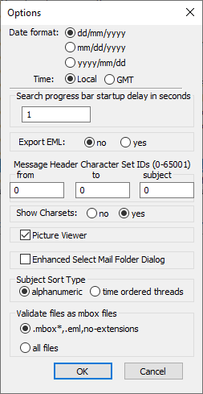

Basic Use Case
Double click of the mboxview to start the viewer. The picture below shows the screen created by the mboxview after few steps performed by a user. Mail Archive Tree, Summary and Message windows are initially blank after start-up. Steps to load a mail archive and display the content are described next.

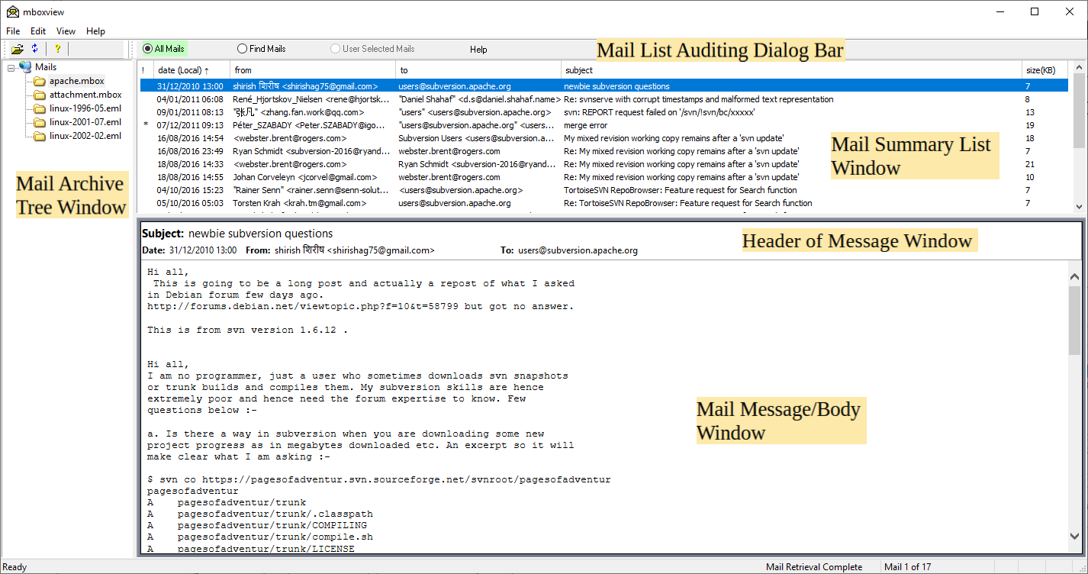

- Click on the “File” to open the drop menu and then select the “Select folder...” option. Browse to the folder containing one or more mbox and/or eml mail archive files and select it. All valid mail archive files will appear in the Mail Archive Tree window.
Note that different “Select Folder” dialog can be configured via File → Options menu dialog.

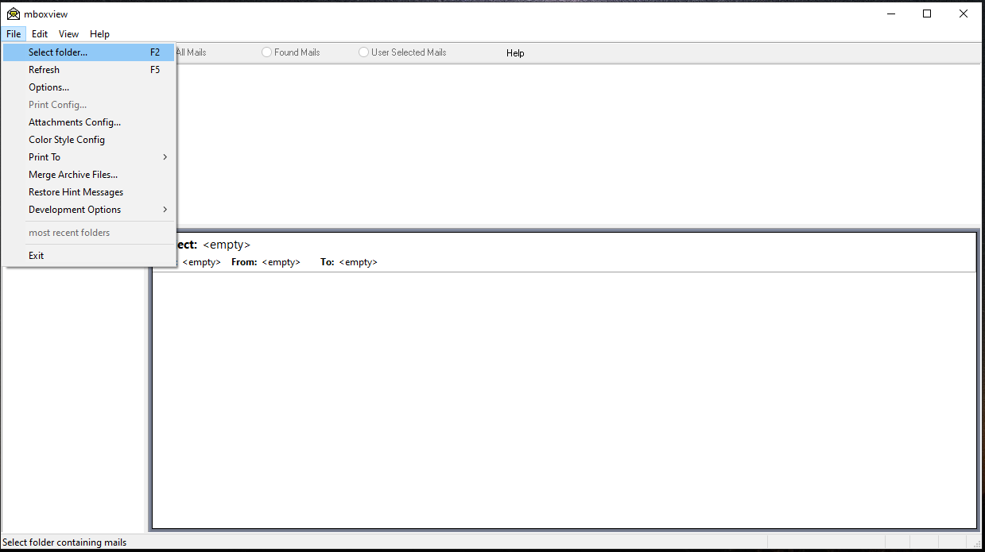
- Left click on one of the archive files to load all mails within that archive. Progress bar will appear and automatically close after the selected archive is fully processed. Mail header information of each email will appear in the Summary window. Note that parsing of very large archive file may take some time since the mail archives are text files and every character has to be examine one by one.
However, subsequent loading of mails is done from the index file created by the mboxview during the initial parsing of the archive file and is much faster. The created index file contains content meta data of each mail in the archive file. i.e. the mail header information and the position of each mail within the mail file for quick access to the mail message/body. The index files have the .mboxview suffix.
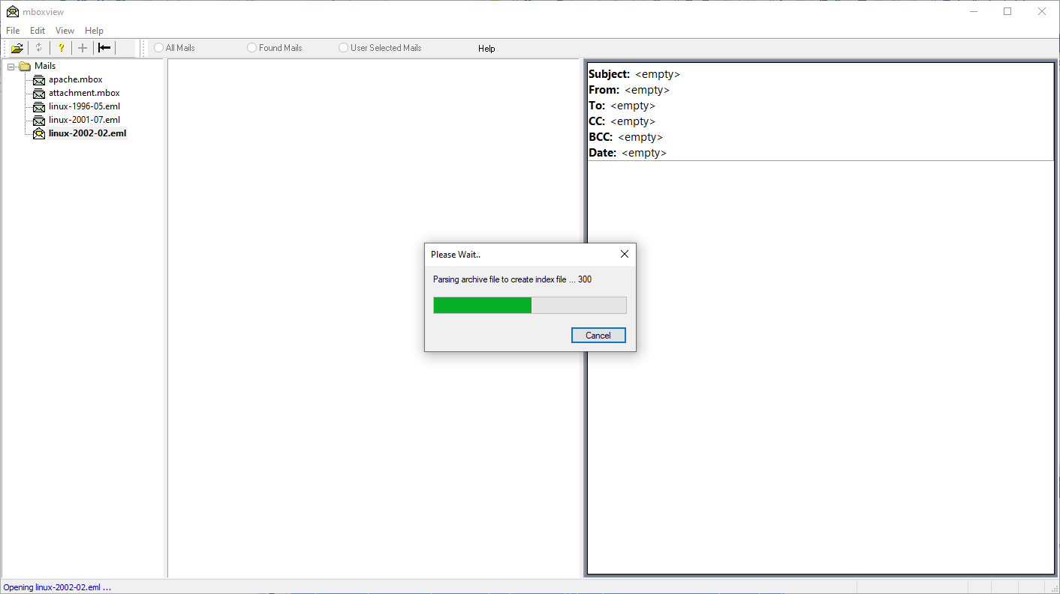
- Left Click on one of the mails in the Summary window to show the Message/Body of that email in the Message window. The mail retrieval state, total number of mails in the archive and the position of the selected mail within the archive is shown on the status bar. Opening a heperlinks within an external browser is recommended since running Java or scripts or ActiveX controls is disabled in the internal browser to improve security.
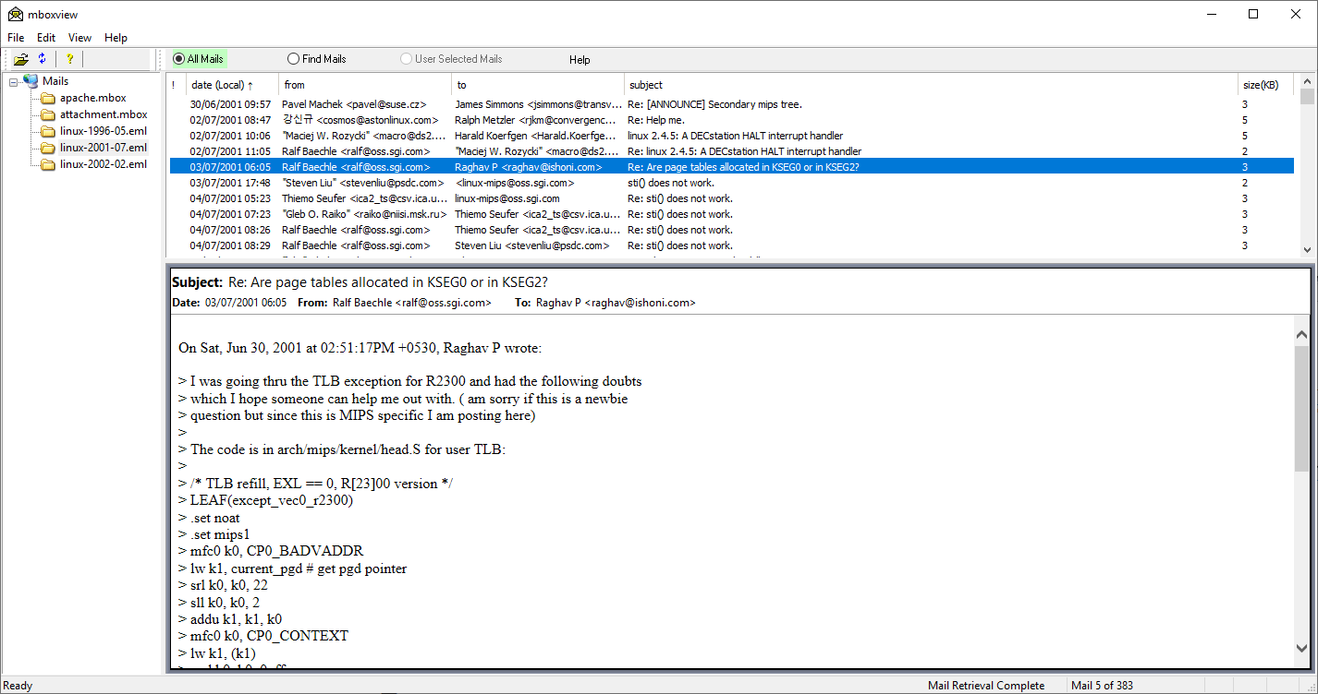

Multiple Folders Support
Each time you click on the “File” to open the drop menu and select new mail archive folder via the “Select folder...” option, the selected folder will be added to list of folders under the Mail Archive Tree.
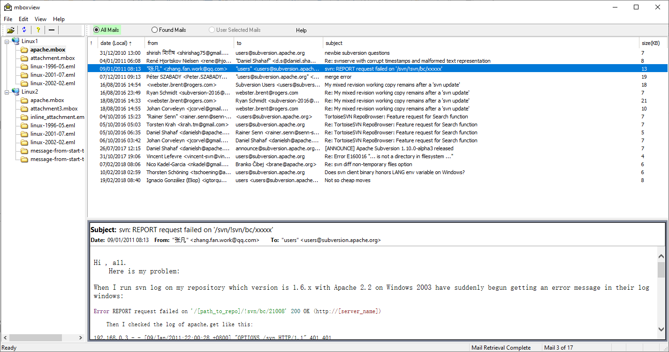
Use +/- icon on the toolbar to expand/collapse the list of archive file under all folders.
To remove folder from the list:
- Left click on the folder to select the folder and then
- Right click on the folder and select Delete Folder menu option
List of the selected folders will persist across multiple runs.

Support for Hierarchy of Folders
MBox Viewer can automatically open mail files residing under the root folder and all sub-folders. Using this capability, user can more easily view emails exported by Thunderbird or similar email clients.
User can select one of two options to leverage this feature.
- Select “File→Select folder as root folder ...” option. MBox Viewer will traverse root folder and all sub-folders and recreate folder hierarchy under the Mail Tree.
- Select “File→Select root folder for merging ...” option. MBox Viewer will traverse root folder and all sub-folders, merge all discovered mbox files and recreate folder structure as Gmail style labels. Duplicate email will be removed.

Option 2, that is merging, allows searching across all discovered mail archives while option 1 allows searching within each mail file only.

Screen snapshot illustrates both cases when applied to the same Thunderbird folder.

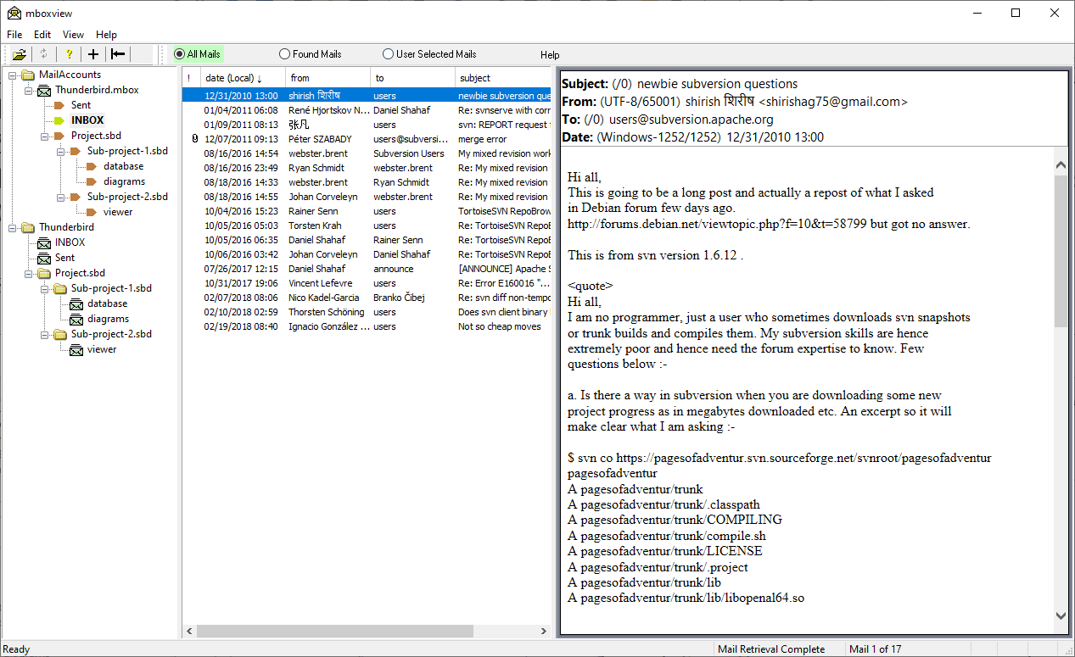

Select Root Folder for Merging Configuration Dialog
The following dialog is presented to users upon selection of the “Select root folder for merging..” option. In addition to support for folder hierarchy and Gmail style labels, other useful options for merging mbox or eml files are supported.
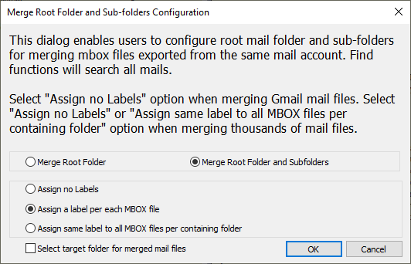

Data Folder Configuration
MBox Viewer will generate files and save them in the user selected data folder when executing some of the options such as “Print To...”, Export All Mails as Eml ..”, etc.
User can select data folder by selecting “File-->Data Folder Config” dialog.
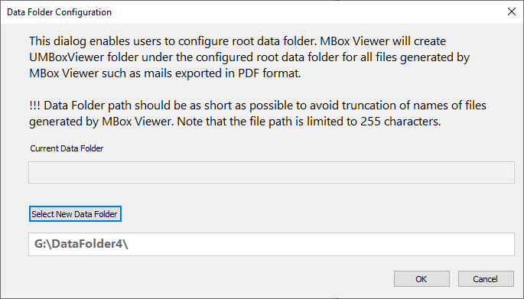

Text Font Size Configuration
By default the system font size is 8 points for all GUI elements. User can configure new font size via “File→Font Config” dialog.

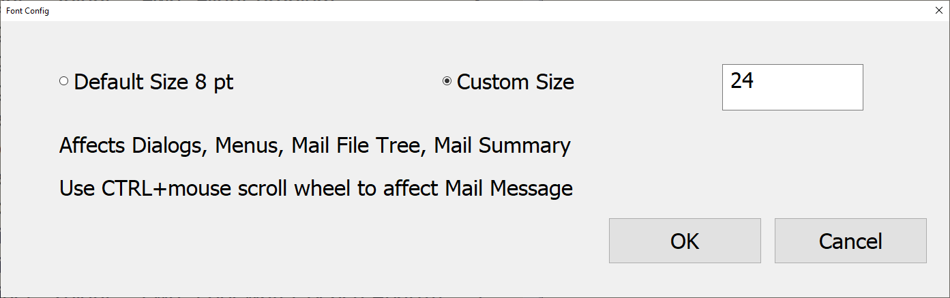

Limitations
- Font size of all title’s windows (dialogs, main frame, etc) is not affected
- Font size of the main menu bar is fixed to 12 points.
- Font size of the status bar is not affected
- Message text is not affected. User can use CTRL+mouse sctroll wheel to change the font size

Hiding and Restoring Mbox Files in Mail Archive Tree Window
User can hide some mbox files temporarily if he is not actively working with these files and restore hidden files later when needed. To hide an mbox file, right click on a file and select “Remove File” option.

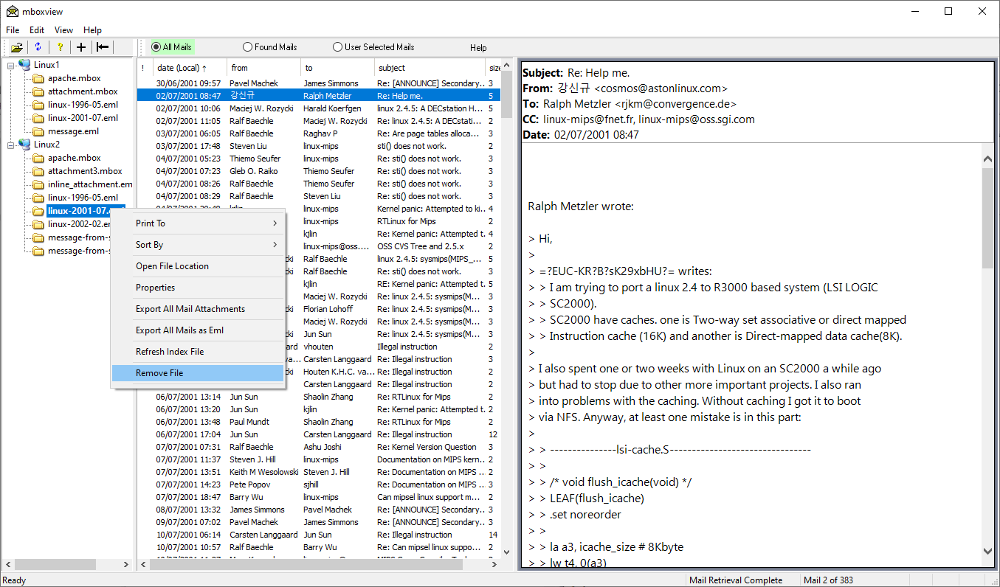
To restore hidden windows, left click on the folder to select the folder and then right click on a folder and select “Restore Removed Folders” option.
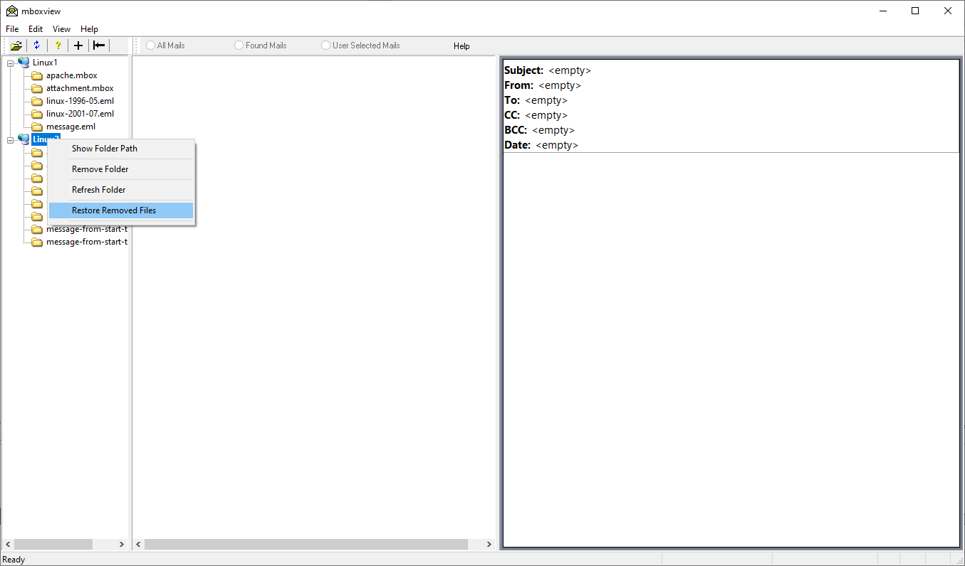
Check files to restore in “Select Files to Restore” dialog.
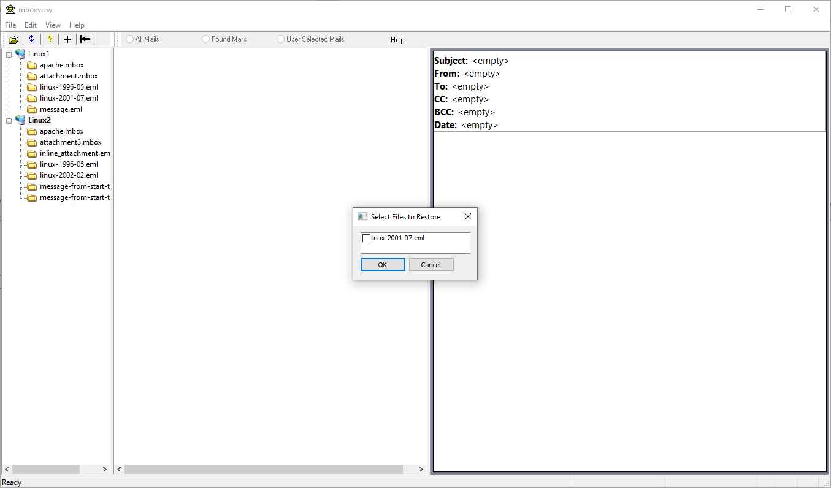

Hiding of Mail Archive Tree Window
User can hide Mail Archive Tree Window to make larger Mail Summary and Mail Message Windows. Select button |←or →| to hide/unhide the Tree Window. Tree Window can be hidden only when one of the mbox mail files is selected.
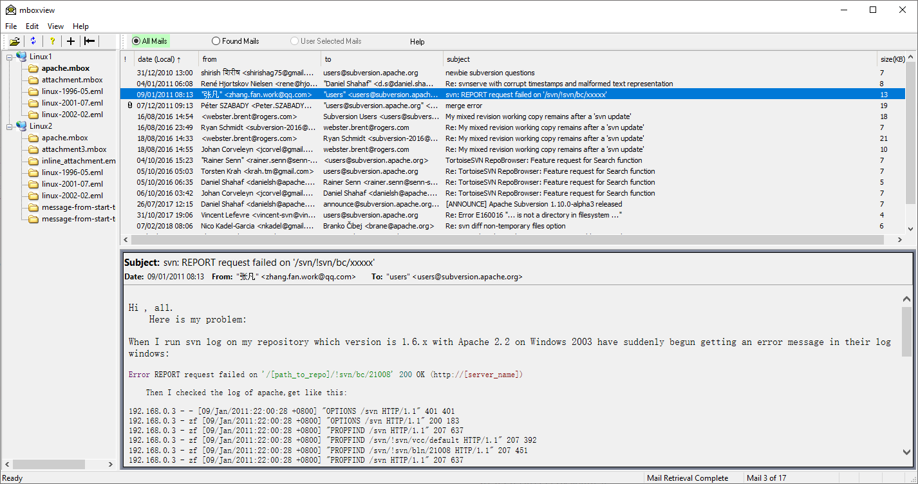

Set MBox Viewer as default application to open mail archive files
MBox Viewer can be configured as default application to open a mail file by double-left-click on the file. There are multiple ways to set MBox Viewer as default application. By default, when you double-left-click on a mail file, Windows will ask user to select program to open the mail file assuming no application was set as default yet. Make sure the “Always use this app to open.” option is set. To redo the current assignment, right-click on the file and select “Open with” option.

Message Window Position
Message Window position can be set to Bottom, Right or Left via View→Message Window option. After setting new position, mbox viewer needs to be restarted for the change to take effect.
When position is set to Right or Left, the mail address format will change to show mail name only or mail address if the name is missing.
By default Message Window position is set to Bottom.
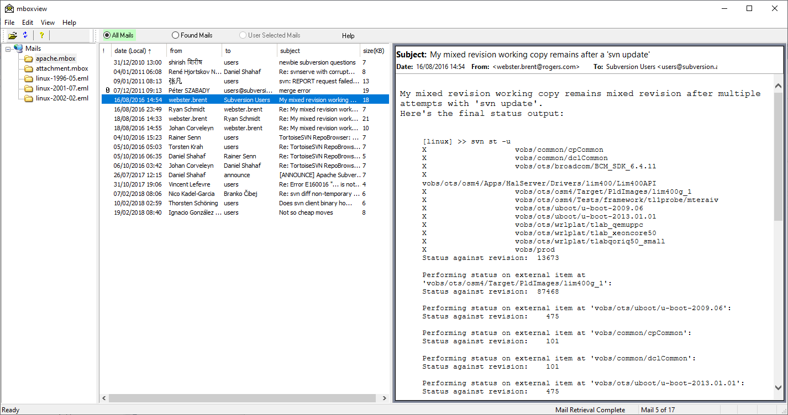

Preservation of Windows Placement
Mbox Viewer will save the windows placement upon exit and restore upon next run.

Background Color Style Customization
By default the background color of all display panes is set to the white color. Select the “File→Color Style Config” menu option to customize colors of display panes. Left click on the Custom button to start customization. The screen similar to the below will be created.
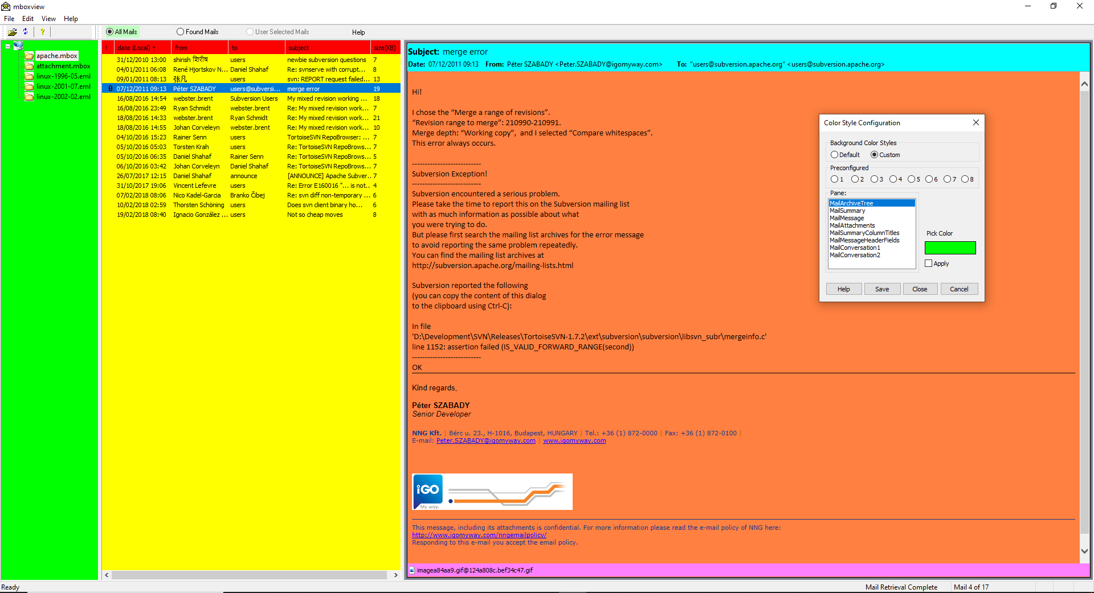
Color Style Configuration dialog allows users to replace the white background of the 8 panes listed on the dialog box with the predefined colors or custom colors defined by users.
The dialog offers eight predefined color styles users can evaluate before attempting to configure the custom color style. It is helpful to open one of the mails with attachments to help to evaluate predefined and custom color styles.
Select "Custom" radio button to start configuration of the custom color style.
Configure the same or different color for each pane (MailArchiveTree, etc).
Select one of the panes and left click on the "Pick Color" button to start the "Color Selection Dialog".
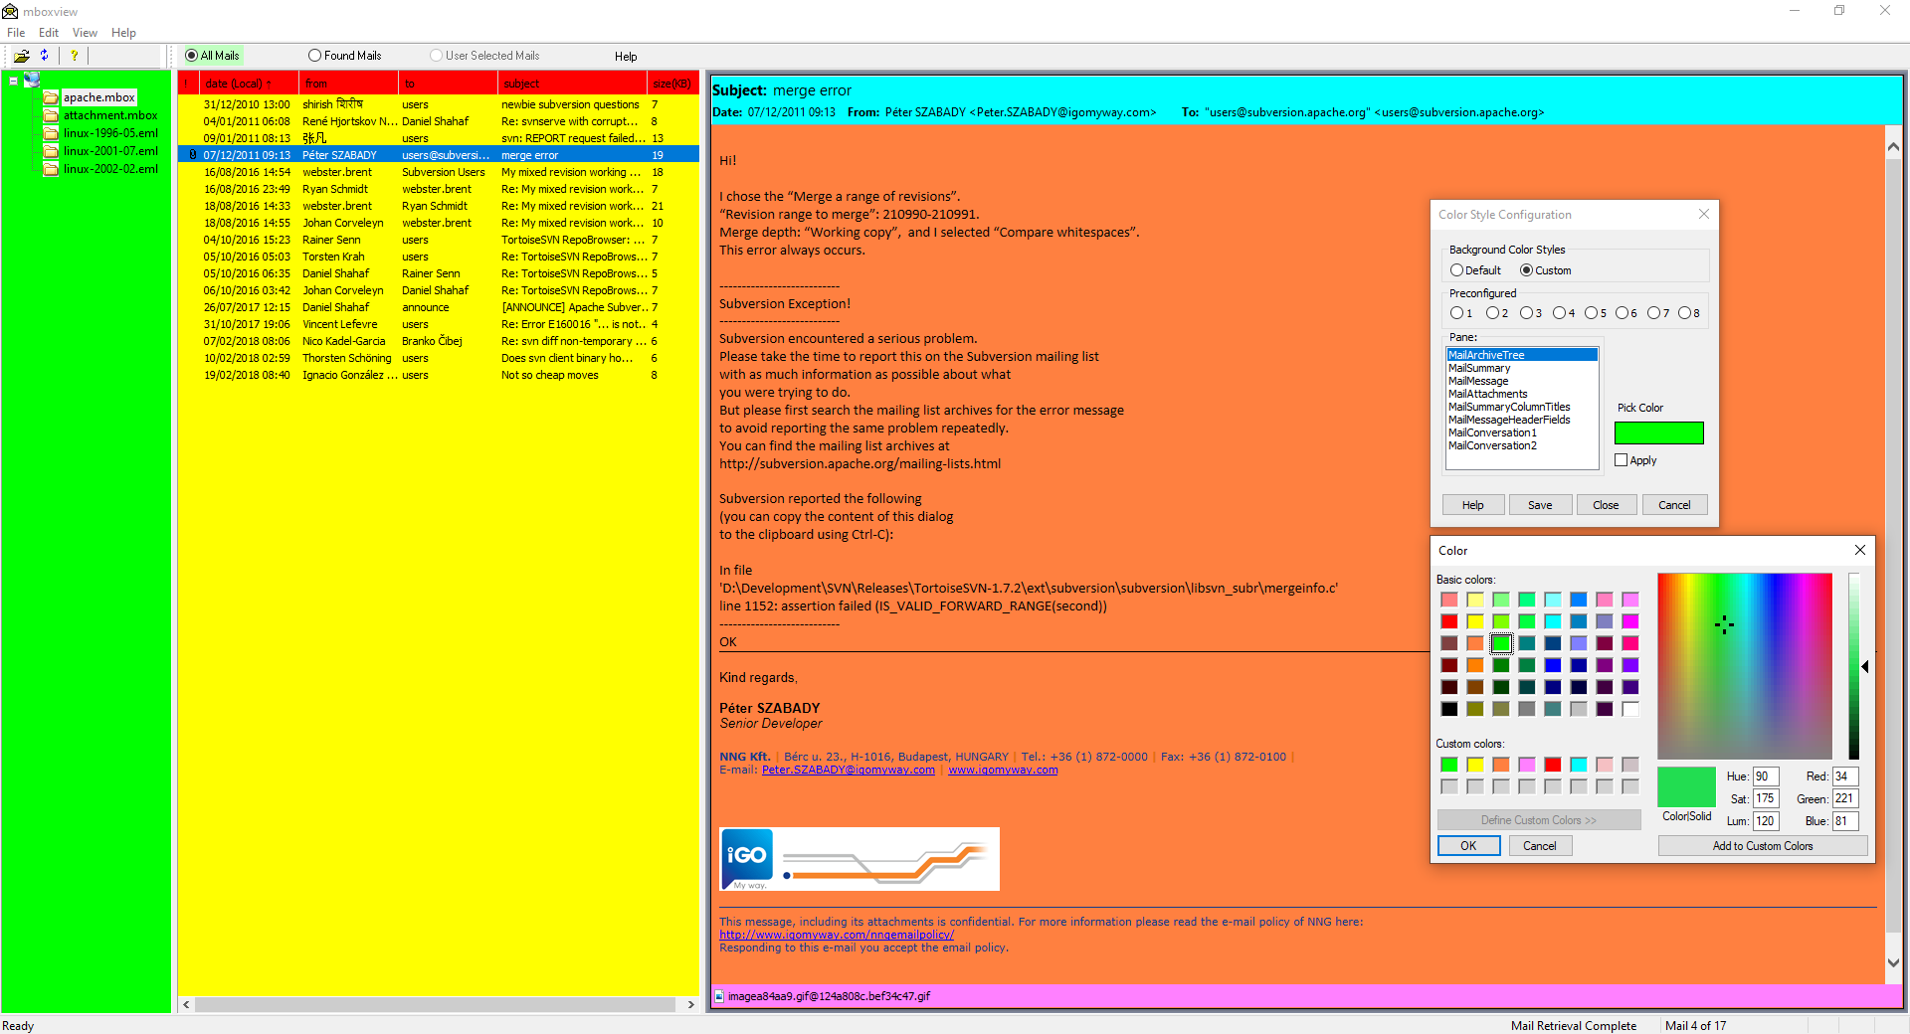
The "Pick Color" button will initially be populated with the color associated with the selected pane.
The top raw of the Custom Colors area will initially be populated with the colors associated with each pane.
You can change the color in four different areas. The top left section displays a list of 48 predefined colors.
If the desired color is not in that section, you can click on the crosshair and drag the mouse in the multi-colored palette.
You can also drag the right bar that displays a range based on the color of the palette.
For more precision, you can type the Red, Green and Blue values in the custom color editor area. Each uses an integral value that ranges from 1 to 255.
Once you are happy with the custom color, left click on the OK button in
the "Color Selection Dialog". The "Color Selection Dialog" will be closed and control will return to the "Color Style Configuration" dialog.
The "Pick Color" button will be painted with the created custom color. Left click on the "Apply" button to apply the new color to the selected pane. Left click on the "Apply" button again to cancel the change.
Left click on the Save button to save the change in order for the change to persist after the mbox viewer shutdown. Or, customize colors of all panes first and then left click on the Save button to save all changes.
Left click on the Cancel button to discard all changes made since the last Save or startup.
Left click on the Close button or standard Windows Close button to hide the "Color Selection Dialog". Changes made so far are not discarded.
To reopen, select File -> Color Style Config menu option.
NOTE that the saved color style will be applied to all mails. You can temporarily disable custom color style for the active mail by right click on the mail header in the mail message window and selecting Enable/Disable Custom Color Style menu option.
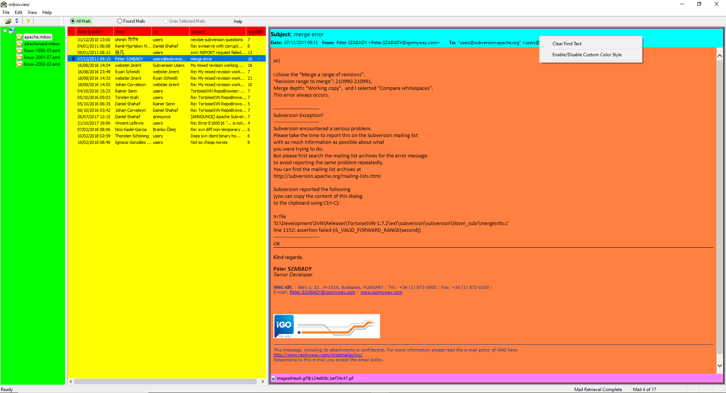

Support for Gmail Labels
User can perform a separate step to recreate Gmail Labels on Gmail mbox mail archives. Gmail Label information is included in every email downloaded from Gmail. To recreate labels, user needs to right click on an active Gmail mail archive in Tree Pane and select “Gmail Labels → Create” option. This will create folders as in example below. Left click on the folder icon to view all mails within the label.
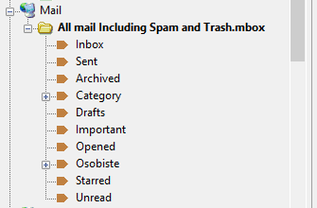
Select the folder icon to view all mails again. Button “All Mails and ‘Found Mails” are scoped to the label when a label is selected. Content of “User Selected Mails” is shared across all labels of the active folder and the folder.

Limitations
If you decide to hide/remove the folder from the Tree Pane Via “Remove File” option and later restore via “Restore Removed Files” option, Gmail labels will not be automatically restored until you recreate the labels.

Expand Message Header Field List
When message window position is configured at the bottom, the message header list doesn’t show CC and BCC message header fields. This can be changed via “View –> Message Header Pane Layout –>Expanded” option.

Viewing raw message header
The raw message headers can be viewed in the message window by setting “View → View Raw Message Headers” option. This is the global change and it needs to be disabled to view messages content again. The raw message header can be viewed by doing the right click on the message header pane and setting “View Raw Header” option. The setting doesn’t persists when new mail is selected.

HTML/PDF Mail Header Customization
The HTML/PDF Header Configuration dialog allows users to select mail header fields for output and to configure fonts for the field name and field text. User can also configure to output the list of all attachments. The customization dialog is selected via “File” --> “Print Config” --> “HTML/PDF Header Configuration” button.
There are two options to configure fonts: Default and Custom.
The Default option allows to configure:
- the font size which be applied to both the field name and text.
- the bold font style which will be applied to the field names only.
The Custom option allows to configure:
- the same or different font for the header field names and text.
- the font dialog allows to configure the font name, style and size.
- the generic family font in addition to the primary font configured via the font dialog.
The following links contain helpful information on HTML fonts.
HTML Fonts
Fonts and Formatting
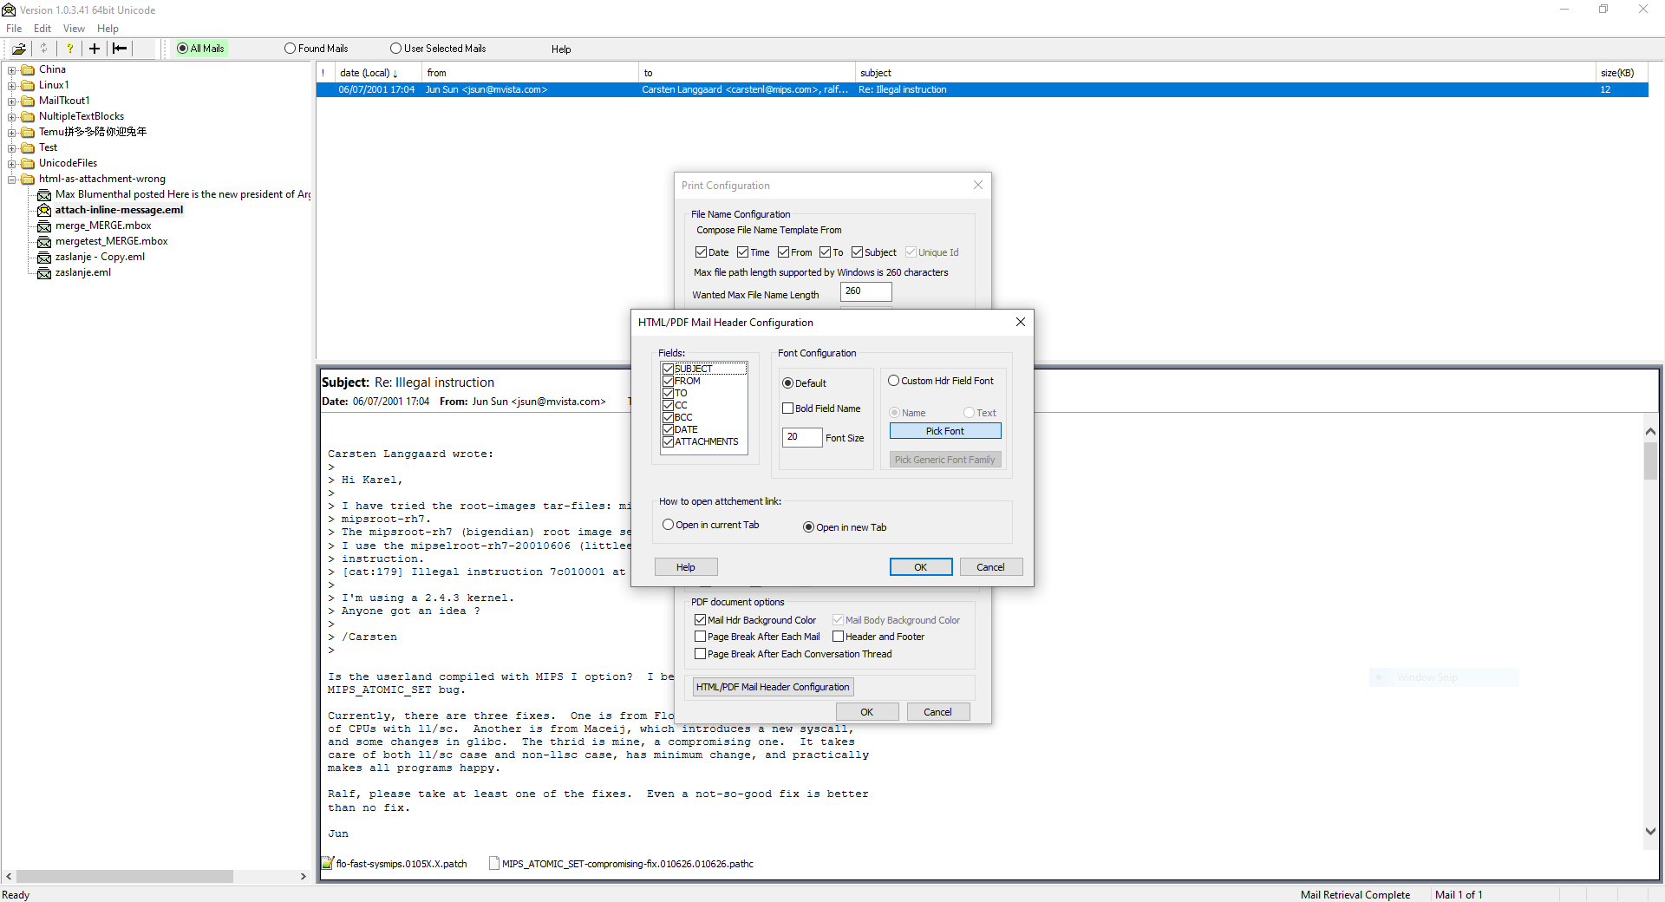
User can also configure how to open document/attachment link in Web browser.

Single Mail Context Menu
Right Click on a selected mail in the Summary Window to open the context menu as shown below.
The “Print to” context menu allows to print the selected mail to Text, HTML or PDF file or to send to the user selected PDF printer.
The “Open in Browser” menu option will open the selected mail in the external default Web Browser.
The “Find Text” option allows to find user specified text and highlight all occurrences in the Message window.
The “Find Advanced” options will start the advanced search dialog and pre-populate From, To and Subject fields from the mail.

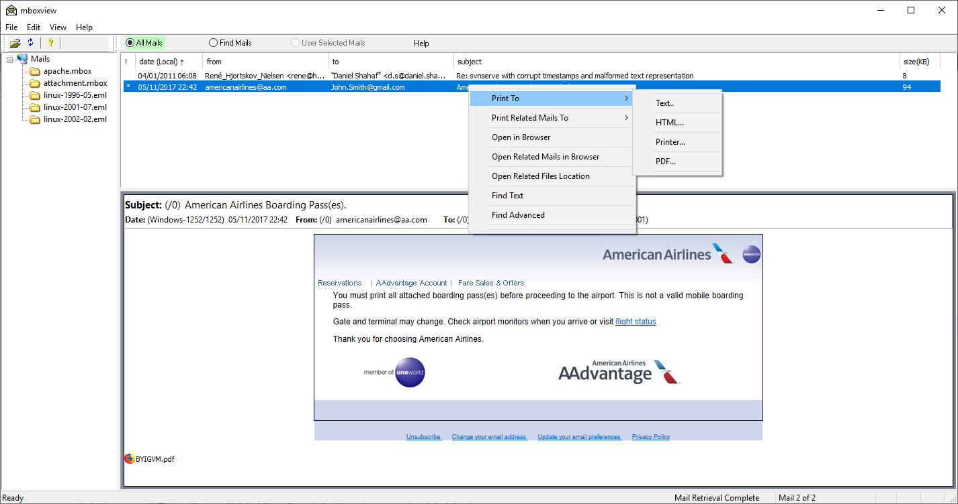

File Names
User can configure file name pattern/template to apply when printing single mail by selecting File -> Print Config dialog. Pattern is composed from Date, Time, From, To, Subject and Unique Id fields. Only alpha numeric characters are selected from the Subject, other characters will be replaced with the underscore.
Files will be saved in the FolderHousingMailArchives/PrintCache/MailArchiveName folder, where MailArchiveName denotes the archive file name without the .mbox extension.
User must enter the target file name manually when printing to PDF printer, i.e. when selecting Print to → Printer mail option or when printing mail to pdf file from the browser.
Print Config dialog allows users to configure the maximum length of created file name. The maximum file path length supported by Windows is 260 characters for non Unicode applications. Therefore the file name will be limited to (260 – length of FolderHousingMailArchives/PrintCache/MailArchiveName/MailFileName) path. User can set wanted file name length limit and the mbox viewer will adjust the configured length if needed.

Multiple Selected Mails Context Menu
Multiple mails can be selected using Windows standard method, i.e. Left click followed by Shift+LeftClick or CTRL+LeftClick or CTRL+A.
Right Click on a multiple selected email in the Summary Window to open the context menu as shown below.
The “Print Selected Mails to” context menu option allows to print the selected mails to single Text or HTML or CSV or PDF files or send to the user selected PDF printer. See also 10.33.7 “Mail Printing to PDF files by Power Users” section.
The “Open Selected Mails in Browser” menu option will open the selected mails in the external default Web Browser.
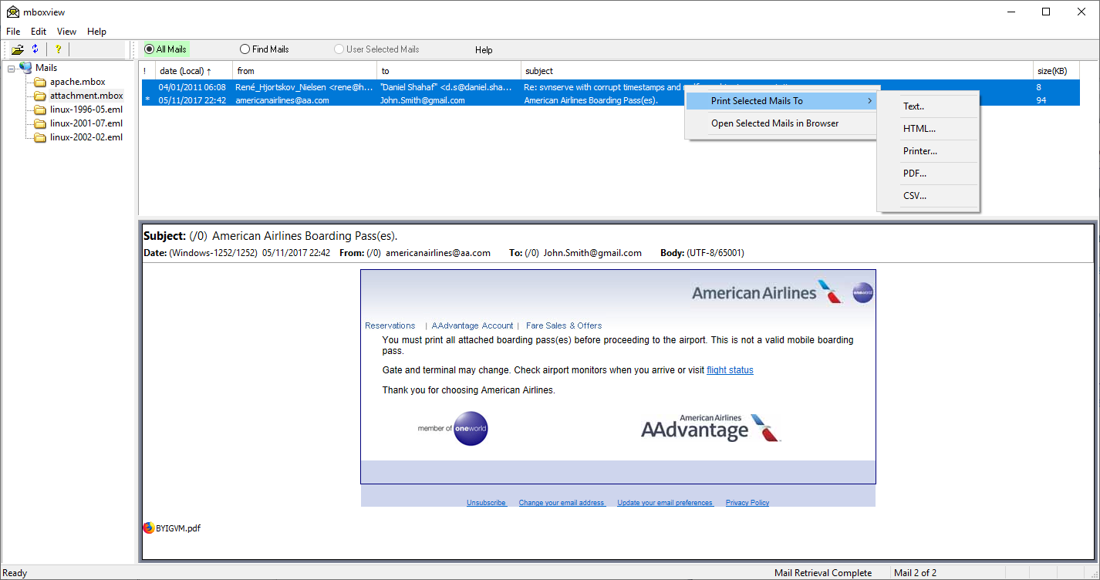

File Names
User can’t configure file name pattern/template to apply when printing multiple mails to a single file. The file name is automatically composed from the archive file name with appropriate extension, i.e. .txt or .htm or .csv or .pdf.
Files will be saved in the FolderHousingMailArchives/PrintCache/MailArchiveName folder, where MailArchiveName denotes the archive file name without the mbox extension.
User must enter the target file name manually when printing to PDF printer, i.e. when selecting Print Selected mails to → Printer mail option or when printing mail to PDF file from the browser.

Conversation Mail Group Context Menu
All Mails must be sorted by the conversation first before context options can be processed. See 10.27 section.
Right Click on any mail within the selected conversation group in the Summary Window to open the context menu as shown in 10.18 section.
The “Print Related Mails to” context menu option allows to print the selected group of mails (conversation) to Text, HTML, CSV or PDF file or to send to the user selected PDF printer.
The “Open Related Mails in Browser” menu option will open the selected mail group in the external default Web Browser.

File Names
See 10.19.1 section.

Mail Archive Context menu
Right click on the active mail archive under the Mail Archive Tree Window to open the context menu as shown below.

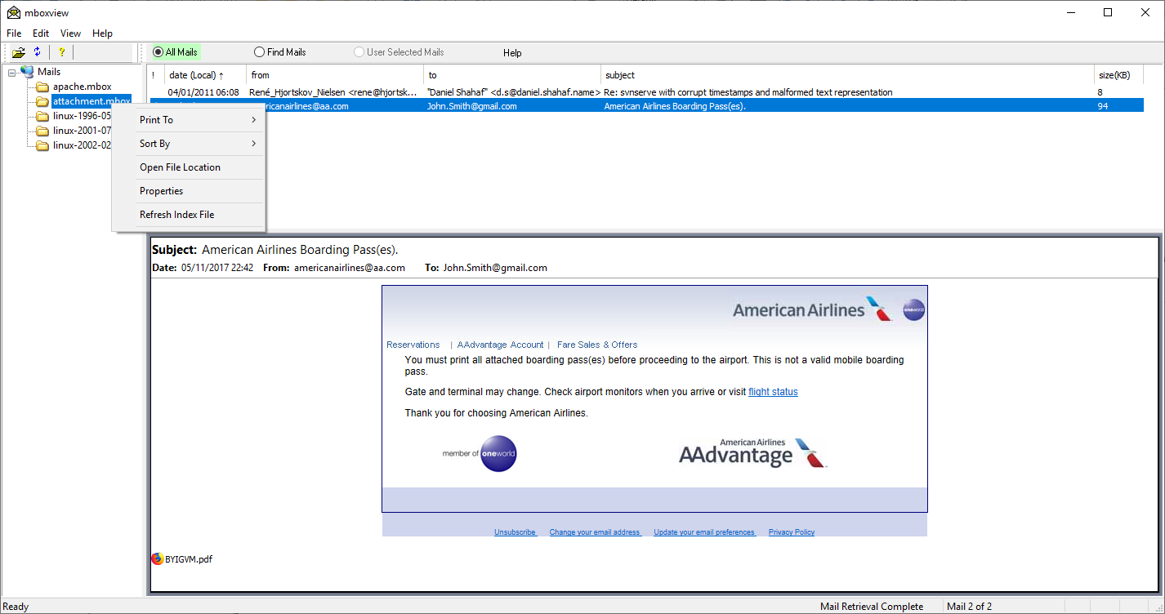
The context menu allows to print all email to single CSV, Text , HTML and PDF files. The name of the created file will be created based on the archive file name with the .csv or .txt or .html or .pdf suffix in the FolderHousingMailArchives/PrintCache/MailArchiveName folder, where MailArchiveName denotes the archive file name without the mbox extension. NOTE that mails will be printed according to the sort order in the summary window.
Size of HTML file can be very large and opening in most of the browsers can be problematic. Microsoft Edge and Google Chrome browser seem to perform best as far as handling large HTML files.
When printing to TEXT file, HTML to Text conversion was added in 1.0.2.8 to handle mails with HTML text block and no Plain text. Conversion can be quite slow and print time could increase significantly compared to 1.0.2.7 in case the large number of conversions is required. Progress bar was added to indicate progress, possibly slow progress.
Printing to single PDF file is the most time consuming. See also 10.33.7 “Mail Printing to PDF files by Power Users” sections for larger scale printing to single PDF file.
All mails of the active archive can be sorted by date, from, to subject, size and conversations in the Summary Window. This feature is the same as the left click on the selected column in the Summary Window.
The “Properties” option shows the archive file location, size and email count
The “Refresh Index File” option will perform fresh parse of the archive file if needed.

Print to CSV File Dialog
When printing selected mail archive or selected set of mails by a user to CSV file, user can select what fields to export, the date format and one of two time zones.
Option to normalize content encoding is also available. Default encoding is set to UTF-8 and should not be changed except possibly in special cases.
The “Limit Message to N Characters” value is set by default to 32500 characters and it should not be set higher otherwise Excel and LibreOffice will complain that the character count limit per spreadsheet cell was exceeded. LibreOffice will gracefully handle the text overflow, Excel spreadsheet will get corrupted.
User can configure string that separates attachment names. The special CRLF string will be replaced with \r\n string in the CSV output.
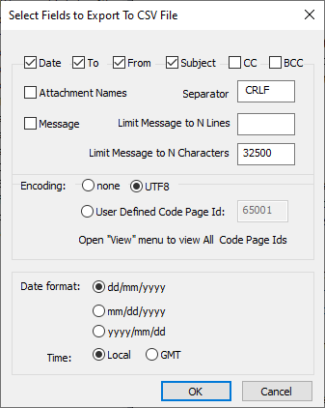

Mail Attachments
Mail attachments are shown at the bottom of the Message window. Note that the “*’ character may appear in the first column for the associated mail to indicate presence of associated attachments. To open location of attachments, double click on the mail in the Summary window or select “View”→”ViewEML” menu option. Temporary folder will open containing all attachments for the email. Use standard Windows applications to view attachments.
You can also double left click to view attachments. Picture attachments will be viewed in the Picture Viewer (if configured in the global Options) and other file types will be viewed by the associated default Windows applications.
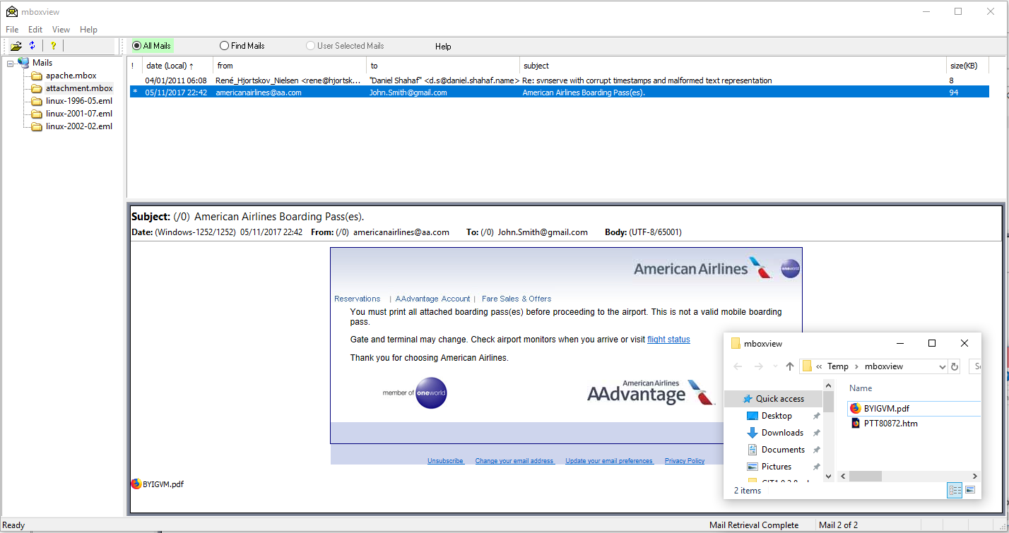

Attachment context menu
Right click on the selected attachment to open the context menu. The context menu allows to open or print the attachment by the associated default application. You can also open the folder housing the attachment. The selected attachment will be highlighted in the folder.
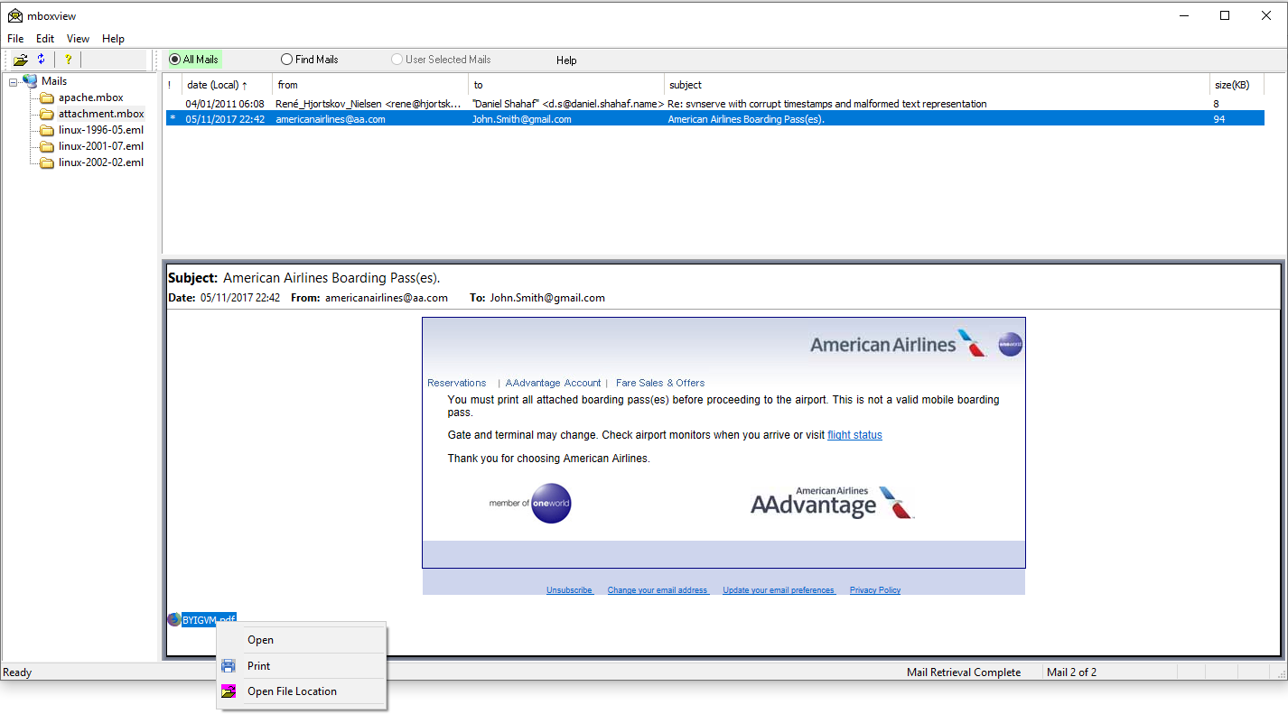

Attachments Configuration
The “Attachment Config” dialog enables users to configure attachment window size, content and attachment indicator criteria. Users can also configure whether image attachments should be appended to mails when showing and/or printing.

Select “File→Attachment Config” to access the dialog.

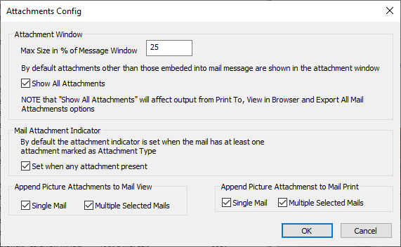

Exporting All Attachments of All Mails
User can export all attachments to the AttachmentCache folder by right clicking on the active mail archive and selecting “Export All Mail Attachments” option. To avoid appendix name clashes, Mbox Viewer will prepend the following prefix to each attachment name:

YYYYMMDD-HHMMSS-IDDDDDD attachment name

where YYYY denotes the year, MM denotes the month, DD denotes day, HH denotes hour, MM denotes minues, SS denotes second of a mail abd IDDDDDD denotes unique ID assign to this email.

Inline Image Cache
The mboxview will create the cache of inline images to support images embedded directly into the mail body/message. The cache with all images can be created during the initial parsing of the mail archive file or subset of images can be created later when needed. Separate cache sub-folder is created per each archive file (assuming at least one inline image was found) in the FolderHousingMailArchives/ImageCache folder. If the inline image cache is missing for any reason, try to refresh the index file by selecting “Refresh Index File” context option on the respective file archive.

Export of all Mails to a Separate Eml files
User can export all mails to separate Eml files via mail archive context menu. Right click on the selected mail archive and select “Export All Mails as Eml” option. Eml files will created in the FolderHousingAllMailArchives/EmlCache/SlectedMailArchiveName folder.
Mbox Viewer will create Eml file names as follow:

YYYYMMDD-HHMMSS-IDDDDDD name using File Name Configuration under File –> Print Config dialog.

where YYYY denotes the year, MM denotes the month, DD denotes day, HH denotes hour, MM denotes minues, SS denotes second of a mail abd IDDDDDD denotes unique ID assign to this email.

Picture Viewer
Double left Click on any attachment to start Picture Viewer dialog, example below.
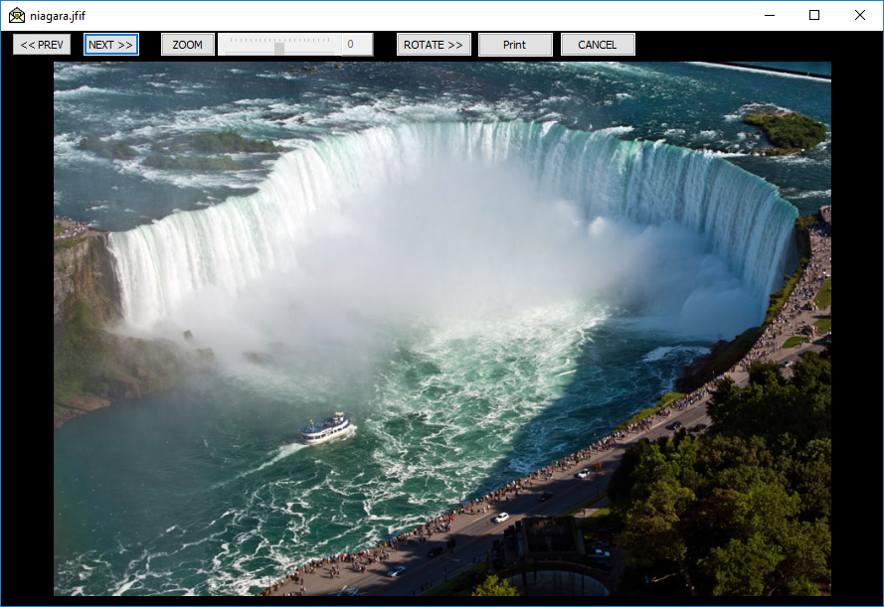
The Picture Viewer supports files with the png, jpg, pjpg, jpeg, pjpeg, jpe, gif, bmp, ico, tif, tiff, jfif, emf, wmf, dib suffixes.
The NEXT and PREV controls enable user to browse all picture/image attachments associated with the selected email. You can select specific attachment to be displayed. You can later browse through all picture attachments.
The ROTATE control allow to rotate clockwise the current/visible picture.
The ZOOM control allows to zoom in/out picture. Click on ZOOM to enable/disable zooming. Slide to right to enlarge an image, slide to left to shrink. Enlarged image can be dragged using the left and scroll buttons of the mouse. Click ZOOM to disable zooming and reset the image to original size.
The PRINT control allow to print via default application.
The Picture Viewer is enabled by default but it can be disabled via FILE→Options dialog. Setting persists in the Registry across multiple runs.
All attachments are also accessible by double clicking on the selected mail in the Summary window or by selecting “View”→”ViewEML” menu option.

Mail Navigation
Click on a specific mail in the Summary window and use UP, DOWN keys to move to the next or previous mail respectively.
Use HOME key to jump to the first mail. Use END key to jump to the last mail.
Use the mouse wheel or vertical bar to scroll up and down mails and then select one of the mails.

Mail Sorting
The Summary window is divided into 6 columns: attachment indicator, date, from, to, subject and mail size. Each column can be sorted by clicking on the column title. Subsequent click on the same column title will reverse the sorting rule. By clicking on the first column title, emails are sorted by conversations and mark by different color as shown below.
Mail can also be sorted via the mail archive context menu or by selecting “File”->“Sort By” menu option.
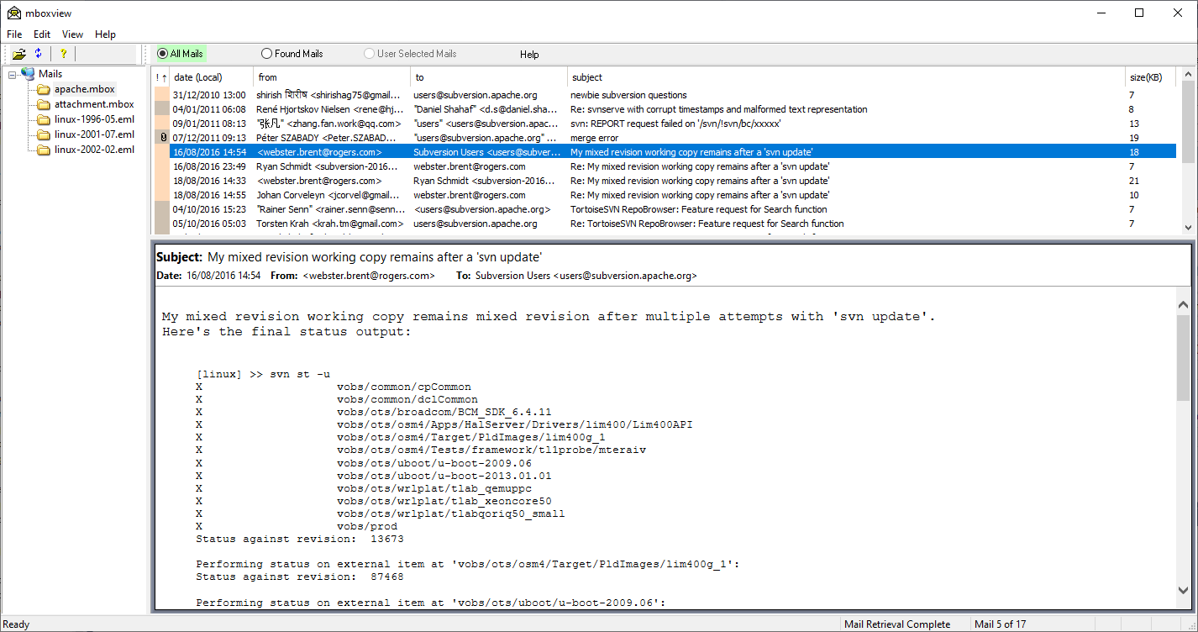

Subject Sorting Rules
Subject sorting creates subject threads, that is a group of mails (or threads) with the same subject. Emails within a thread are sorted by time.
By default the subject threads are sorted alphanumerically.
Subject threads can sorted by time by selecting “File-→Options→time ordered threads” option.

Dynamic Column Resize
Columns in the Summary windows are automatically resized when the window is resized.
However, if columns are resized manually, some of the columns may no longer be present in visible area/window.
You may need to use the scroll bar to see missing columns, otherwise maximize and then restore the window to see all columns within the Summary window again.

Mail Searching
Mbox viewer supports two search options, i.e. basic Find and Advanced Find.
The basic Find option allows users to specify single keyword for searching across header fields, mail text, attachment text and attachment names.
The advanced Find option allows user to specify keyword per each header field, mail text, attachment names and attachments.

Basic Find
The basic Find option allows users to specify single keyword/string for searching across header fields, mail text and attachments.
Users can configure the search scope by selecting all or subset of the from, to, subject, message text, attachment names and attachment text options. The search succeeds if the specified keyword matches any of the checked fields.
Click the “Edit” drop menu and select “Find” option to configure and start the search. Alternatively the CTRL+F will also present the search dialog.
The search dialog box allows user to specify the search string, whether to match the whole word, whether the search is case sensitive, configure the search scope, the start and end dates to consider for filtering, the Next/Previous search direction and whether to highlight all occurrences of the matched text.
Note that the Next search start with the oldest email while the Previous search starts with the latest.
The search logic simple, i.e. mail is considered a match if the search string is found in any of the checked fields in that mail.
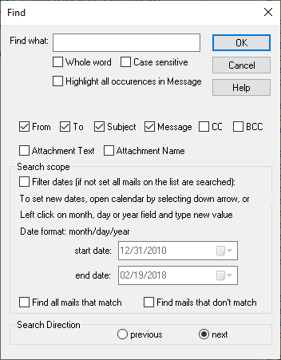

To repeat the search in order to find the next matching mail, click the “Edit” drop menu and select “Find again” option, or select F3 key.
If “Find again” or F3 key is selected without prior “Find” or CTRL+F, the search dialog box will be presented to a user.

Find all mails that match Option
User can check “Find all mails that match” to find all matching mails. Automatic highlighting of all keyword occurrences is not supported in this case. Matched mails will be displayed under the Found Mails List and the corresponding button in the dialog bar will be highlighted. User can left click on All Mails button to switch mail list back to All Mails.
The basic Find can also be run while in the Found Mails list and while in User Selected Mails list when the list is enabled.
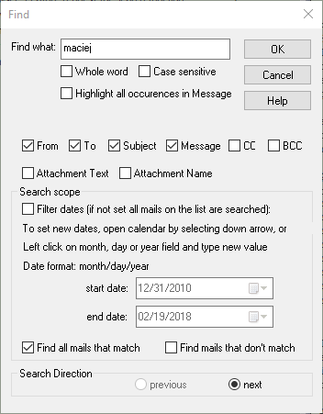

Find mails that don’t match option
User can check “Find mails that don’t match” option to find mails that don’t match search criteria.

Handling of special ‘*’ search string
User can specify single ‘*’ character as the search string to find subset of mails as follows:
- Find mails that have CC header field by checking out CC check box only.
- Find mails that have BCC header field by checking only BCC check box only.
- Find mails that have at least one attachment by checking out Attachment Name check box only.
- Match all mails by checking out any of others check boxes only.
NOTE that if the Find all occurrences option is not selected, user will be traversing the subset of mails/matched mails between the start and end dates.

Filter Dates
Filter Dates option enables users to search mails specified by the date range. By default the start date corresponds to the oldest mail and the end date corresponds to the latest mail. If the Filter Dates option is not set, all mails on the selected list (All Mails, Find Mails, User Selected Mails) are searched regardless of start and end dates values. If the Filter Dates option is set, user can configure the start and end dates for searching. The start and end date processing depends on the mail list selected (All Mails, Find Mails, User Selected Mails). While in All Mails list, the start and end dates are fully under the user control regardless of other user actions such as selecting other lists. However, the start and dates do not persist across application restarts or when new mbox mail archive file is selected by the user. User can set the start and end dates while in Find Mails or User Selected Mails list but the initial values are set to default values.
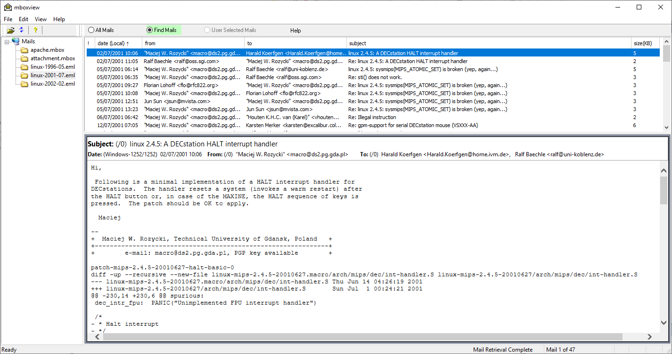

Advanced Find
The advanced Find option allows user to specify different keyword per each header field, mail text, attachment name and attachments.
Users can configure the search scope by selecting all or subset of the from, to, subject, cc, bcc, message text, attachment name and text attachments options.
Click the “Edit” drop menu and select “Find Advanced” option to configure and start the search.
The Find Advanced is also available as menu option for the selected mail. Right click on the mail and select Find Advanced option. Mbox Viewer will pre-populate From, To and Subject fields in this case.
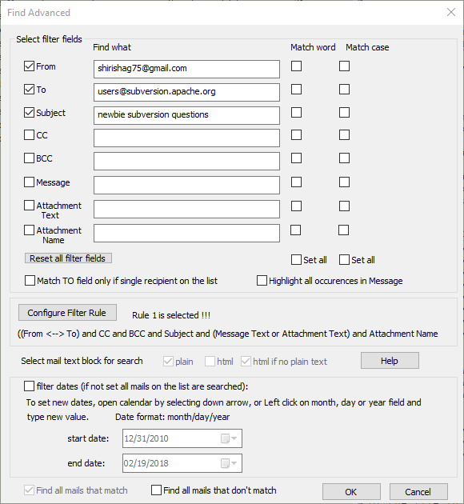
Only checked fields are use by matching logic and search strings are ignored if present unless field is checked.
The search logic is hard-coded for the most common cases. Select “Configure Filter Rule” button to start dialog and select one of the preconfigured filter rules.
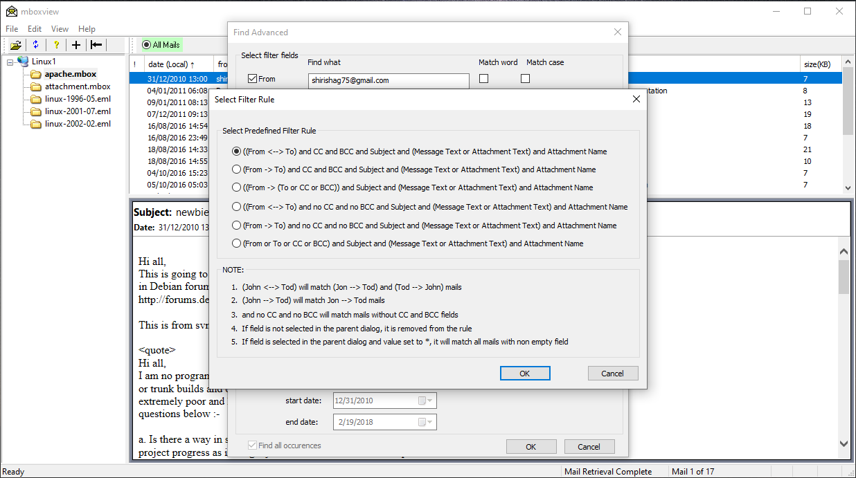
More complex searching can be achieved by leveraging User Selected mails list. User can run multiple advanced searches and merge results into User Selected Mails list.

Find all mails that don’t match option
User can check “Find all mails that don’t match” option to find mails that don’t match search criteria.

Handling of special ‘*’ search string
User can specify single ‘*’ character as the search string in any of the Filter fields to find subset of mails as follows:
- Find all mails that have CC header field by checking out CC check box only.
- Find all mails that have BCC header field by checking only BCC check box only.
- Find all mails that have at least one attachment by checking out Attachment Name check box only.
- Match all mails by checking out any of others check boxes only.

Filter Dates
Filter Dates processing is the same for Basic Find and Find Advanced search. See chapter 10.29.1.4

Search Reliability
MBox Viewer searching is Unicode based since version 1.0.3.40. The search string, mail header fields and mail content are encoded first as Unicode UTF8 strings. Encoding into UT8 is done on the fly in most cases.
Comparing Unicode strings has challenges since the same character may have multiple binary representation. To overcome the problem, Unicode strings need to be normalized before they can be compared. MBox Viewer relies on non-canonical normalization form KC. String normalization is not without issues. To help to resolve or minimize issues, please create tickets and provide as many details as possible to help to diagnose the issue.
In most cases the received mail data contains plain text and html text blocks. Both encode the same/similar content. If the mail contains plain text blocks, only the plain text blocks will be searched. If the mail doesn’t contain any plain text blocks, the html text blocks will be searched.
False positive results may sometimes happen when searching text/html content blocks. MBox Viewer will attempt to extract text from html but the extraction solution is not perfect due to simplistic but low cpu overhead approach.

Search for Words
Search for words is quite reliable for words composed from the following characters from ASCII and ISO-8859-1 (Also known as ISO Latin 1) character sets:
"0123456789abcdefghijklmnopqrstuvwxyz_ABCDEFGHIJKLMNOPQRSTUVWXYZÀÁÂÃÄÅÆÇÈÉÊËÌÍÎÏÐÑÒÓÔÕÖØÙÚÛÜÝÞßàáâãäåæçèéêëìíîïðñòóôõöøùúûüýþÿ"

Any other characters from ASCII and ISO-8859-1 sets are considered as word delimiters.
Searching for words in other character sets/languages is currently not reliable for the following reasons:
1. Some languages don’t have word delimiters
2. Set of all UNICODE delimiters is very large and currently not known to MBox Viewer. Future releases may enhance the search.
Option to search for words should not be set when searching emails not composed from ASCII and ISO-8859-1 character sets.

Search Progress Bar
Search progress bar displays the progress along the configured search string and enables user to cancel the search is so desired. The progress bar is not created unless a given search duration lasts longer than the delay time controlled by -PROGRESS_BAR_DELAY command line option or specified via GUI. Default value is 1 second.

Search Performance
Searching of header fields performs best since all fields reside in the memory.
Searching of messages and text attachments may take some time for very large files, say larger than 10-20 Gbytes. Search requires to read the content blocks from the email file and decode the content when required. Worse case scenario is when the specified search string is not present in the mail archive. When activated, the search progress bar shows the configured search string and enables user to cancel the search is so desired.
Note that when searching of message and text attachments is configured, all mails will be sorted by date first, except when sorted by conversations, to maximize search performance.

Refreshing Archive Tree Window
If an additional mbox or eml file is placed in the already selected folder, the Archive Tree window needs to be refreshed to see the new additions. This can be done by selecting “Refresh” option under the “File” drop menu or by clicking on the button showed below. Individual Folder can be refreshed by the right click on the folder and selecting “Refresh Folder” menu option.

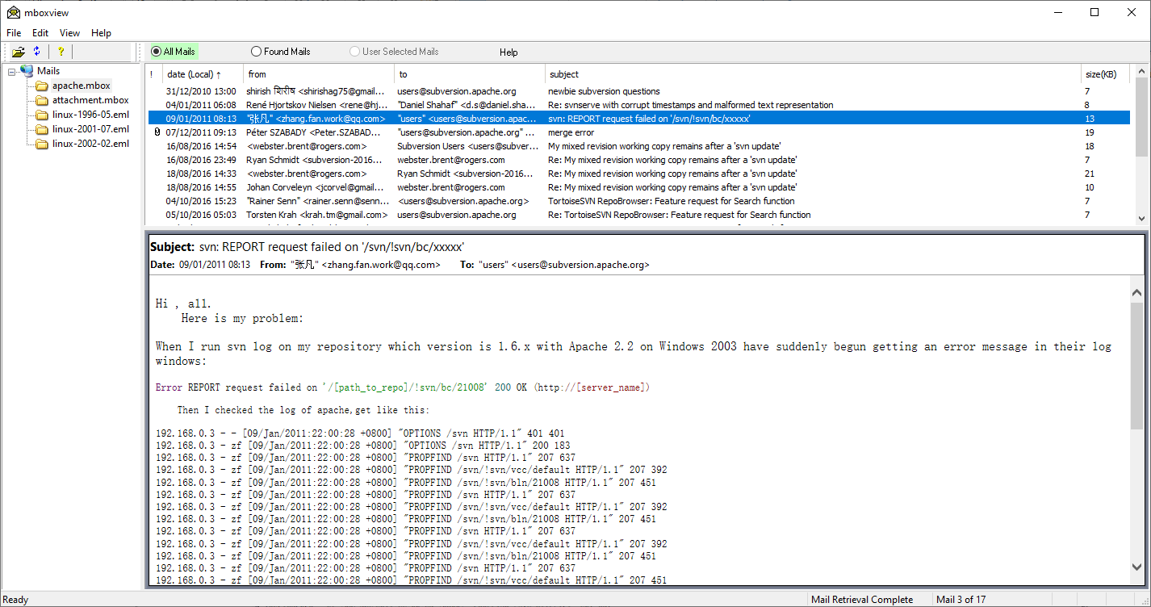

Language (Character Sets) Support

Message Window
Different languages (character sets) are properly supported in the Message Window. This is thanks to the Microsoft Web Browser emulation/control class integrated into the mboxview. The mboxview generates the htm file from the mail’s body and Web Browser displays the generated file in the Message window.
Display may not be correct if the character set for the mail’s body is not defined in the mail. To resolve the incorrect display, you can try to apply different encoding by right clicking within the window, selecting “encoding” and “more” options to apply different language.
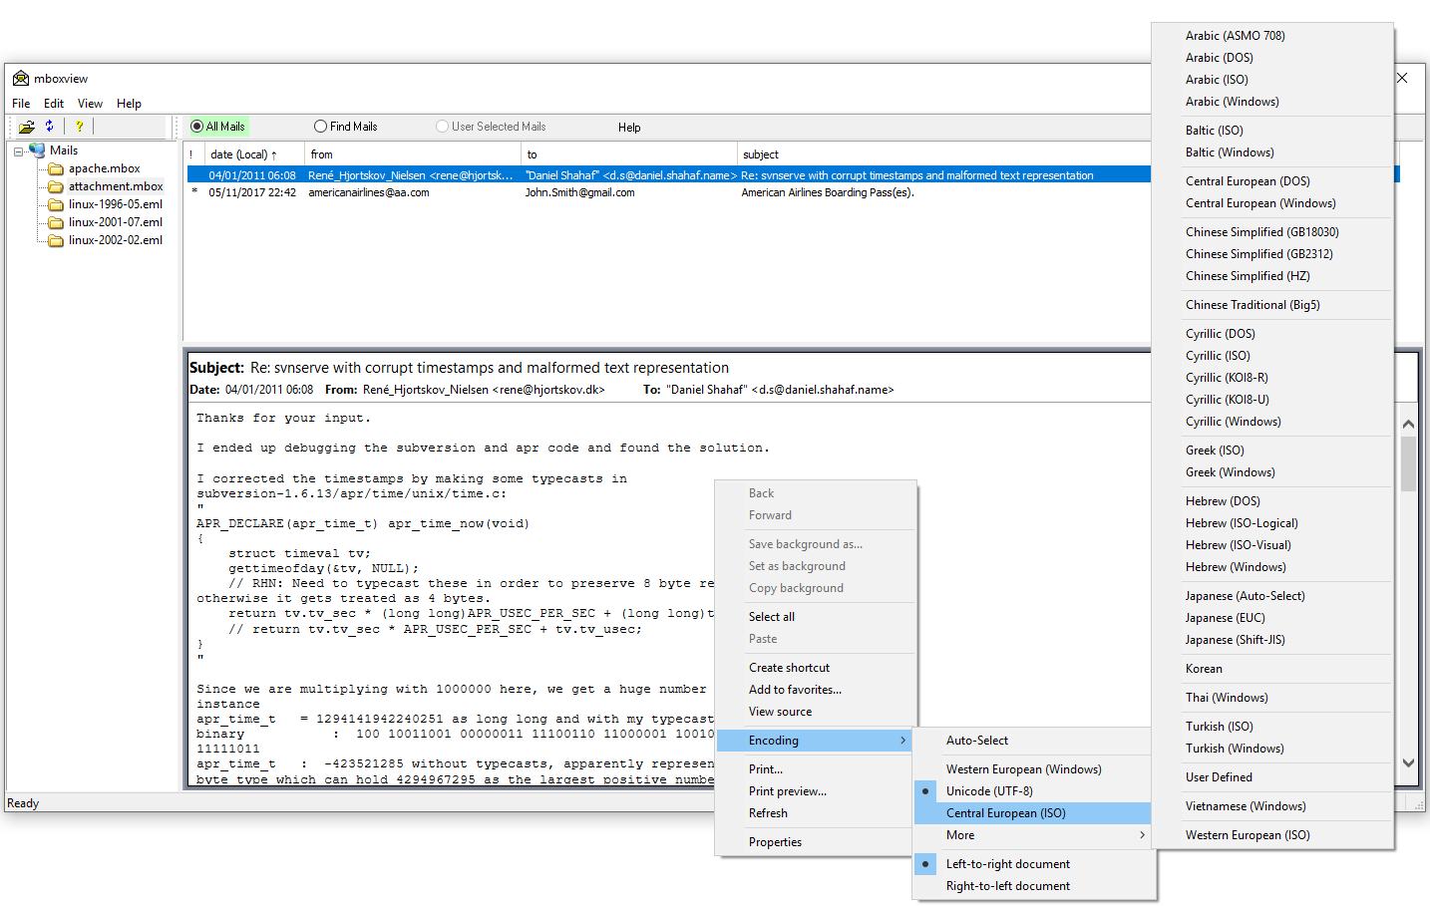

Header of Message Window
The text of the mail header fields is displayed correctly as long as the corresponding field encoding type is present in the email.
Two global options can be used to address incorrect field presentation in the Message Header in case the field encoding is not present in the email. Missing field encoding type may or may not be a problem. It should not be a problem if the default/local character set installed on your computer matches the original encoding of the header fields. It might be an issue if you are receiving emails from different countries.
As shown below, you can see all encoding/character sets applied to the header fields by enabling “Show Charsets” option. To enable, select “Options” from the “File” drop menu and enable “Show Charsets”.
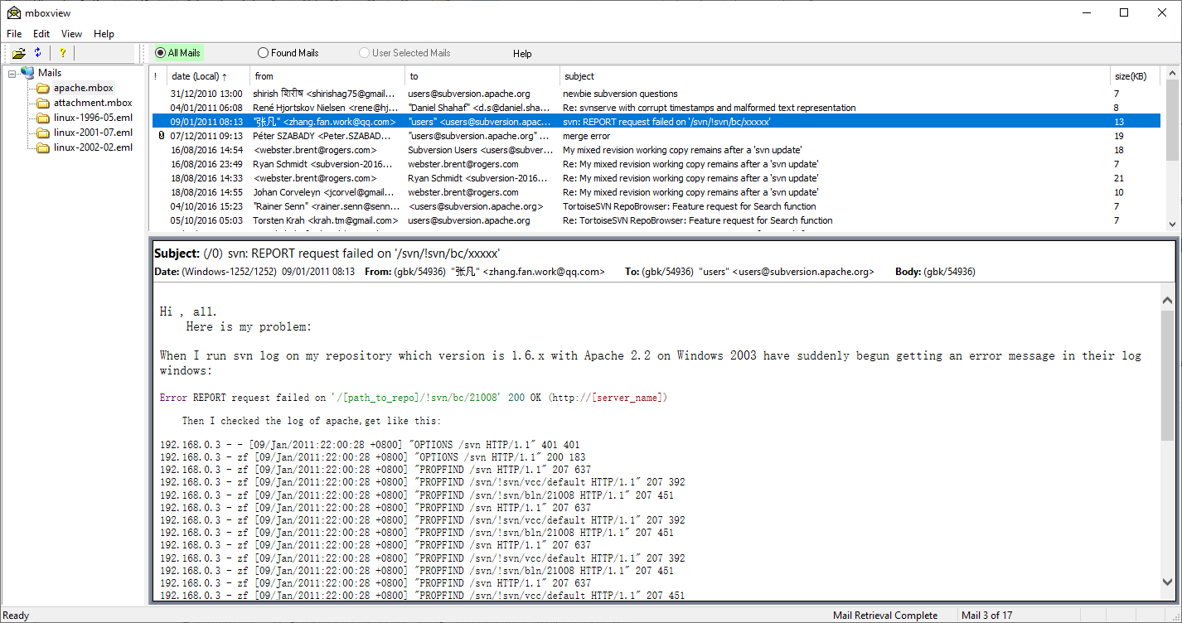
If the field text presentation is not correct, you can try to configure character set (or so called code page according to Microsoft terminology) for the selected header fields and see if that helps. Per field code pages can be configured via Options dialog box. Note that the user provided encoding doesn't override encoding in the email, if present, which is denoted by the code page greater than zero. Code Page set to zero indicates missing or unknown character set.
If you change the code page value(s) in the Options Dialog box, you need to refresh the selected email by going up and down (or down and up).
All Windows supported code pages are listed in chapter 14 or can be viewed in the external Browser by selecting “View”→”View Code Page Ids”.
The character set information appears after the field title and is formatted as “(character set name/code page)”. The ‘*” star character is appended after the code page if the user specified code is applied). Example “(UTF-8/65001*)”.
The character set information after the “Date:’ title shows the local/default character set installed on your computer.

Summary Window
Mail header fields are displayed correctly as long as the corresponding field encoding type is present in the email.

Mail List Auditing
Mail list auditing capability enables users to compose mail list from all mails by merging results of multiple searches and/or by merging one or more user selected mails.
To support list auditing, the Mbox Viewer maintains 3 internal mail lists:
- All Mails list is populated from the selected archive file under the Mail Tree.
- Found Mails list is populated by the search results. User can run Find Advanced dialog or set the Find All Occurrences option in the Find dialog.
- User Selected Mails list is composed by a user from the mails in the All Mails and Found Mails lists. Mails on All Mails and Found Mails lists are marked by the red vertical bar in the first column if they are also on User Selected Mails list.
Each internal mail list has associated button in the dialog bar located next to the tool bar. When a particular mail list is shown in the Mail Summary Window, associated button is highlighted.
Access to the User Selected Mails list is disabled upon startup and the associated Button gray out. It can be enabled by the user to perform simple list auditing if desired by selecting View->User Selected Mail List to enable/disable.
When User Selected Mails list is enabled, additional mail menu options will also be enabled such as Copy Selected Mails to User Selected Mails.
Content of the User Selected Mails list is controlled by the user. User can merge search results with the content of the User Selected List.
User can run the search multiples time and merge results multiple times with the User Selected List. Search results can be pruned before merging.
In addition, user has an option to select/highlight one or more mails in the Summary Mail Window and copy to the User Selected Mails list.
Standard Windows method is used to select and highlight multiple mails, i.e. Shift+Left Click and CTRL+Left Click and CTRL+A.
Merging/copying process will not create duplicate mails in the User Selected List.
User can select and highlight one or more mails in the Summary Mail Window and remove from the active list. Mails can't be removed from the All Mails list.
All Mails list content persists until new mail archive is selected.
Found Mails list content persists until new search or when new mail archive is selected.
User Selected Mails list content persists until cleared by the user or new mail archive is selected.

Mail List Archiving
Found Mails list and User Selected Mails list content can be saved to new mbox archive files or just to the .mboxlist mail list files.
Mail Archive and Mail List files will be created in the FolderHousingMailArchives/ArchiveCache/MailArchiveName folder.
Archive file created from the Found Mails list will be created by appending _FIND suffix to the base name of the main archive file name.
The _USER suffix will be appended when creating archive file from the User Selected Mails list.
For example, if the main mbox archive file from Gmail is called "All mail Including Spam and Trash.11.09.2018.mbox", then created archive file will be named "All mail Including Spam and Trash.11.09.2018_USER.mbox."
When creation of the archive is completed, user is presented with the dialog to open the folder with the created archive file or to open the archive file within the Mbox Viewer.
Separately, user can save mails in User Select Mails list to .mboxlist file, for example "All mail Including Spam and Trash.11.09.2018_USER.mbox.mboxlist”. The .mboxlist files are much smaller than the mail archive files. To protect against catastrophic failure of the mbox viewer while saving mails to .mboxlist file, the mbox viewer maintains “All mail Including Spam and Trash.11.09.2018_USER.mbox.mboxlist.bak1” and “All mail Including Spam and Trash.11.09.2018_USER.mbox.mboxlist.bak2” files. To recover, user must copy one of these two files to "All mail Including Spam and Trash.11.09.2018_USER.mbox.mboxlist” file.
User can reload the last mail list file into the User Select Mails. Reload can be requested at any time including after restart of the mbox viewer.
After mbox viewer is restarted or when User Selected Mails List is empty, User Selected Mails list can be restored when All Mails list is active.
When User Selected Mails list is active and not empty, it can be reloaded by a user from the last .mboxlist file.
WARNING: The .mboxlist file will no longer be valid if the master mail archive is changed.

Merging Multiple Mail Archives

Merging files using command line options
Multiple Mbox and Eml files (full path) can be listed in a file and concatenated into a single archive file using two command line options.
-MBOX_MERGE_LIST_FILE=listFile Name and -MBOX_MERGE_TO_FILE=mergedFile Name command line options to merge content of mbox files listed in the listFile Name. Wildcard file names to merge are supported. The merged mbox file is automatically open in the Mbox Viewer.

Merging files from GUI
Multiple archives can be concatenated into a single archive using "Right click on folder name -> Merge Mail Archive Files" option. This is useful if you need to analyze multiple mail views, provided as separate archive files, derived from the same archive file.
After merging is completed, select " Right click on folder name -> Refresh Folder" to request the Mbox Viewer to discover new archive.
In order to remove duplicate mails from the concatenated file:
- Select the created archive.
- Select "View -> User Selected Mails" to enable User Select Mails list.
- Right click on any mail to select "Copy All into User Selected Mails" option to copy all mails into User Selected Mails list.
- Click on the "User Selected Mails" button to select User Select Mails list.
- Right click on any mail to select "Remove Duplicate Mails" option to remove duplicate mails from User Select Mails list.
- Mails are considered duplicate if the Date, From, To header fields and unique message ID generated by the mail provider match.
- Select "Save as Mail Archive file" option to save mails on the User Selected Mails list.
- Select " Right click on folder name -> Refresh" to discover new no duplicate mails archive file by the Mbox Viewer.
- You may want to rename the default name assigned to the archive file before the above step.

Mail Printing Overview
Mbox Viewer supports printing of all, single or multiple mails to CSV, Text, HTML, PDF files and to PDF printer. Mails can also be printed to PDF from any Web Browser by opening mails printed to HTML files.
By default all, single or multiple mails are printed to single CSV, Text, HTML and PDF files without any additional configuration or manual steps. However there is a limit how many mails can effectively be printed to a single file. Option is provided to print mails to separate files to scale to larger number of mails. See 10.33.7 section.
The next sections below will cover these limitations and alternate solutions.

Print Configuration Dialog
Many aspects of printing can be controlled via “File → Print Config” option. The dialog is shown below and the usage is covered in the subsequent sections.
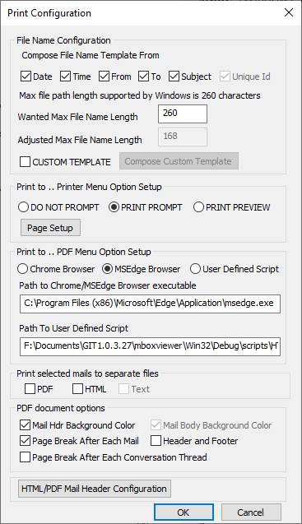

Custom Name Template
User can create custom name template by checking “CUSTOM TEMPLATE” and then selecting “Compose Custom Template”. User will be presented with the below template configuration dialog.
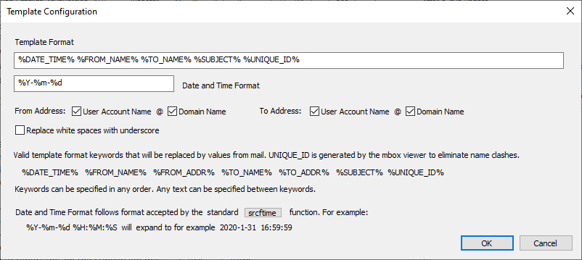

Mail Printing to CSV Spreadsheet file
By default, Mbox Viewer supports printing of all mails or selected group of mails to a single CSV file. All mails can be printed to single CSV file but a particular Spreadsheet tool may limit the maximum supported size of the spreadsheet file.
User can select and print groups/subset of mails to separate CVS files as a work around. There is no option to automatically split all mails into configurable number of mail groups for printing to separate CSV files.

Mail Printing to TEXT file
By default Mbox Viewer supports printing of all, single or selected group of mails to single Text file. All mails can be printed to single TEXT file but a particular Text viewer tool may limit the maximum supported size of the text file.
User can select and print groups/subset of mails to separate Text files as a work around. There is no option to automatically split all mails into configurable number of mail groups for printing to separate Text files

Mail Printing to HTML file
By default Mbox Viewer supports printing of all mails, single or selected group of mails to single HTML file. Mails can also be printed to a separate per mail HTML file for further processing as described in “Mail Printing to PDF” 10.33.6 section and “Mail Printing to PDF files by Power Users” 10.33.7 section.
All archive mails can be printed to single HTML file but HTML viewer tools/Web Browsers may not be able to process large HTML files, become very slow or completely overloaded.
User can select and print groups/subset of mails to separate HTML files as a work around. There is no option to automatically split all mails into configurable number of mail groups for printing to separate HTML files.
There is no hard rule how many mails can be printed to a single HTML file and viewed by a Web Browser. It depends on the size and content (such as heavy graphics) of mails. It should be doable to print up to a couple of thousands small to medium size text mails to a single HTML file for further processing.

Mail Printing to PDF printer
Mbox Viewer supports printing of all, single or selected group of mails to PDF printer.
Printing to PDF printer relies on Microsoft HTML Document object to print its content. First, Mbox Viewer will print mails to a single HTML file, then it will load this file into HTML Document object and request the document object to print itself.
The limitations as far as the maximum number of mails that can be printed are described in the "Printing Mails to HTML file" section.
The "File -> Print Config -> Page Setup" dialog option allows users to control the page title, header, footer and background color.
By default user is prompted to select PDF printer for printing mails. If the PDF printer is configured as the default printer, user can set "File -> Print Config -> Do Not Prompt" dialog option to skip the printer prompt step.

Mail Printing to PDF file
Mbox Viewer supports multiple ways to print all, single or multiple mails to PDF file. All methods convert HTML files, created first from mails by the Mbox Viewer, to PDF format.
By default all, single or selected mails are printed to a single HTML file and then converted to PDF format. The default method limits the number of mails that can be effectively printed to single HTML file as noted in previous sections. More scalable method for is described in “Mail Printing to PDF files by Power Users” 10.33.7 section.
Mbox Viewer supports an option to print mails directly to PDF file without any user interaction. Direct printing to PDF file invokes external application to convert HTML files to PDF. Standard Google Chrome and/or Microsoft Edge browser in so called headless mode are used to perform conversion. MS Edge and Chrome allows users to configure printing of pages with or without standard header and footer.

Use of free wkhtmltopdf application
NOTE: Support for wkhtmltopdf will likely be removed in the future releases. The wkhtmltopdf project is no longer actively developed. It was archived by the main developer and it is in the read-only mode. Open the provided link to view history and status of this project wkhtmltopdf .
An option is provided to leverage free wkhtmltopdf application to covert HTML to PDF and to control the page title, header and footer and the background color. Note however that free wkhtmltopdf application was not fully evaluated and should only be used in very rare cases. Support for wkhtmltopdf seems to be lagging for number of years in comparison to Edge and Chrome.
User can set "File -> Print Config -> Path To User Defined Script" to invoke HTML2PDF-single-wkhtmltopdf.cmd script included in the release package. HTML2PDF-single-wkhtmltopdf.cmd script creates PDF files with the right footer "Page Number of Total Pages" and no page Title and Header. The script can be customized by users if desired.
The wkhtmltopdf can be downloaded from wkhtmltopdf.org downloads.
The wkhtmltopdf command line options are documented in wkhtmltopdf.org usage.

Print Options
When printing multiple mails to a single PDF file, user can
- Set "File -> Print Config -> Page Break After Each Mail" option to start each mail at new page, or
- Set "File -> Print Config -> Page Break After Each Conversation Thread" to start conversation or subject thread at new page.
User can unset "File -> Print Config -> Mail Hdr Background Color" option to remove mail header background color and save on the ink when printing.
User can set/unset "File -> Print Config -> Header and Footer" option to control printing of page standard header and footer via MS Edge and Chrome browser.

Printing directly from Firefox, Chrome and Edge browsers
HTML files created by MBox Viewer can be open within Firefox, Chrome, MS Edge, etc. browser and printed to PDF file and take advantage of additional printing options.
Note that in order for links to attachments be clickable the “Save to PDF” option must be used when printing directly from Edge and Chrome browsers.
Note that links to attachments are clickable when PDF document is open in Edge or Chrome browser but they are not clickable in Firefox.

Impact on Font Size when Printing of Multiple Mails to a Single PDF
MBox Viewer's solution to Print multiple mails to single PDF is non-standard and can affect font sizes in all mails. MBox Viewer concatenates content of all mails and headers in HTML format and ask Edge or Chrome Web Browser to convert HTML document into PDF.
Some of mails may have complex style definitions and they can leak and "pollute" environment of other mails. Frequently, font sizes become smaller and may need to be zoomed in by the PDF viewer. There is no similar solution for zooming when printing generated PDF documents to paper.
Note that this problem was basically resolved over time and no longer occurs in practice.
The following approach is suggested when printing multiple mails into a single PDF.
1. Print mails using default mode. Right-click on selected mails and select "Print Selected Mails to --> PDF --> Default". Evaluate generated PDF document and if not acceptable, follow step 2.
2. Print mails using Merge mode. Right-click on selected mails and select "Print Selected Mails to --> PDF --> Merge" option. By default, this will print all selected mails into separate PDF files first and then merge them into a single target PDF file. Conversion of mails into PDF format by Edge or Chrome Browsers is typically high quality and the merging process typically preserves original quality. Each mail starts at the beginning of a page in the merged PDF. This may be considered less than optimal for small mails. In order to run Merge mode, user must install free java PDFBox command line tool and Java VM. Java VM is typically installed on Windows but PDFBox application must be downloaded from the following link.
https://pdfbox.apache.org/download.html
Please download the latest pdfbox-app-3.*.jar file and install in the same directory as mboxview.exe. Also, check whether java.exe is installed on your system as follow.
Start Command Prompt and type “where java”. If java.exe is not listed in the output, you need to install java for Windows. You may also have to update PATH system environmental variable and restart Explorer and MBox Viewer.
Note that in approach 1 and 2 you can configure MBox Viewer to print page break after each mail or after each conversation thread of mails. Select "File-→Print Config-->PDF document options->Page Break After Each Mail/Page Break After Each Conversation Thread".

Performance
Maximum number of mails that can be merged by 1 and 2 options depends on the complexity and size of mails to be merged.
Merging may take minutes when merging relatively small plain text mails or it may take hours when merging large number of business mails with hyperlinks, graphics, tables, etc.
For example, running option 2 (that is merge option), it took 3 hours to print 3926 mails, mix of simple and business mails, into separate PDFs and another 40 minutes to merge them by PDFBox. Task Manager was showing that PDFBox process memory utilization was close to 8gigabytes.
Option 1 never finished with the same set of mails. The test was canceled when it didn't finish within 5 hours.

Mail Printing to PDF files by Power Users
Some users may need to print very large number of mails to a single PDF file. This is supported by Mbox Viewer but one or multiple manual steps are required. User must first print group of mails to separate HTML files and eventually to PDF files and then merge them into a single PDF file by running provided script.
The count of mails to merge into single HTML file is controlled by the following option:
“File-->General options Config-->Number of HTML mails to merge to increase scalability”
Merging multiple mails into single HTML file reduced time to convert all mails to PDF and also helps to reduce size of the final PDF file. The conversion time of HTML files to PDF files can be reduced further by utilizing multiple Chrome or Edge instances.
Follow the following steps to optimize merging of large number of files into single PDF:
- Set “Number of HTML mails to merge to increase scalability” option to 100 for example. This number depends on the size and complexity of mails. This will reduce the total number of HTML files to convert to PDF by 100 times.
- Install pdfbox-app-3.*.jar file and Java VM as described in section 10.33.6.4
- Open the target folder for PDF files as follow: a) Select any two mails, b) select “Print Selected Mails To --> PDF --> Merge” option, c) wait until Print is done and select Open File Location. Keep the folder open for the future use.
- Select all or subset of mails to convert to single PDF file.
- Right click on one of the selected files and select “Print Selected Mails To --> PDF --> Merge” option.
- Wait until MBox Viewer finishes creating HTML files and begins to convert HTML files to PDF.
- Select Cancel button and wait until Cancel is completed.
- Copy the following scripts to the target folder for PDF files:
- scripts/run-html2pdf-list.cmd
- scripts/html2pdf-list.cmd
- scripts/PDFMerge-pdfbox.cmd
- Update run-html2pdf-list.cmd script to set NumberOfBrowsers and RootUserDataDir. It is recommended that NumberOfBrowsers is not set higher than number of physical cores on user’s computer. Create sub-folders 0,1,2,etc, one per browser instance, under RootUserDataDir folder.
- Left double click on run-html2pdf-list.cmd to start HTML to PDF conversion. This will create number of windows, some will be minimized. Once conversion of HTML files to PDF is complete, Close all windows created by run-html2pdf-list.cmd script.
- Once conversion of HTML files to PDF is complete, left double click on PDFMerge-pdfbox.cmd to merge all PDF files into the target PDF created under PDF_MERGE sub-folder.
The entire process may take many hours depending on the complexity of emails and the number of Browsers configured for conversion.
If more than one merged PDF file is created in the PDF_MERGE sub-folder, PDFMerge-pdfbox.cmd script and pdfbox-app-3.*.jar file need to be copied to that sub-folder and the script executed again until PDFMerge-pdfbox.cmd script creates single PDF file only.
Free PDFBox java tool can be downloaded from pdfbox.apache.org.
PDFBox command line tools usage example can be found in pdfbox.apache.org commandline tools.
Java 8 can must be installed and can be downloaded from jdk8-downloads.

Viewing Large PDF files
Chrome, Edge and Firefox browsers and even Adobe Acrobat viewer have problems handling large Gigabytes PDF files. The Okular viewer seems to be the best and also free viewer for viewing very large PDF files https://okular.kde.org/ .

Mail Sharing with other People
The Mail Sharing (or Mail Export) feature enables users to share one or more of the selected mails in HTML and PDF format with other people. The MBox Viewer will create the following files under ExportCache folder when exporting one or more selected mails. Only files related to selected mails are exported.
1. The “Export selected single mail to a file” option. When single mail is exported the following files are created:
- Single SelectedMailName.htm file under ExportCache folder, where SelectedMailName is a unique name constructed for the selected mail. User can define custom template for file name via “File->Print Config->Custom Template->Compose Custom Template” dialog.
- “Attachments” folder for all inline and non inline attachments.
2. The “Export selected multiple mails to separate files” option. When multiple mails are exported to separate files the following files and folders are created:
- The index.html file that shows all mails as the table with the following columns: attachment indicator, Date, Subject, From and To.
- “Mails” folder for all exported mails in Html format. MBox Viewer creates a separate file for each exported mail as SelectedMailName.htm file, where SelectedMailName is a unique name constructed for the selected mail. User can define custom template for file name via “File->Print Config->Custom Template->Compose Custom Template” dialog.
- “Attachments” folder for all inline non inline attachments
3. The “Export selected multiple mails to a single file” option. If multiple mails are exported to single file the following files are created:
- SelectedMailName.htm file under ExportCache folder, where SelectedMailName is a unique name constructed for the selected mails being concatenated.
- “Attachments” folder for all inline and non inline attachments
In all cases, the exportMails2Pdf.cmd file will also be created in the AttachmentCache folder to create PDF file from mails when needed by a user. By default MBox Viewer doesn’t export mails in PDF format since links to attachments are created as absolute links and work only on local computer. Instead, MBox Viewer creates command script to enable users to create PDF files locally. Edge or Chrome browser must be installed on the user computer.
MBox Viewer allows single export per mbox mail file at a time. If exported files exist already, user is asked to copy ExportCache folder to another location, or to agree to override the existing export folder, that is to delete existing files and create new files.
User can configure how to open linked documents via “Export Selected Mails-> Config” option, i.e. links to attachments or links to mails in the index.html file. The same configuration options are available via “Print Config->HTML/PDF Mail Header Configuration->How to open attachment link” options. The options are persistent.

Support for Outlook .msg Mail Files
Starting with v1.0.3.54, MBox Viewer offers experimental support for Outlook .msg files. The .msg files are converted to Mime .eml files first in order to leverage standard MBox Viewer features.
User can view individual .msg file or all .msg files can be converted to .eml files first and merged into a single .mbox file.
Processing of .msg files is quite complicated and requires significant effort. This initial release doesn't support:
1. message body encoded as RTF Text
User feedback will help to decide whether additional development effort is justified in the future.

Viewing single .msg file
Select “File-->Select Folder..” option to select folder with .msg files and install the folder under the Mail Tree pane. Left click to select any msg file. New instance of MBox Viewer will be created to process and to show the content of the selected file. When done viewing, user can terminate the created MBox Viewer instance by selecting standard Windows Close button or by selecting Escape key on the keyboard.

Viewing Outlook msg internal structure
Left click on selected .msg file to open the Outlook message. Next, right click on the selected .msg file to open options menu and select “Print --> Basic” or “Print --> Expanded” option to print internal structure of the selected Outlook msg.

Merging multiple Outlook .msg mail files
MBox Viewer provides an option to merge multiple .msg files into single Mime .mbox files. The merged file can later be processed by MBox Viewer as yet another .mbox mail file.
User must install the folder under the Mail Tree pane by selecting Select “File-->Select Folder..” option to select folder with .msg files. Next, user must select the installed folder by left-click. And finally, user needs to right-click on the selected folder and select “Merge Outlook Msg Mail Files” option. Once merging is complete, user will be presented with the option to open the created file or to open folder containing the created file.

Support for winmail.dat and .ms-tnef attachments
Users can view winmail.dat and .ms-tnef attachments by double left-click on the selected attachment or by right click on the attachment and selecting `open` option.
Content of these files will be shown in the separate instance of MBox Viewer.

Export and Print Directory Structure
MBox Viewer creates data directory and uses as target directory for files and sub-folders created by MboxViewer such as “Print...” export all mails as eml files, etc
The DIRECTORY is constructed as follow based on the selected data folder:
DIRECTORY= UserSelectedDataFolder\UMBoxViewer\MappedMboxFilePath
Mapping example. Assuming
MboxFilePath=F:\Account\Inbox.mbox, then it will be mapped to
MappedMboxFilePath=F\ Account\Inbox-mbox
and DIRECTORY to
DIRECTORY=UserSelectedDataFolder\UMBoxViewer\F\ Account\Inbox-mbox
The ‘:’ character will be removed and “.mbox” extension, if present, will be mapped to “-mbox”
DIRECTORY - target directory for files and sub-directories created by MBox Viewer
DIRECTORY\MailArchiveFile1.mbox
DIRECTORY\MailArchiveFile1.mbox.mboxview
DIRECTORY\MailArchiveFile2.mbox
DIRECTORY\MailArchiveFile2.mbox.mboxview
DIRECTORY\ImageCache
DIRECTORY\ImageCache\MailArchiveFile1- target directory for image files, such as png, jpg, etc, embeded into mails
DIRECTORY\ImageCache\MailArchiveFile2
DIRECTORY\ArchiveCache
DIRECTORY\ArchiveCache\MailArchiveFile1- target directory for saving Find Mails and User Selected Mails as .mbox archive files and .mboxlist mail list files
DIRECTORY\ArchiveCache\MailArchiveFile2
DIRECTORY\PrintCache
DIRECTORY\PrintCache\MailArchiveFile1 - target directory for printing to single CSV, TEXT, HTML and PDF files
z
DIRECTORY\PrintCache\MailArchiveFile1\PDF_GROUP - target directory for printing to separate PDF files
z
DIRECTORY\PrintCache\MailArchiveFile1\HTML_GROUP - target directory for printing to separate HTML files
z
DIRECTORY\PrintCache\MailArchiveFile2
DIRECTORY\AttachmentCache\MailArchiveFile1 - target directory for all attachment files
DIRECTORY\AttachmentCache\MailArchiveFile2
DIRECTORY\EmlCache\MailArchiveFile1 - target directory for all Eml files
DIRECTORY\EmlCache\MailArchiveFile2
DIRECTORY\LabelCache - target directory for all Label files
DIRECTORY\MergeCache - target directory for intermediate file created when “File-→Select root folder for merging” is selected.
DIRECTORY\ExportCache - target directory for exporting/sharing mails
DIRECTORY\ExportCache\Mails - target directory for mails encoded as HTML files.
DIRECTORY\ExportCache\Attachments - target directory for inline and non-inline attachments related to exported mails.
Mbox Viewer also creates UserSelectedDataFolder/MergeFolder directory to store created merged files when user decides to open created merge file (via presented Open File option) after merging is completed.
Mbox Viewer also creates and manages temporary
C:\Users\UserName\AppData\Local\Temp\UMBoxViewer and
C:\Users\UserName\AppData\Local\Temp\UMBoxViewerPreview
directories to store temporary files (attachments, eml and htm) created when a single mail is selected by the user.
Mbox Viewer created help files such as MailListsInfo.htm and MboxviewerHelp.htm are stored in the temporary directory C:\Users\UserName\AppData\Local\Temp\UMBoxViewer\MboxHelp directory.

Support for Read Only Media
MBox Viewer supports mbox mail archive files saved on Read Only media such as CDs.
MBox Viewer will create index files and other internal directories under the writable data directory as described sections 10.38 and 10.6.

Forward Mails directly from MBox Viewer

Overview
Users can forward single or selected group of emails directly from MBox Viewer. MBox Viewer connects to one of the preconfigured SMTP (Simple Mail Transport Protocol) Servers to forward emails. Emails can be forwarded via Gmail, Yahoo, Outlook Live mail service or user configured Mail Service.
MBox Viewer relies on a separate standalone process, ForwardEmlFile.exe, to connect to SMTP Server and to send emails using the TLS encrypted communication. MBox Viewer links proven MailKit software library to communicate with the SMTP server.
Note that ForwardEmlFile.exe can’t access user mail account data since SMTP Server can send data only.
Be aware that all Mail Services impose limits on the rate, size of sending mails and other factors, see chapter 12.3 . For regular users, Gmail seems to offer better more predictable service than Yahoo or Outlook. However, Yahoo supports mails up to 39MB in size vs 35MB by Outlook and vs 25MB by Gmail.
Note that even so Yahoo can send large mails of 39MB, Outlook may ignore mails larger than 35MB. When forwarding important emails, it is good idea to ask recipient for confirmation.

User Accounts and Passwords
Mail Service providers usually require third-party applications to follow special authentication requirements in order to gain access to their services, i.e. to SMTP Server in this case.
If for whatever reasons you would rather not make changes to your main mail account, you can always create additional mail account on another mail service just to be able forward emails directly from MBox Viewer.
NOTE(2024): During testing in 2024 it was discovered that forwarding mails via Outlook is not working for now. Microsoft dropped basic user authentication method (user name and password) and introduced more complex user authentication for SMTP service.
NOTE(2024): During testing in 2024 it was discovered that forwarding mails via Yahoo is quite slow. Forwarding mails via Gmail is fast, much faster than forwarding mails over Yahoo.

Yahoo Mail Service
In order for third-party SMTP client applications such as ForwardEmlFile.exe to access Yahoo SMTP Server, user must login to Yahoo mail account first and generate one time App Password that can later be used to authenticate ForwardEmlFile application to SMTP Server.
App Password is long string of 16 random characters. Using App Password is very safe since it practically can’t be guessed by hackers using brute force.
Select the below link and click on + sign next to “Generate an App Password” and follow all steps to generate globally unique password for application named ForwardEmlFile. You will need App Password and Yahoo mail user name to communicate with Yahoo SMTP Server.
https://my.help.yahoo.com/kb/account/generate-third-party-passwords-sln15241.html

Gmail Mail Service
Third-party SMTP client application such as ForwardEmlFile.exe can connect to Gmail SMTP Server and be authenticated using either 1) Gmail user name and Gmail user password, or 2) Gmail user name and Gmail App Password.
Note (Nov 2022). Authentication by user name and password is no longer supported by Gmail.

Gmail user didn’t enable 2-step verification to sign up into Gmail
In order to use Gmail user name and Gmail user password, user must login to the Gmail account and enable “Less secure app access” option, see the link:
https://myaccount.google.com/lesssecureapps?pli=1
If you are concerned about this change, you can disable “Less secure app access” option after you are done forwarding emails.
NOTE (2024): “Less secure app access” option is no longer supported by Gmail.

Gmail user did enable 2-step verification to sign up into Gmail
User must login to Google account and generate App Password for Gmail Account. App Password is long string of 16 random characters. Using App Password is very safe since it practically can’t be guessed by hackers using brute force.
Use following link for the general information:
Sign in with app passwords
or search Web for “Sign in with app passwords”
Use the link below to generate App Password:
Create and manage your app passwords
Login and enter “mboxview” as the application name to generate application password.

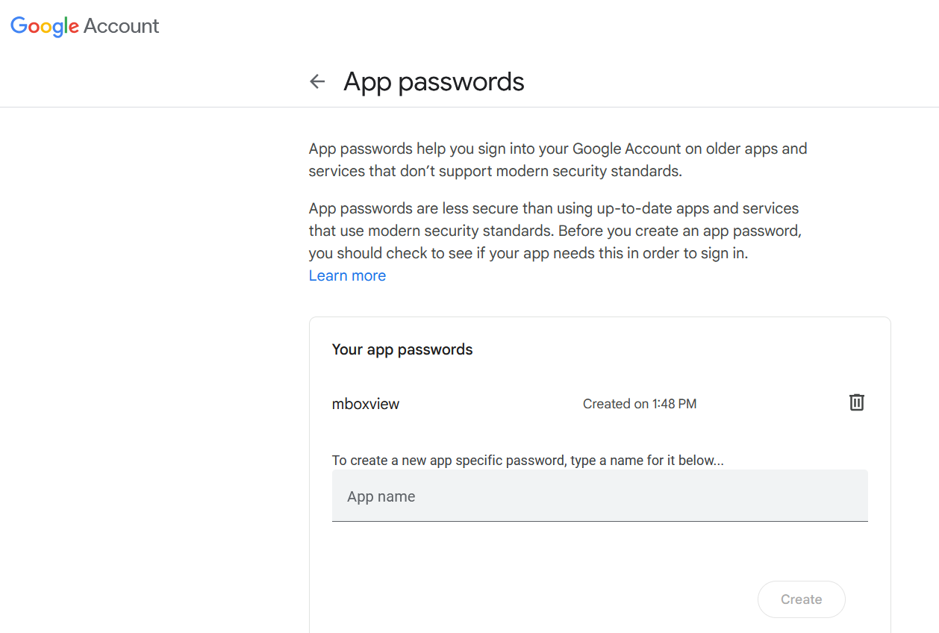

Outlook Live Mail Service
NOTE: Until further notice, forwarding via Outlook is not supported.
Testing was done using Outlook Live free mail account. Microsoft also offers payable Premium Outlook mail service under Office 365 and Microsoft 365 plans. These plans offer much higher sending limits but no evaluation was performed.
If a user did enable 2-step versification, user needs to generate App Password to be properly authenticated, see chapter 12.2.3.2 . App Password is long string of 16 random characters. Using App Password is very safe since it practically can’t be guessed by hackers using brute force.
If a user didn’t enable 2-step versification, there is no requirement to change any security setting for Outlook Live account to be able to send mails via Outlook SMTP Server.
Creating User name and Password to gain access to Outlook SMTP is not exactly clear and can be confusing to set up.

Create Outlook Account, User Name and Password
I suggest the following steps to create valid user names and password. For more information, examine the following link.
Everything you need to know about Microsoft accounts | Windows Community
In my case I already had Microsoft and Outlook accounts but had to perform additional configuration.

You don’t have Microsoft Account (know as MSA) and you don’t have Outlook Live account
Use the following link to create Microsoft account page:
https://account.microsoft.com/account
Select “Sign in”, then select “Create one!”, then select “Get a new email address” and create your new MyName@outlook.com email address.
The below link has more details.
https://support.microsoft.com/en-us/account-billing/how-to-create-a-new-microsoft-account-a84675c3-3e9e-17cf-2911-3d56b15c0aaf
Use your new Outlook User name and Password to open SMTP Server Configuration dialog and configure user name and password. Attempt to forward one of the mails and check if all works.

You already have both Microsoft Account and Outlook Live Account
This is the case I faced. Forwarding of emails was not working properly until I created email alias and make this alias primary as described in following link:
https://support.microsoft.com/en-us/office/add-or-remove-an-email-alias-in-outlook-com-459b1989-356d-40fa-a689-8f285b13f1f2
For some reason, Outlook Account User Name and Password did not work for me but Microsoft Account User name and Password did work.

Generate App Password for Outlook
User must login to Outlook account, enable 2-step verification and generate App Password for Outlook Account. Follow the link below to generate App Password:
https://support.microsoft.com/en-us/account-billing/using-app-passwords-with-apps-that-don-t-support-two-step-verification-5896ed9b-4263-e681-128a-a6f2979a7944

Mail Sending and Size Limits
The limits are listed here to the best of our knowledge and they might be changed by the mail service providers anytime without notice. For regular users, Gmail seems to offer better more predictable service than Yahoo or Outlook. However, Yahoo supports mails up to 39MB in size vs 35MB by Outlook and vs 25MB by Gmail.
Users are mainly responsible for observing sending limits. MBox Viewer will limit the sending rate to 30 mails/minute.

Gmail Mail Service
Sending can be rejected by Gmail for variety of reasons. If a user exceeds various limits, user account can be locked for up to 24 hours. User can take manual steps to restore access.
Regular users are allowed to send up to 500 mails per day.
Mails can be rejected if they are being sent too fast or to too many recipients.
Mails of up to 25MB are accepted.

Yahoo Mail Service
Sending can be rejected by Yahoo for variety of reasons. If a user exceeds various limits, user account can be locked for up to 24 hours. User can take manual steps to restore access.
Yahoo does not disclose sending and size limits.
Mails of up to 39MB are accepted.

Outlook Mail Service
Sending can be rejected by Outlook for variety of reasons including suspicion of spamming. If a user exceeds various limits, user account can be locked for up to 24 hours. User can take manual steps to restore access.
Mails of up to 35MB are accepted. If you attempt to send larger mail, it will appear that the sending was successful. However, Outlook will post rejection mail into your Outlook account.
The other sending limits are not known.

SMTP Server Configuration
Select “File → SMTP Mail Server Config” to open the configuration dialog. Select one of the listed mail services, enter User Account and Password and click on the “Save” button to save the changes.
When you select “Close” button, the SMTP.ini file is created for the selected service in C:\Users\%USERNAME%\AppData\Local\MBoxViewer\MailService and used by ForwardEmlFile.exe to support forwarding of emails.
The “Cancel” button is used to clear unsaved changes made in the dialog. If you switch to different mail service, the unsaved changes in the dialog are lost.
When you exit MBox Viewer, User Password is not saved in the system for safety reasons and must be reentered before any mail can be forwarded again.

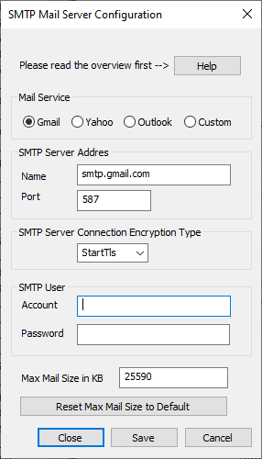

SMTP Servers Default Settings
SMTP Server Address | smtp.gmail.com | smtp.mail.yahoo.com | smtp-mail.outlook.com
SMTP Server Port | 587 | 587 | 587
SMTP Security | StartTls | StartTls | StartTls

Forwarding Mails
MBox viewer supports forwarding of a single and multiple emails.
Note that From address can be specified by a user while in Custom SMTP Configuration option only.

Forwarding a single email
Right click on any email and select “Forward Mail” option to open the dialog to forward the selected email. The dialog can be manually resized if needed.

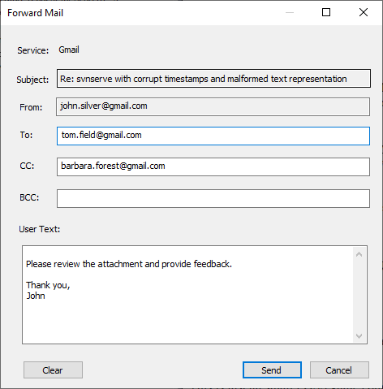
The non-empty To field is required. Other fields are optional. When you open the dialog, To, CC, BCC and User Text fields will show the values set in the last dialog. You can clear these fields by clicking on the “Clear” button.
It is important to make sure all addresses are correct and valid. If any address is not valid, a rejection email will be send by the mail service to the respective user’s mail account. MBox Viewer doesn’t have access to user’s mail accounts.

Forwarding a list of selected emails
User can select multiple email, then right click on any of the selected emails and select “Forward Mails” option to open the dialog to forward the selected email.
To avoid suspension of the user account, the user is warned if the user attempts to forward batch of emails larger than 100. User is also warned when any of the select mails to forward is larger than supported maximum size.

Error Reporting
If forwarding of a mail fails, MBox Viewer will create Message Box with relevant error text.

Support for Multiple Languages
Starting with version 1.0.3.47, MBox Viewer implements more complete support for multiple languages.
Window’s text, button’s labels, menu labels, etc of dialogues, message boxes, menus of mails, mail files and Help Files, User Guide can be configured by users to display in German, French, Spanish, Italian, Polish, Portuguese, Portuguese-Brazil languages, Japanese, Chinese-Simplified and Arabic.

Language Configuration
Language to be used by MBox Viewer can be configured by selecting “Language-->Select Language” main menu option. The following dialog will appear and allow users to select new language. MBox Viewer must be restarted for new language to take effect.
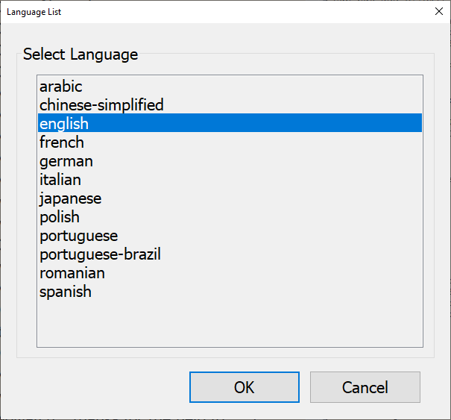

Limitations
- In many cases the text translated to other languages will not fit in the fixed template defined for English text and it will be truncated. As a work around, user can move cursor over the truncated text to activate Tool Tips with the full text.
- The English text and documents were translated to other languages by free Google Translation service and not reviewed by humans yet. Free Google Translation service is not domain specific and therefore has limitations. It is designed to translate commonly daily spoken language. Better use of Google Translation service needs to be investigated.
- There are occasional issues with WORD documents translated by free Google Translation service with regard to formatting and other issues. Translated WORD documents are later exported to PDF.
- Support for Arabic language is experimental and needs users feedback fluent in both English and Arabic.

Windows Code Page Identifiers
The table below shows the supported character sets/code pages by Windows platform. The list is based on the following link.
https://msdn.microsoft.com/en-us/library/windows/desktop/dd317756(v=vs.85).aspx
Code Page | Name | Display Name
37 | IBM037 | IBM EBCDIC (US-Canada)
437 | IBM437 | OEM United States
500 | IBM500 | IBM EBCDIC (International)
708 | ASMO-708 | Arabic (ASMO 708)
720 | DOS-720 | Arabic (DOS)
737 | ibm737 | Greek (DOS)
775 | ibm775 | Baltic (DOS)
850 | ibm850 | Western European (DOS)
852 | ibm852 | Central European (DOS)
855 | IBM855 | OEM Cyrillic
857 | ibm857 | Turkish (DOS)
858 | IBM00858 | OEM Multilingual Latin I
860 | IBM860 | Portuguese (DOS)
861 | ibm861 | Icelandic (DOS)
862 | DOS-862 | Hebrew (DOS)
863 | IBM863 | French Canadian (DOS)
864 | IBM864 | Arabic (864)
865 | IBM865 | Nordic (DOS)
866 | cp866 | Cyrillic (DOS)
869 | ibm869 | Greek , Modern (DOS)
870 | IBM870 | IBM EBCDIC (Multilingual Latin-2)
874 | windows-874 | Thai (Windows)
875 | cp875 | IBM EBCDIC (Greek Modern)
932 | shift_jis | Japanese (Shift-JIS)
936 | gb2312 | Chinese Simplified (GB2312)
949 | ks_c_5601-1987 | Korean
950 | big5 | Chinese Traditional (Big5)
1026 | IBM1026 | IBM EBCDIC (Turkish Latin-5)
1047 | IBM01047 | IBM Latin-1
1140 | IBM01140 | IBM EBCDIC (US-Canada-Euro)
1141 | IBM01141 | IBM EBCDIC (Germany-Euro)
1142 | IBM01142 | IBM EBCDIC (Denmark-Norway-Euro)
1143 | IBM01143 | IBM EBCDIC (Finland-Sweden-Euro)
1144 | IBM01144 | IBM EBCDIC (Italy-Euro)
1145 | IBM01145 | IBM EBCDIC (Spain-Euro)
1146 | IBM01146 | IBM EBCDIC (UK-Euro)
1147 | IBM01147 | IBM EBCDIC (France-Euro)
1148 | IBM01148 | IBM EBCDIC (International-Euro)
1149 | IBM01149 | IBM EBCDIC (Icelandic-Euro)
1200 | utf-16 | Unicode
1201 | unicodeFFFE | Unicode (Big-Endian)
1250 | windows-1250 | Central European (Windows)
1251 | windows-1251 | Cyrillic (Windows)
1252 | Windows-1252 | Western European (Windows)
1253 | windows-1253 | Greek (Windows)
1254 | windows-1254 | Turkish (Windows)
1255 | windows-1255 | Hebrew (Windows)
1256 | windows-1256 | Arabic (Windows)
1257 | windows-1257 | Baltic (Windows)
1258 | windows-1258 | Vietnamese (Windows)
1361 | Johab | Korean (Johab)
10000 | macintosh | Western European (Mac)
10001 | x-mac-japanese | Japanese (Mac)
10002 | x-mac-chinesetrad | Chinese Traditional (Mac)
10003 | x-mac-korean | Korean (Mac)
10004 | x-mac-arabic | Arabic (Mac)
10005 | x-mac-hebrew | Hebrew (Mac)
10006 | x-mac-greek | Greek (Mac)
10007 | x-mac-cyrillic | Cyrillic (Mac)
10008 | x-mac-chinesesimp | Chinese Simplified (Mac)
10010 | x-mac-romanian | Romanian (Mac)
10017 | x-mac-ukrainian | Ukrainian (Mac)
10021 | x-mac-thai | Thai (Mac)
10029 | x-mac-ce | Central European (Mac)
10079 | x-mac-icelandic | Icelandic (Mac)
10081 | x-mac-turkish | Turkish (Mac)
10082 | x-mac-croatian | Croatian (Mac)
12000 | utf-32 | Unicode (UTF-32)
12001 | utf-32BE | Unicode (UTF-32 Big-Endian)
20000 | x-Chinese-CNS | Chinese Traditional (CNS)
20001 | x-cp20001 | TCA Taiwan
20002 | x-Chinese-Eten | Chinese Traditional (Eten)
20003 | x-cp20003 | IBM5550 Taiwan
20004 | x-cp20004 | TeleText Taiwan
20005 | x-cp20005 | Wang Taiwan
20105 | x-IA5 | Western European (IA5)
20106 | x-IA5-German | German (IA5)
20107 | x-IA5-Swedish | Swedish (IA5)
20108 | x-IA5-Norwegian | Norwegian (IA5)
20127 | us-ascii | US-ASCII
20261 | x-cp20261 | T.61
20269 | x-cp20269 | ISO-6937
20273 | IBM273 | IBM EBCDIC (Germany)
20277 | IBM277 | IBM EBCDIC (Denmark-Norway)
20278 | IBM278 | IBM EBCDIC (Finland-Sweden)
20280 | IBM280 | IBM EBCDIC (Italy)
20284 | IBM284 | IBM EBCDIC (Spain)
20285 | IBM285 | IBM EBCDIC (UK)
20290 | IBM290 | IBM EBCDIC (Japanese katakana)
20297 | IBM297 | IBM EBCDIC (France)
20420 | IBM420 | IBM EBCDIC (Arabic)
20423 | IBM423 | IBM EBCDIC (Greek)
20424 | IBM424 | IBM EBCDIC (Hebrew)
20833 | x-EBCDIC-KoreanExtended | IBM EBCDIC (Korean Extended)
20838 | IBM-Thai | IBM EBCDIC (Thai)
20866 | koi8-r | Cyrillic (KOI8-R)
20871 | IBM871 | IBM EBCDIC (Icelandic)
20880 | IBM880 | IBM EBCDIC (Cyrillic Russian)
20905 | IBM905 | IBM EBCDIC (Turkish)
20924 | IBM00924 | IBM Latin-1
20932 | EUC-JP | Japanese (JIS 0208-1990 and 0212-1990)
20936 | x-cp20936 | Chinese Simplified (GB2312-80)
20949 | x-cp20949 | Korean Wansung
21025 | cp1025 | IBM EBCDIC (Cyrillic Serbian-Bulgarian)
21866 | koi8-u | Cyrillic (KOI8-U)
28591 | iso-8859-1 | Western European (ISO)
28592 | iso-8859-2 | Central European (ISO)
28593 | iso-8859-3 | Latin 3 (ISO)
28594 | iso-8859-4 | Baltic (ISO)
28595 | iso-8859-5 | Cyrillic (ISO)
28596 | iso-8859-6 | Arabic (ISO)
28597 | iso-8859-7 | Greek (ISO)
28598 | iso-8859-8 | Hebrew (ISO-Visual)
28599 | iso-8859-9 | Turkish (ISO)
28603 | iso-8859-13 | Estonian (ISO)
28605 | iso-8859-15 | Latin 9 (ISO)
29001 | x-Europa | Europa
38598 | iso-8859-8-i | Hebrew (ISO-Logical)
50220 | iso-2022-jp | Japanese (JIS)
50221 | csISO2022JP | Japanese (JIS-Allow 1 byte Kana)
50222 | iso-2022-jp | Japanese (JIS-Allow 1 byte Kana - SO/SI)
50225 | iso-2022-kr | Korean (ISO)
50227 | x-cp50227 | Chinese Simplified (ISO-2022)
51932 | euc-jp | Japanese (EUC)
51936 | EUC-CN | Chinese Simplified (EUC)
51949 | euc-kr | Korean (EUC)
52936 | hz-gb-2312 | Chinese Simplified (HZ)
54936 | GB18030 | Chinese Simplified (GB18030)
57002 | x-iscii-de | ISCII Devanagari
57003 | x-iscii-be | ISCII Bengali
57004 | x-iscii-ta | ISCII Tamil
57005 | x-iscii-te | ISCII Telugu
57006 | x-iscii-as | ISCII Assamese
57007 | x-iscii-or | ISCII Oriya
57008 | x-iscii-ka | ISCII Kannada
57009 | x-iscii-ma | ISCII Malayalam
57010 | x-iscii-gu | ISCII Gujarati
57011 | x-iscii-pa | ISCII Punjabi
65000 | utf-7 | Unicode (UTF-7)
65001 | utf-8 | Unicode (UTF-8)

Handling Unknown Code Page Names
In a few cases, mboxview will map unknown code names to the equivalent code names supported by Windows.

Unknown Code Name | Mapped To Code Name
gbk | GB18030
cp1252 | Windows-1252
ascii | us-ascii
cp819 | iso-8859-1
latin1 | iso-8859-1
latin2 | iso-8859-2
big-5 | big5
SJIS | shift_jis

