- Photos are zoomed out in this section
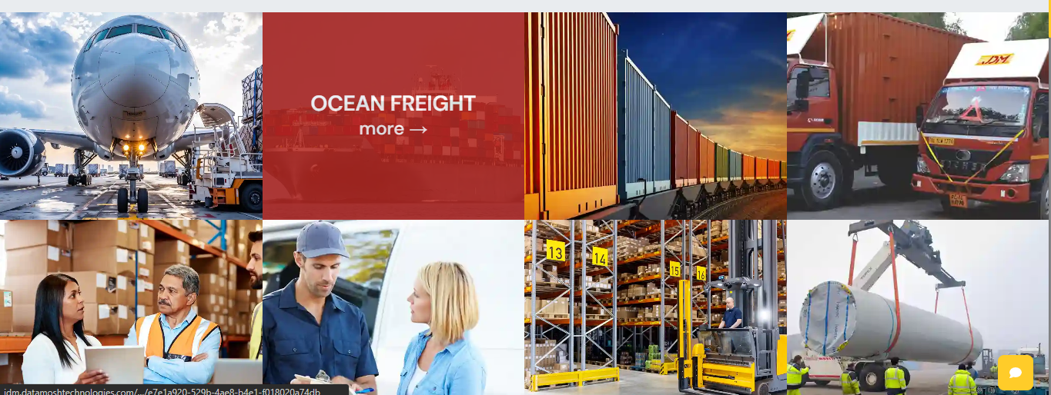

- For this section, we need 2D video with continuous play
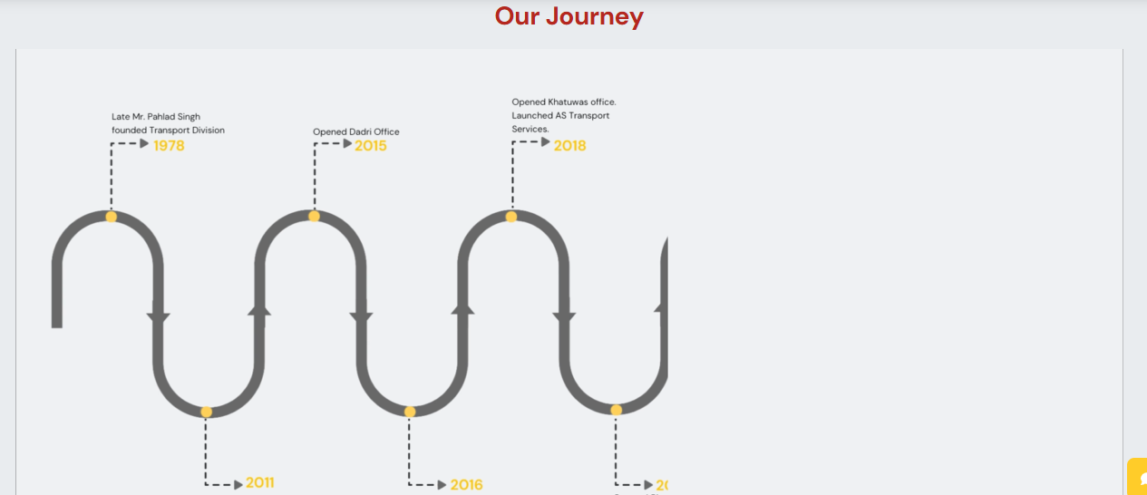

- For the Accreditations & Certifications, Associations, Our Sea Carrier Partners and Our Air Carrier Partners we need to use the Coloured/Actual logs with the background as per the reference shown in the image below and and you can also refre Skyways website- https://skyways-air.in/about-us/

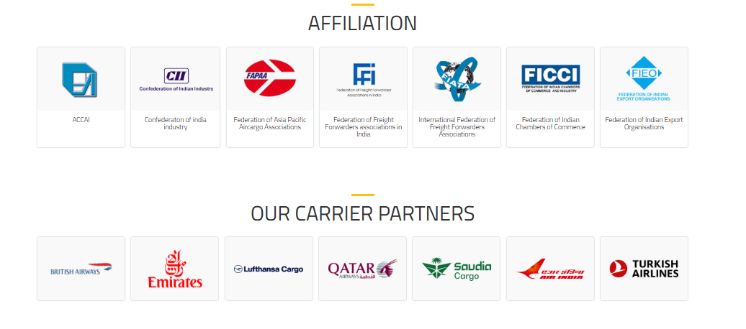
- In this section, we need to make the image a little brighter and need to add Pune location and change the Image in TKD and Delhi. For Delhi, we need to use the New Parliament House, and for TKD we can use an India Gate image as a background
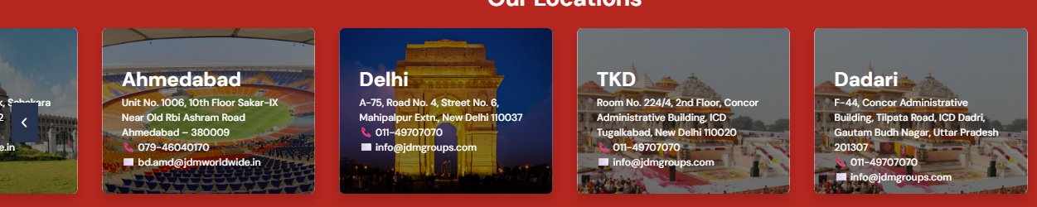

- In the About Us section, we need to use these types of images as backgrounds for Core Values, Vision, Mission and Key Strengths. For reference, you can check the website of SKYways - https://skyways-air.in/about-us/
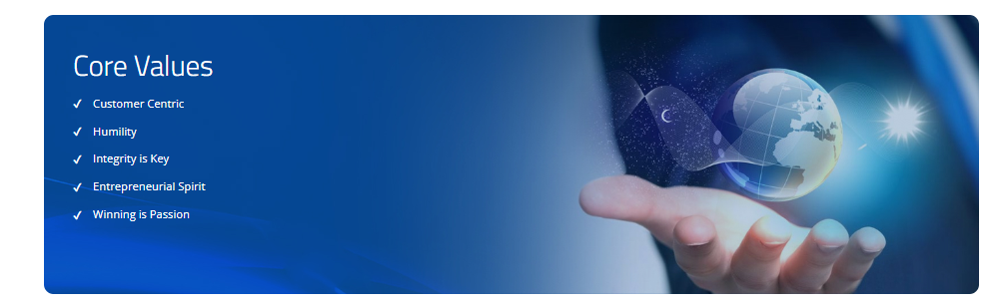
- Need to remove the details and Image of Anuj Arora, also Anju Dubey's image is not visible. We have to add 1 more detail in this section below the Designation, which is Available in another sheet
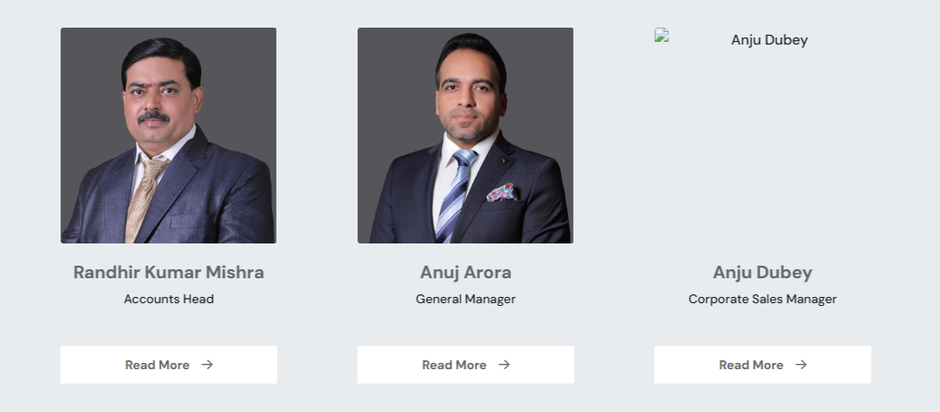

- Manoj Kumar -
Assistant Vice President
Export Air Freight Forwarding and Export Customs House Brokerage

- Rohit Raj
Branch Manager Pune
Freight Forwarding

- Jaspreet Singh
Assistant General Manager
Corporate Customs House Brokerage

- Nitin Mullay
Branch Manager Chennai
Customs House Brokerage
I will share the Write-up and Photo soon

- Abhilash D
Branch Manager Chennai
Customs House Brokerage
- Lijeesh
Branch Manager Chennai
Freight Forwarding

Write Up for Lijesh

My name is Lijeesh. I was born in Thrissur, Kerala, and moved to Chennai in 1990. I completed both my schooling and college education in Chennai. I graduated with a B.Com degree in the year 2002. Following that, my first work experience began at Ashok Leyland in 2002, which marked the start of my career in logistics. After that, I worked across several companies. In 2023, I co-founded a company alongside my senior, but due to certain challenges, I stepped out of it. Afterwards, in 2024, I joined JDM Groups. Two years have passed since, and here I have the complete freedom to operate independently, which enables me to work with great confidence

Photo of Lijeesh 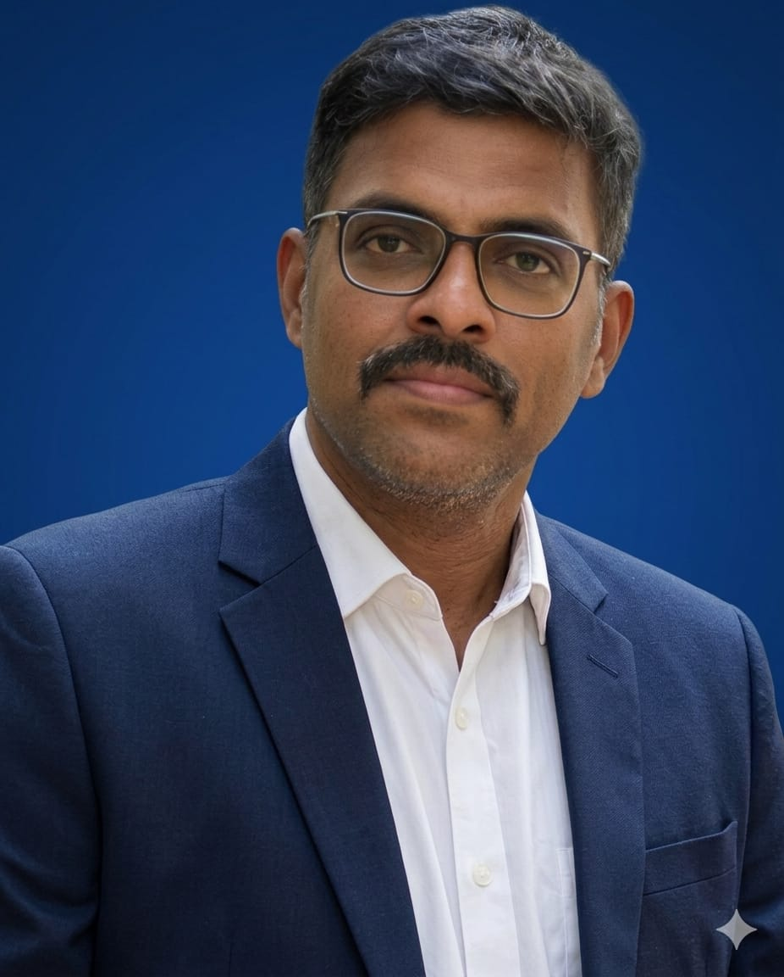

- Below is the new Sequence of Services

- Air Freight
- Ocean Freight
- Rail Freight
- Road Transportation
- Customs Brokerage
- Value Added Services
  - Consultancy
  - SVB
  - EPCG
  - SEZ/STPI
  - FTWZ
  - Moowr
  - IGCR
  - DGFT
  - AA
  - EDD
  - AEO
  - DRAWBACK
  - INSURANCE
  - PACKERS & Movers
- Courier Services
- Project Cargo
- Warehousing
- Perishable Cargo
- Exhibition Cargo

SEZ, STPI- Special Economic Zones SEZ/STPI are growth engines that can boost manufacturing, augment experts and generate employment. The SEZs require a special fiscal and regulatory regime in order to ensure a hassle-free operation encompassing the state-of-the-art infrastructure and support services. JDM is the pioneer in setting up SEZ/STPI units in Economic Zones. Well-versed with the intricacies of the SEZ/STPI rules, we stand tall in providing single window solutions to all these units by handling government regulatory authorities such as SEZ/STPI excise and customs.
For the rest 4 (Moowr, IGCR, FTWZ and EPCG) I will share the write-up soon
- For the Industries page you can refer Hermes Cargo Website - https://www.hermescargo.com/industry.php
in this we need to use the same style as we are using for Values, Vision, and others, but name of the Industries will be similar to that
- Need to work on intro video as well and in that we can refer skyways for the Ocean Rail and Road part

- We need to change the Word Customs Clearance with Customs Brokerage through out the website

- In Services of Air Freight by mistake, we have shared Back to Bade it should be Back to Back

- In the Our Mission Part, we need to change the Our Customers for Sourcing to Our Partner for Sourcing
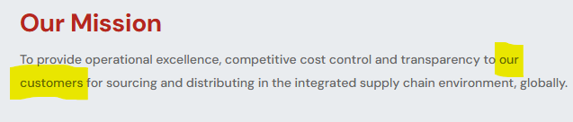
Website for Reference Skyways and Hermes
https://www.hermescargo.com/industry.php
https://skyways-air.in/about-us/

