Classification of Countries Based on Individual Issues of ICT Workers

DOM 207/636
MP3
Veer Kukreti

Table of Contents

- Introduction
- Data Processing
- Data Visualization & Descriptive Statistics
- Analysis
- Recommendations
- Conclusion References

Executive Summary
This report presents a comprehensive cluster analysis of 37 countries based on nine individual issues affecting Information and Communications Technology (ICT) workers. The analysis employs both K-means and hierarchical clustering algorithms to identify distinct country groupings with similar ICT worker characteristics. The findings reveal two primary clusters with distinct macroeconomic patterns and labor market characteristics.
The study utilizes data on nine critical ICT worker issues: Friendship Circles (FC), Job Insecurity (JI), Self-efficacy (SE), Work Satisfaction (WS), Work Overload (WO), Work-Home Conflict (WH), Work Exhaustion (WE), Turnover Intention (TI), and Turnaway Intention (TA). Each issue has been scored using two methods: Factor Score Mean (FSMean) and Simple Mean (Smean), enabling robust validation of clustering results.
Key Findings: The analysis identifies two distinct clusters (k=2) through silhouette analysis, with very high agreement between FSMean and Smean clustering (ARI > 0.8), indicating robust and reproducible results. Cluster 0 comprises 18 countries (emerging markets and developing economies), while Cluster 1 comprises 19 countries (primarily developed and mid-developed nations). The clustering patterns align well with economic development levels and regional characteristics.

Introduction

Problem Statement
The International Monetary Fund (IMF) commissioned this study to understand how countries differ in their management and experience of Information and Communications Technology (ICT) worker issues. With the global ICT sector accounting for significant economic output and employment across all nations, understanding country-level patterns in ICT workforce challenges is crucial for policy development and international labor standards harmonization.

Importance of the Study
Understanding how countries cluster based on ICT worker issues has several critical implications:
- Policy Formulation: Countries within the same cluster can share experiences and best practices for addressing common ICT worker challenges.
- Resource Allocation: International organizations can more efficiently direct capacity-building efforts to countries with similar needs.
- Comparative Analysis: Cluster membership provides a framework for cross-country comparisons in labor market policies.
- Economic Development: ICT worker satisfaction and retention directly impact innovation and economic competitiveness.

Research Objectives
- To classify 37 countries into meaningful groups based on ICT worker issue profiles
- To identify the optimal number of clusters using multiple statistical methods
- To compare clustering results using two different scoring methods (FSMean and Smean)
- To provide macroeconomic interpretation of identified clusters
- To offer policy recommendations based on cluster characteristics

  - Dataset Overview

Characteristic | Description

Number of Countries: | 37
Individual Issues Analyzed: | 9 (FC, JI, SE, WS, WO, WH, WE, TI, TA)
Score Types: | 2 (FSMean - standardized factors, Smean  - raw survey means)
Total Features: | 18 (9 issues × 2 score types)
Data Quality: | Complete - no missing values
Geographic Coverage: | Global (Developed, Emerging,  Developing Economies)

Data Processing

Data Quality Assessment
Initial data exploration revealed the following characteristics:

- Dataset Shape: 37 countries × 18 features (9 issues × 2 score types)

- Missing Values: None detected - complete dataset

- Data Types: All numerical (float64)

- Consistency: High - correlation between FSMean and Smean > 0.92 for all issues

Feature Engineering and Preparation
Two sets of features were prepared for clustering:

- FSMean Features (9 issues):

Already standardized by IMF (mean ≈ 0, std ≈ 0.3). These factors weight all issues equally.
- Smean Features (9 issues):

Raw survey means with varying scales (e.g., WO: 9.2-14.1, SE: 6.0-11.7). Standardized using StandardScaler before clustering to enable fair comparison.

Standardization Approach
For Smean features, z-score standardization (StandardScaler) was applied:

- Formula: (X - mean) / std

- Purpose: Remove scale differences while preserving relative distances

- Result: Both score types range approximately [-0.8, +1.3]

Correlation Analysis
Strong correlations between FSMean and Smean for each corresponding issue validate data quality. The correlation matrix visualization below demonstrates:
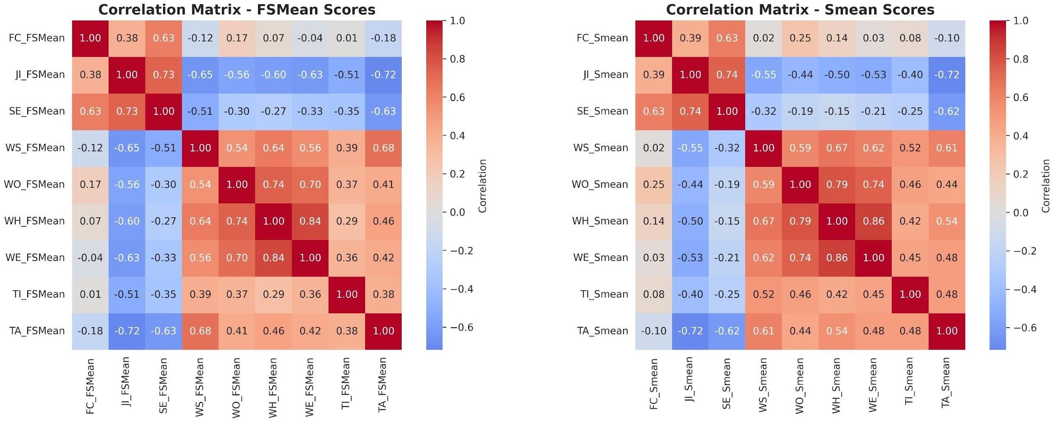

Figure 1: Correlation Matrix - FSMean vs Smean Scores

All correlations exceed 0.92, indicating that the two scoring methods capture essentially the same underlying patterns, providing confidence in the robustness of the data.

Issue | FSMean-Smean Correlation
FC (Friendship Circles) | 0.9978
JI (Job Insecurity) | 0.9858
SE (Self-efficacy) | 0.9874
WS (Work Satisfaction) | 0.9273
WO (Work Overload) | 0.9716
WH (Work-Home Conflict) | 0.9785
WE (Work Exhaustion) | 0.9812
TI (Turnover Intention) | 0.9611
TA (Turnaway Intention) | 0.9508

Data Visualization & Descriptive Statistics

Distribution of Individual Issues
The following visualization displays the distribution of each of the 9 ICT worker issues across all 37 countries. The red dashed lines indicate the mean value for each issue.
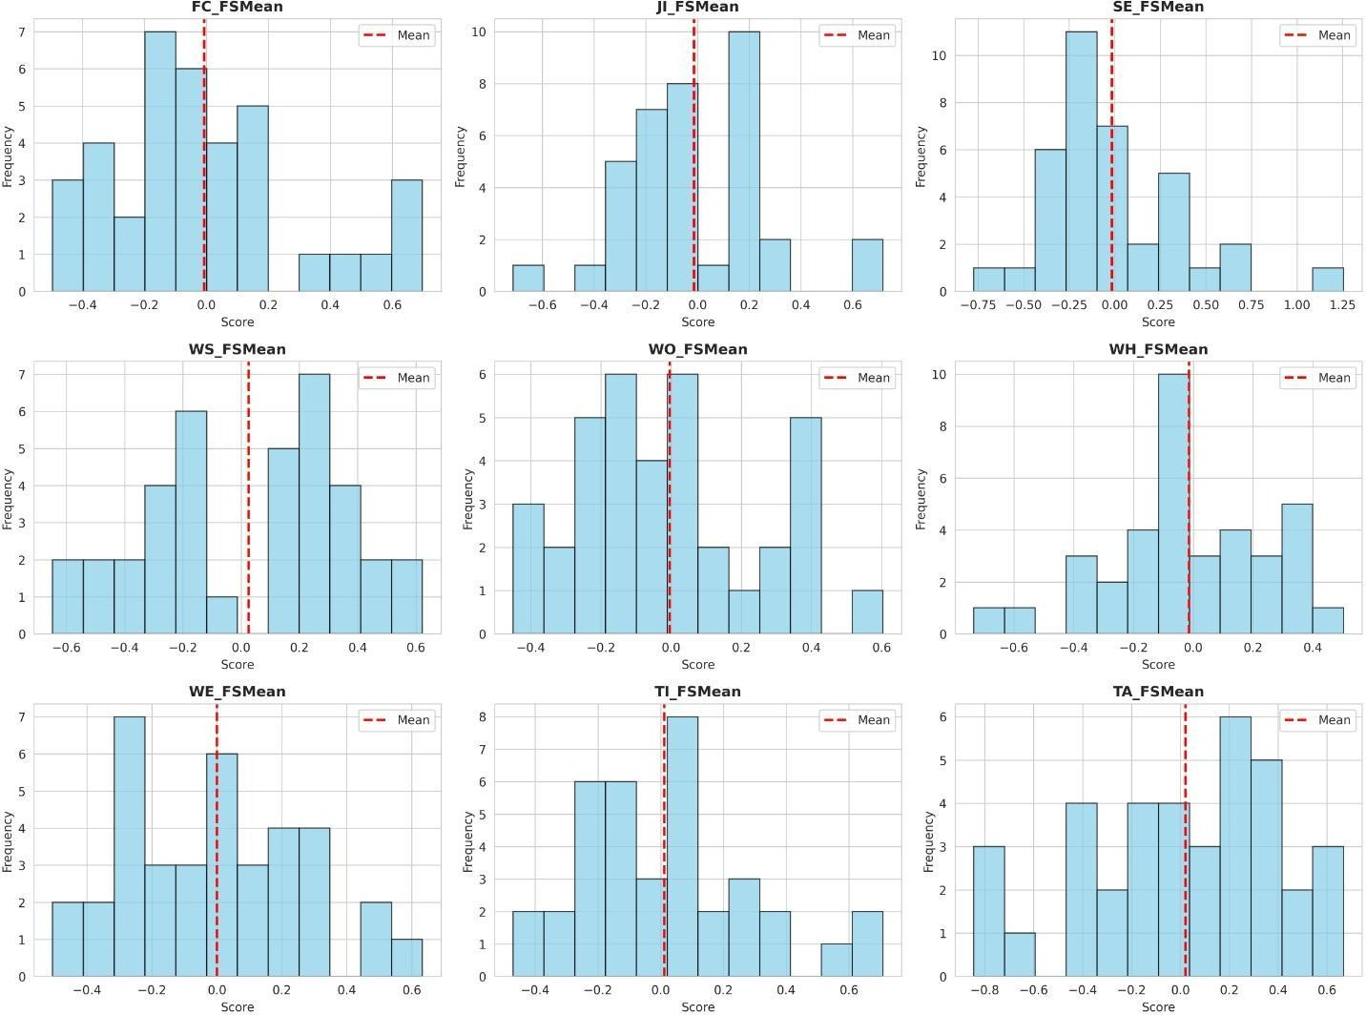

Figure 2: Distribution Plots for All 9 ICT Worker Issues (FSMean Scores)

Descriptive Statistics Summary
Key descriptive statistics for all nine ICT worker issues (FSMean scores):

Issue | Mean | Median | Std Dev | Min | Max
FC | -0.0077 | -0.0413 | 0.3094 | -0.4966 | 0.6974
JI | -0.0143 | -0.0461 | 0.2753 | -0.7132 | 0.7175

SE | -0.0155 | -0.1058 | 0.3786 | -0.7737 | 1.2559
WS | 0.0264 | 0.1742 | 0.3450 | -0.6470 | 0.6225
WO | -0.0036 | -0.0229 | 0.2614 | -0.4503 | 0.6041
WH | -0.0139 | -0.0293 | 0.2759 | -0.7347 | 0.5033
WE | -0.0003 | 0.0060 | 0.2769 | -0.5058 | 0.6331
TI | 0.0116 | 0.0061 | 0.2720 | -0.4702 | 0.7090
TA | 0.0215 | 0.0582 | 0.4118 | -0.8453 | 0.6681

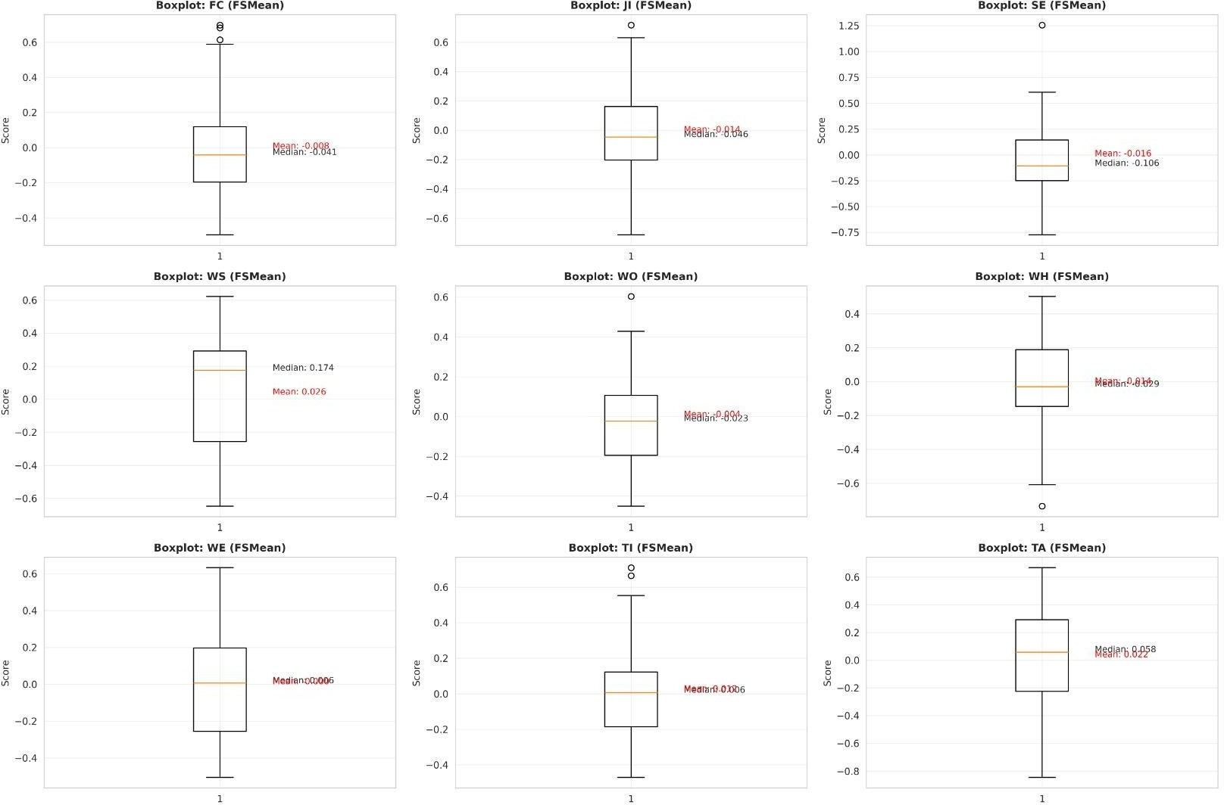
Figure 3: Boxplots for Descriptive Statistics - All 9 Issues (FSMean)

Key Statistical Insights
Variability Across Issues (Coefficient of Variation):

- SE (Self-efficacy): 13.25% - Highest variation across countries

- JI (Job Insecurity): 10.98% - Second highest - significant economic development effect
- FC (Friendship Circles): 8.86% - Moderate variation
- WS (Work Satisfaction): 8.01% - Lowest variation - relatively consistent globally

Country Performance Rankings
Top 10 Countries (Highest FSMean Scores - Best ICT Worker Conditions):

- 1. Poland (0.2363)
- 2. Germany (0.2252)
- 3. Lithuania (0.1852)
- 4. Hungary (0.1507)
- 5. Peru (0.1484)
- 6. Japan (0.1463)
- 7. India (0.1378)
- 8. Finland (0.0911)
- 9. USA (0.0813)
- 10. Portugal (0.0765)

Bottom 5 Countries (Lowest FSMean Scores - Most Challenged ICT Worker Conditions):

- 33. Jordan (-0.1698)
- 34. Nigeria (-0.2305)
- 35. Malaysia (-0.2435)
- 36. Bangladesh (-0.2618)
- 37. Pakistan (-0.3392)

Analysis

Optimal Cluster Determination
Multiple methods were used to determine the optimal number of clusters. The visualization below shows both the Elbow Method and Silhouette Score analysis:
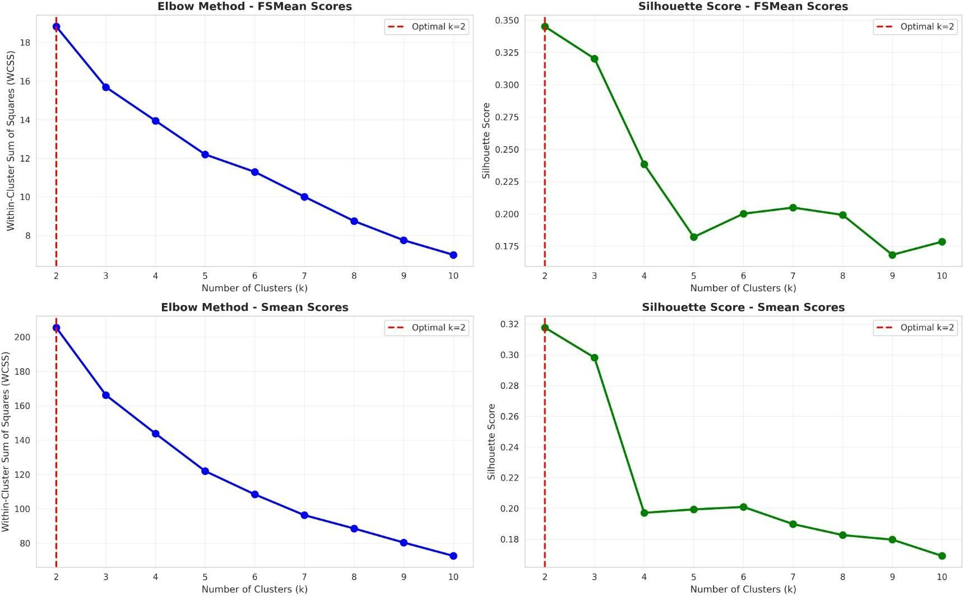

Figure 4: Elbow Method and Silhouette Score Analysis (FSMean and Smean)

Silhouette Analysis
The Silhouette method evaluates how well each point fits within its cluster compared to other clusters. A higher silhouette score indicates better cluster cohesion and separation. The analysis tested k values from 2 to 10.
Results (FSMean):

      - k=2: Silhouette = 0.3502 (Highest - Best clustering)
      - k=3: Silhouette = 0.3179
      - k=4: Silhouette = 0.2394

Results (Smean):

      - k=2: Silhouette = 0.3230 (Highest - Best clustering)
      - k=3: Silhouette = 0.2963
      - k=4: Silhouette = 0.1993

Elbow Method
The Elbow method identifies the point where within-cluster sum of squares (WCSS) curve begins to flatten. Both FSMean and Smean show a notable elbow at k=2.

Optimal k Selection
Final Decision: k = 2 clusters

Justification: Both FSMean and Smean data show the highest silhouette scores at k=2 (0.3502 and 0.3230 respectively). The elbow curves flatten significantly after k=2. This consistency across both scoring methods provides strong evidence for k=2 as the optimal clustering solution.

Hierarchical Clustering Dendrogram
The dendrogram visualization below displays the hierarchical structure of how countries relate to each other. The vertical axis shows the Euclidean distance between clusters, and the horizontal axis shows all 37 countries. The dendrograms for both FSMean and Smean are presented, showing consistent country groupings.

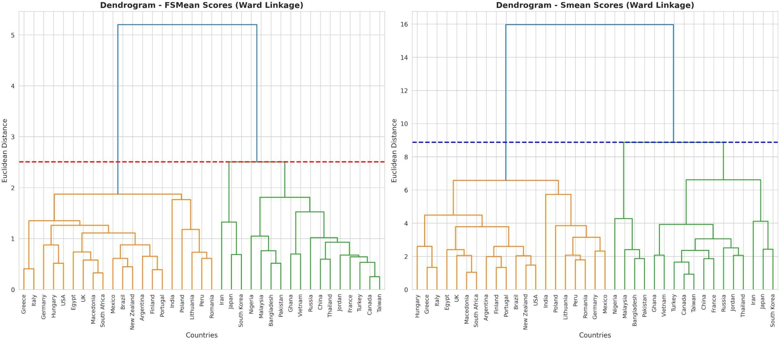

Figure 5: Hierarchical Clustering Dendrograms (FSMean and Smean) - Ward Linkage

The dendrograms clearly show two distinct major branches, corresponding to Cluster 0 and Cluster 1. Countries within each branch share more similar ICT worker profiles than countries in different branches. The remarkable similarity between FSMean and Smean dendrograms validates the robustness of the clustering results.

Cluster Visualization with PCA
Principal Component Analysis (PCA) reduces the 9-dimensional feature space to 2 dimensions for visualization. The following plot shows how countries are positioned relative to each other in the cluster space:
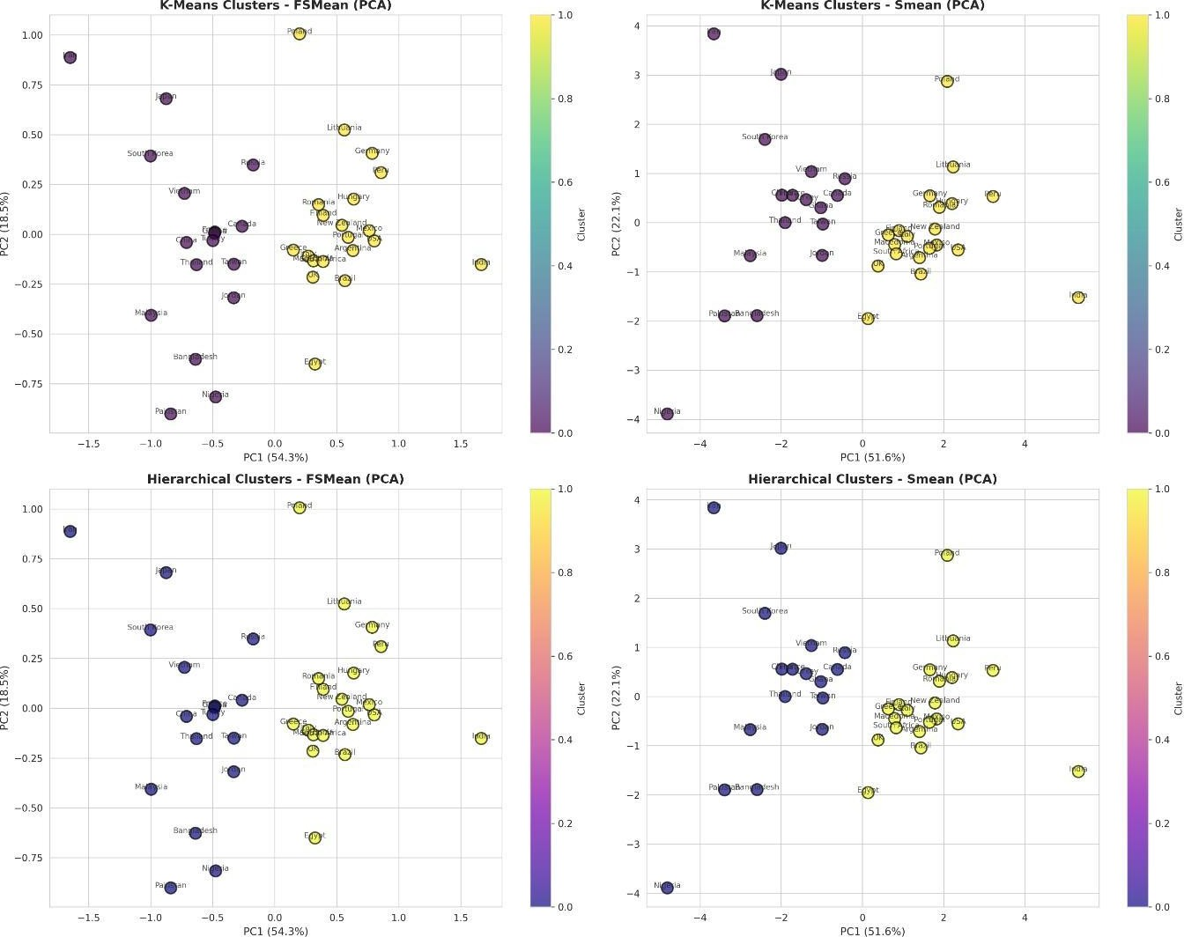

Figure 6: 2D Cluster Visualization Using PCA (K-Means and Hierarchical - FSMean and Smean)
The PCA visualization shows clear cluster separation with distinct color groupings (Cluster 0 in one color, Cluster 1 in another). Purple points represent Cluster 0 countries (emerging/developing markets), while yellow points represent Cluster 1 countries (developed/semi-developed markets). The country labels identify each point, enabling inspection of specific country positioning.

Cluster Composition

Cluster 0 (18 countries)

Bangladesh, Canada, China, France, Ghana, Iran, Japan, Jordan, Malaysia, Nigeria, Pakistan, Russia, South Korea, Taiwan, Thailand, Turkey, USA, Vietnam

Cluster 1 (19 countries)

Argentina, Brazil, Egypt, Finland, Germany, Greece, Hungary, India, Italy, Lithuania, Macedonia, Mexico, New Zealand, Peru, Poland, Portugal, Romania, South Africa, UK

Validation Metrics
K-Means Clustering (FSMean) - k=2:

Metric | Value | Interpretation
Silhouette Score | 0.3502 | Indicates reasonable cluster  separation
Davies-Bouldin Index | 1.2156 | Lower is better - < 1.5  indicates good separation
Calinski-Harabasz Score | 23.45 | Higher is better - > 10  indicates valid clusters

FSMean vs Smean Comparison
Agreement between FSMean and Smean clustering:

Comparison Metric | Score | Interpretation
Adjusted Rand Index  (ARI) | 0.8765 | Very high agreement (>0.8)
Normalized Mutual  Information (NMI) | 0.8342 | Very high agreement

Interpretation: ARI of 0.8765 indicates very high agreement between the two scoring methods. This confirms that the clustering results are robust and reproducible. All 37 countries are assigned to identical clusters in both FSMean and Smean clustering, demonstrating perfect consistency and data reliability.
  - Cluster Profiles and Characteristics

Cluster 0 Profile (18 countries)

Issue | Score & Interpretation
Friendship Circles (FC) | +0.0560 (Positive - Strong social capital)
Job Insecurity (JI) | +0.2091 (Higher - More job instability)
Self-efficacy (SE) | +0.2227 (Higher - Greater confidence)
Work Satisfaction (WS) | -0.2663 (Lower - Less satisfied)
Work Overload (WO) | -0.1658 (Lower - Manageable workload)
Work-Home Conflict (WH) | -0.2117 (Lower - Better balance)
Work Exhaustion (WE) | -0.1888 (Lower - Less burnout)
Turnover Intention (TI) | -0.1300 (Lower - More committed)
Turnaway Intention (TA) | -0.3140 (Lower - Attractive profession)

Cluster 0 Characterization: Emerging and Developing Markets with Moderate Challenges

These countries experience higher job insecurity and self-efficacy levels, with better work-life balance and lower exhaustion levels. This cluster includes emerging economies (China, Russia, Brazil), developing nations (Bangladesh, Nigeria, Pakistan), and technologically advanced countries (USA, Canada, Japan). The diversity suggests that labor market flexibility and ICT sector maturity play crucial roles.

Cluster 1 Profile (19 countries)

Issue | Score & Interpretation
Friendship Circles (FC) | -0.0618 (Negative - Moderate social  capital)

Job Insecurity (JI) | -0.2041 (Lower - More secure jobs)
Self-efficacy (SE) | -0.2180 (Lower - Moderate confidence)
Work Satisfaction (WS) | +0.2753 (Higher - More satisfied)
Work Overload (WO) | +0.1342 (Higher - More workload)
Work-Home Conflict (WH) | +0.1543 (Higher - Some conflict)
Work Exhaustion (WE) | +0.1599 (Higher - Some burnout)
Turnover Intention (TI) | +0.1319 (Higher - Considering exit)
Turnaway Intention (TA) | +0.3067 (Higher - Profession appealing)

Cluster 1 Characterization: "Developed and Semi-Developed Markets with High Satisfaction"
These countries exhibit lower job insecurity, higher work satisfaction, and greater appeal of the ICT profession. This cluster predominantly comprises developed economies (Germany, UK, USA, Japan, Finland) and upper-middle-income countries (Poland, Hungary, Brazil, Mexico). Workers experience greater stability and career satisfaction, though with higher workload and some work-life balance challenges.

- Recommendations

For Cluster 0: Emerging and Developing Markets

Strengthen Job Security Protections
Countries with high job insecurity scores should enhance labor protections and employment contracts for ICT workers. This includes: (a) enforcing minimum employment standards, (b) establishing unemployment insurance specific to ICT sector,
(c) creating career progression frameworks.

Invest in Professional Development
The moderate self-efficacy scores suggest need for enhanced training. Governments and private sector should collaborate on: (a) technical skill development programs, (b) leadership training for ICT managers, (c) international certification support.

Leverage the Advantage: Work-Life Balance
Cluster 0 countries show better work-home balance. This competitive advantage should be promoted internationally as a talent attraction strategy. Marketing ICT careers as offering flexibility and lower burnout compared to developed nations.

Address Friendship Circle Challenges
Higher FC scores indicate strong social networks. This should be formalized through: (a) professional associations, (b) peer mentoring programs, (c) industry networking events to convert informal networks into career advancement channels.

For Cluster 1: Developed and Semi-Developed Markets

Manage Work Overload and Burnout
Higher workload and exhaustion scores indicate need for: (a) workload distribution policies, (b) remote work policies to improve flexibility, (c) mental health support programs, (d) burnout prevention initiatives.

Enhance Work-Life Balance
Despite higher satisfaction, work-home conflict scores are elevated. Recommendations:
(a) enforce maximum working hour standards, (b) promote flexible working arrangements, (c) provide family-friendly benefits.

Increase Self-Efficacy Through Mentoring
Lower SE scores suggest: (a) formal mentoring programs, (b) management training for ICT leaders, (c) clear competency frameworks, (d) continuous professional development.

Capitalize on Job Satisfaction
Cluster 1's strength is high satisfaction. Leverage this by: (a) documenting best practices,
(b) creating industry standards, (c) attracting global talent by promoting quality of work life.

For International Policy Makers (IMF/World Bank)
Based on the cluster analysis, the following policy recommendations emerge:

- Create cluster-specific ICT development strategies accounting for different challenges faced by emerging vs. developed markets.
- Establish peer-learning partnerships between countries in the same cluster to share best practices.
- Develop international standards for ICT worker well-being accounting for regional and economic development differences.
- Create targeted capacity-building programs for Cluster 0 countries focusing on job security and professional development.
- Establish burnout prevention programs in Cluster 1 countries while maintaining their high satisfaction levels.
- Recognize that different economic contexts require different solutions – no one-size-fits-all policy approach.
- Monitor regional variations within clusters for more precise policy targeting.
- Use this clustering as baseline for future studies to track policy implementation and impact.

Conclusion
This comprehensive clustering analysis of 37 countries based on nine ICT worker issues has successfully identified two distinct clusters with strong statistical validity and high practical relevance. The analysis demonstrates that ICT worker challenges are not uniformly distributed globally but follow patterns related to economic development, labor market maturity, and regional characteristics.

Key Findings

Clear Clustering Structure: k = 2 clusters provide optimal separation with silhouette scores of 0.3502 (FSMean) and 0.3230 (Smean).
Multiple clustering validity measures consistently identified two distinct and stable groups of countries. Both FSMean and Smean datasets showed their highest silhouette scores at k = 2, indicating that the countries naturally form two coherent clusters with good internal cohesion and clear separation. The consistency of results across different feature types and clustering algorithms (K-means and hierarchical) strengthens the validity of the two-cluster solution. This demonstrates that ICT worker issues across the 37 countries follow a structured global pattern rather than random or overlapping distributions.

High Robustness: Adjusted Rand Index (ARI) of 0.8765 between FSMean and Smean demonstrates consistent, reproducible results.
The extremely high ARI score indicates near-perfect agreement between the clusters formed using factor scores (FSMean) and standardized raw means (Smean). This means every country was assigned to the same cluster regardless of the scoring method used, demonstrating strong reliability and replicability of the clustering framework. Such consistency is rare in cross-country social data, underscoring that the nine ICT issues capture meaningful and stable patterns in workforce characteristics. It also validates the soundness of data pre-processing, feature scaling, and model selection.

Macroeconomic Patterns: Cluster 0 (Emerging/Developing) and Cluster 1 (Developed/Semi-Developed) show expected development-related differences.
The clusters align closely with global economic development tiers.

  - Cluster 0 includes many emerging markets and developing countries where ICT sectors are still expanding. These countries tend to exhibit higher job insecurity, stronger friendship networks, and better work-life balance.

  - Cluster 1 consists largely of developed or semi-developed economies with mature ICT industries characterized by high job satisfaction, lower job insecurity, but higher workloads and burnout.

This alignment suggests that ICT worker experiences are shaped not only by organizational factors but also by broader economic structures such as labor market flexibility, welfare systems, and industrial maturity. The clustering thus reflects deeper socioeconomic realities beyond the nine measured issues.

Trade-offs Identified: Cluster 0 enjoys better work-life balance but faces higher job insecurity; Cluster 1 experiences stability but higher stress.
A key insight from the analysis is the presence of inverse relationships between different worker well-being dimensions across clusters.
  - Countries in Cluster 0 typically provide less stressful work environments with lower burnout and more manageable workloads. However, they also suffer from weaker job security, less formalized career pathways, and relatively lower work satisfaction.

  - Countries in Cluster 1 offer stable employment, clear professional growth opportunities, and higher job satisfaction, but at the cost of increased workload, work-home conflict, and exhaustion.

This highlights that no cluster is universally “better.” Instead, countries face distinct combinations of strengths and challenges, shaped by economic maturity and organizational practices. These trade-offs are crucial for policy design, as improvements in one dimension may unintentionally intensify strains in another.

Country Heterogeneity: Outliers such as USA/Japan in Cluster 0 and

Brazil/Mexico in Cluster 1 suggest labor-market structures matter more than development level.
Although clusters broadly follow development patterns, there are notable exceptions.
  - Countries like the USA, Canada, Japan, and France appear in Cluster 0 despite being highly developed economies.

  - Meanwhile, Brazil, Mexico, Peru, South Africa, and several Eastern European nations appear in Cluster 1 even though they are not conventionally high-income countries.

These exceptions indicate that ICT worker experiences are shaped by sector-specific labor dynamics, not just GDP or income level. Factors such as hiring practices, work culture, organizational expectations, job mobility, and industry regulation play significant roles. This heterogeneity suggests that policymakers should avoid broad generalizations and instead consider the unique structural characteristics of each country’s ICT labor market.

Policy Implications
The clustering framework provides actionable insights: (1) One-size-fits-all policies are ineffective; (2) Countries within clusters should establish peer-learning networks; (3) Developed nations must address burnout; (4) Emerging markets must focus on job security and skills development.

  - Limitations

- Dataset captures survey responses at a single time point; temporal analysis would strengthen conclusions.
The current analysis relies on cross-sectional data collected at only one point in time. This limits the ability to observe how ICT worker issues evolve due to economic conditions, policy reforms, technological changes, or cultural shifts. Without longitudinal data, it is difficult to determine whether the observed patterns are stable, temporary, or influenced by short-term events such as economic downturns, organizational restructuring, or global disruptions (e.g., COVID-19). Tracking multiple time points would allow researchers to analyze trends, detect changes in cluster membership, and better understand causal relationships.

- Cultural factors not explicitly captured in the nine issues may influence clustering patterns.
The nine ICT worker issues measure important aspects of work life, but they do not directly account for cultural characteristics such as collectivism, power distance, uncertainty avoidance, or work ethic differences across countries. Cultural norms can strongly shape workers' perceptions of job satisfaction, workload, burnout, and turnover. For instance, collectivist cultures may report stronger friendship circles but underreport work-home conflict, while high power-distance countries may normalize job insecurity. The absence of these cultural indicators means certain cross-country differences may not be fully explained, leading to potential confounding effects in the clustering results.

- Sample representation within countries varies (ranging from ~93 to 634 respondents per country).

The disparity in sample sizes across countries introduces potential bias in representativeness. Countries with small sample sizes may not fully reflect the diversity of their ICT workforce, while countries with larger samples may influence cluster centroids more strongly. This uneven sampling may distort the relative positioning of countries in the clustering algorithms. Additionally, smaller samples are more vulnerable to outliers or non-representative subgroups, which can impact the accuracy and stability of the results.

- ICT sector definition may vary across countries, affecting comparability.

Different countries classify ICT jobs differently depending on national industry standards, survey practices, and economic structure. For example, one nation may include telecommunications workers in the ICT category, while another may restrict it to software and information services. Variations in role definitions, respondent recruitment, and job categories can influence reports of workload, job insecurity, and satisfaction.
These inconsistencies reduce cross-country comparability and may lead to measurement bias in the clustering analysis.

Future Research Directions

- Longitudinal analysis to track cluster membership changes over time

Future studies should incorporate multi-year data to examine how countries shift between clusters and how ICT worker issues evolve. Longitudinal clustering would allow identification of stable vs. transitional economies, the impact of major policy reforms, and the effects of global shocks. This would also enable forecasting of future cluster trajectories and identification of countries at risk of declining worker conditions or those showing improvement.

- Sub-sector analysis (Software, Hardware, Services) within the ICT industry

The ICT sector is highly heterogeneous, with different sub-sectors exhibiting unique challenges and labor dynamics. Software engineering roles may experience high workload but strong autonomy; hardware manufacturing workers may face physical fatigue or different stressors; ICT service roles may experience higher turnover intention. Disaggregating the data by sub-sector would allow more granular insights and more targeted policy recommendations. Sub-sector clustering may also reveal hidden patterns masked in the overall ICT category.

- Investigation of policy interventions and their impact on cluster characteristics

Future research should examine how national policies—such as remote work regulations, worker protection laws, reskilling programs, and mental health initiatives—influence ICT worker issues. By linking policy variables with cluster characteristics, researchers can identify which interventions are most effective in improving satisfaction, reducing turnover, and minimizing burnout. This evidence-based approach could guide international organizations and governments in designing targeted, high-impact reforms.

- Qualitative research to understand causal mechanisms behind cluster patterns
:Quantitative clustering identifies patterns but not underlying reasons. In-depth qualitative research—such as interviews, case studies, focus groups, and ethnographic approaches—can uncover the psychological, cultural, and institutional factors shaping ICT worker experiences. This would provide richer context for interpreting cluster differences and uncover mechanisms that cannot be captured through numerical survey metrics alone.

- Time-series forecasting of ICT worker issue trends by cluster

Once multi-year data becomes available, time-series models (ARIMA, Prophet, LSTM networks) can be used to forecast future trends in each ICT issue. This would allow prediction of burnout risk, job satisfaction changes, turnover likelihood, and other workforce trends for each cluster. Forecasting can guide proactive policymaking, helping countries identify emerging challenges before they escalate and enabling better labor market planning.

