MOVIE-THIS

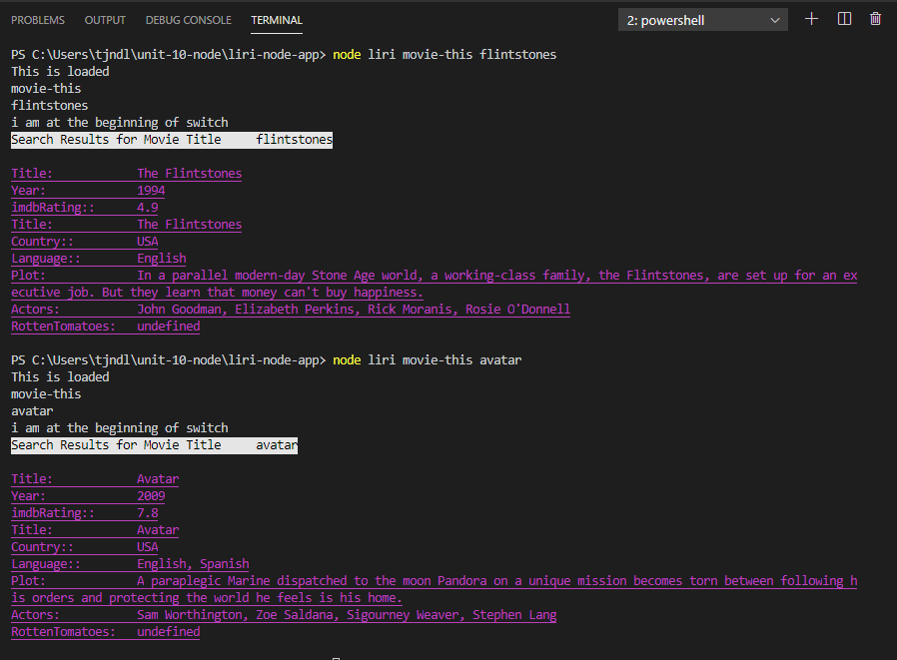

NEXT CONCERT VENUE SEARCH

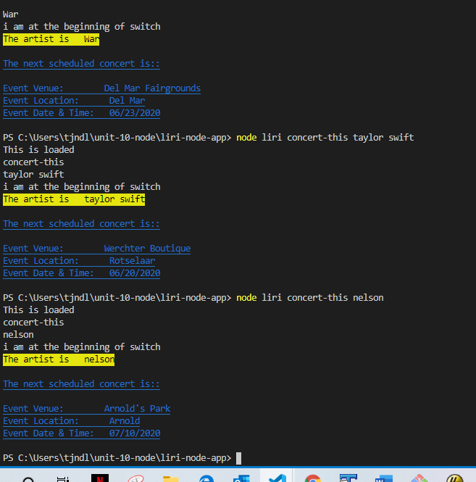

SEARCHING FOR A SONG BY ‘Song title’ or ‘artist name’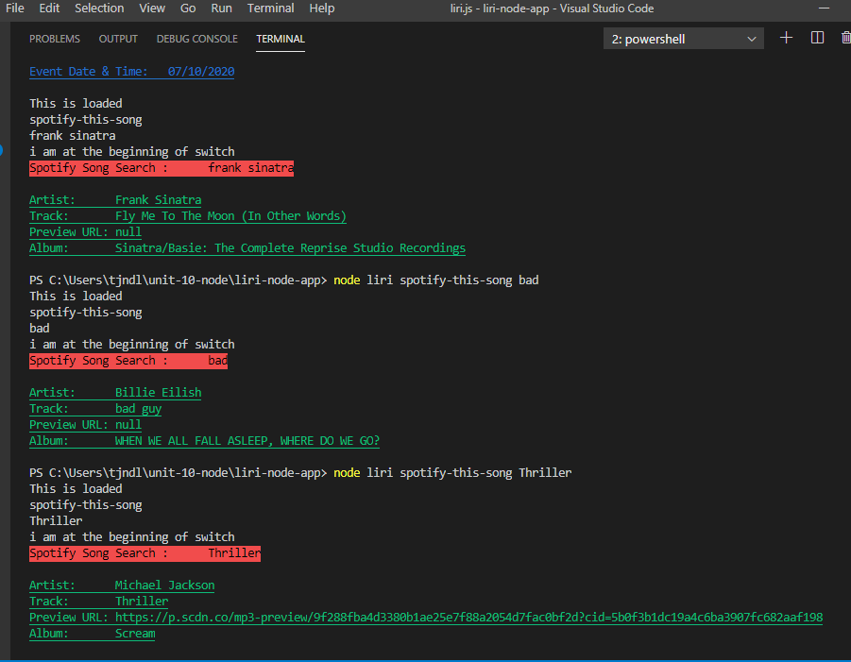

Searching by Do what-it-says (read randon.txt file):

