BamazonCustomer App

>node bamazonCustomer.js

An example of a purchase

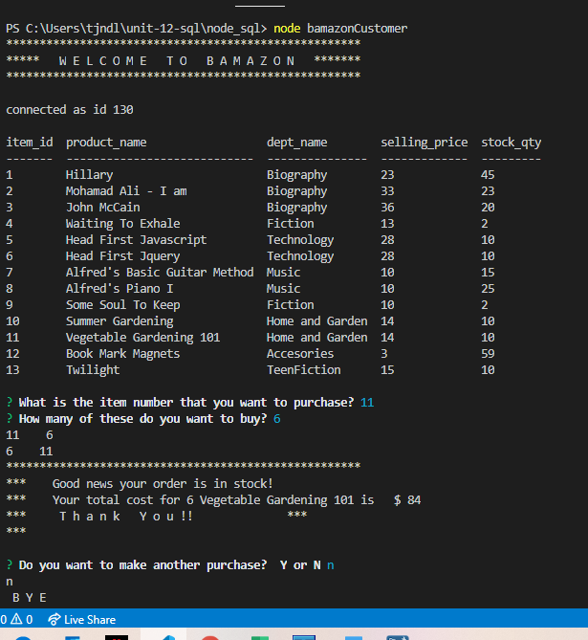

An example of a customer ordering qty of an item where orderQty > actual inventory qty.

