BamazonManager APP

>node bamazonManager

Initial menu

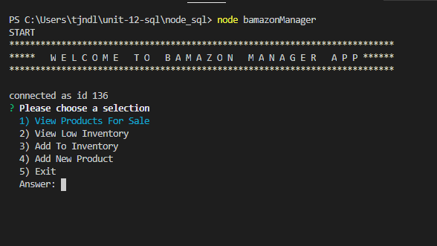

Option 1 ”view products for sale”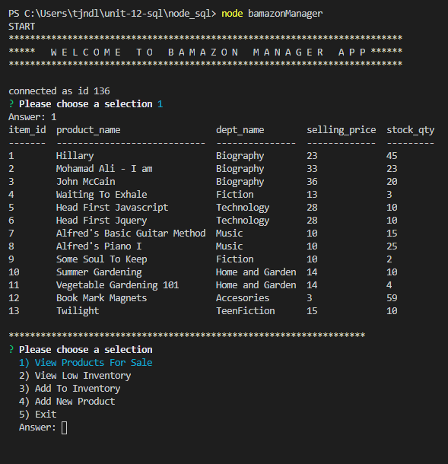

Option 2 – “View Low inventory” (qty < 5)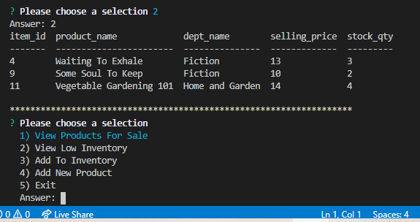

Option 3 “Add to Inventory” (Changing qty-on hand)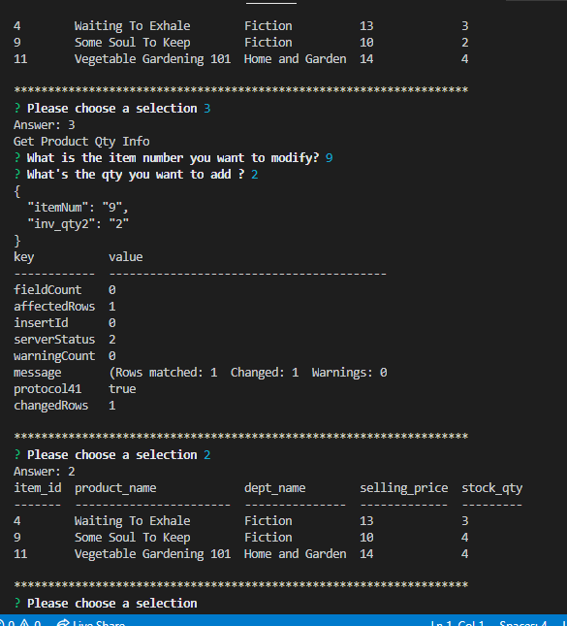

Option 4 “Add New Item”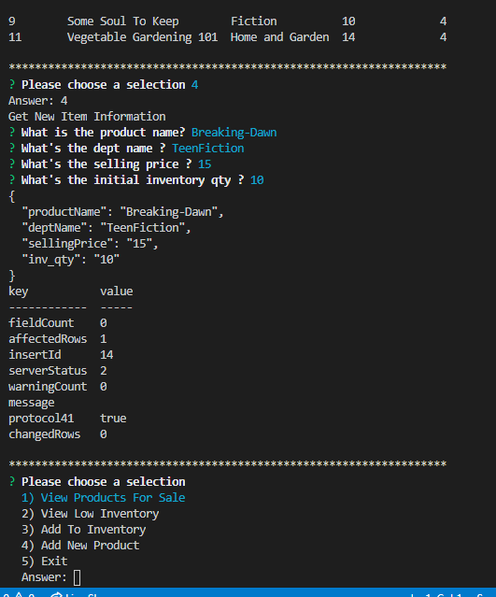

Option 5 – “EXIT”

