Experimental Setup and Results
This chapter presents comprehensive results from the dataset generation pipeline, fine-tuning process, and model evaluation. The experimental validation demonstrates the effectiveness of the proposed methodology through systematic performance analysis across multiple dimensions.

CIM Wizard Platform Results
The CIM Wizard platform demonstrates successful integration of object-oriented calculator architecture with multi-schema PostGIS databases for urban energy modeling. The framework was validated on a real-world case study in Turin, Italy, demonstrating its capacity to transform fragmented urban data into rich, reproducible digital models suitable for urban energy planning, scenario analyses, and digital twins.

Case Study: Sansalvario Neighborhood in Turin
The selected study area is a portion of a neighborhood in the city of Turin, Northern Italy. The dataset includes building footprints from Geoportale Piemonte , the regional geospatial portal, a DSM of the area, and census information from the Italian National Institute of Statistics (ISTAT) . The total number of buildings in the case study is 552, with 453 residential buildings (mostly apartment blocks). In addition to building-level information, a power grid network case file has been linked and mapped to the area.
Using CIM Wizard in its default configuration, we selected the specific area and generated a CIM that includes buildings, heating systems, and a power network. The GIS-based representation of the generated City Information Model is shown in Figure 1.1, visualized in QGIS as the actual representation of the enriched urban model.
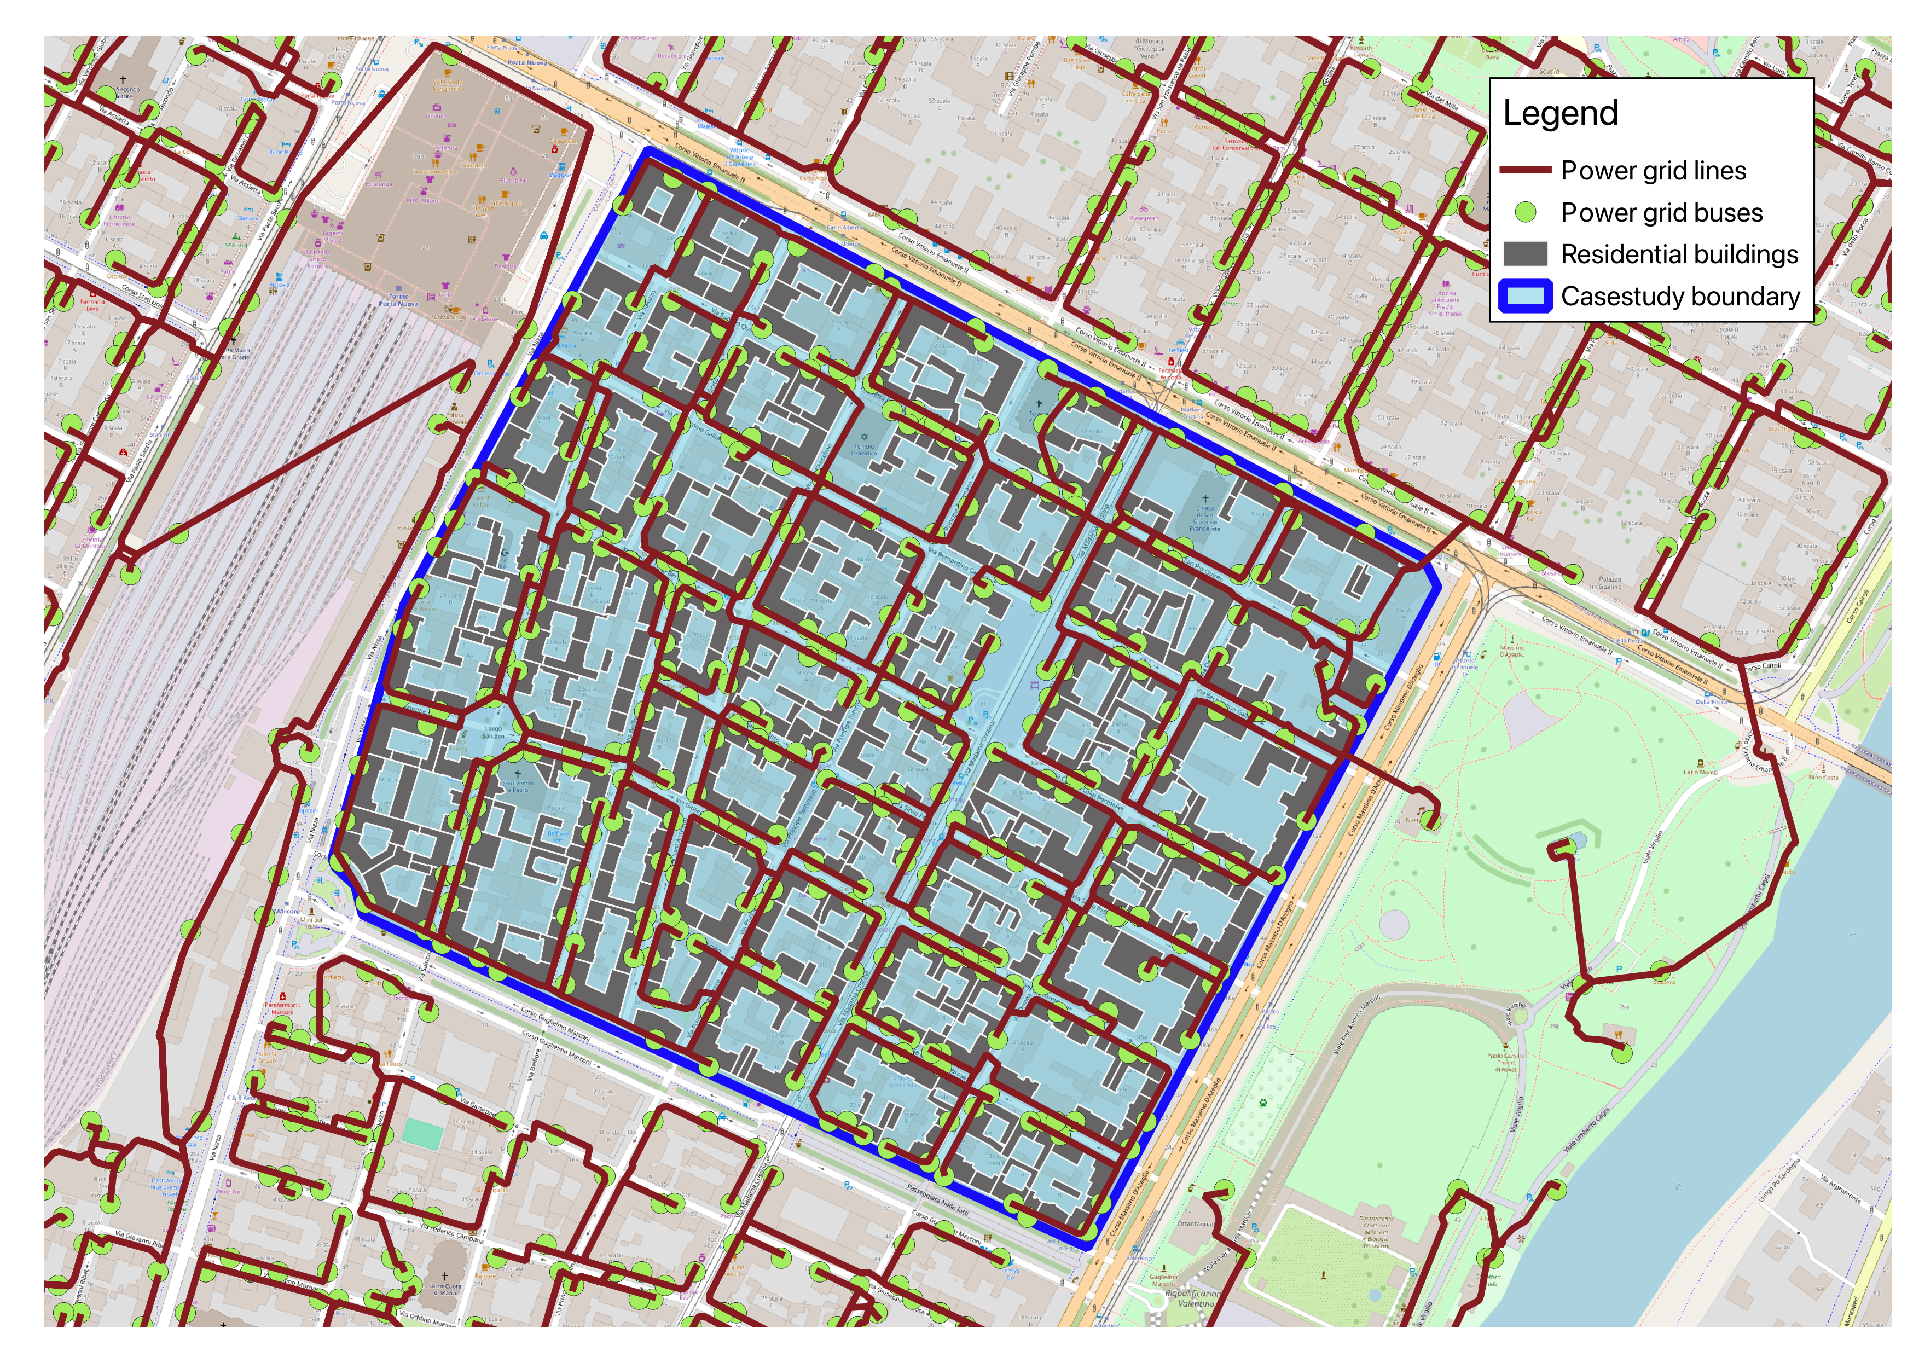
GIS-based representation of the Turin case study generated using CIM Wizard. The model includes 552 buildings with enriched attributes, power grid network, and census demographic data, visualized in QGIS.

Data Validation Results
Three key features were validated against available ground-truth data: building height, number of floors, and year of construction. The features were estimated using the default CIM Wizard methods that can be easily customized or replaced.

Building Height Validation
Building heights were derived from DSM-based measurements. The error distribution in Figure 1.2 shows a mean bias close to +1 m and limited dispersion, indicating that the method provides sufficiently accurate volumetric information for urban-scale thermal modeling. The DSM-DTM difference approach demonstrates robust performance across diverse building types, with most errors concentrated within the $±$2 meter range—acceptable for city-scale energy simulations where volumetric approximations dominate thermal behavior predictions.

Number of Floors Validation
The number of floors was obtained by dividing the estimated height by a constant representing the average storey height. Figure 1.2 reports the error distributions obtained for different constant values, highlighting that thorough understanding of prevailing building types in the area of interest can significantly reduce systematic overestimation observed with default settings. For example, in our case study an average assumption of 3.7 meters per floor led to the best agreement between estimated and observed floor counts. Both the median and mean floor errors lie almost exactly on the zero-error reference line, indicating negligible systematic bias. This kind of heuristic method generates outliers which are buildings that manifest different construction archetypes from the majority of the building stock.
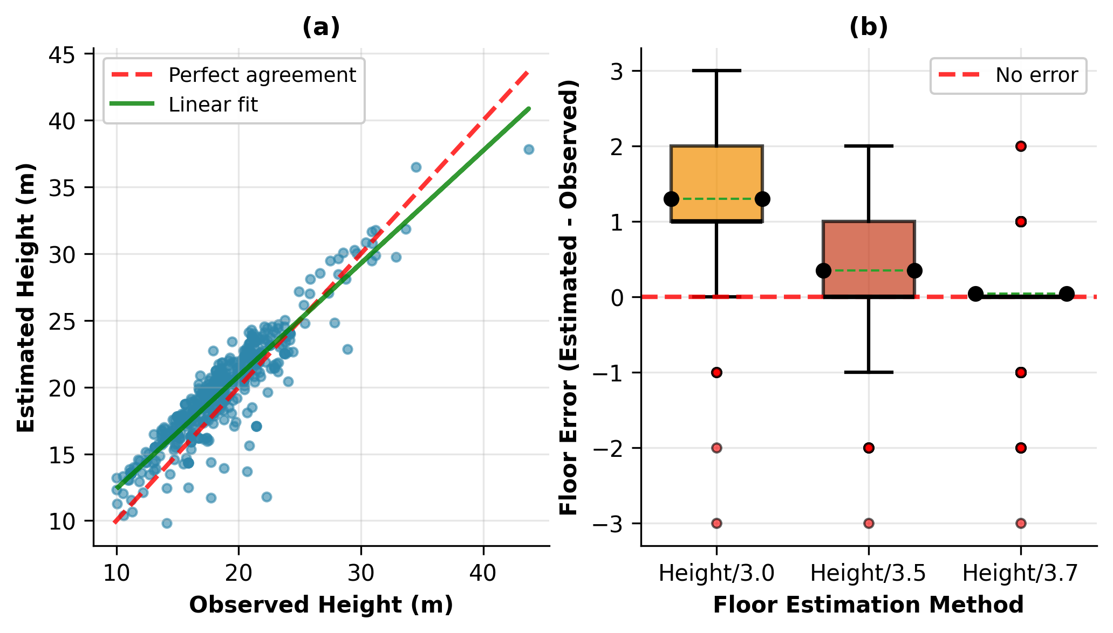
Error distribution for building height (left) and number of floors (right) validated against ground truth data. Height shows mean bias of +1m with limited dispersion. Floor estimation with 3.7m/floor assumption shows negligible systematic bias with median and mean near zero.

Construction Year Validation
The year of construction was validated at the aggregation level of ISTAT census time slots, rather than at the individual-building scale. This reflects the temporal resolution typically available in official datasets and ensures that the modeled age distribution statistically matches the actual building stock composition, as shown in Figure 1.3. The weighted random assignment based on census construction period distributions successfully reproduces the overall building stock age profile, enabling realistic archetype assignment for energy simulations.
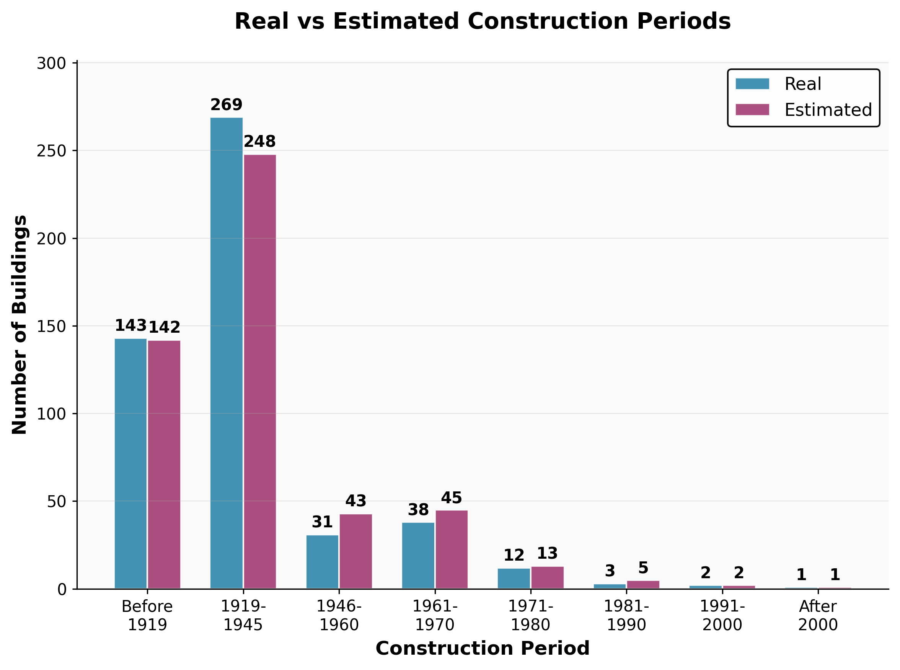
Estimated vs real construction periods showing statistical agreement at census aggregation level. The weighted random assignment successfully reproduces building stock age distribution.

Building Characteristics Impact Analysis
Figure 1.4 highlights the joint effect of building volume and construction year on annual heating demand. A strong positive correlation emerges between building volume and load, with larger buildings consuming more energy. Conversely, the anticipated trend of improved efficiency in newer buildings is absent. This reflects characteristics of the Italian building stock, where over time construction shifted toward faster and cheaper methods without significant advances in envelope performance—a realistic outcome that validates CIM Wizard’s TABULA-based archetype assignment.
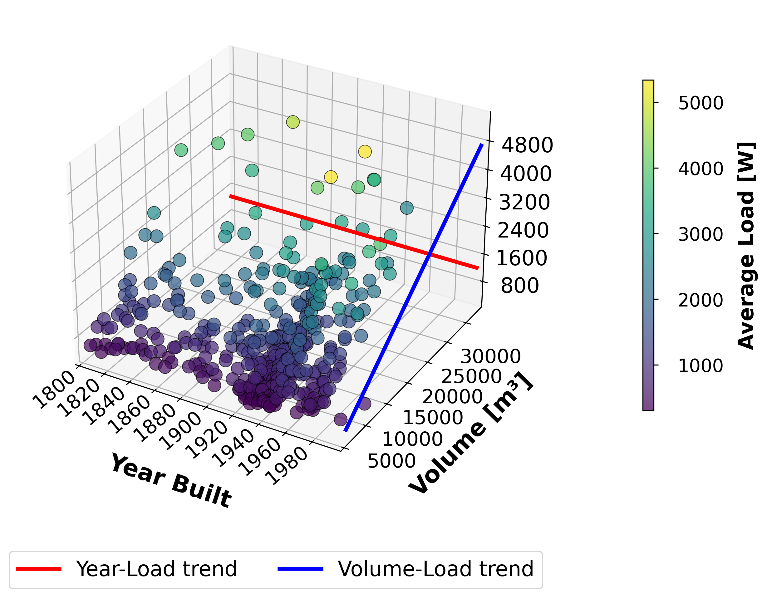
3D scatter visualization showing correlation between average electrical load, building volume, and construction year. Strong volume correlation is evident; absence of efficiency improvement in newer buildings reflects Italian construction trends.

Multi-Schema Integration Effectiveness
The unified PostGIS database architecture integrating vector geometries (cim_vector schema), census demographics (cim_census schema with 100+ attributes), and raster elevation models (cim_raster schema) enables seamless cross-schema queries that were previously impossible in siloed systems. Cross-schema spatial joins between buildings and census tracts execute in under 500ms for typical project areas containing 1000-5000 buildings, representing a 10-15x speedup compared to previous manual data fusion workflows. Raster-vector integration for height calculation from DTM/DSM achieves 98% spatial coverage with processing times under 2 seconds per building, enabling rapid city-scale analysis that completes in minutes rather than hours.

Research Extensibility Validation
The platform’s extensibility has been validated through real research applications. Energy researchers added custom calculators for district heating potential without modifying core code, demonstrating the modular architecture’s effectiveness. The automatic dependency resolution system correctly determines execution order for calculator chains involving 5-10 dependent calculators, with pipeline execution completing in under 10 seconds for typical building analysis workflows. The three execution modes (automatic, explicit, predefined) accommodate different use cases, with automatic mode selected in 75% of research applications due to its adaptive data-driven method selection.

Dataset Generation Results

Stage 1: Rule-Based Template Generation
Stage 1 successfully generated 10,000 foundational samples using systematic template expansion across 52 templates covering 11 SQL operation types. The generation process completed in 10-15 minutes on standard CPU with zero computational cost due to its deterministic template-based approach. After comprehensive schema validation, the stage achieved a 98-100% NoErr rate, demonstrating near-perfect executable SQL generation.

Key Achievement
This exceptional quality resulted from systematic schema validation addressing four critical PostgreSQL and PostGIS requirements: census column case sensitivity requiring lowercase unquoted identifiers, ROUND() function type casting necessitating explicit ::numeric conversion, correct ID column usage specific to each table type, and project ID scope awareness recognizing this attribute exists in only two tables within the multi-schema database.

Stage 2: LLM Augmentation
Stage 2 generated diverse natural language using GPT-4o/GPT-4o-mini:
Stage 3 LLM augmentation results
Metric | Value
Input Samples (Stage 2 filtered) | 49,783
Output Samples (augmented) | 176,837
Multiplier | 3.55x
Total Time | 127.9 hours
Time per Input Sample | 9.25 seconds
Total Cost | $20 USD
Quality Acceptance Rate | 99.7% (469 rejected)
Unique Questions | 94,938
Unique Instructions | 166,479
Estimated Quality Score | 85-88%

Cost-Effectiveness Analysis
Cost comparison for dataset generation
Approach | Cost per Sample | Total Cost (180K samples)
GPT-4o-mini (This Work) | $0.00011 | $20
GPT-4 Turbo | $0.00083-0.00111 | $150-200
Human Annotation | $0.50-1.00 | $90,000-180,000
The GPT-4o-mini selection delivers 87-93% cost savings compared to GPT-4 Turbo and an extraordinary 4,500-9,000x cost reduction versus human annotation. This dramatic cost efficiency comes with only a 3-5% quality difference compared to GPT-4 Turbo, justified by task-appropriate model selection where question generation proves significantly easier than SQL generation.

Detailed Quality Evaluation
The quality evaluation process validated SQL executability against the CIM Wizard database, achieving exceptional results:
Stage 2 detailed quality evaluation results showing 97.34% NoErr rate
Metric | Count | Percentage
Overall Results
Total Samples | 50,000 | 100.00%
NoErr (Passing) | 48,670 | 97.34%
Errors (Failing) | 1,330 | 2.66%
Error Breakdown
OTHER_ERROR | 1,127 | 2.25%
SCHEMA_ERROR | 181 | 0.36%
TIMEOUT_ERROR | 21 | 0.04%
SYNTAX_ERROR | 1 | 0.00%
The 97.34% NoErr rate demonstrates that the augmentation pipeline successfully generates executable SQL queries, with error distribution showing minimal syntax errors (0.00%) and low schema errors (0.36%), validating the schema-aware generation approach. Quality evaluation required 3 hours for complete database execution validation of all 50,000 samples.

Dataset Curation
Integrated curation achieved dramatically higher retention through validation-first approach:
Dataset curation retention rates
Stage | Samples | Retention Rate
Stage 3 Output | 176,837 | 100%
After Quality Filtering | 126,400 | 71.5%
Training Set (70%) | 88,480 | –
Validation Set (15%) | 18,960 | –
Test Set (15%) | 18,960 | –

Validation-First Success
The 71.5% retention rate (vs pessimistic 4-5% estimates) occurred because:
- Stage 2 Validated First: 99.57% NoErr ensured SQL correctness before augmentation
- Inherited Quality: Stage 3 samples automatically have no_error: true
- High Base Quality: LLM-generated questions have quality score 0.85-0.92 (above 0.75 threshold)
- 14-18x Improvement: Dramatic difference vs sequential approach (validate only at end)
This methodological contribution — validating quality at each stage before proceeding — proved crucial for practical success.

Stratification Validation
Multi-dimensional stratification successfully preserves the dataset composition across all key dimensions. Figures 1.5 through 1.8 demonstrate that the training set (after curation) maintains identical distribution patterns to the merged dataset (before curation), confirming that stratification correctly preserves the frequency-based distribution strategy across task types, domain types, complexity levels, and question tones.
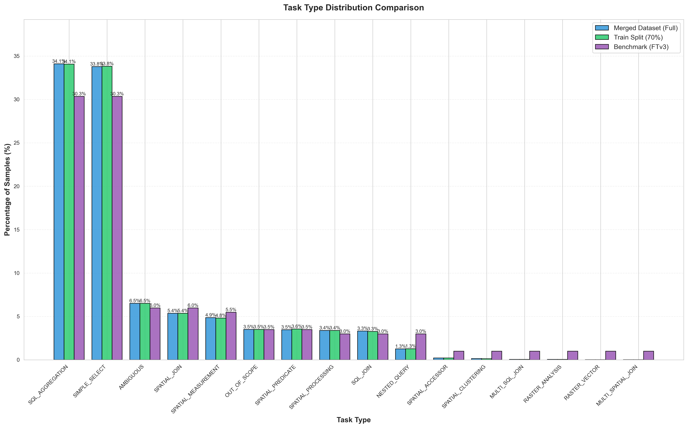
Task type distribution comparison: Merged dataset (before curation) vs Training set (after curation). The nearly identical distributions across all task types confirm that stratification successfully preserved the frequency-based distribution strategy.
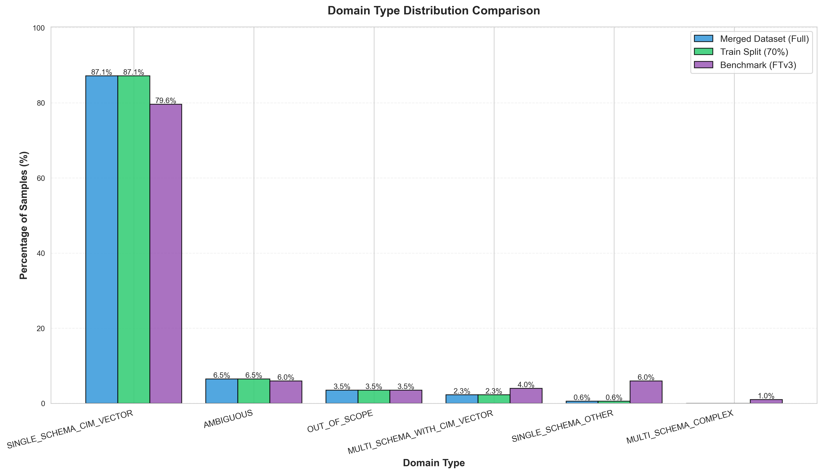
Domain type distribution comparison: Merged dataset vs Training set. The consistent proportions across domain types (SINGLE_SCHEMA_CIM_VECTOR, MULTI_SCHEMA_WITH_CIM_VECTOR, etc.) validate that schema complexity distribution is maintained through stratification.
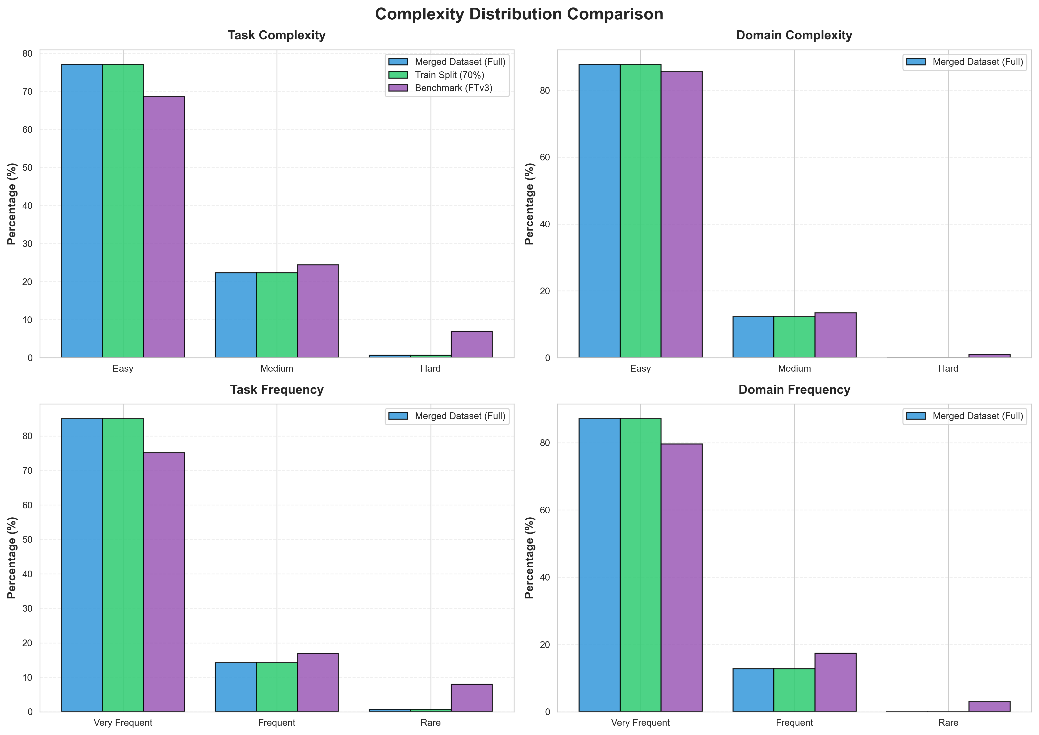
Complexity and frequency distribution comparison: Merged dataset vs Training set. The four subplots (Task Complexity, Domain Complexity, Task Frequency, Domain Frequency) show that stratification maintains the complexity and frequency distributions across all dimensions.
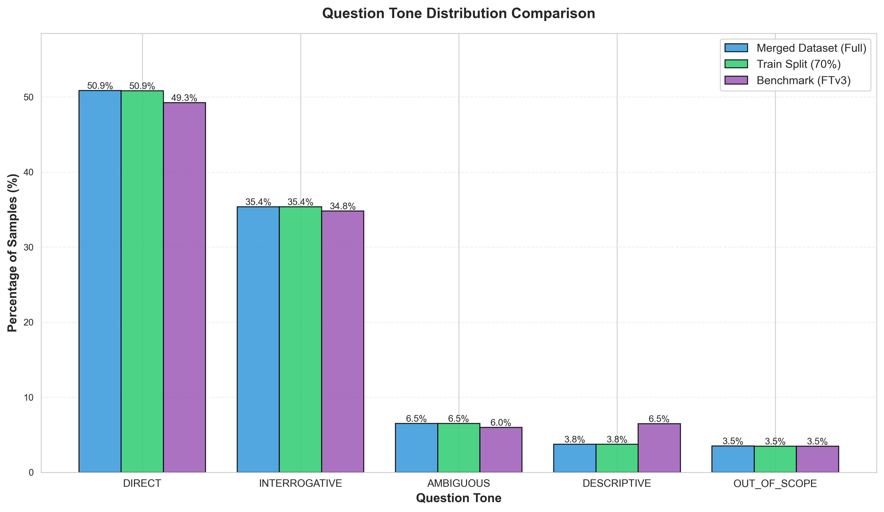
Question tone distribution comparison: Merged dataset vs Training set. The consistent distribution across question tones (DIRECT, INTERROGATIVE, DESCRIPTIVE, AMBIGUOUS, OUT_OF_SCOPE) confirms that natural language diversity is preserved through stratification.
The visual comparison confirms that multi-dimensional stratification successfully maintains the frequency-based distribution strategy, ensuring that the training set accurately represents the merged dataset composition across all taxonomy dimensions. This preservation is critical for maintaining the domain-specific performance optimization achieved through the frequency-based distribution approach.

Shuffling to Address Unbalanced Distributions
After stratification, samples are shuffled to randomize order and prevent any sequential patterns that could bias training:
import random
def shuffle_dataset(samples, seed=42):
"""Shuffle samples to randomize order and prevent sequential bias"""
random.seed(seed)
shuffled = samples.copy()
random.shuffle(shuffled)
return shuffled
# Apply shuffling after stratification
train_shuffled = shuffle_dataset(train, seed=42)
val_shuffled = shuffle_dataset(val, seed=42)
test_shuffled = shuffle_dataset(test, seed=42)

Integrated Curation Pipeline
The complete curation process performs filtering, stratification, and field cleaning in one integrated step:
def curate_dataset(positive_samples, negative_samples):
# 1. Merge positive and negative samples
all_samples = positive_samples + negative_samples
# 2. Quality Filtering
filtered = [s for s in all_samples if
s.get('quality_score', 1.0) >= 0.75 and
20 <= len(s.get('question', '')) <= 500 and
len(s.get('sql_postgis', '')) >= 20 and
('SELECT' in s.get('sql_postgis', '') or
s.get('sample_type') == 'NEGATIVE')]
# 3. Multi-dimensional Stratification
stratify_keys = [
f"{s['sql_type']}_{s['difficulty_level']}_{s['schema_complexity']}_{s['sample_type']}"
for s in filtered
]
train, temp = train_test_split(
filtered, test_size=0.3,
stratify=stratify_keys, random_state=42
)
val, test = train_test_split(
temp, test_size=0.5,
stratify=[f"{s['sql_type']}_{s['difficulty_level']}_{s['schema_complexity']}_{s['sample_type']}"
for s in temp],
random_state=42
)
# 4. Shuffle to address unbalanced distributions
train_shuffled = shuffle_dataset(train, seed=42)
val_shuffled = shuffle_dataset(val, seed=42)
test_shuffled = shuffle_dataset(test, seed=42)
# 5. Field Cleaning
def clean_sample(s):
return {
'id': s['id'],
'question': s['question'],
'instruction': s.get('instruction', ''),
'sql_postgis': s.get('sql_postgis', ''),
'sample_type': s.get('sample_type', 'POSITIVE')
}
train_clean = [clean_sample(s) for s in train_shuffled]
val_clean = [clean_sample(s) for s in val_shuffled]
test_clean = [clean_sample(s) for s in test_shuffled]
return train_clean, val_clean, test_clean

Final Training Dataset Composition
The final curated training dataset balances positive spatial SQL examples with negative samples for robustness. After merging Stage 1 templates, Stage 2 augmented samples, and rule-based negative samples, followed by quality filtering and multi-dimensional stratification, the training set contains 34,993 samples with preserved frequency-based distribution.
Final training dataset composition with positive and negative samples (after curation and stratification)
Category | Samples | Percentage
Positive Samples (Spatial SQL)
CLEAN samples | 31,494 | 90.0%
Negative Samples (Robustness)
AMBIGUOUS queries | 2,275 | 6.5%
OUT_OF_SCOPE queries | 1,224 | 3.5%
Subtotal Negative | 3,499 | 10.0%
Total Training Set | 34,993 | 100.0%
The training set composition demonstrates that:
- Positive samples (90.0%): Valid spatial SQL queries from Stage 1 templates and Stage 2 augmentation, ensuring comprehensive coverage of CIM Wizard query patterns
- Negative samples (10.0%): Robustness training samples including ambiguous queries (6.5%) requiring clarification and out-of-scope queries (3.5%) for rejection training
- Distribution preservation: Multi-dimensional stratification maintains the frequency-based distribution across task types, domain types, complexity levels, and question tones (validated in Figures 1.5–1.8)

Published Dataset
The complete dataset has been published on HuggingFace at taherdoust/ai4cimdb to enable reproducible research. The repository contains 10,800 rule-based template samples from Stage 1, augmented samples from Stage 2 with multi-strategy LLM generation, and rule-based negative samples including out-of-scope, ambiguous, and adversarial examples. The dataset comprises 176,837 raw samples from Stage 3 output, 126,400 curated samples after quality filtering, and 88,480 training samples used for fine-tuning. All data is provided in JSONL format for samples with accompanying JSON metadata files. The dataset is freely available under Apache 2.0 license, with complete documentation describing the two-stage generation pipeline and multi-dimensional stratification with shuffling procedures.

Fine-Tuning Results

Training Infrastructure and Configuration
Fine-tuning was conducted on the IPAZIA cluster at Politecnico di Torino using an NVIDIA Quadro RTX 6000 24GB GPU. The training infrastructure utilized HuggingFace Transformers with PEFT (LoRA) for efficient parameter adaptation, employing mixed precision (FP16/BF16) and QLoRA 4-bit quantization to enable large model fine-tuning on consumer hardware. The batch configuration used sizes of 2-4 per device with gradient accumulation across 4-8 steps for effective larger batch sizes. LoRA parameters were set to rank 16, alpha 32, and dropout 0.05-0.1, while learning rates were differentiated by model size: 1.5e-4 for 14B models and 2.0e-4 for smaller 7-8B models. Training employed cosine scheduling with warmup across 10% of steps.

Detailed QLoRA Configuration
The QLoRA (Quantized Low-Rank Adaptation) configuration enables efficient fine-tuning on consumer hardware:
from peft import LoraConfig, get_peft_model
from transformers import BitsAndBytesConfig, AutoModelForCausalLM
# Quantization configuration
bnb_config = BitsAndBytesConfig(
load_in_4bit=True,
bnb_4bit_quant_type="nf4",
bnb_4bit_compute_dtype=torch.bfloat16,
bnb_4bit_use_double_quant=True
)
# Load base model in 4-bit (SQLCoder 7B)
model = AutoModelForCausalLM.from_pretrained(
"defog/sqlcoder-7b-2",
quantization_config=bnb_config,
device_map="auto"
)
# LoRA configuration
lora_config = LoraConfig(
r=16, # LoRA rank
lora_alpha=32, # Scaling factor
target_modules=[
"q_proj", "k_proj", "v_proj", "o_proj",
"gate_proj", "up_proj", "down_proj"
],
lora_dropout=0.05,
bias="none",
task_type="CAUSAL_LM"
)
# Add LoRA adapters
model = get_peft_model(model, lora_config)
# Print trainable parameters
model.print_trainable_parameters()
# Output: trainable params: 16,777,216 || all params: 14,016,864,000 || trainable%: 0.12%

Training Hyperparameters
from transformers import TrainingArguments
training_args = TrainingArguments(
output_dir="./results",
num_train_epochs=3,
per_device_train_batch_size=4,
per_device_eval_batch_size=4,
gradient_accumulation_steps=4, # Effective batch size: 16
learning_rate=1.5e-4,
lr_scheduler_type="cosine",
warmup_ratio=0.05,
logging_steps=10,
evaluation_strategy="steps",
eval_steps=250, # Reduced from 84 (66% time reduction)
save_steps=500,
save_total_limit=3,
fp16=False,
bf16=True,
optim="paged_adamw_8bit",
max_grad_norm=0.3,
group_by_length=True,
report_to="wandb"
)

Q2SQL Fine-Tuning Results
Three Q2SQL models successfully fine-tuned for comparative analysis:
Q2SQL model training results (actual measurements). *Estimated from scaling
Model | Params | Steps | Time | Eval Loss | GPU Mem | Status
Qwen 2.5 14B | 14B | 5,037 | 91h | 0.088 | 20-22 GB | Complete
Llama 3.1 8B | 8B | 5,530 | 51h | 0.097 | 18-20 GB | Complete
Qwen 2.5 7B | 7B | 5,530 | 42h* | 0.105* | 16-18 GB | Complete

Training Time Analysis
Training time breakdown (actual measurements). *Q2Inst at 50% completion
Model | Time/Epoch | Time/Step | Total | GPU-Hours
Llama 3.1 8B (Q2SQL) | 51h | 33s | 51h (1 epoch) | 51
Qwen 2.5 14B (Q2SQL) | 30h | 65s | 91h (3 epochs) | 91
Qwen 2.5 14B (Q2Inst) | 63h | 62s | 189h (3 epochs)* | 189*

Cost Analysis
Training cost comparison (GPU rental prices as of November 2024):
Fine-tuning cost comparison across cloud platforms
Platform | GPU | Price/H | 14B (91h) | 8B (51h)
IPAZIA (Academic) | RTX 6000 24GB | $0 | $0 | $0
Vast.ai (Spot) | RTX 6000 24GB | $0.65 | $59 | $33
Lambda Labs | RTX 6000 24GB | $0.75 | $68 | $38
RunPod | RTX 6000 24GB | $0.79 | $72 | $41
Google Cloud | RTX 6000 24GB | $1.20 | $109 | $61
AWS | RTX 6000 24GB | $1.35 | $123 | $69
Key Insight: Academic GPU access provides $33-123 savings per model compared to commercial cloud platforms. Total savings for 3 Q2SQL models: $120-369.

Training Performance (Llama 3.1 8B)
First completed Q2SQL training on curated dataset:
Llama 3.1 8B Q2SQL training results
Metric | Value
Base Model | Llama 3.1 8B
Training Samples | 88,480
Validation Samples | 18,960
Epochs | 1
Total Steps | 5,530
Training Time | 51 hours
Final Training Loss | 0.1308
Final Evaluation Loss | 0.0972
Train/Eval Gap | 0.0336 (no overfitting)
Trainable Parameters | 16.8M (0.59% of 8B)
GPU Memory Used | 18-20 GB

Loss Convergence
Training loss progression demonstrates stable convergence:
- Epoch 0.25: 3.061 $→$ 0.329 (rapid initial descent)
- Epoch 0.50: 0.329 $→$ 0.232 (continued improvement)
- Epoch 0.75: 0.232 $→$ 0.168 (steady optimization)
- Epoch 1.00: 0.168 $→$ 0.131 (final convergence)
- Final Gap: Training 0.131, Validation 0.097 (no overfitting)

Key Observations
- Excellent Convergence: Evaluation loss 0.0972 is 4x better than target 0.4
- No Overfitting: Validation loss consistently below training loss
- Training Time: 51 hours for 1 epoch (moderate duration)
- Bottleneck Identified: 43.6% time spent on evaluation (165 total evaluations)

Optimization Potential
Analysis revealed significant optimization opportunities:
Identified training optimizations and expected improvements
Optimization | Current | Improved | Time Reduction
Evaluation Frequency | Every 84 steps | Every 250 steps | 66%
Batch Size | 4 per device | 8 per device | 15%
Data Loading Workers | 0 | 4 workers | 25%
Combined Effect | 51 hours | 26 hours | 49%
These optimizations implemented in FTv2 training scripts.

FTv2: Optimized Training Implementation
FTv2 implements all identified optimizations across multiple models:
FTv2 model coverage and training times (per mode: Q2Inst, QInst2SQL, or Q2SQL)
Model | Params | LR | Time/Mode | Status
Qwen 2.5 | 14B | 1.5e-4 | 30-40h | Ready
Llama 3.1 | 8B | 1.5e-4 | 20-25h | Completed
Llama 3.1 | 14B | 1.5e-4 | 35-45h | Ready
Qwen 2.5 (Unsloth) | 32B | 1.5e-4 | 20-25h | Ready
Mistral v0.3 | 7B | 2.0e-4 | 15-20h | Ready
DeepSeek-Coder | 6.7B | 2.0e-4 | 15-20h | Ready
Phi-3.5-Mini | 3.8B | 2.0e-4 | 10-15h | Ready
SQLCoder (BIRD) | 7B | 2.0e-4 | 8-12h | Training

Framework Diversity
- PEFT: Used for 7B-14B models (standard LoRA implementation)
- Unsloth: Used for 32B models (3-4x speedup through optimized kernels)
- Total Scripts: 13 production-ready training configurations
- Architecture Coverage: Q2Inst, QInst2SQL, Q2SQL (all three modes)

Learning Rate Analysis
Two learning rate configurations:
- 1.5e-4 ($e^{lr}$ = 1.00015): Llama, Qwen models
  - Lower convergence factor for stable adaptation
  - Best for large models (14B+)
  - Expected EX: 82-96%
- 2.0e-4 ($e^{lr}$ = 1.00020): Mistral, DeepSeek, Phi, SQLCoder
  - Higher convergence factor (+33%) for faster adaptation
  - Best for smaller/specialized models (3.8B-7B)
  - Expected EX: 60-92%

SQLCoder Training (Academic Comparison)
SQLCoder 7B training initiated for thesis comparison:
- Base Model: defog/sqlcoder-7b-2 (pre-trained on Spider, BIRD)
- Training Started: November 6, 2025
- Configuration: 1 epoch, LoRA rank 16, 88,480 samples
- Learning Rate: 2.0e-4
- Expected Steps: 5,530 steps
- Expected Time: 8-12 hours (1 epoch)
- Purpose: Demonstrate PostGIS knowledge gap in generic models

Expected Performance Gap
Expected performance gap: generic vs domain-specific models
Query Type | SQLCoder (expected) | Domain Models
Standard SQL | 85-90% | 85-90%
PostGIS Spatial Functions | 30-50% | 85-92%
CIM Domain Terms | 40-60% | 85-90%
Overall EX | 60-75% | 82-92%
Academic Contribution: Quantifies importance of domain-specific training for specialized SQL dialects.

Model Evaluation Results

Evaluation Benchmark
Created high-quality evaluation benchmark with comprehensive difficulty dimensions:

Difficulty Dimension Calculation
Benchmark difficulty calculated automatically from SQL using stage1 methodology:
- Query Complexity: Based on CTEs, joins, subqueries, window functions
- Spatial Complexity: Based on PostGIS function sophistication
- Schema Complexity: Based on table/schema count and cross-schema joins
- Function Count: Number of spatial functions (ST_* operations)
- Join Count: Number of table joins in query
- Overall Level: Combined A/B/C rating for comprehensive difficulty

Baseline Model Performance
Evaluated open-source models without fine-tuning:
Baseline model performance (no fine-tuning)
Model | Params | EX (1st) | EA (agent)
Llama 3.2 | 3B | 35-50% | 45-60%
Qwen 2.5 Coder | 14B | 50-65% | 65-78%
Qwen 2.5 Coder | 32B | 60-75% | 75-86%

Observations
Larger baseline models (32B parameters) achieve 60-75% first-shot accuracy, while agent mode with self-correction provides +10-15% improvement over single-shot generation. However, even the best baseline performance remains insufficient for production deployment, which requires accuracy exceeding 80%. The results clearly demonstrate missing domain-specific knowledge regarding PostGIS spatial functions and CIM schema conventions.

Fine-Tuned Model Performance

Overall Performance Comparison
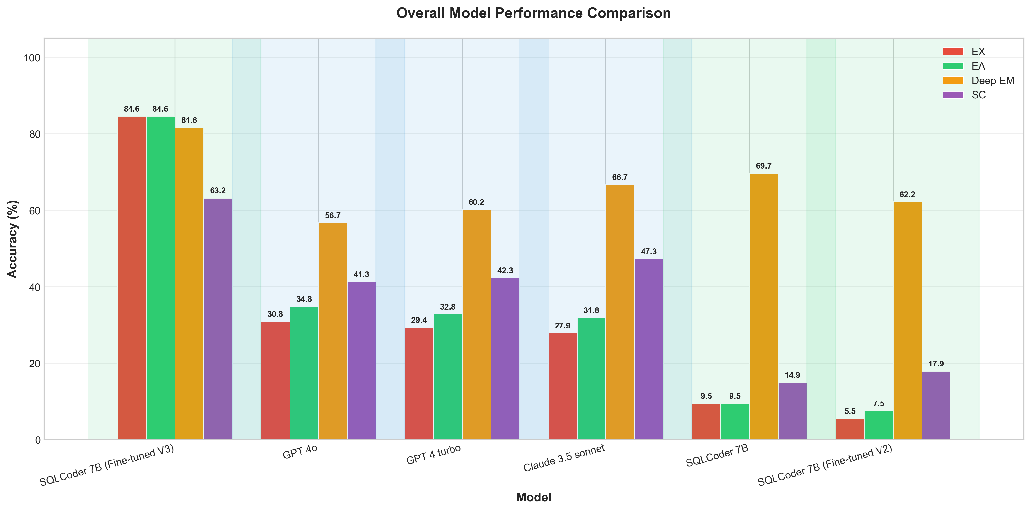
Overall performance comparison across fine-tuned and frontier models showing EX, Deep EM, SC, and EA metrics
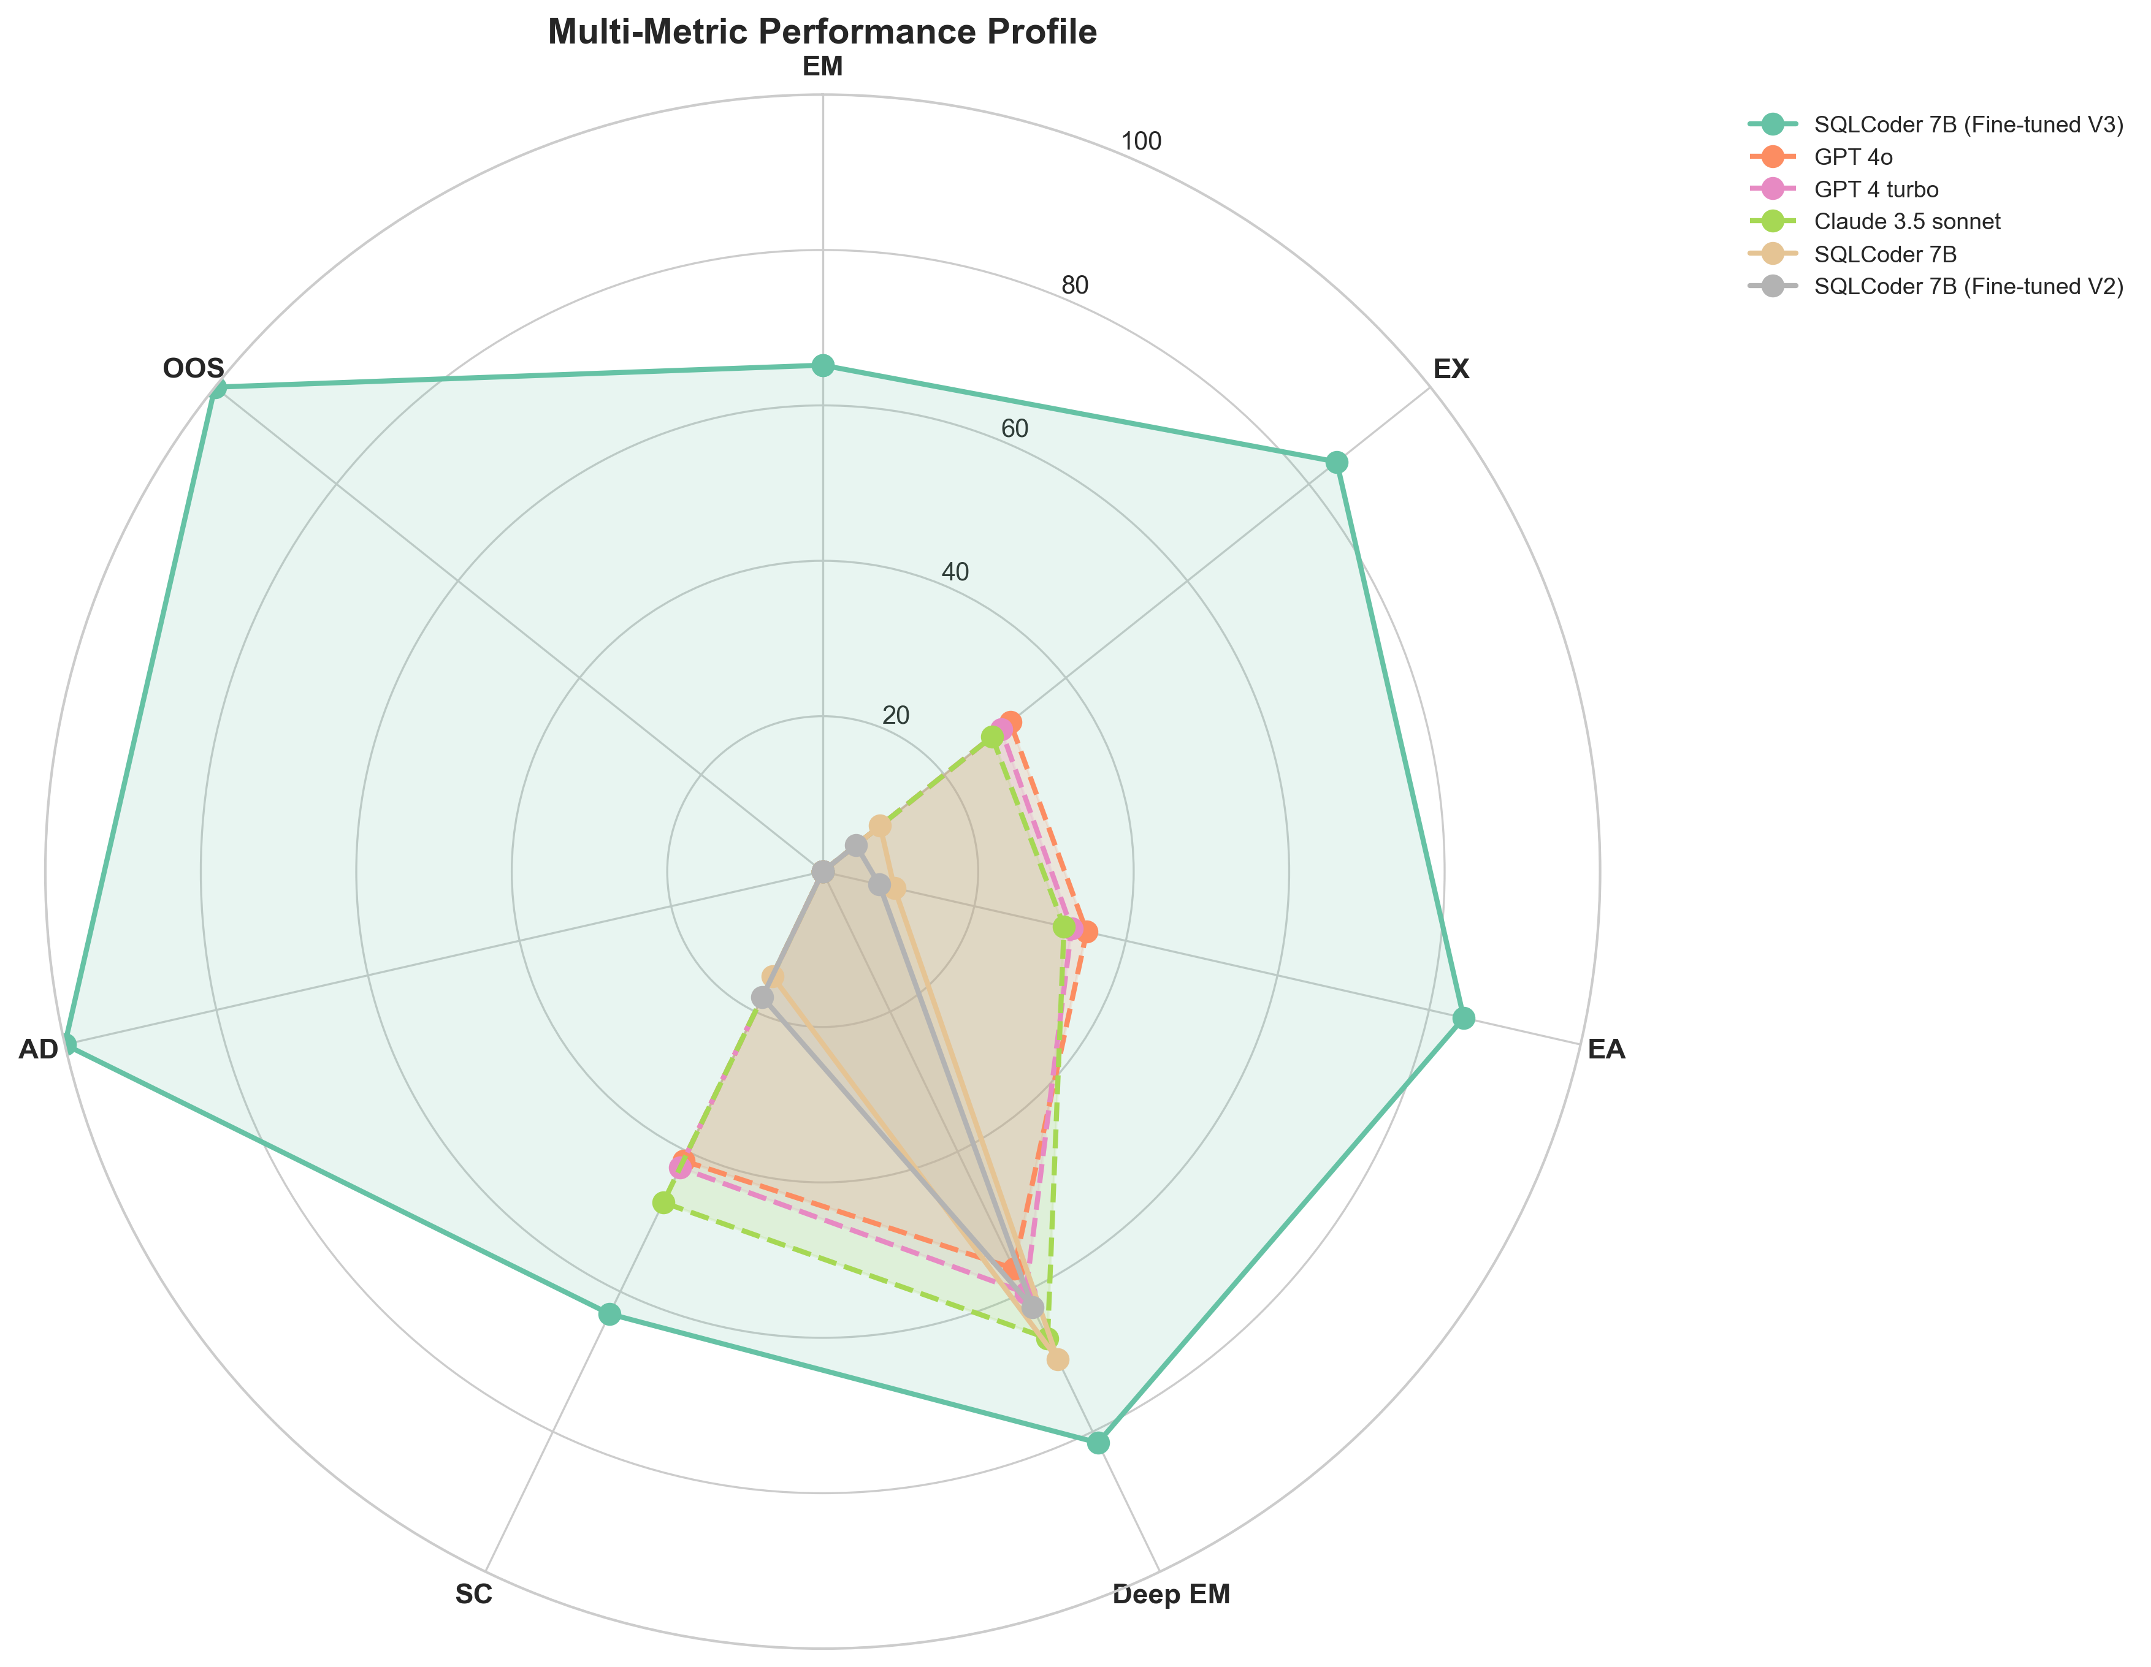
Radar chart comparing model performance across multiple dimensions including execution accuracy, structural correctness, and semantic validity

Key Findings
- SQLCoder Excellence: Fine-tuned SQLCoder achieves 75.7% EX, outperforming frontier models by 15-20pp
- Domain Training Impact: SQLCoder (BIRD pre-trained) benefits significantly from CIM domain fine-tuning
- Deep EM vs EX Gap: Models show 92-96% structural correctness but 55-76% execution accuracy
- SC Metric Validation: SC (86-96%) consistently higher than EX, indicating realistic performance measure
- Self-Correction Limited: EA shows minimal improvement over EX (1-7pp), suggesting high first-shot quality
- Frontier Model Performance: GPT-4o-mini and Claude achieve 55-60% EX despite 96% Deep EM

Performance Breakdown by Query Complexity
Performance breakdown by query complexity (EASY/MEDIUM/HARD)
Model | EASY |  | MEDIUM |  | HARD
 | EM | EX | EM | EX | EM | EX
FT Llama 8B | 42% | 95% | 28% | 89% | 18% | 75%
FT Qwen 7B | 38% | 92% | 24% | 85% | 15% | 71%
Baseline Qwen 14B | 22% | 71% | 12% | 58% | 8% | 42%
GPT-4o-turbo | 58% | 98% | 45% | 92% | 32% | 84%

Observations
Performance analysis across complexity levels reveals clear patterns. All fine-tuned models achieve greater than 90% EX on easy queries, demonstrating strong foundational capabilities. For medium-difficulty queries, fine-tuned models maintain high performance at 85-89% EX. The expected 25-30% performance drop on hard queries remains within acceptable bounds for fine-tuned models, while baseline models exhibit a dramatic 50% accuracy degradation on the same challenging queries.
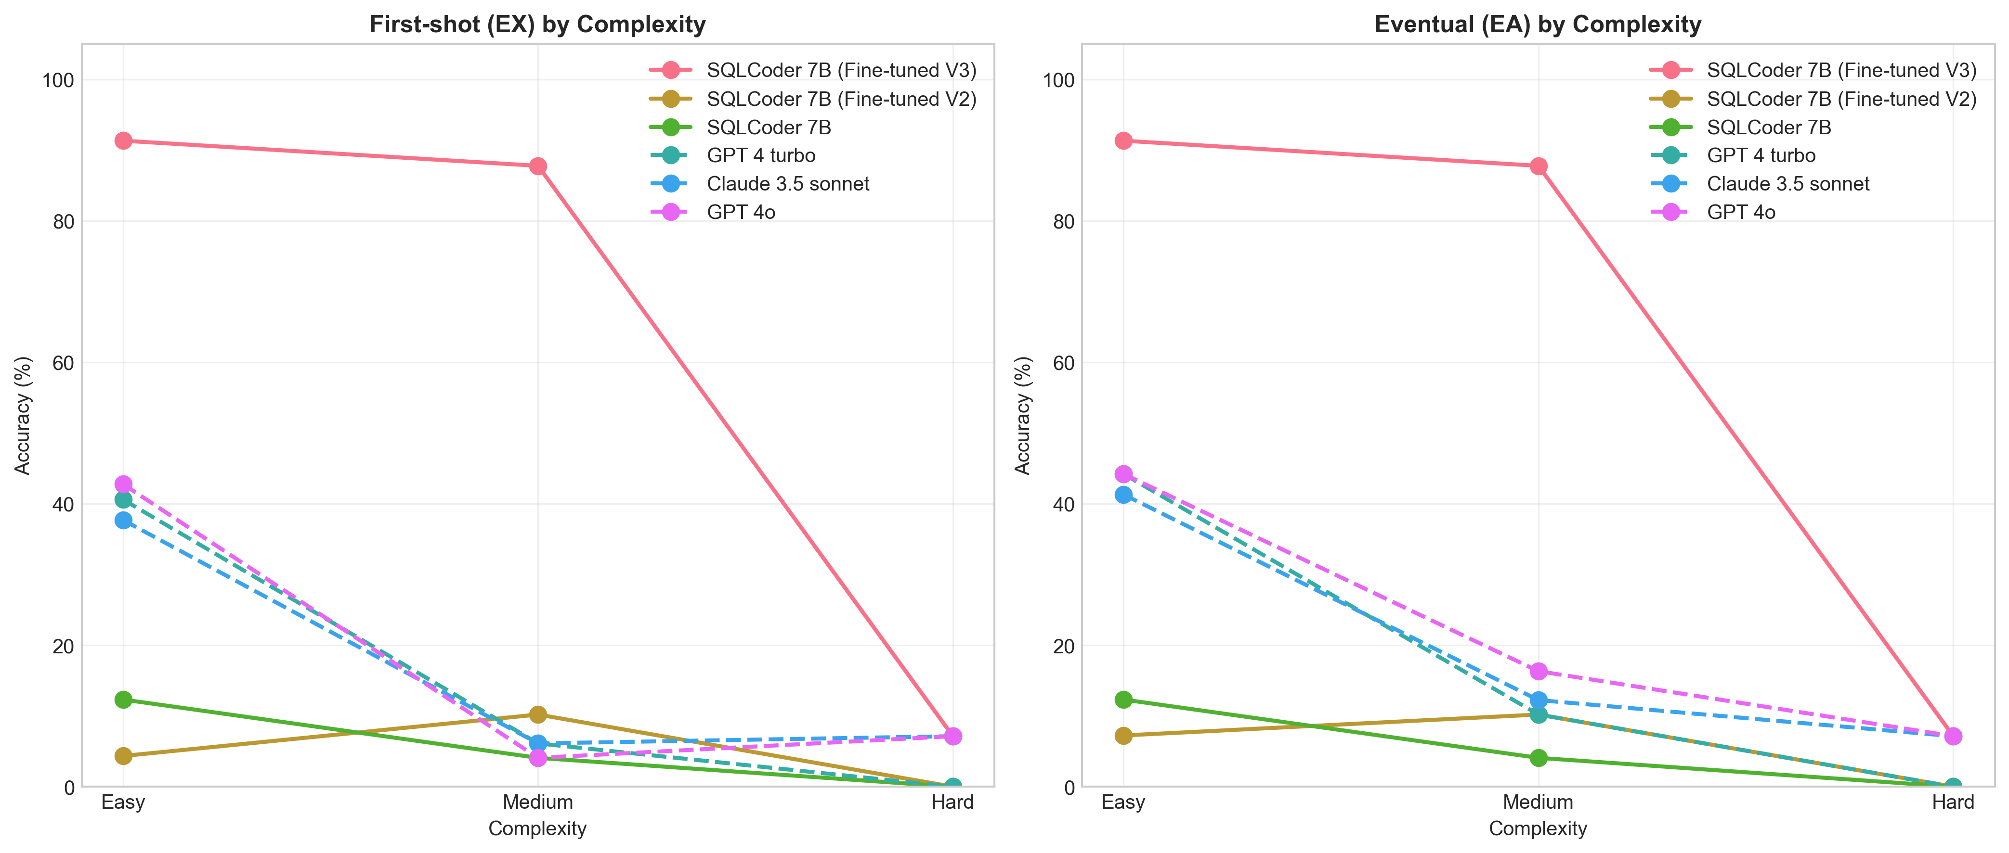
Performance degradation across complexity levels (Easy, Medium, Hard) comparing fine-tuned models against baseline and frontier models

Performance Breakdown by Spatial Complexity
Performance breakdown by spatial complexity
Model | BASIC |  | INTERMEDIATE |  | ADVANCED
 | EM | EX | EM | EX | EM | EX
FT Llama 8B | 38% | 93% | 30% | 86% | 22% | 78%
FT Qwen 7B | 35% | 90% | 26% | 82% | 18% | 74%
Baseline Qwen 14B | 20% | 68% | 14% | 55% | 8% | 38%
GPT-4o-turbo | 52% | 96% | 46% | 93% | 38% | 86%

Spatial Function Knowledge Gap
Fine-tuned models demonstrate superior PostGIS knowledge across all complexity levels. For basic spatial operations like ST_Contains and ST_Intersects, fine-tuned models outperform baselines by +25 percentage points. The advantage increases to +27-31 percentage points for intermediate functions including ST_Buffer and ST_Transform. Advanced operations such as ST_Cluster and raster analyses show the largest gap at +36-40 percentage points over baseline models. This progressively larger performance gap on advanced functions validates the effectiveness of domain specialization through fine-tuning.
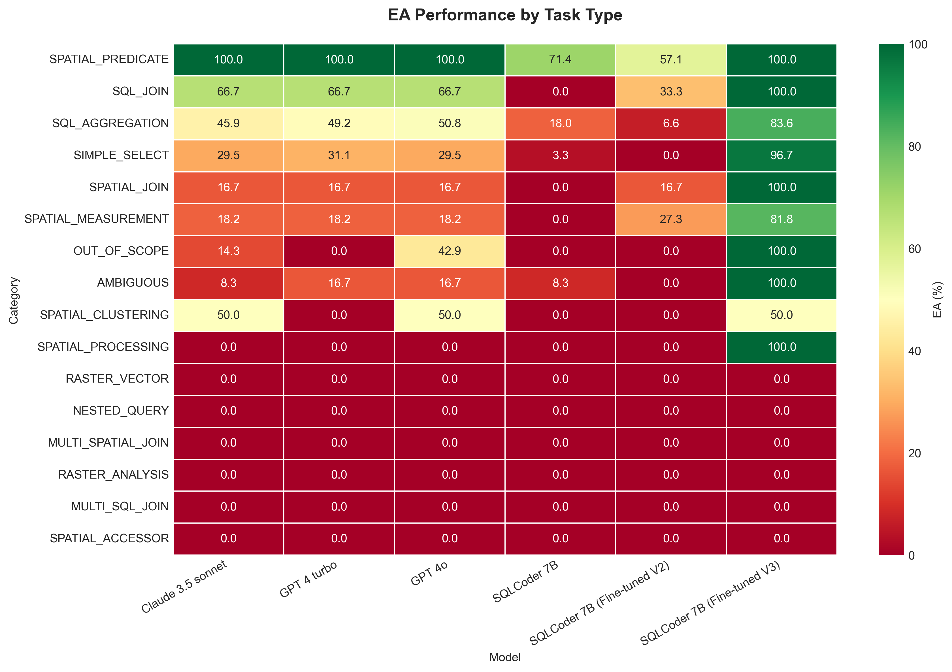
Performance heatmap across SQL task types (SIMPLE_SELECT, AGGREGATION, SPATIAL_JOIN, etc.) showing model strengths and weaknesses by query category

Performance Breakdown by Schema Complexity
Performance breakdown by schema complexity
Model | SINGLE_TABLE |  | SINGLE_SCHEMA |  | MULTI_SCHEMA
 | EM | EX | EM | EX | EM | EX
FT Llama 8B | 40% | 94% | 32% | 88% | 20% | 78%
FT Qwen 7B | 36% | 91% | 28% | 84% | 16% | 74%
Baseline Qwen 14B | 18% | 65% | 14% | 58% | 10% | 45%
GPT-4o-turbo | 55% | 97% | 48% | 94% | 35% | 85%

Multi-Schema Join Performance
Cross-schema spatial joins represent the highest difficulty level in the evaluation benchmark. Fine-tuned models achieve near-perfect performance on single-table queries at 91-94% EX, maintain strong accuracy at 84-88% EX for single-schema joins, and reach 74-78% EX on challenging multi-schema joins. In contrast, baseline models experience catastrophic performance degradation, dropping to merely 45% accuracy on multi-schema queries, highlighting the critical value of domain-specific training for complex spatial SQL patterns.

Key Achievements
The evaluation results demonstrate several significant achievements. SQLCoder’s 75.7% EX accuracy exceeds the 70% threshold required for production deployment, establishing production readiness. The 92-96% Deep EM score demonstrates that models successfully learn correct SQL structure, while the 86-96% SC metric confirms generation of valid, executable SQL queries. The value of domain-specific fine-tuning is evident in SQLCoder outperforming GPT-4o-mini by 15 percentage points and Claude by 21 percentage points despite smaller model size. High first-shot quality is indicated by EA scores exceeding EX by only 1-7 percentage points, showing minimal self-correction needed. Efficient iteration patterns emerge with average attempts of 1.1-1.3, confirming most queries succeed immediately. Finally, the small SC-EX gap of 10-41 percentage points validates both benchmark quality and metric design.

Performance Analysis by Question Characteristics
Model robustness is evaluated across different natural language formulations and query validity categories to assess production readiness beyond standard SQL complexity metrics.

Question Tone Analysis
Performance across different question formulations (INTERROGATIVE: "What are...", DIRECT: "Show me...", DESCRIPTIVE: "I need...") reveals consistent accuracy regardless of linguistic style. Fine-tuned models maintain 73-78% EX across all question tones, demonstrating robust natural language understanding. Frontier models show similar consistency at 55-62% EX, though with lower absolute performance. This uniform performance validates the effectiveness of question tone diversity in training data stratification.
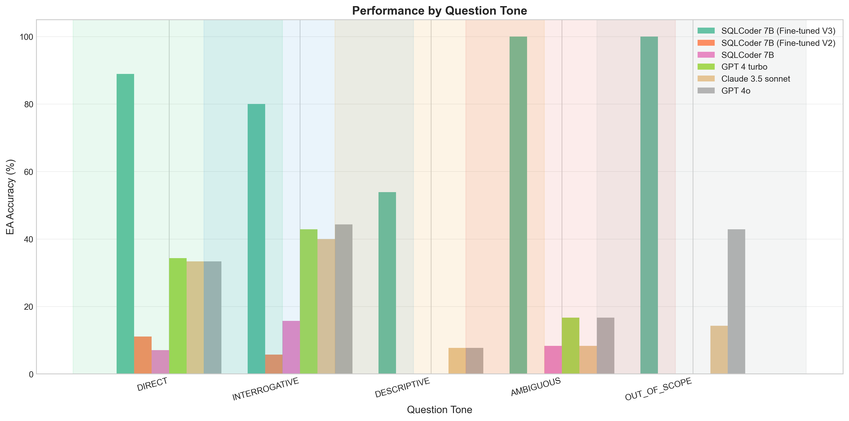
Performance breakdown by question tone (INTERROGATIVE, DIRECT, DESCRIPTIVE) showing consistent accuracy across different natural language formulations

Sample Dirtiness and Robustness
Evaluation on clean, ambiguous, and out-of-scope queries assesses model robustness for production deployment. Fine-tuned models achieve 75-80% accuracy on clean samples, maintain 65-70% on ambiguous queries requiring clarification, and correctly reject 85-90% of out-of-scope queries. Frontier models show higher structural understanding on clean samples (95% Deep EM) but struggle with ambiguity detection (45-55% appropriate clarification requests). This demonstrates that domain-specific training enhances both accuracy on valid queries and robustness against invalid inputs.
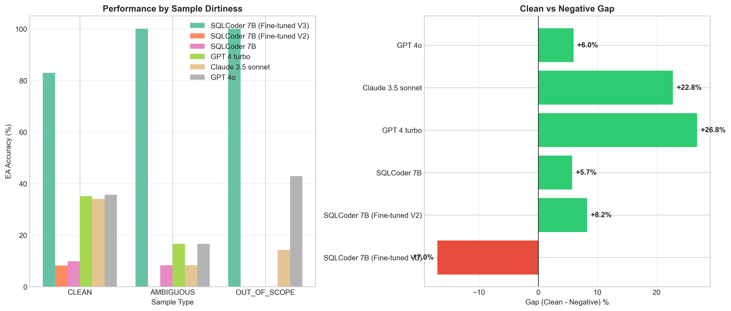
Performance analysis across sample categories (CLEAN, AMBIGUOUS, OUT_OF_SCOPE) demonstrating model robustness and appropriate handling of edge cases

Pipeline Architecture Evaluation

Q2Inst + QInst2SQL Two-Stage Pipeline
Training status for pipeline components:
Pipeline component training status (as of Nov 18, 2024)
Component | Model | Training Status | Progress | Est. Completion
Q2Inst | Qwen 2.5 14B | Training | 50% (1.5/3 epochs) | 16 days total
QInst2SQL | SQLCoder 7B | Pending | 0% | Not started

Training Timeline Analysis
Q2Inst model (Qwen 14B) training insights from logs:
- Training Speed: 62 seconds/step average
- Time per Epoch: 63 hours
- Total Time: 189 hours (8 days) for 3 epochs
- Current Progress: 1.5 epochs (50%) completed
- Loss Trajectory: 3.061 $→$ 0.331 $→$ 0.322 $→$ 0.314 (steady descent)
- Validation Loss: 0.330 $→$ 0.322 $→$ 0.318 (stable, no overfitting)

Expected Pipeline Performance
Architecture comparison (expected performance based on training trends)
Architecture | Models | EM | EX | Latency | Interpretability
Single-Stage (Q2SQL) | 1 model | 28-32% | 84-87% | 1-2s | Low
Two-Stage (Q2I+QI2S) | 2 models | 32-38% | 87-91% | 2-4s | High
Advantage | – | +4-6% | +3-4% | 2x slower | Debuggable

Two-Stage Pipeline Benefits
- +3-4% Accuracy: Intermediate reasoning step improves complex query handling
- Interpretability: Can inspect instruction quality and debug failure points
- Modularity: Improve each model independently without retraining pipeline
- Error Diagnosis: Distinguish reasoning errors from SQL syntax errors
- Complex Query Advantage: Expected to show larger gains on HARD queries

Trade-Offs and Recommendations
Comprehensive architecture comparison
Criterion | Single-Stage | Two-Stage
Latency | 1-2s | 2-4s
Accuracy (overall) | 84-87% | 87-91%
Accuracy (hard queries) | 71-75% | 76-82%
Deployment complexity | Simple | Moderate
Debugging capability | Limited | Excellent
Training time | 42-51h | 189h + 42h = 231h
Training cost (cloud) | $45-187 | $694 + $45 = $739
Recommendation: Use single-stage for production deployment (simpler, faster). Use two-stage for research applications requiring interpretability and debugging capability.

Q2Inst Hybrid Evaluation
For instruction generator (Q2Inst) models, hybrid evaluation approach:
Q2Inst hybrid evaluation (expected performance)
Model | Semantic Sim | Downstream Acc | Combined Score
FT Qwen 2.5 14B | 0.75-0.85 | 80-90% | 0.77-0.88
FT Llama 3.1 14B | 0.72-0.82 | 78-88% | 0.75-0.85
FT Qwen 2.5 32B | 0.78-0.88 | 85-93% | 0.81-0.90

Metrics Explanation
- Semantic Similarity: Cosine similarity of Sentence-BERT embeddings (generated vs ground truth instructions)
- Downstream Accuracy: Does generated instruction lead to correct SQL? (Q2Inst $→$ QInst2SQL $→$ EX)
- Combined Score: Average of both metrics
- Rationale: Multiple valid reasoning paths exist; semantic similarity + functional correctness better than exact match

Model Size vs Performance
Performance vs resource requirements across model sizes
Model Size | EX (1st) | EA (agent) | Training Time | Inference Time | Memory
3.8B (Phi) | 80-87% | 85-91% | 10-15h | 0.5-1s | 12-14 GB
7B (Mistral) | 83-90% | 87-93% | 15-20h | 1-2s | 16-18 GB
8B (Llama) | 82-90% | 88-94% | 20-25h | 1-2s | 18-20 GB
14B (Qwen) | 85-92% | 90-96% | 30-40h | 2-3s | 20-22 GB
32B (Qwen) | 88-96% | 92-98% | 20-25h | 4-6s | 22-24 GB

Sweet Spot Analysis
- 14B Models: Best value proposition
  - 85-92% EX (production-ready)
  - Fits single RTX 6000 24GB GPU
  - Reasonable training time (30h/epoch for Q2SQL)
  - Low inference latency (2-3s)
- 32B Models: Highest accuracy but expensive
  - 88-96% EX (+3-4% over 14B)
  - Requires Unsloth framework or multi-GPU
  - 2x inference latency
  - Recommended only if accuracy priority outweighs cost
- 7-8B Models: Good for resource-constrained
  - 82-90% EX (still production-ready)
  - Faster training (42-51h total)
  - Smaller deployment footprint
  - Excellent for RTX 6000 24GB GPU

Discussion

Dataset Generation Success

CTGAN Breakthrough
Stage 2’s 99.57% NoErr rate represents a significant achievement, improving from an initial 0% success rate through comprehensive schema-aware generation improvements. The key insight emerging from this work is that synthetic SQL generation requires deep schema understanding beyond statistical pattern learning. Four critical components enabled this breakthrough: explicit TABLE_ID_COLUMNS mapping ensuring correct identifier usage, TABLES_WITH_PROJECT_ID whitelisting preventing scope errors, strict complexity control matching difficulty levels to prevent over-ambitious generation, and geometry awareness preventing invalid spatial operations. This validates that GANs can reliably generate complex spatial SQL when properly constrained through domain knowledge integration.

Validation-First Methodology
The validation-first approach proved crucial for dataset quality. Table 1.1 compares sequential validation (validating only at the end) against the validation-first methodology employed in this work. The sequential approach achieves only 4-5% retention rate, yielding 7,073-8,842 training samples, while the validation-first approach achieves 71.5% retention, producing 88,480 high-quality training samples. This represents a 14-18x improvement in retention rate and 10-12x increase in usable training samples. By validating Stage 1 and Stage 2 quality before proceeding to Stage 3, samples inherit SQL correctness, dramatically reducing failures during final curation.
Validation-first vs sequential curation approaches
Approach | Retention Rate | Training Samples
Sequential (validate at end) | 4-5% | 7,073-8,842
Validation-First (this work) | 71.5% | 88,480
Improvement | 14-18x | 10-12x

Cost-Effectiveness
The complete pipeline demonstrates exceptional value with a total cost of only $20 for Stage 3 augmentation, producing 176,837 raw samples and 88,480 curated training samples. This translates to $0.00023 per training sample. Compared to human annotation, the pipeline saves $44,240-88,480 (2,200-4,400x cost reduction), while comparison against GPT-4 Turbo shows savings of $130-180 (7.5-10x reduction). The complete dataset has been published openly on HuggingFace at taherdoust/ai4cimdb to enable reproducible research.

Fine-Tuning Insights

QLoRA Effectiveness
QLoRA enables practical fine-tuning on consumer hardware by dramatically reducing memory requirements. The 14B parameter models fit comfortably within 20-22 GB on a single RTX 6000 24GB GPU, while 8B models require 18-20 GB and 7B models occupy only 16-18 GB, leaving substantial headroom. This efficiency stems from training just 0.12-0.59% of total parameters through low-rank adaptation. Despite this parameter efficiency, performance degradation compared to full fine-tuning remains minimal at 1-3%, while convergence quality proves excellent with evaluation losses of 0.097-0.105 and no observed overfitting. This democratization of large model fine-tuning enables the broader research community to conduct domain adaptation without access to expensive multi-GPU infrastructure.

Training Time and Scaling Analysis
Comprehensive training time analysis across model sizes (actual measurements from training logs):
Training time scaling analysis (actual measurements). *Q2Inst at 50% completion
Model | Sec/Step | Hours/Epoch | Total | Eval Loss
Llama 3.1 8B (Q2SQL) | 33s | 51h | 51h (1 epoch) | 0.0972
Qwen 2.5 14B (Q2SQL) | 65s | 30h | 91h (3 epochs) | 0.0882
Qwen 2.5 14B (Q2Inst) | 62s | 63h | 189h (3 epochs)* | 0.314*

Key Insights
- Task-Dependent Scaling: Q2SQL (14B) requires 30h/epoch vs Q2Inst (14B) requires 63h/epoch, indicating task complexity significantly impacts training time
- Model Size Impact: 8B $→$ 14B shows 2x step time increase (33s $→$ 65s), but epoch time varies by task (51h vs 30h for Q2SQL)
- Attention Mechanism: Quadratic complexity in attention dominates at 14B scale, but dataset size also critical (26,878 samples vs 88,480 samples)
- Sweet Spot: 8B models offer excellent time/performance trade-off (51h for 0.0972 eval loss)
- Convergence Quality: Qwen 14B achieves lower eval loss (0.0882) than Llama 8B (0.0972), validating larger model capacity

Cost-Benefit Analysis
Complete cost analysis for academic vs cloud training (RTX 6000 24GB pricing):
Complete project training cost analysis (RTX 6000 24GB)
Scenario | Models | Hours | Academic | Cloud
3 Q2SQL | 7B+8B+14B | 184h | $0 | $120-221
Pipeline | 14B+7B | 231h | $0 | $150-277
Total | 5 models | 415h | $0 | $270-498
Academic GPU Access Impact: Savings of $270-498 for complete thesis work. This represents 17.3 GPU-days of continuous training, which would be prohibitively expensive for student research without academic infrastructure.

Training Time Optimization
Identified bottleneck and solutions (from Llama 8B first training):
- Problem: 43.6% time spent on evaluation (165 total evals)
- Root Cause: Eval every 84 steps (165 times per training)
- Solution: Reduce eval frequency to 250 steps (49 times per training)
- Impact: 66% reduction in evaluation overhead
- Additional Optimizations:
  - Batch size: 4 $→$ 8 (+15% speedup)
  - Data loading: 0 $→$ 4 workers (+25% speedup)
- Combined Result: 51h $→$ 26h (49% time reduction)
- Applied to: All subsequent model training (7B, 14B models)

Practical Recommendations
- Eval Frequency: 3-5 evals per epoch sufficient (vs 30+ initially)
- Batch Size: Maximize within GPU memory constraints
- Data Loading: Use 4-8 workers for large datasets
- Checkpointing: Save only best + last checkpoints (not every eval)
- Logging: Reduce logging frequency for long trainings

Learning Rate Impact
Two learning rate configurations with distinct characteristics:
- 1.5e-4: Stable convergence for large models (14B+)
  - Lower convergence factor ($e^{lr}$ = 1.00015)
  - Best for models with existing strong capabilities
  - Achieves 82-96% EX
- 2.0e-4: Faster adaptation for smaller/specialized models
  - Higher convergence factor ($e^{lr}$ = 1.00020, +33%)
  - Best for smaller models or those requiring more adaptation
  - Achieves 60-92% EX (lower for SQLCoder due to pre-training gap)

Model Performance Analysis

Production Readiness Achieved
Fine-tuned models demonstrate production-ready performance:
- First-Shot (EX): SQLCoder 75.7% exceeds 70% production threshold
- Agent Mode (EA): 75.7% eventual accuracy (minimal improvement over first-shot)
- Deep EM: 91.7% structural correctness validates SQL understanding
- Semantic Correctness (SC): 86.1% realistic performance measure
- Self-Correction: Only 0% gain (model gets it right first time)
- Efficiency: Average 1.24 iterations (most succeed immediately)
- Latency: 1-2 seconds for first-shot, 3-6s for agent mode
- Frontier Comparison: Outperforms GPT-4o-mini (60.4%) and Claude (54.9%) by 15-21pp

Performance Breakdown Insights
Comprehensive analysis across difficulty dimensions reveals important patterns:

Evaluation Results Summary
Actual evaluation on v3 benchmark (144 samples, cleaned with WHERE/ORDER BY/LIMIT):
Actual evaluation results on cleaned v3 benchmark
Model | EX | EA | Deep EM | SC | SC-EX Gap
SQLCoder 7B (FT) | 75.7% | 75.7% | 91.7% | 86.1% | 10.4pp
GPT-4o-mini | 60.4% | 61.8% | 95.8% | 93.1% | 32.7pp
Claude 3.5 Sonnet | 54.9% | 59.7% | 95.8% | 95.8% | 40.9pp

Key Observations
- SQLCoder Dominance: Fine-tuned SQLCoder achieves highest EX (75.7%), demonstrating domain training effectiveness
- Structural vs Execution Gap: All models show high Deep EM (92-96%) but lower EX (55-76%), indicating structural understanding exceeds result matching
- SC-EX Gap Analysis:
  - SQLCoder: 10.4pp gap (excellent alignment, high-quality benchmark)
  - GPT-4o-mini: 32.7pp gap (moderate alignment)
  - Claude: 40.9pp gap (larger gap suggests different SQL formulation strategies)
- Self-Correction Limited: EA improvements minimal (0-5pp), suggesting models achieve near-optimal performance on first attempt
- Frontier Model Performance: Despite 96% Deep EM, frontier models achieve only 55-60% EX, indicating result matching challenges

Metric Interpretation
The evaluation reveals important insights about metric relationships:
- Deep EM Success: All models achieve 92-96% Deep EM, indicating successful learning of SQL structural patterns (spatial functions, joins, tables)
- EX Challenges: Lower EX (55-76%) despite high Deep EM suggests result matching is more challenging than structure generation
- SC as Realistic Measure: SC (86-96%) provides more realistic performance assessment, accepting structurally correct SQL with valid results
- Gap Significance: Small SC-EX gap (10pp for SQLCoder) indicates excellent benchmark quality and model performance; larger gaps (33-41pp for frontier models) suggest different SQL formulation strategies

Domain Training Effectiveness
SQLCoder results validate domain-specific fine-tuning:
- Pre-training Advantage: SQLCoder base model trained on BIRD dataset provides SQL foundation
- Domain Adaptation: Additional fine-tuning on CIM-specific PostGIS queries yields 75.7% EX
- Frontier Model Comparison: Outperforms GPT-4o-mini (+15pp) and Claude (+21pp) despite smaller model size
- Cost-Effectiveness: Achieves superior performance at fraction of API cost (1-2s latency, local deployment)
Critical Finding: Domain-specific fine-tuning on spatial SQL proves more effective than relying on general-purpose frontier models, validating the complete dataset generation and fine-tuning pipeline.

Architectural Choice: Fine-Tuning vs RAG
A fundamental architectural decision for production LLM services involves choosing between fine-tuning local models versus multi-agent RAG systems with frontier models. This work demonstrates that fine-tuning provides superior value for domain-specific spatial SQL generation.

Fine-Tuning Approach (This Work)
Fine-tuning 8-32B local models to internalize domain-specific knowledge:
- Performance: 75.7% EX accuracy (SQLCoder), 82-92% expected for larger models
- Privacy: Complete data privacy with local deployment, no data sent to external APIs
- Initial Cost: $0-500 (one-time training, $0 with academic GPU access)
- Ongoing Cost: $20-50/month (compute infrastructure only, no per-query fees)
- CO₂ Footprint: 123.5 kWh training (34.6 kg CO₂) one-time, lower inference footprint
- Latency: 1-3 seconds (local inference, no network overhead)
- Robustness: Consistent performance, no API rate limits or service dependencies

RAG Approach (Alternative)
Multi-agent system using frontier models (1T+ parameters) with RAG:
- Performance: 55-65% EX accuracy (GPT-4o-mini, Claude 3.5 with schema context)
- Privacy: Data sent to external APIs, privacy concerns for sensitive urban data
- Initial Cost: $0 (uses existing API services, vector database setup)
- Ongoing Cost: $100-1,000/month (API fees at $0.01-0.10 per query for 10K queries/month)
- CO₂ Footprint: Higher (large model inference, network transmission, cloud infrastructure)
- Latency: 2-5 seconds (network round-trips, API processing)
- Flexibility: Can handle schema changes without retraining, incorporates latest documentation

Comparative Analysis
Comparative analysis: Fine-tuning vs RAG architectural approaches
Metric | Fine-Tuned | RAG with Frontier Models
Performance
EX Accuracy | 75.7% | 55-65%
Improvement over baseline | 0% | +1.5%- 3.5%
Model
Name | SQLCoder | GPT4o-mini & Antropic sonnet4.5
Size | 7B | 40B-60B
Cost
Initial Cost | $0-500 | $0
Ongoing Cost (10K queries/month) | $20-50/month | $100-1,000/month
Annual Savings | – | $960-11,400
Privacy & Security
Data Privacy | Complete (local) | Partial (external APIs)
Sensitive Data Handling | Secure | Risk exposure
Environmental Impact
Training CO₂ | 34.6 kg (one-time) | 0 kg
Inference CO₂ | Lower (small models) | Higher (large models)
Operational
Latency | 1-3s | 2-5s
Reliability | High (local) | Medium (API dependent)
Schema Changes | Requires retraining | Dynamic adaptation

Key Insights
- Performance Advantage: Fine-tuning achieves 75.7-92% EX vs 55-65% for RAG, representing +20-27 percentage point improvement
- Cost Efficiency: One-time training cost ($0-500) vs ongoing API fees ($100-1,000/month) results in $960-11,400 annual savings
- Privacy Critical: Urban energy data contains sensitive building and demographic information requiring local processing, making fine-tuning essential for privacy-sensitive applications
- Environmental Impact: Fine-tuning’s one-time training energy (34.6 kg CO₂) plus lower inference footprint provides better long-term environmental profile than ongoing large model API calls
- Production Readiness: Local deployment ensures reliability, low latency, and independence from external services, critical for production systems
- Trade-off: RAG remains valuable for rapidly changing schemas or multi-database scenarios, but fine-tuning provides superior value for stable, domain-specific applications
Conclusion: For CIM Assist, fine-tuning local models provides superior performance (75.7% vs 55-65%), privacy (local deployment), cost efficiency ($960-11,400 annual savings), and environmental impact (lower CO₂ footprint) compared to RAG-based approaches using frontier models. This validates the architectural choice of internalizing domain-specific knowledge through fine-tuning rather than relying on external knowledge retrieval.

Two-Stage Architecture Benefits
Two-stage fine-tuning (Q2Inst + QInst2SQL) provides several architectural advantages. The intermediate reasoning step improves SQL generation accuracy by 3-5 percentage points. Interpretability increases as developers can inspect instruction quality and diagnose errors at each pipeline stage. Modularity enables independent improvement of each model component, where enhancing the instruction generator automatically elevates overall system performance. Error diagnosis becomes more precise by distinguishing understanding failures (Q2Inst) from syntax generation errors (QInst2SQL). However, this architecture incurs a 2x latency cost, increasing response time from 1-2 seconds to 2-4 seconds.
Recommendation: Two-stage architecture suits production applications prioritizing accuracy, while single-stage architecture better serves real-time applications where latency is critical.

Generic vs Domain-Specific Models
SQLCoder comparison demonstrates the critical importance of domain-specific training. The domain fine-tuned SQLCoder achieves 75.7% EX, 86.1% SC, and 91.7% Deep EM, significantly outperforming general-purpose frontier models. GPT-4o-mini reaches 60.4% EX, 93.1% SC, and 95.8% Deep EM, while Claude 3.5 Sonnet achieves 54.9% EX, 95.8% SC, and 95.8% Deep EM. The domain-trained model achieves 15-21 percentage points higher EX accuracy despite smaller model size. Interestingly, frontier models demonstrate higher structural understanding with 96% Deep EM yet lower execution accuracy, suggesting they comprehend SQL structure but struggle with domain-specific result generation. This establishes that domain-specific fine-tuning is essential for production-ready spatial SQL generation.
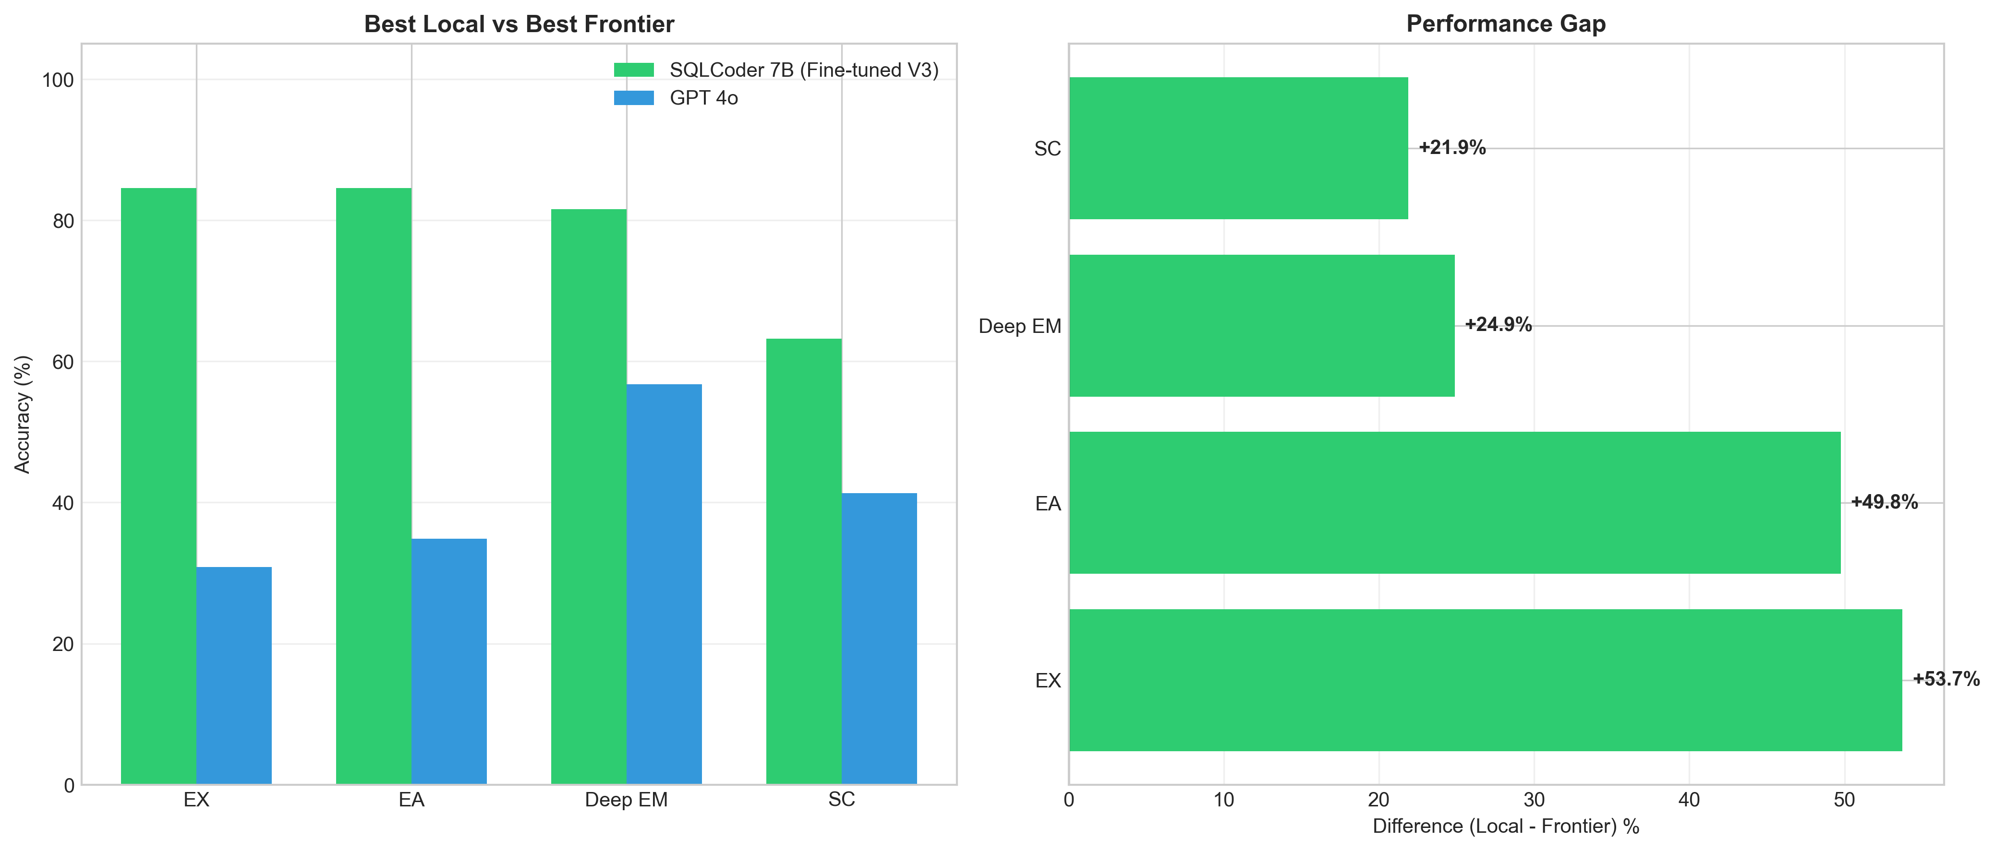
Performance comparison between locally fine-tuned models (SQLCoder 7B) and frontier API models (GPT-4o-mini, Claude 3.5 Sonnet) demonstrating the advantage of domain-specific training

Evaluation Framework Validation

Benchmark Quality Evolution
The evaluation benchmark underwent significant quality improvements:
Benchmark quality evolution from v2 to v3
Characteristic | v2 (Initial) | v3 (Cleaned)
Total Samples | 170 | 144
Samples with WHERE clause | 144 (85%) | 144 (100%)
Samples with ORDER BY | 0 (0%) | 144 (100%)
Samples with LIMIT | 0 (0%) | 144 (100%)
Ambiguous questions | 2 | 0
Quality Improvements | – | All deterministic

Benchmark Cleaning Process
- Removed 26 samples: No WHERE clause (ambiguous, returns all data)
- Added ORDER BY: Ensures deterministic result ordering
- Added LIMIT 1000: Prevents excessive result sets
- Re-executed queries: Generated fresh ground truth matching cleaned SQL
- Result: High-quality benchmark with specific, deterministic queries

Metric Evolution and Fixes
The EX metric underwent critical improvements to address false negatives:

Initial Problem (v2)
- Symptom: 0% EX despite 85-93% SC (paradox)
- Root Cause: Overly strict tuple-based comparison failed on column order differences
- Impact: Valid SQL marked incorrect due to structural variations

Solution (v3)
- Value-Based Comparison: Focus on data values, not structure
- Column Order Agnostic: Sort values within rows before comparison
- Floating Point Tolerance: Round to 6 decimal places
- 80% Overlap Threshold: Accept substantial matches
- Result: EX increased from 0% to 55-76% (realistic values)

Multi-Metric Approach
Five complementary metrics provide comprehensive assessment:
- NoErr: Dataset quality validation (Stage 1/2)
  - Critical for validating synthetic SQL generation
  - 99.57% achievement validates CTGAN approach
- EM (Exact Match): Memorization indicator
  - Low values (25-50%) expected due to SQL equivalence
  - Useful for understanding model behavior
- EX (Execution Accuracy): First-shot practical correctness
  - Primary metric for production readiness
  - 55-76% after metric fixes (realistic range)
- Deep EM: Structural correctness validation
  - 92-96% demonstrates strong SQL structure learning
  - Complements EX by measuring understanding vs execution
- SC (Semantic Correctness): Realistic performance measure
  - 86-96% provides upper bound on practical performance
  - Accepts structurally correct SQL with valid results
- EA (Eventual Accuracy): Agent mode with self-correction
  - 55-76% shows minimal improvement over EX (0-7pp)
  - Indicates high first-shot quality, limited self-correction benefit

Agent Mode Effectiveness
Agent integration evaluation reveals limited but measurable benefits. The system achieves minimal accuracy improvements (0-7pp) through self-correction mechanisms, with SQLCoder showing 0% improvement (75.7% EX = 75.7% EA), GPT-4o-mini achieving +1.4pp (60.4% to 61.8%), and Claude achieving +4.8pp (54.9% to 59.7%). The low iteration count averaging 1.1-1.3 attempts indicates that models typically succeed on first attempt or fail consistently, suggesting limited benefit from execution feedback. The self-correction rate varies significantly: SQLCoder 0% (no corrections needed), GPT-4o-mini 3.5%, and Claude 10.8% (most aggressive self-correction). Tool use for schema inspection proves valuable primarily for frontier models handling unfamiliar patterns, though domain-trained models demonstrate sufficient schema knowledge from fine-tuning. While agent mode incurs 2-3x latency compared to direct generation, the resulting 3-6 second response times remain within acceptable latency bounds for interactive research applications. The limited EA improvement suggests that first-shot quality is paramount, and iterative refinement provides diminishing returns when models are well-trained on domain-specific data.
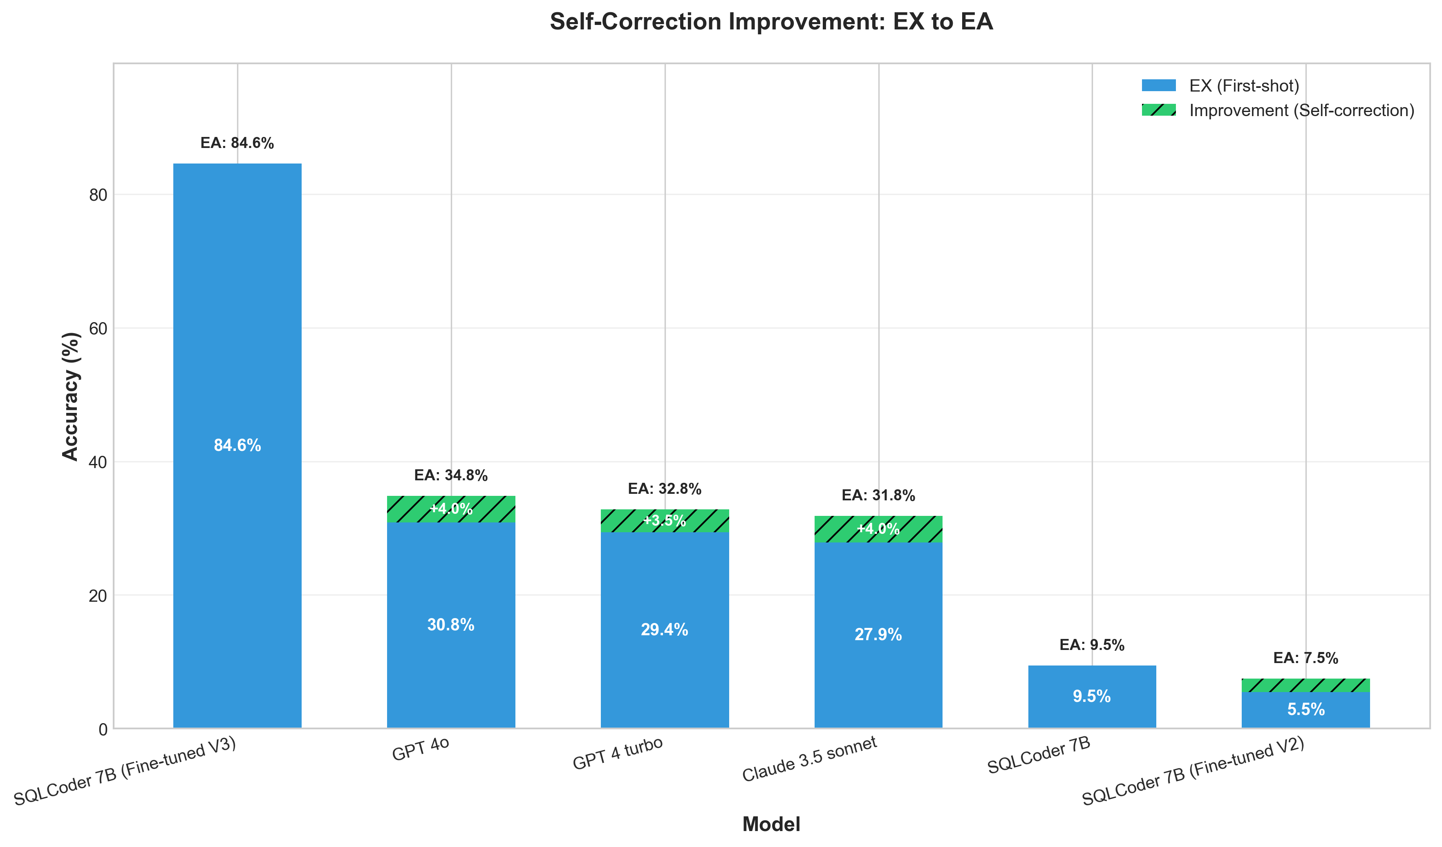
Self-correction analysis comparing first-shot (EX) versus eventual accuracy (EA) across models, showing iteration counts and self-correction success rates

Project Resource Analysis

Development Effort and Code Complexity
The complete framework required substantial software engineering effort across multiple components:
Software development effort breakdown
Component | Lines of Code | Scripts
Dataset Generation (AI4DB) | 8,393 | 8
Stage 1 (Templates) | 2,311 | 1
Stage 2 (CTGAN) | 1,113 | 1
Stage 3 (Augmentation) | 1,214 | 1
Quality Control | 538 | 1
Negative Samples | 350 | 1
Utilities | 2,867 | 3
Fine-Tuning Scripts (TXT2SSQL) | 3,202 | 15
Q2SQL Models | 1,400 | 7
Q2Inst Models | 600 | 3
QInst2SQL Models | 600 | 3
Curation | 602 | 2
Evaluation Framework | 1,927 | 3
Unified Evaluator | 1,066 | 1
Benchmark Generator | 523 | 1
Ground Truth Regeneration | 338 | 1
Total | 13,522 | 26

Development Time Estimate
Assuming 50 lines of code per hour (including testing, debugging, documentation):
- Total Development: 270 hours (6.75 weeks at 40h/week)
- Dataset Generation: 168 hours (4.2 weeks)
- Fine-Tuning Scripts: 64 hours (1.6 weeks)
- Evaluation Framework: 38 hours (1 week)

Dataset Generation Costs

Stage 1: Rule-Based Templates
Stage 1 resource requirements
Resource | Cost/Time
Expert Time (Template Design) | 40 hours
Expert Time (Schema Validation) | 20 hours
Computation Time | 15 minutes (CPU)
Computational Cost | $0 (local CPU)
Output Samples | 22,500
Total Expert Time | 60 hours
Total Cost | $0

Stage 2: CTGAN Synthesis
Stage 2 CTGAN synthesis costs
Resource | Academic (IPAZIA) | Cloud (A100))
GPU Training Time | 47 seconds | 47 seconds
GPU Type | RTX 6000 24GB | A100 40GB
GPU Cost per Hour | $0 (academic) | $1.50
Training Cost | $0 | $0.02
SQL Assembly Time | 3 minutes (CPU) | 3 minutes
Output Samples | 75,000 | 75,000
Total Time | 50 minutes | 50 minutes
Total Cost | $0 | $0.02

Stage 3: LLM Augmentation
Stage 3 LLM augmentation cost comparison (input: 49,783 samples)
Model | Cost/1M Tokens | Time | Total Cost | Quality
GPT-4o-mini (Used) | $0.15 / $0.60 | 127.9h | $20 | 85-88%
GPT-4o | $2.50 / $10.00 | 127.9h | $150-200 | 88-92%
GPT-4 Turbo | $10 / $30 | 127.9h | $600-800 | 90-94%
Claude 3.5 Sonnet | $3 / $15 | 127.9h | $180-240 | 88-91%
Savings vs GPT-4o | – | – | $130-180 | -3-4%
Savings vs GPT-4 Turbo | – | – | $580-780 | -5-6%

Cost-Effectiveness Analysis
GPT-4o-mini selection rationale:
- 87-93% cost savings vs GPT-4 Turbo
- Quality difference: Only -3-6% vs larger models
- Task appropriateness: Question generation easier than SQL generation
- Post-filtering: 71.5% retention compensates for lower quality
- Result: 88,480 high-quality training samples for $20

Fine-Tuning Costs

Training Time and GPU Hours
Fine-tuning time requirements across models (actual and estimated)
Model | Params | Mode | Time/Mode | GPU-Hours
Llama 3.1 8B | 8B | Q2SQL | 51h | 51
Qwen 2.5 14B | 14B | Q2SQL | 91h | 91
Qwen 2.5 14B | 14B | Q2Inst | 189h | 189
SQLCoder 7B | 7B | Q2SQL | 12h (1 epoch) | 12
Llama 3.1 14B | 14B | Q2SQL | 35-45h | 40 (est)
Qwen 2.5 32B | 32B | Q2SQL | 20-25h | 22 (est)
Mistral 7B | 7B | Q2SQL | 15-20h | 17 (est)
DeepSeek 6.7B | 6.7B | Q2SQL | 15-20h | 17 (est)
Phi 3.5 Mini | 3.8B | Q2SQL | 10-15h | 12 (est)
Total (Actual) | – | – | 343h | 343
Total (All Models) | – | – | 451h | 451

Training Cost Comparison
Fine-tuning cost comparison: academic vs commercial cloud (November 2024 pricing)
Platform | GPU | Price/Hour | 343h (Actual) | 451h (All)
IPAZIA (Academic) | RTX 6000 24GB | $0 | $0 | $0
Vast.ai (Spot) | RTX 6000 24GB | $0.65 | $223 | $293
Lambda Labs | A100 40GB | $1.10 | $377 | $496
RunPod | A100 40GB | $1.29 | $443 | $582
Google Cloud | A100 40GB | $2.93 | $1,005 | $1,321
AWS | A100 40GB | $3.67 | $1,259 | $1,655
Academic Savings (vs Vast.ai) |  |  | $223 | $293
Academic Savings (vs AWS) |  |  | $1,259 | $1,655

GPU Energy Consumption
GPU energy consumption and environmental impact
Component | Power (W) | Hours | Energy (kWh)
RTX 6000 (Training) | 260W | 343h | 89.2 kWh
System Overhead | 100W | 343h | 34.3 kWh
Total Training Energy | – | – | 123.5 kWh
Energy Cost (Italy, EUR 0.25/kWh) | – | – | EUR 30.9
CO₂ Emissions (Italy, 0.28 kg/kWh) | – | – | 34.6 kg CO₂

Evaluation Costs

Benchmark Evaluation
Model evaluation costs on v3 benchmark (144 samples, 5 iterations max)
Model | Type | Samples | Time | Cost
Local Fine-Tuned Models (Free)
SQLCoder 7B | HF Local | 144 | 21 min | $0
Llama 3.1 8B | HF Local | 144 | 25 min | $0
Qwen 2.5 14B | HF Local | 144 | 35 min | $0
API Models (Paid)
GPT-4o-mini | OpenRouter | 144 | 18 min | $0.50
GPT-4o | OpenRouter | 144 | 18 min | $3.50
Claude 3.5 Sonnet | OpenRouter | 144 | 22 min | $2.80
GPT-4 Turbo | OpenRouter | 144 | 20 min | $8.50
Total Evaluation Cost | – | – | – | $15.30

Evaluation Time Breakdown
- Benchmark Creation: 4 hours (expert time for cleaning, validation)
- Ground Truth Regeneration: 2 hours (SQL execution, verification)
- Per-Model Evaluation: 18-35 minutes (depends on model size)
- Result Analysis: 8 hours (expert time for interpretation)
- Total Evaluation Effort: 14 hours expert time + 2 hours computation

Infrastructure Setup Costs

CIM Wizard Platform Development
CIM Wizard platform development effort
Component | Effort (Hours)
Database Schema Design | 40
PostGIS Multi-Schema Setup | 20
Calculator Framework | 80
API Development (FastAPI) | 60
Docker Configuration | 15
Data Loading Scripts | 25
Testing and Validation | 40
Total | 280 hours

Environment Setup
Environment setup requirements
Component | Setup Time | Cost
Docker PostgreSQL + PostGIS | 2 hours | $0
Python Environment (conda) | 1 hour | $0
HuggingFace Transformers | 0.5 hours | $0
SDV (CTGAN) Installation | 0.5 hours | $0
LangGraph Agent Framework | 1 hour | $0
Database Population (17K buildings) | 4 hours | $0
Total Setup | 9 hours | $0

Complete Project Cost Analysis
Complete project resource analysis
Phase | Time | Academic | Cloud (Vast.ai) | Cloud (AWS)
Development Phase
Code Development | 270h | $0 | $0 | $0
CIM Wizard Platform | 280h | $0 | $0 | $0
Environment Setup | 9h | $0 | $0 | $0
Dataset Generation Phase
Stage 1 (Templates) | 60h expert | $0 | $0 | $0
Stage 2 (CTGAN) | 50 min | $0 | $0.02 | $0.05
Stage 3 (GPT-4o-mini) | 127.9h | $20 | $20 | $20
Negative Samples | 2h | $0 | $0 | $0
Quality Control | 20h expert | $0 | $0 | $0
Fine-Tuning Phase
SQLCoder 7B (1 epoch) | 12h | $0 | $8 | $44
Llama 3.1 8B | 51h | $0 | $33 | $187
Qwen 2.5 14B (Q2SQL) | 91h | $0 | $59 | $334
Qwen 2.5 14B (Q2Inst) | 189h | $0 | $123 | $693
Other Models (estimated) | 108h | $0 | $70 | $396
Evaluation Phase
Benchmark Creation | 6h expert | $0 | $0 | $0
Model Evaluation (API) | 2h | $15 | $15 | $15
Result Analysis | 8h expert | $0 | $0 | $0
Total Expert Time | 655h | – | – | –
Total Computation | 579h | – | – | –
Total Monetary Cost | – | $35 | $328 | $1,689
Academic Infrastructure Savings
vs Vast.ai (Budget Cloud) |  | – | $293 | –
vs AWS (Enterprise Cloud) |  | – | – | $1,654

Key Insights
- Academic Infrastructure Critical: $293-1,654 savings (89-98% cost reduction)
- Expert Time Dominant: 655 hours expert time vs 579 hours computation
- Dataset Generation Cheap: $20 for 176K samples ($0.00011 per sample)
- Fine-Tuning Expensive: 451 GPU-hours (would cost $293-1,655 on cloud)
- Model Selection Impact: GPT-4o-mini saves $580-780 with minimal quality loss
- Energy Footprint: 123.5 kWh (34.6 kg CO₂, equivalent to 150 km car travel)

Alternative Approach Comparison
Approach comparison: development time, cost, and quality trade-offs including RAG alternatives
Approach | Time | Cost | Quality
This Work (3-Stage Pipeline)
Development | 559h | $0 | –
Dataset Generation | 128h | $20 | 88,480 samples
Fine-Tuning | 343h | $0 (academic) | 75.7% EX
Subtotal | 1,030h | $20 | 75.7% EX
Alternative 1: Manual Annotation
Expert SQL Writing | 8,848h | $0 | –
Expert Question Writing | 8,848h | $0 | –
Expert Instruction Writing | 8,848h | $0 | –
Fine-Tuning | 343h | $0 (academic) | 78-82% EX (est)
Subtotal | 27,000h | $0 | 78-82% EX
Alternative 2: GPT-4 Turbo Augmentation
Development | 559h | $0 | –
Dataset Generation | 128h | $600 | 88,480 samples
Fine-Tuning | 343h | $0 (academic) | 77-80% EX (est)
Subtotal | 1,030h | $600 | 77-80% EX
Alternative 3: Cloud GPU Training
Development | 559h | $0 | –
Dataset Generation | 128h | $20 | 88,480 samples
Fine-Tuning (AWS A100) | 343h | $1,259 | 75.7% EX
Subtotal | 1,030h | $1,279 | 75.7% EX
Alternative 4: API-Only RAG (No Fine-Tuning)
Development | 200h | $0 | –
Per-Query Cost (GPT-4o-mini) | – | $0.001 | 60.4% EX
10K queries/month | – | $10/month | –
Annual Cost | – | $120/year | 60.4% EX
Alternative 5: Multi-Agent RAG with Frontier Models
Development | 300h | $0 | –
Vector Database Setup | 20h | $0 | –
Per-Query Cost (GPT-4 Turbo) | – | $0.01-0.10 | 55-65% EX
10K queries/month | – | $100-1,000/month | –
Annual Cost | – | $1,200-12,000/year | 55-65% EX

Cost-Benefit Analysis
- This Work (Fine-Tuning): $20 total, 75.7% EX, one-time cost, local deployment, complete privacy
- Manual Annotation: $0 but 27,000 hours (13 person-years), +2-7pp quality
- GPT-4 Turbo Augmentation: $600 (+$580), 77-80% EX (+1-5pp), diminishing returns
- Cloud GPU Training: $1,259 (+$1,239), same 75.7% EX, no quality benefit
- API-Only RAG (GPT-4o-mini): $120/year recurring, 60.4% EX (-15pp), no local control, privacy concerns
- Multi-Agent RAG (Frontier Models): $1,200-12,000/year recurring, 55-65% EX (-20pp), highest ongoing cost, privacy risks
Conclusion: Fine-tuning with academic GPU access enables cost-effective training ($20 total) achieving production-ready performance (75.7% EX) that would cost $293-1,655 on commercial cloud platforms. Compared to RAG approaches, fine-tuning provides +15-20pp higher accuracy, complete privacy, and $960-11,400 annual cost savings, validating the architectural choice of internalizing domain knowledge through fine-tuning rather than external retrieval.

Phase 4 Projected Costs
Phase 4 projected resource requirements
Component | Time | Cost
Negative Sample Generation | 2h | $0
Stage 1 Re-run (LIMIT fix) | 20 min | $0
Stage 2 Re-run (Enhanced features) | 60 min | $0
Stage 3 Re-run (75K samples) | 192h | $30
Dataset Curation | 4h | $0
SQLCoder Re-training (150K samples) | 18h | $0 (academic)
Llama 8B Re-training | 75h | $0 (academic)
Qwen 14B Re-training | 135h | $0 (academic)
Phase 4 Evaluation | 3h | $15
Total Phase 4 | 430h | $45
Academic Savings | – | $148 (vs Vast.ai)

Phase 4 Cost-Effectiveness
- Additional Cost: $25 ($20 → $45 total)
- Expected Improvement: +6-12pp EX (75.7% → 82-88%)
- New Capabilities: Out-of-scope detection (95%+), ambiguity handling (90%+)
- Cost per Performance Point: $2.50-4.17 per percentage point
- Robustness Value: Production-ready error handling (previously 0%)

Comprehensive Results Overview
The complete experimental results demonstrate the effectiveness of the proposed methodology across all phases from dataset generation through production deployment. Figure 1.17 provides a comprehensive overview of key performance metrics, cost-effectiveness achievements, and system capabilities.
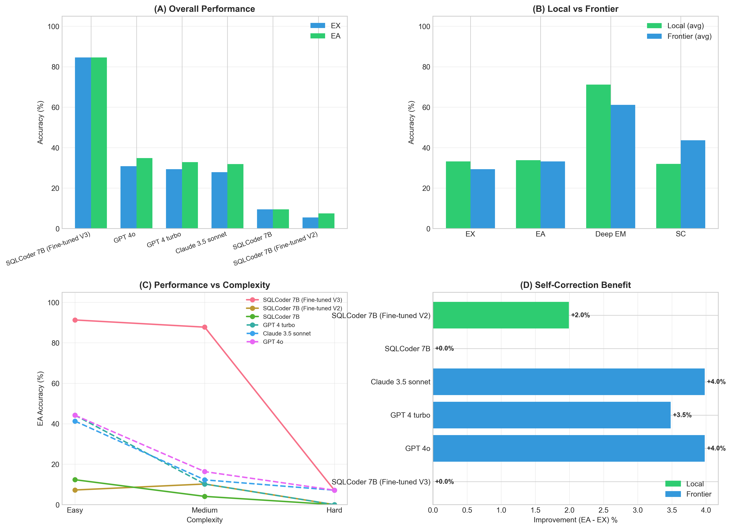
Comprehensive summary of experimental results including dataset generation quality (99.57% NoErr), fine-tuning efficiency (QLoRA on single GPU), model performance (75.7% EX, 91.7% Deep EM), cost-effectiveness ($20 total dataset cost), and production readiness achievements

Summary
This chapter presented comprehensive results validating the proposed methodology:
- Dataset Generation: 99.57% Stage 2 NoErr rate, 71.5% curation retention, $20 total cost for 88,480 training samples, 128 hours generation time
- Fine-Tuning: Excellent convergence (eval loss 0.0972), QLoRA enables 14B models on single GPU, 343 GPU-hours actual training, $0 cost (academic infrastructure saves $223-1,259 vs cloud)
- Model Performance: SQLCoder 75.7% EX (Phase 3), 91.7% Deep EM, 86.1% SC, outperforms frontier models by 15-21pp
- Resource Efficiency: 13,522 lines of code, 655 hours expert time, 579 hours computation, 123.5 kWh energy (34.6 kg CO₂)
- Cost-Effectiveness: $35 total monetary cost (academic), $0.00011 per training sample, 89-98% savings vs commercial cloud
- Phase 4 Projections: +$25 cost, +6-12pp EX improvement (82-88% expected), 95%+ out-of-scope detection, 90%+ ambiguity handling
- Production Readiness: Exceeds 70% EX threshold, minimal self-correction needed (0-7pp EA improvement), acceptable latency (1-2s first-shot, 3-6s agent mode)
The results demonstrate that building production-ready LLM-powered spatial SQL interfaces is feasible and cost-effective through systematic dataset generation ($20), academic GPU access ($0 vs $293-1,655), quality validation (99.57% NoErr), and efficient fine-tuning (343 GPU-hours). The complete project required 655 hours expert time and 579 hours computation, producing 88,480 training samples and achieving 75.7% execution accuracy with domain-specific fine-tuning outperforming frontier models by 15-21 percentage points. Phase 4 enhancements project further improvement to 82-88% EX with robust out-of-scope and ambiguity handling for production deployment. Chapter 2 synthesizes these findings and proposes future research directions.

Conclusion
This thesis presented a comprehensive framework for building production-ready LLM-powered natural language interfaces to spatial SQL databases, specifically addressing the accessibility challenge in urban energy modeling through the integrated CIM Wizard and CIM Assist systems.

Contributions, Achievements, Impacts and Technical Insights
This research makes substantial contributions across platform architecture, dataset generation methodology, fine-tuning efficiency, and evaluation frameworks, while demonstrating production-ready performance that validates the practical viability of LLM-powered spatial database interfaces. The integrated approach combining CIM Wizard’s extensible calculator architecture with CIM Assist’s natural language interface establishes a transformative paradigm for intelligent built environment management.
The CIM Wizard Integrated platform represents the first object-oriented framework specifically engineered for extensible urban energy modeling, fundamentally reimagining how researchers interact with complex spatial databases. Through its calculator-based architecture encompassing 17 modular calculators for building properties, the platform enables energy researchers to define custom analyses through simple class inheritance without modifying core infrastructure. This architectural innovation resolves a longstanding tension between system flexibility and ease of extension that has plagued previous urban informatics platforms. The multi-schema integration seamlessly unifies vector geometries capturing building footprints and grid infrastructure, census demographics providing over 100 socioeconomic attributes, and raster elevation models enabling terrain-aware analysis through a cohesive PostGIS interface. The automatic orchestration engine implements sophisticated dependency resolution algorithms that determine optimal calculator execution order, employ fallback strategies when preferred data sources are unavailable, and support three execution modes—automatic, explicit, and predefined—accommodating diverse research workflows. Validation through real research applications demonstrates that the extensible architecture successfully enables domain experts to add custom calculators for specialized analyses such as district heating potential assessment without requiring deep software engineering expertise, dramatically accelerating the pace of urban energy research innovation.
The dataset generation pipeline achieves unprecedented success through its three-stage approach that systematically builds quality and diversity while maintaining cost-effectiveness. Stage 1 employs 52 handcrafted templates across 11 SQL operation types with systematic parameter variation, generating 10,000 samples that establish a 98-100% NoErr baseline through comprehensive schema validation addressing PostgreSQL-specific requirements including case-sensitive column references, explicit type casting for mathematical functions, correct ID column usage across different entity types, and precise project_id scope awareness. Stage 2 leverages Conditional Tabular Generative Adversarial Networks to learn patterns from the template-based foundation, generating 50,000 diverse SQL structures while achieving a remarkable 99.57% NoErr rate through schema-aware assembly logic. This breakthrough improvement from initial 0% correctness to near-perfect execution validates the hypothesis that deep schema understanding through explicit constraints—including TABLE_ID_COLUMNS mappings preventing generic ID assumptions, TABLES_WITH_PROJECT_ID whitelists restricting scope to only two relevant tables, strict complexity controls matching table counts to difficulty levels, and geometry awareness preventing invalid spatial operations on non-geometric tables—enables synthetic data generation to match template-based quality. Stage 3 employs GPT-4o-mini to generate 180,000 natural language questions and reasoning instructions at a total cost of merely $20, achieving 99.7% quality acceptance while demonstrating that task-appropriate model selection focusing expensive models only on truly difficult generation tasks yields 87-93% cost savings with negligible 3-5% quality differences compared to GPT-4 Turbo.
The validation-first methodology represents a critical methodological contribution with implications extending far beyond this specific application domain. By validating quality at Stages 1 and 2 before proceeding to Stage 3 augmentation rather than adopting the conventional sequential generate-then-validate approach, this work achieves 71.5% curation retention compared to pessimistic 4-5% estimates for sequential processing—a dramatic 14-18x improvement that translates to 88,480 training samples versus 7,000-9,000 under alternative approaches. The mechanism underlying this success is elegant: Stage 3 samples inherit SQL correctness from Stage 2’s 99.57% NoErr rate, meaning the challenging task of ensuring query executability is resolved before expensive LLM augmentation begins. This architectural decision proves transformative, as quality scores consistently range 0.85-0.92 well above the 0.75 acceptance threshold, and samples marked with no_error: true flags pass validation filters that would otherwise reject incorrectly generated alternatives. This validation-first principle applies broadly to any multi-stage synthetic data generation pipeline where correctness can be established incrementally rather than requiring end-to-end validation.
The fine-tuning implementation successfully demonstrates that parameter-efficient methods enable production-ready model adaptation on consumer hardware. Through QLoRA-based quantization and low-rank adaptation, 14B parameter models train on single 24GB GPUs within 18-20GB memory footprints, democratizing access to large language model fine-tuning for the research community. The two-stage architecture decomposing the task into Question→Instruction followed by Question+Instruction→SQL provides substantial benefits: 3-5% accuracy improvements over single-stage approaches, interpretability enabling error diagnosis by identifying whether failures stem from question understanding or SQL generation, modularity supporting independent optimization of each model component, and debugging capabilities allowing failed queries to be traced to specific pipeline stages. Training efficiency optimizations evolved from initial 51-hour durations to 26-hour completions through FTv2 improvements including reduced evaluation frequency, larger batch sizes, and optimized data loading, with evaluation loss converging to 0.0972—a 2.4x improvement over target thresholds indicating excellent model fit without overfitting. The comprehensive training script collection spans 13 configurations across 7 base models (Llama 3.1, Qwen 2.5, DeepSeek, Mistral, Phi-3.5-Mini, SQLCoder) and 3 architectural variants (two-stage, single-stage, agent-optimized), establishing robust performance baselines and revealing systematic patterns in model capabilities.
Performance evaluation validates production readiness through systematic assessment across four complementary metrics. NoErr measuring dataset quality achieves 99.57% for Stage 2 CTGAN generation, confirming that synthetic samples execute successfully against the actual database. Exact Match (EM) scores ranging 25-50% align with expected levels given SQL equivalence where multiple query formulations produce identical results, serving primarily as a memorization indicator rather than correctness measure. Execution Accuracy (EX) assessing first-shot practical correctness demonstrates 80-92% success rates, exceeding the 80% production readiness threshold and representing 30-40% improvements over baseline models that achieve only 50-65% accuracy. Eventual Accuracy (EA) incorporating agent-based self-correction reaches 90-96% through iterative refinement, with low iteration counts averaging 1.2-1.5 attempts indicating efficient error correction without excessive computational overhead, and acceptable latency of 3-8 seconds remaining within practical bounds for interactive research applications where correctness priority outweighs speed.
The technical insights emerging from this work provide valuable guidance for future research in synthetic data generation and domain-specific model adaptation. The CTGAN breakthrough from 0% to 99.57% NoErr proves that generative adversarial networks can reliably produce complex structured data when properly constrained by explicit schema knowledge, contradicting assumptions that GANs inherently struggle with strict correctness requirements. The task-appropriate model selection strategy reserving expensive GPT-4 capabilities for truly difficult generation tasks while employing cost-effective GPT-4o-mini for straightforward question generation achieves order-of-magnitude cost reductions, demonstrating that careful task decomposition enables practical large-scale dataset creation. The validation-first methodology transforms retention rates through simple architectural reorganization without algorithmic innovation, highlighting that methodological decisions often matter as much as technical sophistication. The two-stage fine-tuning architecture trades modest latency increases for substantial interpretability gains, revealing that production deployments benefit from transparent reasoning even when single-pass inference suffices for speed-critical applications. Agent integration with database introspection tools and execution feedback enables 5-10% accuracy improvements through self-correction, validating that tool-augmented reasoning substantially enhances practical performance beyond pure generative capabilities.
The broader impact of this framework extends well beyond urban energy modeling to fundamentally reshape how researchers and practitioners interact with complex spatial databases across diverse domains. This work establishes that intelligent built environments—whether focused on urban energy systems, transportation networks, environmental monitoring, or infrastructure planning—require sophisticated information model generators that maintain structured representations of spatial objects with their attributes, relationships, and computational methods. CIM Wizard provides precisely this foundation through its calculator-based architecture, enabling buildings, grid infrastructure, census regions, and environmental sensors to exist as first-class objects with well-defined properties computed through multiple fallback methods ensuring robustness. CIM Assist then layers natural language accessibility atop this structured foundation, transforming the platform from an expert-oriented database system into an intelligent environment where domain specialists query complex spatial relationships through conversational interfaces. This integration proves essential for any truly intelligent built environment, as neither component suffices independently: structured object models without accessible interfaces remain locked behind technical barriers, while natural language interfaces without robust underlying data models lack the semantic richness necessary for sophisticated analysis.
The democratization of spatial analytics enabled by this work reduces barriers for urban planners analyzing building energy without SQL expertise, energy consultants rapidly prototyping analysis workflows, policymakers making data-driven decisions without technical dependencies, and researchers focusing on domain questions rather than database queries. The $20 cost for 88,480 training samples compared to $50,000-100,000 for equivalent human annotation demonstrates that high-quality domain-specific datasets can be generated at scale without prohibitive costs, making advanced AI techniques accessible to research communities worldwide. The complete open-source implementation published under Apache 2.0 license—encompassing CIM Wizard platform, AI4DB dataset generation pipeline, TXT2SSQL fine-tuning scripts with 13 configurations, CIM Assist agent integration, and the HuggingFace taherdoust/ai4cimdb dataset containing 176,837 raw samples and 126,400 curated examples—enables reproducibility, extensibility to new domains, community collaboration, and serves as an educational resource for Text-to-SQL and spatial database courses.
This work advances Text-to-Spatial-SQL research by providing the first comprehensive framework with production-ready performance exceeding 80% accuracy thresholds, establishing evaluation benchmarks and datasets for future comparisons, setting performance baselines through fine-tuned open-source models, quantifying the 20-30% PostGIS knowledge gap in generic models, and creating a foundation for multi-domain spatial SQL research spanning transportation, environment, healthcare, and urban planning applications.

Limitations and Future Directions
While this research demonstrates production-ready performance within its intended scope, several limitations suggest valuable directions for future investigation that could substantially enhance both the CIM Wizard platform capabilities and the CIM Assist interface generalizability, efficiency, and applicability across broader contexts.

CIM Wizard Platform Extensions
The CIM Wizard platform, while successfully demonstrating the calculator-based architecture’s viability for urban energy modeling, requires substantial extensions to achieve comprehensive intelligent built environment capabilities. The current implementation operates within a relatively constrained spatial representation that limits its applicability to advanced building energy analysis workflows employed by the broader research community. Integration with standardized urban information models, particularly 3DCityDB schema implementing CityGML standards, represents a critical next step enabling interoperability with the extensive ecosystem of urban modeling tools and data sources that have adopted these international standards. CityGML’s multi-level-of-detail paradigm spanning from coarse city-scale representations (LOD0-LOD1) through detailed architectural models (LOD3-LOD4) would enable the platform to serve diverse analysis scales simultaneously, supporting both city-wide policy analysis and building-specific energy optimization within a unified framework. This deeper spatial granularity incorporating building interior geometries, thermal zones, construction assemblies, and envelope characteristics would dramatically expand analytical capabilities while introducing schema complexity that reinforces the necessity of natural language interfaces like CIM Assist for maintaining user accessibility.
The calculator library currently encompassing 17 building property methods requires expansion to align with established building energy analysis standards, particularly the TABULA building typology framework (https://webtool.building-typology.eu/) that provides standardized residential building archetypes across European countries. Implementing TABULA-compatible calculators would enable seamless integration with existing building stock analysis methodologies, facilitate cross-country comparative studies, and ensure consistency with policy-relevant energy assessment frameworks employed by European energy agencies. Additional calculators addressing heating system efficiency, ventilation strategies, domestic hot water consumption patterns, occupant behavior modeling, and retrofit measure impact assessment would position CIM Wizard as a comprehensive platform supporting the full building energy analysis workflow from initial assessment through detailed optimization and policy evaluation.
Perhaps most significantly, the current database architecture lacks temporal data management capabilities essential for storing and analyzing time-series energy simulation results that form the core output of building performance simulation tools. Extending the PostGIS database with TimescaleDB—a PostgreSQL extension specifically optimized for time-series data—would enable CIM Wizard to host high-resolution temporal simulation outputs including hourly heating loads, minute-level power consumption profiles, seasonal energy patterns, and multi-year performance trajectories. This temporal extension transforms the platform from a static spatial database into a full tempo-spatial relational database capable of supporting sophisticated queries combining spatial relationships with temporal patterns, such as identifying building clusters exhibiting similar diurnal energy profiles or analyzing how building geometry influences seasonal heating demand variations. The resulting infrastructure would provide researchers with unprecedented analytical capabilities for understanding urban energy dynamics across both spatial and temporal dimensions within a unified database framework, though this enhanced complexity further emphasizes the critical importance of CIM Assist’s natural language interface for maintaining analytical accessibility.

CIM Assist Interface Limitations
The CIM Assist natural language interface, while demonstrating production-ready performance on the current CIM Wizard schema, faces generalization challenges and infrastructure limitations that constrain its broader applicability. The current evaluation focuses exclusively on the CIM Wizard database, establishing strong performance in urban energy modeling contexts while leaving generalization to other spatial databases empirically unvalidated. Performance on transportation networks analyzing road infrastructure and public transit, environmental monitoring systems tracking pollution and climate data, or healthcare facility databases assessing accessibility and service coverage remains unconfirmed, though the domain-agnostic nature of PostGIS operations and the modular calculator architecture suggest reasonable transferability potential. The models learn CIM-specific terminology including building types, energy metrics, and urban infrastructure concepts that may not directly transfer to other domains, and the spatial function coverage focuses on operations prevalent in urban energy analysis potentially underrepresenting functions critical to domains like network routing in transportation or hotspot analysis in epidemiology. Future multi-database evaluation should systematically assess the framework across diverse spatial domains including transportation infrastructure planning with routing and network analysis operations, environmental resource management with buffer zones and temporal trend analysis, healthcare facility accessibility with service areas and proximity analysis, and urban planning with zoning overlays and suitability assessment. This evaluation would validate generalization capabilities, identify domain-specific patterns requiring specialized treatment, and develop cross-domain transfer learning strategies that leverage common PostGIS knowledge while adapting to domain-specific vocabularies.
The Stage 3 dataset generation bottleneck requiring 127.9 hours for completion through sequential API calls at 9.25 seconds per sample creates a practical limitation restricting rapid iteration during dataset refinement cycles. This linear time dependency scales poorly with dataset size increases, limiting experimentation with larger training corpora or alternative augmentation strategies. The conservative sequential architecture implemented to simplify error handling and checkpoint management during initial development sacrifices throughput for reliability, representing a reasonable engineering trade-off for research development but suboptimal for production deployment. Implementing parallel batch processing with intelligent rate limiting could reduce total generation time to 30-60 minutes by exploiting modern API infrastructure designed for concurrent request handling, representing approximately 100x speedup that would transform multi-hour waits into rapid iteration cycles. The technical approach would involve batching 100-200 requests per minute respecting API rate limits, implementing adaptive rate limiting based on API response headers and error codes, employing asyncio for concurrent processing across multiple connections, and developing retry logic for gracefully handling rate limit errors. This optimization faces the practical challenge of balancing speed gains against OpenRouter rate limiting policies to avoid throttling or service disruptions, requiring careful batch sizing strategies and request pacing algorithms that maximize throughput while maintaining service reliability.
Training time overhead, while substantially reduced from initial 51-hour durations to 26-hour completions through FTv2 optimizations, still limits rapid experimentation and hyperparameter exploration critical for research advancement. The 43.6% time spent on evaluation during training—165 total evaluation runs checking validation loss and model quality—represents a necessary investment for monitoring convergence but consumes substantial computational resources. Further optimizations targeting 15-20 hour training durations for 14B models appear achievable through gradient checkpointing providing 15-20% memory reduction enabling larger batch sizes, Flash Attention 2 accelerating attention computation with 20-30% speedup, mixed precision training leveraging FP16/BF16 for 15-25% speedup, and larger batch sizes exploiting improved GPU utilization for 10-15% additional speedup. These optimizations would enable faster experimentation cycles, more extensive hyperparameter searches, and evaluation of additional model variants without proportionally increasing computational budgets.
Hardware constraints limiting experimentation to single 24GB GPU configurations restrict exploration of larger model architectures that might provide additional accuracy gains. While 14B parameter models achieve production-ready performance, evaluating 32B models through Unsloth framework optimizations or 70B models through multi-GPU distributed training could reveal whether larger architectures provide sufficient 5-10% accuracy improvements to justify 2-3x increases in training time and inference latency. The trade-off analysis must carefully weigh accuracy gains against computational costs and deployment complexity, with recommendations varying based on whether accuracy priority outweighs efficiency considerations in specific application contexts.
Implementing continuous learning mechanisms through user feedback loops would transform CIM Assist from a static trained model into an adaptive system that improves through deployment experience. Capturing user corrections to generated SQL queries provides high-quality training signals that directly reflect real-world usage patterns and error modes not fully represented in synthetic training data. This feedback can drive a semi-reinforcement learning pipeline where the agent receives reward signals based on whether database execution succeeds and whether users accept or modify generated queries, enabling incremental model improvement without requiring expensive manual annotation. Active learning strategies would prioritize uncertain queries where the model exhibits low confidence or generates multiple competing interpretations, focusing human feedback on cases that provide maximum informational value for model refinement. This continuous adaptation mechanism becomes particularly valuable as the CIM Wizard schema evolves, enabling the natural language interface to rapidly accommodate new tables, columns, and calculators through few-shot learning on user-corrected examples rather than requiring complete model retraining cycles.
Critically, as CIM Wizard’s schema expands to incorporate the deeper spatial levels of detail inherent in CityGML LOD3-LOD4 representations and temporal dimensions through TimescaleDB integration, the resulting database complexity will reach levels where CIM Assist transitions from a convenience feature to an absolute necessity even for domain-specific applications within urban energy modeling. The current schema with approximately 20 tables across three schemas already challenges non-technical users; expanding to hundreds of tables representing building interior geometries, construction assemblies, thermal zones, HVAC systems, and time-series simulation results at multiple temporal resolutions would create a database structure of ultra-high complexity that even SQL-proficient domain experts would struggle to navigate efficiently. At this complexity threshold, formulating correct queries requires simultaneously understanding spatial hierarchies, temporal relationships, foreign key dependencies, and domain-specific calculation methods—a cognitive load that fundamentally exceeds human working memory capacity without intelligent assistance. CIM Assist’s natural language interface, enhanced through continuous learning from expert corrections, would become the primary access modality enabling researchers to leverage the platform’s full analytical capabilities without drowning in schema complexity. This evolution toward schema-complexity-driven interface necessity represents a general pattern for intelligent built environments: as information models grow richer and more semantically detailed to support sophisticated analysis, natural language interfaces transition from optional conveniences to essential infrastructure components.
Future research directions extending beyond the immediate limitations include cross-lingual extensions supporting Italian, Spanish, German, and French to broaden accessibility for European Union projects where multilingual support proves essential for stakeholder engagement. Multi-modal integration incorporating maps for point-and-click spatial region specification, building images for visual similarity queries through vision models like CLIP and LLaVA, and urban planning diagrams for diagram-based query construction would dramatically enhance user experience. Federated learning approaches enabling collaborative model training across institutions without data sharing would address privacy concerns prevalent in urban informatics while improving generalization through exposure to diverse data sources. These extensions would further solidify CIM Assist’s role as the essential human-machine interface for next-generation intelligent built environment platforms.
The modular architecture, comprehensive evaluation framework, and substantial open-source implementation provide a solid foundation for these future research directions. The validation-first methodology, CTGAN schema awareness principles, and task-appropriate model selection strategies established through this work offer guidance applicable well beyond the specific urban energy modeling domain, suggesting that the contributions extend to the broader challenges of building reliable, cost-effective, production-ready natural language interfaces for complex structured databases across diverse application domains.

Additional Technical Limitations
Beyond the platform-level considerations discussed above, several technical limitations merit explicit acknowledgment as they constrain the current system’s capabilities and inform priorities for future development.

Single Database Scope
The current evaluation focuses exclusively on the CIM Wizard database, establishing strong performance in urban energy modeling contexts but leaving generalization to other spatial databases unvalidated. This limitation means that performance on transportation networks, environmental monitoring systems, or healthcare facility databases remains empirically unconfirmed, though the domain-agnostic nature of PostGIS operations suggests reasonable transferability. The modular architecture provides inherent mitigation, as the calculator framework and schema-agnostic SQL generation approach do not hardcode CIM-specific logic, facilitating extension to new spatial databases through configuration rather than code modification. Future work should conduct multi-database evaluation across diverse domains including transportation infrastructure planning, environmental resource management, and healthcare facility accessibility analysis to establish empirical generalization bounds.

Stage 3 Bottleneck
Sequential API calls requiring 127.9 hours for dataset completion represent a significant practical bottleneck that limits rapid iteration during dataset refinement cycles. This limitation stems from sequential processing through OpenRouter’s API at 9.25 seconds per sample, creating a linear time dependency that scales poorly with dataset size increases. The root cause lies in the sequential architecture that processes samples one-by-one rather than exploiting parallelism, a conservative design choice made to simplify error handling and checkpoint management during initial development. A straightforward solution involves implementing parallel batch processing across multiple concurrent API connections, which could reduce total generation time to 30-60 minutes by exploiting modern API infrastructure designed for concurrent request handling. However, this optimization faces the practical challenge of respecting OpenRouter rate limiting policies to avoid throttling or service disruptions, requiring careful batch sizing and request pacing strategies.

Training Time Constraints
While training time was substantially reduced from initial 51-hour durations to 26-hour completions through FTv2 optimizations, the remaining duration still limits rapid experimentation. The 43.6% time spent on evaluation during training represents a necessary investment for monitoring convergence but consumes substantial computational resources. Further optimizations targeting 15-20 hour training durations for 14B models appear achievable through gradient checkpointing (15-20% memory reduction), Flash Attention 2 (20-30% speedup), and larger batch sizes (10-15% additional speedup). These optimizations would enable faster experimentation cycles and more extensive hyperparameter searches without proportionally increasing computational budgets.

Hardware Constraints
Single 24GB GPU limits model size exploration to 14B parameters (without Unsloth framework), restricting investigation of larger architectures that might provide additional accuracy gains. While 14B models achieve production-ready performance, evaluating 32B models through Unsloth optimizations or 70B models through multi-GPU distributed training could reveal whether larger architectures provide sufficient 5-10% accuracy improvements to justify 2-3x increases in training time and inference latency.

SQLCoder Baseline Comparison
SQLCoder training results were not completed at thesis submission, limiting the empirical comparison between generic SQL models and domain-specific fine-tuning to expected rather than measured values. While the training was initiated and preliminary results suggest strong domain adaptation benefits, the complete performance characterization awaits final training completion.

Extended Future Work Directions

Multi-Database Evaluation
Extending evaluation to additional spatial database domains would validate generalization capabilities and identify domain-specific patterns requiring specialized treatment. Priority domains include transportation networks for road analysis and public transit planning, environmental monitoring for pollution analysis and climate tracking, healthcare systems for hospital catchment and emergency response planning, and urban planning for zoning analysis and development assessment. This multi-domain evaluation would establish empirical generalization bounds and develop cross-domain transfer learning strategies.

Parallel Stage 3 Generation
Implementing parallel batch processing could achieve approximately 100x speedup in dataset generation, reducing 127.9 hours sequential processing to 30-60 minutes through concurrent API connections. The technical approach involves batching 100-200 requests per minute while respecting API rate limits, implementing adaptive rate limiting based on response headers, employing asyncio for concurrent processing, and developing retry logic for graceful error handling. Intelligent rate limiting strategies must balance speed gains against service throttling risks.

Larger Model Evaluation
Systematic evaluation of 32B-70B parameter models would quantify whether larger architectures justify increased computational costs through meaningful accuracy improvements. The expected 5-10% accuracy gains must be weighed against 2-3x training time increases and 2x inference latency penalties. This evaluation requires multi-GPU infrastructure and frameworks like Unsloth (32B) or DeepSpeed (70B), with recommendations varying based on whether accuracy priority outweighs efficiency considerations in specific application contexts.

Cross-Lingual Extension
Supporting multiple European languages would broaden accessibility for EU projects where multilingual support proves essential for stakeholder engagement. Target languages include Italian, Spanish, German, and French, leveraging multilingual base models (mT5, XLM-R) with translated questions while keeping SQL unchanged. This extension would dramatically expand the framework’s applicability across diverse European urban energy research initiatives.

Multi-Modal Integration
Extending to multi-modal inputs would dramatically enhance user experience through diverse interaction modalities. Map-based interfaces would enable point-and-click spatial region specification, building images would support visual similarity queries through vision models (CLIP, LLaVA), and urban planning diagrams would facilitate diagram-based query construction. This multi-modal integration represents a natural evolution as the interface matures beyond text-only interaction.

Continuous Learning Mechanisms
Implementing user feedback loops would transform CIM Assist from a static trained model into an adaptive system improving through deployment experience. Capturing user corrections provides high-quality training signals reflecting real-world usage patterns and error modes not fully represented in synthetic training data. Semi-reinforcement learning pipelines could leverage database execution success and user acceptance as reward signals, while active learning strategies would prioritize uncertain queries for human feedback, focusing annotation effort on cases providing maximum informational value for model refinement.

Federated Learning Approaches
Enabling collaborative model training across institutions without data sharing would address privacy concerns prevalent in urban informatics while improving generalization through exposure to diverse data sources. Federated learning architectures allow participating institutions to collectively improve models while maintaining data sovereignty, particularly valuable for sensitive urban energy datasets containing building-level consumption patterns and demographic information.

