**Plan of Action Fischer Technik**

**Project: Fischer Technik**

**Client: Fisher Technik**

**Projectnumber:** <Geef het projectnummer op.>

**Auteur: Jesse Jan Siersema**

**Date: 23-4-2018**

**Version:** <Geef het versienummer op.>

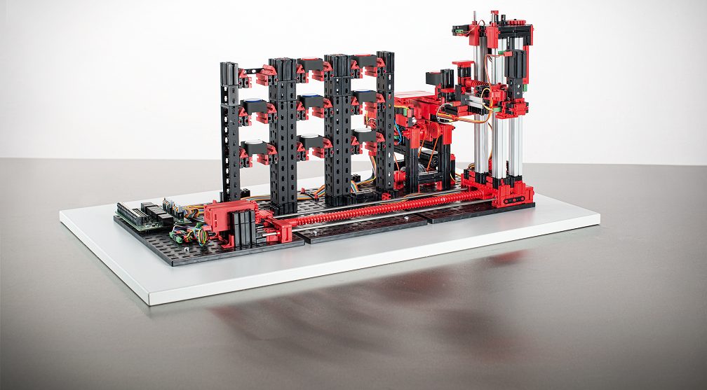

The undersigned declare their agreement with the content of this plan of action document

**Client Projectmanager**

***Initial Seen: Initial Seen:***

Date: <Geef de datum op.> Date: <Geef de datum op.>

Place: <Geef de plaats op.> Place: <Geef de plaats op.>

Contents

Background 4

Project assignment 4

Project activities 4

Requirements 4

Products 4

Quality assurances (optional) 4

Project organization 5

Planning 5

Costs and benefits (optional) 5

Risks 5

Appendices 6

# Background

We’re making this project for Fischer Technik  
we’re making this Plan of action for The Protask Assignment.

# Project assignment

Making use of a Controllino and an Automated High-Bay Warehouse 24 volt  
While we are going to work in Arduino C.  
The Goal is to make the Warehouse fully work, so Let it pick up boxes, Check if the boxes are empty or not and what color is inside the boxes.

# Project activities

We’re going to achieve this by working in sprints. Researching the machine itself and Coding the Machine.  
to successfully end the project we are going to Present the Machine along on the presentation evening and earlier that week to the Teachers to get a grade

# Requirements

|  |  |  |  |
| --- | --- | --- | --- |
| Must | Should | Could | Wont |
| Moving arm | Check if boxes are empty | See Color | Break the Components |
| Pick up Objects | Take a Chosen box | Website |  |
| Controls | Put box back |  |  |
| Drop off at Conveyor belt |  |  |  |

We should make the arm moving so that it can pick up the Boxes, for which we need controls and where it eventually will drop it off at the conveyor belt.

Furthermore, before it picks up the boxes it should check if the box is empty and ask in a prompt if they still want to continue with getting the box, if Not then put back the box in the rack, if the answer is yes it should take the box and put it on the conveyor belt.

# Products

When the product is finished we will have a functional Automated High Bay Warehouse.  
At the end we will present this Product and do some demonstrations of how the product works During the presentation evening and Earlier that week to the Teachers involved to get a grade for our project.

Some of the Parts we’ll use are:

* A Controllino Mega
* Automated High Bay Warehouse 24 volt from Fisher Technik.

# Project organization

The People involved with this project:

* Mr. van Dooren
  + Client
* Jesse Jan Siersema
  + Project Leader
* Jeremey van Uden
  + Programmer

Every Morning we Gather and do a little check.  
We will mainly Communicate through Talking and Sometimes Mailing if there are questions while someone isn’t present.

# Planning

Documentation:

Plan of action: 23rd and 24th of April

Statements of Requirements: 23rd of April

Functional Design:24th of April

Technical Design: 24th of April

Documentation Design Enviroment: 25th of april

Conduct a planning possibly using a graph

Per Project activity:

* Description
* The project member involved
* Time/date (start/planned end)

Also name the de intermediate results

# Costs and benefits (optional)

* What will be the cost of the project in
  + Money
  + Time
  + Classification per project fase/activity
* What are the benefits of the project
  + Money
  + KnowHow
  + Image
* How do we guard the costs and benefits

# Risks

* What will influence the feasibility of the project?
* For example:
  + Not enough time (deadline)
  + Not enough knowledge
  + Project formulation is inadequate and unclear
  + Not enough resources or access to resources
* With which counter measures could you diminish the risks
* Who is responsible for the implementation of those measure(s)

# Appendices

Here we refer to relevant **standards** and in house **procedures**

Where appropriate, reference will be made to existing or customary company standards. Under the condition that they are documented.

**Definitions** are only included to avoid confusion.

The **glossary** does not have to be exhaustive, only the terms used in the Plan of Action are eligible for this

Name each Appendice with a short description (no more than 3 words)

Don’t forget to adjust the table of content.