Assignment due: Check eConestoga

Problem Specification: (Airline Reservation System)

1. Write a reservation system for an airline flight seating. Assume the airplane has 5 rows with 3 seats in each row.
2. Allow the user the following options:
   1. Add a passenger to the flight or waiting list.
      1. Request the passenger’s name.
      2. Display a chart of the seats in the airplane. (When “All Seats” are pressed);
      3. If seats are available, let the passenger choose a seat. Update the passenger to the seating chart
      4. You cannot add a person to waiting list (size 10) if there are seats available.
      5. If no seats are available, place the passenger to the waiting list. In this case, “Book” and “Add to waiting list” buttons will do the same thing (the person will be added to the waiting list). If waiting list is full don’t add to waiting list, just show a message that the waiting list if full.
      6. If seats are available, “add to waiting list” button will not do anything, except showing a message “Seats are available”.
      7. By pressing “Status” button, the status (Available/Not Available) will be shown.
   2. Remove a passenger from the flight
      1. Choose the seat number to be cancelled.
      2. Delete the passenger’s name.
      3. If the waiting list is empty, update the array so the seat is available
      4. If the waiting list is not empty, remove the first person from the list, and give him or her newly vacated seat.
3. Show message when
   1. “Book” is pressed but no passenger name, and seat is specified.
   2. “Book” is pressed when an already booked seat is chosen.
   3. “Add to Waiting List” is pressed when there are seats available.
   4. “Cancel” is pressed without specifying the seat.
   5. After successfully booking.
   6. After successfully cancelling a seat.
   7. After successfully adding to waiting list.
4. Add a “Fill All” button. Clicking this button will fill all the 15 seats. You may use the same passenger name for all seats.
5. Don’t restrict the length of the passenger name. For example, I should be able to book a person with name “a”.

**Remember to incorporate the followings for all assignments (if applicable)**

* Add Header comments.
* Add Documentation comment.
* Incorporate all the highlighted standards provided on Standard Summary.
* Add Implementation comments where (you think) necessary.

RichTextBox. Don’t use List box.

These buttons do nothing. They are only to show the seats orientation and arrangement.

List Box

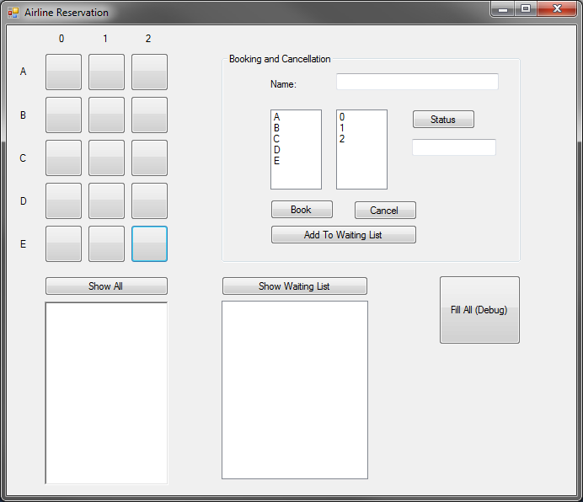

Note:

* You *may* use your own imagination for designing the user interface. The snapshot of the Form is given only to clarify the requirement. You don’t have to make it exactly the same (but you are certainly welcome to make it the same).
* **You must not use any collection/Listbox for showing all passengers and waiting list. You need to use arrays and loop to generate the output.**
* **Don’t disable/enable any button. All buttons should be enabled all the time.**

Hints:

* You must generate at least 1 - 2-dimentional array to store passenger information. Use array to store waiting list.
* Use loop to iterate through all the array elements and generate a string. Then show the string in the RichTextBox when “show all” and “show waiting list” buttons are pressed.

Softcopy Submission Requirements

1. Name the project as follows:

*FirstNameInitialLastName*Assignment*Assignmentnumber*

Replace *FirstNameInitial* and *LastName* based on your name. (Example: if the

student’s name is Jason Bourne, for Assignment 1, the name of the project

will be JBourneAssignment1)

1. Upload the entire solution (after zipping it up) to eConestoga. Make sure the executable also fulfills the naming rule mentioned at point 1.