ENSPRESO- an open data, EU-28 wide, transparent and coherent database of wind, solar and biomass energy potentials

*P. Ruiz1a, W. Nijs1a, D. Tarvydas1a, A. Sgobbi1a, A.Zucker1a, R. Pilli1b, R. Jonsson1b, A. Camia1b, C. Thiel1b,   
C.Hoyer-Klick2, F. Dalla Longa3, T. Kober4, J. Badger5, P. Volker5,   
B.S. Elbersen6, A. Brosowski7, D. Thrän8

1a European Commission, Joint Research Centre, Westerduinweg 3, NL-1755LE, Petten, The Netherlands

pablo.ruiz-castello@ec.europa.eu

1b European Commission, Joint Research Centre (JRC), Ispra, Italy.

2German Aerospace Centre, Institute of Engineering Thermodynamics, Department of Systems Analysis and Technology Assessment, Stuttgart, Germany   
3Energy Transition Studies, ECN part of TNO, Amsterdam, The Netherlands

4Paul Scherrer Institute (PSI), Laboratory for Energy systems Analysis, Switzerland

5DTU Wind Energy, Technical University of Denmark, Roskilde, Denmark

6Wageningen Environmental Research (Alterra), Wageningen University, The Netherlands

7German Biomass Research Centre (DBFZ), Leipzig, Germany

8Helmholtz Centre of Environmental Research (UFZ), Leipzig, Germany

# Supplementary data

## Timeslices structure used for solar

Table 2. Day time D (day), N (night), P (peak) as a function of the season

|  |  |  |  |  |
| --- | --- | --- | --- | --- |
| Hour of day | Spring | Summer | Fall | Winter |
| 1 | N | N | N | N |
| 2 | N | N | N | N |
| 3 | N | N | N | N |
| 4 | N | N | N | N |
| 5 | N | N | N | N |
| 6 | N | N | N | N |
| 7 | N | N | N | N |
| 8 | N | N | N | N |
| 9 | D | D | D | D |
| 10 | D | D | D | D |
| 11 | D | D | D | D |
| 12 | D | P | D | D |
| 13 | D | D | D | D |
| 14 | D | D | D | D |
| 15 | D | D | D | D |
| 16 | D | D | D | D |
| 17 | D | D | D | D |
| 18 | D | D | D | D |
| 19 | D | D | D | D |
| 20 | P | D | P | P |
| 21 | N | N | N | N |
| 22 | N | N | N | N |
| 23 | N | N | N | N |
| 24 | N | N | N | N |

## Assumed minimum distances to settlement

These distances can increase in the case of different turbine type/design (up to 2 times in case of height limitations). Having several turbines in one site could increase sound limited placement distance considerably.

Table 3. Assumed minimum distances to settlement, based on different size of wind turbines and other limitations.

|  |  |  |  |
| --- | --- | --- | --- |
|  |  | Large Wind Turbines | Small Wind Turbines |
|  |  | (m) | (m) |
| Noise | 45 dB | 500 | 120 |
|  | 40 dB | 700 | 200 |
| Hub Height | 1x | 80 | 35 |
| Tip Height | 1x | 125 | 55 |
| Hub Height | 4x | 320 | 140 |
| Tip Height | 4x | 500 | 220 |

## Offshore available area scenarios

The following table depicts the how the selected parameters are used to define the available area scenarios for wind offshore.

Table 4. Offshore wind scenario definition parameters

|  |  |  |  |  |
| --- | --- | --- | --- | --- |
| Parameter | High scen | Low scen | Ref scen | Comment |
| Sea depth | < 100 m | < 50 m | < 50 m | Based on the scenarios analysed in the WindSpeed project |
| Shipping density (ships per year) | < 500 | < 5,000 | < 1,000 | Based on the scenarios analysed in the WindSpeed project |
| Distance to shipping lanes | 2NM | 4NM | 2NM | Based on the scenarios analysed in the WindSpeed project |
| Distance to gas & oil pipelines | 2NM | 4NM | 2NM | Based on the scenarios analysed in the WindSpeed project |
| Distance to oil and gas wells | 2NM | 4NM | 2NM | Based on the scenarios analysed in the WindSpeed project |
| Minimum distance to shore | 12NM | 12NM | 12NM | While near-shore areas are typically available for wind installations, in practice these are often used for other purposes (e.g. sand extraction) or are kept free to minimise visual impact (especially in touristic regions). An exception to this rule of thumb may be Denmark where very near shore installations occur and may represent a significant potential in the future. |
| Submarine cables | 2NM | 4NM | 2NM | Based on the scenarios analysed in the WindSpeed project |

## Onshore wind exclusion zones

Table 5. Onshore wind exclusion zones

| Scenario | | Wind high | Wind low | Wind ref |
| --- | --- | --- | --- | --- |
|  |  | Usable | Usable | Usable |
| GLCplus | |  | |  |
| Class | Class Description |  |  |  |
| 11 | Post-flooding or irrigated croplands (or aquatic) | no | no | no |
| 14 | Rainfed croplands | yes | yes | yes |
| 20 | Mosaic cropland (50-70%) / vegetation (grassland/shrubland/forest) (20-50%) | yes | yes | yes |
| 30 | Mosaic vegetation (grassland/shrubland/forest) (50-70%) / cropland (20-50%) | yes | yes | yes |
| 40 | Closed to open (>15%) broadleaved evergreen or semi-deciduous forest (>5m) | no | no | no |
| 50 | Closed (>40%) broadleaved deciduous forest (>5m) | no | no | no |
| 60 | Open (15-40%) broadleaved deciduous forest/woodland (>5 m) | no | no | no |
| 70 | Closed (>40%) needleleaved evergreen forest (>5m) | no | no | no |
| 90 | Open (15-40%) needleleaved deciduous or evergreen forest (>5 m) | no | no | no |
| 100 | Closed to open (>15%) mixed broadleaved and needleleaved forest (>5 m) | no | no | no |
| 110 | Mosaic forest or shrubland (50-70%) / grassland (20-50%) | yes | yes | yes |
| 120 | Mosaic grassland (50-70%) / forest or shrubland (20-50%) | yes | yes | yes |
| 130 | Closed to open (>15%) (broadleaved or needleleaved, evergreen or deciduous) shrubland (<5 m) | no | no | no |
| 140 | Closed to open (>15%) herbaceous vegetation (grassland, savannas or lichens/mosses) | yes | yes | yes |
| 150 | Sparse (<15%) vegetation | yes | yes | yes |
| 160 | Closed to open (>15%) broadleaved forest regularly flooded (semi-permanently or temporarily) - Fresh or brackish water | no | no | no |
| 170 | Closed (>40%) broadleaved forest or shrubland permanently flooded - Saline or brackish water | no | no | no |
| 180 | Closed to open (>15%) grassland or woody vegetation on regularly flooded or waterlogged soil - Fresh, brackish or saline water | no | no | no |
| 190 | Artificial surfaces and associated areas (Urban areas >50%) | no | no | no |
| 191 | Artificial surfaces, Urban fabric, Continuous urban fabric | no | no | no |
| 192 | Artificial surfaces, Urban fabric, Discontinuous urban fabric | no | no | no |
| 193 | Industrial, commercial and transport units | no | no | no |
| 194 | Road and rail networks and associated land | no | no | no |
| 195 | Port areas | no | no | no |
| 196 | Airports | no | no | no |
| 197 | Artificial surfaces, "Artificial, non-agricultural vegetated areas", Green urban areas | no | no | no |
| 198 | Artificial surfaces," Artificial, non-agricultural vegetated areas", Sport and leisure facilities | no | no | no |
| 200 | Bare areas | yes | yes | yes |
| 210 | Water bodies | no | no | no |
| 220 | Permanent snow and ice | no | no | no |
| 230 | No data (burnt areas, clouds,…) | no | no | no |
| LUISA | |  | |  |
| Class | Class Description |  |  |  |
| 1 | Urban | no | no | no |
| 2 | Industry | no | no | no |
| 3 | Other Arable | yes | yes | yes |
| 4 | Permanent Crops | yes | yes | yes |
| 5 | Pastures | yes | yes | yes |
| 6 | Forests | no | no | no |
| 7 | Transitional woodland-shrub | no | no | no |
| 8 | Cereals | yes | yes | yes |
| 9 | Maize | yes | yes | yes |
| 10 | Root crops | yes | yes | yes |
| 11 | Abandoned Arable Land | yes | yes | yes |
| 12 | Abandoned Permanent Crops | yes | yes | yes |
| 13 | Abandoned Pastures | yes | yes | yes |
| 14 | Abandoned Urban | yes | yes | yes |
| 15 | Abandoned Industry | yes | yes | yes |
| 16 | New Energy Crops | yes | yes | yes |
| 17 | Natural land | yes | yes | yes |
| 18 | Infrastructure | no | no | no |
| 19 | Other Nature | no | no | no |
| 20 | Wetlands | no | no | no |
| 21 | Water Bodies | no | no | no |
| 22 | Urban green leisure | no | no | no |
|  | Additional Criteria: |  |  |  |
|  | Protected Areas | no | no | no |
|  | Geomorphology | no | no | no |
|  | Slope <2.1° | no | no | no |
|  | Distance to Settlements | MS - specific values | MS - specific values | MS - specific values |

## Wind onshore available land

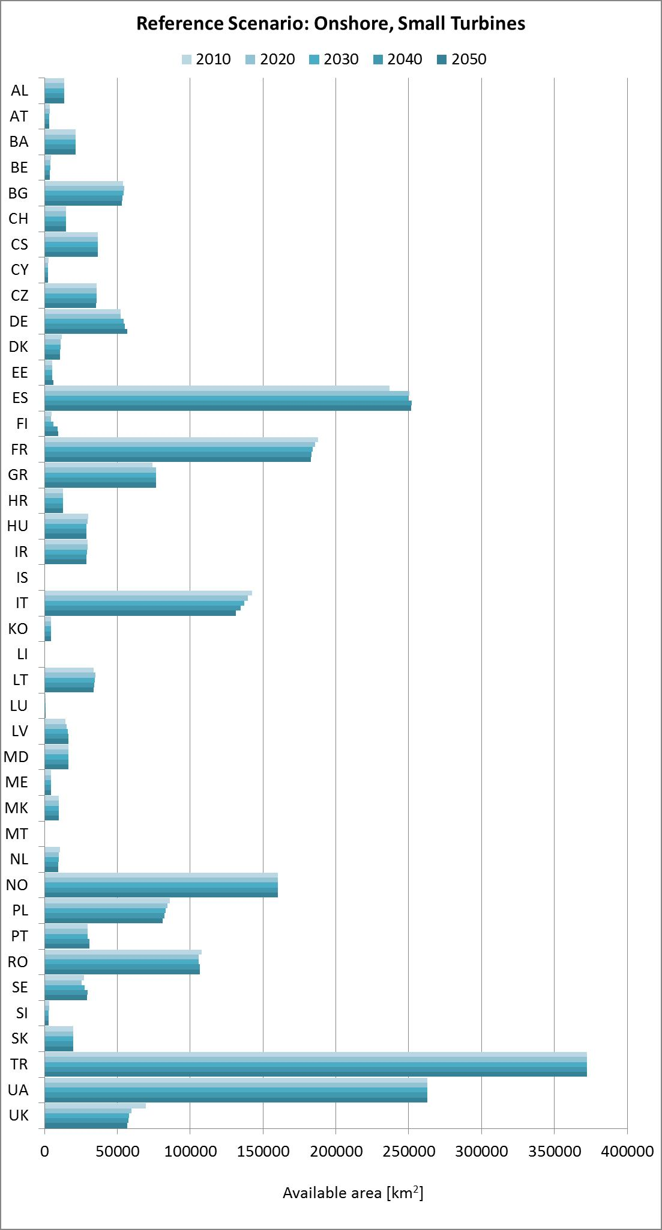

Figure 8 Available land for wind onshore in the reference scenario

## Wind offshore available area

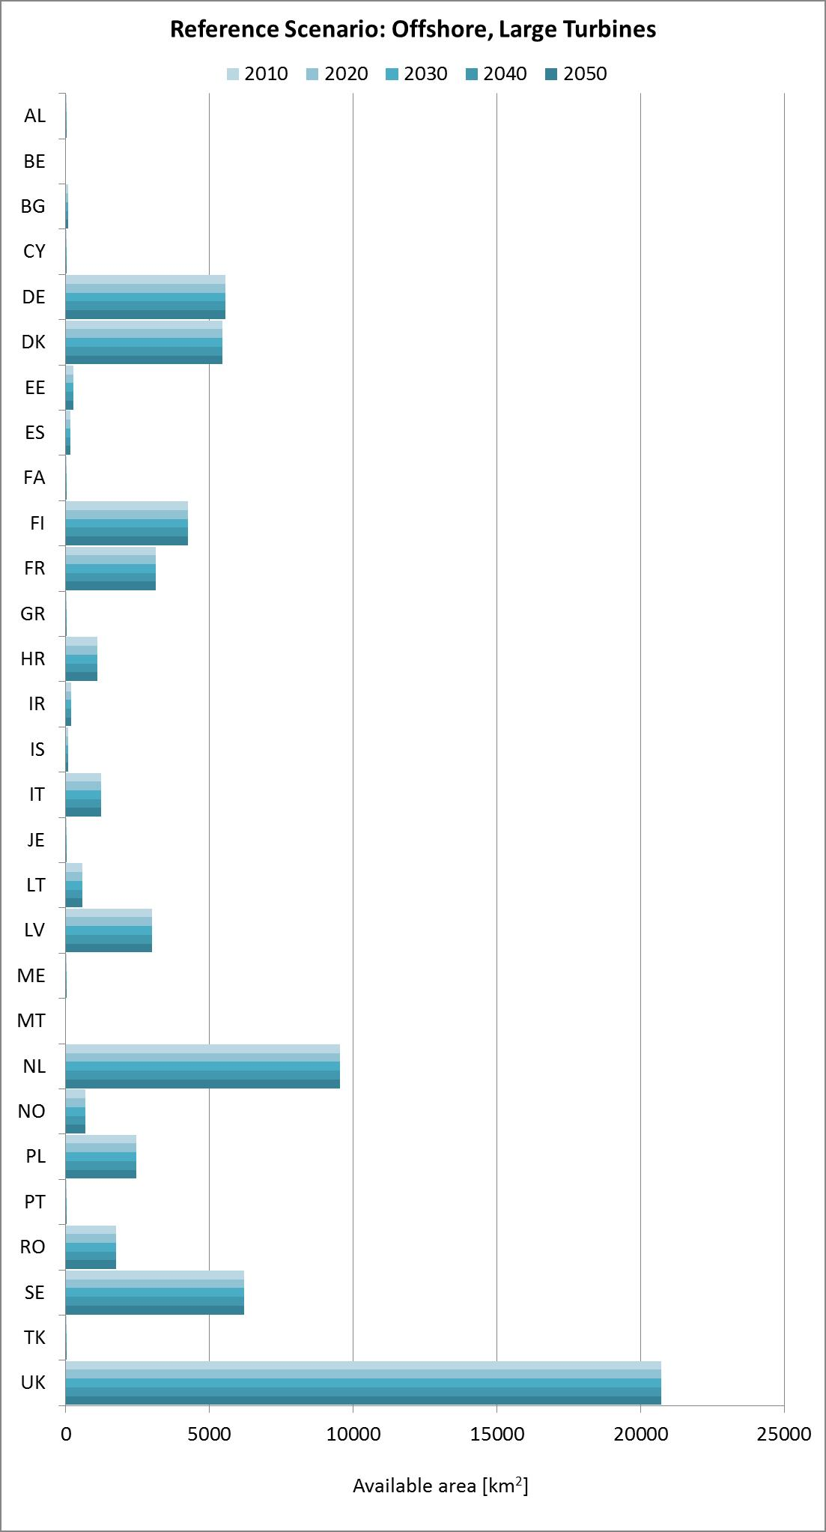

Figure 9 Available area for wind onshore in the reference scenario

## Wind technologies scheme



## Wind technology matrix

Table 6. Wind technology Matrix



## Wind capacity factor derivation

Table 7. List of dependencies in the processing

|  |  |
| --- | --- |
| Height: | (1) 50 m, (2) 100 m, and (3) 200 m |
| Sector: | 12 x 30° sectors |
| Season: | (1) Spring(15/03 - 31/05)  (2) Summer(01/06 - 30/08)  (3) Autumn(31/08 - 15/11)  (4) Winter(16/11 - 14/03) |
| Time of day: | (1) day (D), (2) night (N), and (3) peak (P) |
| Turbine technology: | (1) Vestas V90, (2) Vestas V112, and (3) Vestas V136 |

Global Wind Atlas (GWA) Weibull A (Agwa) and k (kgwa) parameters are available sector-wise for 50 m, 100 m, and 200 m heights with a 250 m spatial resolution. Now, for every height, timeslice (day time and season) and sector, we step through the wind speed distribution with a resolution of dws (set to 1m/s). For every bin, we correct the lower boundary of the bin with: $U_{ c1}=A_{gwa}{\left(\frac{U_{b1}}{A_{ren}}\right)}^{\frac{k_{ren}}{k_{gwa}}}$ ( 1 )

and the upper boundary of the bin with:

$U_{ c2}=A_{gwa}{\left(\frac{U_{b2}}{A_{ren}}\right)}^{\frac{k_{ren}}{k_{gwa}}}$ ( 2 )

Here, Uc and Ub are the corrected and original bin boundaries. From the corrected lower and upper bin boundaries the corrected average wind speed (Uav) is calculated. Then, we loop over the turbine technologies and if Uav is between the cut-in (Uin) and cut-out (Uout) wind speed of the specific turbine, the wind direction (FWDts) and wind speed (FWSts) weighted capacity factor is calculated:

$CF\left(i,j,k,l,m\right)=\sum_{q=1}^{12}{\sum_{p=\left(U_{in}+1\right)}^{U_{out}}{{FWD}_{ts}\left(i,j,k,l,q\right)∙{FWS}_{ts}}}∙\left[\frac{\left(P\left(p,m\right)-P\left(p-1,m\right)\right)\left(U_{av}-U\left(p-1\right)\right)}{U\left(p\right)-U\left(p-1\right)}++ P\left(p-1,m\right)\right]$ ( 3 )

where i is the longitude, j is the latitude, k the season. l day time, m the turbine technology, and P the normalised turbine power production. The wind direction weights is normalised such that:

$\sum_{q=1}^{12}{{FWD}_{ts}\left(i,j,k,l,q\right)=1 ∀ i,j,k,l.}$ ( 4 )

The wind speed weights (FWSts) are obtained from difference of the season and day time dependent weibull cumulative distribution functions of the upper:

$P_{2}=1-exp\left(-{\left(\frac{U_{c2}}{A_{ts}}\right)}^{k_{ts}}\right)$ ( 5 )

and lower:

$P_{1}=1-exp\left(-{\left(\frac{U_{c1}}{A_{ts}}\right)}^{k_{ts}}\right)$ ( 6 )

corrected wind speed bin. The results are stored in geotiff tiles.

## Wind capacity factor distributions

The blue dots represent the CF of each available raster cell in the country. The three red lines represent the average of the top 10% of the CFs (classified as high resource areas), the middle 40% (medium resource areas), and the lowest 50% (low resource areas) , respectively.

In this way the available area is subdivided into three separate classes in each country (see technology matrix), depending on the wind resource level. The three levels of capacity factors per country are then used in the input files for the energy system models.

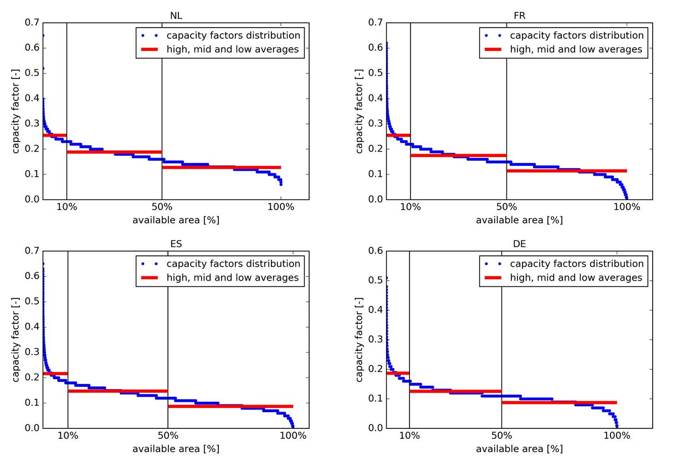

Figure 10. Onshore capacity factor distributions for the Netherlands (top left), France (top right), Spain (bottom left) and Germany (bottom right). Note the difference in y-axis scale in the ‘DE’ panel.

## Potential capacity for wind onshore

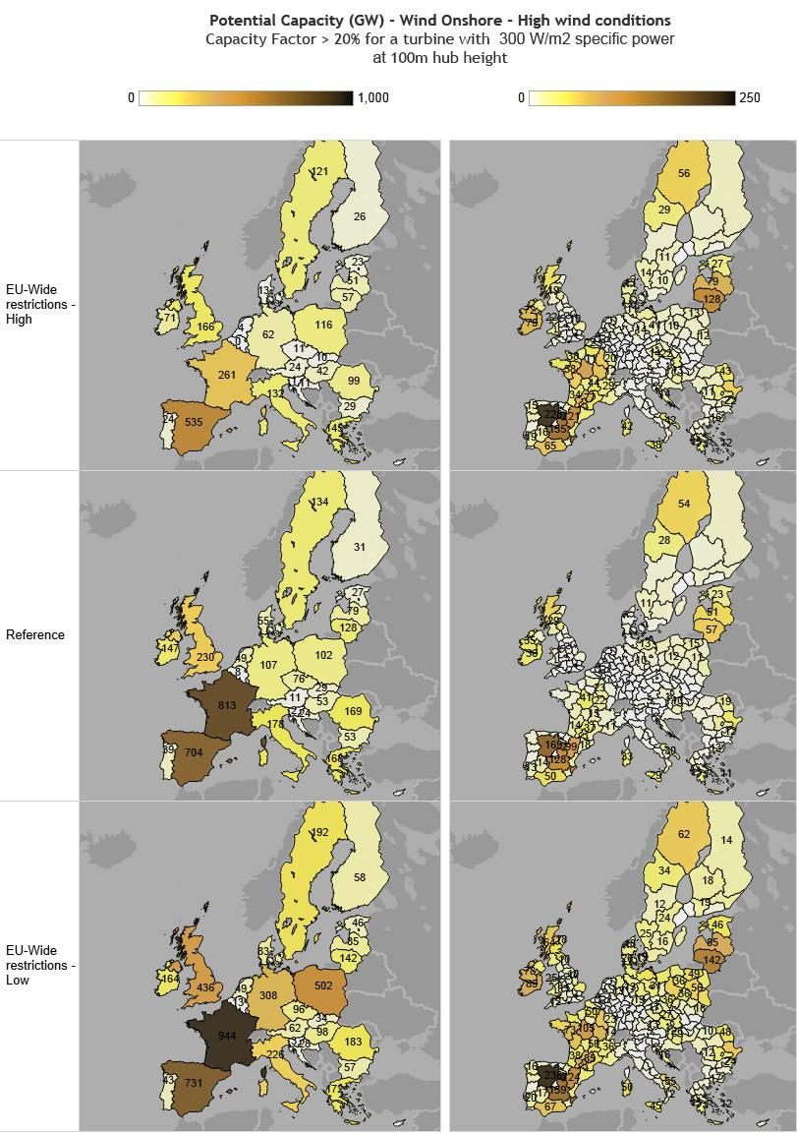

Figure 11 Potential capacity (GW)with capacity factor over 20% and technology matrix cell

## Solar area, irradiations and technology clusters

Table 8: Interrelations between area, irradiations and technology clusters



## Solar land exclusion criteria summary

We distinguish between:

* natural areas, for which we assume ground-mounted solar technology to be applied,
* and artificial land area, for which we consider roof-top-mounted and façade-mounted solar applications. The artificial areas were further subdivided into residential and industrial area.

To calculate the available area for solar technology for these land classifications we apply exclusion criteria to the total land area (see Table 9).

Artificial areas are classified in residential and industrial, as we think roof types will be quite different in these two areas, so it makes sense to treat them differently. More inclined rooves are expected in residential areas, whilst more flat rooves are expected in industrial areas.

The natural areas are further subdivided into high and low radiation areas. The distinction is done by additionally applying a threshold of 1,800 kWh/m² DNI and a maximum slope of 2.1° to the natural areas. The regions which fulfil both criteria are marked as high radiation areas. These are areas which are typically suitable for large scale concentrating technologies. All other suitable natural areas are marked as low. The distinction of high and low radiation areas has been applied to avoid that high radiation areas are averaged out if the data are further aggregated or averaged from the NUTS2 level. While the allocation into different irradiation classes is done at pixel level, the distinction between agricultural and non-agricultural areas is done at NUTS2 level, by considering crop data from the Bioenergy Work Package and subtracting them from the total natural land area suitable for solar applications, which is derived from the GIS analysis. As this analysis has been done at the NUTS2 region level, both high and low irradiation areas were treated equally, meaning that the shares of agricultural areas and non-agricultural areas are the same for high and low irradiation clusters per NUTS2 region.

Table 9 Solar land exclusion criteria



In addition to the exclusion criteria provided in this table, we assume protected areas (based on World Data of Protected Areas 2010) (www.wpda.org) are not to be used for solar application, as well as areas with unsuitable geomorphology based on FAO’s Digital Soil Map of the World. We apply coefficients (area factors) to selected land types which are meant to reflect the actual usable area.

Sports and leisure has only been assessed as available area, as there is a very high uncertainty and no empirical base as to how much of the sports and leisure area is actually buildings which could be used for solar applications. Sports and Leisure is about 7% of the residential area, so the maximum contribution of sports and leisure could theoretically be 7% if it would be treated similarly to residential areas. However, as most of the sports and leisure area is probably playground and grasslands with only a very small fraction of buildings, the actual contribution will be much smaller and probably close to 0%.

## Shares of available area for ground mounted solar

In some countries the share of available area for ground-mounted solar installation is very high (above 60%). Table 10 presents the total shares of available area for ground-mounted solar per country, and the land-use category providing the highest contribution to the total share. The countries where the total share of available area for ground mounted is above 60% are highlighted in bold font.

Table 10: Land-use categories influencing area availability for ground-mounted solar.

|  |  |  |
| --- | --- | --- |
| **Country** | **Total share of area available for ground mounted** | **Land-use category with largest share** |
| AT | 30% | Pastures (11%) |
| BE | 49% | other arable (21%) |
| BG | 50% | other arable (28%) |
| CY | 46% | other arable (38%) |
| CZ | 49% | other arable (22%) |
| DE | 44% | cereals (14%) |
| DK | 63% | other arable (29%) |
| EE | 23% | other arable (14%) |
| EL | 43% | other arable (20%) |
| ES | 48% | other arable (21%) |
| FI | 3% | cereals (3%) |
| FR | 53% | other arable (19%) |
| HR | 17% | cereals (10%) |
| HU | 63% | other arable (24%) |
| IE | 60% | Pastures (44%) |
| IT | 49% | other arable (26%) |
| LT | 54% | other arable (33%) |
| LU | 36% | Abandoned (15%) |
| LV | 28% | other arable (12%) |
| MT | 39% | other arable (21%) |
| NL | 53% | Pastures (21%) |
| PL | 50% | cereals (21%) |
| PT | 35% | other arable (19%) |
| RO | 59% | other arable (19%) |
| SE | 5% | other arable (3%) |
| SI | 30% | other arable (16%) |
| SK | 43% | other arable (22%) |

## Heliosat Method

**Figure 12** depicts the evaluation sequence for the Heliosat Method. The currently used Bird model has originally been proposed by [77] and has later been modified by [78] as Model C. The broadband direct normal irradiance *Gdn* is calculated as:

( 7 )



The factor 0.9751 is a conversion faction, since the model used for the development (SOLTRAN) considered the spectral interval of 0*.*3 -3*.*0*µm*. *Gext* is the extraterrestrial irradiance or solar constant. The *τ*x are the individual transmittances of the different atmospheric constituents. They are described below.

Iqbal uses the old air mass *ma* of [79] with a correction for the height h above sea level:

( 8 )



θz is the solar zenith angle. The transmittance by Rayleigh scattering is calculated by: τ

( 9 )



The transmittance by ozone is:

( 10 )



with

( 11 )



l is the vertical ozone layer thickness in cm and *m* is the uncorrected air mass. The transmittance by uniformly mixed gases is given by:

( 12 )



The transmittance by water vapour is calculated from:

( 13 )



with

( 14 )



*w* is the precipitable water.

The aerosol transmittance is given by:

( 15 )



with

( 16 )



If α and β from the Angstrom law are known, the following equation from [80] can be used:

( 17 )



The diffuse irradiance *Gdiff* is calculated from three components, where *Gdiff,r* is the diffuse irradiance due to Rayleigh scattering, *Gdiff,a* due to aerosol scattering and *Gdiff,m* due to multiple reflections between surface and atmosphere. The diffuse irradiance due to Rayleigh scattering is:

( 18 )



where τaa is the is the transmittance of direct irradiance due to aerosol absorption:

. ( 19 )



ω0 is the single scattering albedo of the aerosols. It is the relationship of the radiation scattered by the aerosol to the total aerosol extinction. [77] have recommended using 0*.*9 for ω0 as long as no better value is available.

The aerosol-scattered diffuse irradiance after the first pass through the atmosphere is:

( 20 )



With

( 21 )



and Fc is recommended to be used as 0.84.

To calculate the irradiance by multiple reﬂections, the following expression for the atmospheric albedo *ρa* is suggested:

( 22 )



The irradiance due to multiple reflections is then given by:

( 23 )



with the ground albedo *ρg*, which is taken as 0.2. The diffuse irradiance is the sum of its components:

( 24 )



Finally the total clear sky irradiance on the horizontal surface is the sum of the components:

( 25 )



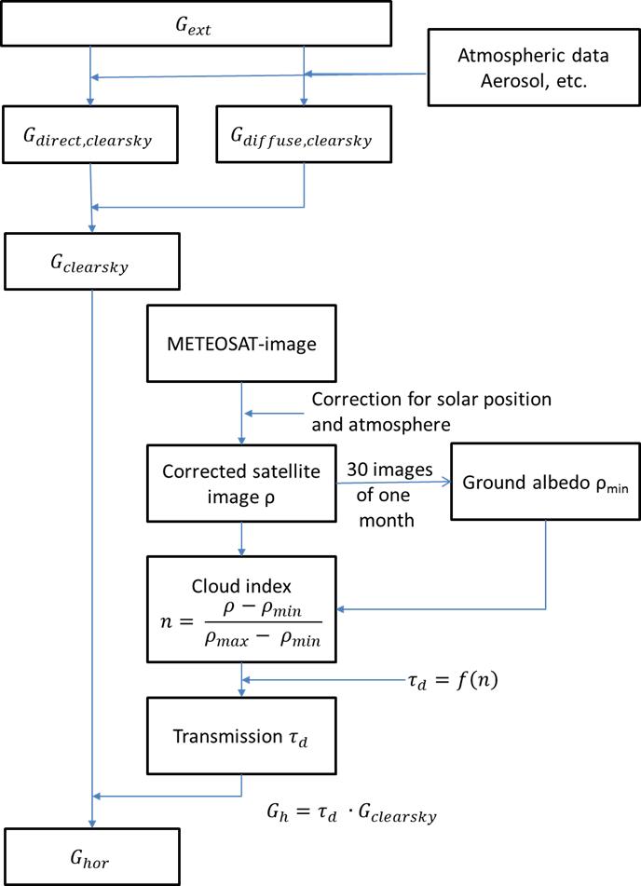

**Figure 12 Outline of the Heliosat Method**

## Timeslice irradiation example output

|The following graphs show how irradiation [MJ] in the left axis, is distributed along the different timeslices (color code) for different countries (NUTS0 level, horizontal axis)

Figure 13: Timeslice irradiation [MJ] left axis,for roof-top solar (45 degree, south) distributed by timeslice (color code by right axis)

## Irradiation classes based on differences between NUTS2 regions

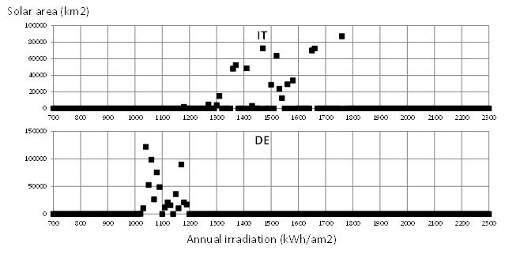

Figure 14: Variation of solar irradiation in Italy and Germany.

## Solar Technology scenarios

The techno-economic data characterizing the technologies is included in the JRC-DC. The data in [81] has been used as a basis for the technology assessment. For technologies and techno-economic parameters not covered in [81], the IEA-ETSAP & IRENA Technology Briefs and the database of ECN Resolve-H/C and RESolve-E models have been used.

Data is provided for four scenarios, differentiated by considering alternative sets of techno-economic parameters. The reference scenario is based on the ETRI report and the data in the sources mentioned. Besides the ETRI *ref* scenario, an ETRI *high* and a *low* scenario have been constructed by assuming a more optimistic and a more pessimistic investment cost, respectively. In addition, we provide a scenario with an *alternative* solar technology parameter set with different investment costs and PV module efficiencies, which are derived from IRENA and DLR sources.

The fact that there is an influence of the ambient temperature and module/collector temperature on the conversion efficiency of the solar technology is taken explicitly into account and implemented through the solar technology efficiency parameter on the timeslice level. It is necessary to distinguish between solar PV and solar thermal applications, because:

* Efficiency of PV modules declines with increasing module temperature
  + Calculated according method and coefficients applied in [82]
* Efficiency of solar thermal collectors increases with increasing collector temperature
  + Calculated separately for flat collectors and vacuum collectors and different collector temperature levels (40 / 60 / 80 / 120 degree C) assuming different temperature levels of the heat consumers (warm water, space heating and industrial process heat).

Table 11: Technical parameters of PV plants ([82], based on [83])

|  |  |  |  |  |  |
| --- | --- | --- | --- | --- | --- |
|  | Symbol | Unit | 2010 | 2020 | 2050 |
| Temperature coefficient | $$f_{T}^{PV}$$ | 1/C | -0.005 | -0.0045 | -0.004 |
| Availability factor | $$f_{AV}^{PV}$$ | - | 0.98 | 0.98 | 0.98 |
| Module efficiency1 |  | - | 0.161 | 0.173 | 0.18 |
| q-factor | $$q^{PV}$$ | - | 0.811 | 0.82 | 0.847 |
| System efficiency, annual average | - | - | 0.128 | 0.139 | 0.149 |
| Installation density (for open space PV)2 |  | - | 0.33 | 0.33 | 0.33 |

1Under standard test conditions: 25°C module temperature, 1000 W/m2 irradiance

2For urban PV installations this factor is set to 1

According to [82] “the deviation of the power output from the power output at 25°C conditions is specified by the temperature coefficient *f* PV. In order to take into account the influence of the module temperature ☺ *PV* ,*time* at a given time on the power output of PV modules, ☺ *PV* ,time is calculated according to the following correlation with the ambient temperature ☺*time* and the irradiance on the module with the correlation coefficients k1 = -2 °C, k2 = 1.02 and k3 = 0.03 °C*m2/W”:

$ϑ_{M}^{PV,time}=k_{1}+k_{2}∙ϑ_{ambient}^{time}+k_{3}∙G_{glob, surf}^{time}$ ( 26 )

For solar thermal technology we apply a linear relationship of the collector efficiency to the temperature difference of the collector and the ambient air according to **Figure 15** which is estimated from [84].

**Figure 15: Temperature-related Efficiency loss for solar thermal techonolgy (estimated based on** [84]

## PV potentials for the EU28

Table 12 Summary of Solar potentials for EU28 by technology cluster – assuming a 3% use of the available non-artificial area.

|  |  |  |  |
| --- | --- | --- | --- |
| **Surface** | **Technology** | **Efficiency assumption - power density [Wp/m2]** | **Potential [GW]** |
| TOTAL |  | 170 | 10,127 |
| TOTAL |  | 300 | 17,871 |
| residential areas roof-top 45 degree south | PV | 170 | 83 |
| residential areas roof-top 45 degree east | PV | 170 | 56 |
| residential areas roof-top 45 degree west | PV | 170 | 56 |
| residential areas roof-top latitude tilt | PV | 170 | 87 |
| residential areas facade south | PV | 170 | 108 |
| residential areas facade east | PV | 170 | 108 |
| residential areas facade west | PV | 170 | 108 |
| industrial areas roof-top 45 degree south | PV | 170 | 37 |
| industrial areas roof-top 45 degree east | PV | 170 | 25 |
| industrial areas roof-top 45 degree west | PV | 170 | 25 |
| industrial areas roof-top latitude tilt | PV | 170 | 287 |
| industrial areas facade south | PV | 170 | 66 |
| industrial areas facade east | PV | 170 | 66 |
| industrial areas facade west | PV | 170 | 66 |
| natural areas agriculture high irradiation | CSP - before storage | 170 | 598 |
| natural areas agriculture low irradiation | PV - ground | 170 | 7,867 |
| natural areas non-agriculture high irradiation | CSP - before storage | 170 | 26 |
| natural areas non-agriculture low irradiation | PV - ground | 170 | 458 |
| residential areas roof-top 45 degree south | PV | 300 | 147 |
| residential areas roof-top 45 degree east | PV | 300 | 98 |
| residential areas roof-top 45 degree west | PV | 300 | 98 |
| residential areas roof-top latitude tilt | PV | 300 | 154 |
| residential areas facade south | PV | 300 | 191 |
| residential areas facade east | PV | 300 | 191 |
| residential areas facade west | PV | 300 | 191 |
| industrial areas roof-top 45 degree south | PV | 300 | 65 |
| industrial areas roof-top 45 degree east | PV | 300 | 43 |
| industrial areas roof-top 45 degree west | PV | 300 | 43 |
| industrial areas roof-top latitude tilt | PV | 300 | 506 |
| industrial areas facade south | PV | 300 | 117 |
| industrial areas facade east | PV | 300 | 117 |
| industrial areas facade west | PV | 300 | 117 |
| natural areas agriculture high irradiation | CSP - before storage | 300 | 1,055 |
| natural areas agriculture low irradiation | PV - ground | 300 | 13,883 |
| natural areas non-agriculture high irradiation | CSP - before storage | 300 | 45 |
| natural areas non-agriculture low irradiation | PV - ground | 300 | 808 |

## Biomass availability scenarios definition.

Table 13. Scenario definition parameters for agriculture sector

| CAT. | TYPE | SUB-TYPE | PARAMETERS SET: | | | Productivity | | | | Limitation of biofeedstocks & available land | | |
| --- | --- | --- | --- | --- | --- | --- | --- | --- | --- | --- | --- | --- |
| SCENARIO: | | | HIGH | MED | LOW | | HIGH | MED | LOW |
| ENERGY CROPS | **Sugar starch & oil biofuel crops**  **-** | | **Available Land** | | | + 10% land area available for biofuel and energy maize vs CAPRI baseline | Consistent with CAPRI | Consistent with CAPRI | | Biofuel crops grow in competition for land with food and feed crops but this is no impediment for their use for energy. Their share can be even 10% above the land use share as predicted by CAPRI | Biofuel crops grow in competition for land with food and feed crops as assessed by CAPRI | Biofuel crops grow in competition for land with food and feed crops as assessed by CAPRI  2) No irrigation in biofuel crops  1) Biofuel crops cannot be sourced from HNV farmland |
| **Irrigation** | | | Yes | Yes | No | |
| **Yield [% Increase/y]** | | | Consistent with CAPRI yield increases | | | |
| **Energy maize/silage (for biogas)**  **-** | | **Available Land** | | | Yes | Yes | No | | As for biofuel crops | As for biofuel crops | As for biofuel crops |
| **Irrigation** | | | Yes | Yes | No | |
| **Yield [% Increase/y]** | | | CAPRI+10% | CAPRI+10% | CAPRI+10% | |
| **Woody/ ligno-cellulosic biomass**  **-** | | **Available Land** | | | As MED Scenario | Consistent with Capri land release between 2008 and analysis year (2020, 2030, 2040 or 2050) | As MED Scen, but excludes protected areas and high nature value farmland | | 1) high yield factor increases per year for dedicated bioenergy crops as result of improved technological developments in perennial breeds and farm management systems  2) Growing energy crops (perennials) on marginal and fallow lands, such as highly erodible lands, poor soils, which have been released from agriculture already a long time ago  3) Dedicated cropping can take place in High biodiversity lands  4) Irrigation is allowed | 1) Medium increase per year in yield factors for dedicated bioenergy crops as result of improved technological developments in perennial breeds and farm management systems  2) Growing energy crops (perennials) on marginal lands  3) no crops on biodiversity rich land and on land (e.g. High Nature Value (HNV) farmland and Natura 2000 land in EU) with high carbon stocks  4) Irrigation in dedicated cropping is allowed | 1) Low increase per year in yield factors for dedicated bioenergy crops as no investments in technological developments in perennial breeds and farm management systems  2) no crops on biodiversity rich land and on land with high carbon stocks and on fallow land.  3) Marginal lands can be used for dedicated perennial crop, but limited investments and no irrigation allowed. 4) Urban planning policies (more urban sprawl and less land for biomass) |
| **Irrigation** | | | Yes | Yes | No | |
| **Yield**  **[% Increase per year]** | | | 1 | 0.5 | 0.25 | |
| **Competing use**  **[% NOT going to energy /total]** | | | 0% | 50% | 75% | |
| PRIMARY RESIDUES | **Manure** | **Dry (poultry, sheep, goat)** | **Livestock** | | | Consistent with Capri animal number and type developments | | | | 1) Increase in the removal rate of residues from arable and permanent crops  2)Increase of sustainable yield ratios for straw up to 50% of straw available  3) Minimum use of straw for alternative (non-energy) uses 4) straw use in bedding declines because of alternative uses and new livestock housing systems  5) Re-use of all woody material from pruning and cutting- residues from abandoned grassland are usable for bioenergy | 1) Removal rates of arable and permanent crop residues will stabilise at what is also currently a common practice and sustainable acceptable (not taking account of specific regional circumstances making sustainable removal more of an issue)  2) Use of straw for alternative (non-energy) uses according to current conditions  3) Moderate increase use of woody material from pruning and cutting from today’s level  4) No residues from abandoned grassland | 1) Today’s patterns for residue-producing crops  2) Stricter sustainable yield ratios for straw then in current situation  3) Use of straw for alternative (non-energy) uses according to current conditions  4) Use of woody material from pruning and cutting on today’s level  5) No residues from grassland |
| **Competing use [% NOT going to energy /total]** | | | 0% | 50% | 75% | |
| **Wet (manure (pig, cattle)** | **Livestock** | | | Consistent with Capri animal number and type developments | | | |
| **Manure available for digestion** | | | All manure produced on farms with >100 Livestock Units | All manure produced on farms with >200 Livestock Units | All manure produced on farms with >500 Livestock Units | |
| SECONDARY RESIDUES | **Pits from olive pitting** | | **Residue ratio** | | | All olive pits going to processing industries in EU | | | |
| **EU Collection ratio** | **2020** | | 50% | 30% | 20% | |
| **2030** | | 60% | 35% | 20% | |
| **2040-50** | | 70% | 40% | 20% | |
| **Competing use [% NOT going to energy /total]** | | | 0% | 50%(2020), 60%(2030-2050) | 80%(2020), 85%(2030-2050) | |
| SOLID RESIDUES | **Prunings (permanent crops (e.g. orchards, vineyards, olives, citrus, nuts) residues** | | **Area** | | | Consistent with Capri permanent crop area developments | | | |
| **Harvest ratio [%/total]** | | **2020** | 60% | 40% | 20% | |
| **2040** | 70% | 10% | |
| **2030** | 80% | 10% | |
| **2050** | 90% | 10% | |
| **Competing use [% NOT going to energy /total]** | | **2020** | 20% | 60% | 70% | |
| **2030** | 15% |
| **2040-50** | 10% |
| **Straw/stubbles** | | **Area** | | | Consistent with Capri cereals, OSR, grain maize, sunflower development | | | |
| **Harvest ratio [%/total]** | | | 40% | 30% | | 0-30% |
| **Competing use [% NOT going to energy /total]** | | **2020-30** | 20% | 50% | | 80% |
| **2040-50** | 10% | 60% | | 90% |

Table 14. Scenario definition parameters for forestry sector

| CAT. | TYPE | PARAMETERS SET: | | Productivity | | | | Limitation of biofeedstocks & available land | | | | |
| --- | --- | --- | --- | --- | --- | --- | --- | --- | --- | --- | --- | --- |
| SCENARIO: | | HIGH | MED | | LOW | HIGH | MED | | | LOW |
| ROUND-WOOD  PRODUCTION | **Stemwood (from roundwood and thinnings)** | **Timber demand**  **[Million m3]** | **2020** | 1,239 | 1,064 | | 966 | 1) stem wood and forestry residues available for energy production  2) Increased woodland productivity by fertilization and harvesting mechanisation efficiency and increased mobilisation of wood from smallholders  3) Reduced competing demand for non-energy purposes  4) Increased mobilization of primary forestry residues because of increased demand for biomass for energy, which leads to increased stump and residue removal1 | | 1) Stem wood is mainly used for non-energy purposes, but improved mobilisation of stemwood, primary and secondary forestry residues compared to today because of increase in contribution of small holders.  2) Stump removal is however limited because of sustainability considerations.  3) reference woodland productivity and mobilization1 | 1) Forestry harvest patterns according to strict sustainability criteria and low mobilisation of small and medium forest holders use of forestry residues only  2) available residues only from residue extraction, but no stump removal allowed  3) lower ratios of usage of primary and secondary residues and more competition | |
| **2030** | 1,419 | 1,168 | |
| **2040** | 1,661 | 1,267 | |
| **2050** | 2,073 | 1,472 | |
| **Harvesting techniques applied** | | High efficiency | Medium efficiency | | Low efficiency |
| **Sustainability considerations** | | Low | Medium | | High |
| **Competing use (% NOT going to energy)** | **2020** | 45% | 52% | | 55% |
| **2030** | 39% | 50% | |
| **2040** | 31% | 47% | |
| **2050** | 23% | 42% | |
| PRIMARY FORESTRY RESIDUES | **Logging residues (tops, branches, stumps and early pre-commercial thinnings)** | **residue removal rate** | | No limitation for stump and residue extraction | Low stump extraction and medium residue extraction | | Stump extraction excluded, low residue extraction |
| **Competing use (% NOT going to energy)** | **2020** | 0% | 50% | | 50% |
| **2030-2050** | 0% | 60% | | 60% |
| SECONDARY FORESTRY RESIDUES (FROM WOOD AND PAPER & PULP INDUSTRIES) | **Woodchips & pellets** | **Amount of residue/residue ratio** | | Linked to wood demand and locations of processing industries | | | |
| **Competing use (% NOT going to energy)** | **2020** | 0% | | 50% | 50% |
| **2030-2050** | 60% | 60% |
| **Sawdust** | **Amount of residue/residue ratio** | | Linked to wood demand and locations of processing industry | | | |
| **Competing use**  **(% NOT going to energy)** | **2020-2030** | 0% | | 50% | 70% |
| **2040-2050** | 60% | 90% |
| **Black liquor** | **Amount of residue/residue ratio** | | Based on Euwood/Biomass Futures (endogenous in JRC-EU-TIMES model) | | | |
| **Competing use (% NOT going to energy)** | | 0% | | 0% | 0% |

Table 15. Scenario definition parameters for waste sector

| CAT. | TYPE | SUB-TYPE | | PARAMETERS SET: | | Productivity | | | | | Limitation of biofeedstocks / land area | | |
| --- | --- | --- | --- | --- | --- | --- | --- | --- | --- | --- | --- | --- | --- |
| SCENARIO: | | HIGH | | MED | | LOW | HIGH | MED | LOW |
| PRIMARY RESIDUES | **Bio-degradable waste** | **Abandoned grasslands cuttings** | | **Collection ratio** | **2020** | 50% | | 50% | | 20% | Landfill gas  All landfill gas is used for energy production, because of a ban on landfill on all countries Production of MSW will stabilize at current levels  Biowaste (municipal)  1) All biowaste is used for energy production; 100% for all countries from 2030 onwards  2) High efficiencies of (separate) waste collection  Biowaste (industrial)  1) All biowaste is used for energy production, recycling quota = 100%, no industrial waste for non-energy purposes  2) High efficiencies of (separate) waste collection  3) Production levels of waste stabilize at current levels | Landfill gas  Recycling quota for landfill gas harmonized; minimum 80% in 2030 in all EU-countries and 100% in 2050 Production of MSW will go down slightly as compared to current levels  Biowaste (municipal)  1) reference efficiencies of (separate) waste collection  2) Recycling quotas for regions harmonize on highest benchmark (today: Austria ~60%) until 2030 an increase up to 80% of waste going to energy until 2050 for all countries  Biowaste (industrial)  1) Recycling quotas for regions harmonize on highest benchmark  2) Bioenergy has preference over non-energy use of industrial biowaste  3) Production levels of waste decline at medium rate towards 2050 as compared to current levels | Landfill gas  Recycling quota for landfill gas remains on current level in the countries  Biowaste (municipal)  1) Today’s recycling quotas of the countries persist  2) biowaste in competition with non-energy use  Biowaste (industrial)  1) Today’s recycling quotas of the countries remain  2) Food chain efficiency improvements (better efficiency and less biowaste) |
| **2030** | 60% | | 60% | | 20% |
| **2040-50** | 70% | | 70% | | 20% |
| **Public green = municipal landscape manage-** | | **Collection ratio** | **2020** | 50% | | Base year | | 20% |
| **2030** | 60% | |
| **2040-50** | 70% | |
| **Roadside verges** | | **Competing use (non energy %)** | **2020** | 50% | | Base-year | | 80% |
| **2030** | 40% | |
| **2030-50** | 30% | |
| TERTIARY RESIDUES | **Bio-degradable waste** | **Shells/ husks** | | **Recycling ratio** | | Overall recycling quotas for regions increase from status-quo to 100% in 2030 and afterwards, with high residue ratios | | Overall recycling quotas for regions harmonize on highest benchmark (today: Austria~60%). 70% in 2040.80% in 2050 with reference residue ratio | | Today’s overall recycling quotas of the countries persist |
| **Nut shelling** | | **Recycling ratio** | |
| **Animal and mixed food** | | **Recycling ratio** | |
| **Vegetal waste** | | **Recycling ratio** | |
| **Municipal Solid Waste** | | **Recycling ratio** | |
| **Woody waste (incl. Discarded furniture, Woody fraction)** | | | **Residue ratio** | | As in Eurostat for base year extrapolated towards 2050 according to | | | | |
| **Competing use (% NOT going to energy)** | | 20% | Base Year | | 50% | |
| **Other waste** | | **Paper cardboard** | **Competing use**  **Residue Ratio** | | All biomass from other waste sources are used for energy purposes | Interpolation between low and high scenario | | Today’s recycling quotas of the countries persist | |
| **Sewage sludge** |
| **Dredging spoils** |

## Forestry energy biomass alternative modelling scheme.

**CBM**

THINNING, FINAL FELLINGS, GROWING STOCK

STUMPS, TOPS & BRANCHES, PRECOMERCIAL THINNINGS

1-POTENTIALY HARVESTABLE STEMWOOD

2-OTHER WOOD

3-STEMWOOD AVAILABLE FOR ENERGY

4-AVAILABLE FORENERGY

Primary residues

**GFTM**

5-SAW LOGS & PULP

CHIPS & PELLETS

FUEL WOOD

Secondary residues

Figure 16 Forestry modelling layout for alternative biomass for energy availability scenario

## Supplementary data references.

[77] R. E. Bird, R. L. Hulstrom, R.E. Bird, R.L. Hulstrom, Review, evaluation, and improvement of direct irradiance models, J. Sol. Energy Eng. 103 (1981) 182–192. doi:10.1115/1.3266239.

[78] M. Iqbal, An introduction to solar radiation, Elsevier, 2012.

[79] F. Kasten, A new table and approximation formula for the relative optial air mass, Arch. Für Meteorol. Geophys. Und Bioklimatologie, Ser. B. 14 (1965) 206–223.

[80] M.A. Mächler, Parameterization of solar irradiation under clear skies, University of British Columbia, 1983.

[81] J. Carlsson, M. del M.P. Fortes, G. de Marco, J. Giuntoli, M. Jakubcionis, A. Jäger-Waldau, R. Lacal-Arantegui, S. Lazarou, D. Magagna, C. Moles, others, ETRI 2014-Energy technology reference indicator projections for 2010-2050, Eur. Comm. Jt. Res. Centre, Inst. Energy Transp. Luxemb. Publ. Off. Eur. Union. (2014).

[82] Y. Scholz, Renewable energy based electricity supply at low costs: development of the REMix model and application for Europe, (2012).

[83] J. Nitsch, T. Pregger, T. Naegler, N. Gerhardt, B. Wenzel, Langfristszenarien und Strategien für den Ausbau der erneuerbaren Energien in Deutschland, DLR Stuttgart, Fraunhofer-IWES, Kassel, IfnE Teltow. (2012).

[84] R. Corradini, M. Sutter, T. Leukefeld, others, Solarthermie--Technik, Potenziale, Wirtschaftlichkeit und Ökobilanz für solarthermische Systeme in Einfamilienhäusern, 2014.