Bad Face Detection

- All the code is in the landmarks.ipynb. I prefer exploration and testing phases initially to be more visual, that is why I use jupyter + Voxel51

- The 4 facial position features were calculated according to the the face_position_calculation.md

- The main question in a real ML project will be to define what is BAD FACE - so what are the thresholds
  - Do the threshes differ for different age, gender, race?
  - How are faces with distortions (e.g. broken nose) handled?
  - Basically to decide for this, we need to know what is the next task in the pipeline and test what positions are handled by the next model
    - E.g. if we have face verification or classification -> What are the face position values that make the concrete model fail?

- If the bad face is a preprocessor for the Classification Task, I would use the same landmarks model to infer the landmarks on the classification dataset and analyse when the model performs and when not

- If I had more time, I would have used another landmarks detector to perform the above point

Face Classification:
- Exploration and cleaning:
  - There were a lot of duplicates and near-duplicates. I cleaned using different techniques - hash, voxel uniqueness, similarity with clip feature vectors. There were images without faces. There were gray-scale images as well. Many images were very blurry
  - Looking at a tsne visualization revealed that there are mislabeled images -> I didn’t have the time to clean those
  - There was a large imbalance in the age distribution as well. I didn’t handle that

Further assumptions:

Experiments:
- All training was tracked with MLFlow.
- Summary:
  - Multiple runs with different loss functions - (UncertaintyMultiTaskLoss, Simplified UncertaintyMultiTaskLoss, Manually Weighted combined CE loss, Combined CE loss without weights)
  - different data versions -> not cleaned, cleaned
- Results for UncertaintyMultiTaskLoss with cleaned dataset:
Confusion matrix gender:
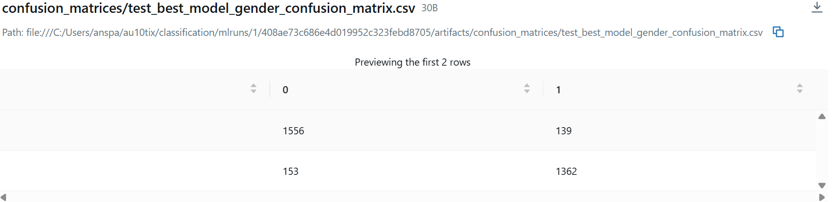
Confusion Matrix Race:
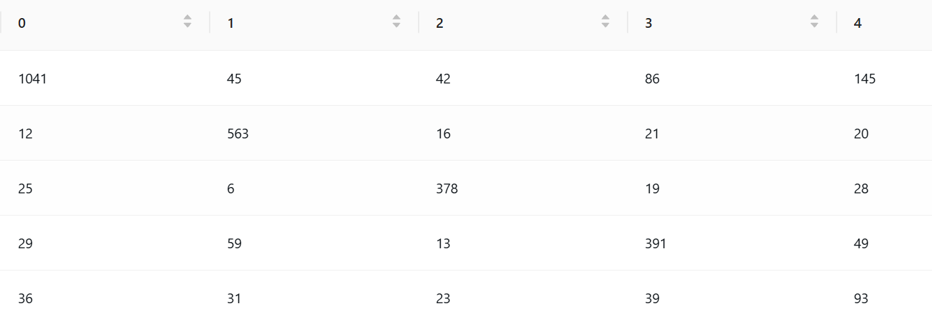

- val gender accuracy: 0.926921860170832
- val race accuracy: 0.8076558051249605
- val race balanced accuracy: 0.7441998607551363
- per class metrics were tracked as well

If I had more time - further experiments, simplifying and cleaning code
Further Experiments:
- I would clean images better - try exclude blurry images, bad pose, gray-scale
- Better results analysis and next development iterations
- Maybe experiment with training in 2 stages instead of simultaneously.

Some results analysis

Gender:
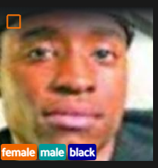 Right prediction, but miss-labeled

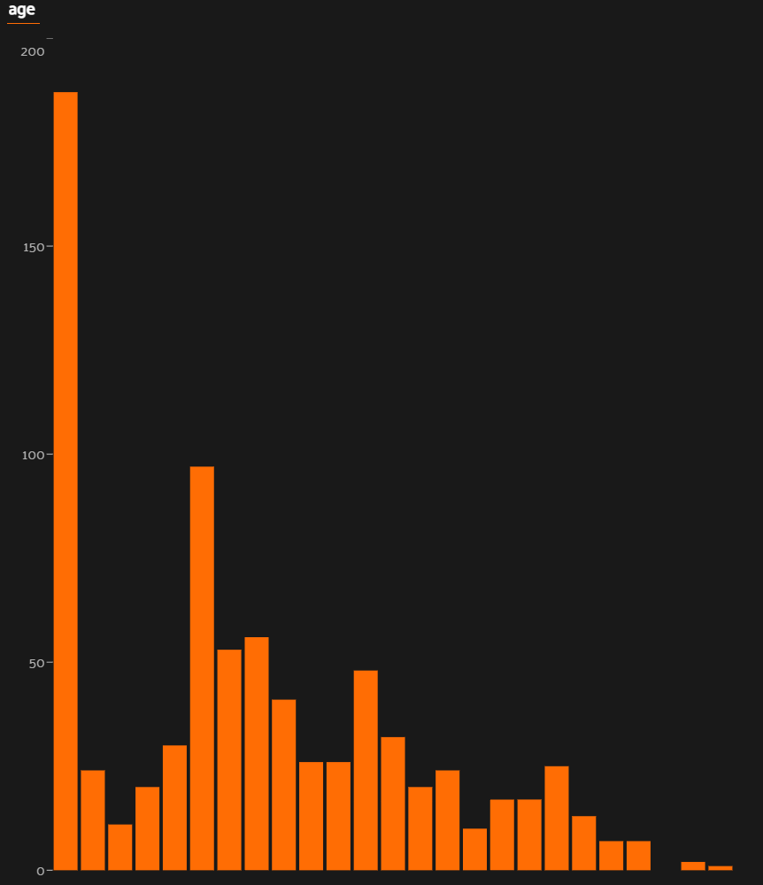 This shows predictions as male and label as female. This shows that many errors are for babies

Race:
Prediction white, but label black. Only a few misscliassified. Majority gray-scale
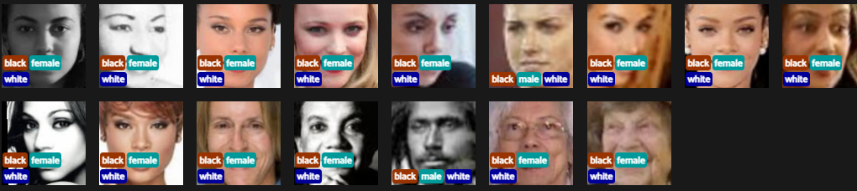

Prediction white, label asian. It shows that the model could struggle more with babies. Labels are not always unambiguous. Squeezing the eyes have an impact.
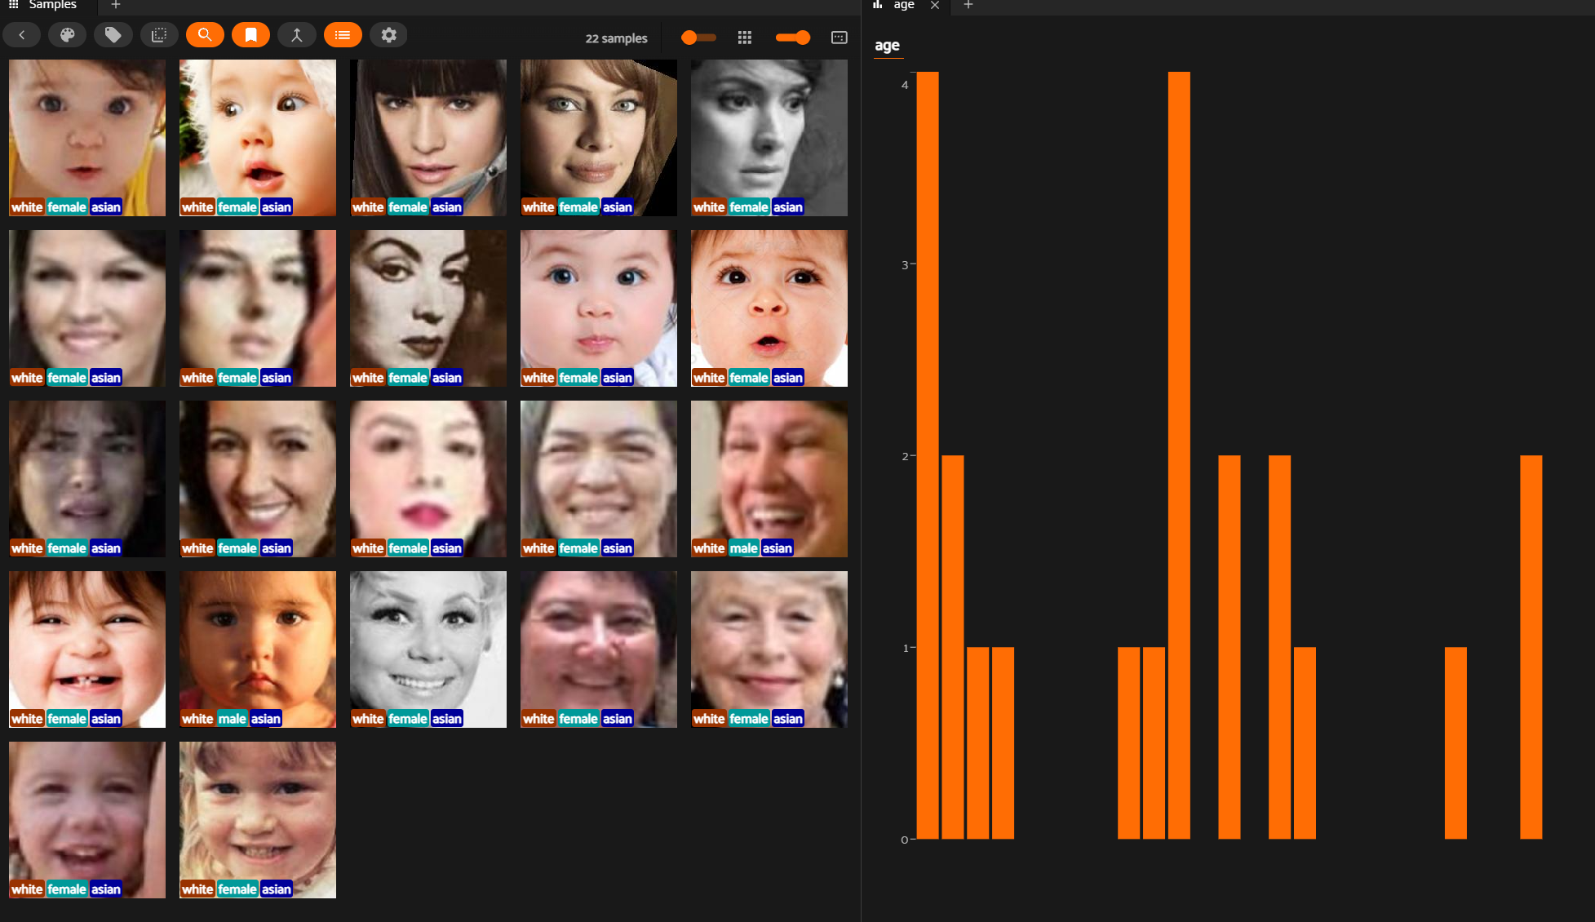

Production:
Top 3 production changes for 1000 faces/sec:

- Serve the model as an optimized inference service Use batching, GPU/CPU autoscaling, ONNX/TensorRT if relevant, and low-latency APIs instead of running prediction as a notebook/script.

- Add monitoring and quality checks Track latency, throughput, error rates, confidence scores, data drift, and prediction distribution so bad outputs or model degradation are caught quickly.

- Make the pipeline reliable and scalable. Use queues/streams, backpressure, retries, timeouts, versioned models, and safe fallback behavior so the system keeps working under load.

