**Glass Identification Data Set**

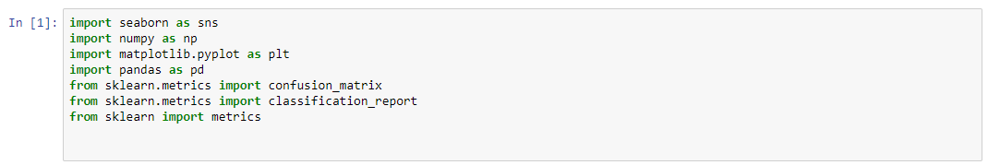

Importing necessary libraries

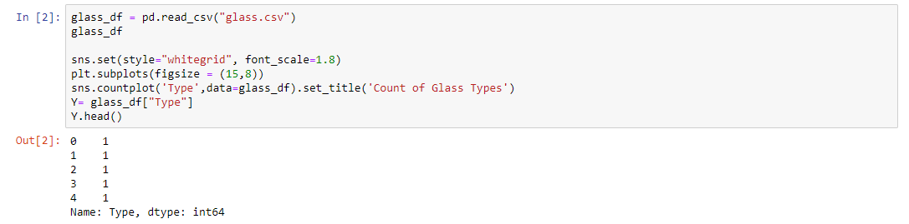

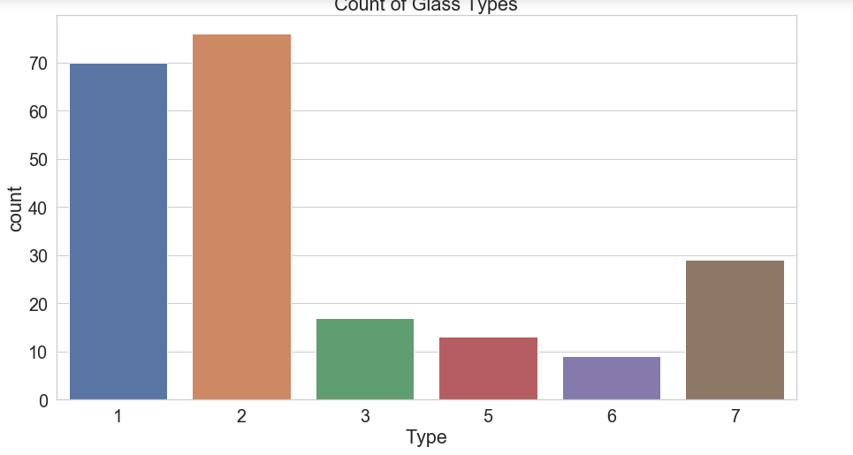

Loading files and draw graph

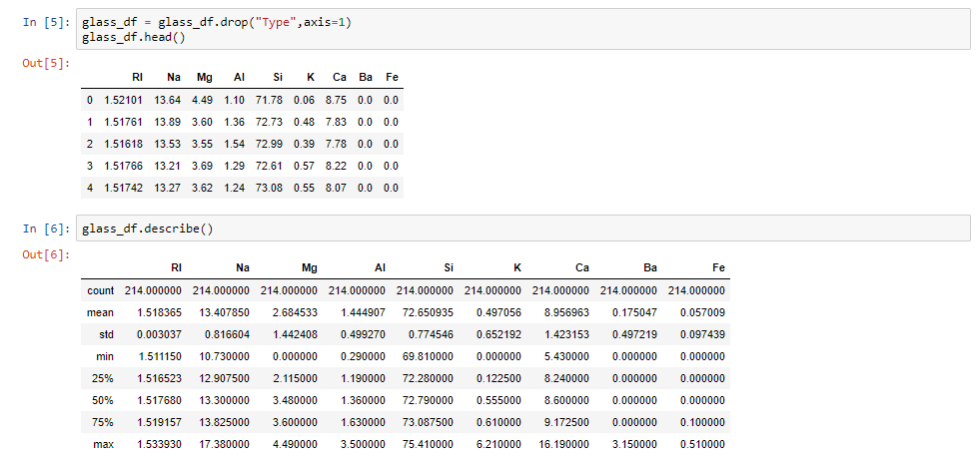

Some data and their features

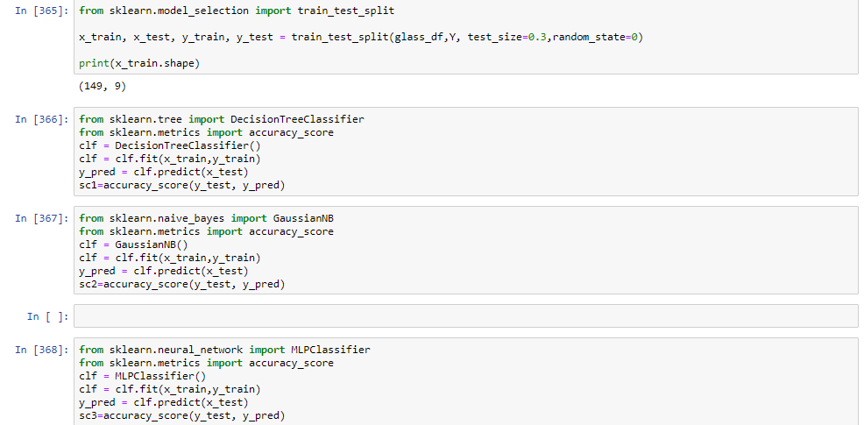

Training model

In[366] Decision Tree,In[367] Naive Bayes,In[368] Neural Network

In[365] You can change test rate and random state.

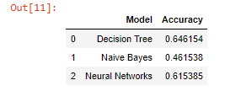

Output of program.According to my observations, Accuracies can vary but Usually,Naive Bayes have highest accuracy.Also criterion and random state affects accuracy.

**Pima Indians Onset of Diabetes Data Set**

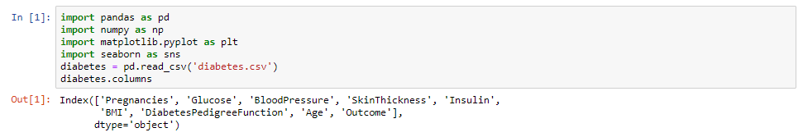

Importing necessary libraries

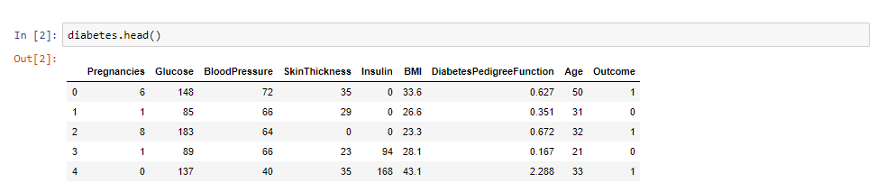

Some data samples

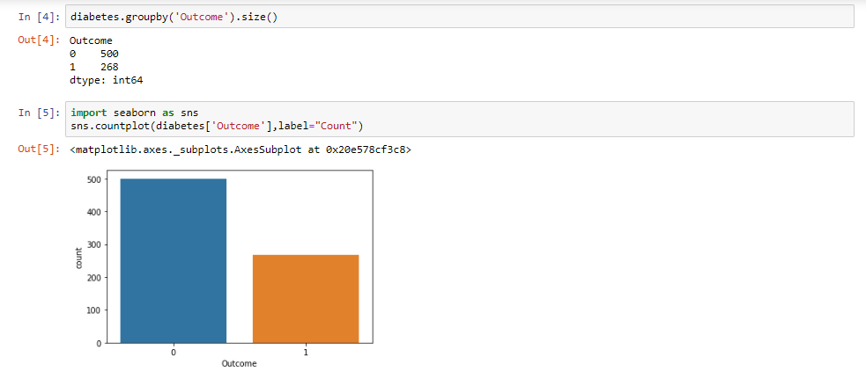

Grouping data and its chart.” O” means diabetes,”1” not

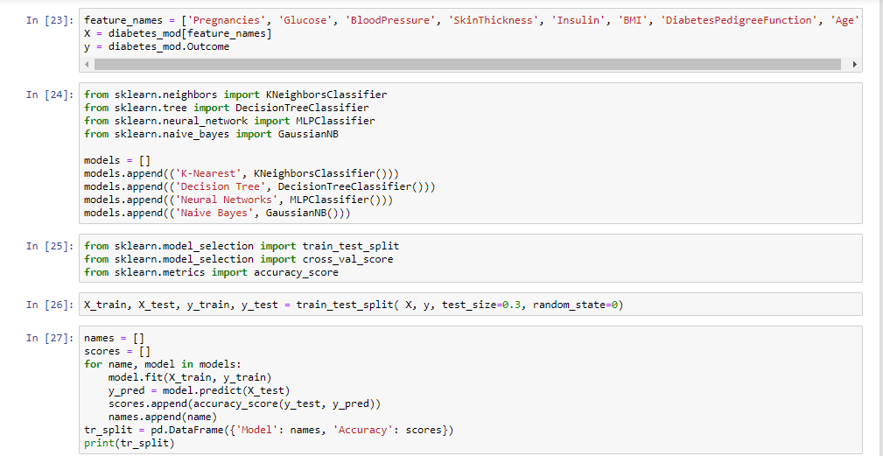

Training model

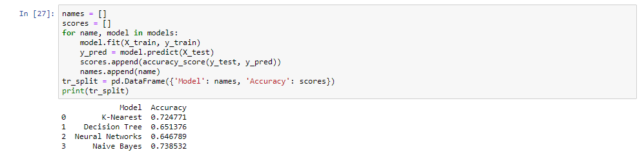

Output.Naive Bayes usually comes first

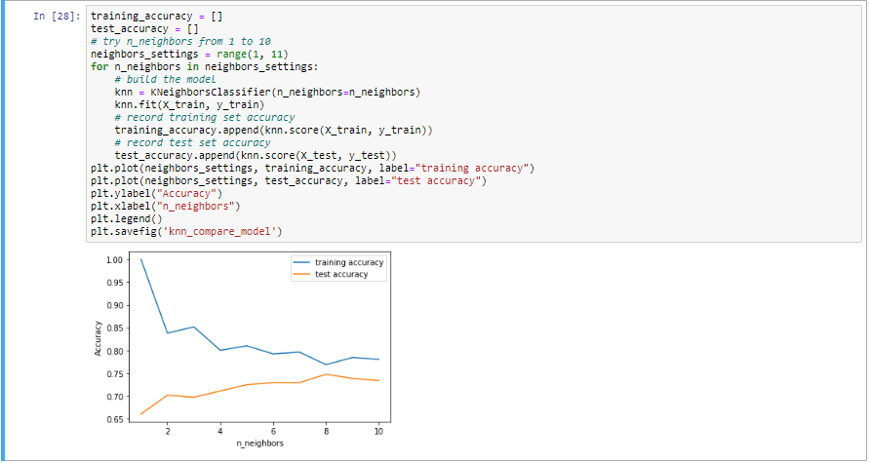

Bonus:Train and testing rates