HOW TO MAKE CARDS IN O-CH
WARNING: This only explains how the cards are technically made.

Basics of how they work:
A card is just a .json file which is just a big dictionary that the scripts reference. They can be created and modified pretty easily. There will be limitations (like having some functions not being implemented) but they are good enough for modding purposes.

The start of the file:
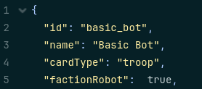
These first lines tell very important values for the card. The “id” of the card is used in the hand of the player. The “name” is the display name of the card. Its used while checking the cards abilities and “did by thing” text. The card type tells which type of card it is (they are “troop”, “trick” and “envoriment”). Troops are your minions for doing anything to susceed or not. Tricks are your spells to clear out enemy annoyances or give you advanteges. Envoriments are the card that can be played on the grounds lanes for a lot of the same reasons as tricks. The “faction” tells which side the card is at. Its a boolean written like “factionFactionName” There are two factions you can put if your gonna modify the main game. They are “animal” and “robot”. One factions cards cant be played by another.

The “stats” dictionary:
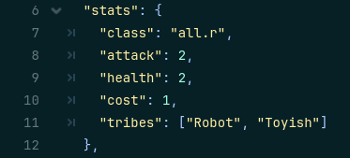
These lines give the basic propeties to make a card playable. The “class” dictates which class the card is in. there are 10 classes in the game, 5 each for every faction. The class of the card may go into hero’s deck with the matching class. You can’t put a card with a class that doesn’t match up with one of the heroses. (You can play them still if you get it from a different source than your deck.) The “attack” & “health” are only in troops and they dictate the base attack and the max hp of the troop. (You can increase or decrease them too, they are not locked.)

