1. Occupation:
   * *Definition:* Occupation refers to a person's regular work or profession, often associated with a specific job or trade.
2. Health:
   * *Definition:* Health is the overall well-being of an individual, encompassing physical, mental, and social aspects. It includes the absence of illness or injury and the presence of conditions that contribute to a fulfilling life.
3. Safety:
   * *Definition:* Safety involves the measures and precautions taken to protect individuals from harm, danger, or injury. It encompasses the prevention of accidents, incidents, and the promotion of a secure environment.

**Moral Reason:**

* *Definition:* Ensuring the well-being of employees as a fundamental ethical obligation, recognizing their right to a safe work environment.

**Financial Reason:**

* *Definition:* Maintaining high occupational safety standards to save costs, avoiding expenses related to fines, compensations, legal issues, injuries, and reputational damage.

**Legitimate Reason:**

* *Definition:* Adhering to mandatory minimum health and safety standards dictated by national legislation, with specified fines for non-compliance.

**WHO defines:**

*“The promotion and maintenance of the highest degree of physical, mental social well- being of workers in all occupation”*

**Potential Issues In Future:**

1. **Occupational Health in the Digital Era:**
   * Addressing health issues related to new information technologies and automation.
2. **Emerging Substances and Energies:**
   * Managing health risks associated with new chemical substances and physical energies.
3. **Biotechnological Health Hazards:**
   * Dealing with health challenges linked to new biotechnologies.
4. **Technology Transfer Concerns:**
   * Handling the transfer of hazardous technologies.
5. **Aging Workforce:**
   * Addressing health considerations arising from an aging working population.

These challenges encompass the evolving landscape of occupational health, ranging from technological advancements to demographic shifts.

**The objectives of Occupational Health**

The objectives of Occupational Health and Safety are to safeguard the overall well-being of workers by:

1. **Promoting Health:**
   * Maintaining and enhancing the physical, mental, and social well-being of workers.
2. **Preventing Injuries and Diseases:**
   * Proactively preventing occupational injuries and diseases.
3. **Ergonomic Workplace:**
   * Adapting the workplace to the needs of workers, incorporating ergonomic principles.
4. **Preventive Focus:**
   * Emphasizing a preventive approach over a curative one, prioritizing measures to avoid harm.

**ISO: International Organization for Standardization**

**ILO: The International Labor Organization**

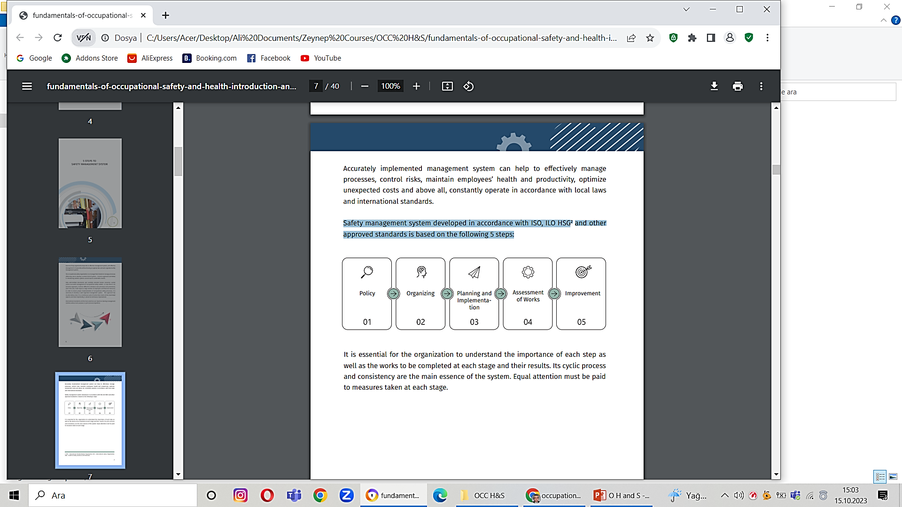

**Policy:**

The first step in a management system is creating an Occupational Safety Policy, a concise document outlining the organization's commitment to occupational health and safety. Key goals may include:

1. Ensuring employee health and safety by preventing accidents and occupational diseases.
2. Minimizing human and material losses through ongoing risk assessment and control.
3. Involving and training employees in occupational health and safety.
4. Continuously monitoring and improving the safety management system.
5. Operating in compliance with local laws and regulations.

**Organizing:**

In the organizing stage, the company:

1. Defines duties and responsibilities of employees.
2. Determines necessary competence for work and provides relevant training.
3. Drafts Occupational Safety and Health action plans.
4. Defines and introduces effective communication methods.

This establishes a vital foundation for successful safety processes.

**Planning and Implementation:**

During implementation:

1. Schedule and perform works.
2. Identify hazards and assess risks.
3. Supervise ongoing works.
4. Collect occupational safety data (KPI).

**Assesment Of Works:**

In this management stage:

1. Monitor and assess Key Performance Indicators (KPI).
2. Analyze statistical data to identify system faults and discuss improvement plans.
3. Investigate and analyze reported incidents to understand their causes.

**Improvement:**

1. Detect faults, even in well-implemented safety systems.
2. Address two main problems: lack of competence in fault detection and underreporting.
3. Recognize that all management systems have flaws.
4. Emphasize the importance of detection and improvement for a robust reporting culture.
5. Engage management and occupational representatives to discuss detected faults and analyze statistical data.
6. Provide recommendations for future improvements to strengthen the safety management system.

**Common problems in developing occupational health services include:**

1. Lack of awareness among stakeholders.
2. Shortage of trained human resources.
3. Inadequate, inaccessible, and unevenly distributed health service institutions.
4. Insufficient budget for inspections and research.
5. Poor working environments.
6. Lack of specific regulations on occupational health and safety.
7. Limited collaboration among stakeholders.
8. Absence of integration between occupational health and general health services.

**The Elements of Work Environment:**

* The employees
* The tool
* The process
* The work environment

**Employee:**

An employee is an individual employed for wages under a contract of service related to an industry and:

1. Directly employed by the principal employer for work connected to the industry.
2. Employed by an immediate employer at the industry's place of work or under the principal employer's supervision.
3. Services temporarily lent or hired to the principal employer by another contracting party.

**Vulnerable populations in the workplace include:**

1. Women workers affected by gender-specific health and safety challenges.
2. Home-based workers, subject to varying inclusion in health and safety legislation.
3. Part-time workers.
4. Contract workers.
5. Drivers.

**The Tool:**

Tools can range from very primitive tools like a hammer, chisel, and needle, to automated equipment.

**The Process;**

* Materials used can be toxic.
* The industrial process can influence the harmfulness of materials.
* Particle size and physical state (solid, liquid, gas) are crucial factors.
* These factors determine potential ill effects on workers.

**Reasons for poor and hazardous performances include:**

**Workplace:**

* Unsafe building.
* Old machines.
* Poor ventilation.
* Noise.
* Inaccessible to inspection.

**Workers:**

* Limited education.
* Limited skill and training.

**Employers:**

* Limited financial resources.
* Low attention and knowledge.

**Groups at risk or overlooked:**

1. **Women Workers:**
   * Gender division impacts health and safety, beyond reproductive hazards.
   * Health and safety field is male-dominated, leading to discrimination.
2. **Home-Based Workers:**
   * Varied inclusion in health and safety legislation worldwide.
   * Home Work Convention, 1996 (No. 177), mandates equal protection.
3. **Part-Time Workers:**
   * Often not covered by health and safety provisions.
   * Part-Time Work Convention, 1994 (No. 175), mandates equal protection.
4. **Contract Workers:**
   * Accident rate is twice that of permanent workers.
   * Misconception that subcontracting tasks absolves safety responsibilities.
5. **Drivers:**
   * Particularly at risk.
   * 15-20% of work-related fatalities due to road accidents are often not categorized as work-related.

**Principles of Occupational Health and Safety:**

1. **Worker Rights:**
   * All workers have rights to a safe, healthy, and dignified working environment.
2. **Regulations and Policies:**
   * Governments and enterprises must establish and communicate effective occupational health and safety regulations.
3. **Consultation with Stakeholders:**
   * Social partners and stakeholders, including employers and workers, should be consulted in policy formulation, implementation, and review.
4. **Prevention and Protection:**
   * Emphasis on primary prevention at the workplace level, ensuring safe and healthy work environments.
5. **Information Management:**
   * Accurate information collection, dissemination, surveillance, and monitoring are essential for effective policies.
6. **Health Promotion:**
   * Prioritize the enhancement of workers' physical, mental, and social well-being.
7. **Occupational Health Services:**
   * Establish comprehensive occupational health services accessible to all workers, regardless of economic activity.
8. **Compensation and Rehabilitation:**
   * Provide compensation, rehabilitation, and curative services for workers affected by occupational injuries, accidents, and diseases.
9. **Education and Training:**
   * Promote awareness and training for safe working procedures, tailored to industry-specific concerns.
10. **Responsibilities and Obligations:**
    * Define responsibilities for workers, employers, and competent authorities, ensuring compliance with safety procedures.
11. **Policy Enforcement:**
    * Implement an inspection system to enforce compliance with occupational health and safety legislation.

**Formun Üstü**

**Occupational health focuses on:**

1. **Maintenance and Promotion of Workers' Health:**
   * Ensuring the well-being and capacity of workers.
2. **Improvement of Working Environment:**
   * Creating a safe and healthy workplace.
3. **Development of Positive Work Cultures:**
   * Establishing organizational values that prioritize health and safety, fostering a positive social climate and enhancing productivity.

**Employer’s Responsibilities**

The enterprise policy should emphasize employers' responsibility for a safe and healthy workplace. Specific measures will vary based on the industry and job type, but in general, employers should:

1. Maintain safe workplaces, machinery, and equipment.
2. Control substances and agents to ensure they pose no health risks.
3. Provide appropriate training to managers and staff.
4. Supervise work practices and the use of safety measures.
5. Establish organizational arrangements for occupational safety.
6. Supply personal protective clothing and equipment when needed.
7. Ensure work organization supports safety and health.
8. Mitigate physical and mental fatigue.
9. Prepare for emergencies with first-aid arrangements.
10. Stay informed about relevant scientific and technical knowledge.
11. Collaborate with other employers to enhance occupational health and safety.

**Worker’s Responsibilities**

Workers play a crucial role in preventing accidents and illnesses at work. The enterprise policy should encourage workers and their representatives to actively participate. Workers should receive clear information, training, and opportunities to discuss safety measures with the employer. Their individual duties include:

1. Taking care of their own safety and others.
2. Following safety instructions and procedures.
3. Using safety devices and equipment properly.
4. Reporting hazardous situations promptly.
5. Reporting any work-related accidents or injuries**.**

In addition to their responsibilities, workers have certain rights outlined in the enterprise policy. These include:

1. The right to remove themselves from danger and refuse work that poses a serious threat to their life or health.
2. Protection from unforeseen consequences when acting on these rights.
3. The ability to request inspections and investigations regarding health and safety concerns.
4. Access to information about workplace hazards affecting their health or safety.
5. Obtaining relevant health and safety information held by the employer or competent authority.
6. Collective selection of health and safety representatives.