

**YILDIZ TECHNICAL UNIVERSITY**

**CONTROL AND AUTOMATION ENGINEERING**

**KOM3570**

**DR. MUHARREM MERCİMEK**

**ASSIGNMENT1**

**ENES FURKAN BAŞLIK**

**16015040**

**RESULTS**

I use peppers image for my codes. You can use another images. Codes gives you true outputs.

**Original image**

s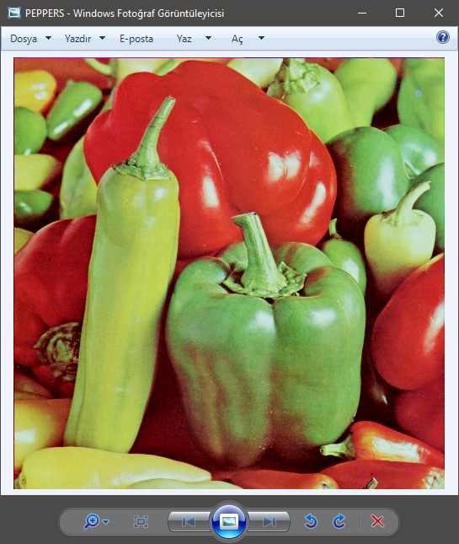

**sampleImage**



**quantizeImage**

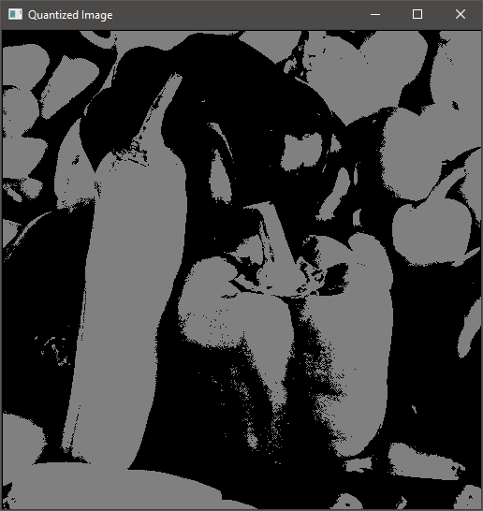

**Powerlawtransform**

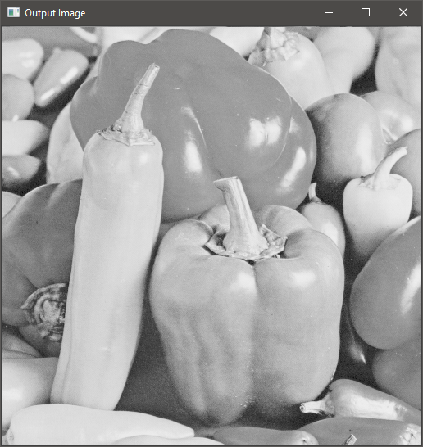

**Graylevelslicing**

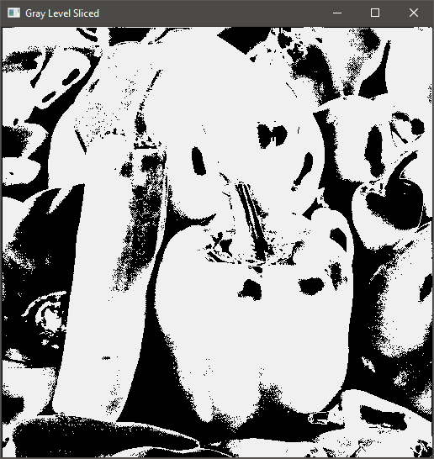

**Bitplaneslicing**

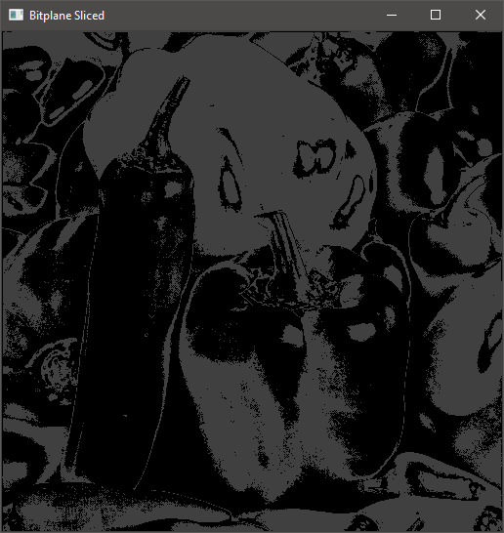

**getHistogram**

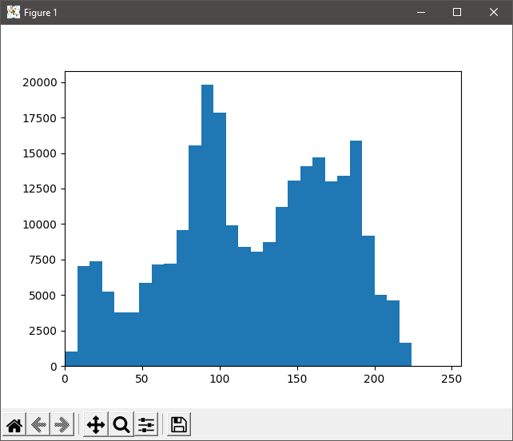

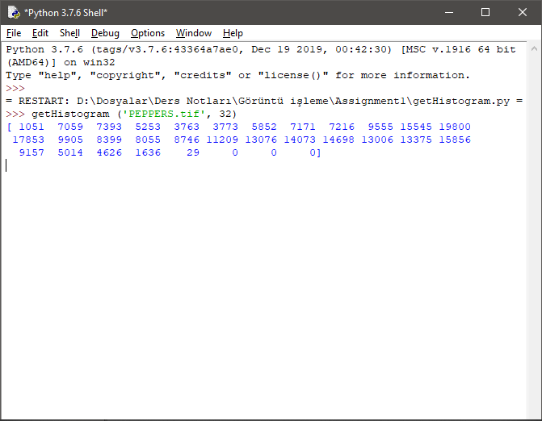

**histogramEqualization**

My code fails every time when i use the bins

