

**MARMARA UNIVERSITY**

FACULTY OF ENGINEERING

COMPUTER SCIENCE & ENGINEERING

CSE3055

DATABASE SYSTEMS

PROJECT - STEP #(1, 2)

*150116005 – Veysi ÖZ*

*150116025 – Ahmet Hamza DEMİR*

*150116034 – Enes GARİP*

*150119802 – Nurefşan YÜCEL*

**RESTAURANT MANAGEMENT SYSTEM**

**Introduction**

In this project, our goal is to create a database for “Paşazade” restaurant. With this database we will create, we will facilitate our customer’s business follow-up. After completing our database design, we will create a user-friendly web interface so that our client can manage it.

**What Will Be In Our Database?**

Our database will have all the data that could be important, and we will try to reach the best design by connecting these data with rational solutions. For example, we wil keep all necessary information about customers. Likewise, we will keep employee information by categorizing them according to their positions. We will keep the menu information by categorizing the foods in it. We will also have entity for the recipe of the foods. We will keep payment information, either by credit card or cash. The bill information will also be in a separate entity. We will link order, booking and table informations. The database will also keep the information of the food ingredients in order to see the stock information.

**Customer Information**

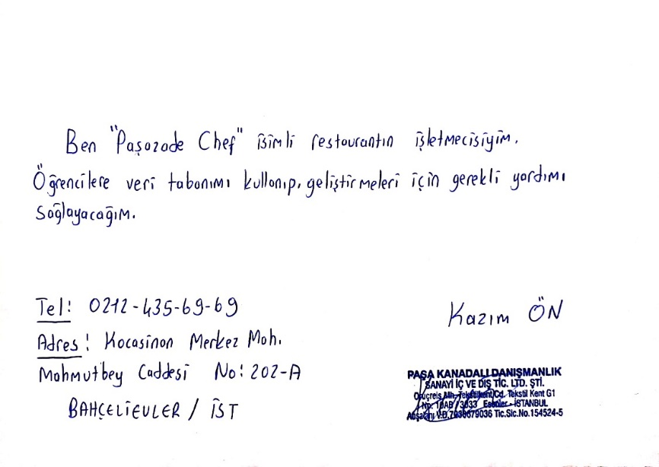

metin, bina, açık hava, sahne içeren bir resim

Açıklama otomatik olarak oluşturuldu

**Requirement Analysis**

* Each Customer has unique CustomerID, FirstName, LastName, Address and PhoneNumber attributes. A customer may have one or more PhoneNumbers.
* Each Employee has unique EmployeeID, FirstName, LastName, Address, PhoneNumber and salary attributes. A Employee may have one or more PhoneNumbers.
* Each Item has unique ItemID, Name, Description and Price attributes.
* Each Menu has unique MenuID, ChangedDate and MenuType attributes.
* Each Bill has unique BillID, Date, Amount and Discount attributes.
* Each Ingredient has unique IngredientID and a Name attributes.
* Each Category has unique CategoryID and Name attributes.
* Each Payment has unique PaymentID and PaymentType attributes.
* Each Position has unique PositionID and Name attributes.
* Each Booking has a unique BookingID, Date and PeopleNumber attributes.
* Each Order has unique OrderID, Date and OrderType attributes.
* Each Recipe has unique RecipeID, Name and Instructions attributes.
* Each Table has unique TableID and ChairNumber attributes.
* Each Transaction has unique TransactionID, CourierName which composite of FirstName and LastName, Status and Date attributes.
* Each Stock has unique StockNO and Amount Attributes.
* Each Section has unique SectionNO and Name attributes.
* Each Supplier has unique SupplierID, Name, Address and PhoneNumber attributes. A Supplier may have one or more PhoneNumbers.
* Each ServiceType has unique ServiceTypeID, Name and Description attributes.
* A Customer has one or more orders. An order can belong to only one customer.
* Each Employee works in an one position, and in one position there can be one or more Employee.
* Sections have many tables. Each Bill has a Table information. A Table may in many Bills.
* Each Item has a Recipe. Each Recipe has many Ingredients. An Ingredient is in many Recipe.
* Each Menu has one or more Categories, and each category has one or more Items.
* A table may have been booked. A booking has one or more Tables.
* Each Order has one or more Items. An Item may be in many Orders.
* Each Transaction has one Order.
* Each Payment has one Bill.
* Each Stock keeps an Ingredient Amount.
* Each Supplier supplies one or more Ingredients. An Ingredient comes from one or more Suppliers.
* An Employe may have ServiceTypes.

**Conseptual Database Design**