 | COMP 3326  Web Application development  Final Project

Project Web Development Details Template

Enes Kemal Ergin – Python Course Web Page – Link

Purpose of the Project
Purpose of this website is to give easy access for students who want to study and learn Python programming language. In this website Python Teachers can store their course links and information. With the future upgrades students can also create their own accounts and follow their learning progress, with the instructors help along side.

Needs of Assessment
The need for this website was too obvious, but in any case I interviewed with 20 people who wants to learn Python or did learn Python from a non-credit course here in NAU. They expressed that they need a platform to follow-up what is going on in the Python Learning community in NAU. They also want to see contents of the courses that they previously attended courses, or even courses that they did not attend. This way they will be able to remind themselves Python language.

Intended Audience
The intended audience is people who wants to learn Python or want to contribute to Python Learning community in NAU.

Project Goals
- Reach out the proper audience
- Simple and elegant design
- Just template of the website to build on top of it

Project Structure and Outline
1. Discovery Phase
- Key stakeholder goals
- Campus input (interviews, surveys, feedback)
- Secondary research (industry white papers, best practices)
- Peer and competitive review
- Existing content and design analysis (including content inventory and audit, server logs, analytics)
- Gather baseline data (current usage data, existing success metrics)
2. Strategy Phase
- Project charter (define project scope, goals, business case, requirements)
- Define and prioritize key audiences
- Task analysis for interactivity (user experience development, personas)
- Determine content requirements
- Information architecture (site map, wireframes)
- Content gap analysis
- Brainstorm content delivery types & component needs (page types, information
types, component types)
3. Design & Development Phase
- Content development (set standards, create/obtain text and graphic content, assign new content, supervise creation, editorial quality control)
- Visual design and front end prototyping (moodboards, design explorations, style tiles, working styles, design comps, page mockups, design production)
- Set up content-ready site (early programming and site engineering – wireframes to templates, code, graphic identity)
- Migrate content (add text and images to content-ready site – page production, content assembly)
- Programming and integration (custom functionality, CMS integration, move to staging server)
- Content approval (proofread and approve text and images)
- Functionality testing and quality assurance

Screenshots

Home Page:
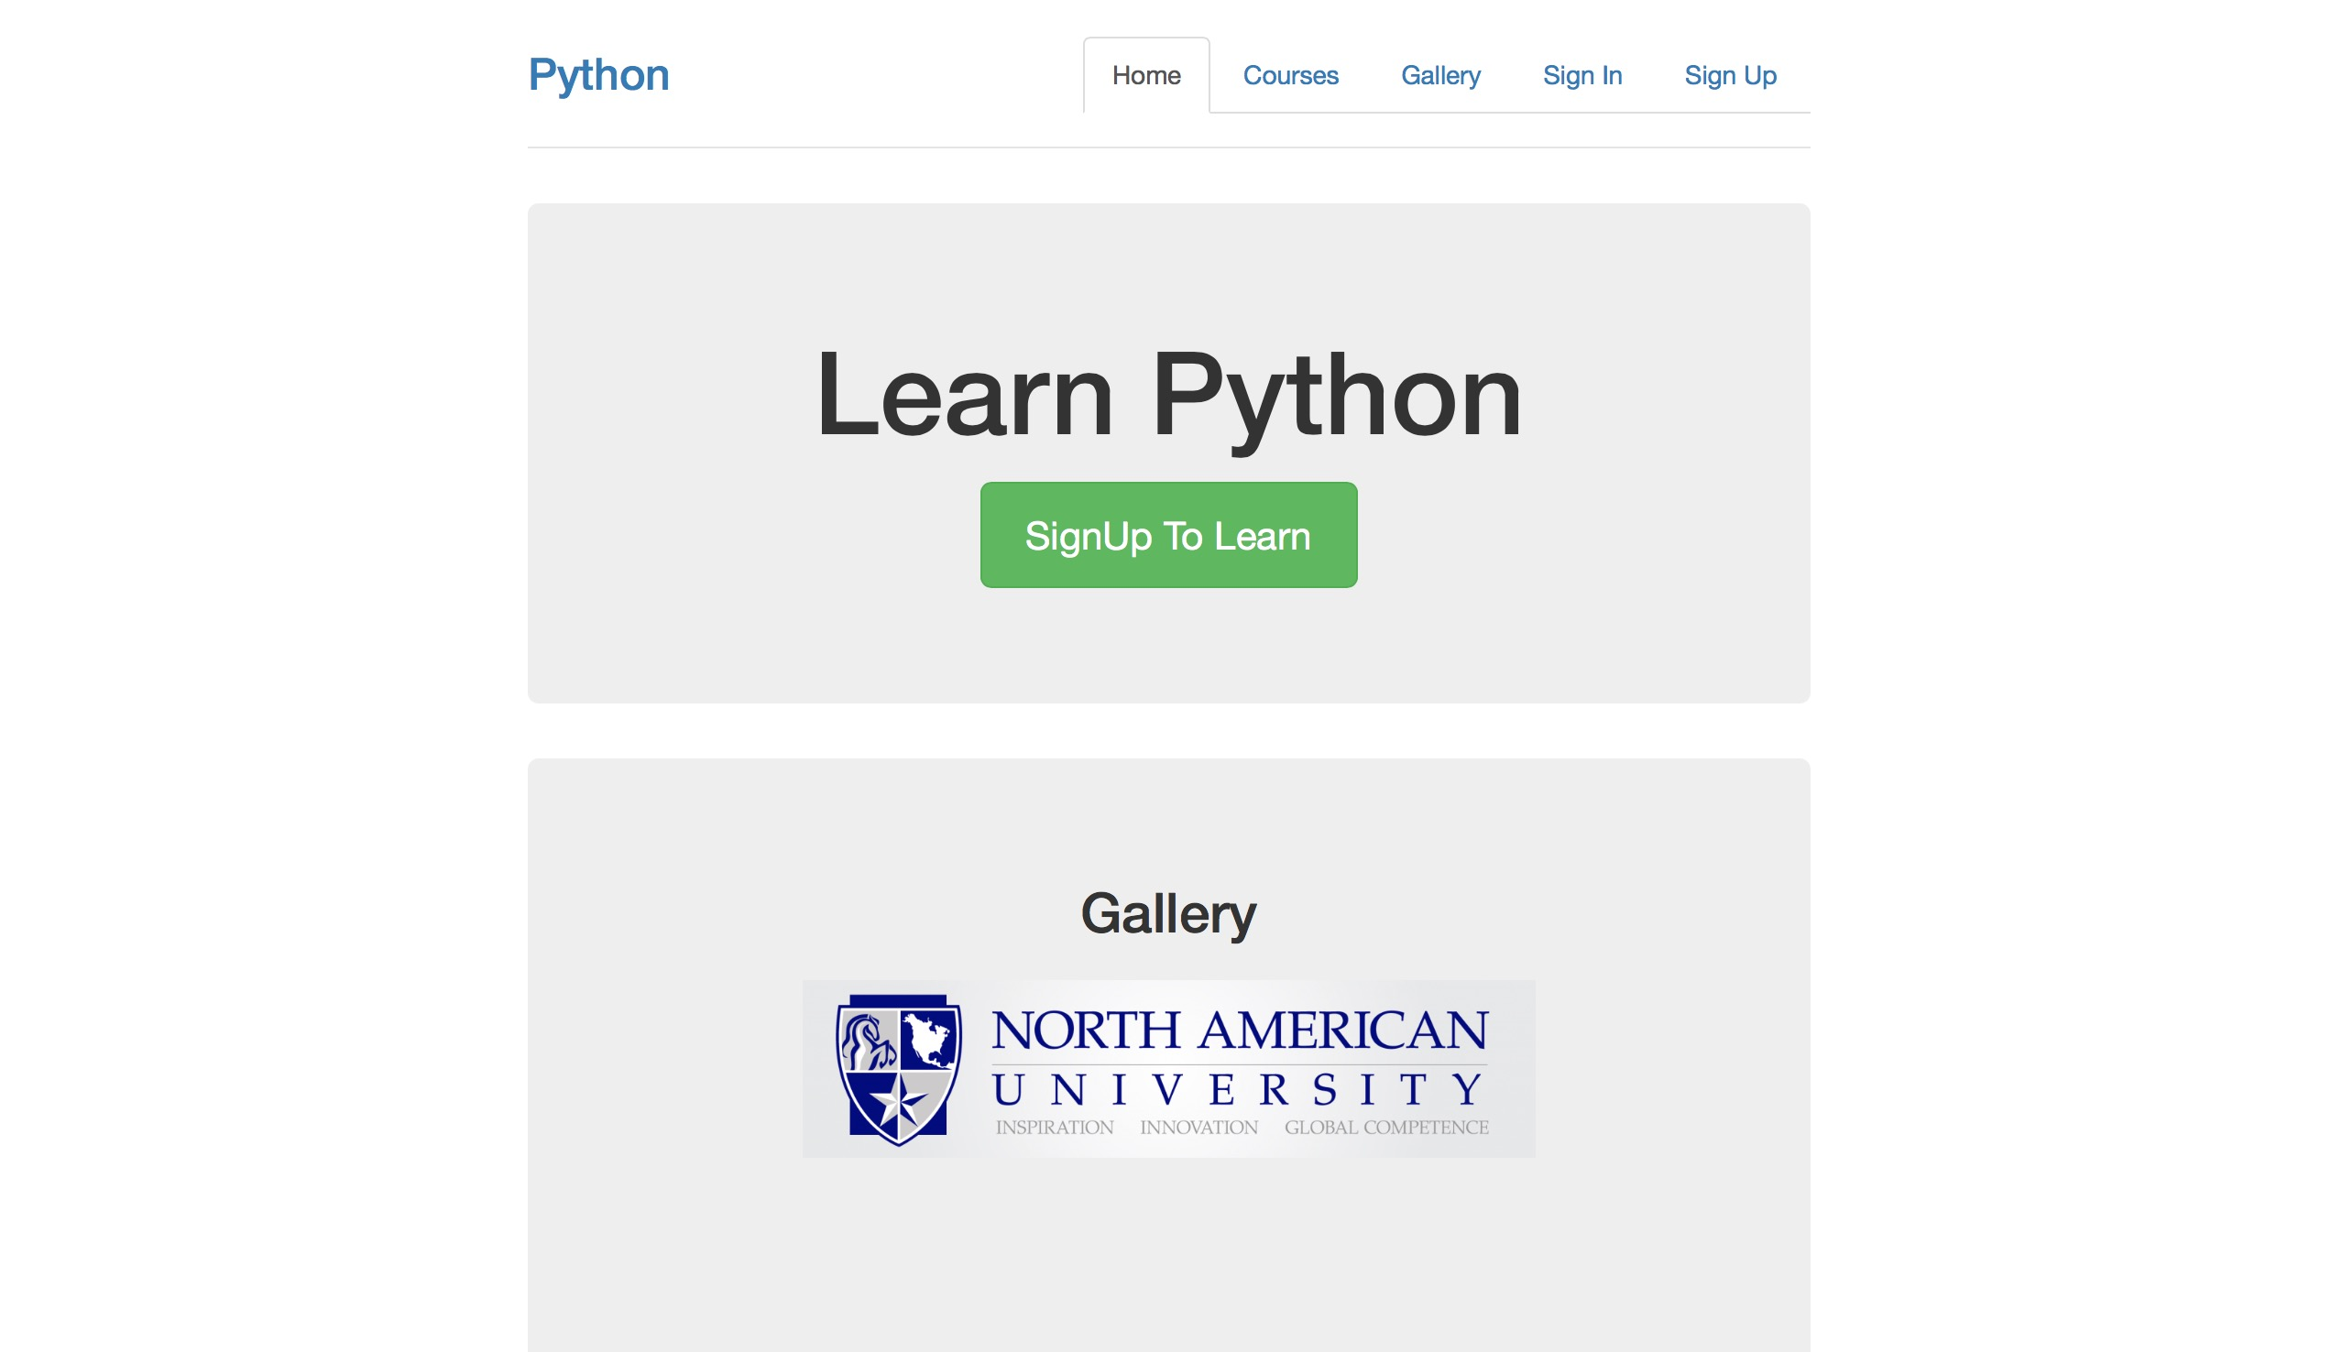

Courses Page:
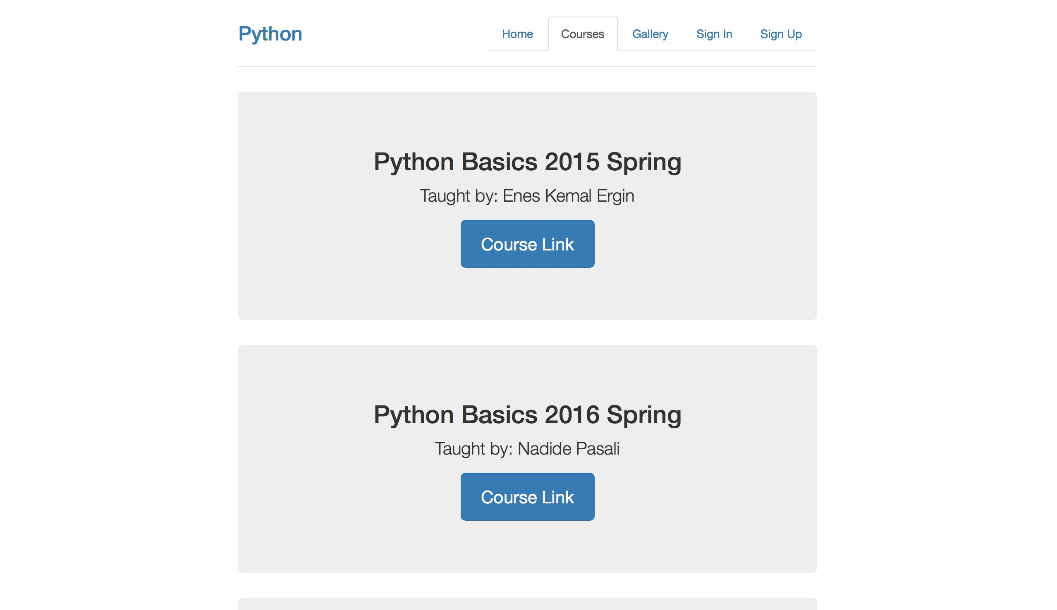

Gallery Page:

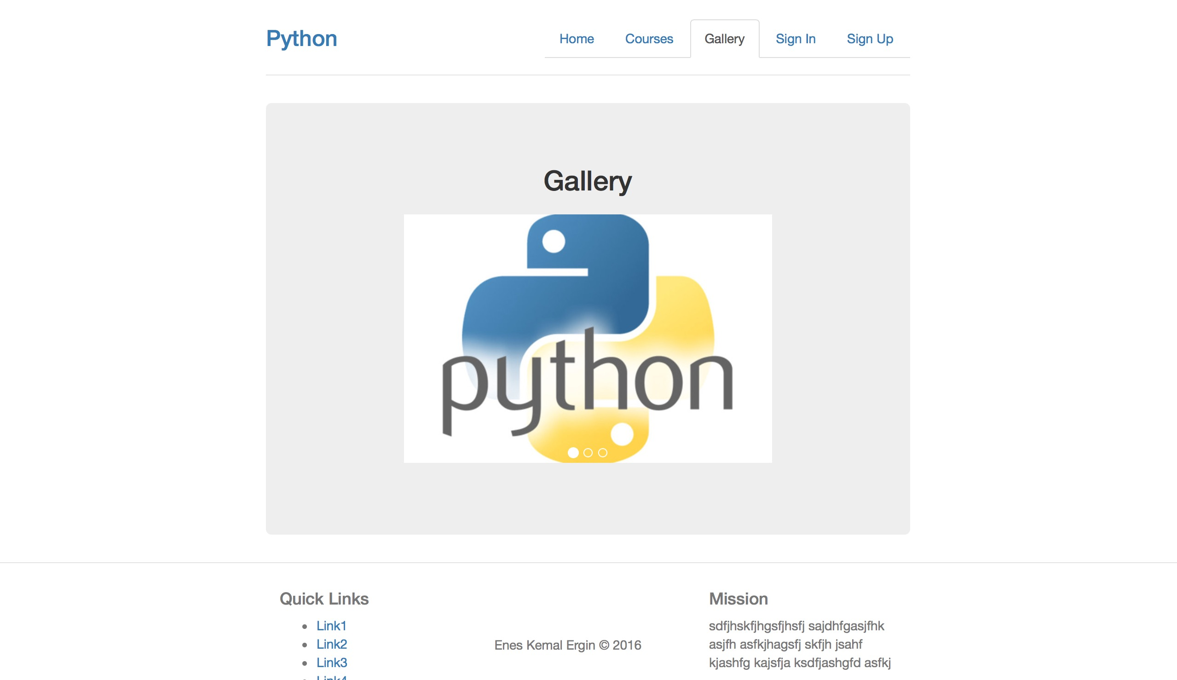

Sign-in Page:
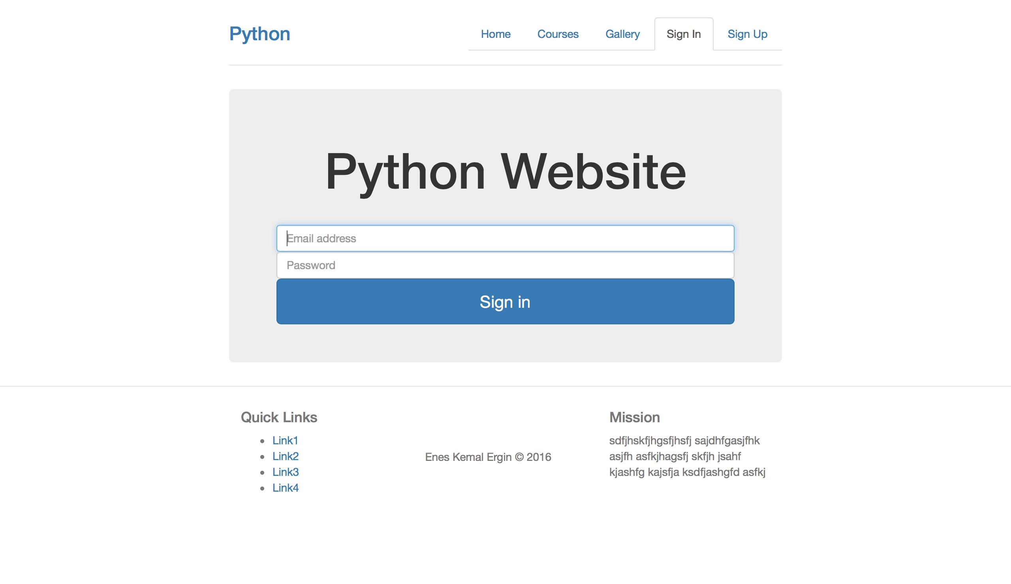

Sign-up Page:
