**EEE 486/586 Statistical Foundations of Natural Language Processing**

**Midterm Project Report**

**Enes Koşar – 21901224**

**ABSTRACT**

In this report, I will investigate some basic laws and methods used in Natural Language Processing (NLP). I will start choosing some corpora. Then I will apply necessary preprocessing steps. So that, the corpora will be ready to extract meaningful statistics and information. I will explore frequencies of word types, type frequency vs rank plots and type size vs token size plots for different variations of my corpora. I will investigate if the results are consistent with the Zipf’s Law and Heaps’ Law. I will explore the effect of removing stop words from the corpora. Then, I will try to find a simple clustering method to separate one particular corpus from another. At the end I will explore if a randomly generated text obeys Zipf’s Law and Heaps’ Law.

**INTRODUCTION**

NLP is a subfield of computer science and linguistics. It’s concern is about how to program computers to process and analyze natural language data. The challenges in NLP are mainly speech recognition, natural language understanding and natural language generation. For this purposes, scientist explored some statistical laws. These laws are not as strong as physics laws. But still, they provide a good understanding about the text or the language for us. Two important laws are Zipf’s Law and Heaps’ Law.

**Zipf’s Law** explains the relation between rank and frequency of a type. It states that there is a constant K such that:

K = rank * frequency

So, Zipf’s Law states that frequency of a type is inversely proportional to rank of that type. When we take logarithm of both sides:

Log(K) = Log(rank) + Log(frequency)

A result of Zipf’s Law is that, inverse proportionality is in linear format when we evaluate frequency-rank relation in Log-Log format.

For a given corpus, type-token relation is explained via **Heaps’ Law.** (1) It is an empirical law which describes the number of distinct words(types) in a document as a function of the document length (total number of token). It is formulated as:

In this formula, is number of types (vocabulary size), n is number of tokens, k and are free parameters determined empirically. In an English text corpora, k is typically between 10-100 and is between 0.4 and 0.6.

I will investigate if various corpora are consistent with Zipf’s Law and Heaps’ Law. I will also explore the effect of removing stop words to these laws. I will develop a simple clustering method based on these laws. Then I will check if a randomly generated corpus obeys Zipf’s Law and Heaps’ Law.

**CORPUS CONSTRUCTION AND IMPLEMENTATION**

I will investigate some fundamental laws of statistical natural language processing. I will explore these laws by using 18 different books. Each book is approximately 1 MB. There will be two categories: Author based grouped books and genre based grouped books. In each category, I will choose 3 different author/genre. For each author/genre, I will pick 3 different books. My books are as follows:

1. Author based books:
   * Charles Dickens
     + Bleak House
     + Dombey and Son
     + Our Mutual Friend
   * Dostoyevsky
     + Idiot
     + Karamazov Brothers
     + Possessed
   * Tolstoy
     + Anna Karenina
     + Resurrection
     + War and Peace
2. Genre based books:
   * Biography
     + Life and Letters of Robert Browning
     + Life of Froude
     + Life of William Ewart
   * Detective
     + Moonstone
     + Sherlock
     + Twenty Years Detective
   * Myths
     + Assyria
     + China
     + Rome

After choosing my books, I followed these pre-processing steps:

* Tokenization
* Getting rid of punctuation marks
* Casting every word to lowercase

I used following basic Python functions for this purpose: split(), str.maketrans(), translate(), lower(). So that, I obtained a corpus for each book. Then, I determined a common English stop word list. Then I removed those words from my corpus. Stop word list(2) is attached in appendix. So that, I obtained my corpora which are ready to apply statistical methods.

**RESULTS**

**(e)** Type frequencies are calculated by using Counter() function from the Counter library. This is done for all the books before and after stop word removal. Results are written in text files. Two examples can be seen partly in the figures below:

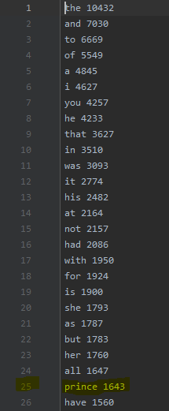 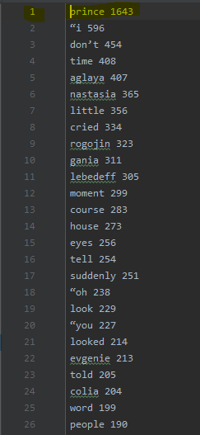

Fig1: Word type vs Frequencies of Idiot Fig2: Word type vs Frequencies of Idiot

(Before stop word removal) (After stop word removal)

**(f)** I composed larger author corpora by combining books of the same authors. Frequency/Rank plots are as follows:

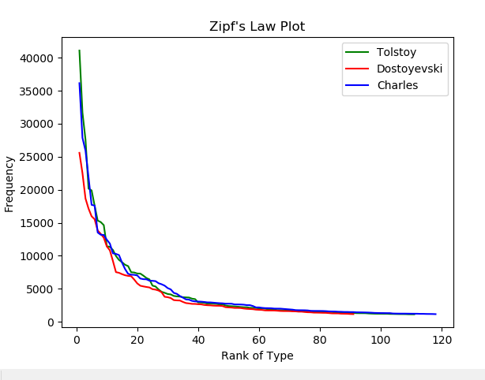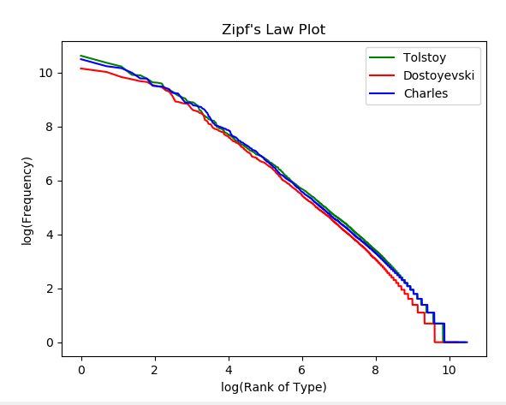

Fig3: Normal Frequency/Type Fig4: Log-Log Frequency/Type

Plot of Author Corpora Plot of Author Corpora

- Figure 3 shows that rank and frequency of a type are inversely proportional.

- Figure 4 shows that when we plot frequency/rank plot in log-log form, it becomes approximately a linear line.

Zipf’s Law says that there is a constant k such that k = rank*frequency. Figure 3 is obviously consistent with this formula.

When we take logarithm of both sides, we see that log(k) = log(rank)+log(frequency). This formula shows that frequency/rank relationship in log-log form is inversely linear. So, figure 4 is also consistent with Zipf’s Law.

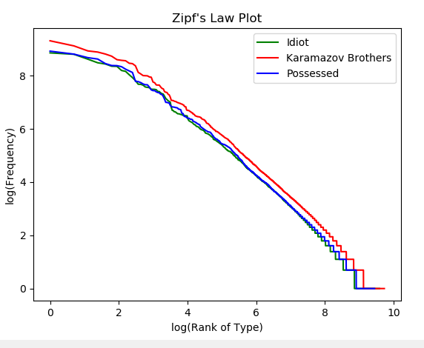

Fig5: Books of Dostoyevsky

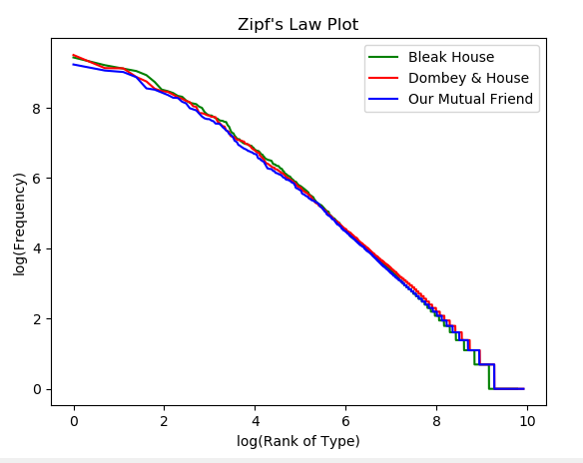

Fig6: Books of Charles Dickens

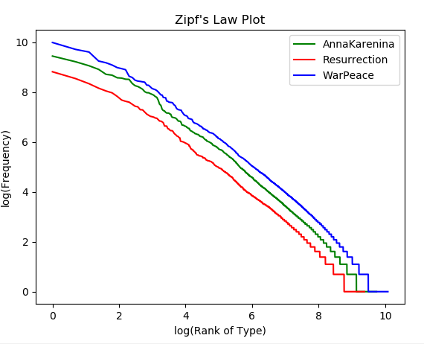

Fig7: Books of Tolstoy

In the figures 5,6 and 7 we see the frequency/rank plot of different books of different authors. These plots are in log-log form and they are linear and inversely proportional as in the larger author corpora case. Since Zipf’s Law says that log(k) = log(rank)+log(frequency), these three plots are consistent with Zipf’s Law.

**(g)** Token is number of words in a corpus. Type is number of unique words. For the larger author corpora, I plotted type/token graph below in normal and Log-Log formats. In normal format, as we traverse the corpus, number of types decreasingly increases. This makes sense intuitively. Because as we traverse the corpus, some types will be already seen. So, they won’t be added to total number of types.

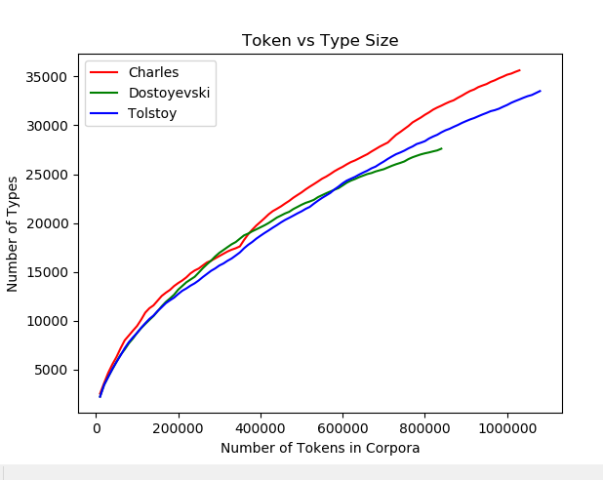

Fig8: Type Token Relation for Larger Author Corpora

When we plot this graph in Log-Log format we see an almost linear relation.

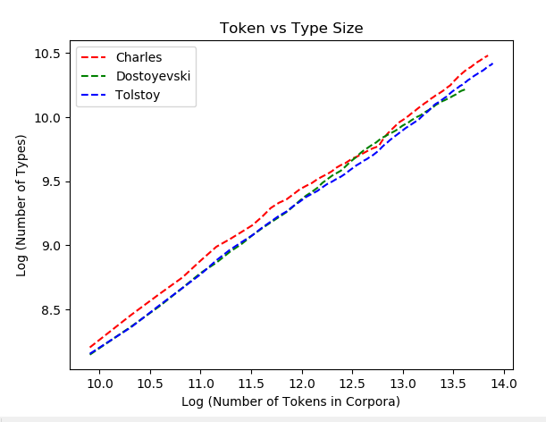

Fig9: Type Token Relation for Larger Author Corpora in Log-Log Format

For a given corpus, type-token relation is explained via **Heaps’ Law.** (1) It is an empirical law which describes the number of distinct words(types) in a document as a function of the document length (total number of token). It is formulated as:

In this formula, is number of types (vocabulary size), n is number of tokens, k and are free parameters determined empirically. In an English text corpora, k is typically between 10-100 and is between 0.4 and 0.6.

The type-token plots we obtained are obviously consistent with Heaps’ Law.

**(h)** When I explore the relation between number of type and token for each book separately, I obtained the following figures.

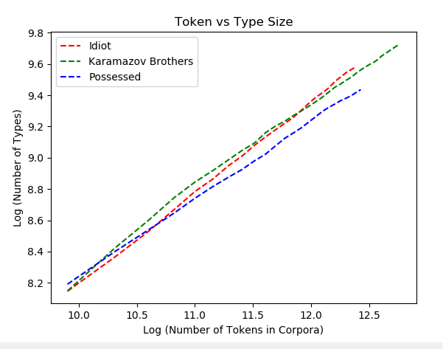

Fig10: Type Token Relation for Books of Dostoyevsky

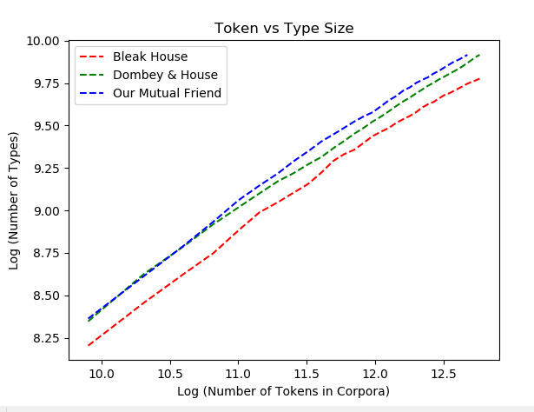

Fig11: Type Token Relation for Books of Charles Dickens

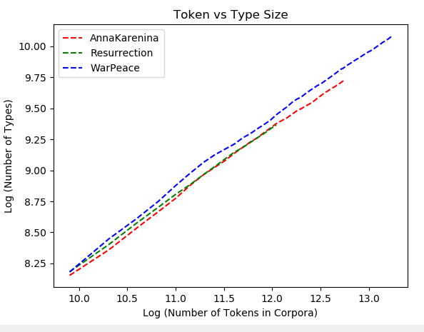

Fig12: Type Token Relation for Books of Tolstoy

There are small differences between slopes of the lines. Larger slope means that the author uses new types in the new pages of the book. Small slope means that the author doesn’t use so many new words in upcoming pages. So, type-token ratio gives us idea about richness of vocabulary usage.

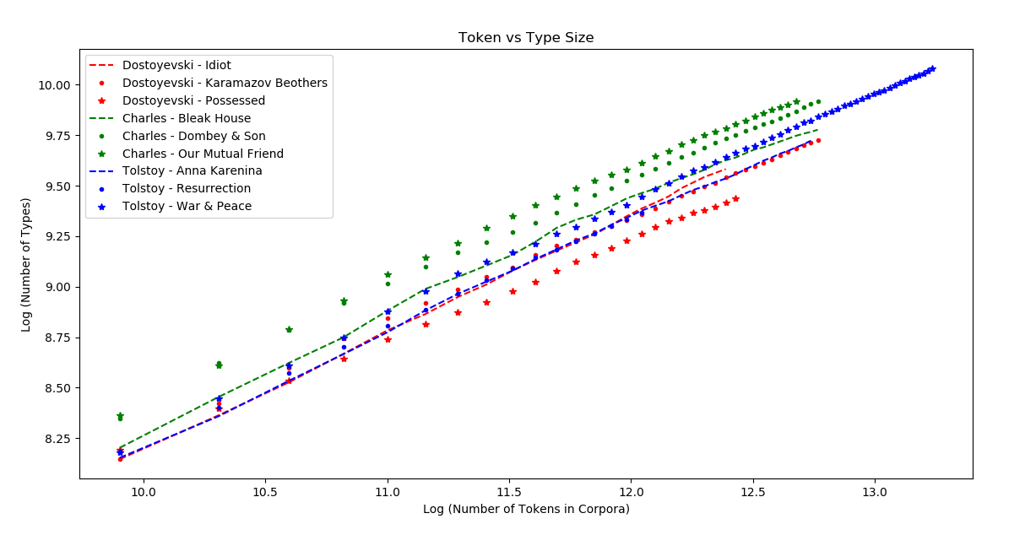

Fig13: Type Token Relation for All Books

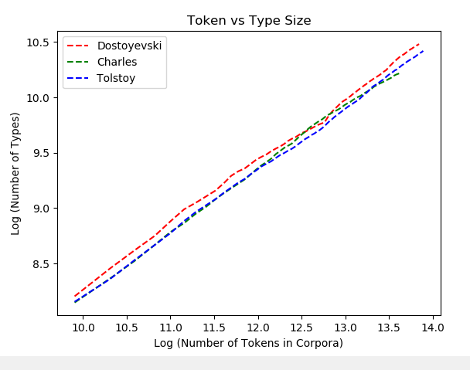

Fig14: Type Token Relation for Larger Author Corpora

By looking at figure 14, one can say that Dostoyevsky’s usage of vocabulary is his books are richer than Tolstoy and Charles. However, the corpora include stop words in this plot. So, it may give wrong idea about the real content of the books.

**(i)** I find the best fitting lines in terms of mean square error (MSE).

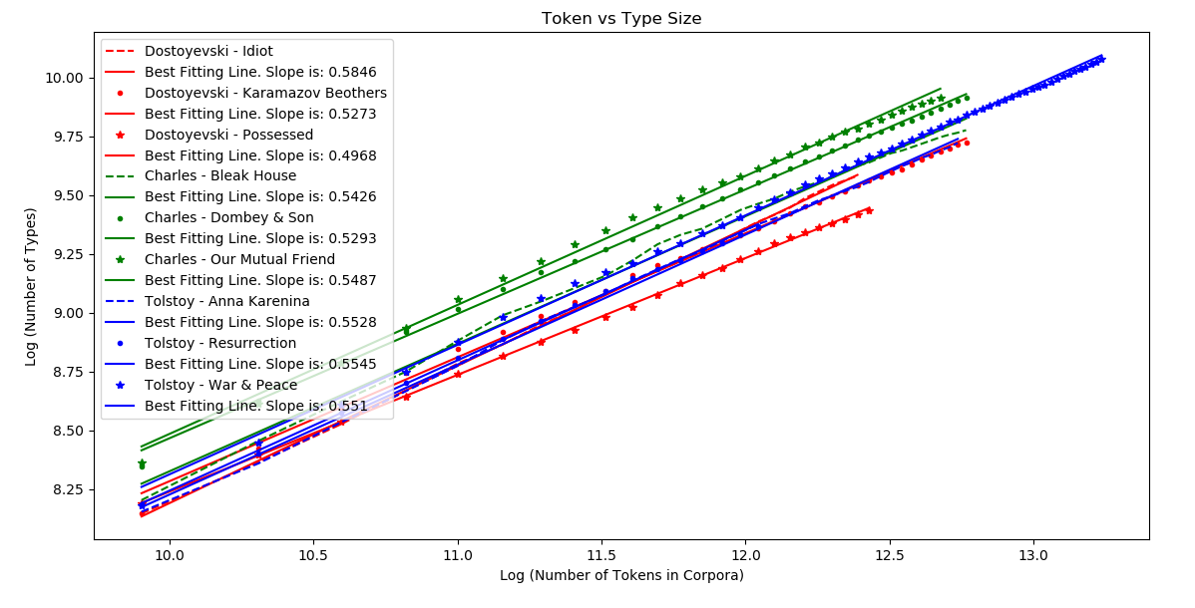

Fig15: Type Token Relation and best Fitting Lines for Each Book

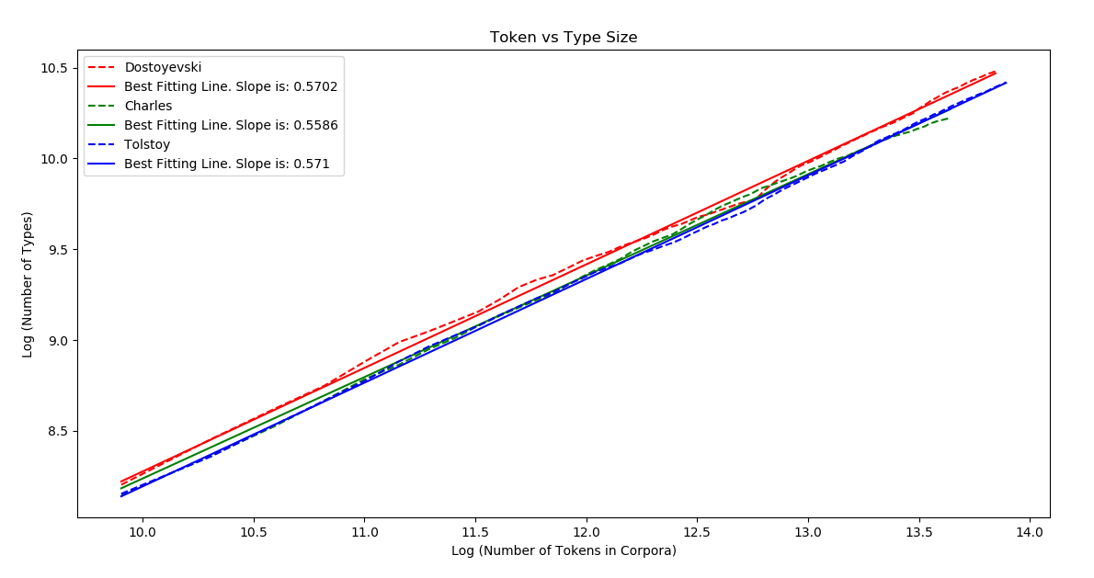

Fig16: Type Token Relation and best Fitting Lines for Larger Author Corpora

|  |  |
| --- | --- |
| Book Name | Best Fitting Line Slope |
| Dostoyevsky - Idiot | 0.5846 |
| Dostoyevsky – Karamazov Brothers | 0.5273 |
| Dostoyevsky - Possessed | 0.4968 |
| Charles Dickens – Bleak House | 0.5426 |
| Charles Dickens – Dombey & Son | 0.5293 |
| Charles Dickens – Our Mutual Friend | 0.5487 |
| Tolstoy- Anne Karenina | 0.5528 |
| Tolstoy- Resurrection | 0.5545 |
| Tolstoy- War & Peace | 0.5510 |

Table1: Best Fitting Line Slopes of Each Book

|  |  |
| --- | --- |
| Larger Author Corpora | Best Fitting Line Slope |
| Dostoyevsky | 0.5702 |
| Charles Dickens | 0.5586 |
| Tolstoy | 0.5710 |

Table2: Best Fitting Line Slopes of Larger Author Corpora

Slopes are pretty close to each other. The reason is probably stop words. Because they are major part of the corpora and affect the slopes a lot. So, dominance of stop words don’t allow us to get an idea about the content of the books. Another observation is that: Books of Tolstoy have a richer vocabulary than others. Because slopes of the books of Tolstoy are higher. This is a sign of rich vocabulary usage of the author. On the other hand, Merged corpora slope of Dostoyevsky is very high compared to single slope of his books. This is a sign that, Dostoyevsky uses different vocabulary in his different books. Also, his vocabulary richness change from book to book. However, Tolstoy uses more standard vocabulary richness in his books. Because all his books have similar slopes.

**(j)** I repeat parts (h) and (i) for literary types corpora.

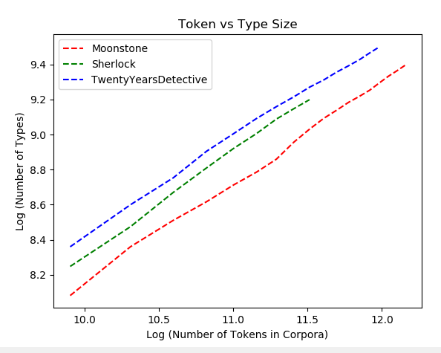

Fig17: Type Token Relation for the Books in Detective Genre

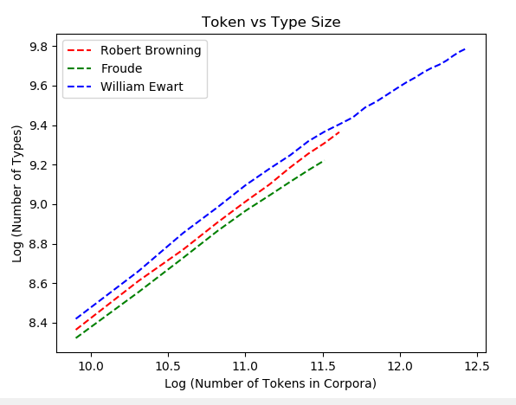

Fig18: Type Token Relation for the Books in Biography Genre

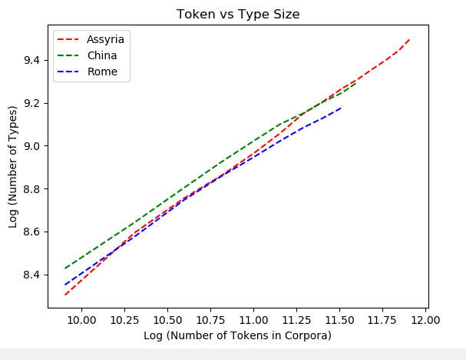

Fig19: Type Token Relation for the Books in Myth Genre

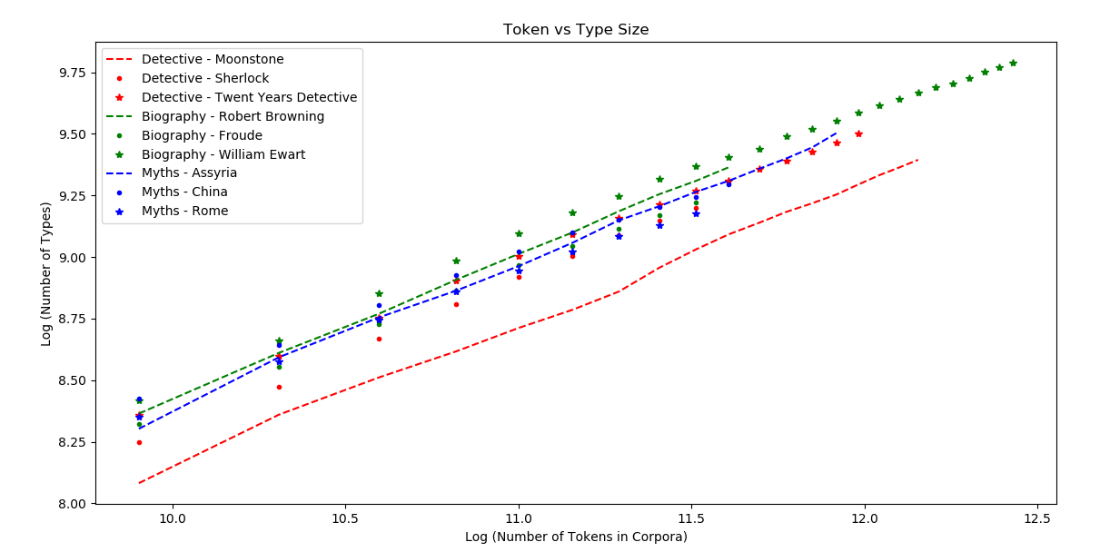

Fig20: Type Token Relation for Each Book in Genre Group

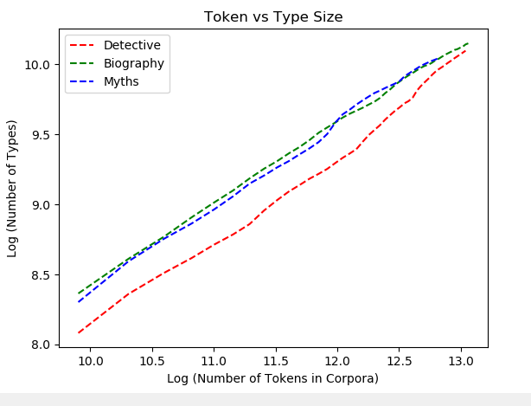

Fig21: Type Token Relation for Larger Genre Corpora

When we look at the best fitting lines, we see that they are more separable than author based books. This is probably because of that author based books are all literary books and their contents are more similar to each other. However, for different genres richness of vocabulary varies more. For example vocabulary richness of biography type of books are smaller than myths and detectives. This is as expected. Because describing detective stories or myths requires richer vocabulary than describing someone’s life.

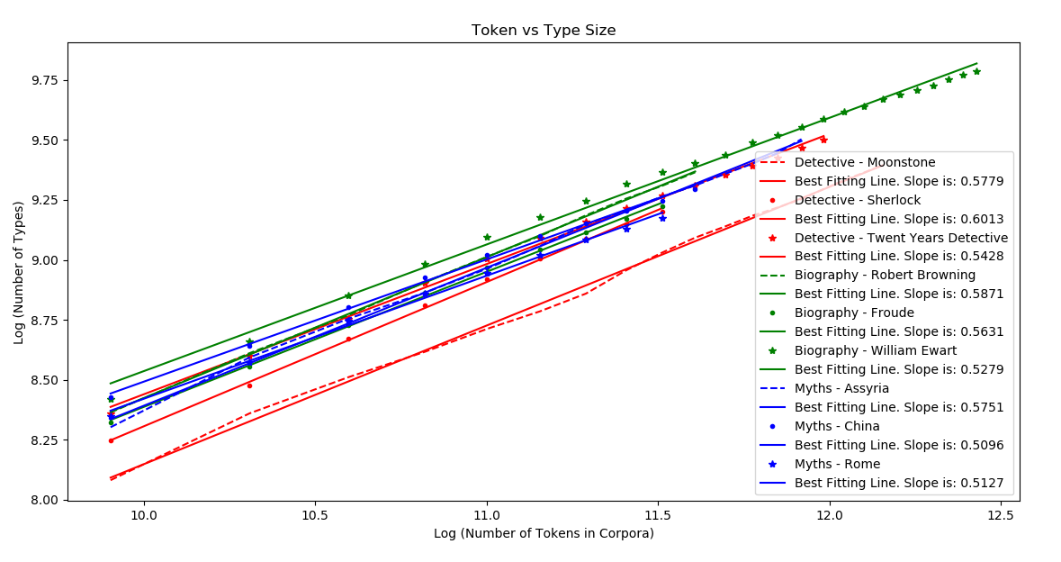

Fig22: Best Fitting Lines for Each Book in Genre Class

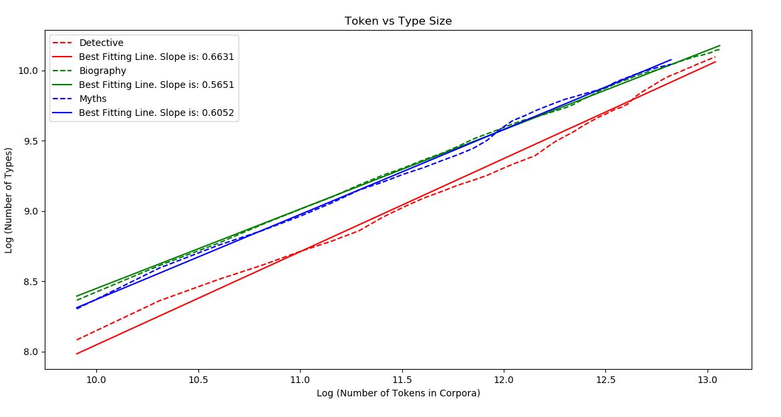

Fig23: Best Fitting Lines for Larger Genre Corpora

Another observation is that: Biography books individually have higher slopes than Myths books. However merged corpus of biography books have smaller slope than merged corpus of myths books. This means that different biography books have similar vocabularies. So, when we merge the books, total slope isn’t so high. On the other hand, different myths books have different vocabularies. Hence, slope of merged books of myths have higher slope than biography books.

|  |  |
| --- | --- |
| Book Name | Best Fitting Line Slope |
| Detective - Moonstone | 0.5779 |
| Detective - Sherlock | 0.6013 |
| Detective - Twenty Years Detective | 0.5428 |
| Biography – Robert Browning | 0.5871 |
| Biography – Froude | 0.5631 |
| Biography – Ewart | 0.5279 |
| Myths - Assyria | 0.5751 |
| Myths - China | 0.5096 |
| Myths - Rome | 0.5127 |

Table3: Best Fitting Line Slopes of Each Book in Genre Class

|  |  |
| --- | --- |
| Larger Author Corpora | Best Fitting Line Slope |
| Detective | 0.6631 |
| Biography | 0.5651 |
| Myths | 0.6052 |

Table4: Best Fitting Line Slopes of Larger Genre Corpora

**(k)** When we look at the table1 we see that books of the same author have very similar slopes. This intuitively makes sense. Because type token slope represents the vocabulary of the author. So, it is expected that different books of the same author have similar vocabularies and similar slope values. Hence for Charles Dickens and Tolstoy we can use this as a clue and determine a clustering method based on average slopes of the books:

- We can classify the books which has slope values 0.55 with error margin 0.005 as Tolstoy.

- We can classify the books which has slope values 0.535 with error margin 0.015 as Charles Dickens.

- However, we can’t classify books of Dostoyevsky. Because Dostoyevsky has a very large variance of type/token slopes for the given three books. This is a possible case, because the author may prefer different vocabularies while writing different books. Types of these books may be different. So, this may change the language.

**(l)** When I remove stop words, I some observed small changes.

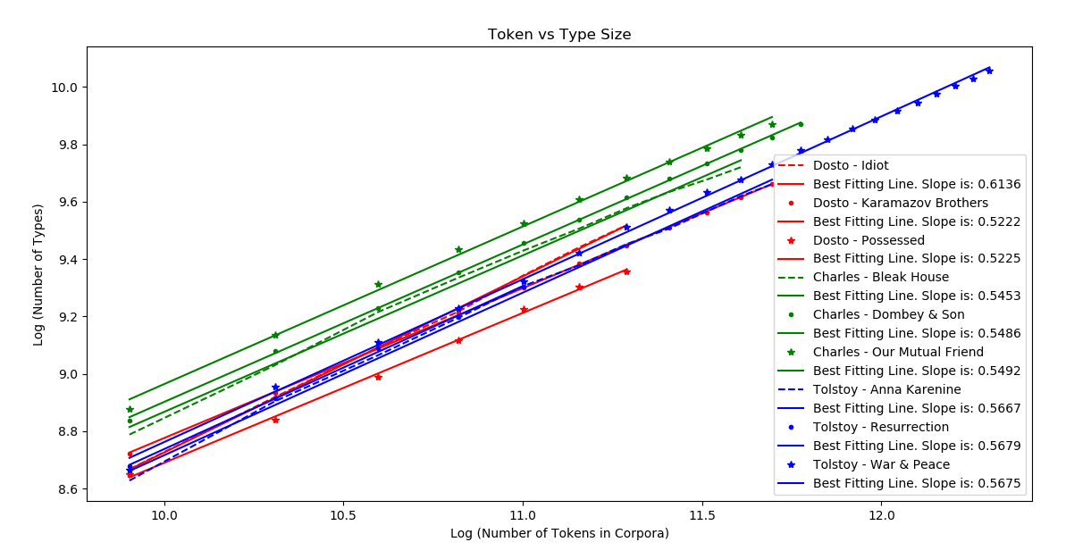

Fig24: Best Fitting Lines for each Author Based Book After Removal of Stop Words

My first observation is that: Variance of slopes for the books of Dostoyevsky decreased. Before removing stop words, slope of each book was very different from each other. Now, slope of two books are almost the same.

My second observation is that: Variance of slopes of merged books increased. This is as intiutivily expected. Because common part of the vocabulary is removed from the corpora. So, differences will be more. Other than that, individual slopes didn’t change much as we can see in the figures and tables.

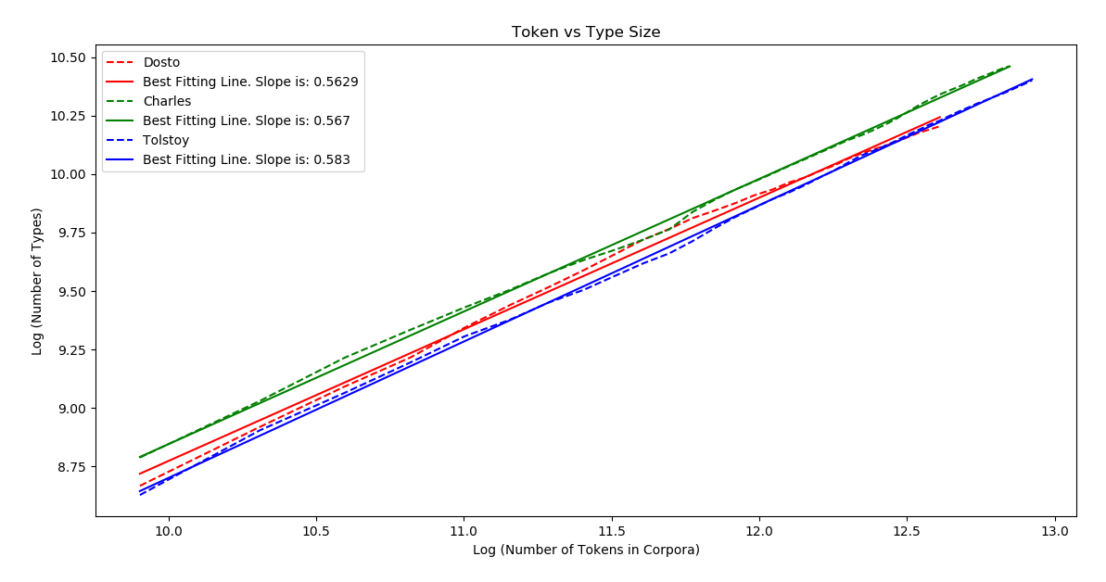

Fig25: Best Fitting Lines for Larger Author Corpora After Stop Word Removal

|  |  |
| --- | --- |
| Book Name | Best Fitting Line Slope |
| Dostoyevsky - Idiot | 0.6136 |
| Dostoyevsky – Karamazov Brothers | 0.5222 |
| Dostoyevsky - Possessed | 0.5225 |
| Charles Dickens – Bleak House | 0.5453 |
| Charles Dickens – Dombey & Son | 0.5486 |
| Charles Dickens – Our Mutual Friend | 0.5492 |
| Tolstoy- Anne Karenina | 0.5667 |
| Tolstoy- Resurrection | 0.5679 |
| Tolstoy- War & Peace | 0.5675 |

Table5: Best Fitting Line Slopes of Each Book Without Stop Words

|  |  |
| --- | --- |
| Larger Author Corpora | Best Fitting Line Slope |
| Dostoyevsky | 0.5629 |
| Charles Dickens | 0.5670 |
| Tolstoy | 0.5830 |

Table6: Best Fitting Line Slopes of Larger Author Corpora Without Stop Words

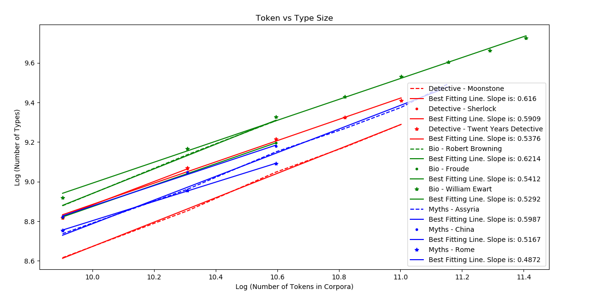

Fig26: Best Fitting Lines for Each Book in Genre Corpora After Stop Word Removal

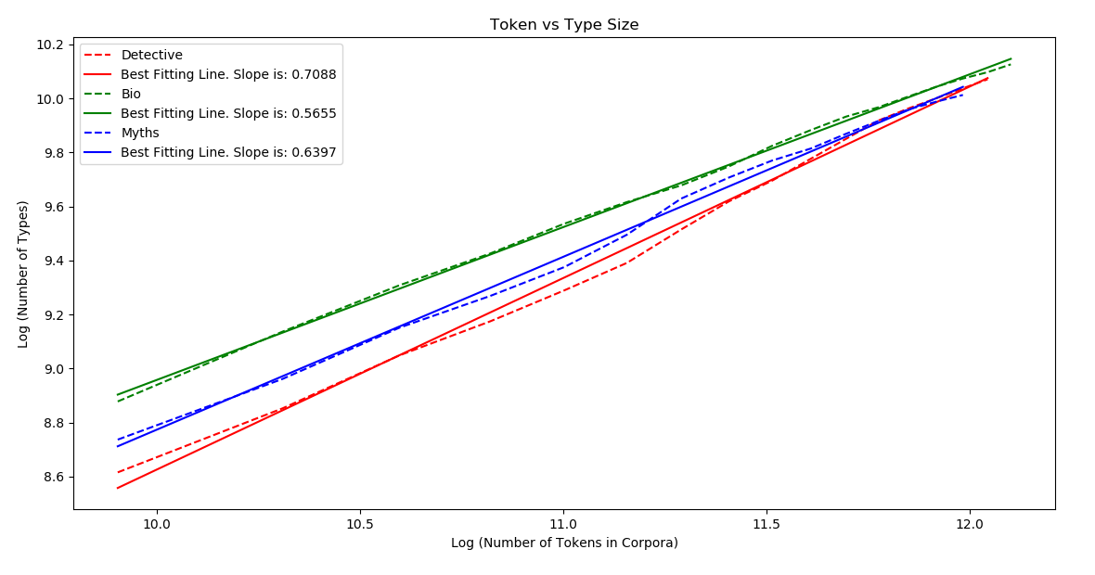

Fig27: Best Fitting Lines for Larger Genre Corpora After Stop Word Removal

|  |  |
| --- | --- |
| Book Name | Best Fitting Line Slope |
| Detective - Moonstone | 0.6160 |
| Detective - Sherlock | 0.5909 |
| Detective - Twenty Years Detective | 0.5376 |
| Biography – Robert Browning | 0.6214 |
| Biography – Froude | 0.5412 |
| Biography – Ewart | 0.5292 |
| Myths - Assyria | 0.5987 |
| Myths - China | 0.5167 |
| Myths - Rome | 0.4872 |

Table7: Best Fitting Line Slopes of Each Book in Genre Class Without Stop Words

|  |  |
| --- | --- |
| Larger Author Corpora | Best Fitting Line Slope |
| Detective | 0.7088 |
| Biography | 0.5655 |
| Myths | 0.6397 |

Table8: Best Fitting Line Slopes of Larger Genre Corpora Without Stop Words

**(m)** I created a random corpus which has 1.500.000 words. Length of a word is between 1 and 4. Possible letters are English alphabet letters and numbers. For each word, firstly I choose a random number between 1 and 4 to determine word length. Then I generate a random string with the randomly generated length. All random generations have uniform pdf’s. For this randomly generated corpus, I obtained following results. These results show that, this corpus obeys Zipf’s Law and Heaps’ Law.

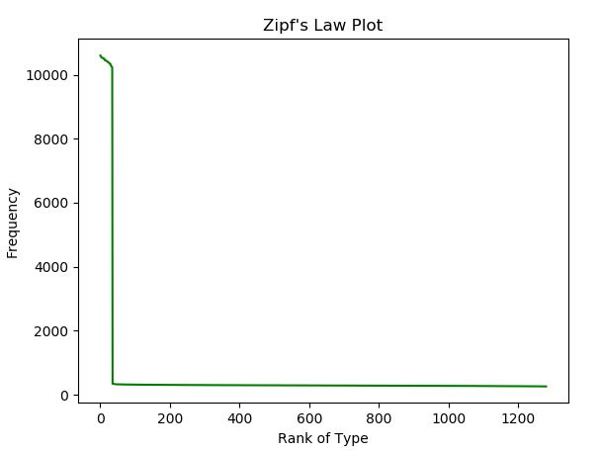

Fig28: Frequency rank relation of Randomly Generated Corpus

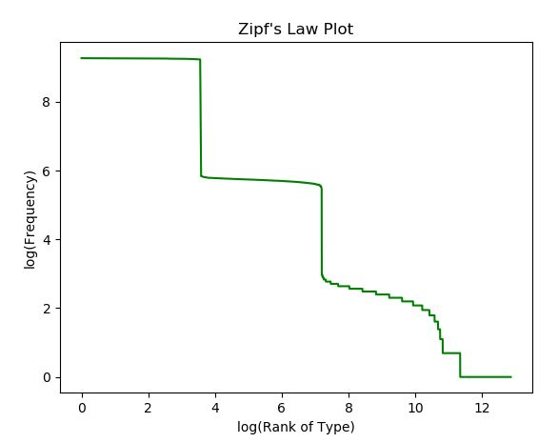

Fig29: Frequency rank relation of Randomly Generated Corpus in Log-Log Format

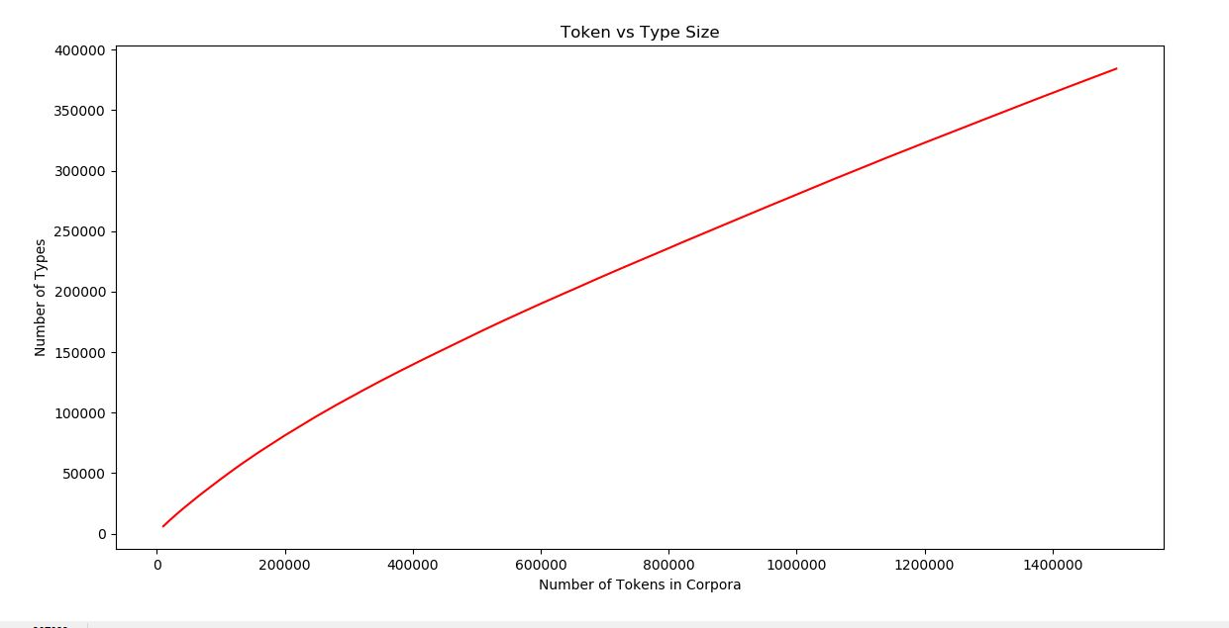

Fig30: Type Token Relation of Randomly Generated Corpus

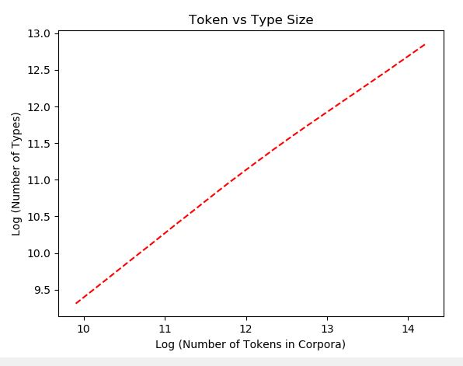

Fig31: Type Token Relation of Randomly Generated Corpus in Log-Log Format

**DISCUSSION AND CONCLUSIONS**

In this study used 18 different books. By preprocessing them, I created 18 basic corpora. By merging them with groups of 3 books, I created 6 more corpora. Also, I used stop word removed version of these corpora.

I investigated frequency rank relation by using these corpora. I have seen that there is an inverse proportional relation between frequency and rank of types in normal format. When I plot this in Log-Log format, I have seen that the relation becomes linear. This case was correct for any single book, their merged versions and even for randomly generated book. The law explains this relation is called Zipf’s Law.

I also investigated number of type-token relation. I have seen that: number of type is a function of number of tokens. This is an increasing function. However, amount of increase decreases at every step. When I investigate this relation in Log-Log format, I have seen a linear relation. This observations were the same for all versions of the corpora. The law explaining this relation is called Heaps’ Law. It is formulated as:

In this formula, is number of types (vocabulary size), n is number of tokens, k and are free parameters determined empirically. In an English text corpora, k is typically between 10-100 and is between 0.4 and 0.6.

Also I investigated that type-token relation gives us idea about the vocabulary of the corpora. For example, detective books tend to have higher type-token ratio than biography books. This means that, vocabulary of detective books are richer than biography books. This information also gives us some hints about the authors of the books. When I checked the type-token ratio of the books of the authors, I have seen that books of the same author have very close type-token ratio slopes. This is because, this ratio slope represents the vocabulary of the authors. So, books of the same author tend to have similar type-token slopes. But there may be exception according to type of the book and target reader of the author. Two books of the same author written in different genres may have different type-token slopes.

At the end, I checked effect of removing stop words. It increased especially the variance of the slopes of merged books. Because stop words are common among different books. So, removing them makes vocabulary of books more different.

I have also investigated that even a randomly generated corpus obeys the Zipf’s and Heaps’ Laws.

**REFERENCES**

[1] Wikizeroo.org. 2020. *Heaps' Law - Wikipedia*. [online] Available at: <https://www.wikizeroo.org/index.php?q=aHR0cHM6Ly9lbi53aWtpcGVkaWEub3JnL3dpa2kvSGVhcHMnX2xhdw> [Accessed 1 April 2020].

[2] Brownlee, J., 2020. *How To Clean Text For Machine Learning With Python*. [online] Machine Learning Mastery. Available at: <https://machinelearningmastery.com/clean-text-machine-learning-python/> [Accessed 2 April 2020].

[3] Brownlee, J., 2020. *How To Clean Text For Machine Learning With Python*. [online] Machine Learning Mastery. Available at: <https://machinelearningmastery.com/clean-text-machine-learning-python/> [Accessed 2 April 2020].

**APPENDIX**

The code for the implementation of the methods is here. This code has two classes. Methods are implemented in the class “Operations”. Main flow of the operations are in the class “Main”.

WARRNING: This code is written assuming the text files are in the directories given in the following hierarchy and names:

-NLPPoroject

* Books

- Author

- Genre

- MergedBooks

* Frequencies

- AfterStopWord

- BeforeStopWord

- MergedFrequencies

**CODE:**

**MAIN CLASS:**

from Operations import Operations  
authorBasedBooks = ["Author/Dostoyevski-Idiot.txt", "Author/Dostoyevski-KaramazovBrothers.txt" , "Author/Dostoyevski-Possessed.txt",  
 "Author/CharlesDickens-BleakHouse.txt", "Author/CharlesDickens-Dombey&Son.txt", "Author/CharlesDickens-OurMutualFriend.txt",  
 "Author/Tolstoy-AnnaKarenina.txt", "Author/Tolstoy-Resurrection.txt", "Author/Tolstoy-War&Peace.txt"]  
genreBasedBooks = ["Genre/Detective-Moonstone.txt", "Genre/Detective-Sherlock.txt", "Genre/Detective-TwentyYearsDetective.txt",  
 "Genre/Biography-Life&LettersofRobertBrowning.txt", "Genre/Biography-LifeofFroude.txt", "Genre/Biography-LifeofWilliamEwart.txt",  
 "Genre/Myths-Assyria.txt", "Genre/Myths-China.txt", "Genre/Myths-Rome.txt" ]  
  
authorBasedFrequencyTexts = ["Freq_Dostoyevski-Idiot.txt", "Freq_Dostoyevski-KaramazovBrothers.txt" , "Freq_Dostoyevski-Possessed.txt",  
 "Freq_CharlesDickens-BleakHouse.txt", "Freq_CharlesDickens-Dombey&Son.txt", "Freq_CharlesDickens-OurMutualFriend.txt",  
 "Freq_Tolstoy-AnnaKarenina.txt", "Freq_Tolstoy-Resurrection.txt", "Freq_Tolstoy-War&Peace.txt"]  
genreBasedFrequencyTexts = ["Freq_Detective-Moonstone.txt", "Freq_Detective-Sherlock.txt", "Freq_Detective-TwentyYearsDetective.txt",  
 "Freq_Biography-Life&LettersofRobertBrowning.txt", "Freq_Biography-LifeofFroude.txt", "Freq_Biography-LifeofWilliamEwart.txt",  
 "Freq_Myths-Assyria.txt", "Freq_Myths-China.txt", "Freq_Myths-Rome.txt" ]  
  
Corpora_authorBased = []  
Corpora_genreBased = []  
CorporaWOStopWords_authorBased = []  
CorporaWOStopWords_genreBased = []  
  
TypeFrequencies_authorBasedCorpora = []  
TypeFrequencies_genreBasedCorpora = []  
TypeFrequencies_authorBasedCorporaWOStopWords = []  
TypeFrequencies_genreBasedCorporaWOStopWords = []  
  
op = Operations()  
  
########## PART C  
for i in range(9):  
 Corpora_authorBased.append(op.createCorpora(authorBasedBooks[i]))  
  
for i in range(9):  
 Corpora_genreBased.append(op.createCorpora(genreBasedBooks[i]))  
  
########## PART D  
for i in range(9):  
 CorporaWOStopWords_authorBased.append(op.removeStopWords(Corpora_authorBased[i]))  
  
for i in range(9):  
 CorporaWOStopWords_genreBased.append(op.removeStopWords(Corpora_genreBased[i]))  
########## PART E  
for i in range(9):  
 TypeFrequencies_authorBasedCorpora.append(op.countTypeFrequencies(Corpora_authorBased[i]))  
 TypeFrequencies_genreBasedCorpora.append(op.countTypeFrequencies(Corpora_genreBased[i]))  
 TypeFrequencies_authorBasedCorporaWOStopWords.append(op.countTypeFrequencies(CorporaWOStopWords_authorBased[i]))  
 TypeFrequencies_genreBasedCorporaWOStopWords.append(op.countTypeFrequencies(CorporaWOStopWords_genreBased[i]))  
  
op.writeFrequenciesToText(authorBasedFrequencyTexts, TypeFrequencies_authorBasedCorpora, "BeforeStopWord/AuthorBasedFrequencies/")  
op.writeFrequenciesToText(genreBasedFrequencyTexts, TypeFrequencies_genreBasedCorpora, "BeforeStopWord/GenreBasedFrequencies/")  
op.writeFrequenciesToText(authorBasedFrequencyTexts, TypeFrequencies_authorBasedCorporaWOStopWords, "AfterStopWord/AuthorBasedFrequencies/")  
op.writeFrequenciesToText(genreBasedFrequencyTexts, TypeFrequencies_genreBasedCorporaWOStopWords, "AfterStopWord/GenreBasedFrequencies/")  
  
########## PART F  
mergedBook = op.mergeCorpora(authorBasedBooks[0],authorBasedBooks[1],authorBasedBooks[2])  
with open ("C:/Users/enesk/PycharmProjects/NLPminiProject/Books/MergedBooks/" + 'MergedBook_Dostoyevski.txt', 'w', encoding="utf8") as fp:  
 fp.write(mergedBook)  
  
mergedBook = op.mergeCorpora(authorBasedBooks[3], authorBasedBooks[4], authorBasedBooks[5])  
with open("C:/Users/enesk/PycharmProjects/NLPminiProject/Books/MergedBooks/" + 'MergedBook_CharlesDickens.txt', 'w',encoding="utf8") as fp:  
 fp.write(mergedBook)  
  
mergedBook = op.mergeCorpora(authorBasedBooks[6], authorBasedBooks[7], authorBasedBooks[8])  
with open("C:/Users/enesk/PycharmProjects/NLPminiProject/Books/MergedBooks/" + 'MergedBook_Tolstoy.txt', 'w',encoding="utf8") as fp:  
 fp.write(mergedBook)  
  
mergedCorporaDostoyevski = op.createCorpora("/MergedBooks/MergedBook_Dostoyevski.txt")  
mergedFreqDostoyevski = op.countTypeFrequencies(mergedCorporaDostoyevski)  
op.writeFrequencyToText("MergedFreq_Dostoyevski" ,mergedFreqDostoyevski, "MergedFrequencies/" )  
  
mergedCorporaCharles = op.createCorpora("/MergedBooks/MergedBook_CharlesDickens.txt")  
mergedFreqCharles = op.countTypeFrequencies(mergedCorporaCharles)  
op.writeFrequencyToText("MergedFreq_CharlesDickens" ,mergedFreqCharles, "MergedFrequencies/" )  
  
mergedCorporaTolstoy = op.createCorpora("/MergedBooks/MergedBook_Tolstoy.txt")  
mergedFreqTolstoy = op.countTypeFrequencies(mergedCorporaTolstoy)  
op.writeFrequencyToText("MergedFreq_Tolstoy" ,mergedFreqTolstoy, "MergedFrequencies/" )  
  
op.plotLogZipfsForThree(mergedFreqTolstoy, mergedFreqDostoyevski, mergedFreqCharles, "Tolstoy", "Dostoyevski", "Charles")  
op.plotNormalZipfsForThree(mergedFreqTolstoy, mergedFreqDostoyevski, mergedFreqCharles, "Tolstoy", "Dostoyevski", "Charles")  
  
  
op.plotLogZipfsForThree(TypeFrequencies_authorBasedCorpora[0],  
 TypeFrequencies_authorBasedCorpora[1],  
 TypeFrequencies_authorBasedCorpora[2],  
 "Idiot", "Karamazov Brothers", "Possessed")  
  
op.plotLogZipfsForThree(TypeFrequencies_authorBasedCorpora[3],  
 TypeFrequencies_authorBasedCorpora[4],  
 TypeFrequencies_authorBasedCorpora[5],  
 "Bleak House", "Dombey & House", "Our Mutual Friend")  
  
op.plotLogZipfsForThree(TypeFrequencies_authorBasedCorpora[6],  
 TypeFrequencies_authorBasedCorpora[7],  
 TypeFrequencies_authorBasedCorpora[8],  
 "AnnaKarenina", "Resurrection", "WarPeace")  
  
  
########## PART G  
op.plotNormalTokenVsVocabularySizeForThree(mergedCorporaCharles, mergedCorporaDostoyevski, mergedCorporaTolstoy,  
 "Charles", "Dostoyevski", "Tolstoy")  
op.plotLogTokenVsVocabularySizeForThree(mergedCorporaCharles, mergedCorporaDostoyevski, mergedCorporaTolstoy,  
 "Charles", "Dostoyevski", "Tolstoy", False)  
########## PART H  
op.plotLogTokenVsVocabularySizeForThree(Corpora_authorBased[0], Corpora_authorBased[1], Corpora_authorBased[2],  
 "Idiot", "Karamazov Brothers", "Possessed", False)  
op.plotLogTokenVsVocabularySizeForThree(Corpora_authorBased[3], Corpora_authorBased[4], Corpora_authorBased[5],  
 "Bleak House", "Dombey & House", "Our Mutual Friend", False)  
op.plotLogTokenVsVocabularySizeForThree(Corpora_authorBased[6], Corpora_authorBased[7], Corpora_authorBased[8],  
 "AnnaKarenina", "Resurrection", "WarPeace", False)  
  
op.plotLogTokenVsVocabularySizeForNine(Corpora_authorBased[0], Corpora_authorBased[1], Corpora_authorBased[2],  
 Corpora_authorBased[3], Corpora_authorBased[4], Corpora_authorBased[5],  
 Corpora_authorBased[6], Corpora_authorBased[7], Corpora_authorBased[8],  
 "Dostoyevski", "Charles", "Tolstoy", False)  
  
op.plotLogTokenVsVocabularySizeForThree(mergedCorporaCharles, mergedCorporaDostoyevski, mergedCorporaTolstoy,  
 "Dostoyevski", "Charles", "Tolstoy", False)  
  
########## PART I  
op.plotLogTokenVsVocabularySizeForNine(Corpora_authorBased[0], Corpora_authorBased[1], Corpora_authorBased[2],  
 Corpora_authorBased[3], Corpora_authorBased[4], Corpora_authorBased[5],  
 Corpora_authorBased[6], Corpora_authorBased[7], Corpora_authorBased[8],  
 "Dostoyevski", "Charles", "Tolstoy", True)  
  
op.plotLogTokenVsVocabularySizeForThree(mergedCorporaCharles, mergedCorporaDostoyevski, mergedCorporaTolstoy,  
 "Dostoyevski", "Charles", "Tolstoy", True)  
  
########## PART J  
mergedBook = op.mergeCorpora(genreBasedBooks[0],genreBasedBooks[1],genreBasedBooks[2])  
with open ("C:/Users/enesk/PycharmProjects/NLPminiProject/Books/MergedBooks/" + 'MergedBook_Detective.txt', 'w', encoding="utf8") as fp:  
 fp.write(mergedBook)  
  
mergedBook = op.mergeCorpora(genreBasedBooks[3], genreBasedBooks[4], genreBasedBooks[5])  
with open("C:/Users/enesk/PycharmProjects/NLPminiProject/Books/MergedBooks/" + 'MergedBook_Biography.txt', 'w',encoding="utf8") as fp:  
 fp.write(mergedBook)  
  
mergedBook = op.mergeCorpora(genreBasedBooks[6], genreBasedBooks[7], genreBasedBooks[8])  
with open("C:/Users/enesk/PycharmProjects/NLPminiProject/Books/MergedBooks/" + 'MergedBook_Myths.txt', 'w',encoding="utf8") as fp:  
 fp.write(mergedBook)  
  
mergedCorporaDetective = op.createCorpora("/MergedBooks/MergedBook_Detective.txt")  
mergedFreqDetective = op.countTypeFrequencies(mergedCorporaDetective)  
op.writeFrequencyToText("MergedFreq_Detective" ,mergedFreqDetective, "MergedFrequencies/" )  
  
mergedCorporaBiography = op.createCorpora("/MergedBooks/MergedBook_Biography.txt")  
mergedFreqBiography = op.countTypeFrequencies(mergedCorporaBiography)  
op.writeFrequencyToText("MergedFreq_Biography" ,mergedFreqBiography, "MergedFrequencies/" )  
  
mergedCorporaMyths = op.createCorpora("/MergedBooks/MergedBook_Myths.txt")  
mergedFreqMyths = op.countTypeFrequencies(mergedCorporaMyths)  
op.writeFrequencyToText("MergedFreq_Myths" ,mergedFreqMyths, "MergedFrequencies/" )  
  
##############  
  
op.plotLogTokenVsVocabularySizeForThree(Corpora_genreBased[0], Corpora_genreBased[1], Corpora_genreBased[2],  
 "Moonstone", "Sherlock", "TwentyYearsDetective", False)  
op.plotLogTokenVsVocabularySizeForThree(Corpora_genreBased[3], Corpora_genreBased[4], Corpora_genreBased[5],  
 "Robert Browning", "Froude", "William Ewart", False)  
op.plotLogTokenVsVocabularySizeForThree(Corpora_genreBased[6], Corpora_genreBased[7], Corpora_genreBased[8],  
 "Assyria", "China", "Rome", False)  
  
op.plotLogTokenVsVocabularySizeForNine(Corpora_genreBased[0], Corpora_genreBased[1], Corpora_genreBased[2],  
 Corpora_genreBased[3], Corpora_genreBased[4], Corpora_genreBased[5],  
 Corpora_genreBased[6], Corpora_genreBased[7], Corpora_genreBased[8],  
 "Detective", "Biography", "Myths", False)  
  
op.plotLogTokenVsVocabularySizeForThree(mergedCorporaDetective, mergedCorporaBiography, mergedCorporaMyths,  
 "Detective", "Biography", "Myths", False)  
  
op.plotLogTokenVsVocabularySizeForNine(Corpora_genreBased[0], Corpora_genreBased[1], Corpora_genreBased[2],  
 Corpora_genreBased[3], Corpora_genreBased[4], Corpora_genreBased[5],  
 Corpora_genreBased[6], Corpora_genreBased[7], Corpora_genreBased[8],  
 "Detective", "Biography", "Myths", True)  
  
op.plotLogTokenVsVocabularySizeForThree(mergedCorporaDetective, mergedCorporaBiography, mergedCorporaMyths,  
 "Detective", "Biography", "Myths", True)  
  
##### PART L  
op.plotLogTokenVsVocabularySizeForNine(op.removeStopWords(Corpora_authorBased[0]),  
 op.removeStopWords(Corpora_authorBased[1]),  
 op.removeStopWords(Corpora_authorBased[2]),  
 op.removeStopWords(Corpora_authorBased[3]),  
 op.removeStopWords(Corpora_authorBased[4]),  
 op.removeStopWords(Corpora_authorBased[5]),  
 op.removeStopWords(Corpora_authorBased[6]),  
 op.removeStopWords(Corpora_authorBased[7]),  
 op.removeStopWords(Corpora_authorBased[8]),  
 "Dosto", "Charles", "Tolstoy", True)  
  
op.plotLogTokenVsVocabularySizeForThree(op.removeStopWords(mergedCorporaDostoyevski),  
 op.removeStopWords(mergedCorporaCharles),  
 op.removeStopWords(mergedCorporaTolstoy),  
 "Dosto", "Charles", "Tolstoy", True)  
  
op.plotLogTokenVsVocabularySizeForNine(op.removeStopWords(Corpora_genreBased[0]),  
 op.removeStopWords(Corpora_genreBased[1]),  
 op.removeStopWords(Corpora_genreBased[2]),  
 op.removeStopWords(Corpora_genreBased[3]),  
 op.removeStopWords(Corpora_genreBased[4]),  
 op.removeStopWords(Corpora_genreBased[5]),  
 op.removeStopWords(Corpora_genreBased[6]),  
 op.removeStopWords(Corpora_genreBased[7]),  
 op.removeStopWords(Corpora_genreBased[8]),  
 "Detective", "Bio", "Myths", True)  
  
op.plotLogTokenVsVocabularySizeForThree(op.removeStopWords(mergedCorporaDetective),  
 op.removeStopWords(mergedCorporaBiography),  
 op.removeStopWords(mergedCorporaMyths),  
 "Detective", "Bio", "Myths",True)  
  
########### PART M  
randomText = op.createRandomText()  
randomTextCorpora = op.createRandomCorpora(randomText)  
print (randomTextCorpora)  
frequenciesOfRandomText = op.countTypeFrequencies(randomTextCorpora)  
print (frequenciesOfRandomText)  
op.plotNormalZipfsForOne(frequenciesOfRandomText)  
op.plotLogZipfsForOne(frequenciesOfRandomText)  
op.plotNormalTokenVsVocabularySizeForOne(randomTextCorpora)  
op.plotLogTokenVsVocabularySizeForOne(randomTextCorpora, False)  
 # REFERENCES  
 # https://machinelearningmastery.com/clean-text-machine-learning-python/  
 # https://gist.github.com/larsyencken/1440509 -> stop words

**OPERATIONS CLASS:**

class Operations:  
 def plotNormalTokenVsVocabularySizeForOne(self, Corpora1):  
 import matplotlib.pyplot as plt  
 plt.xlabel('Number of Tokens in Corpora')  
 plt.ylabel('Number of Types')  
 plt.title("Token vs Type Size")  
  
 import math  
 x = []  
 y = []  
 for i in range(math.floor(len(Corpora1) / 10000)):  
 x.append(10000 * (i + 1))  
 y.append(len(self.countTypeFrequencies(Corpora1[1:10000 * (i + 1)])))  
 print("x = ", x)  
 print("\n")  
 print("y = ", y)  
 plt.plot(x, y, "r")  
 plt.show()  
  
  
 def plotLogTokenVsVocabularySizeForOne(self, Corpora1, showBestFitLine):  
 import matplotlib.pyplot as plt  
 import numpy  
 plt.xlabel('Log (Number of Tokens in Corpora)')  
 plt.ylabel('Log (Number of Types)')  
 plt.title("Token vs Type Size")  
 import math  
 x = []  
 y = []  
 for i in range(1, math.floor(len(Corpora1)/10000)):  
 x.append(10000*(i+1))  
 y.append(len(self.countTypeFrequencies(Corpora1[1:10000*(i+1)])))  
 print("x = " , x)  
 print("\n")  
 print("y = ", y)  
 plt.plot(numpy.log(x), numpy.log(y), "r--")  
 if showBestFitLine:  
 x = numpy.array(x)  
 y = numpy.array(y)  
 m, b = numpy.polyfit(numpy.log(x), numpy.log(y), 1)  
 plt.plot(numpy.log(x), m*numpy.log(x)+b, "r", label = "Best Fitting Line. Slope is: " + str(round(m,4)))  
 plt.show()  
  
  
 def plotLogZipfsForOne(self, TypeFrequencies1):  
 import numpy  
 freqArray = []  
 for letter, count in TypeFrequencies1.most_common(len(TypeFrequencies1)):  
 freqArray.append(count)  
 x = []  
 y = []  
 import matplotlib.pyplot as plt  
 plt.figure(2)  
 for i in range(1, len(freqArray)):  
 x.append(i)  
 y.append(freqArray[i])  
 plt.xlabel('log(Rank of Type)')  
 plt.ylabel('log(Frequency)')  
 plt.title("Zipf's Law Plot")  
 plt.plot(numpy.log(x), numpy.log(y), 'g')  
 plt.show()  
  
 def plotNormalZipfsForOne(self, TypeFrequencies1 ):  
  
 import math  
 freqArray = []  
 for letter, count in TypeFrequencies1.most_common(len(TypeFrequencies1)):  
 freqArray.append(count)  
 x = []  
 y = []  
 import matplotlib.pyplot as plt  
 plt.figure(1)  
 for i in range(1, math.floor(len(freqArray)/300)):  
 x.append(i)  
 y.append(freqArray[i])  
 plt.xlabel('Rank of Type')  
 plt.ylabel('Frequency')  
 plt.title("Zipf's Law Plot")  
 plt.plot(x, y, 'g' )  
 plt.show()  
  
 def createRandomText(self):  
 import string  
 import random  
 from random import seed  
 from random import randint  
 seed(1)  
  
 numberOfWords = 1500000  
 maxNumberofLettersInaWord = 4  
  
 text = ""  
  
 for i in range(numberOfWords):  
 numberOfLetters = randint(1, maxNumberofLettersInaWord)  
 text = text + " " + str(''.join(random.choices(string.ascii_uppercase +  
 string.digits, k=numberOfLetters)))  
  
 return text  
  
 def plotLogTokenVsVocabularySizeForNine(self, Corpora1, Corpora2, Corpora3,Corpora4, Corpora5, Corpora6,  
 Corpora7, Corpora8, Corpora9,  
 Corpora1Name, Corpora2Name, Corpora3Name , showBestFitLine):  
 import matplotlib.pyplot as plt  
 import numpy  
  
 plt.xlabel('Log (Number of Tokens in Corpora)')  
 plt.ylabel('Log (Number of Types)')  
 plt.title("Token vs Type Size")  
  
 import math  
 x = []  
 y = []  
 for i in range(1, math.floor(len(Corpora1)/10000)):  
 x.append(10000*(i+1))  
 y.append(len(self.countTypeFrequencies(Corpora1[1:10000*(i+1)])))  
 print("x = " , x)  
 print("\n")  
 print("y = ", y)  
 plt.plot(numpy.log(x), numpy.log(y), "r--", label = Corpora1Name + " - Idiot")  
 if showBestFitLine:  
 x = numpy.array(x)  
 y = numpy.array(y)  
 m, b = numpy.polyfit(numpy.log(x), numpy.log(y), 1)  
 plt.plot(numpy.log(x), m * numpy.log(x) + b, "r",label = "Best Fitting Line. Slope is: " + str(round(m,4)))  
  
 x = []  
 y = []  
 for i in range(1, math.floor(len(Corpora2)/10000)):  
 x.append(10000*(i+1))  
 y.append(len(self.countTypeFrequencies(Corpora2[1:10000*(i+1)])))  
 print("x = " , x)  
 print("\n")  
 print("y = " , y)  
 plt.plot(numpy.log(x), numpy.log(y), "r.", label = Corpora1Name + " - Karamazov Brothers")  
 if showBestFitLine:  
 x = numpy.array(x)  
 y = numpy.array(y)  
 m, b = numpy.polyfit(numpy.log(x), numpy.log(y), 1)  
 plt.plot(numpy.log(x), m * numpy.log(x) + b, "r",label = "Best Fitting Line. Slope is: " + str(round(m,4)))  
  
 x = []  
 y = []  
 for i in range(1, math.floor(len(Corpora3)/10000)):  
 x.append(10000*(i+1))  
 y.append(len(self.countTypeFrequencies(Corpora3[1:10000*(i+1)])))  
 print("x = " , x)  
 print("\n")  
 print("y = " , y)  
 plt.plot(numpy.log(x), numpy.log(y), "r*", label = Corpora1Name + " - Possessed")  
 if showBestFitLine:  
 x = numpy.array(x)  
 y = numpy.array(y)  
 m, b = numpy.polyfit(numpy.log(x), numpy.log(y), 1)  
 plt.plot(numpy.log(x), m * numpy.log(x) + b, "r",label = "Best Fitting Line. Slope is: " + str(round(m,4)))  
  
 x = []  
 y = []  
 for i in range(1, math.floor(len(Corpora4) / 10000)):  
 x.append(10000 * (i + 1))  
 y.append(len(self.countTypeFrequencies(Corpora4[1:10000 * (i + 1)])))  
 print("x = ", x)  
 print("\n")  
 print("y = ", y)  
 plt.plot(numpy.log(x), numpy.log(y), "g--", label=Corpora2Name + " - Bleak House")  
 if showBestFitLine:  
 x = numpy.array(x)  
 y = numpy.array(y)  
 m, b = numpy.polyfit(numpy.log(x), numpy.log(y), 1)  
 plt.plot(numpy.log(x), m * numpy.log(x) + b, "g",label = "Best Fitting Line. Slope is: " + str(round(m,4)))  
  
 x = []  
 y = []  
 for i in range(1, math.floor(len(Corpora5) / 10000)):  
 x.append(10000 * (i + 1))  
 y.append(len(self.countTypeFrequencies(Corpora5[1:10000 * (i + 1)])))  
 print("x = ", x)  
 print("\n")  
 print("y = ", y)  
 plt.plot(numpy.log(x), numpy.log(y), "g.", label=Corpora2Name + " - Dombey & Son")  
 if showBestFitLine:  
 x = numpy.array(x)  
 y = numpy.array(y)  
 m, b = numpy.polyfit(numpy.log(x), numpy.log(y), 1)  
 plt.plot(numpy.log(x), m * numpy.log(x) + b, "g",label = "Best Fitting Line. Slope is: " + str(round(m,4)))  
  
 x = []  
 y = []  
 for i in range(1, math.floor(len(Corpora6) / 10000)):  
 x.append(10000 * (i + 1))  
 y.append(len(self.countTypeFrequencies(Corpora6[1:10000 * (i + 1)])))  
 print("x = ", x)  
 print("\n")  
 print("y = ", y)  
 plt.plot(numpy.log(x), numpy.log(y), "g*", label=Corpora2Name + " - Our Mutual Friend" )  
 if showBestFitLine:  
 x = numpy.array(x)  
 y = numpy.array(y)  
 m, b = numpy.polyfit(numpy.log(x), numpy.log(y), 1)  
 plt.plot(numpy.log(x), m * numpy.log(x) + b, "g",label = "Best Fitting Line. Slope is: " + str(round(m,4)))  
  
 x = []  
 y = []  
 for i in range(1, math.floor(len(Corpora7) / 10000)):  
 x.append(10000 * (i + 1))  
 y.append(len(self.countTypeFrequencies(Corpora7[1:10000 * (i + 1)])))  
 print("x = ", x)  
 print("\n")  
 print("y = ", y)  
 plt.plot(numpy.log(x), numpy.log(y), "b--", label=Corpora3Name + " - Anna Karenine")  
 if showBestFitLine:  
 x = numpy.array(x)  
 y = numpy.array(y)  
 m, b = numpy.polyfit(numpy.log(x), numpy.log(y), 1)  
 plt.plot(numpy.log(x), m * numpy.log(x) + b, "b",label = "Best Fitting Line. Slope is: " + str(round(m,4)))  
  
 x = []  
 y = []  
 for i in range(1, math.floor(len(Corpora8) / 10000)):  
 x.append(10000 * (i + 1))  
 y.append(len(self.countTypeFrequencies(Corpora8[1:10000 * (i + 1)])))  
 print("x = ", x)  
 print("\n")  
 print("y = ", y)  
 plt.plot(numpy.log(x), numpy.log(y), "b.", label=Corpora3Name + " - Resurrection")  
 if showBestFitLine:  
 x = numpy.array(x)  
 y = numpy.array(y)  
 m, b = numpy.polyfit(numpy.log(x), numpy.log(y), 1)  
 plt.plot(numpy.log(x), m * numpy.log(x) + b, "b",label = "Best Fitting Line. Slope is: " + str(round(m,4)))  
  
 x = []  
 y = []  
 for i in range(1, math.floor(len(Corpora9) / 10000)):  
 x.append(10000 * (i + 1))  
 y.append(len(self.countTypeFrequencies(Corpora9[1:10000 * (i + 1)])))  
 print("x = ", x)  
 print("\n")  
 print("y = ", y)  
 plt.plot(numpy.log(x), numpy.log(y), "b*", label=Corpora3Name + " - War & Peace")  
 if showBestFitLine:  
 x = numpy.array(x)  
 y = numpy.array(y)  
 m, b = numpy.polyfit(numpy.log(x), numpy.log(y), 1)  
 plt.plot(numpy.log(x), m*numpy.log(x)+b, "b",label = "Best Fitting Line. Slope is: " + str(round(m,4)))  
  
 plt.legend()  
 plt.show()  
  
  
  
 def plotLogTokenVsVocabularySizeForThree(self, Corpora1, Corpora2, Corpora3, Corpora1Name,  
 Corpora2Name, Corpora3Name, showBestFitLine):  
 import matplotlib.pyplot as plt  
 import numpy  
  
 plt.xlabel('Log (Number of Tokens in Corpora)')  
 plt.ylabel('Log (Number of Types)')  
 plt.title("Token vs Type Size")  
  
 import math  
 x = []  
 y = []  
 for i in range(1, math.floor(len(Corpora1)/10000)):  
 x.append(10000*(i+1))  
 y.append(len(self.countTypeFrequencies(Corpora1[1:10000*(i+1)])))  
 print("x = " , x)  
 print("\n")  
 print("y = ", y)  
 plt.plot(numpy.log(x), numpy.log(y), "r--", label = Corpora1Name)  
 if showBestFitLine:  
 x = numpy.array(x)  
 y = numpy.array(y)  
 m, b = numpy.polyfit(numpy.log(x), numpy.log(y), 1)  
 plt.plot(numpy.log(x), m*numpy.log(x)+b, "r", label = "Best Fitting Line. Slope is: " + str(round(m,4)))  
  
 x = []  
 y = []  
 for i in range(1, math.floor(len(Corpora2)/10000)):  
 x.append(10000*(i+1))  
 y.append(len(self.countTypeFrequencies(Corpora2[1:10000*(i+1)])))  
 print("x = " , x)  
 print("\n")  
 print("y = " , y)  
 plt.plot(numpy.log(x), numpy.log(y), "g--", label = Corpora2Name)  
 if showBestFitLine:  
 x = numpy.array(x)  
 y = numpy.array(y)  
 m, b = numpy.polyfit(numpy.log(x), numpy.log(y), 1)  
 plt.plot(numpy.log(x), m*numpy.log(x)+b, "g", label = "Best Fitting Line. Slope is: " + str(round(m,4)))  
  
 x = []  
 y = []  
 for i in range(1, math.floor(len(Corpora3)/10000)):  
 x.append(10000*(i+1))  
 y.append(len(self.countTypeFrequencies(Corpora3[1:10000*(i+1)])))  
 print("x = " , x)  
 print("\n")  
 print("y = " , y)  
 plt.plot(numpy.log(x), numpy.log(y), "b--", label = Corpora3Name)  
 if showBestFitLine:  
 x = numpy.array(x)  
 y = numpy.array(y)  
 m, b = numpy.polyfit(numpy.log(x), numpy.log(y), 1)  
 plt.plot(numpy.log(x), m*numpy.log(x)+b, "b", label = "Best Fitting Line. Slope is: " + str(round(m,4)))  
  
 plt.legend()  
 plt.show()  
  
 def plotNormalTokenVsVocabularySizeForThree(self, Corpora1, Corpora2, Corpora3, Corpora1Name, Corpora2Name, Corpora3Name):  
 import matplotlib.pyplot as plt  
 plt.xlabel('Number of Tokens in Corpora')  
 plt.ylabel('Number of Types')  
 plt.title("Token vs Type Size")  
  
 import math  
 x = []  
 y = []  
 for i in range(math.floor(len(Corpora1)/10000)):  
 x.append(10000*(i+1))  
 y.append(len(self.countTypeFrequencies(Corpora1[1:10000*(i+1)])))  
 print("x = " , x)  
 print("\n")  
 print("y = " , y)  
 plt.plot(x, y, "r", label = Corpora1Name)  
  
 x = []  
 y = []  
 for i in range(math.floor(len(Corpora2)/10000)):  
 x.append(10000*(i+1))  
 y.append(len(self.countTypeFrequencies(Corpora2[1:10000*(i+1)])))  
 print("x = " , x)  
 print("\n")  
 print("y = " , y)  
 plt.plot(x, y, "g", label = Corpora2Name)  
  
 x = []  
 y = []  
 for i in range(math.floor(len(Corpora3)/10000)):  
 x.append(10000*(i+1))  
 y.append(len(self.countTypeFrequencies(Corpora3[1:10000*(i+1)])))  
 print("x = " , x)  
 print("\n")  
 print("y = " , y)  
 plt.plot(x, y, "b", label = Corpora3Name)  
 plt.legend()  
 plt.show()  
  
  
 def plotNormalZipfsForThree(self, TypeFrequencies1,TypeFrequencies2, TypeFrequencies3, name1, name2, name3 ):  
  
 import math  
  
 freqArray = []  
 for letter, count in TypeFrequencies1.most_common(len(TypeFrequencies1)):  
 freqArray.append(count)  
 x = []  
 y = []  
 import matplotlib.pyplot as plt  
 plt.figure(1)  
 for i in range(1, math.floor(len(freqArray)/300)):  
 x.append(i)  
 y.append(freqArray[i])  
 plt.xlabel('Rank of Type')  
 plt.ylabel('Frequency')  
 plt.title("Zipf's Law Plot")  
 plt.plot(x, y, 'g', label = name1 )  
  
 freqArray = []  
 for letter, count in TypeFrequencies2.most_common(len(TypeFrequencies2)):  
 freqArray.append(count)  
 x = []  
 y = []  
 for i in range(1, math.floor(len(freqArray)/300)):  
 x.append(i)  
 y.append(freqArray[i])  
 plt.plot(x, y, 'r', label = name2)  
  
 freqArray = []  
 for letter, count in TypeFrequencies3.most_common(len(TypeFrequencies3)):  
 freqArray.append(count)  
 x = []  
 y = []  
 for i in range(1, math.floor(len(freqArray)/300)):  
 x.append(i)  
 y.append(freqArray[i])  
 plt.plot(x, y, 'b', label = name3)  
 plt.legend()  
 plt.show()  
  
 def plotLogZipfsForThree(self, TypeFrequencies1,TypeFrequencies2, TypeFrequencies3, name1, name2, name3 ):  
  
 import numpy  
 freqArray = []  
 for letter, count in TypeFrequencies1.most_common(len(TypeFrequencies1)):  
 freqArray.append(count)  
 x = []  
 y = []  
 import matplotlib.pyplot as plt  
 plt.figure(2)  
 for i in range(1, len(freqArray)):  
 x.append(i)  
 y.append(freqArray[i])  
 plt.xlabel('log(Rank of Type)')  
 plt.ylabel('log(Frequency)')  
 plt.title("Zipf's Law Plot")  
 plt.plot(numpy.log(x), numpy.log(y), 'g', label = name1 )  
  
 freqArray = []  
 for letter, count in TypeFrequencies2.most_common(len(TypeFrequencies2)):  
 freqArray.append(count)  
 x = []  
 y = []  
 for i in range(1, len(freqArray)):  
 x.append(i)  
 y.append(freqArray[i])  
 plt.plot(numpy.log(x), numpy.log(y), 'r', label = name2)  
  
 freqArray = []  
 for letter, count in TypeFrequencies3.most_common(len(TypeFrequencies3)):  
 freqArray.append(count)  
 x = []  
 y = []  
 for i in range(1, len(freqArray)):  
 x.append(i)  
 y.append(freqArray[i])  
 plt.plot(numpy.log(x), numpy.log(y), 'b', label = name3)  
 plt.legend()  
 plt.show()  
  
 def mergeCorpora(self, book1, book2, book3):  
 file1 = open("C:/Users/enesk/PycharmProjects/NLPminiProject/Books/" + book1, encoding="utf8")  
 text1 = file1.read()  
 file1.close()  
 file2 = open("C:/Users/enesk/PycharmProjects/NLPminiProject/Books/" + book2, encoding="utf8")  
 text2 = file2.read()  
 file2.close()  
 file3 = open("C:/Users/enesk/PycharmProjects/NLPminiProject/Books/" + book3, encoding="utf8")  
 text3 = file3.read()  
 file3.close()  
 text1 += "/n"  
 text1 += text2  
 text1 += "/n"  
 text1 += text3  
 return text1  
 def writeFrequenciesToText(self, names, frequencies, dirName):  
 for i in range(9):  
 with open("Frequencies/" + dirName + names[i], 'w', encoding="utf8") as f:  
 for k, v in frequencies[i].most_common():  
 f.write("{} {}\n".format(k, v))  
  
 def writeFrequencyToText(self, name, frequency, dirName):  
 with open("Frequencies/" + dirName + name, 'w', encoding="utf8") as f:  
 for k, v in frequency.most_common():  
 f.write("{} {}\n".format(k, v))  
  
 def createRandomCorpora (self, text):  
  
 ##### split into words by white space  
 words = text.split()  
 # print(words[:100])  
 ##### remove punctuation from each word  
 import string  
 table = str.maketrans('', '', string.punctuation)  
 strippedWords = [w.translate(table) for w in words]  
 # print(strippedWords[:100])  
  
 ##### convert to lower case  
 strippedWordsLower = [strippedWords.lower() for strippedWords in strippedWords]  
 # print(strippedWordsLower[:100])  
 return strippedWordsLower  
  
 def createCorpora (self, bookName):  
 ##### load text  
 file = open("C:/Users/enesk/PycharmProjects/NLPminiProject/Books/" + bookName, encoding="utf8")  
 text = file.read()  
 # print(text)  
 file.close()  
  
 ##### split into words by white space  
 words = text.split()  
 # print(words[:100])  
 ##### remove punctuation from each word  
 import string  
 table = str.maketrans('', '', string.punctuation)  
 strippedWords = [w.translate(table) for w in words]  
 # print(strippedWords[:100])  
  
 ##### convert to lower case  
 strippedWordsLower = [strippedWords.lower() for strippedWords in strippedWords]  
 # print(strippedWordsLower[:100])  
 return strippedWordsLower  
  
 def removeStopWords(self, strippedWordsLower):  
 ##### remove stopwords  
 filename = 'stopwords.txt'  
 file = open(filename, 'r+')  
 stopWords = file.read()  
 file.close()  
 strippedWordsWOStopWords = [w for w in strippedWordsLower if not w in stopWords]  
 return strippedWordsWOStopWords  
 # print(strippedWordsWOStopWords[:100000])  
  
 def countTypeFrequencies(self, strippedWords):  
 from collections import Counter  
 wordFrequencies = Counter(strippedWords)  
 return wordFrequencies  
 #print(wordFrequencies)