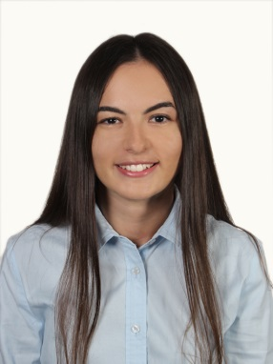

**ILGIN BOZ**

1988 , single

Yeniköy, Istanbul

+90 (530) 065 26 90 d.ilginboz@hotmail.com

**WORK EXPERIENCE**

**Allianz Sigorta , Turkey** **Nov.2016 –**

**Financial Reporting Specialist**

• Preparing monthly financial statements in according with IFRS&US GAAP,

• Preparation of monthly management reports,

• Preparation of monthly&quarterly report to the Undersecretariat of Treasury,

• Preparation of quarterly Market Value Balance Sheet for Allianz Group,

• Providing information to financial auditors during the quarter year & year end field works,,

• Preparing quarterly consolidated financial statements in Turkish Legislation (Allianz Sigorta&Allianz Yaşam ve Emeklilik)

• Analysing Balance Sheet and P&L line item,

• Preparing ad hoc reports to the management

**Doğuş Group D-Marin, Turkey** **Sep.2015 – May.2016**

**Financial Reporting Specialist**

• Preparing monthly financial statements in according with IFRS,

• Preparation of monthly management reports,

• Preparation of monthly forecast management reports,

• Performing review of budget & actual,

• Analysing Balance Sheet and P&L line item,

• Preparing ad hoc reports to the management.

**Towers Watson , Turkey**

**Financial Analyst**                    **May.2013 – Sep.2015**

• Preparing monthly financial statements in according with US GAAP,

• Preparation of monthly management reports,

• Performing review of budget & actual results,

• Providing information to financial auditors during the quarter year & year end field works,

• Analysing Balance Sheet and P&L line item,

• Preparing ad hoc reports to the management,

• Preparing quarterly estimation Cash Flow report,

• Controlling accounting activities for Turkish Legislation.

**Meda Pharma , Turkey**

**Financial Affairs Associate**                   **Feb.2012- Apr.2013**

• Reconciling balance with Local and Intercompany suppliers and Local and Intercompany customers quarterly,

• Prepared journal entries  AP invoices , expenses  , accruals,

• Prepared cheque and related data before bank process,

• Supported to tax declaration preparation and upload system,

• Supported to budget preparation and analysed for operating expense,

• Supported to the finance monthly profitability report.

• Provided for comparing actual to budget.

**Toros Tarım, Turkey,**

**Intern**                 **Jul.2009 – Aug.2009**

• Responsible for journalizing entries AR invoices for major customer

• Responsible for preparing aging report.

**EDUCATION**

**Istanbul University, Turkey,        2007 - 2011**

Business Administration

**Yeni Levent Anatolian High School        2002 - 2006**

Turkish - Mathematics

**TRAINING AND CERTIFICATES**

**Accounting & Tax (Dec.2012**)

PWC

**Budget Reporting and Control (Aug.2012)**

Deloitte

**Balance Sheet and P&L line item for Bank (Jul.2010)**

T.C Central Bank

**COMPUTER SKILLS**

SAP, MS Office Application, Oracle , Hyperion, CPM

**SOCIAL ACTIVITIES**

Tennis