# BLM19417E

# Web Design And Programming

## Midterm Homework Analysis Document

Subject: Sport fixtures And Points

Student Name: Nazif Enes Kızılcin

School Number: 1721221006

Lecturer: Dr. Öğretim Üyesi Ali NİZAM

Date: 8 December 2021, 12:00 pm

### Sport Fixtures And Points Tracking System

#### a-)

##### Models

Fixture: It is the model that stands for a designated competition between 2 teams.

Club: It is the model that refers to the clubs which are the owner of teams.

Team: It is the model that stands for a group of people playing sport fixtures in a club.

Sport: It is the model that refers to sport types ( volleyball, basketbol lor etc. ) and holds its properties.

Fixture Result: It is the model that represents the result of a competition between two team.

Controllers

FixtureController: Create,Edit, List, Delete operations of fixture model handling in this object. It redirects to the related views to perform this operations.

ClubController: Create,Edit, List, Delete operations of club model handling in this object. It redirects to the related views to perform this operations.

TeamController: Create,Edit, List, Delete operations of team model handling in this object. It redirects to the related views to perform this operations.

SportController: Create,Edit, List, Delete operations of sport model handling in this object. It redirects to the related views to perform this operations.

FixtureResultController: Create,Edit, List, Delete operations of sport model handling in this object. It redirects to the related views to perform this operations.

Views

For the views, there will be create view,edit view, delete view, detail view for all models. But here, just writed in one main heading.

Create View: The view that takes the required fields for the chosen model (Sport, Team, Club or Fixture), to create new record of chosen model and add to database.

Edit View: The view that provides to edit chosen record and then triggers update of this record by button

Delete View: The view that provides deleting a record for any kind of model(Sport,Team,Club,Fixture)

Fixture Detail View: Show every detail of the chosen fixture (date,home,

Club Detail View: Show all the teams in club and the club purpose, description or etc. Details.

FixturesView: Show all the fixtures without team scores by weekly and capsuled by day.

FixturesPointView: Shows teams points on the table.

FixturesResultView: Shows the fixtures results

Index View: Which represents for welcome page, which also handles query

#### b-)

-User able to add new sports to the system with required fields.

-User able to edit sports, teams, clubs.

-User able to delete sports, teams, clubs.

-If user deletes a sport type, then the related teams,fixtures and fixture results also deleted.

-If user deletes a team, the related fixtures and fixture_results will be deleted too.

-Teams of different sport can not match.

-If user deletes a club, then related teams, fixtures, fixture results will be deleted too

#### c-)

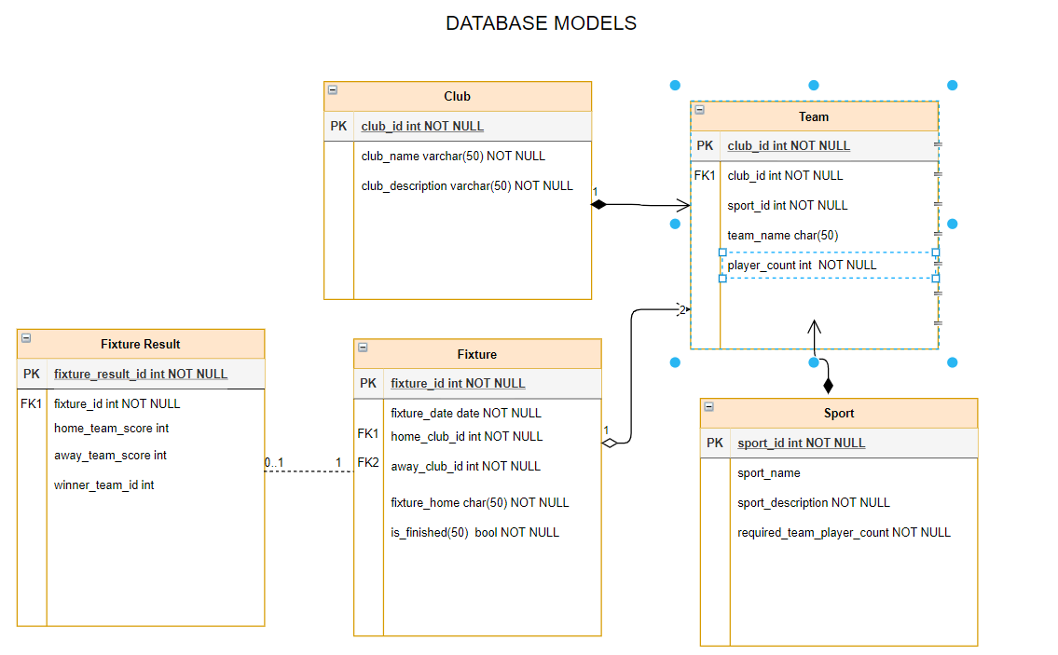

Scaffold-DbContext "Server=(localdb)\mssqllocaldb;Database=SportFixturePoing;Trusted_Connection=True;" Microsoft.EntityFrameworkCore.SqlServer -OutputDir Models