
University of Tirana
Faculty of Natural Science
Department of Informatics

Master of Science Data Science and Artificial Intelligence

PROJECT

Subject: Process mining

Topic: Developer work process

Worked in this project: Supervised by:
Enes Mezani, Shpetim Alimi Endri Xhina

Academic Year: 2024 - 2025

Introduction
This document presents an analysis of the software development process using Process Mining techniques. The project focuses on modeling a BPMN diagram and a decision tree to visualize and analyze the software development workflow.
The main objectives are:
- Understand the development process using event logs.
- Generate process models using BPMN and Petri nets.
- Compare different process mining techniques including Heuristic Miner and Alpha Miner.

Phase 1

How BPMN is Used in Business Processes

In our case, BPMN is used to model the software development workflow for handling and reviewing a development ticket. The BPMN diagram visually represents the sequential steps that a developer, team lead, and QA team member follow from receiving a ticket assignment to merging the final code.







Tests fail
Gets assigned a ticket
Does he need more clarification?
No
Ticket review
Starts working on the task
Runs automated test
Tests pass
Creates a pull request and assigns it to QA
Fixies the requested changes
Notifies the tester
Start
Yes
Sets up a meeting
It is not okay
Holds meeting
Code review
It is okay
Writes comments and changes the status on the PR
Merges the pull request
Finish
It is okay
Approves the pull request
Test the pull request
It is not okay
Request changes in the pull request and writes what is wrong

1. Ticket Assignment and Review:
The process starts when a developer receives a ticket. They review the ticket to understand the requirements. If they need further clarification, a gateway directs them to schedule a meeting with the team lead.

2. Task Execution and Testing:
After the developer fully understands the task, they begin working on it. Once completed, they run automated tests. A gateway is used to check if the tests pass. If the tests fail, they loop back to fix the issues and rerun the tests until successful.

3. Pull Request Creation and QA Assignment:
Once the tests pass, the developer creates a pull request and assigns it to the QA team for testing.

4. Quality Assurance (QA) Testing:
The QA team tests the pull request.
A gateway here determines whether the code meets QA standards:
If the QA finds issues, they request changes, sending the process back to the developer for revisions.
If QA approves, the process moves forward to code review.

5. Code Review and Approval:
The team lead performs a code review.
A gateway checks if the code meets quality standards:
If it does not, the team lead requests further changes, and the developer revises the code accordingly.
If the code is approved, the team lead merges the pull request, marking the end of the process.

How Decision Trees Are Utilized in Our Decision-Making Process

In our workflow, the decision tree represents the path a developer takes from being assigned a task to final approval. Each node corresponds to a decision point in the development cycle, such as:

Whether the developer can start working or needs clarification.

The outcome of automated tests and QA checks.

The final decision on code review by the team lead.

By following the branches in this tree, we can clearly see the sequential steps based on each decision, along with any potential loops for rework (e.g., "Rewrite the code" after a failed test or review). The decision tree provides a clear roadmap, making it easier to navigate complex workflows and address issues that may arise at each decision point.

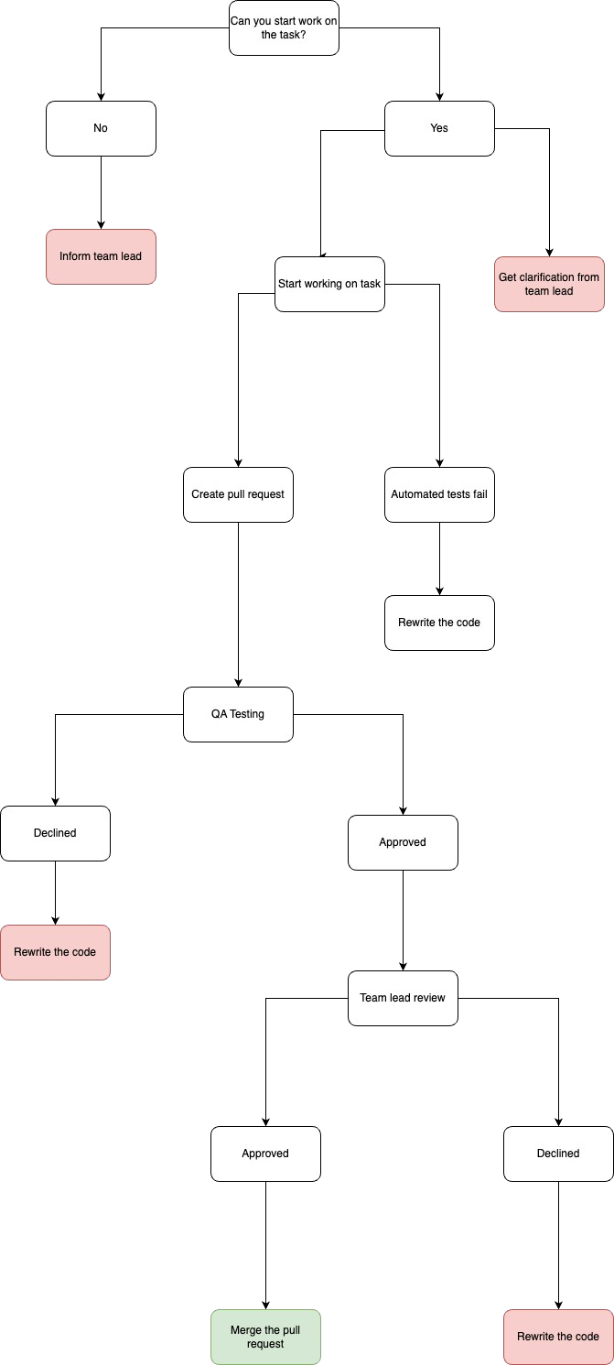

Phase 2

Generating a CSV file

The dataset used for this project is stored in a CSV file It contains the following key attributes:
- Case_ID: Identifies unique cases in the process.
- Activity: Represents different tasks in the process.
- Resource: Represent the person
- Timestamp: Records the exact time of each event.
- Status: Represent the status the end of the specific task
The data is processed and cleaned to ensure accuracy before applying process mining techniques.
Case 1:
- Ticket Review (Developer) → Assesses the task.
- Clarification Meeting (Team Lead) → Needed additional clarification.
- Start Working on Task (Developer) → Began implementation.
- Runs Automated Tests (Developer) → Passed successfully.
- Creates Pull Request (Developer) → Sent code for review.
- QA Testing (QA) → Approved.
- Code Review (Team Lead) → Approved.
- Merge Pull Request (Team Lead) → Successfully merged.

Case 2:
- Ticket Review (Developer) → Assesses the task.
- Start Working on Task (Developer) → Began implementation.
- Runs Automated Tests (Developer) → Failed.
- Fix Issues (Developer) → Fixed test failures.
- Runs Automated Tests (Developer) → Passed.
- Creates Pull Request (Developer) → Sent for review.
- QA Testing (QA) → Issues Found.
- Fix Issues (Developer) → Addressed QA concerns.
- QA Testing (QA) → Approved after re-evaluation.
- Code Review (Team Lead) → Approved.
- Merge Pull Request (Team Lead) → Successfully merged.

Case 3:
- Ticket Review (Developer) → Assesses the task.
- Start Working on Task (Developer) → Began implementation.
- Runs Automated Tests (Developer) → Passed successfully.
- Creates Pull Request (Developer) → Submitted for review.
- QA Testing (QA) → Issues Found.
- Fix Issues (Developer) → Addressed QA concerns.
- QA Testing (QA) → Issues Found Again.
- Fix Issues (Developer) → Fixed QA issues again.
- QA Testing (QA) → Approved after multiple fixes.
- Code Review (Team Lead) → Approved.
- Merge Pull Request (Team Lead) → Successfully merged.

Case 4:
- Ticket Review (Developer) → Assesses the task.
- Start Working on Task (Developer) → Implementation started.
- Runs Automated Tests (Developer) → Passed successfully.
- Creates Pull Request (Developer) → Submitted for review.
- QA Testing (QA) → Approved.
- Code Review (Team Lead) → Issues Found.
- Fix Issues (Developer) → Addressed code review comments.
- Creates Pull Request (Developer) → Submitted again.
- QA Testing (QA) → Approved after resubmission.
- Code Review (Team Lead) → Approved after fixes.
- Merge Pull Request (Team Lead) → Successfully merged.

Phase 3

Process Mining Implementation

Process Mining with Heuristic Miner
Heuristic Miner is an advanced process discovery algorithm that is useful when working with real-life event logs that contain noise, incomplete data, and infrequent behaviors. The Heuristic Miner:
- Identifies frequent patterns in the event log.
- Filters out less significant activities to reduce complexity.
- Creates a process model based on observed behavior.
Data Preprocessing
- The dataset is read from the CSV file.
- The "Timestamp" column is cleaned and converted into a proper datetime format.
- The event log is sorted chronologically to ensure correct process sequencing.
Applying Heuristic Miner
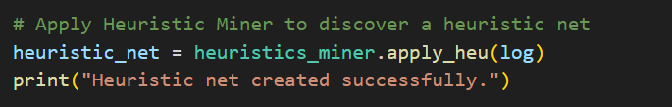

- This command applies the Heuristic Miner algorithm to the structured event log.
- It analyzes event sequences, calculates dependency frequencies, and constructs a heuristic process net.

Visualizing the Results
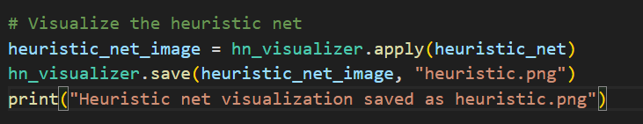

- Generates a graphical representation of the heuristic model.
- The output heuristic.png visualizes the process flow, highlighting frequent transitions.

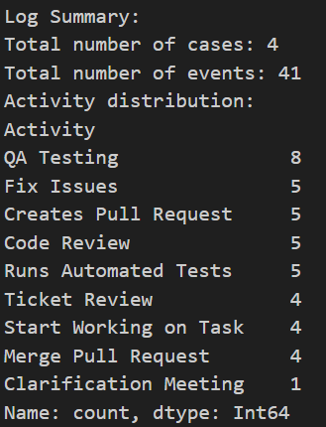

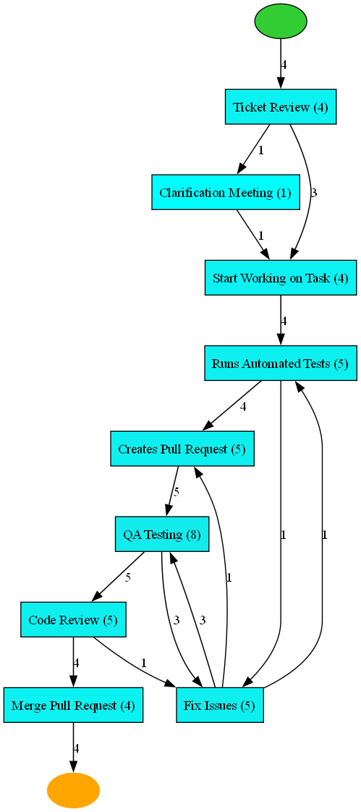

Process Mining with Alpha Miner

Alpha Miner is a formal process discovery algorithm that constructs a Petri Net from event logs. Unlike Heuristic Miner, it:
- Assumes an ideal structure for the process.
- Strictly follows a causality-based model.
- Does not handle noise well, making it better suited for structured workflows.
Data Preprocessing
- The dataset is read from the CSV file.
- The "Timestamp" column is cleaned and converted into a proper datetime format.
- The event log is sorted chronologically to ensure correct process sequencing.

Applying Alpha Miner
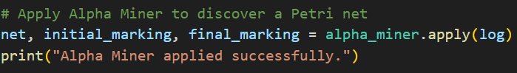

- This command applies the Alpha Miner algorithm to the structured event log.

Visualizing the Results
