1. Original data is as given below: There are 2 classes.

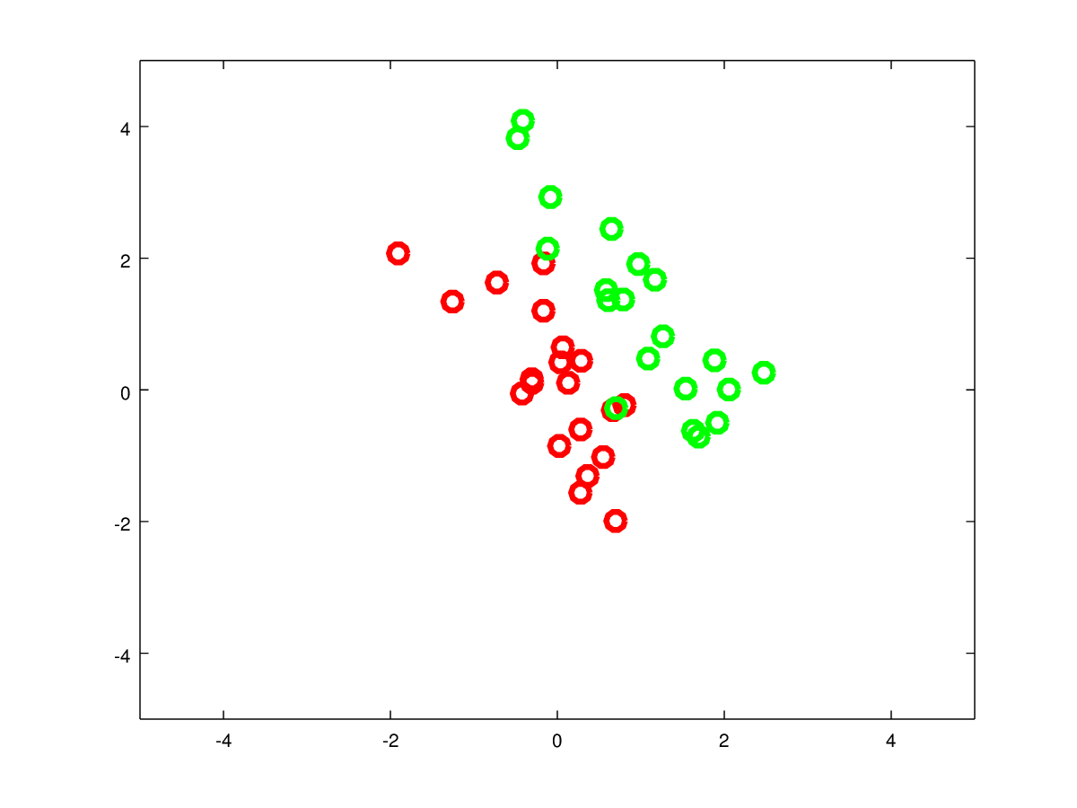

PCA: Projection of data to first principle component of PCA

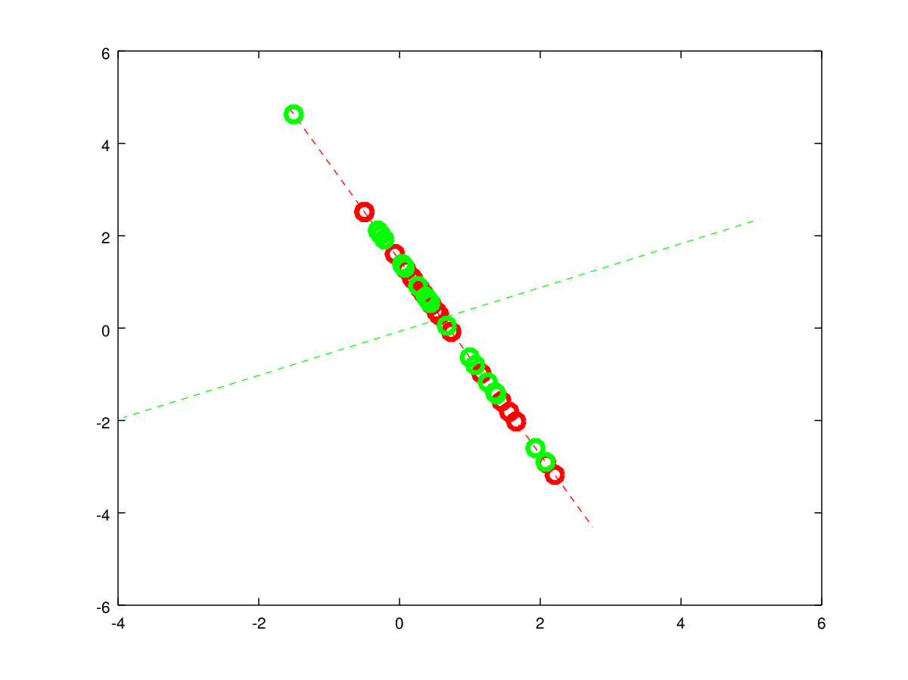

2-) LDA: Projection of data to first principle component of LDA

We can see that data is more separable in LDA compared to PCA.

