MERGEN

System Design Description
System-level architecture and engineering baseline

Document ID | MERGEN-SYS-DES-001
Revision | 2.0
Status | Current System Baseline
Language | English

This revision supersedes the previous Mergen design/implementation documents. Obsolete concepts and superseded scope have been removed.

Document Control and Revision History
Revision | Date | Status | Summary of Changes
1.0 | 2026-09 | Superseded | Initial Software Design Description.
2.0 | 2026-09-12 | Current | Renamed to System Design Description. Removed obsolete scope and prior alternatives. Consolidated the latest Python/Kubernetes, remote-first, deterministic-control-plane architecture. Detailed software design and detailed requirements are intentionally deferred to separate documents.

1. Purpose
This document defines the current system-level architecture of Mergen. It describes system boundaries, major subsystems, execution and security models, external integrations, data flows, and the intended evolution path. It is the authoritative architectural baseline for system composition, not a detailed software design specification.

2. Scope
Mergen is a self-hosted, remote-first personal AI engineering orchestration platform. It converts project work items into policy-controlled, isolated coding-agent executions, validates the resulting work deterministically, and returns the result to human review. The system is designed to support multiple software projects, multiple model providers, and progressively stronger automation without making the agent itself a security or authorization boundary.
Document boundary: Detailed functional/non-functional requirements will be defined in a separate System Requirements Specification (SRS). Detailed classes, modules, package boundaries, schemas, and code-level interfaces will be defined in a future Software Design Description (SWDD). This document intentionally remains at system level.

3. Governing Design Principles
- Human ownership remains final: Git review and explicit approval are the authoritative acceptance boundary.
- The agent may propose and execute work only within permissions granted by deterministic Mergen services.
- One task is executed in one disposable environment. Execution state must survive the destruction of that environment.
- Project-specific behavior is configuration-driven through a project contract rather than hard-coded framework knowledge.
- Control plane and execution plane are separated. The agent never receives Docker socket access, Kubernetes control credentials, Plane credentials, host SSH, or host filesystem access.
- Every privileged operation is auditable. Important execution events are persisted as structured records.
- External providers are replaceable through adapters/gateways to minimize vendor lock-in.
- Remote access is a first-class property, but administrative reachability is restricted to the private management network (for example WireGuard).

4. System Context
The system is positioned between project planning, model providers, source control, and an isolated execution substrate. Plane remains the work-item/planning engine. Mergen is responsible for orchestration, authorization, policy enforcement, execution, validation, and execution history.
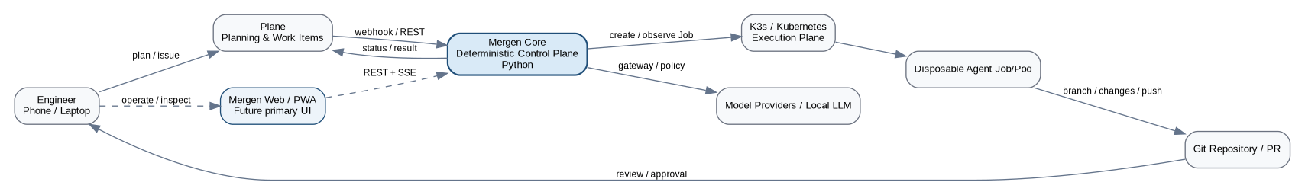

5. Logical Architecture
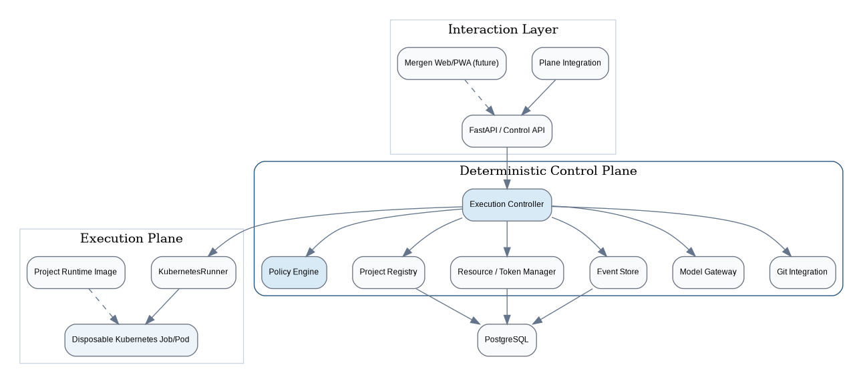
Subsystem | Responsibility | Initial Technology Direction
Mergen Control API | Authenticated system API for task submission, status, intervention, and integration. | Python / FastAPI / Pydantic
Execution Controller | Owns the execution state machine and coordinates validation, scheduling, runtime creation, result handling, and cleanup. | Python application service
Policy Engine | Deterministically approves or rejects privileged actions and enforces global/project constraints. | Python domain/service layer
Project Registry | Tracks repositories, project contracts, default profiles, provider/budget preferences, and project health. | PostgreSQL-backed
Event Store | Persists append-only semantic execution events independent of disposable runtime lifetime. | PostgreSQL initially
Resource / Token Manager | Represents execution resources and provider quotas using reservation/accounting semantics. | Deferred beyond Alpha; Python service
Model Gateway | Normalizes access to cloud/local providers and isolates provider credentials from agents. | Provider adapters; later routing logic
KubernetesRunner | Creates, observes, and terminates disposable task Jobs/Pods. | Kubernetes Python client / K3s
Git Integration | Branch lifecycle, push/review integration, commit/result metadata. | Git CLI/library plus provider adapter
Plane Integration | Maps Plane work items and workflow states to Mergen executions and results. | Webhooks/REST
Mergen Web/PWA | Future primary operational UI for remote inspection and human-in-the-loop controls. | TypeScript/React direction; deferred from Alpha

6. User Interaction Model
The latest design separates project planning from Mergen operations. Plane is retained as the planning/work-item engine. Mergen will eventually provide its own responsive web/PWA interface as the primary operational console. A Plane fork is not required by the target architecture.
Interface | Role | Current/Target
Plane | Project planning, issues/work items, workflow states, comments, lightweight remote task initiation. | Used in Alpha and retained long term.
Mergen API | Programmatic operational interface; also usable during Alpha through generated API documentation and logs. | Used in Alpha.
Mergen Web/PWA | Execution timeline, resource views, approvals, pause/stop/instructions, checkpoints, policies, administration. | Target post-Alpha interface.
Desktop Admin Console | No longer a baseline requirement. A native desktop client may be added only if a future desktop-specific use case justifies a second UI codebase. | Optional future concept only.

7. Execution Model
The standard unit of work is a disposable Kubernetes Job. A Job receives a scoped project/task context, performs agent work inside a constrained Pod, runs deterministic validation, publishes results, and is then removed or expired by policy. Persistent execution history is held by Mergen, not by the Pod.

8. Execution State Model
The control plane, rather than the agent, owns execution state. State transitions must be explicit, validated, and persisted. A representative system-level state model is shown below; the future SWDD will define exact transition guards and data structures.
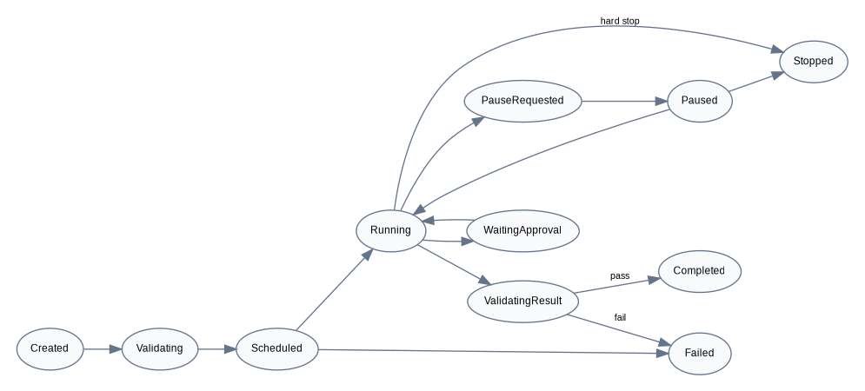

9. Project Contract and Portability
Mergen should not embed framework-specific build knowledge in the orchestrator. Each repository may define a versioned project contract under `.mergen/`. The contract declares environment, setup, validation, build behavior, resource constraints, Git conventions, and project rules.
repo/
.mergen/
project.yaml
rules.md
Dockerfile # optional / profile-dependent
src/...
project: example-project
runtime:
image: mergen/cpp-cmake:1
setup:
- cmake -S . -B build
validation:
- cmake --build build
- ctest --test-dir build --output-on-failure
resources:
cpu: 2
memory: 4Gi
timeout: 30m
git:
base_branch: main
branch_prefix: agent/
Configuration precedence for onboarding should prefer an explicit `.mergen/project.yaml`, then reusable Mergen profiles, then import/analysis of existing development-environment metadata such as `devcontainer.json`, Dockerfiles, and CI workflows. Automatic inference must produce a proposal requiring user approval before becoming authoritative project configuration.

10. Semantic Execution History and Human Intervention
Mergen records important agent and controller activity as structured semantic events rather than exposing only raw terminal output. The intent is to make a long-running execution understandable and interruptible from any authorized client.
Event Category | Examples
Lifecycle | TASK_ACCEPTED, SCHEDULED, STARTED, COMPLETED, FAILED, STOPPED
Planning/Reasoning Summary | PLAN_CREATED, DECISION_SUMMARY, NEXT_STEP (structured summary only)
Action | TOOL_REQUESTED, COMMAND_STARTED, FILE_CHANGED, GIT_OPERATION
Result | COMMAND_FINISHED, BUILD_RESULT, TEST_RESULT, VALIDATION_RESULT
Control | PAUSE_REQUESTED, PAUSED, RESUMED, HUMAN_INSTRUCTION
Approval | APPROVAL_REQUESTED, APPROVAL_GRANTED, APPROVAL_REJECTED
Checkpoint | CHECKPOINT_CREATED, RESTORE_REQUESTED, EXECUTION_FORKED
Resource | BUDGET_RESERVED, USAGE_UPDATED, BUDGET_RELEASED
Reasoning visibility: Mergen should store concise structured plan/decision/rationale summaries produced for auditability. It should not depend on, expose, or attempt to preserve a model provider's private chain-of-thought.
For live UI delivery, Server-Sent Events (SSE) are the initial preferred server-to-client mechanism, while REST is used for control operations such as pause, resume, instruction, approval, rejection, and stop. More complex messaging infrastructure can be introduced only when required by scale.

11. Security and Trust Boundaries
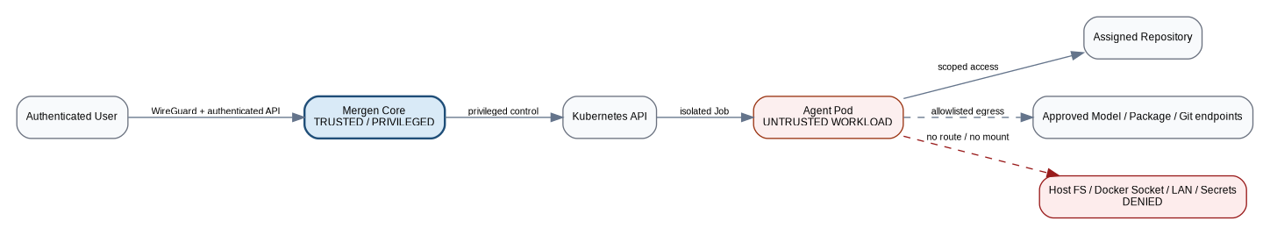
- Agent Pods are untrusted workloads. They receive only the minimum repository, model gateway, package registry, and task permissions required for the assigned execution.
- Only Mergen Core is authorized to create/observe Kubernetes Jobs. Agent Pods do not receive Kubernetes API credentials.
- No Docker socket, privileged containers, hostPID, hostIPC, hostNetwork, or hostPath mounts are allowed for normal agent execution.
- Runtime processes should execute as non-root with dropped capabilities, resource limits, timeouts, and hardened security context.
- Network policy follows default-deny as the target posture. Allowed egress is explicitly scoped to required Git/model/package/DNS endpoints.
- Plane/API/provider credentials are held by trusted adapters or secret-management mechanisms and are not injected wholesale into agent environments.
- Protected branches are never directly pushed by agents. Force-push and direct main/master updates are prohibited.
- Validation outcome is authoritative: an agent cannot declare a task successful when required deterministic validation fails.

12. Model and Resource Management
The long-term scheduler treats model/provider quota as a first-class resource alongside CPU, memory, disk, and execution time. Before dispatch, a task may reserve estimated provider capacity. Actual consumption is reconciled after execution and unused reservation is released. Exact provider accounting is used where official APIs expose it; otherwise usage is represented as measured/estimated rather than falsely precise.
available quota -> estimate -> reserve -> dispatch
|
+-> reconcile actual usage -> release unused reservation
Advanced routing between local and cloud models is intentionally not part of the Alpha release. The architecture must nevertheless keep provider access behind a stable gateway/adapter boundary so routing can be added without rewriting execution logic.

13. Persistence and Data Ownership
Data | System of Record | Notes
Projects / execution metadata | Mergen PostgreSQL | Persistent across disposable Pods.
Semantic execution events | Mergen PostgreSQL | Append-oriented event history; raw log references may be attached.
Work items / planning | Plane | Mergen stores mapping IDs and execution linkage.
Source code / branches / review | Git provider/repository | Git remains the human acceptance boundary.
Large artifacts | Future object store | Deferred from Alpha; only metadata/reference contract should be preserved.
Runtime workspace | Ephemeral Pod volume/workspace | Destroyed/expired after execution; must not be the only copy of important state.

14. Deployment Topology
The target homelab deployment is a private, headless Linux server reachable over WireGuard. Mergen Core and supporting services run in a trusted services domain. K3s provides the isolated execution plane. Public exposure is not required. The exact packaging of Mergen Core itself may evolve from containerized service to Kubernetes deployment, but the trust boundary between Core and agent workloads must remain explicit.
Remote client
|
WireGuard management network
|
Mergen Core + PostgreSQL + Plane
|
K3s API
|
Disposable agent Jobs/Pods
|
Scoped Git / model / package access

15. Failure and Recovery Model
- Controller restart: running/scheduled executions are reconstructed from persisted state plus Kubernetes Job status.
- Pod failure or timeout: execution transitions to failed/stopped with durable diagnostic events; environment is cleaned according to retention policy.
- Validation failure: branch/workspace may be preserved long enough to inspect or continue, but Plane must not be advanced to successful review state automatically.
- Provider failure/quota exhaustion: dispatch is rejected or execution fails with explicit resource/provider status; no silent provider substitution for critical work unless routing policy permits it.
- Plane outage: Mergen execution state remains authoritative; synchronization resumes when Plane becomes available.
- Git failure: task cannot complete successfully until branch/result publication is confirmed.

16. Current Alpha System Boundary
The current near-term implementation target deliberately excludes the custom Mergen Web/PWA. Alpha uses Plane for task creation/workflow and Mergen API/logs for operational visibility. The Alpha exists to prove the end-to-end deterministic orchestration path before UI and advanced resource-management work.
Included in Alpha | Deferred beyond Alpha
Docker runtime/image fundamentals | Custom Mergen Web/PWA; TypeScript/React
K3s/Kubernetes Job execution | Live semantic timeline UI and graphical intervention controls
Python Core: FastAPI, Pydantic, state machine | Checkpoint/rewind UI and execution-tree UX
KubernetesRunner | Token-aware scheduler and advanced model router
Git branch/build/test/push lifecycle | Multi-agent planning/coding/review roles
Plane trigger/status/result integration | Prometheus/Grafana/Loki/OpenTelemetry stack
Minimum security controls | Advanced network-policy profiles and artifact store

17. Current Architecture Decisions
Decision | Current Baseline
Control-plane language | Python
API / validation | FastAPI + Pydantic direction
Execution substrate | K3s/Kubernetes Jobs; Docker is the image/runtime prerequisite
Planning/work-item engine | Plane
Primary future Mergen UI | Independent responsive Web/PWA; no mandatory Plane fork
Execution history | Durable semantic event store
Live server-to-client stream | SSE initially
Control operations | REST initially
Human acceptance boundary | Git review/approval
Agent privilege model | Untrusted; no infrastructure-control credentials
Architecture style | Modular monolith first; adapters around external systems
Native desktop UI | Not part of baseline; optional future only

18. Future Specifications
The following documents should be authored after the system baseline stabilizes:
- System Requirements Specification (SRS): uniquely identified functional, security, interface, performance, reliability, and operational requirements with acceptance criteria.
- Software Design Description (SWDD): Python package/module architecture, domain model, exact state machine, database schema, API schemas, adapters, concurrency model, exception/error strategy, and detailed test design.
- API and Event Contract Specification: versioned REST/SSE payloads, event schemas, compatibility rules, idempotency, and authentication/authorization behavior.
- Security Design and Threat Model: assets, trust boundaries, attack surfaces, threat scenarios, mitigations, secret lifecycle, network policy, and security verification plan.

Appendix A - PlantUML Sources
The diagrams above are system-level renderings. The following PlantUML sources are retained as editable architecture definitions for future documentation tooling.

A.1 System Context
@startuml
left to right direction
actor Engineer
rectangle Plane
rectangle "Mergen Web / PWA\n(future primary UI)" as Web
rectangle "Mergen Core\nDeterministic Control Plane" as Core
rectangle "K3s / Kubernetes" as K8s
rectangle "Disposable Agent Job/Pod" as Agent
rectangle "Git Repository / PR" as Git
cloud "Model Providers / Local LLM" as Models
Engineer --> Plane : plan / work item
Engineer --> Web : inspect / operate
Plane --> Core : webhook / REST
Web --> Core : REST + SSE
Core --> K8s : create / observe Job
K8s --> Agent
Agent --> Git : branch / push
Core --> Models : model gateway
Git --> Engineer : review / approval
Core --> Plane : status / result
@enduml

A.2 Execution Sequence
@startuml
actor User
participant Plane
participant "Mergen Core" as Core
participant "Kubernetes API" as K8s
participant "Agent Pod" as Agent
participant Git
User -> Plane : Ready for Agent
Plane -> Core : work-item event
Core -> Core : validate policy + project
Core -> K8s : create Job
K8s -> Agent : start Pod
Agent -> Git : clone + create branch
Agent -> Agent : modify code
Agent -> Agent : build/test
Agent -> Git : push branch
Core -> Plane : In Review + result
Core -> K8s : cleanup / TTL
@enduml

A.3 Trust Boundary
@startuml
rectangle "Trusted Management Domain" {
rectangle "Mergen Core" as Core
database PostgreSQL
}
rectangle "Kubernetes Execution Domain" {
rectangle "Untrusted Agent Pod" as Agent
}
cloud Git
cloud "Approved Model/Package Endpoints" as External
rectangle "Host FS / Docker Socket / LAN / Infra Secrets" as Denied
Core --> Agent : scoped task + runtime
Agent --> Git : assigned repo only
Agent --> External : allowlisted egress
Agent -[#red,dashed]-> Denied : DENIED
Agent -[#red,dashed]-> Core : no admin credentials
@enduml

A.4 Execution State
@startuml
[*] --> Created
Created --> Validating
Validating --> Scheduled
Scheduled --> Running
Running --> PauseRequested
PauseRequested --> Paused
Paused --> Running : resume
Running --> WaitingApproval
WaitingApproval --> Running : approve / reject handled
Running --> ValidatingResult
ValidatingResult --> Completed : validation passes
ValidatingResult --> Failed : validation fails
Running --> Stopped : hard stop
Paused --> Stopped
Completed --> [*]
Failed --> [*]
Stopped --> [*]
@enduml

