Turkey Treasury / ALM & Liquidity Risk Dashboard
A Public-Data Market and Banking-Sector Monitoring Case with Garanti BBVA ALM Proxy Extension
Treasury / ALM & Liquidity Risk Portfolio Case
Enes Sarı
Data through: 15 May 2026 | Final revision date: 18 May 2026
Metric | Latest reading | Interpretation
Policy rate | 37.0% | Monetary policy anchor
TLREF | 40.0% | Overnight TL funding proxy
TLREF-policy spread | 3.0 pp | Short-term funding pressure signal
USD/TRY | 45.50 | FX pressure monitor
Gram gold | TRY 6,651 | FX/gold liquidity watch
CPI YoY | 32.4% | Inflation context
Real policy rate proxy | 4.6 pp | Policy rate less CPI YoY
10Y-2Y slope | -6.7 pp | Curve shape / rate-risk signal
Loan/deposit ratio | 88.1% | Sector funding balance
FX deposit share | 40.5% | Dollarization / deposit mix
Total reserves | USD 171,529mn | FX-gold buffer proxy
Liquidity stress score | 57.0 / 100 (Elevated) | Composite dashboard signal
Table 1. Executive treasury dashboard snapshot.
Scope note: This memo is a portfolio case study. It uses public market, banking sector, and Garanti BBVA financial statement data to construct treasury-oriented monitoring indicators and proxy ALM metrics.

1. Executive Summary
This case study builds a Turkey-focused treasury and ALM monitoring dashboard using publicly available market, macro-financial, banking-sector, and selected bank financial statement data. The dashboard tracks TL funding conditions, FX and gold liquidity pressures, inflation-adjusted rates, yield curve movements, deposit and loan dynamics, reserves, and a composite liquidity stress score.
The core finding is that the latest dashboard reading points to an elevated but not extreme treasury stress environment: TLREF remains above the policy rate, the yield curve is inverted, FX and gold prices remain structurally higher than the 2021 base, and the banking sector loan/deposit ratio is below 100%, but funding conditions remain rate-sensitive.
The Garanti BBVA extension is not presented as an internal ALM model. Instead, it uses unconsolidated financial statement line items to construct public-data-based proxies for asset/funding mix, liquidity buffer, foreign-currency (FC) balance-sheet gap, funding-cost sensitivity, and repricing-gap sensitivity.
The practical objective is to show how a treasury, ALM, or liquidity risk team could translate observable market and sector conditions into a concise management dashboard and risk memo.

2. Data and Methodology
The main dashboard is built at weekly frequency. Daily market variables are mapped to weekly observations, monthly inflation is forward-filled, and bank/sector variables are aligned to the same weekly frame where available. This allows market, macro, and balance-sheet indicators to be viewed together without claiming daily precision for slower-moving banking data.
Data block | Primary variables | Use in memo
Market funding | Policy rate, TLREF, deposit rate proxy, loan rate proxy | TL funding and margin-pressure monitoring
FX and gold | USD/TRY, EUR/TRY, gram gold, rolling volatility | FX-gold liquidity watch
Inflation and curve | CPI YoY, 2Y/5Y/10Y yields, 10Y-2Y spread | Real-rate and interest-rate risk context
Banking sector | Loans, deposits, FX deposits, KKM, securities, FX position, reserves | Liquidity, dollarization, collateral, and reserve-buffer indicators
Bank-specific extension | Garanti BBVA unconsolidated financial statements, 1Q25-1Q26 | Public-data-calibrated ALM proxy analysis

3. TL Funding Conditions
The first treasury question is whether short-term market funding is aligned with the policy anchor. TLREF above the policy rate signals tighter overnight funding conditions and can pressure banks and corporates that rely on short-dated TL liquidity.
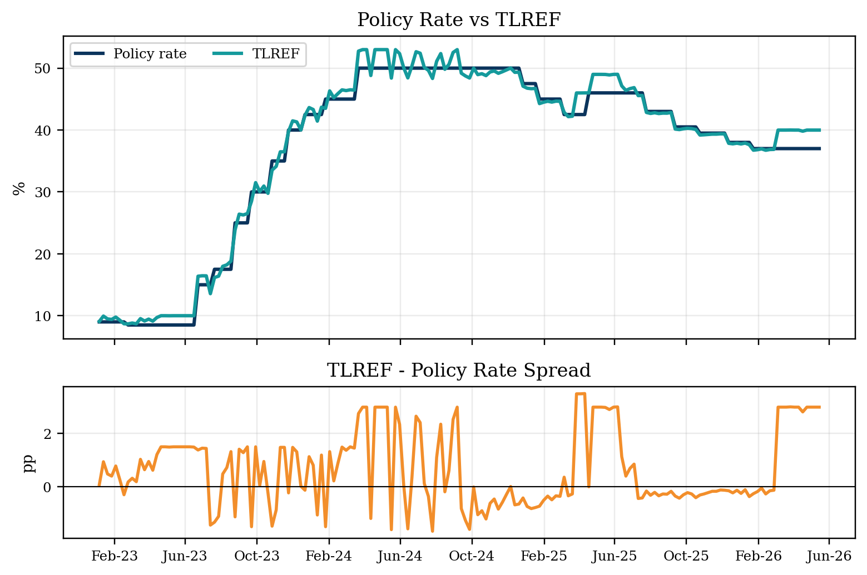
Figure 1. TL funding conditions: policy rate, TLREF, and spread.
As of 15 May 2026, TLREF stood at 39.99%, compared with a policy rate of 37.00%, implying a 2.99 percentage-point spread. For treasury monitoring, this spread is more informative than the policy rate alone because it captures the actual short-term funding environment.

4. FX and Gold Liquidity Watch
FX and gold indicators matter for Turkish treasury teams because they affect collateral values, customer dollarization behavior, foreign-currency (FC) liquidity planning, precious-metal liquidity, and hedge requirements. The indexed chart is designed to show direction and relative pressure rather than forecast exchange rates.
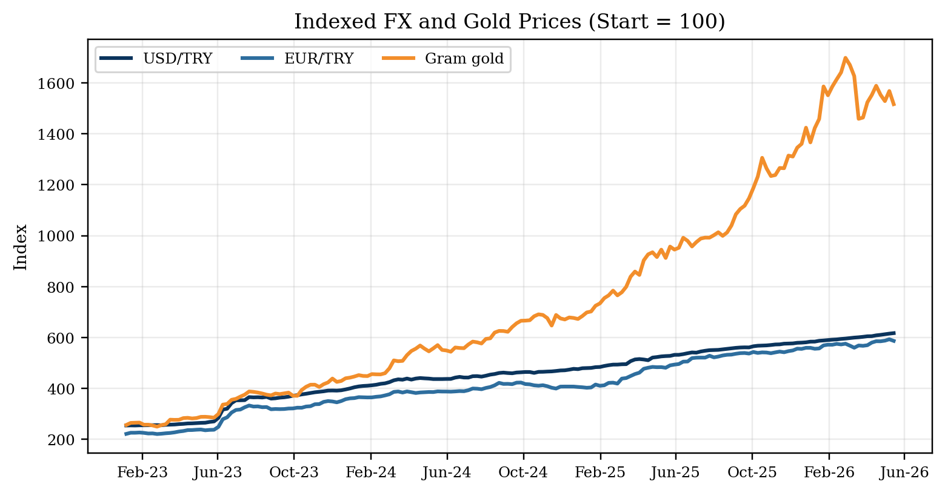
Figure 2. FX and gold liquidity watch: indexed USD/TRY, EUR/TRY, and gram gold.

5. Inflation, Real Rates, and Yield Curve
Nominal funding costs should be interpreted in light of inflation. A positive real policy-rate proxy supports the attractiveness of TL assets and deposit liberalization, while a negative or declining proxy can weaken the TL funding base.
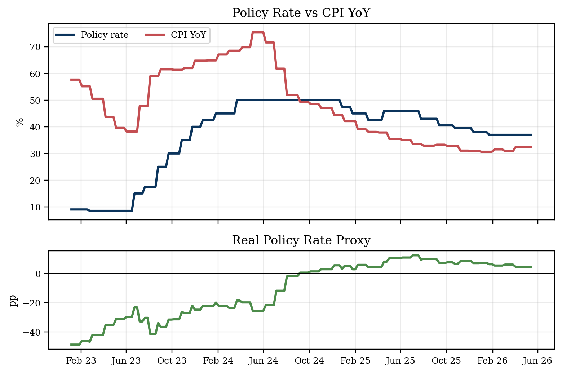
Figure 3. Inflation and real rate conditions.
The yield-curve panel adds the market-rate dimension to the policy-rate story. Inverted curves and high short-end yields are relevant for securities valuation, duration management, reinvestment decisions, and the funding cost of longer-tenor liabilities.
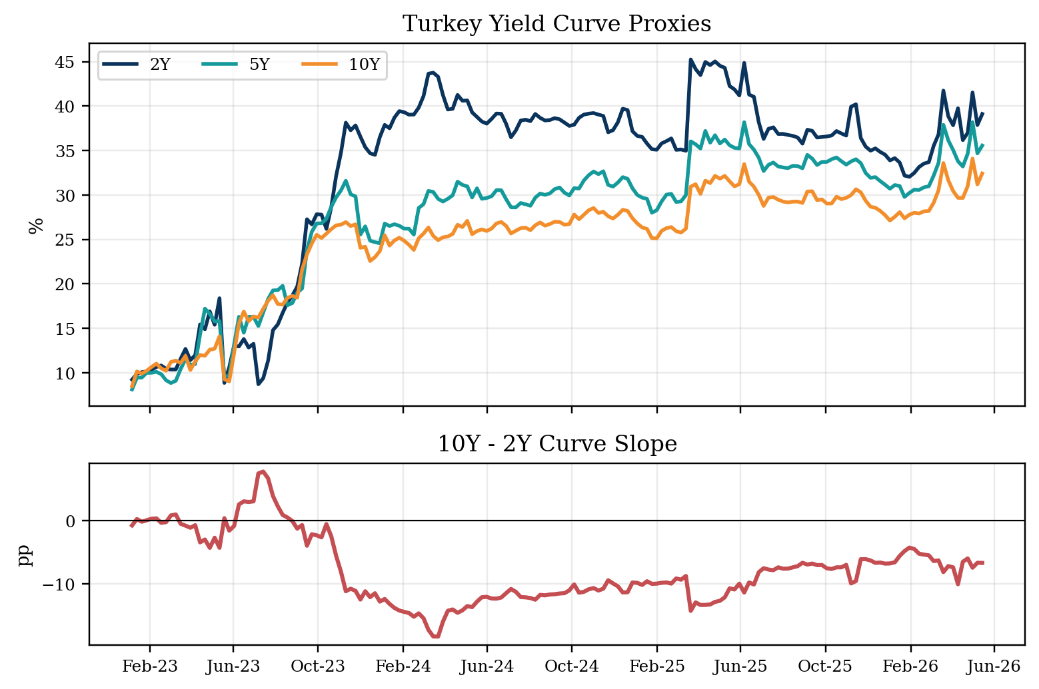
Figure 4. Yield curve and interest-rate risk: 2Y/5Y/10Y yields and 10Y-2Y slope.

6. Banking-Sector Liquidity Conditions
The banking-sector block connects market rates to balance-sheet behavior. The loan/deposit ratio is a simple but useful proxy for funding balance: a rising ratio may indicate stronger credit extension relative to deposit funding, while a lower ratio suggests greater deposit-funded balance-sheet capacity.
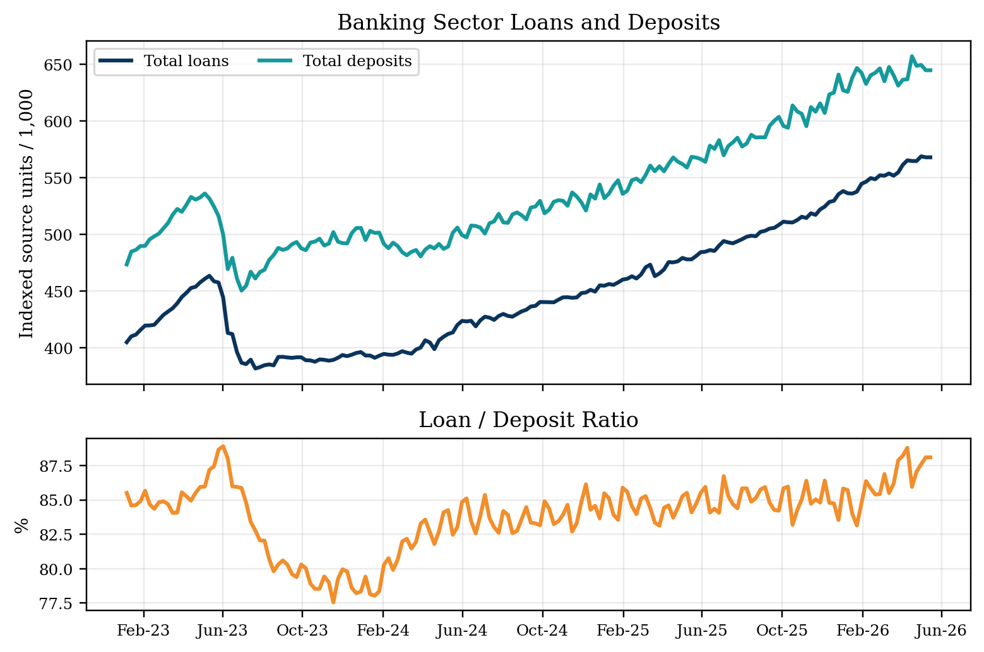
Figure 5. Banking-sector liquidity: loans, deposits, and loan/deposit ratio.
Deposit composition is equally important. FX deposit share captures dollarization and FC funding behavior, while KKM share tracks the legacy stock of FX-protected TL deposits and the transition toward standard TL deposits.
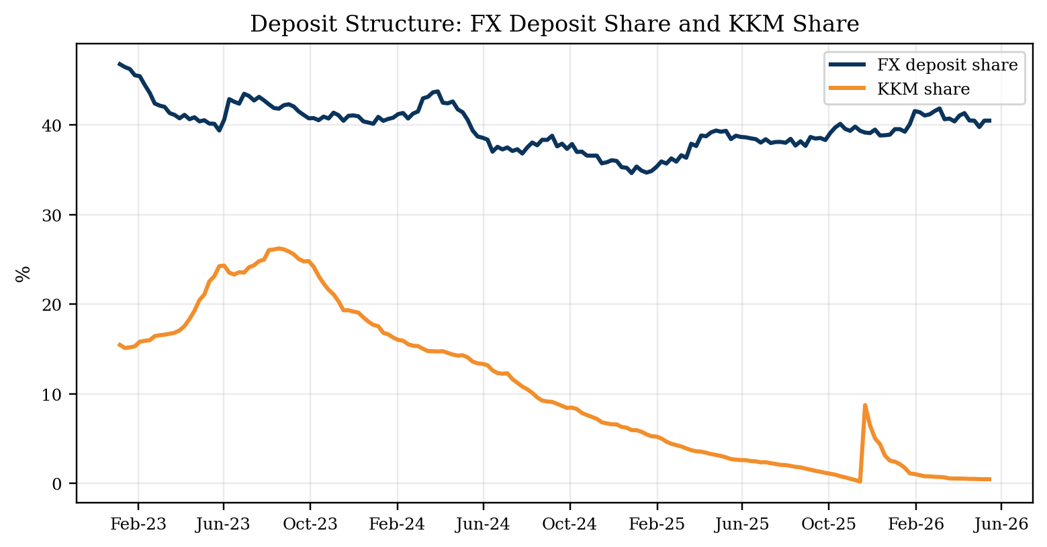
Figure 6. Deposit structure: FX deposit share and KKM share.

7. Composite Treasury Liquidity Stress Score
To turn the dashboard into a management signal, the project builds a composite liquidity stress score. The score combines funding pressure, FX/gold volatility, curve inversion pressure, banking liquidity dynamics, FX deposit behavior, and reserve-buffer changes. The score is normalized to a 0-100 scale and labelled as Low, Moderate, Elevated, or High.
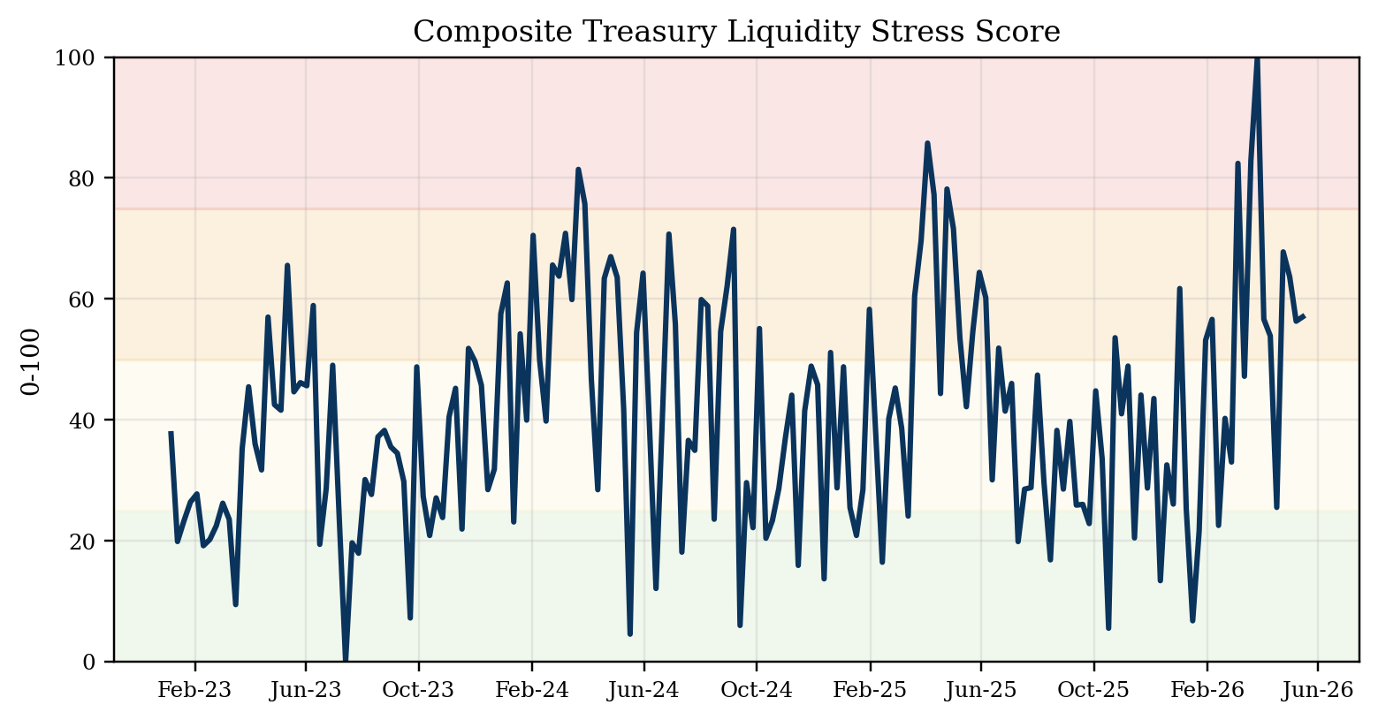
Figure 7. Composite treasury liquidity stress score.
Component | Latest raw input | Standardized contribution | Stress direction
TLREF-policy spread | 2.99 pp | 2.16 | Higher spread increases funding stress
USD/TRY 12-week volatility | 0.82% | -0.54 | Higher volatility increases FX stress
Gold 12-week volatility | 28.77% | 0.42 | Higher volatility increases gold/precious-metal stress
Curve inversion pressure | 6.69 pp | 0.27 | Deeper inversion increases rate-risk stress
Loan-deposit growth gap | 0.00 pp | 0.04 | Loan growth above deposit growth increases liquidity stress
FX deposit share change | 0.00 pp | 0.06 | Rising FX deposit share increases dollarization stress
Reserve decline pressure | 0.00 pp | 0.10 | Reserve declines increase FX liquidity stress
Raw score / normalized score | 2.52 raw | 57.0 / 100 | Elevated dashboard signal
Table 2. Composite liquidity stress score calculation and latest component readings.
Calculation note: each component is standardized against the available dashboard history, then summed to produce a raw score. The raw score is normalized to a 0-100 monitoring scale; it is a management dashboard signal, not a regulatory liquidity metric.
The latest score is 57.0/100, classified as Elevated. The score should not be interpreted as a regulatory metric; it is a dashboard signal designed to prioritize monitoring and scenario discussion.

8. Garanti BBVA Bank-Specific ALM Proxy Extension
The preceding sections use public market and banking-sector data. Institution-level ALM metrics such as contractual cash-flow ladders, regulatory LCR, internal FTP curves, and true internal net interest income (NII) sensitivity require confidential internal bank data. To avoid overstating precision, this section uses Garanti BBVA unconsolidated financial statements to build a public-data-calibrated ALM proxy extension.
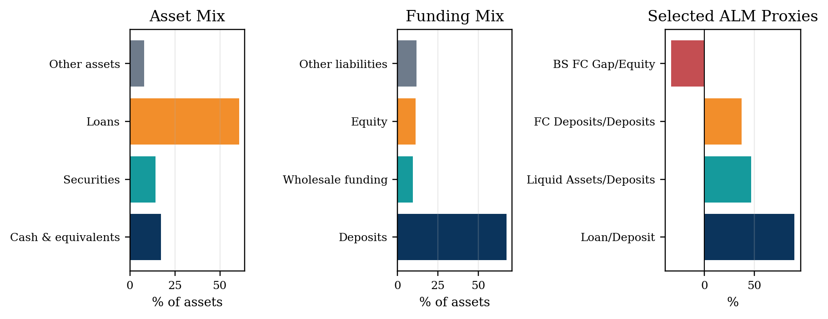
Figure 8. Garanti BBVA ALM proxy snapshot based on public financial statement inputs.
Metric | Latest bank proxy reading | Interpretation
Total assets | TL 4,016.8bn | Balance-sheet scale used for proxy extension
Loans / assets | 60.7% | Earning asset concentration
Liquid assets / assets | 31.5% | Cash and securities liquidity buffer proxy
Loan / deposit ratio | 89.9% | Bank-level funding balance proxy
Liquid assets / deposits | 46.6% | Simple liquidity buffer relative to deposits
FC deposits / deposits | 37.1% | Bank-specific dollarization/funding mix proxy
Balance-sheet FC gap / equity | -33.0% | Balance-sheet currency mismatch proxy

9. Maturity Ladder and Scenario Sensitivity
The maturity ladder is stylized, but it is calibrated from the latest bank financial statement line items. It is not a behavioral internal ALM cash-flow ladder. Its purpose is to demonstrate the mechanics of translating liquid assets, securities, loans, deposits, and wholesale funding into a maturity-bucket view.
Bucket | Asset inflow allocation | Liability outflow allocation
0-1M | Cash 60%; securities 25%; loans 18% | Deposits 25%; wholesale funding 25%
1-3M | Cash 20%; securities 20%; loans 20% | Deposits 25%; wholesale funding 25%
3-6M | Cash 10%; securities 20%; loans 22% | Deposits 20%; wholesale funding 20%
6-12M | Cash 5%; securities 15%; loans 20% | Deposits 15%; wholesale funding 15%
1Y+ | Cash 5%; securities 20%; loans 20% | Deposits 15%; wholesale funding 15%
Check | Allocations sum to 100% within each asset class | Allocations sum to 100% within each liability class
Table 3. Maturity ladder proxy allocation assumptions.
Assumption note: the allocation is deliberately simple and transparent. It approximates how cash, securities, loans, deposits and wholesale funding could be distributed across maturity buckets for a public-data proxy; it does not model behavioral deposit stickiness, loan prepayments or internal rollover assumptions.
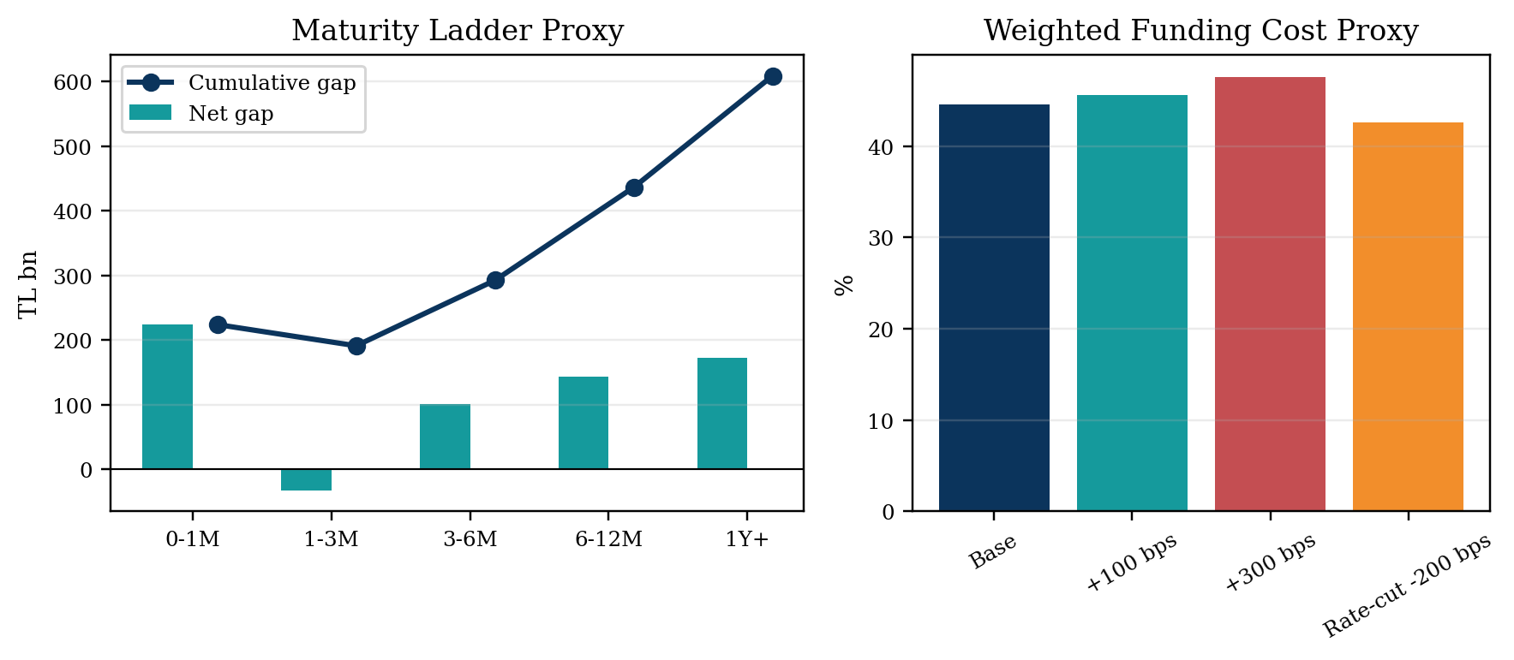
Figure 9. Garanti BBVA maturity-ladder proxy and weighted funding-cost scenario.
Scenario | Assumption | Expected treasury impact | Management monitoring point
Base case | Current market rates and current balance-sheet structure | Normal monitoring; elevated rate sensitivity remains | Track TLREF-policy spread, deposit costs, and reserve buffer
FX depreciation stress | USD/TRY +10%; FX/gold volatility rises | Potential dollarization pressure and FC liquidity focus | Monitor FC deposits, FC position, reserve buffer, and hedge needs
Rate volatility stress | TLREF +300 bps; short-end yields stay elevated | Higher funding cost and potential NII pressure if liabilities reprice faster | Repricing gap, deposit beta, securities duration, wholesale rollover
Liquidity tightening | Deposit outflows increase; wholesale rollover becomes costlier | Liquidity buffer requirement rises; coverage proxy weakens | Short-term cash-flow ladder, collateral availability, repo capacity
Rate-cut scenario | Policy and market rates decline by 200 bps | Funding cost relief but possible compression depending on asset repricing | Deposit repricing speed, asset yield reset, customer behavior
Table 4. Scenario monitoring table.
Scenario | Rate shock | Estimated annual repricing-gap impact | Interpretation
Rate cut -200 bps | -2.0 pp | TL 15.0bn | Positive in this proxy because liabilities are assumed to reprice faster
Rate shock +100 bps | +1.0 pp | TL -7.5bn | Negative repricing-gap impact
Liquidity tightening +300 bps | +3.0 pp | TL -22.6bn | Amplifies funding and margin pressure
Table 5. Simplified repricing-gap sensitivity.

10. Conclusion and Application Relevance
The case demonstrates a practical treasury workflow: collect public data, standardize frequencies, build core funding and liquidity metrics, translate market signals into risk labels, and connect sector-level indicators to a selected-bank ALM proxy. The main value of the project is not a single forecast or target value, but a structured monitoring system that can be adapted to bank treasury, corporate treasury, ALM, liquidity risk, money market operations, or treasury technology roles.
The strongest application signal is the combination of public data, clean dashboard design, transparent proxy construction, and management-style interpretation. The analysis is deliberately conservative about what cannot be observed from public data: it does not claim to reproduce a bank’s internal LCR, FTP, behavioral cash-flow ladder, or true internal NII model.

Appendix A - Supporting Charts and Method Notes
Data block | Source / file family | Frequency treatment | Main use
Policy rate | TCMB 1-week repo rate | Decision dates carried forward to weekly | Policy anchor
TLREF | BIST TLREF historical data | Daily to weekly observation | Overnight TL funding proxy
FX and gold | USD/TRY, EUR/TRY, GAU/TRY market data | Daily to weekly observation | FX/gold liquidity watch
Inflation | TCMB/TURKSTAT CPI YoY | Monthly forward-filled to weekly | Real policy-rate proxy
Yields | Turkey 2Y/5Y/10Y public yield data | Daily to weekly observation | Yield curve and duration risk
Banking sector | Loans, deposits, securities, FX position, reserves | Weekly alignment | Sector liquidity and stress score
Selected bank | Garanti BBVA unconsolidated financials, 1Q25-1Q26 | Quarterly bank-specific extension | ALM proxy inputs
Appendix Table A1. Data sources, frequency treatment, and dashboard use.
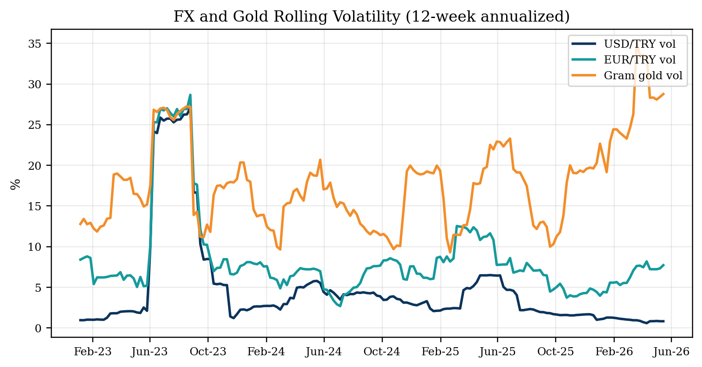
Appendix Figure A1. FX and gold rolling volatility.
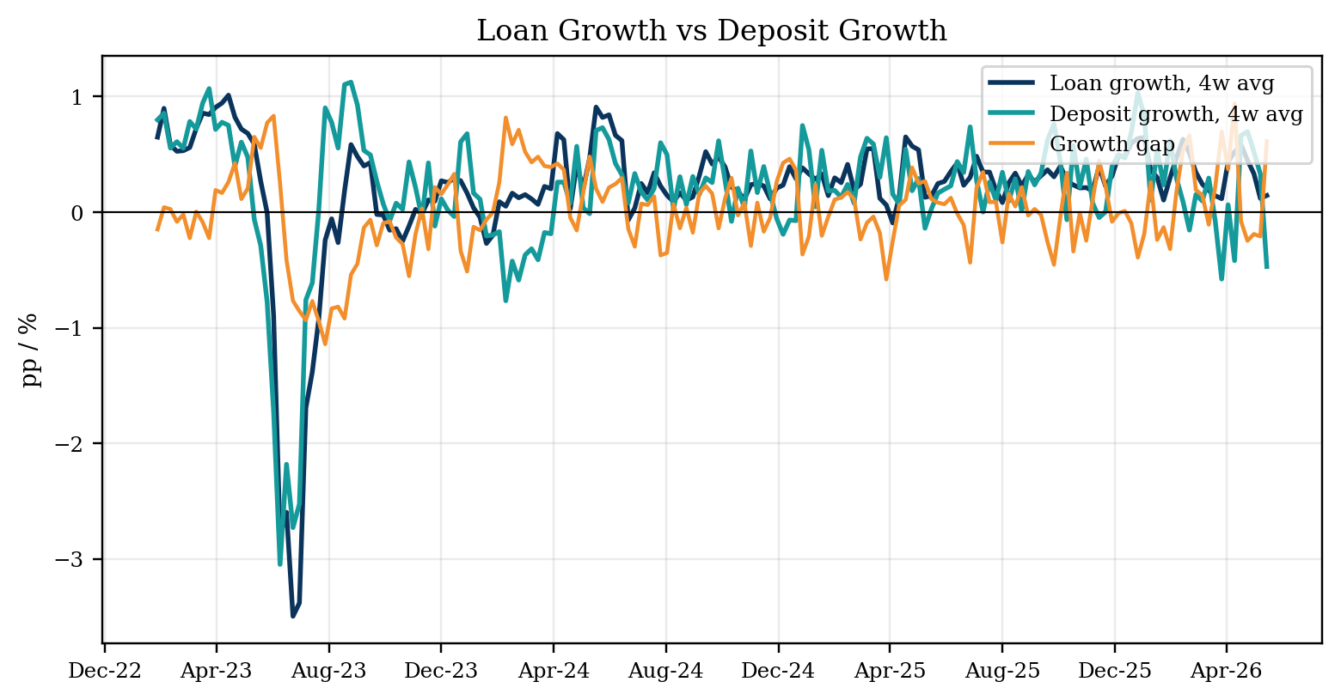
Appendix Figure A2. Loan growth vs deposit growth.
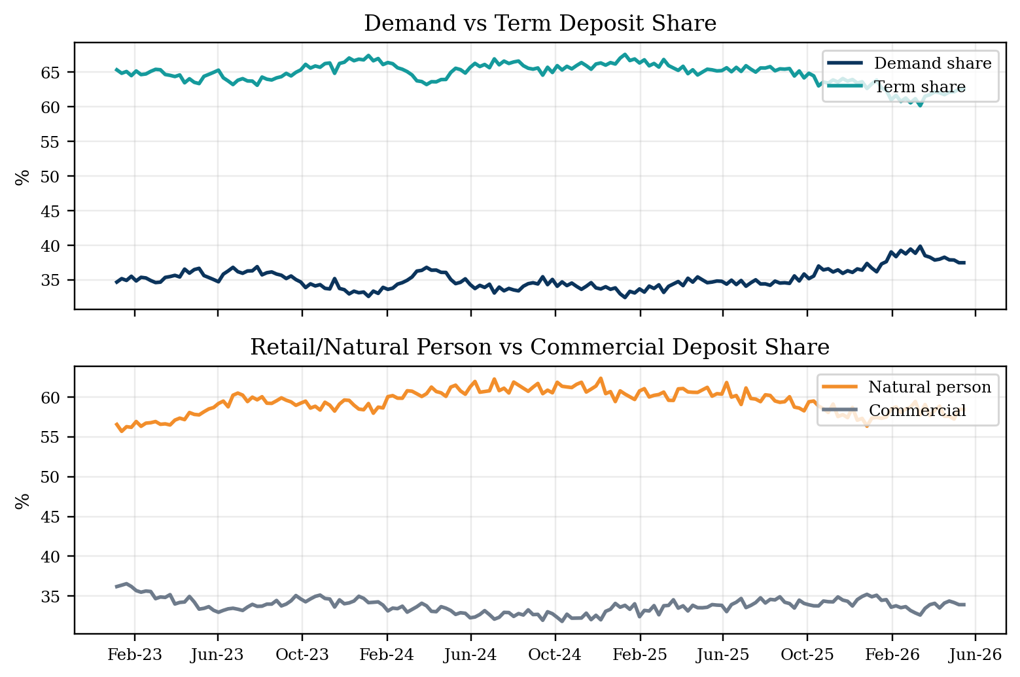
Appendix Figure A3. Deposit composition: demand/term and customer-type shares.
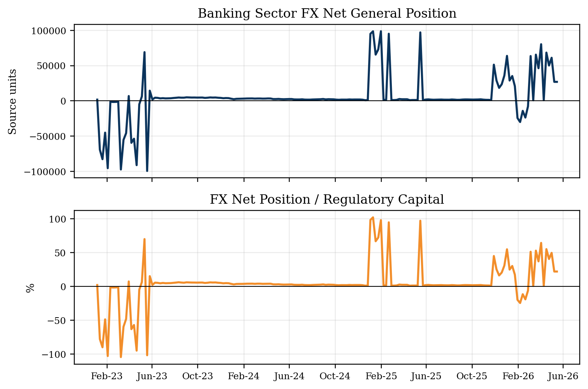
Appendix Figure A4. FX general position and capital-relative FX risk.
Proxy item | Construction | Caveat
Liquidity coverage proxy | Post-haircut cash + securities divided by stressed outflows | Not a regulatory LCR calculation; no HQLA classification or 30-day regulatory outflow engine
Maturity ladder proxy | Latest bank balance-sheet line items distributed into maturity buckets with explicit assumptions | Not an internal behavioral cash-flow ladder; no deposit stickiness or prepayment model
Market-implied funding cost | Funding mix from bank financials combined with public market rate proxies | Not internal FTP; does not reflect product-level transfer pricing or liquidity premiums
Simplified repricing-gap sensitivity | Rate-sensitive assets minus rate-sensitive liabilities multiplied by rate shock | Not a bank internal NII simulation; simplified repricing assumptions only
FX gap proxy | Balance-sheet FC assets less FC non-equity liabilities, scaled by equity | Does not fully model off-balance-sheet hedge accounting or internal risk limits
Appendix Table A2. ALM proxy methodology and caveats.

Appendix B - Source Notes
Specific sources: TCMB/EVDS, BIST TLREF, BDDK/BRSA, Turkey 2Y/5Y/10Y yield files, USD/TRY-EUR/TRY-GAU/TRY histories, Garanti BBVA reports, Corporate Presentation May 2026 and 1Q25-1Q26 unconsolidated financials.

