Ford Otosan Valuation Case
DCF, Trading Comps, and Valuation Method Divergence
Public Company Valuation & DCF / Trading Comps Case
Enes Sarı
Valuation date: 15 May 2026
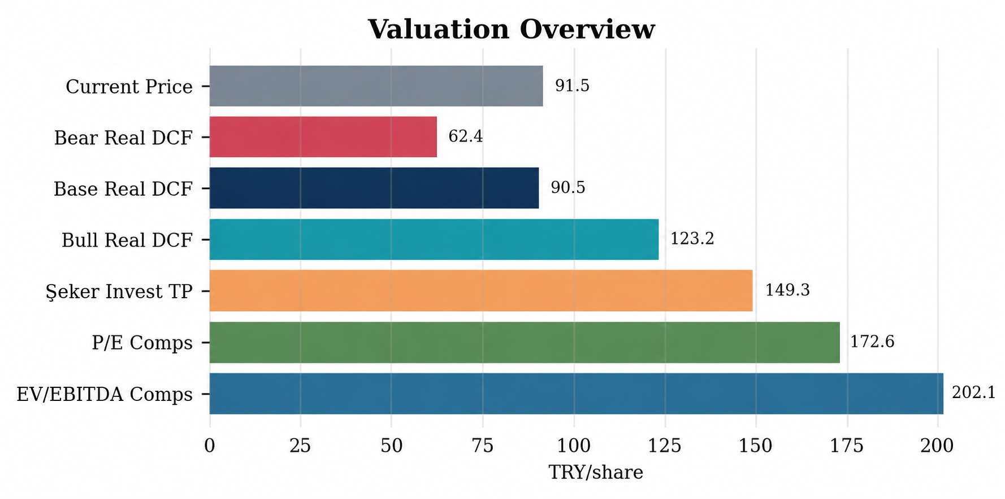
Figure 1. Valuation overview across intrinsic, relative, and external reference points.
Scope note: This memo is a portfolio case study, not a sell-side recommendation. It separates the intrinsic valuation output from relative valuation signals and broker sanity checks.

1. Executive Summary
Ford Otosan appears broadly fairly valued under a conservative IAS29-consistent real DCF, while local trading comps and an external broker target price point to a more constructive relative valuation signal.
Reference point | Value | Interpretation
Current price | TRY 91.45 | 15.05.2026 market reference
Base real DCF | TRY 90.45 | Intrinsic value anchor
Real DCF range | TRY 62.43-123.17 | Bear/base/bull framework
Şeker Invest target price | TRY 149.30 | External sanity check only
Trading comps range | TRY 172.55-202.11 | Relative valuation indication
Central conclusion: The case should not force a single target price. The more defensible reading is valuation-method divergence: conservative intrinsic DCF near current price, with relative valuation suggesting that FROTO trades at a discount to selected local auto peers.
Key risk: The DCF is sensitive to the beta/WACC framework, whereas the peer multiple output is sensitive to peer comparability, EBITDA definitions, and business model differences.

2. Company and Investment Context
Ford Otosan is a large-scale, export-oriented automotive manufacturer with operations in Türkiye and Romania. Its investment case is anchored in commercial vehicles, Ford’s European production network, export revenues, and manufacturing scale.
- Export-heavy revenue base: 2025 export revenue was TL 660.2bn, compared with TL 170.6bn in domestic revenue.
- Industrial scale: Total revenue in 2025 reached TL 830.8bn, with adjusted EBITDA of TL 66.6bn.
- Accounting treatment: 2024-2025 financials are presented under IAS 29/TAS 29, which is relevant to DCF consistency.
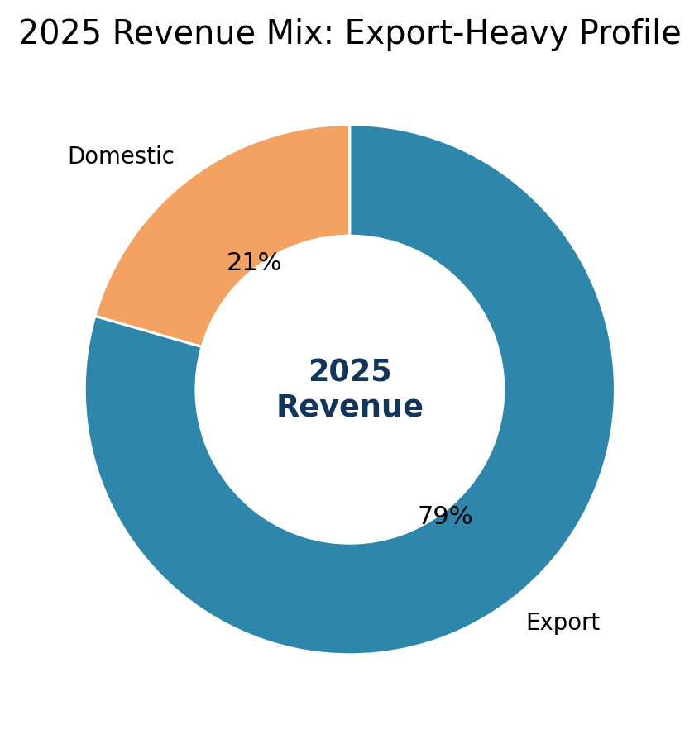
Figure 2. 2025 revenue mix highlights Ford Otosan’s export-heavy profile.
The export-heavy mix is an important difference from several local peers. It gives FROTO stronger exposure to European commercial vehicles and a more FX-linked revenue base, but it also makes near-term assumptions more sensitive to European demand and EUR/TRY dynamics.

3. Recent Performance and 2026 Setup
The model does not mechanically extrapolate profitability for 2025. 2025 was operationally strong, but 1Q26 and guidance point to a more cautious near-term setup.
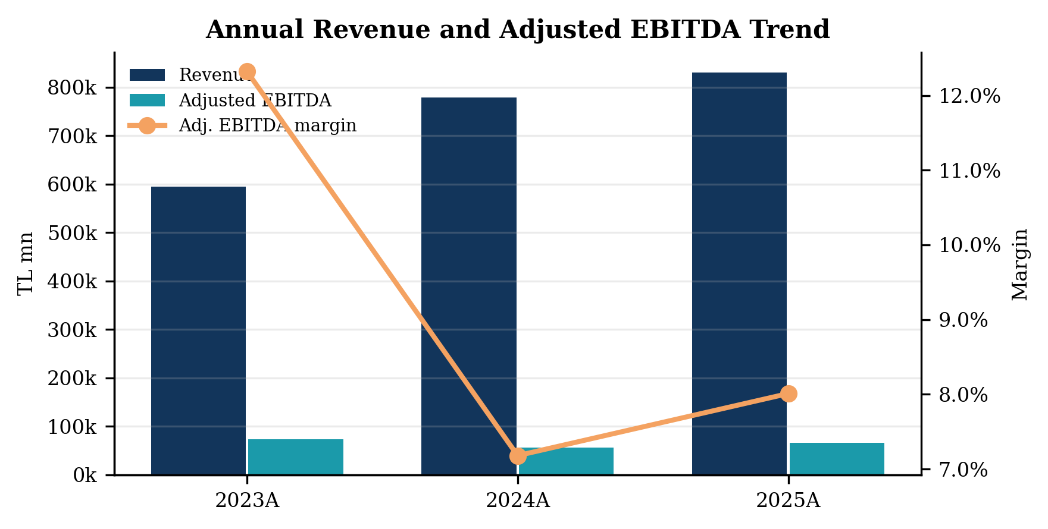
Figure 3A. Annual revenue and adjusted EBITDA trend, 2023A-2025A.
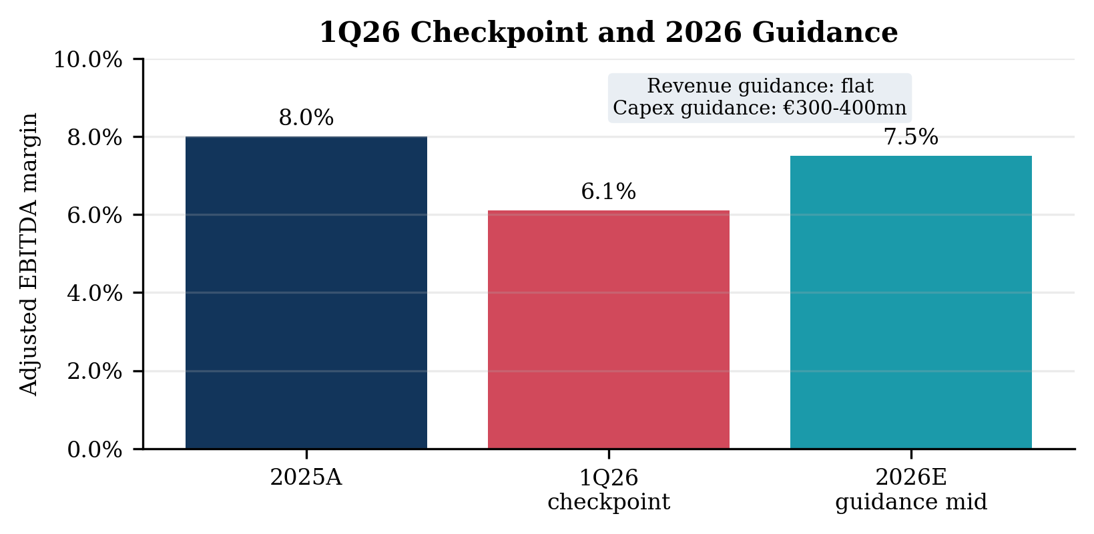
Figure 3B. 1Q26 checkpoint and 2026 guidance; 1Q26 is not annualized.
- 2025 actual: Revenue of TL 830.8bn, adjusted EBITDA margin of 8.0%, and net financial debt / adjusted EBITDA of 1.49x.
- 1Q26 pressure: 1Q26 adjusted EBITDA margin declined to around 6.1%, reflecting domestic volume and margin pressure.
- 2026 guidance anchor: Revenue growth was revised to flat, adjusted EBITDA margin guidance remained 7-8%, and capex guidance was €300-400mn.

4. Trading Comparables Analysis
FROTO screens at a visible EV/EBITDA discount to selected BIST auto peers. However, the peer set is heterogeneous, so the result should be interpreted directionally rather than mechanically.
Peer audit table:
Company | Ticker | Peer role | EV/EBITDA | P/E | EBITDA margin | Net debt/EBITDA | Core median?
Ford Otosan | FROTO | Target | 6.3x | 9.4x | 8.0% | 1.49x | -
Tofaş | TOASO | Core manufacturing | 18.5x | 18.1x | 3.1% | 3.35x | Yes
Türk Traktör | TTRAK | Core manufacturing | 11.2x | 103.9x | 9.3% | 1.76x | Yes
Anadolu Isuzu | ASUZU | Core manufacturing | 12.1x | 17.6x | 6.8% | 3.44x | Yes
Otokar | OTKAR | Broader check | 33.3x | N.M. | 4.1% | 12.90x | No / sensitivity
Doğuş Otomotiv | DOAS | Broader check | 4.4x | 12.7x | 5.8% | 1.69x | No / sensitivity
Karsan | KARSN | Sensitivity peer | 6.1x | 68.7x | 20.7% | 2.10x | No
Note: P/E is treated as secondary because peer earnings are affected by financing costs, deferred taxes, inflation accounting effects, and cyclical earnings distortion.
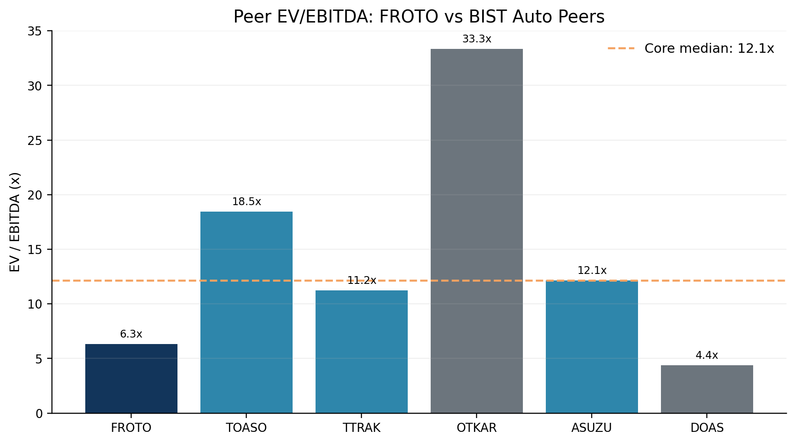
Figure 4. Peer EV/EBITDA comparison; FROTO is below the core manufacturing peer median.
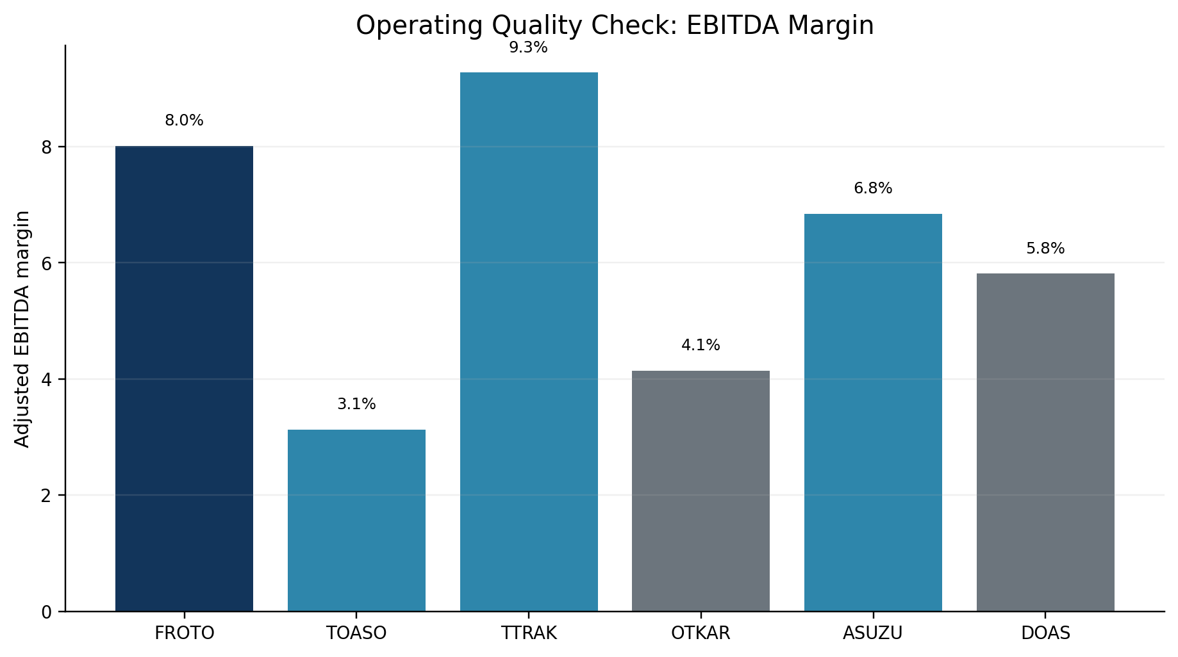
Figure 5. EBITDA margin check: FROTO’s multiple discounts are not solely attributable to weak margin quality.
Peer interpretation: TOASO, TTRAK, and ASUZU are the core manufacturing set, while OTKAR and DOAS are useful broader checks but less precise comparables due to defense/project exposure and distribution-led business models. KARSN remains a sensitive peer rather than a main median input.

5. DCF Methodology and Base Case
The main DCF uses a real framework consistent with IAS 29. This is critical: constant-purchasing-power cash flows should not be mechanically discounted using spot nominal TRY rates as a base case.
- Base year: 2025A, the latest audited full-year period.
- Forecast period: 2026E-2030E.
- Revenue growth: Flat in 2026E, followed by normalized recovery assumptions.
- Profitability: 2026E adjusted EBITDA margin is set around the mid-point of guidance, then gradually normalizes.
- Discounting: 11.0% real WACC and 2.0% real terminal growth are used in the base real DCF.
DCF forecast assumptions:
Assumption | 2026E | 2027E | 2028E | 2029E | 2030E | Rationale
Revenue growth | 0.0% | 8.0% | 7.0% | 6.0% | 5.0% | 2026 guidance revised to flat; later years reflect normalization
Adj. EBITDA margin | 7.5% | 7.7% | 7.8% | 8.0% | 8.0% | Guidance midpoint and gradual recovery toward 2025A margin
D&A / Revenue proxy | 2.9% | 2.8% | 2.8% | 2.75% | 2.75% | Adjusted EBITDA-to-EBIT bridge / revenue
Capex / Revenue | 2.7% | 2.6% | 2.5% | 2.5% | 2.5% | 2026 capex guidance and post-investment-cycle normalization
NWC / Revenue | 4.5% | 4.5% | 4.5% | 4.5% | 4.5% | Historical working-capital behavior and 2025 cash conversion improvement
Tax rate | 25.0% | 25.0% | 25.0% | 25.0% | 25.0% | Normalized cash tax proxy
Real WACC | 11.0% |  |  |  |  | Base IAS29-consistent real discount rate
Real terminal growth | 2.0% |  |  |  |  | Long-term real growth for constant-purchasing-power cash flows
WACC derivation and real/nominal reconciliation:
Component | Base assumption | Comment
Risk-free rate | 32.42% | Nominal TRY 10Y yield; used for spot stress, not directly as base real DCF input
Equity risk premium | 8.89% | Turkey ERP / CRP-inclusive input used in beta sensitivity
Beta | 0.40 | Yahoo Finance 5Y monthly; Şeker 2Y daily beta of 0.80 used as sensitivity
Nominal cost of equity | 35.98% | Risk-free rate + beta x ERP; spot nominal reference
Pre-tax cost of debt | 19.03% | FROTO proxy based on net financial expense / average financial debt
Tax rate | 25.0% | Normalized corporate cash tax assumption
After-tax cost of debt | 14.28% | Pre-tax cost of debt x (1 - tax rate)
Equity / debt weights | 76.4% / 23.6% | Market-cap and net-debt based capital structure approximation
Spot nominal WACC | 30.85% | Retained only as nominal spot-rate macro stress test
Inflation framework | 15.0% | Medium-term normalization anchor; used conceptually to avoid nominal/real mismatch
Selected real WACC | 11.0% | IAS29-consistent DCF input
Note: The 11.0% real WACC is not a mechanical Fisher conversion of the spot nominal WACC; it is a normalized real discount-rate assumption used to avoid mixing IAS29 constant-purchasing-power cash flows with volatile spot TRY nominal rates.
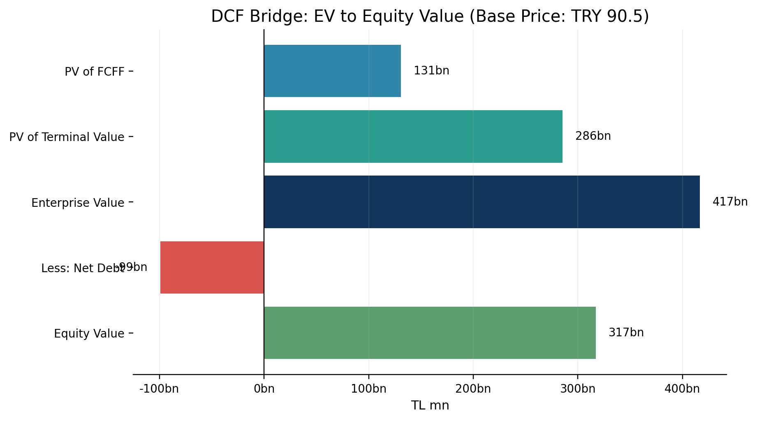
Figure 6. DCF bridge from PV of cash flows to equity value and implied share price.
The base DCF implied share price is approximately TRY 90.45, very close to the 15.05.2026 market price of TRY 91.45. This is a conservative intrinsic value anchor rather than a bullish target price.

6. Beta, WACC, and Valuation Sensitivity
The DCF output is highly sensitive to beta and the real WACC assumption. This is also the main reason the model should show a range rather than a single target price.
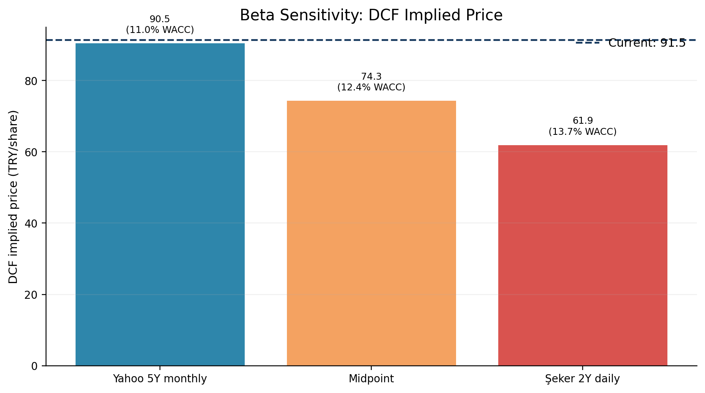
Figure 7. Beta sensitivity: DCF value declines as beta and real WACC increase.
The Yahoo 5Y monthly beta of 0.40 supports a base real DCF close to the current price. Using Şeker Invest’s 2Y daily beta of 0.80 lowers the DCF value. This does not invalidate the DCF; it shows that the investment case is highly sensitive to risk measurement and normalization assumptions.
Şeker Invest’s TRY 149.30 target price sits above our conservative DCF range, which likely reflects a different forecast base, forward EBITDA, target multiple, and WACC methodology. The broker number is therefore treated as an external sanity check rather than an input to our valuation.

7. Market and Sector Context
Sector data support a cautious near-term forecast. The Turkish market, production, and exports weakened in 1Q26, while commercial vehicle production was more resilient.
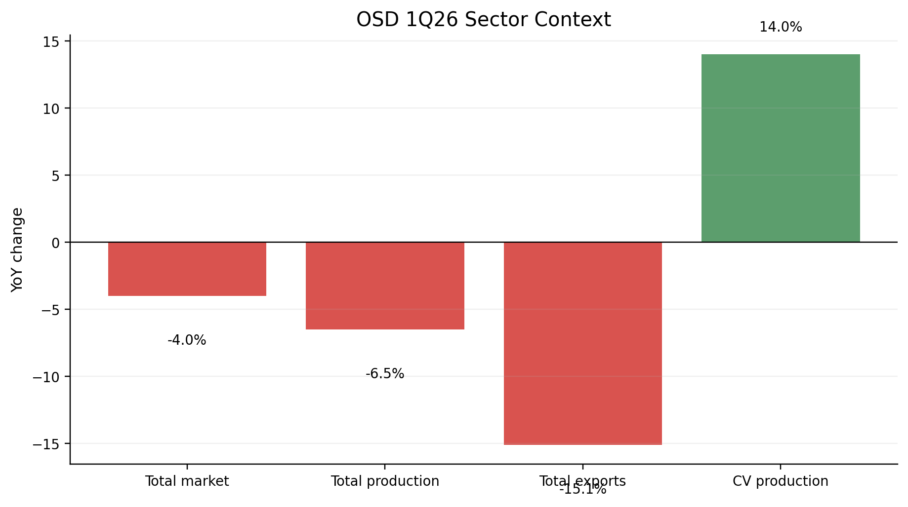
Figure 8. OSD 1Q26 sector context: near-term pressure with commercial vehicle resilience.
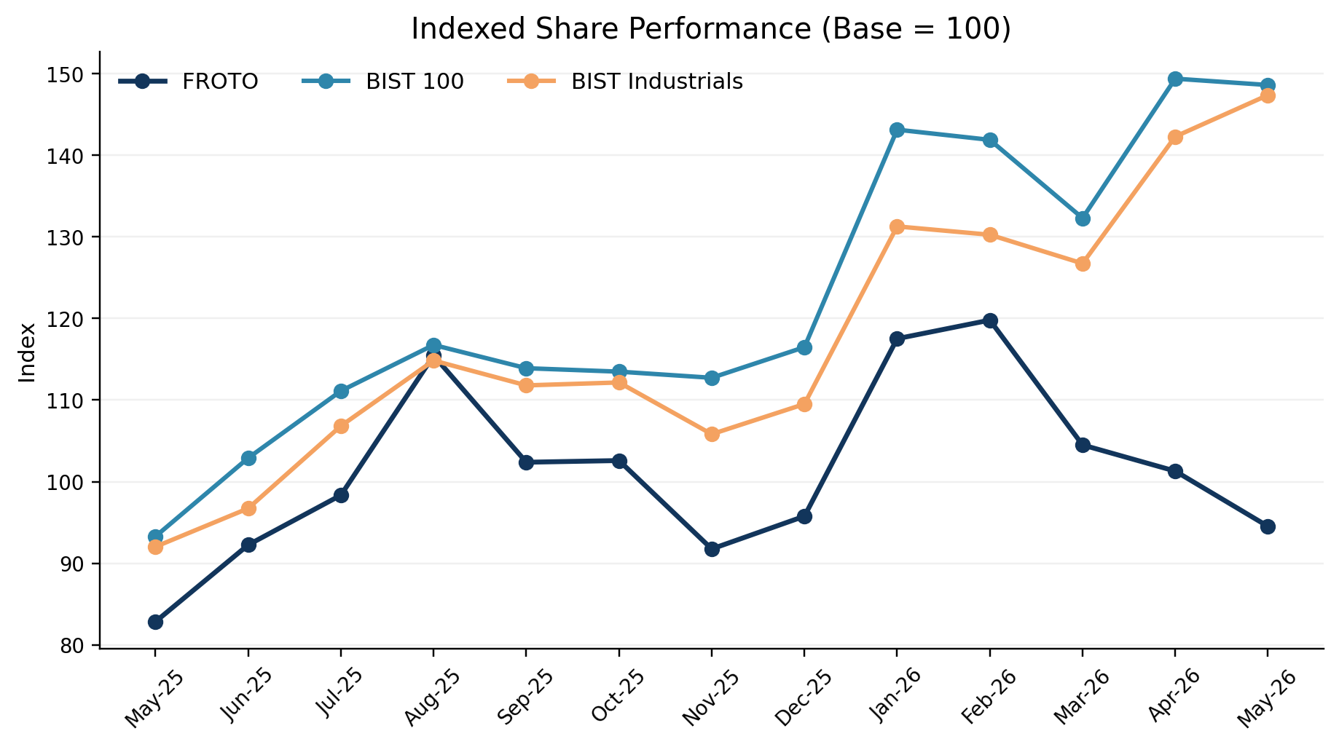
Figure 9. Indexed share performance versus BIST 100 and BIST Industrials.
This context supports a balanced conclusion. Near-term sector pressure justifies conservative DCF assumptions, while FROTO’s scale, commercial-vehicle exposure, and export-heavy profile support a more constructive relative valuation.

8. Conclusion and Portfolio Case Interpretation
The most defensible conclusion is not that FROTO is simply cheap or expensive. The stronger analytical point is that different valuation methods answer different questions.
Question | Answer | Implication
Is FROTO clearly undervalued on DCF? | No. Base real DCF is close to current price. | Intrinsic valuation is a fair-value anchor, not a bullish target.
Does FROTO screen cheap vs peers? | Yes, especially on EV/EBITDA versus core manufacturing peers. | Relative valuation signal is constructive.
Is the relative upside mechanically reliable? | No. Peer set is heterogeneous and multiples are sensitive to EBITDA definitions. | Use peer-implied prices directionally, not mechanically.
What explains the divergence? | Real WACC/beta framework, IAS29 treatment, peer comparability and forward EBITDA assumptions. | This is the main analytical finding.
Best interpretation | Fair intrinsic value with a constructive relative valuation signal. | Valuation-method divergence, not a single-point target price.
Final takeaway: Under conservative real DCF assumptions, FROTO appears broadly fairly valued around the current market price. However, local trading comps and the external broker reference point indicate a more constructive relative valuation signal. The gap should be framed as valuation-method divergence driven by WACC, beta, IAS29 treatment, peer comparability and forward earnings assumption.

Appendix A - Supporting Charts
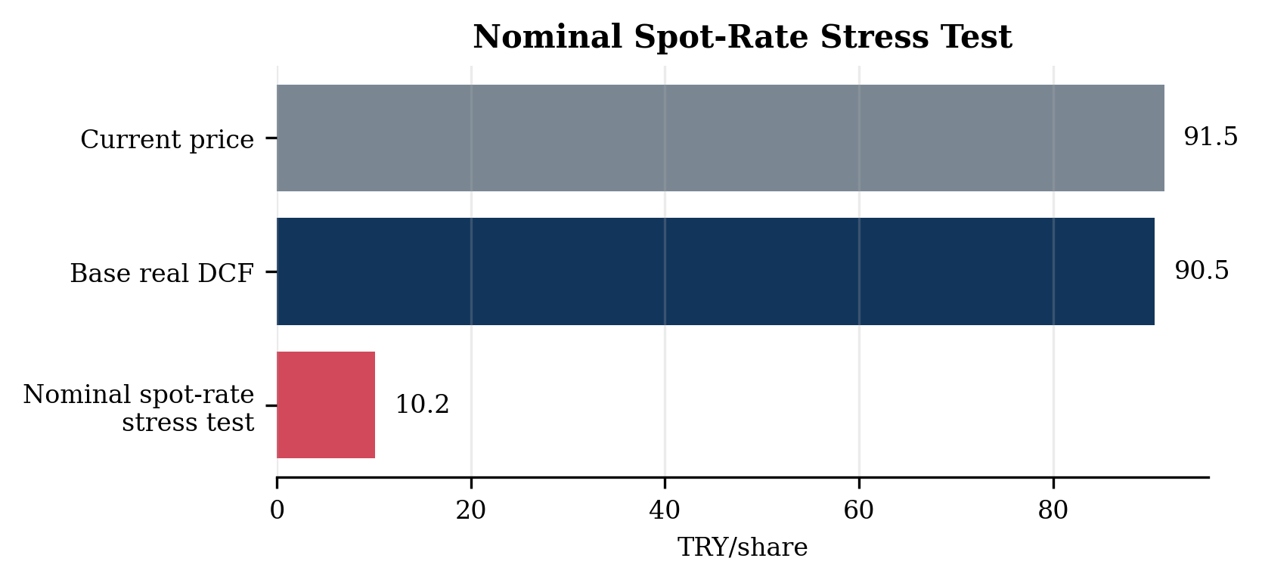
Appendix Figure A0. Nominal spot-rate stress test, retained only as a macro stress illustration.
This scenario is not used as a base valuation framework because the financials are treated in constant purchasing power terms under IAS29/TAS29.
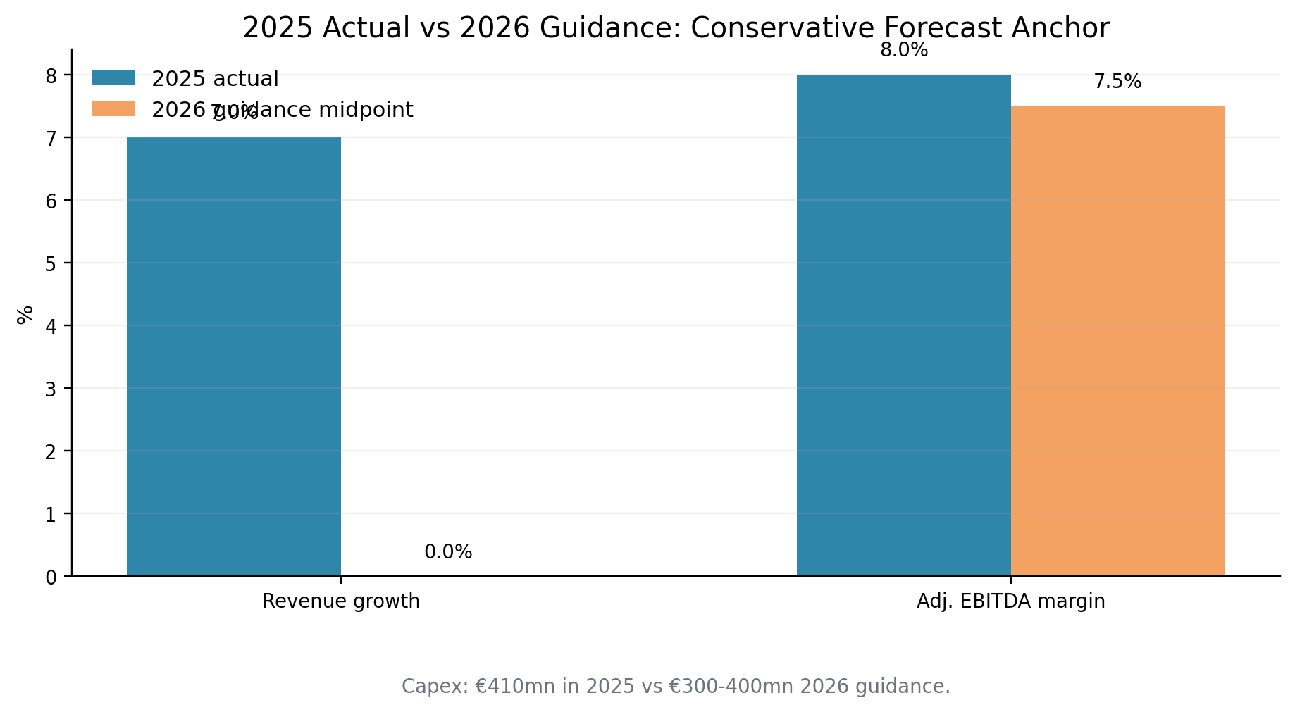
Appendix Figure A1. 2025 actual vs 2026 guidance.
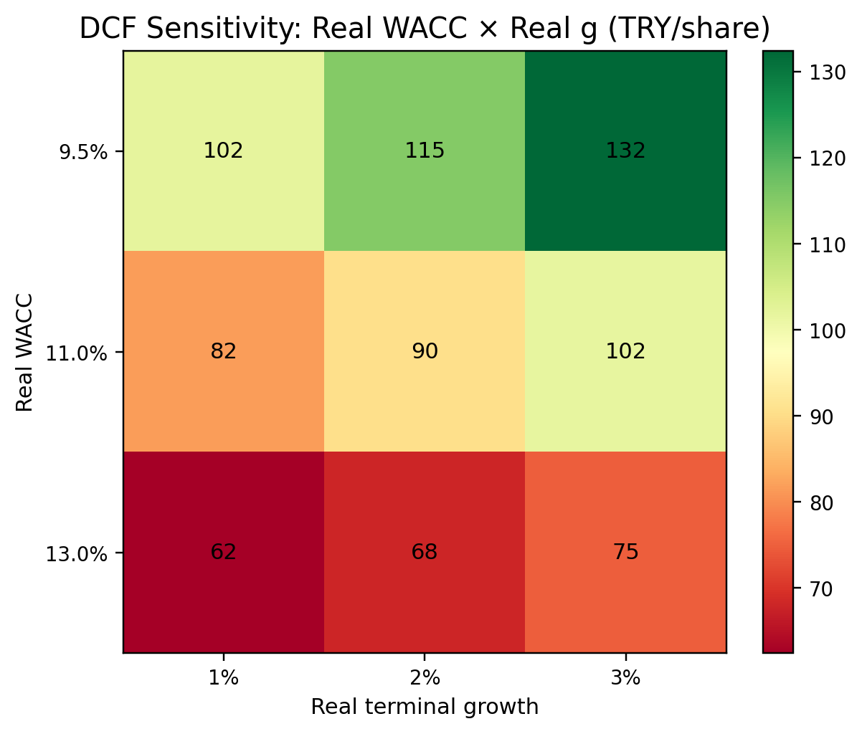
Appendix Figure A2. DCF sensitivity heatmap: real WACC x real terminal growth.
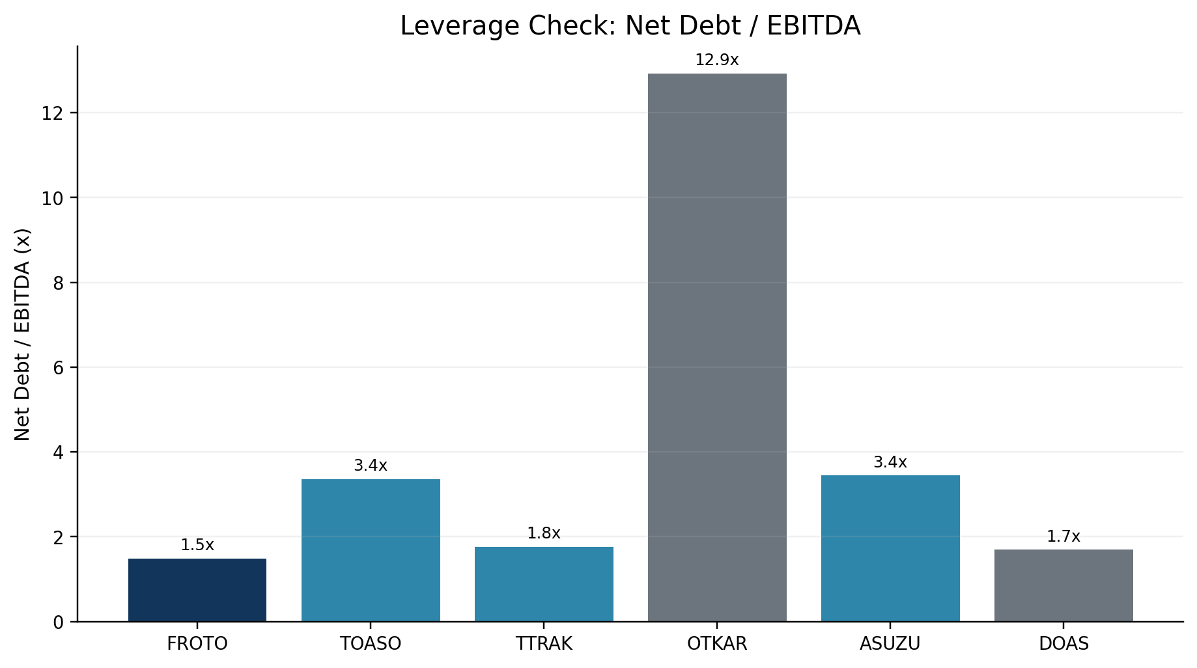
Appendix Figure A3. Peer leverage check: net debt / EBITDA.

Appendix B - Source Notes and Method Caveats
- Market data uses a valuation date of 15.05.2026 for price, share count, and market cap calculations.
- Financial data are based on company filings, annual reports, investor presentations, earnings releases, and reviewed peer financial statements.
- FROTO 2024-2025 financials are treated carefully because the statements are presented under IAS29/TAS29 in constant purchasing power terms.
- Peer EV/EBITDA is preferred over P/E because peer earnings are affected by financing cost, deferred tax, inflation accounting effects, and cyclical earnings distortion.
- This memo intentionally avoids copying the sell-side target price methodology. Şeker Invest is used only as a sanity check and methodological comparison point.
Main sources used: Ford Otosan 2025 Annual Report; Ford Otosan 1Q26 Earnings Release and Interim Report; Şeker Invest 1Q26 Earnings Update; OSD March 2026 Automotive Industry Monthly Report; TCMB Inflation Report 2026-II; peer company annual reports, financial statements, and investor presentations.

