Credit Risk Analytics Mini-Model
PD Estimation, Model Validation, IFRS 9-style ECL and Turkey Macro-Sector Overlay
Credit Risk Analytics / Risk Methodologies Portfolio Case
Enes Sarı
Data through: 8 May 2026 | Final revision date: 19 May 2026
Metric | Latest reading | Interpretation
Clean modeling observations | 1,369,164 | Resolved LendingClub modeling sample
Observed default rate | 21.23% | Bad-rate base for PD modeling
Logistic Regression test AUC | 0.709 | Primary interpretable PD model
XGBoost challenger test AUC | 0.718 | Non-linear benchmark
Very High Risk default rate | 38.86% | Risk-band separation signal
Very High Risk ECL share | 53.05% | Expected-loss concentration
Base scenario ECL | USD 1.34bn | Illustrative ECL on test sample
Severe stress ECL increase | 61.43% | Stress sensitivity
PD score PSI | 0.00002 (Stable) | Train-test score stability
Latest Turkey total NPL ratio | 2.78% | Local sector overlay
Table 1. Executive credit risk analytics snapshot.
Scope note: This memo is a portfolio case study. It uses the public LendingClub accepted-loan file family (accepted_2007_to_2018Q4.csv.gz) for the core PD/ECL workflow and public BDDK/TCMB indicators only as a separate Turkey macro-sector overlay.

1. Executive Summary
This case study builds a public-data credit risk analytics workflow using LendingClub loan-level data. The project develops an interpretable probability-of-default (PD) model, validates the model through out-of-sample performance and calibration checks, segments borrowers into risk bands, and translates predicted PDs into an illustrative IFRS 9-style expected credit loss (ECL) framework.
The primary logistic regression model achieved a test AUC of 0.709 and a test Gini of 0.417, while the XGBoost challenger model achieved a moderately higher test AUC of 0.718. Logistic regression is retained as the primary model because its predicted PDs are well-calibrated across deciles, and its drivers are easier to interpret in credit-risk governance terms.
The strongest portfolio finding is concentration. The Very High Risk band accounts for 31.2% of test-sample exposure but 45.7% of observed defaults and 53.1% of illustrative ECL. Under the severe stress scenario, total illustrative ECL increases from USD 1.34bn to USD 2.17bn, a 61.4% increase relative to the base case.
The project also adds model-stability and strategy layers: train-test PD score PSI is approximately 0.00002, indicating no material distribution shift; threshold simulation shows the trade-off between approval volume, retained exposure and default capture; and stress migration illustrates how exposure shifts toward higher-risk bands under adverse PD multipliers. A separate Turkey macro-sector overlay uses BDDK and TCMB indicators to show how similar monitoring logic can be connected to local banking-sector conditions.

2. Dataset and Default Definition
The core modeling dataset uses the public LendingClub accepted-loan file family, accepted_2007_to_2018Q4.csv.gz. To approximate an application-time PD model, the variable set is restricted to information available at or near origination, such as loan amount, funded amount, term, interest rate, installment, grade, employment length, home ownership, annual income, debt-to-income ratio, FICO proxy, delinquencies, inquiries, revolving utilization, public records and loan purpose. Post-origination variables such as recoveries, total payments and last payment information are excluded to reduce target leakage.
The binary default flag is based on resolved or materially default-like loan statuses. Fully paid loans are treated as non-default observations. Charged-off, defaulted and late 31-120 day loans are treated as default observations. Current, issued, grace-period and short-term delinquency observations are excluded from the binary modeling sample.
Target class | LendingClub status mapping | Modeling treatment
Good / non-default | Fully Paid; Does not meet the credit policy. Status:Fully Paid | default_flag = 0
Bad / default | Charged Off; Default; Late (31-120 days); not meet the credit policy. Status: Charged Off | default_flag = 1
Excluded | Current; Issued; In Grace Period; short-term delinquency or unresolved performance states | Excluded modeling sample
Default definition box. Binary target construction and status treatment.
Item | Reading | Interpretation
Raw selected observations | 2,260,701 | Selected LendingClub columns read from raw file
Clean modeling observations | 1,369,164 | After status filter and core missing-value checks
Observed default rate | 21.23% | Charged-off/default/late 31-120 definition
Total EAD proxy in clean data | USD 19.77bn | Funded amount used as exposure proxy
Table 2. Modeling data construction summary.

3. PD Model Development
The project estimates two models. Logistic regression is used as the primary PD model because it is transparent and aligned with traditional credit scorecard logic. XGBoost is trained as a challenger model to test whether a non-linear structure improves discrimination. Both models are trained on the same leakage-controlled feature set and evaluated on a 30% holdout sample using stratified splitting.
An initial class-weighted logistic specification was rejected because it produced overstated PD levels despite improving default recall. The final logistic model is estimated without class weighting to prioritize probability calibration, which is more appropriate for PD estimation and ECL translation than a pure classification objective. A compact driver table is added below to make the expected feature-risk relationships visible to non-technical readers and model reviewers.
Driver |  |  | Expected risk direction |  |  | Model interpretation
Higher interest rate |  |  | Higher PD |  |  | Pricing embeds borrower risk
Lower FICO proxy |  |  | Higher PD |  |  | Weaker credit quality
Higher DTI |  |  | Higher PD |  |  | Debt burden risk
More delinquencies |  |  | Higher PD |  |  | Prior repayment stress
Longer term |  |  | Higher PD |  |  | Longer exposure horizon
Higher revolving utilization |  |  | Higher PD |  |  | Liquidity pressure
Model | Sample | AUC |  | Gini | Precision |  | Recall
Logistic Regression | Train | 0.710 |  | 0.420 | 0.558 |  | 0.070
Logistic Regression | Test | 0.709 |  | 0.417 | 0.560 |  | 0.070
XGBoost | Train | 0.722 |  | 0.444 | 0.579 |  | 0.087
XGBoost | Test | 0.718 |  | 0.436 | 0.575 |  | 0.085
Table 3. Model performance summary.
Classification metrics use a 0.50 threshold for transparency. The model is primarily used for PD estimation, calibration, ranking and risk segmentation rather than binary default classification at a fixed threshold. Because the model is used for PD ranking and ECL translation rather than hard binary classification, AUC, Gini, calibration and risk-band separation are more decision-relevant than recall at an arbitrary 0.50 threshold.
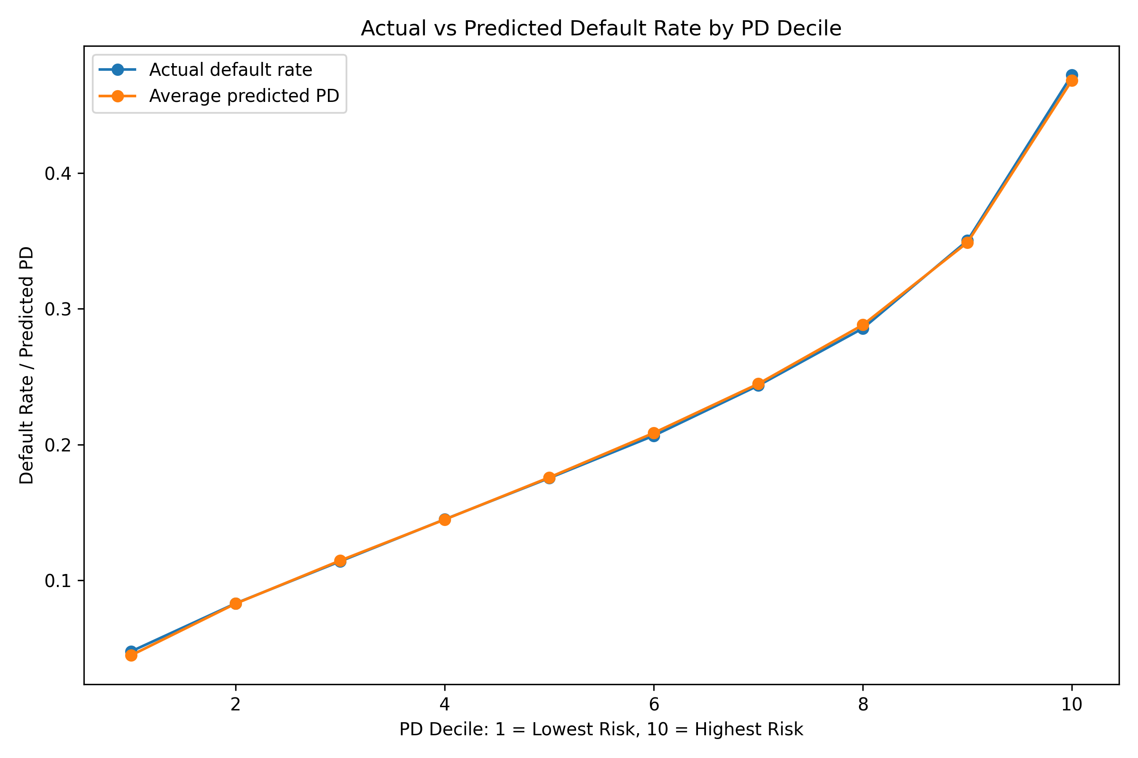
Figure 1. Actual versus predicted default rate by PD decile.

4. Model Validation and Calibration
Model validation focuses on both discrimination and calibration. Discrimination is measured through ROC/AUC and Gini. Calibration is evaluated by comparing average predicted PDs with realized default rates by PD decile. The final logistic model shows strong out-of-sample calibration: the first decile has a realized default rate of 4.76% versus an average predicted PD of 4.47%, while the tenth decile has a realized default rate of 47.24% versus an average predicted PD of 46.85%.
This decile-level behavior supports the use of the logistic model as the primary PD source for risk bands and illustrative ECL. XGBoost produces a modestly higher AUC, but the logistic model is preferred for the main risk workflow because its probability outputs are easier to validate and explain.
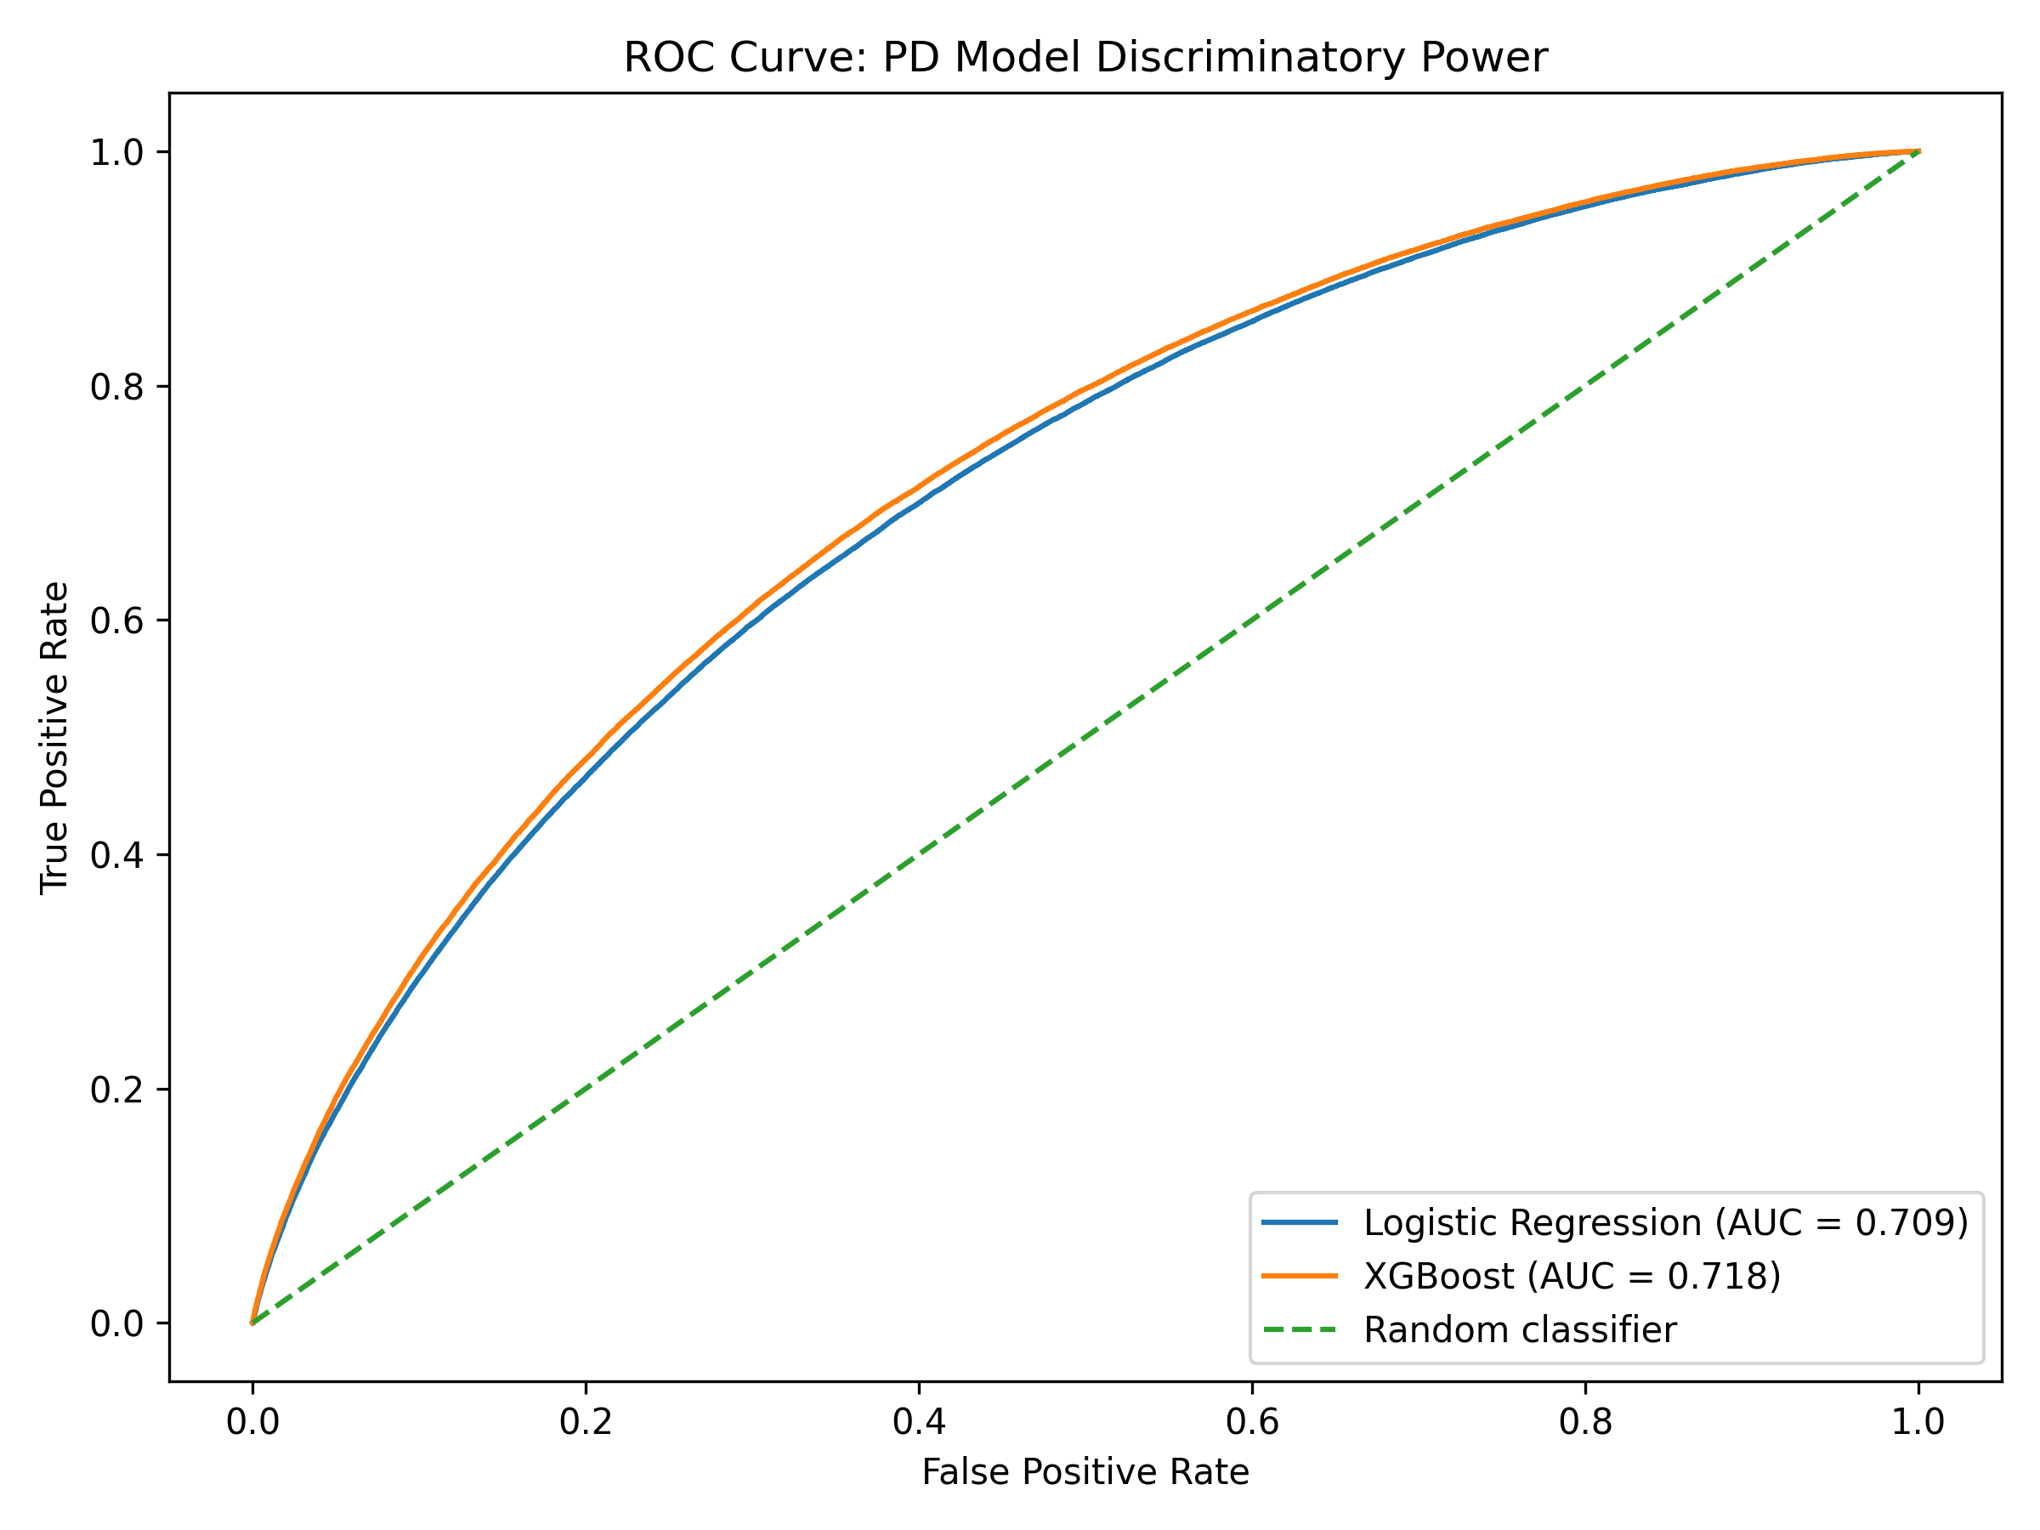
Figure 2. ROC curve and discriminatory power of the logistic and XGBoost PD models.

5. Risk Segmentation
Borrowers are segmented into four quantile-based risk bands using the primary logistic PD. The bands show a clean monotonic default gradient: Low Risk loans have a 7.37% realized default rate, while Very High Risk loans have a 38.86% realized default rate. The Very High Risk band accounts for 31.2% of exposure but 45.7% of observed defaults, indicating a material credit risk concentration.
Risk band | Loans | Exposure | Avg PD | Actual default | Exposure share | Default share
Low Risk | 102,688 | USD 1.36bn | 7.2% | 7.4% | 23.0% | 8.7%
Medium Risk | 102,687 | USD 1.31bn | 15.3% | 15.2% | 22.1% | 17.9%
High Risk | 102,687 | USD 1.40bn | 23.7% | 23.5% | 23.7% | 27.6%
Very High Risk | 102,688 | USD 1.85bn | 38.7% | 38.9% | 31.2% | 45.7%
Table 4. Risk-band summary based on primary logistic PD.
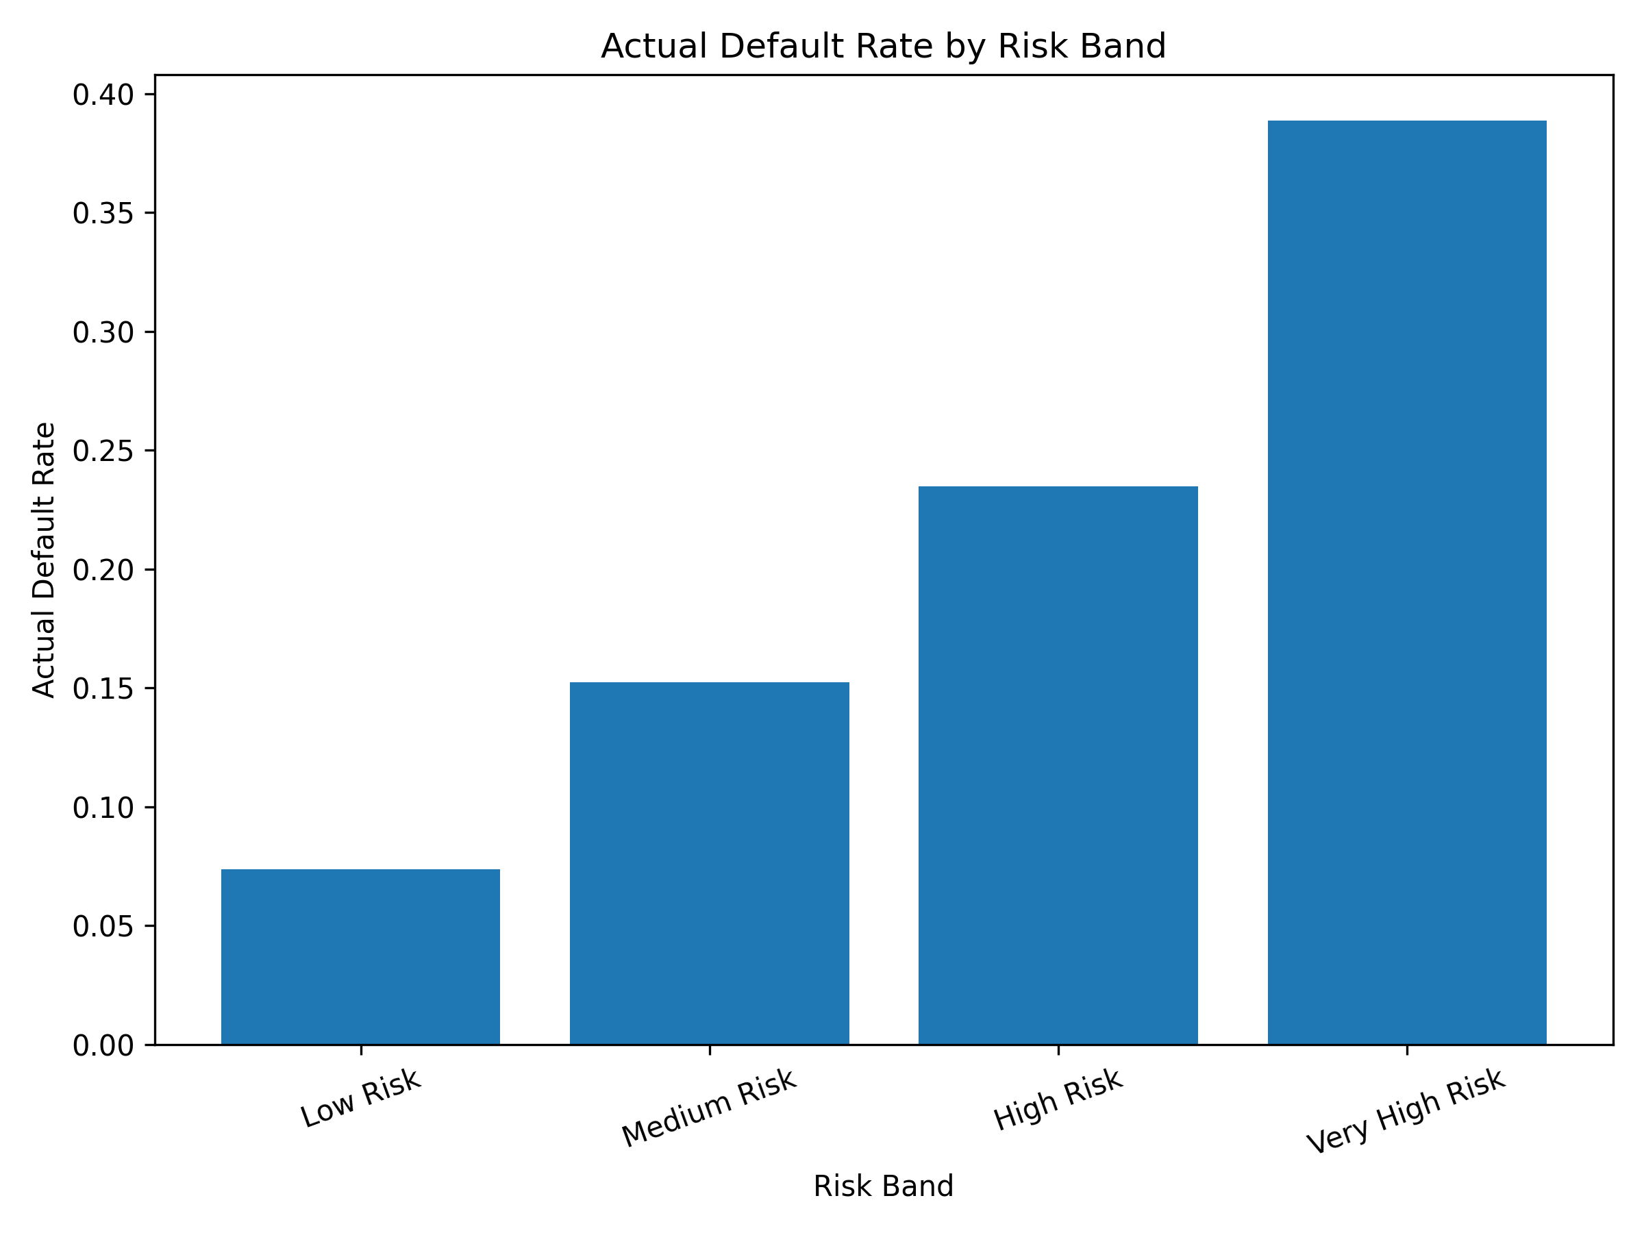
Figure 3. Actual default rate by risk band.

6. IFRS 9-style ECL Framework
The ECL layer translates calibrated PDs into a simplified expected-loss framework. EAD is proxied using funded loan amount. LGD is assumed at 45% in the base case because the public dataset does not provide a reliable internal recovery, collateral and workout dataset. Stage 1 consists of non-defaulted Low and Medium Risk loans; Stage 2 consists of non-defaulted High and Very High Risk loans; and Stage 3 consists of observed defaulted loans. This is an illustrative IFRS 9-style approximation rather than a regulatory implementation. In a production IFRS 9 framework, Stage 2 assignment would require comparing current lifetime risk against origination risk and applying bank-specific significant-increase-in-credit-risk (SICR) rules; here, high predicted PD is used only as a transparent public-data proxy.

Stage proxy | Loans | Exposure | Avg ECL PD | ECL | Exposure share | ECL share | ECL rate
Stage 1 | 182,171 | USD 2.38bn | 11.0% | USD 117mn | 40.0% | 8.7% | 4.9%
Stage 2 | 141,359 | USD 2.19bn | 59.3% | USD 611mn | 37.0% | 45.5% | 27.9%
Stage 3 | 87,220 | USD 1.36bn | 100.0% | USD 614mn | 23.0% | 45.8% | 45.0%
Table 5. Illustrative IFRS 9-style stage and ECL summary.
Stage 2 and Stage 3 together account for 91.3% of illustrative ECL, despite representing a smaller share of exposure than the full portfolio. This reinforces the importance of credit monitoring and risk migration analysis in expected-loss management.
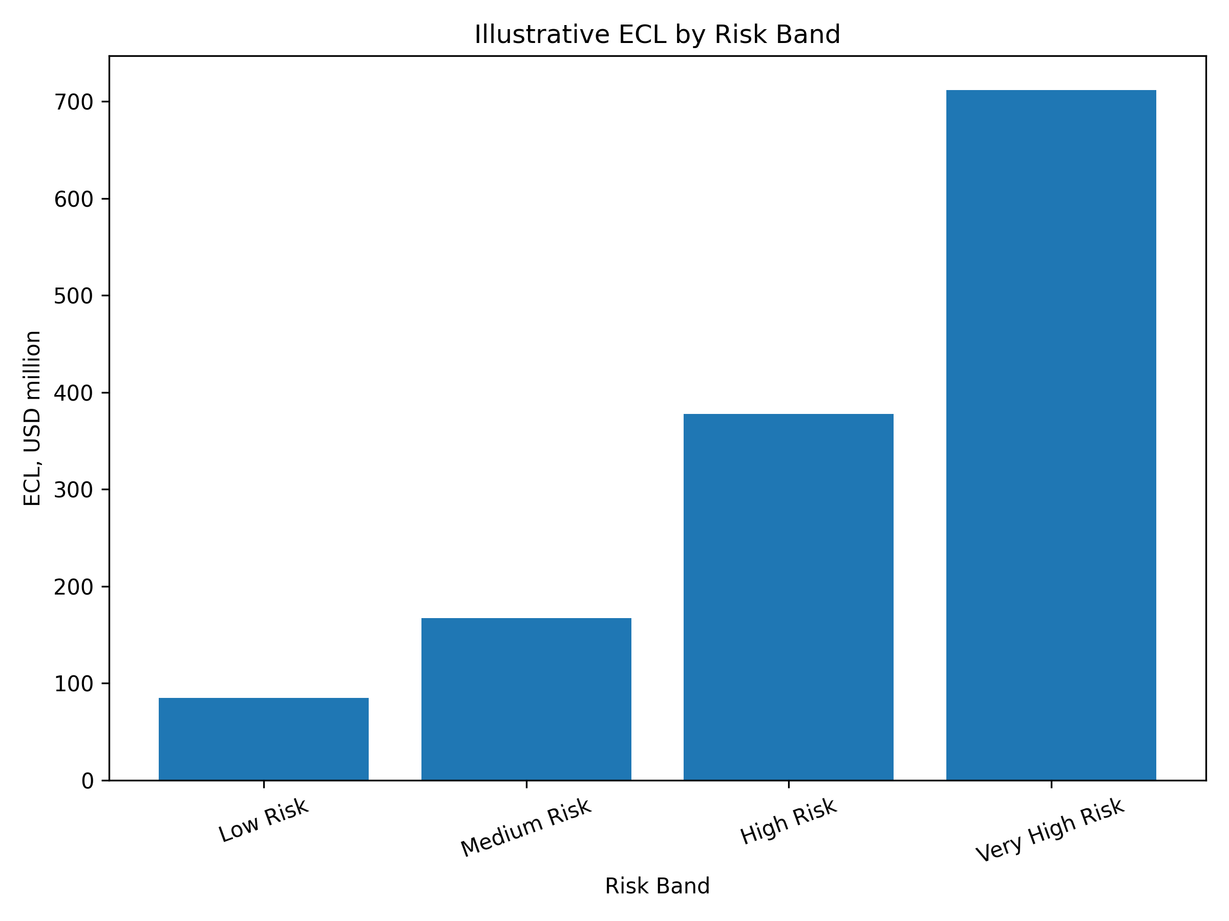
Figure 4. Illustrative ECL by risk band.

7. Stress Testing and Portfolio Impact
The stress framework applies scenario-level PD multipliers and LGD assumptions. The base case uses the calibrated ECL PD and a 45% LGD. Mild deterioration, adverse, and severe stress scenarios increase both PD and LGD. EAD is held constant to isolate credit-quality deterioration rather than balance-sheet growth effects.
Scenario | PD multiplier | LGD | Total ECL | ECL / exposure | Increase vs base
Base | 1.00x | 45.0% | USD 1.34bn | 22.6% | 0.0%
Mild Deterioration | 1.15x | 50.0% | USD 1.60bn | 26.9% | 19.2%
Adverse | 1.25x | 55.0% | USD 1.83bn | 30.9% | 36.5%
Severe Stress | 1.50x | 60.0% | USD 2.17bn | 36.5% | 61.4%
Table 6. Scenario ECL summary.
Under the severe stress scenario, total illustrative ECL rises from USD 1.34bn to USD 2.17bn, a 61.4% increase versus the base case. The result shows how a relatively simple PD-LGD-EAD engine can be used for management-style sensitivity analysis.
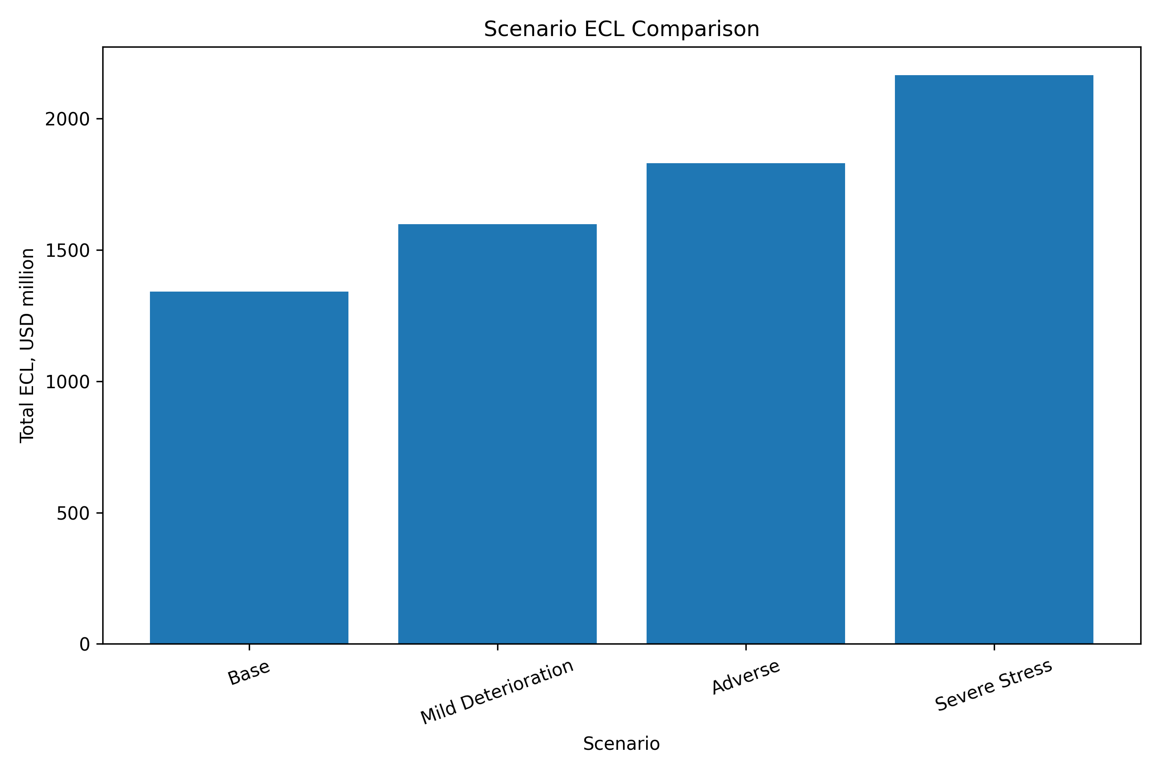
Figure 5. Scenario ECL comparison.

8. Model Stability and Strategy Simulation
The train-test PD score PSI is approximately 0.00002, which indicates no material distribution shift between the model development and holdout samples. This supports the stability of the score distribution in the holdout validation setup.
The threshold simulation is not an underwriting recommendation. It illustrates how a PD model can support risk strategy discussions by showing the trade-off between approval rate, retained exposure and the share of defaults captured in a review or rejection population. At a 20% PD threshold, the model approves 52.5% of loans, retains 47.3% of exposure and captures 71.1% of defaults in the rejected or manual-review segment.
PD threshold | Approval rate | Approved default rate | Exposure retained | Default capture in review/reject
10% | 20.2% | 6.6% | 18.8% | 93.7%
20% | 52.5% | 11.7% | 47.3% | 71.1%
30% | 77.5% | 15.8% | 71.4% | 42.4%
40% | 90.9% | 18.5% | 87.3% | 20.7%
50% | 97.3% | 20.3% | 96.1% | 7.0%
Table 7. Approval-threshold simulation summary.
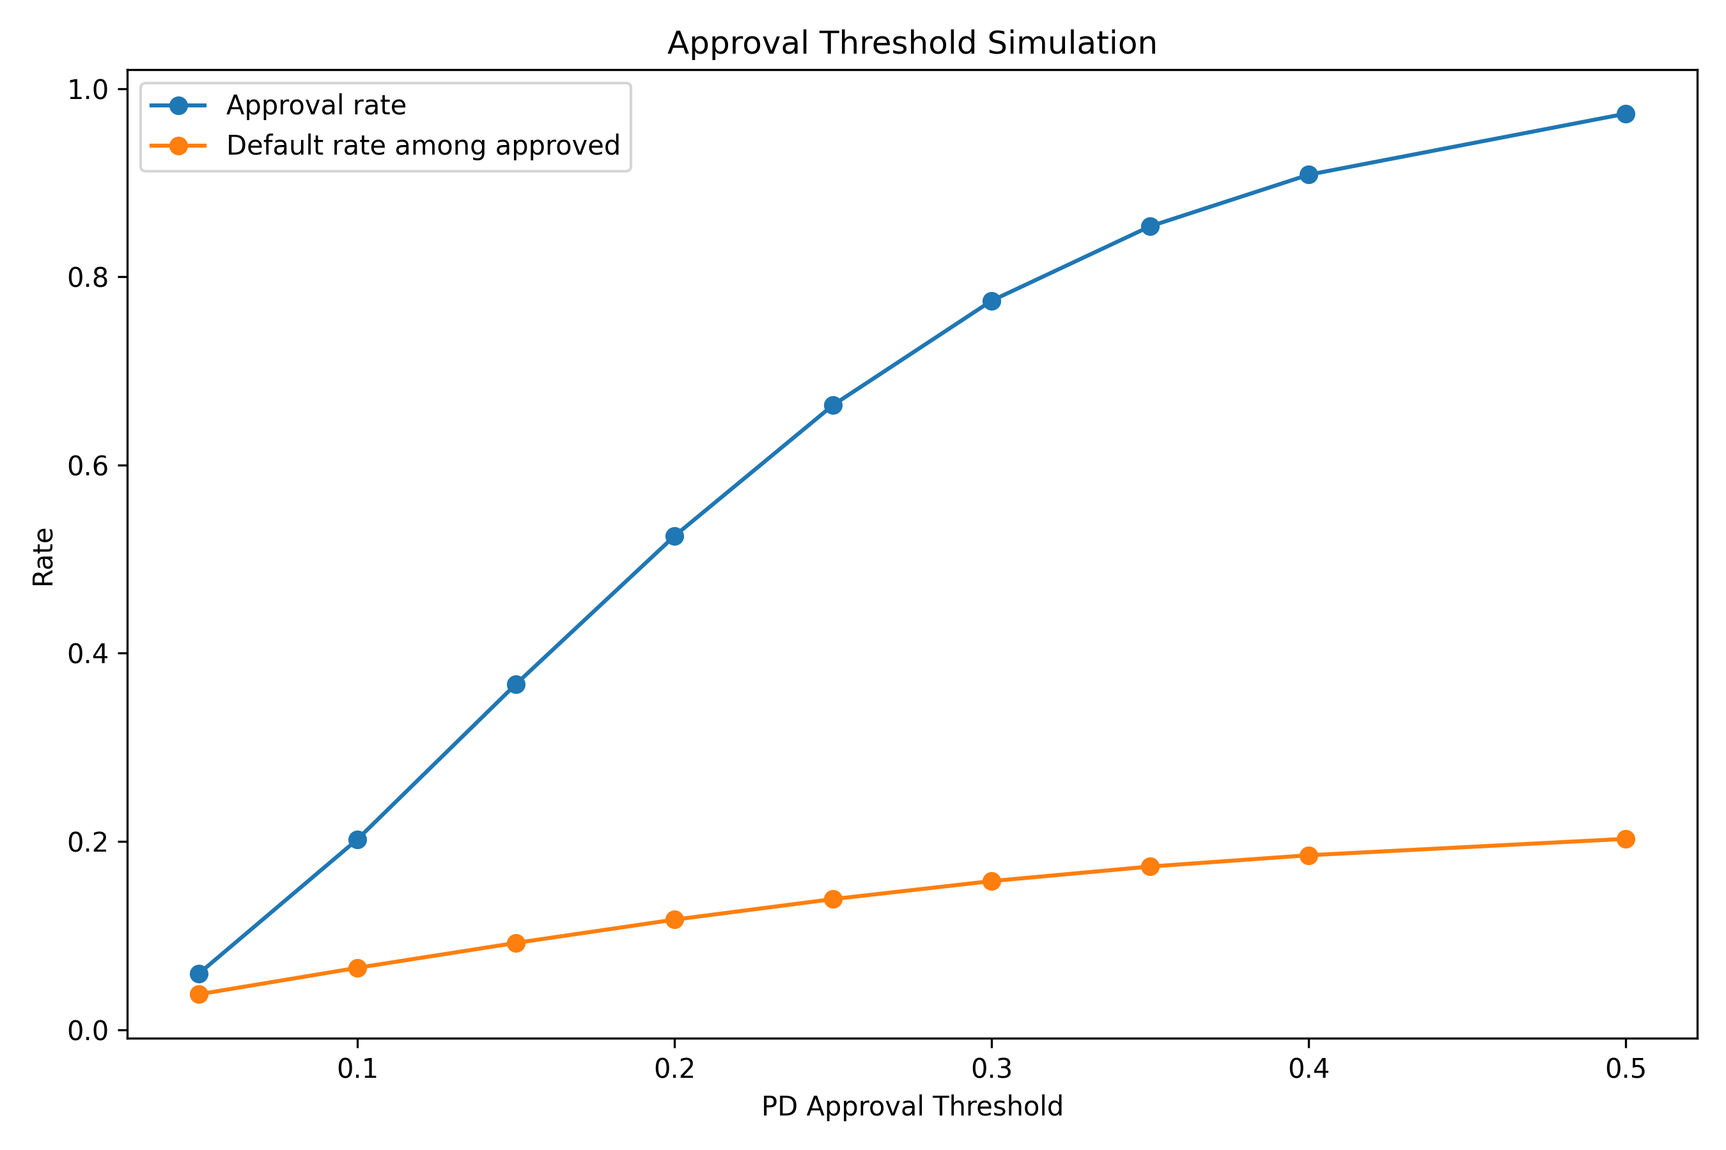
Figure 6. Approval threshold simulation.
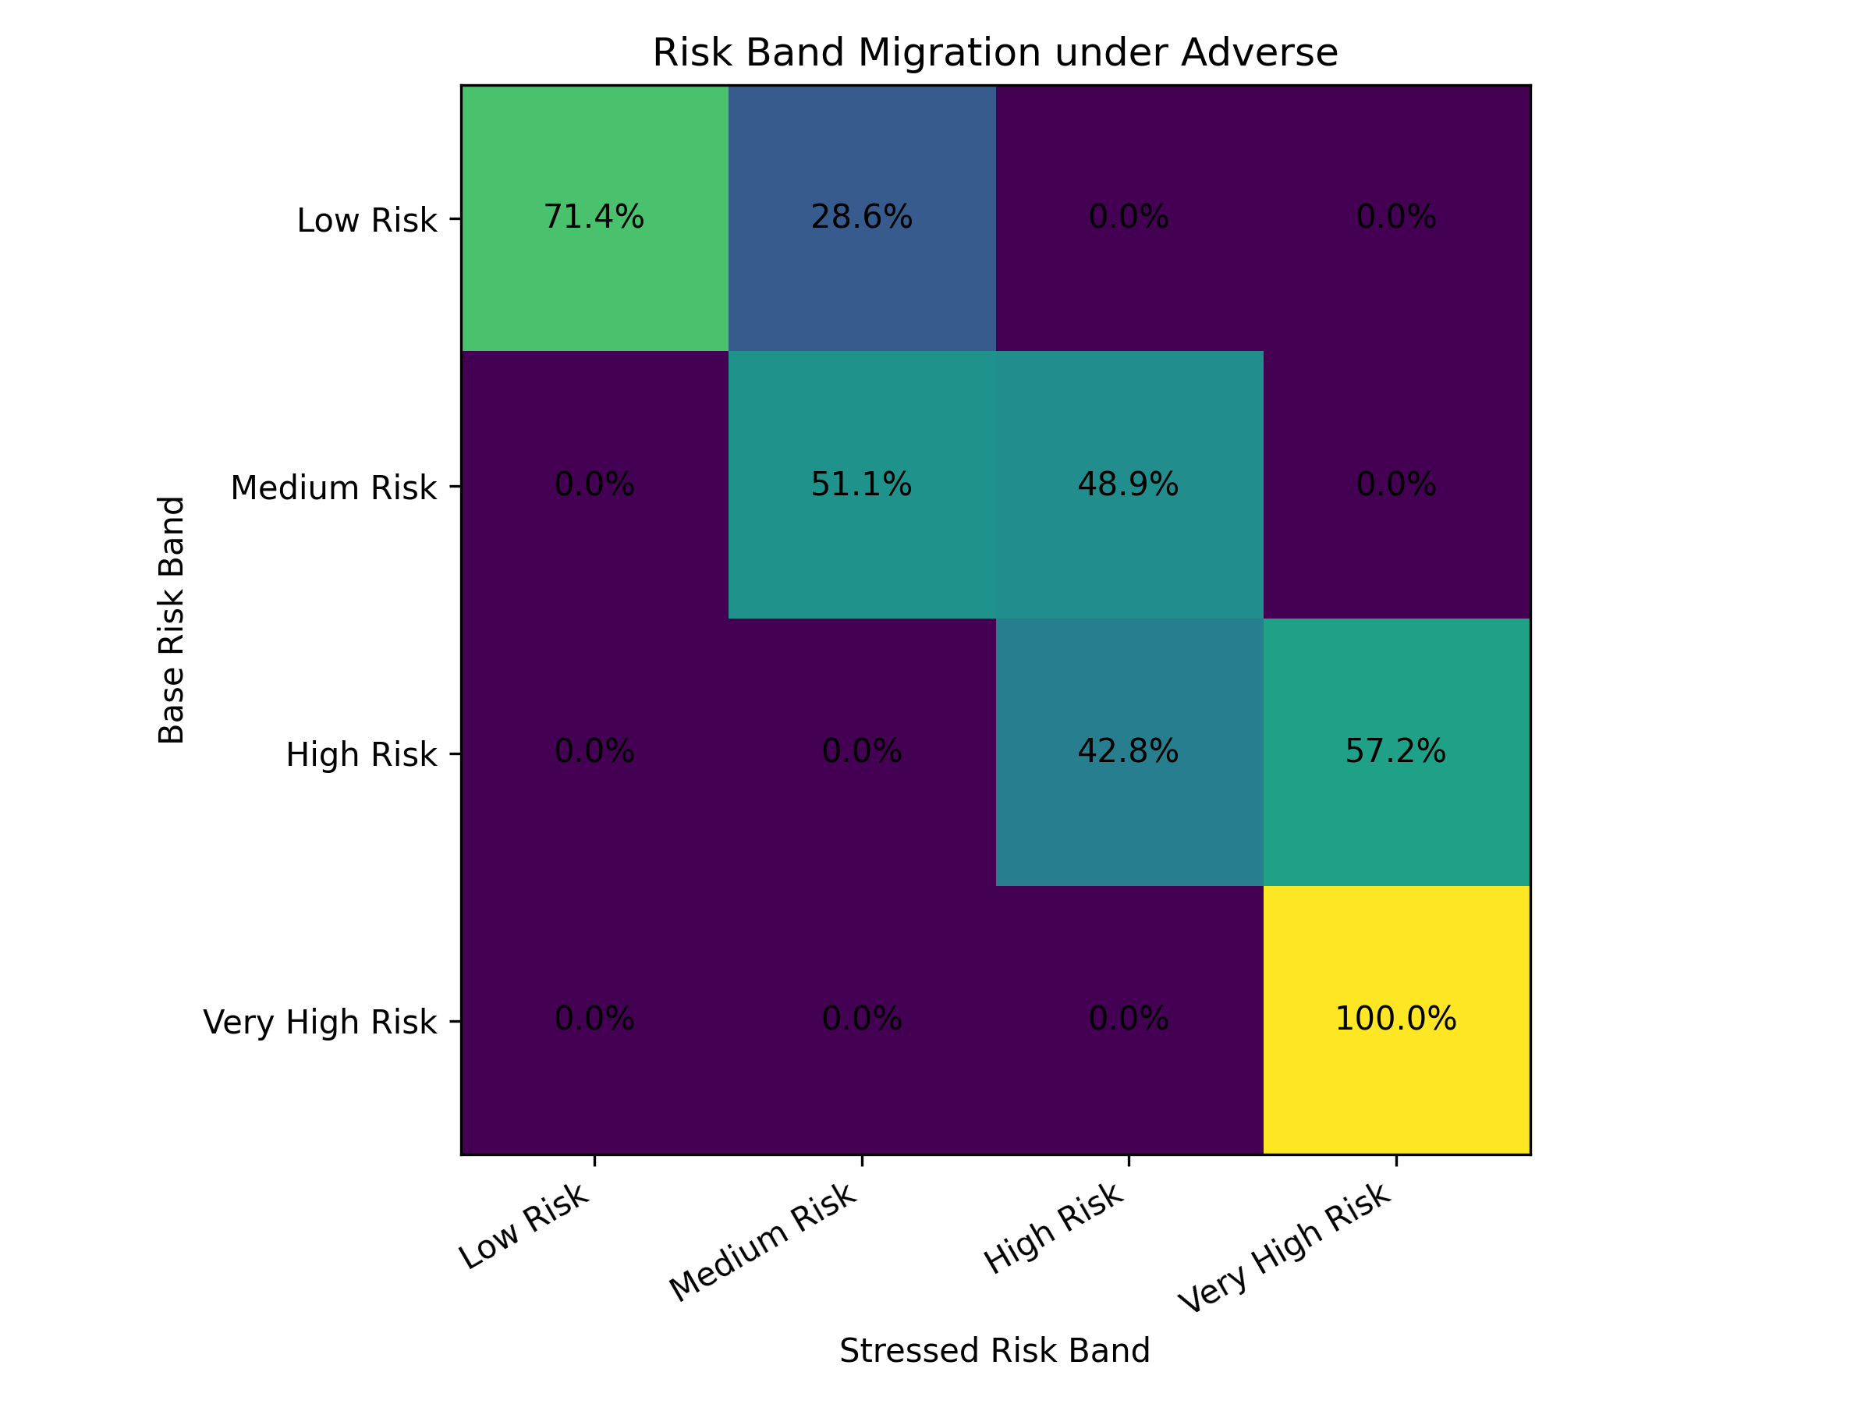
Figure 7. Risk band migration under adverse stress.

9. Turkey Macro-Sector Overlay
The Turkey overlay is included to connect the credit risk workflow to local banking-sector monitoring. It is not used as a model input because the core PD model is estimated on U.S. LendingClub borrower-level data. Instead, public BDDK loan and NPL indicators and TCMB macro variables are used as contextual indicators for how a similar framework would be read in a Turkish banking environment. The overlay demonstrates how the same PD/ECL monitoring logic could be contextualized for a Turkish banking portfolio if institution-level borrower data were available.
Indicator | Value
Latest selected date | 2026-05-08
Latest total NPL ratio | 2.78%
Latest consumer NPL ratio | 4.63%
Latest commercial NPL ratio | 2.18%
Latest SME NPL ratio | 3.61%
Latest coverage ratio | 75.42%
Latest policy rate | 37.00%
Latest CPI YoY | 32.37%
Total loan growth since first selected date | 41.93%
NPL growth since first selected date | 157.20%
Table 8. Turkey macro-sector overlay snapshot.
The selected Turkey overlay shows that total loans increased by 41.9% while NPL stock increased by 157.2% between the first selected date and 8 May 2026. The latest total NPL ratio is 2.78%, while the consumer NPL ratio is higher at 4.63%. This supports the relevance of portfolio monitoring, risk segmentation, stress testing, and ECL-style analysis for local credit-risk functions.
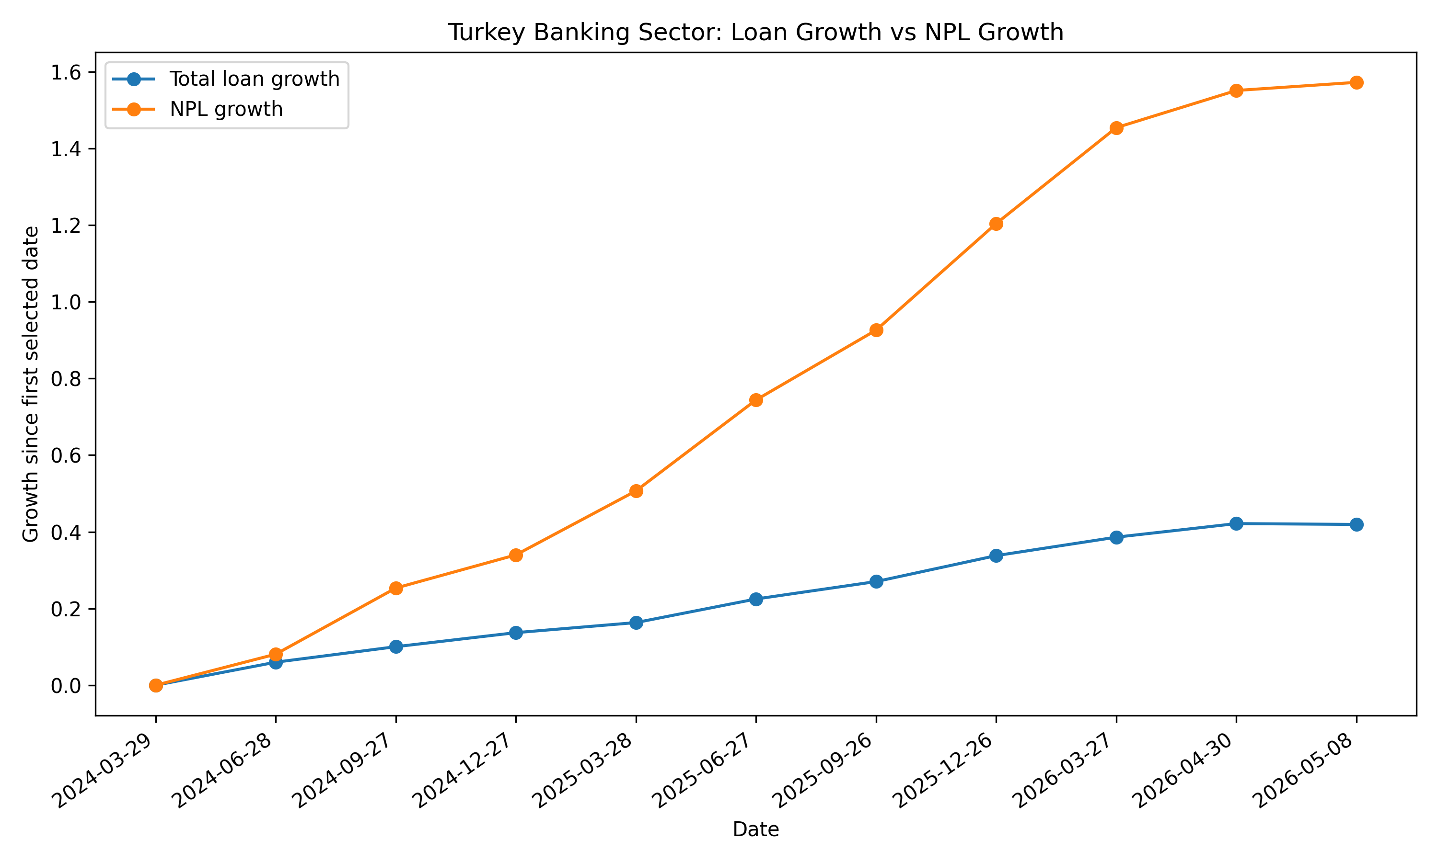
Figure 8. Turkey banking-sector loan growth versus NPL growth.
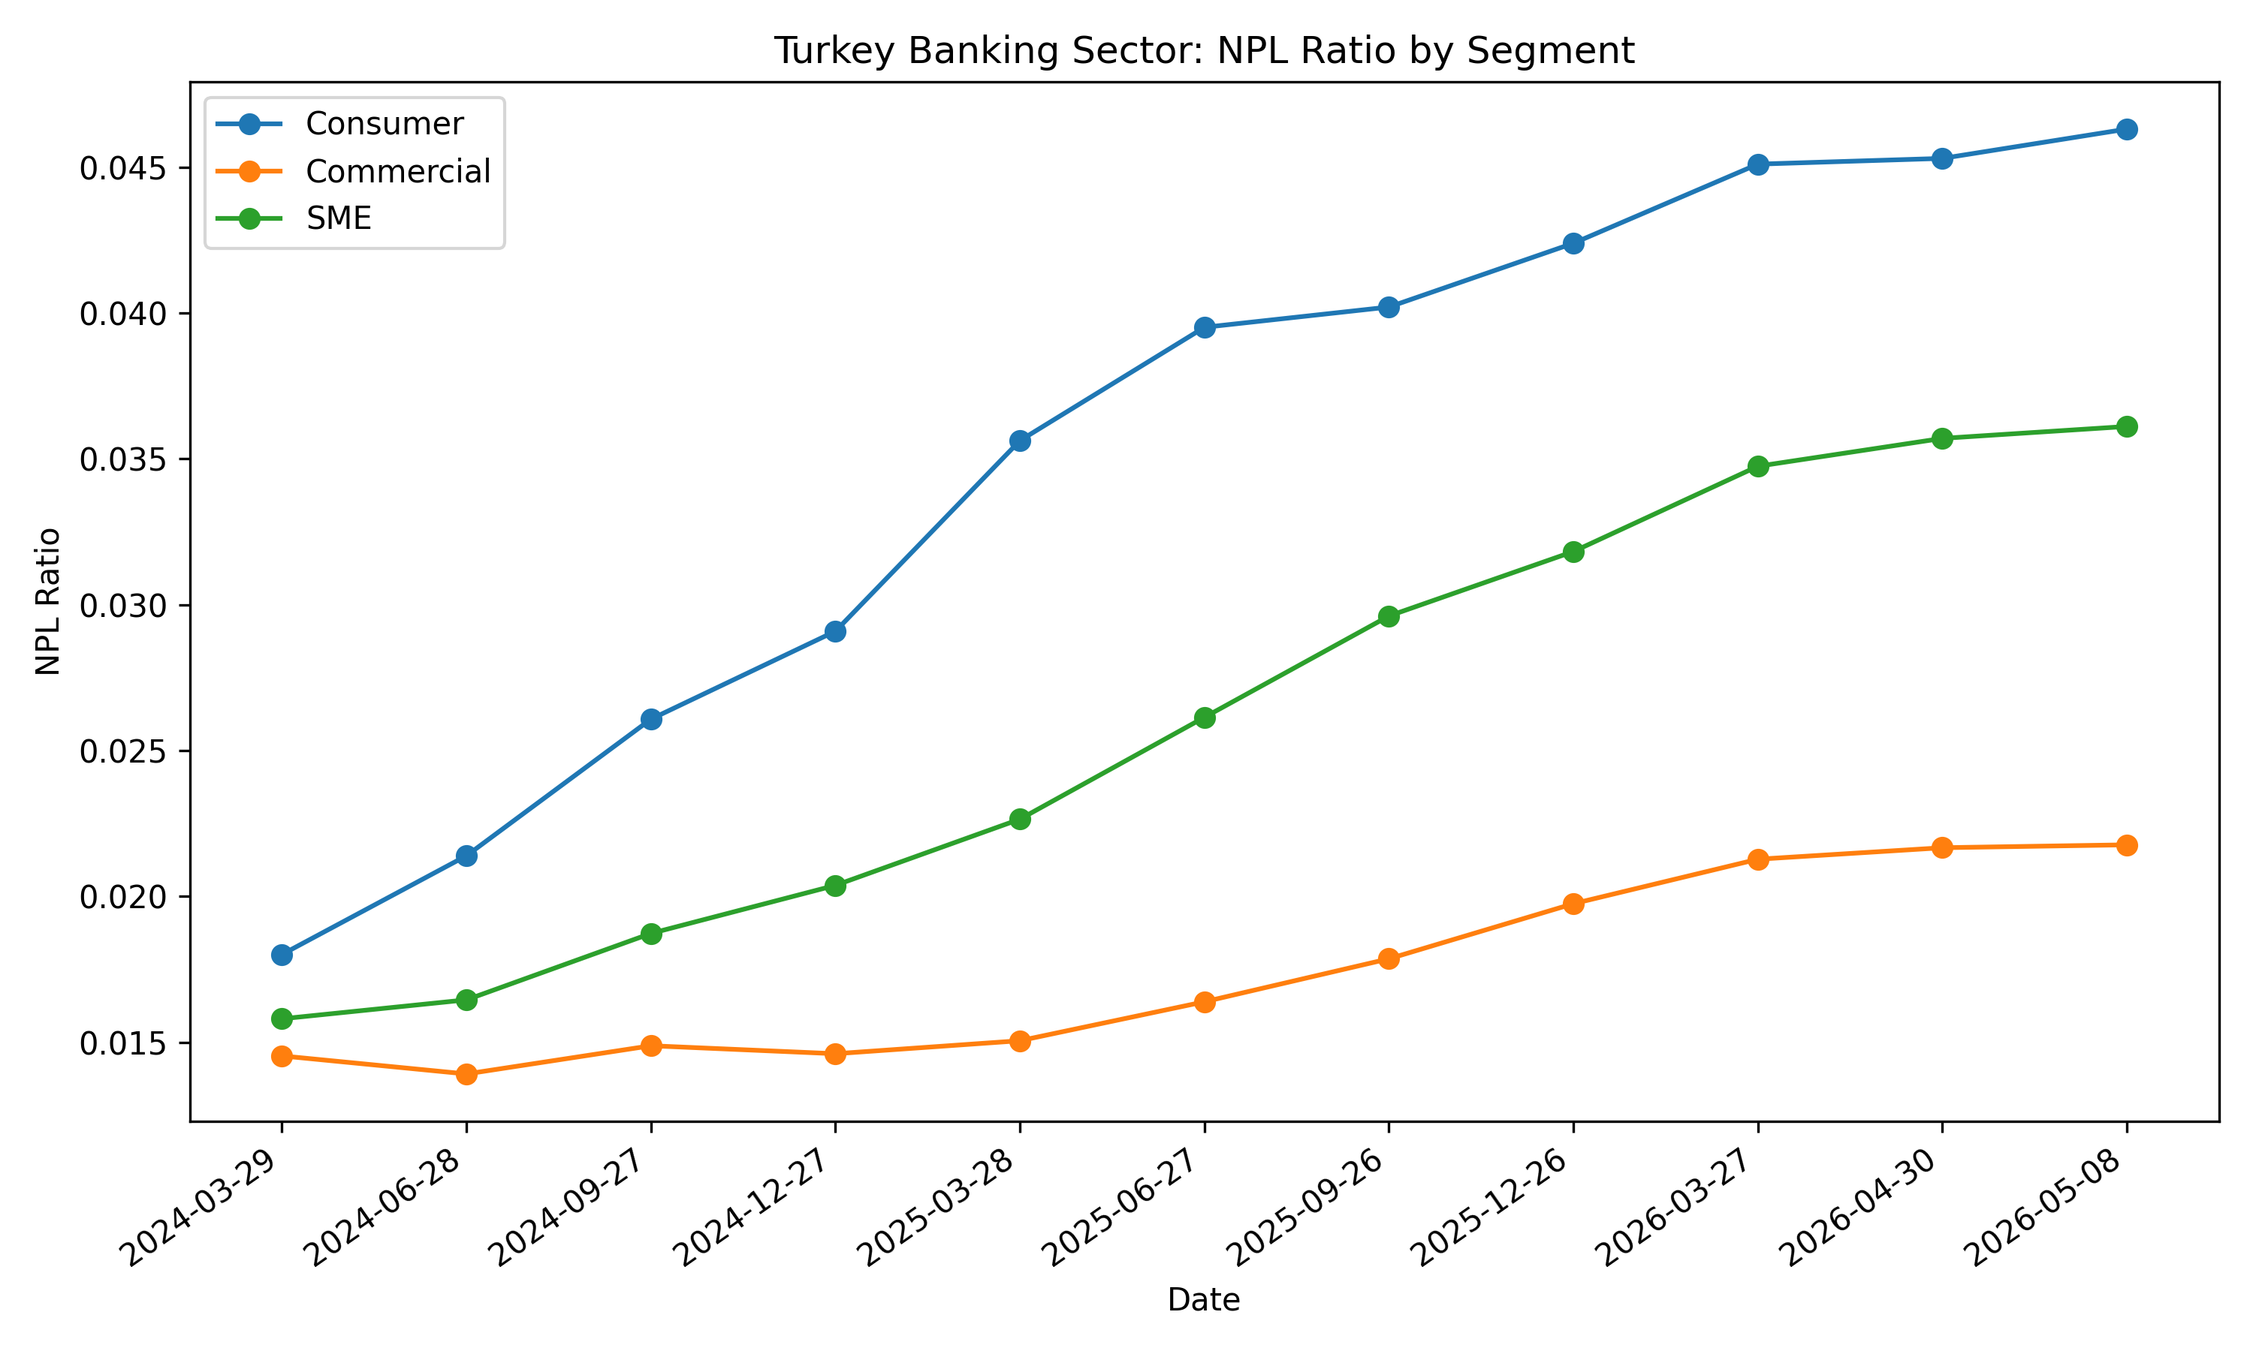
Figure 9. Turkey banking-sector NPL ratios by segment.

10. Conclusion and Application Relevance
The case demonstrates a practical credit risk analytics workflow: define a default outcome, build a leakage-controlled modeling dataset, estimate an interpretable PD model, benchmark against a challenger algorithm, validate discrimination and calibration, translate PDs into risk bands and illustrative ECL, and extend the model output into stress, strategy, and monitoring views.
The strongest application signal is the combination of calibrated PD modeling, transparent validation, expected-loss translation, portfolio concentration analysis, and management-style reporting. The project is deliberately conservative about what cannot be inferred from public data. It does not claim to reproduce a bank's internal IFRS 9 model, internal ratings-based model, production underwriting engine, or true regulatory ECL framework.
For credit risk analysts, risk methodologies, model validation, IFRS 9 analytics, credit portfolio monitoring, and financial services advisory roles, the project demonstrates how quantitative modeling and reporting skills can be applied to banking risk use cases with public data and reproducible Python workflows.

Appendix A - Additional Model Outputs
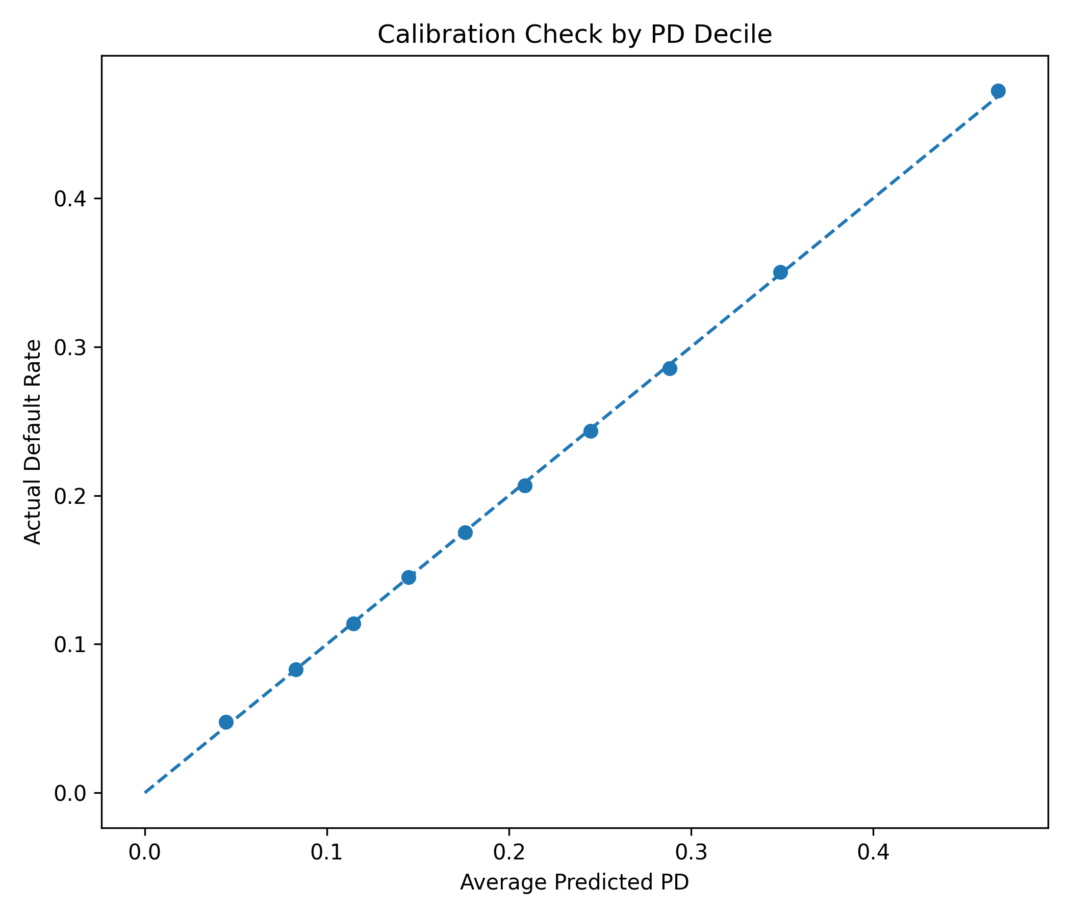
Appendix Figure A1. Calibration check by PD decile.
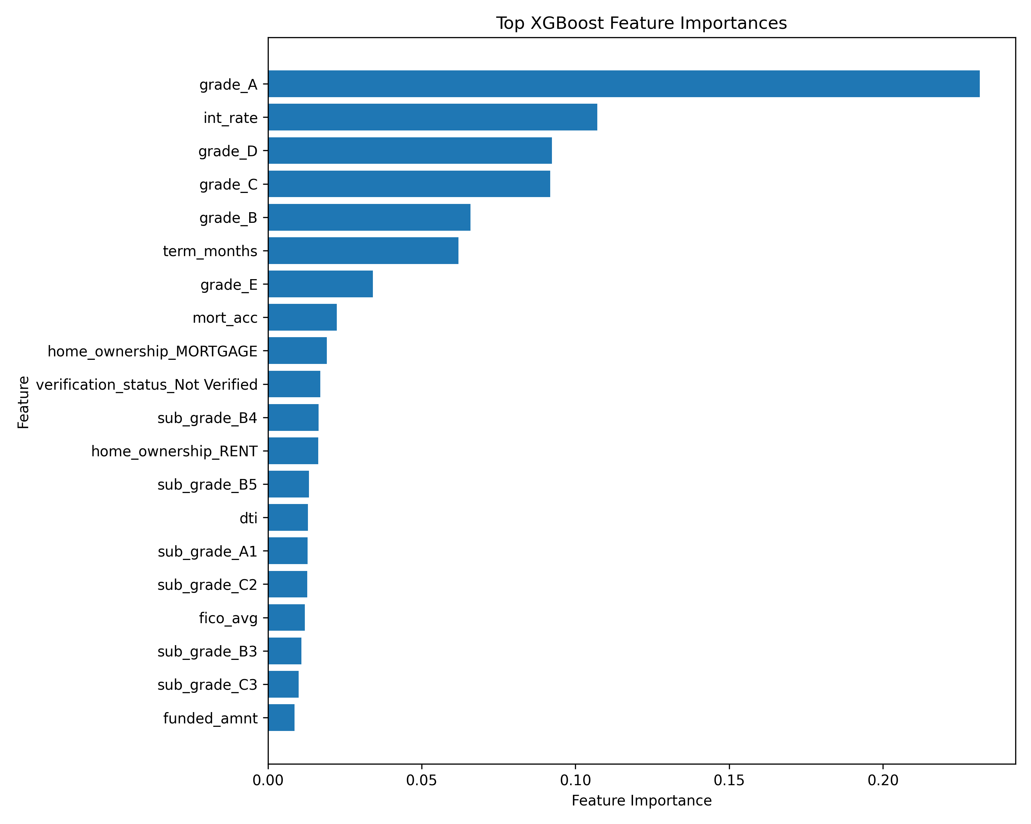
Appendix Figure A2. XGBoost challenger feature importance.
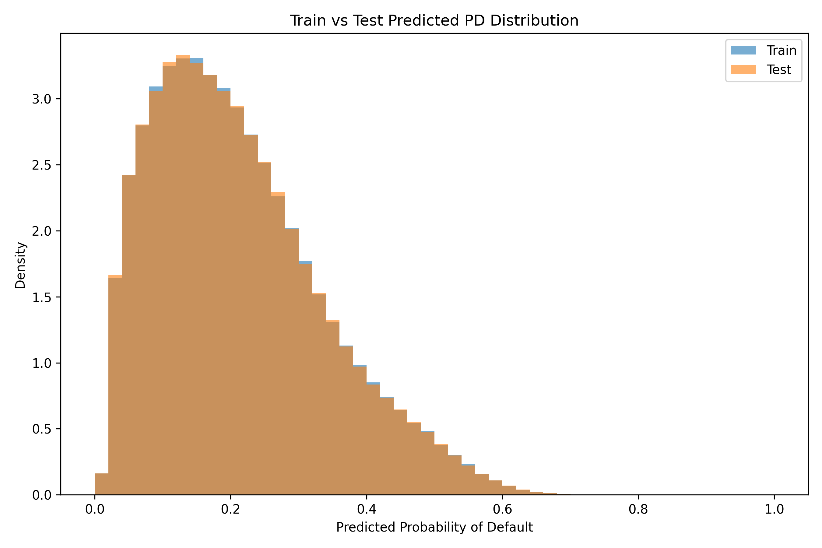
Appendix Figure A3. Train versus test predicted PD distribution.
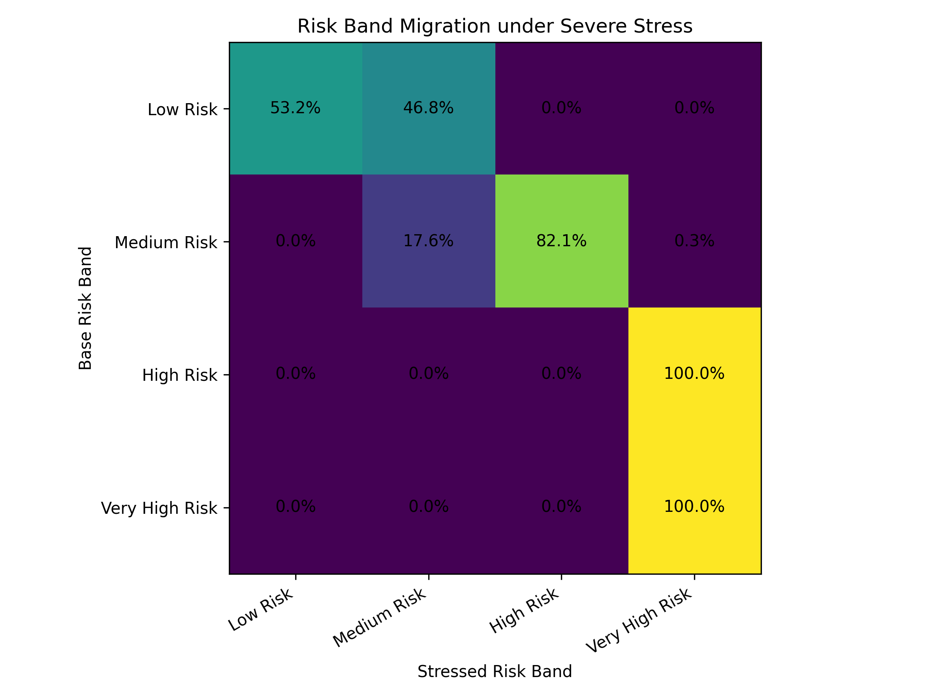
Appendix Figure A4. Risk band migration under severe stress.
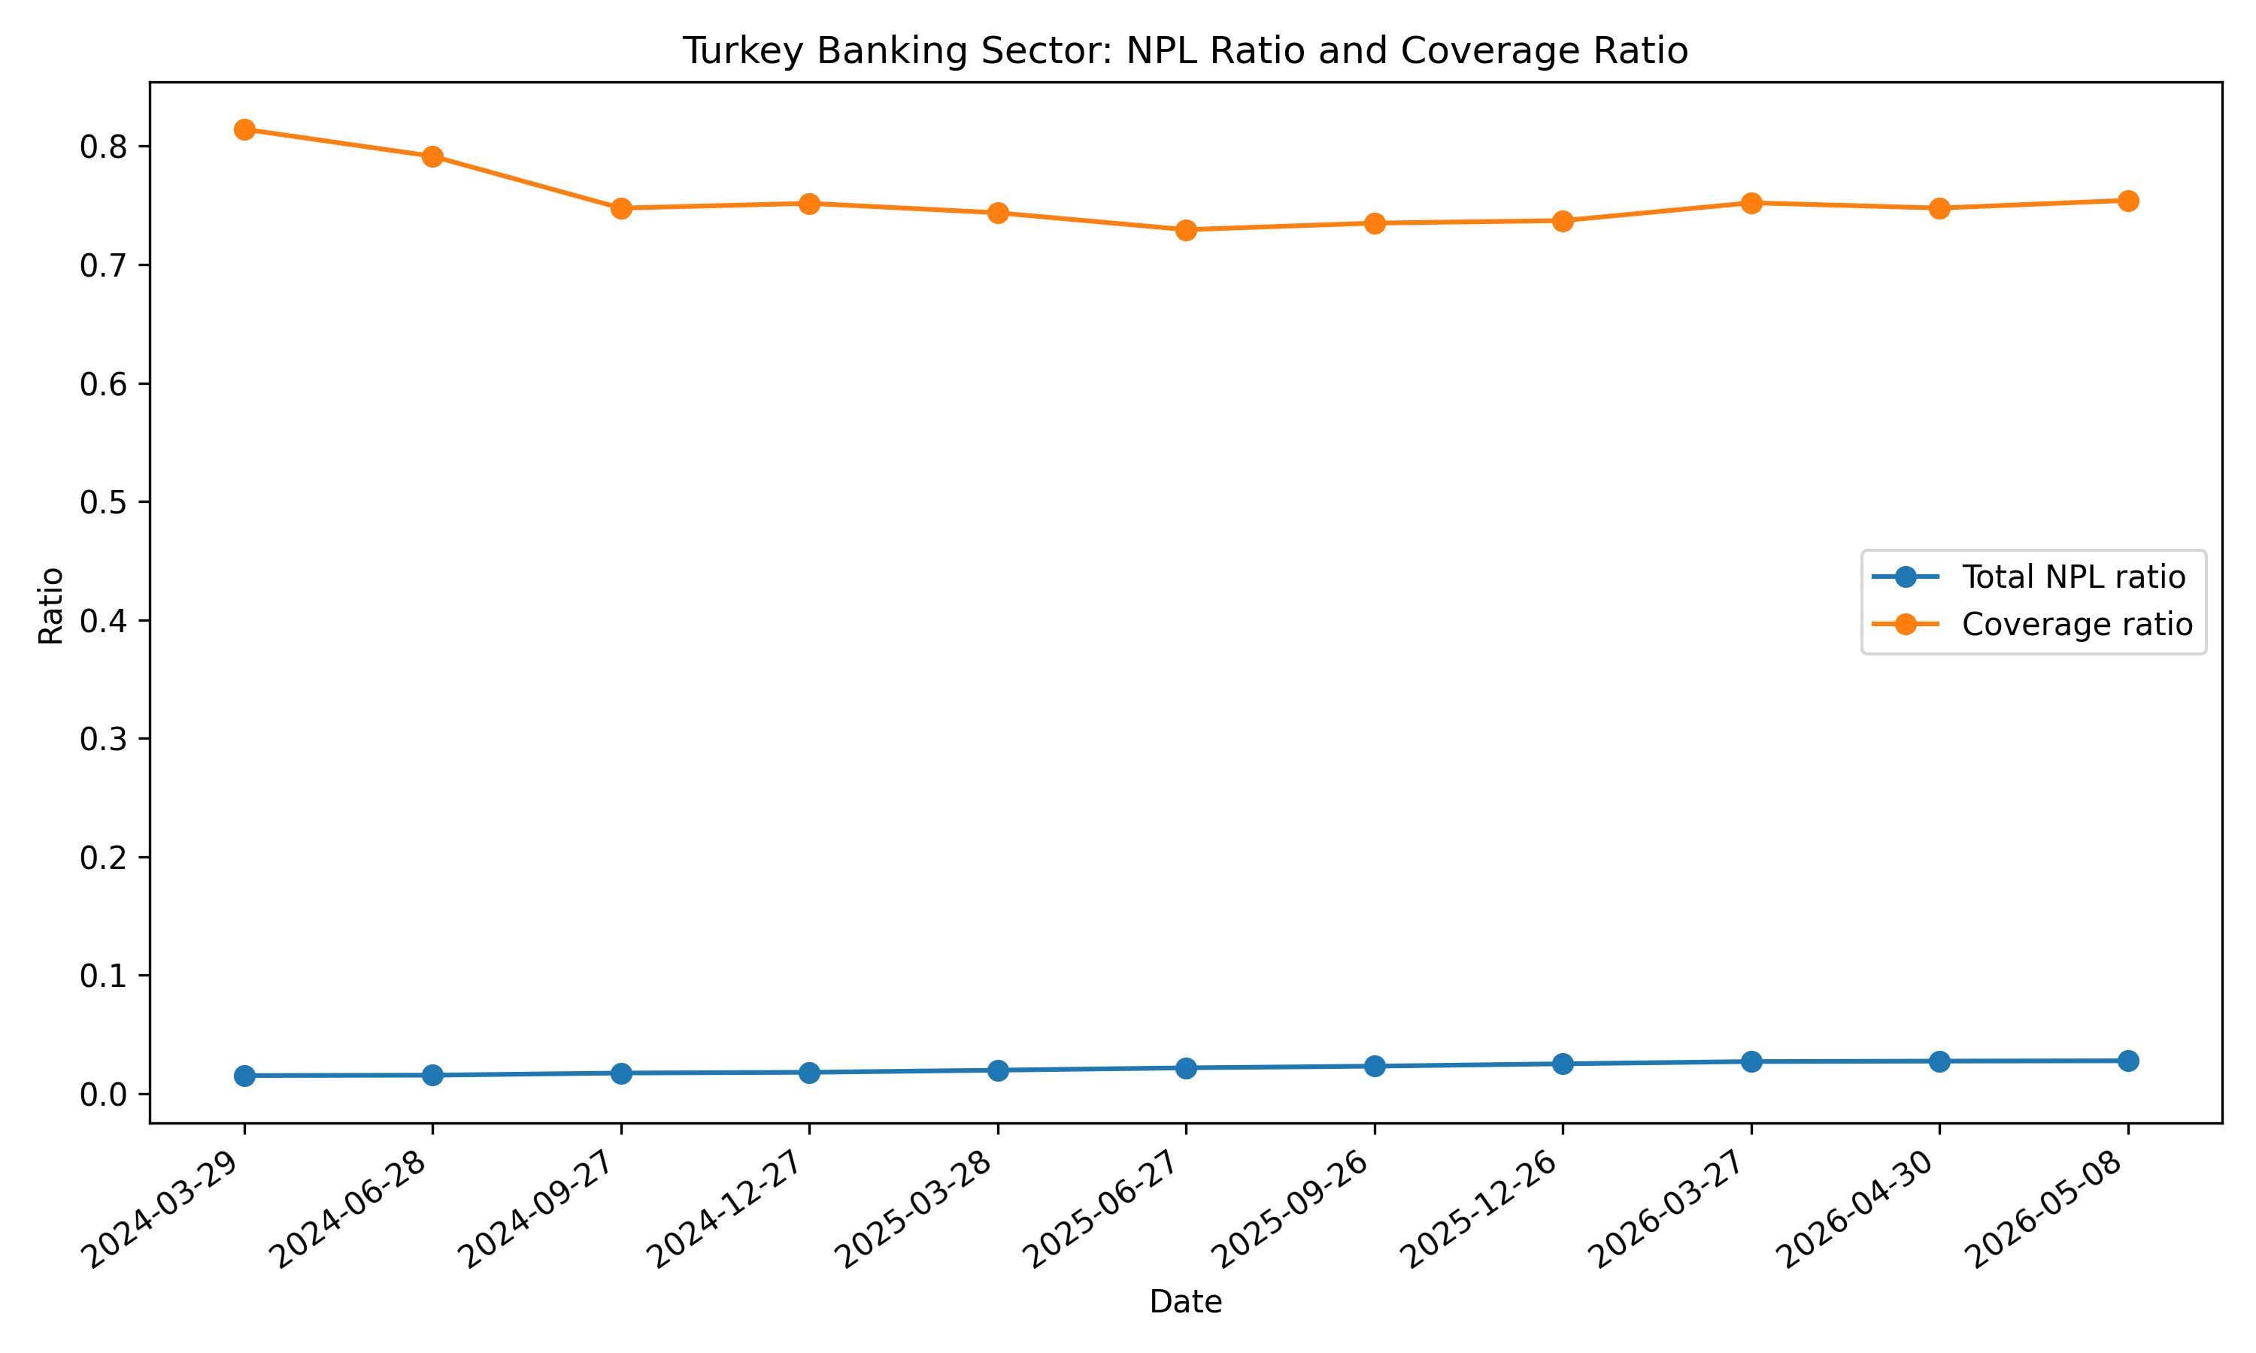
Appendix Figure A5. Turkey banking-sector total NPL ratio and coverage ratio.
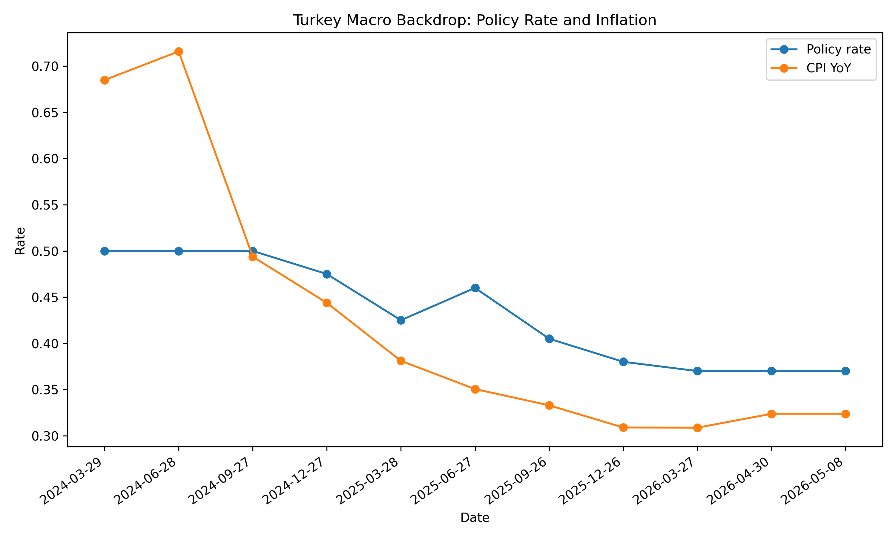
Appendix Figure A6. Turkey macro backdrop: policy rate and inflation.

Appendix B - Methodology and Caveats
Component | Construction | Caveat
PD model | Logistic regression primary model; XGBoost challenger | Public loan-level data; not a production underwriting model
Default definition | Charged-off, default and late 31-120 day loans treated as bad | Resolved-loan sample; current loans excluded
EAD proxy | Funded amount | Simplified exposure-at-default proxy
LGD assumption | 45% base; 50%-60% under stress | Assumed due to absence of internal recovery and collateral data
Stage proxy | Risk-band and observed-default based Stage 1/2/3 approximation | Illustrative IFRS 9-style framework only
PSI | Train-test PD score distribution comparison | Stability checks within the sampled holdout design
Turkey overlay | BDDK loan/NPL indicators and TCMB policy/inflation variables | Contextual only; not used as model features
Appendix Table B1. Methodology summary and caveats.

