Multi-Asset Portfolio Analysis: Türkiye Case Study
ENES SARI
Independent Portfolio Analytics Project

Executive Summary
This project evaluates a simple Türkiye-focused multi-asset framework using four asset proxies: GAU/TRY (gold), USD/TRY (FX), BIST 30 Futures (equity), and an HST bond fund (fixed income proxy). The analysis covers the common sample from 2 May 2023 to 29 April 2026 and compares both individual assets and three model portfolios.
At the asset level, GAU/TRY delivered the strongest annualized return (74.67%), while BIST 30 Futures was the most volatile asset (32.55%). The HST Bond Fund combined the lowest volatility (6.37% ) with the strongest standalone return-to-volatility ratio (4.81).
At the portfolio level, FX & Gold Hedge Tilt produced the highest annualized return (46.97%), whereas Conservative / Pension-like delivered the strongest risk-adjusted profile with the lowest annualized volatility (8.29%), the shallowest maximum drawdown (-5.16%), and the highest return-to-volatility ratio (4.98).
Scenario analysis reinforces the portfolio differentiation. The FX & Gold Hedge Tilt performs best under TRY depreciation and fixed-income stress, while the Conservative / Pension-like portfolio is most resilient during an equity drawdown. Under a more supportive risk-on / disinflation environment, the Balanced portfolio shows the strongest upside among the three stress-tested portfolios.
Historical VaR / Expected Shortfall metrics and an illustrative Monte Carlo simulation point to the same broad conclusion: a more defensive allocation sacrifices some upside but provides superior downside protection, while a hedge-oriented allocation captures more upside in inflation / depreciation-sensitive settings.

1. Objective and Data
The objective is to build a compact but credible multi-asset portfolio analysis that demonstrates data handling, portfolio construction, risk-return analysis, stress testing, and presentation of investment-relevant findings.
Asset Class | Proxy | Role in Analysis
Gold | GAU/TRY | Inflation and depreciation hedge
FX | USD/TRY | TRY depreciation exposure / portfolio hedge
Equity | BIST 30 Futures | Risk asset / growth exposure
Fixed Income | HST Bond Fund | Defensive / stabilizing allocation
Sample period: 02 May 2023 to 29 Apr 2026. Total common price observations: 750. Daily returns are calculated from cleaned price/NAV series and annualized using 252 trading days.

2. Methodology
The analysis proceeds in five steps: (i) clean and harmonize the four time series, (ii) compute daily returns and annualized risk-return statistics, (iii) construct three model portfolios with different allocation profiles, (iv) evaluate scenario impacts and historical downside risk, and (v) run an illustrative 1-year Monte Carlo simulation.
Risk metrics include annualized volatility, maximum drawdown, historical Value-at-Risk (VaR), and Expected Shortfall (ES). Dynamic monitoring is supplemented with 60-day rolling volatility and rolling correlation measures.
The three model portfolios are intentionally simple. They are designed to illustrate different allocation logics rather than optimize weights through an efficient frontier approach.

3. Portfolio Construction
Portfolio | GAU/TRY | USD/TRY | BIST 30 Futures | HST Bond Fund
Balanced Multi-Asset | 15.00% | 20.00% | 35.00% | 30.00%
Conservative / Pension-like | 15.00% | 15.00% | 20.00% | 50.00%
FX & Gold Hedge Tilt | 25.00% | 30.00% | 25.00% | 20.00%
Balanced multi-asset aims to distribute risk more evenly across asset classes. Conservative / Pension-like prioritizes capital preservation with a heavier fixed-income allocation. FX & Gold Hedge Tilt increases protection against inflation and TRY weakness.

4. Asset-Level Performance
Asset | Annualized Return | Annualized Volatility | Max Drawdown | Return / Volatility
GAU/TRY | 74.67% | 21.17% | -19.05% | 3.53
USD/TRY | 32.79% | 8.38% | -5.17% | 3.91
BIST 30 Futures | 44.84% | 32.55% | -24.32% | 1.38
HST Bond Fund | 30.62% | 6.37% | -6.81% | 4.81

Figure 1. Asset performance indexed to 100.
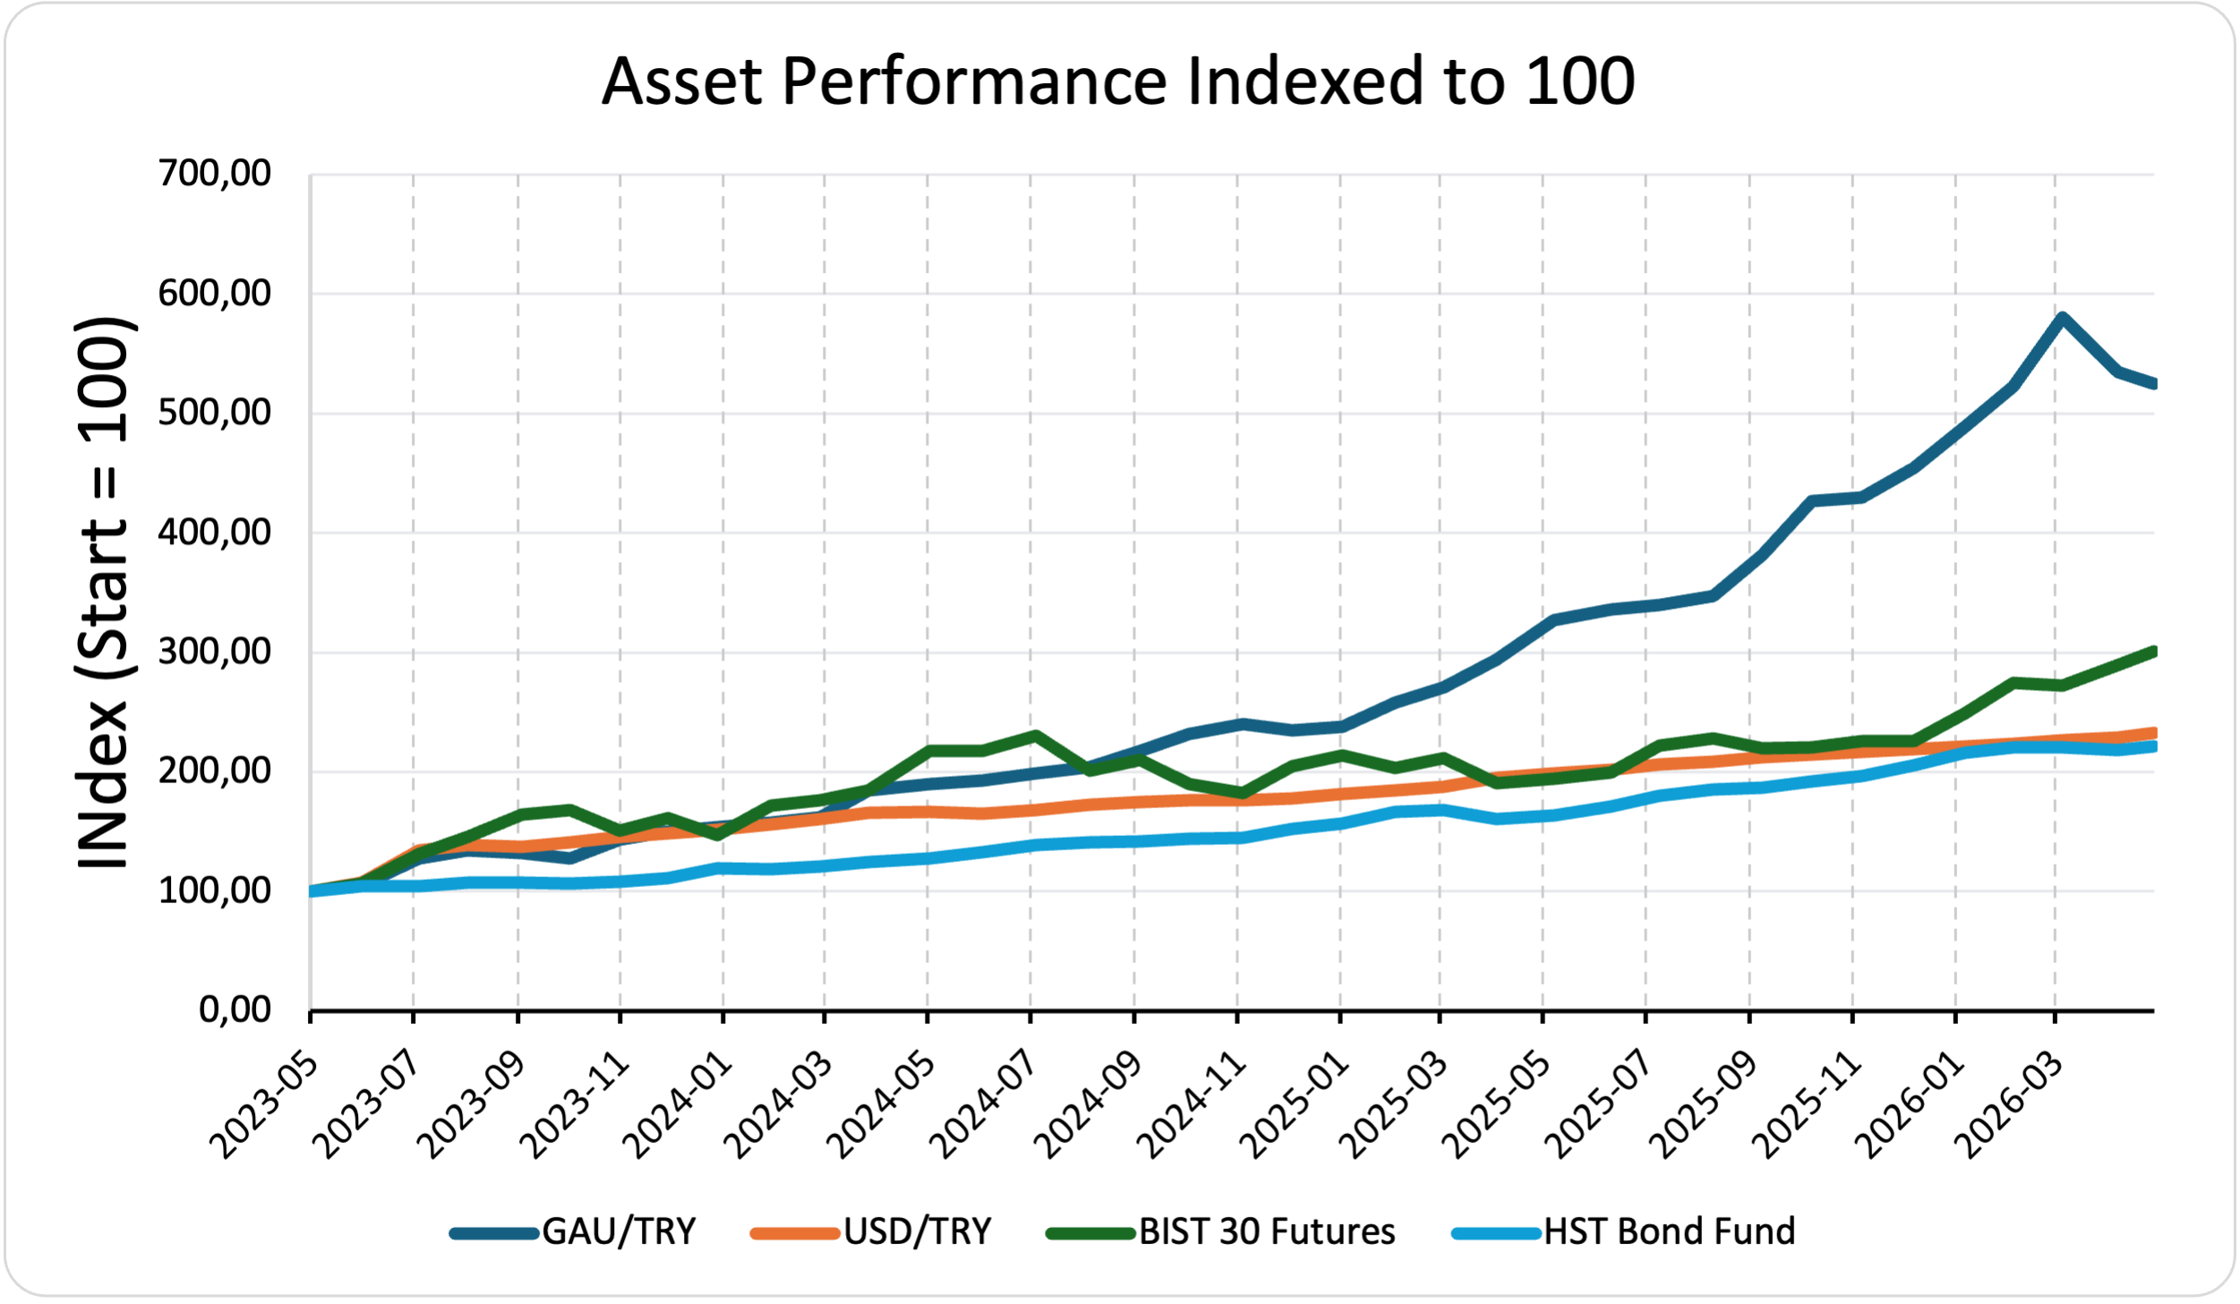
Gold (GAU/TRY) clearly dominates cumulative performance over the sample, while BIST 30 Futures offers strong nominal return but with the largest volatility and drawdown. USD/TRY and the HST Bond Fund exhibit lower drawdowns and help explain why diversified portfolios perform much more smoothly than a single-asset allocation.

5. Portfolio Performance and Risk-Return Trade-Off
Portfolio | Annualized Return | Annualized Volatility | Max Drawdown | Return / Volatility
Balanced Multi-Asset | 44.13% | 12.41% | -7.03% | 3.56
Conservative / Pension-like | 41.32% | 8.29% | -5.16% | 4.98
FX & Gold Hedge Tilt | 46.97% | 10.70% | -5.94% | 4.39

Figure 2. Model portfolio performance indexed to 100.
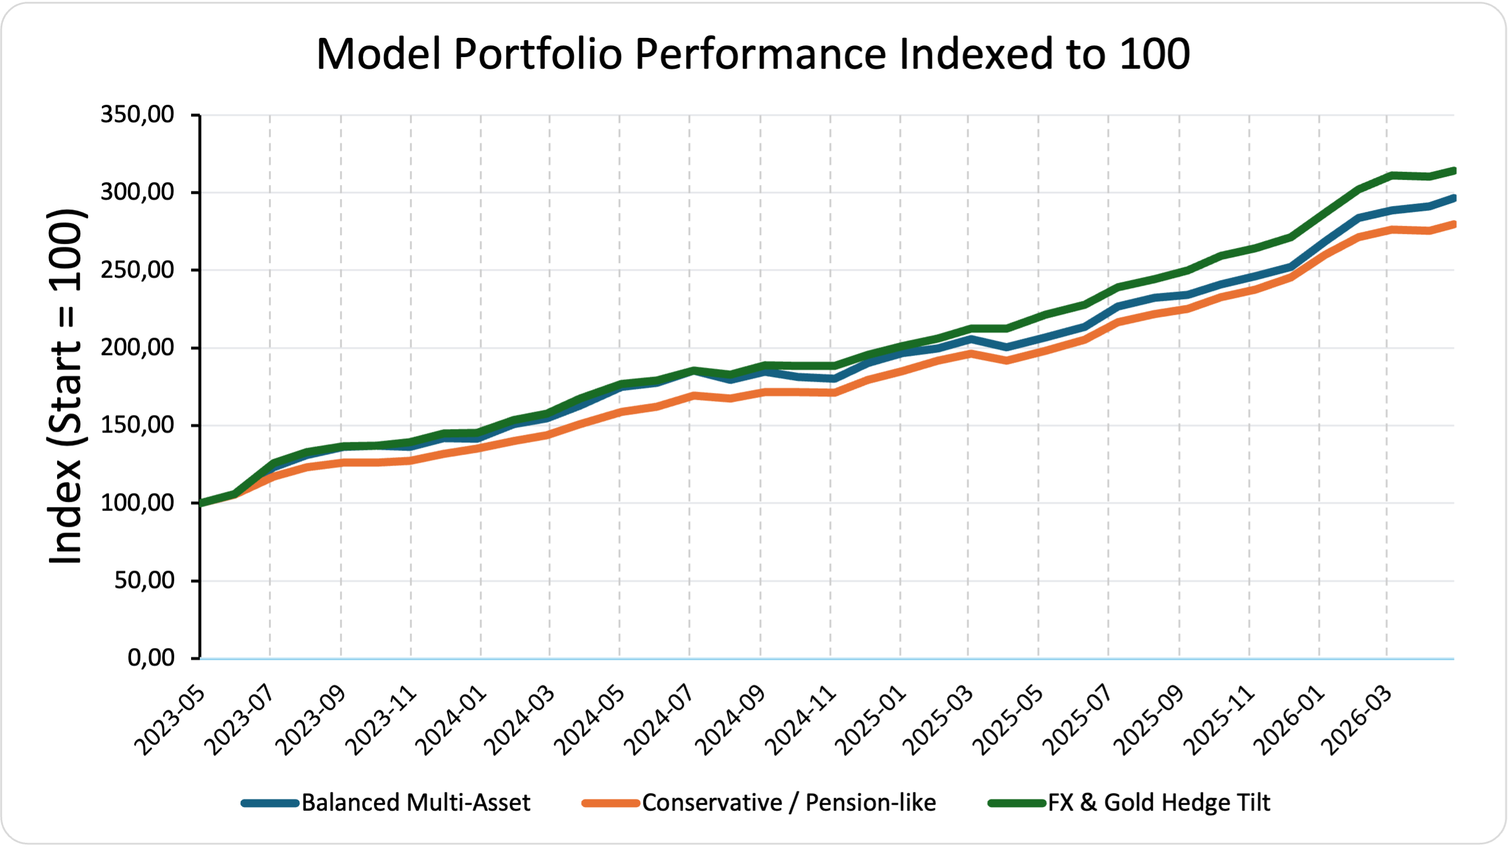
Figure 3. Portfolio drawdowns.
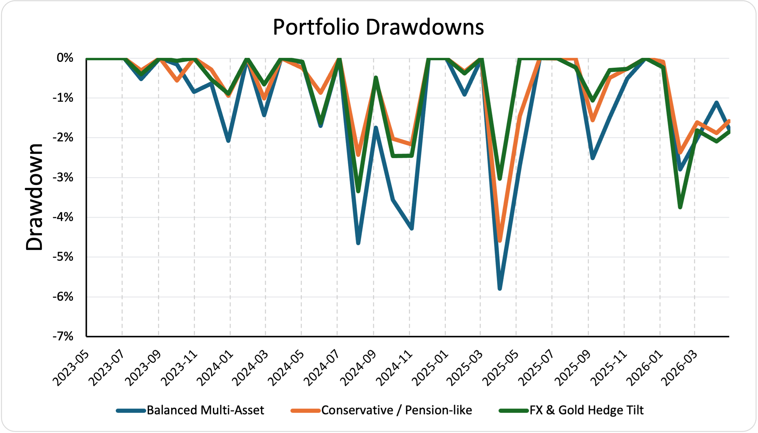
Figure 4. Risk-return map for assets and model portfolios.
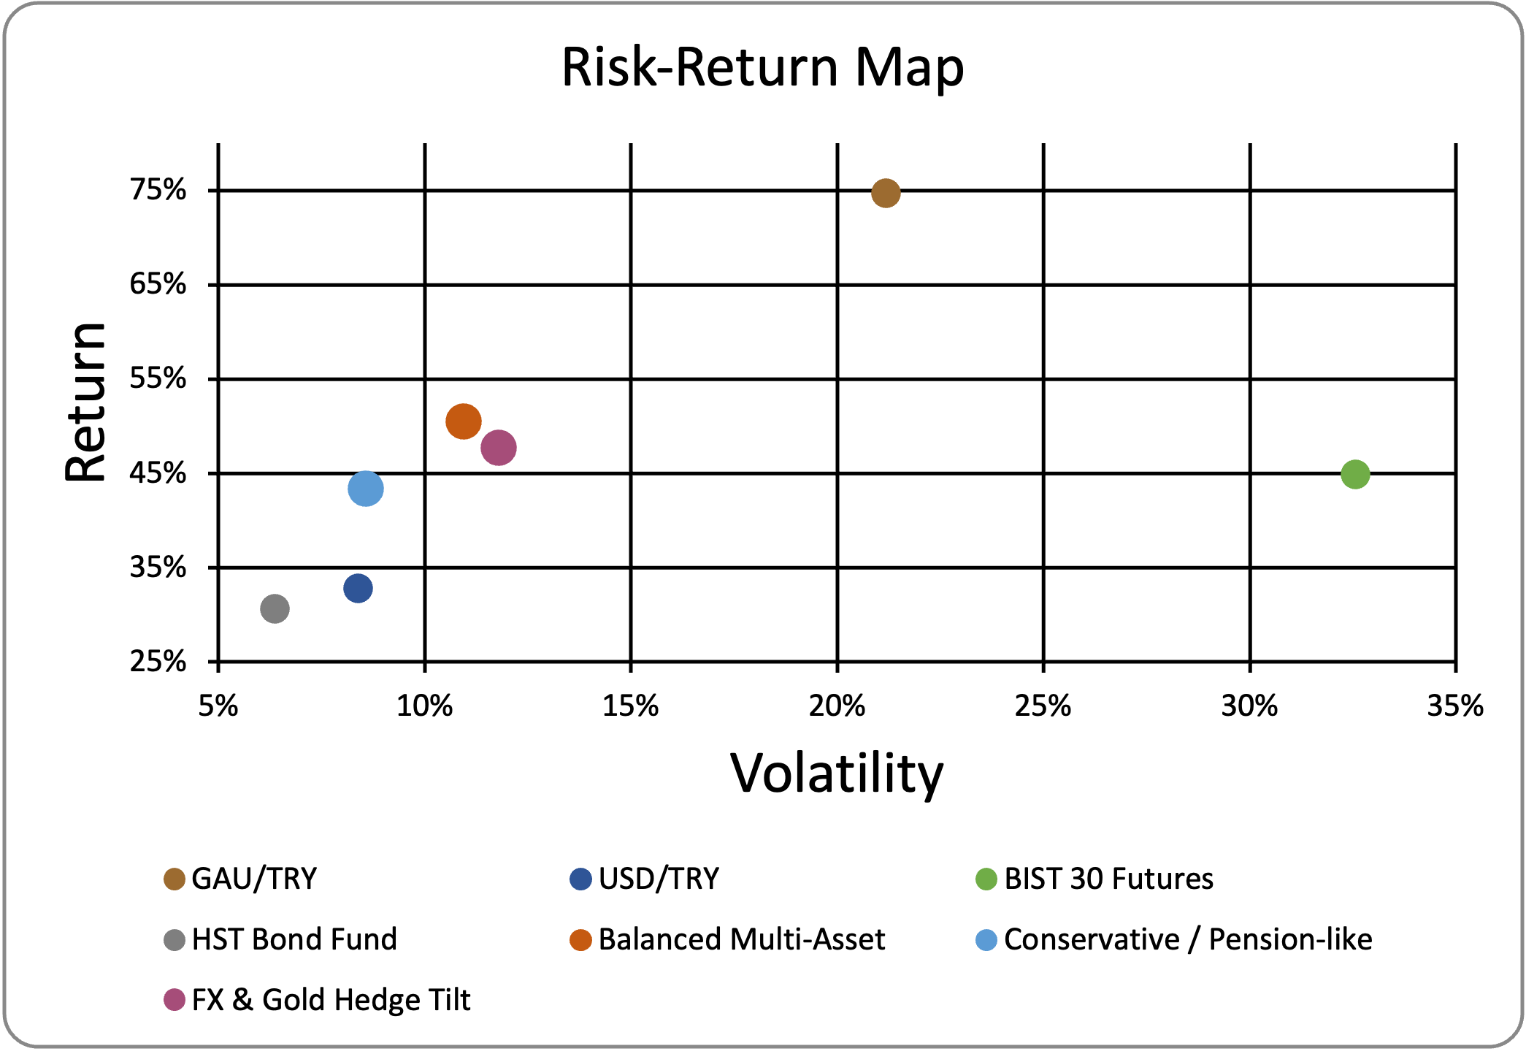

6. Scenario and Stress Testing
Scenario | Balanced Multi-Asset | Conservative / Pension-like | FX & Gold Hedge Tilt
Base Case | 42.64% | 40.40% | 45.84%
TRY Depreciation Shock | 8.15% | 6.20% | 11.55%
Equity Drawdown Shock | -5.05% | -1.30% | -0.95%
Rate-Sensitive Fixed Income Stress | -1.40% | -1.90% | 1.80%
Risk-On / Disinflation | 8.10% | 7.15% | 5.20%
Figure 5. Portfolio impact under alternative scenarios.
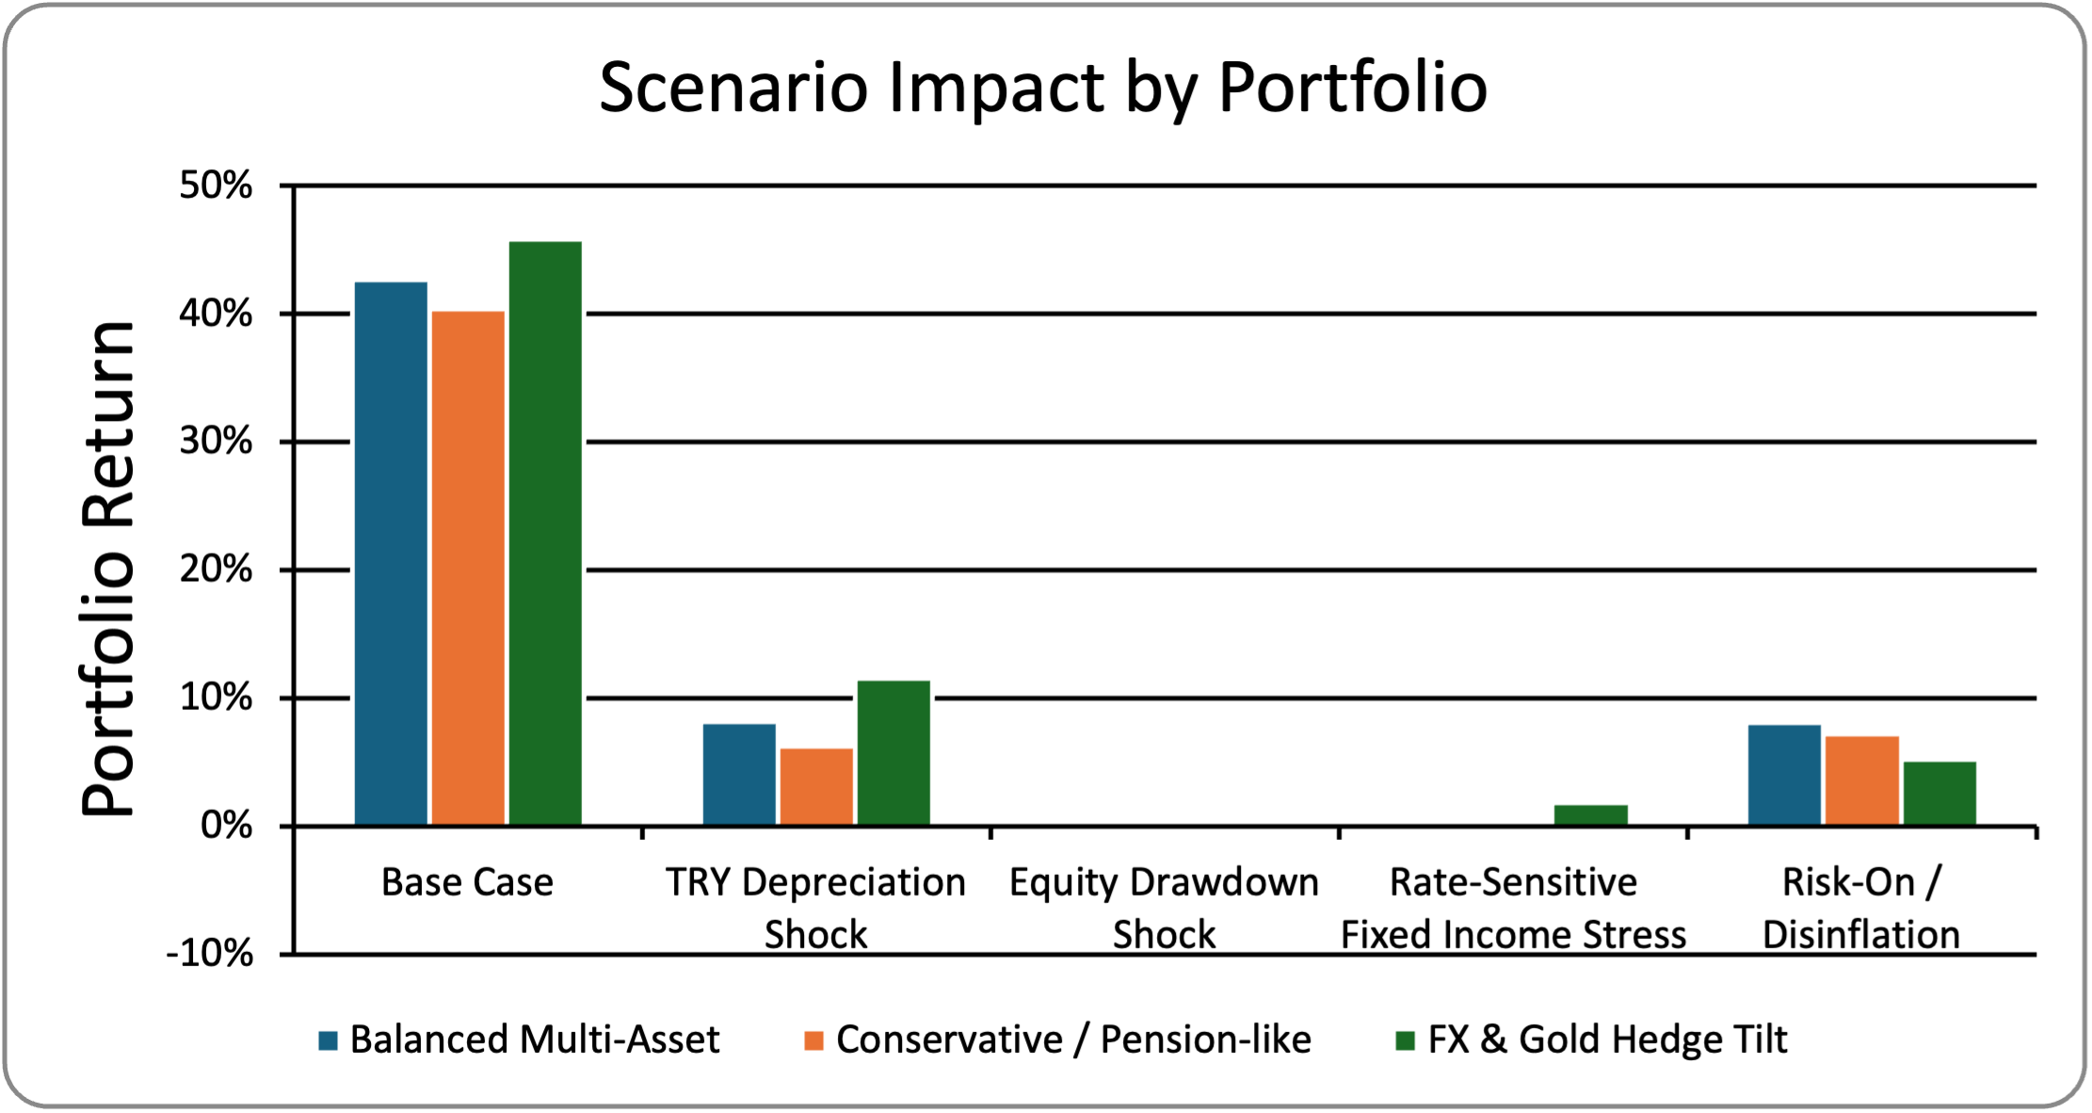
Under a TRY Depreciation Shock, FX & Gold Hedge Tilt performs best at 11.55%. This is the most intuitive outcome and validates the portfolio design logic.
Under an Equity Drawdown Shock, Conservative / Pension-like proves most defensive with an estimated return of -1.30% versus -5.05% for the Balanced portfolio.
Under a Rate-Sensitive Fixed Income Stress scenario, FX & Gold Hedge Tilt remains positive at 1.80% thanks to higher FX and gold exposure. In a Risk-On / Disinflation environment, the Balanced allocation performs best (8.10%).

7. Downside Risk: Historical VaR and Expected Shortfall
Portfolio | VaR 95% | ES 95% | VaR 99% | ES 99%
Balanced Multi-Asset | -0.87% | -1.37% | -1.64% | -2.45%
Conservative / Pension-like | -0.58% | -0.92% | -1.09% | -1.65%
FX & Gold Hedge Tilt | -0.74% | -1.21% | -1.35% | -2.17%
Historical downside risk metrics confirm the same ranking seen in volatility and drawdown analysis. The Conservative / Pension-like portfolio has the smallest tail-loss estimates, while the Balanced portfolio is the most exposed of the three at both the 95% and 99% confidence levels. The FX & Gold Hedge Tilt sits between the two.

Figure 6. Historical VaR and Expected Shortfall for model portfolios.
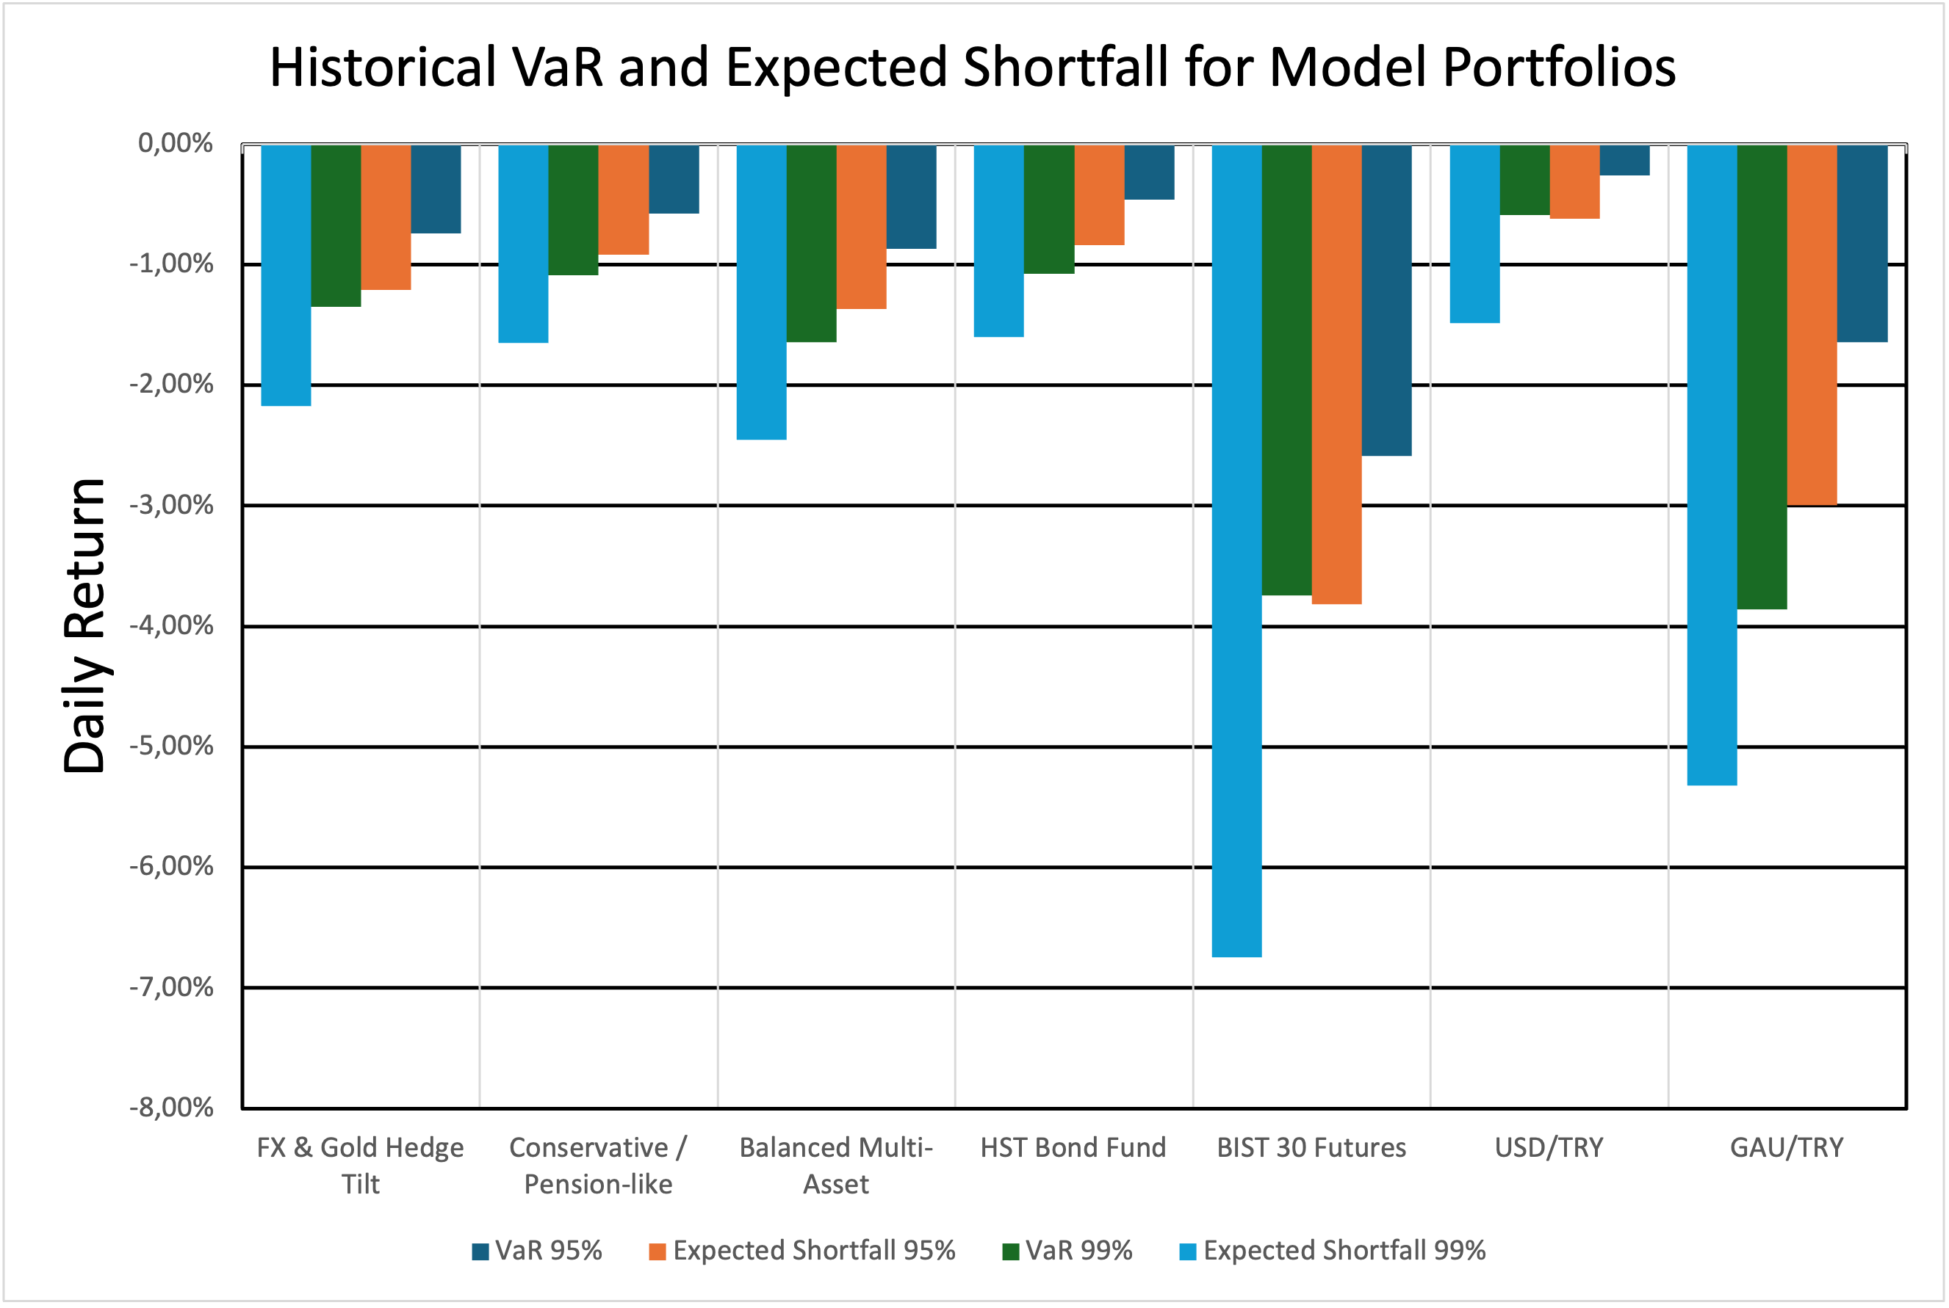

8. Dynamic Risk Monitoring
Figure 7. 60-day annualized rolling volatility of model portfolios.
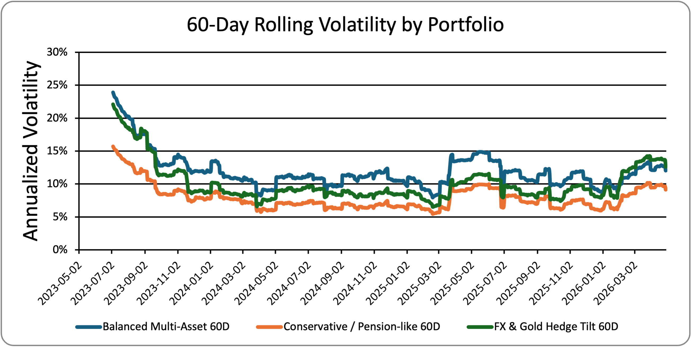
Figure 8. 60-day rolling correlations of selected asset pairs.
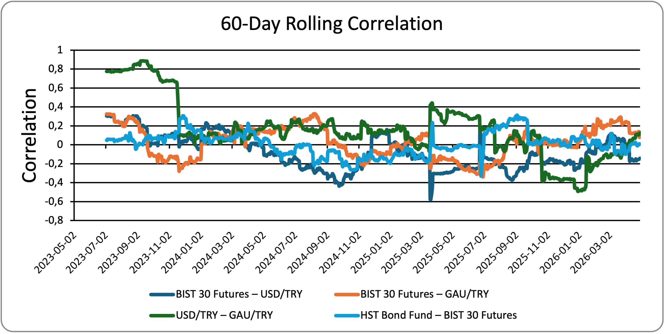
Rolling volatility shows that risk is not static: even the most conservative allocation experiences periods of higher realized volatility, but these spikes remain meaningfully smaller than in the Balanced portfolio. Rolling correlations fluctuate around low-to-moderate levels, supporting the idea that combining equity, bonds, FX and gold improves diversification relative to concentrated exposure.

9. Illustrative Monte Carlo Simulation
Portfolio | Mean Ending Value | 5th Percentile | 95th Percentile | Probability of Loss
Balanced Multi-Asset | 145.45 | 118.39 | 176.70 | 0.04%
Conservative / Pension-like | 141.87 | 123.11 | 162.65 | 0.02%
FX & Gold Hedge Tilt | 148.22 | 123.19 | 176.42 | 0.04%
Figure 9. Illustrative Monte Carlo results over a 1-year horizon.
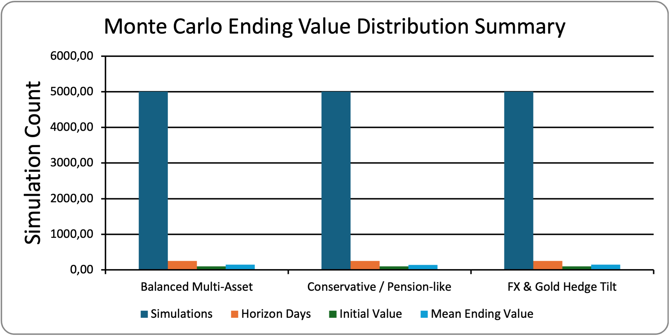
The simulation, based on historical daily mean and volatility and 5,000 random paths, indicates a favorable medium-term profile for all three portfolios. FX & Gold Hedge Tilt shows the highest mean ending value, while Conservative / Pension-like has the strongest lower-tail protection with the highest 5th percentile outcome. Probability of loss is very low across all three portfolios, but lowest for the more defensive allocations.

10. Investment Implications
- For a Türkiye-focused multi-asset framework, diversification across equity, fixed income, FX, and gold materially improves portfolio stability relative to holding a single risk asset.
- A conservative allocation appears more appropriate when capital preservation, smoother performance, and lower tail risk are the priority.
- A hedge-oriented allocation is more suitable when the investment view emphasizes inflation persistence and the risk of TRY depreciation.
- A balanced allocation remains attractive when the objective is to retain more equity upside while keeping risk below that of a pure equity position.

11. Limitations
- The exercise uses a compact set of market proxies rather than investable institutional share classes or benchmark indices for each sleeve.
- Scenario analysis is intentionally stylized and should be read as sensitivity testing rather than as a formal macro forecast.
- The Monte Carlo section is illustrative; it relies on historical mean and volatility and does not explicitly model regime shifts, time-varying correlations, or fat tails.

