


MARMARA UNIVERSITY
FACULTY OF ENGINEERING
COMPUTER ENGINEERING DEPARTMENT
CSE3063
Object Oriented Software Design
Requirement Analysis Document (RAD) - Iteration1
1. Göktuğ Gökçe 150119817
2. Halil İbrahim Ayan 150119753
3. Ceyda Uçar 150119783
4. Gamze Bulut 150124826
5. Enes Yuşa Dülger 150119010
1. Vision & Goals
The goal is to build a text-based chatbot that answers questions about the CSE department, Faculty of Engineering, and University regulations. The system must use local documents (no external APIs) and prioritize software design quality (SOLID, GRASP).

2. Functional Requirements
- FR1: The system shall accept natural language questions via CLI.
- FR2: The system shall classify the intent of the question (e.g., Staff Lookup, Policy).
- FR3: The system shall retrieve relevant text chunks from a local corpus.
- FR4: The system shall provide a final answer with citations (Document ID).
- FR5: The system shall log execution traces to a JSONL file.

3. Use Cases (Fully Dressed)

UC1: Staff Lookup

Primary Actor: Student

Preconditions: The system is running and the corpus is loaded.

Main Success Scenario:
1. Student enters a question: "Where is Murat Can Ganiz's office?"
2. System detects intent as `StaffLookup`.
3. System retrieves relevant chunks containing "Murat Can Ganiz" and "office".
4. System extracts the answer from the top-ranked chunk.
5. System displays the answer: "Ofisi MB-342'dedir." with citation.
Postconditions: The interaction is logged in `trace.jsonl`.

UC2: Course Information

Primary Actor: Student

Preconditions: The system is running.

Main Success Scenario:
1. Student enters a question: "What are the prerequisites for CSE3063?"
2. System detects intent as `Course`.
3. System retrieves chunks related to "CSE3063" and "prerequisites".
4. System ranks chunks to find the most relevant syllabus info.
5. System displays the answer: "Prerequisites are CSE1142." with citation.
Postconditions: The interaction is logged.

4. Non-Functional Requirements (NFRs)
- NFR1 (Modularity): Components (Retriever, Reranker) must be swappable via configuration (Strategy Pattern).
- NFR2 (Maintainability): The code must adhere to SOLID principles (SRP, OCP, DIP).
- NFR3 (Traceability): Every run must be reproducible and logged.
- NFR4 (No External Deps): No usage of external LLM APIs or Vector DBs for Iteration 1.

5. Glossary
- RAG: Retrieval-Augmented Generation.
- Corpus: The collection of text documents used for answering.
- Chunk: A small segment of text from a document.
- Intent: The user's goal (e.g., finding a phone number).

Appendix: LLM Usage Report
Overview
In this project (Iteration 1), we utilized an AI coding assistant (Google Deepmind Agent) to accelerate the development process, ensure adherence to SOLID principles, and generate documentation artifacts.
Usage Areas
1. Architecture Design
The AI assisted in designing the class hierarchy to comply with the Strategy Pattern . We defined interfaces (`IntentDetector`, `Retriever`, etc.) to ensure modularity and the Open/Closed Principle.
2. Code Generation
The AI generated the initial boilerplate code for:
- Interfaces: Defining the contracts for each pipeline stage.
- Implementations: Creating baseline implementations (e.g., `KeywordRetriever`, `RuleIntentDetector`).
- Orchestration: Implementing the `RagOrchestrator` using the Template Method pattern.
3. Documentation & UML
The AI helped in:
- Drafting the Requirement Analysis Document (RAD).
- Generating Mermaid.js code for:
- Domain Model
- Design Class Diagram (DCD)
- System Sequence Diagram (SSD)
- Design Sequence Diagram (DSD)
4. Verification
The AI guided the verification process by suggesting CLI scenarios and debugging minor syntax issues during the initial compile phase.
Conclusion
The use of LLM tools allowed us to focus on high-level design decisions and logic while automating repetitive coding tasks and documentation formatting. All generated code was reviewed and verified by the team.

1. Domain Model (Conceptual)
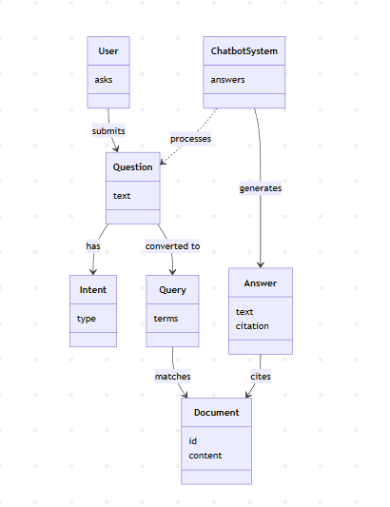

2. Design Class Diagram (DCD)
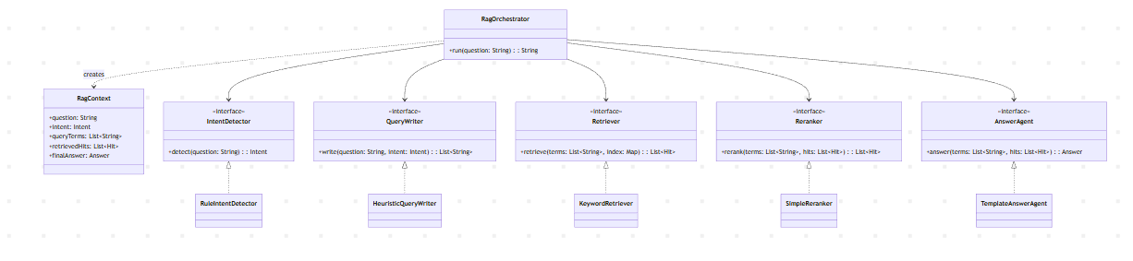

3. System Sequence Diagram (SSD)
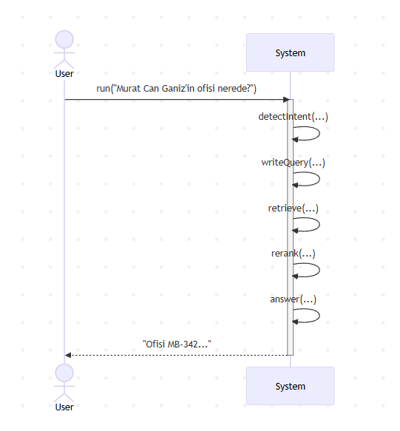
4. Design Sequence Diagram (DSD)

