CPI – Gmail Example

The Gmail sample code for SAP Cloud Platform Integration is a simple example that shows the ability to use CPI to create and email from Postman and send to a designed Gmail account.

To use this sample:

1. Download from the “Build Block” samples for CPI … the “CPI_GMail.zip” file and save to a folder on your computer.
2. Open a browser and open your CPI server.
3. Click on the “Design” option on the left Tool Bar .
4. On the top-right of the window click “Create”.
5. You will see this window:

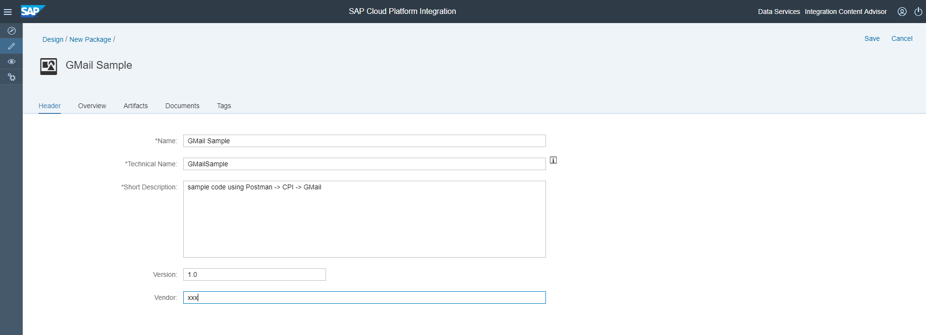

Enter: Name, Technical Name a Short Description, Version and a Vendor Name.

1. Click “Save” on top-right of window.
2. From the same window click “Artifacts”.

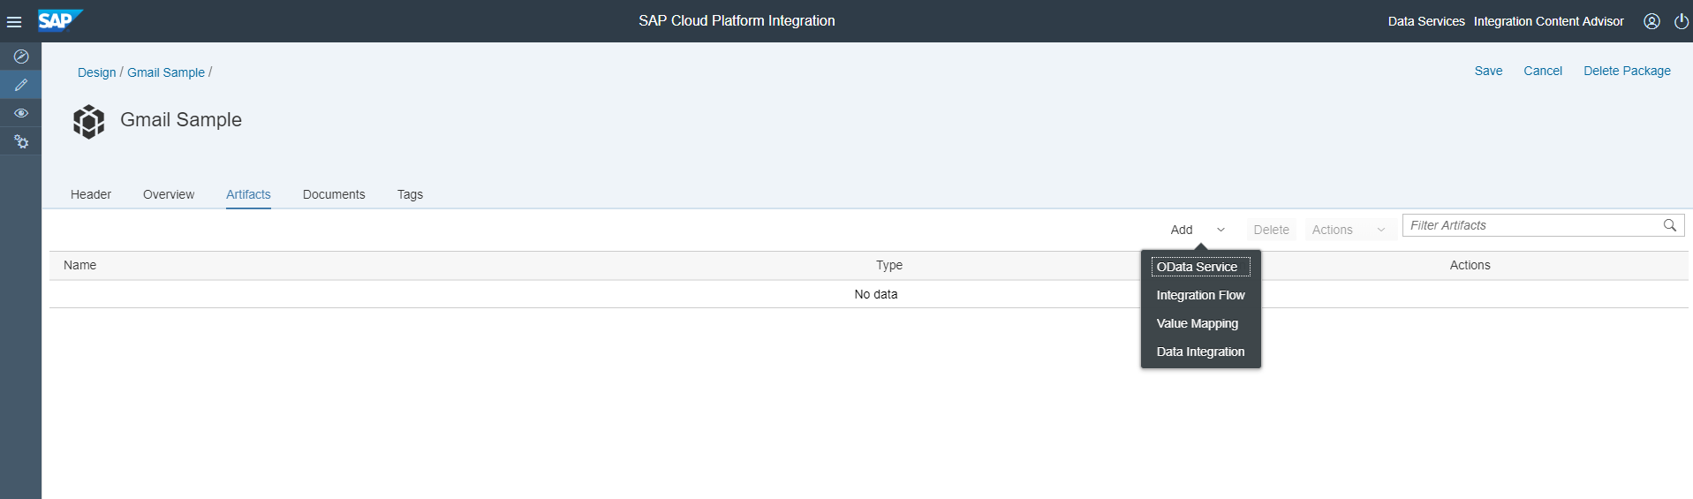

1. Click “Add” and choose “Integration Flow”. You should now see:

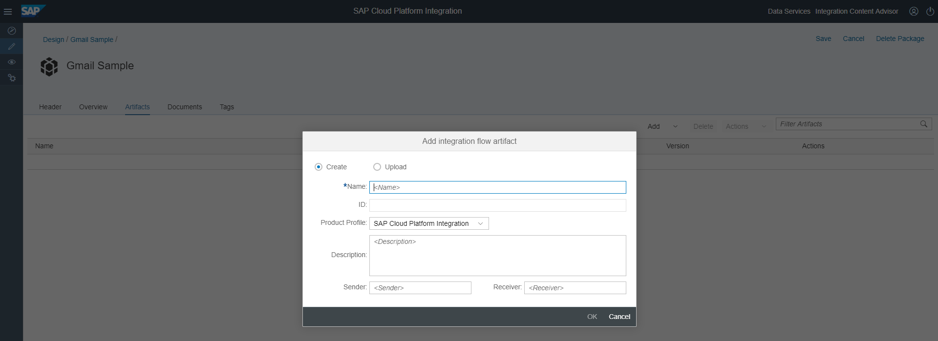

1. Choose the “Upload” option. You should now see:

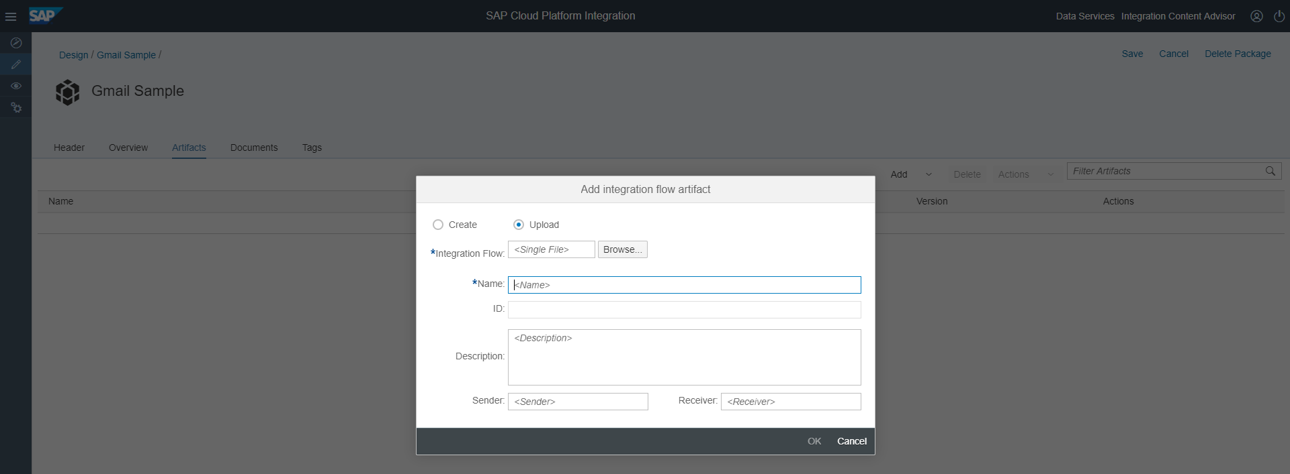

1. Click on “Browse” and navigate to the “CPI_GMail.zip” file from step #1 above.

You should now see:

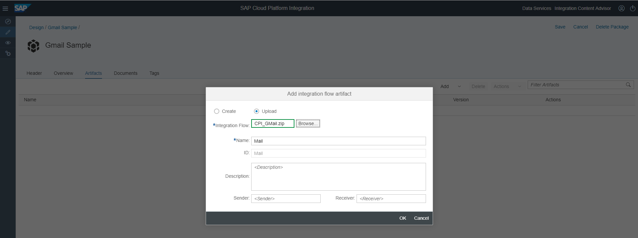

1. Enter …

Sender: HTTP

Receiver: Mail

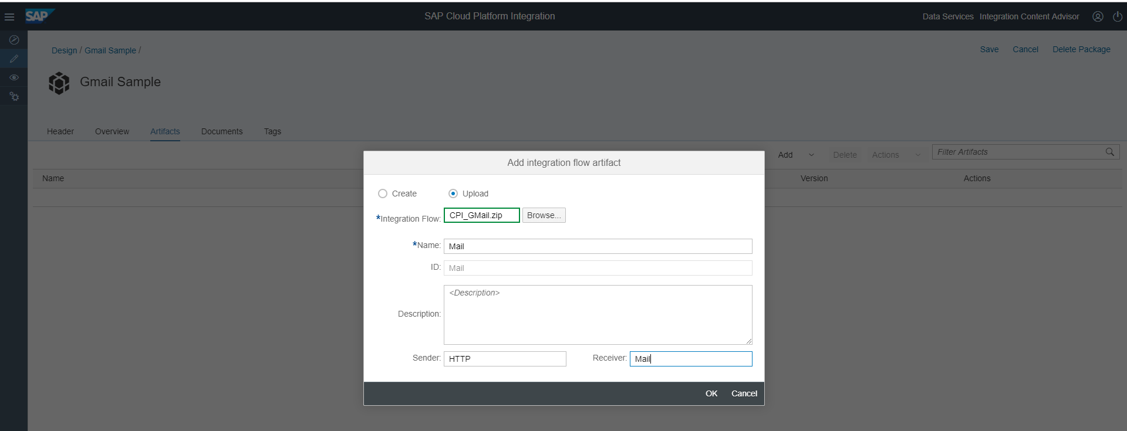

1. Click “OK”.

You should now see …

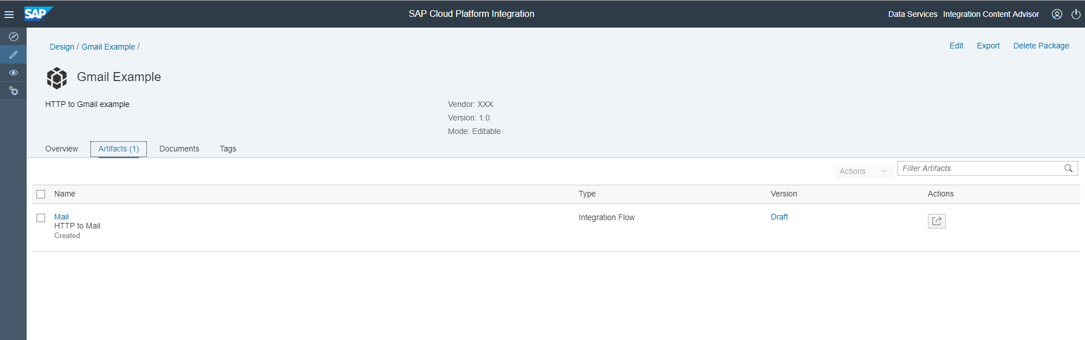

1. Click on “Mail”.

You should see …

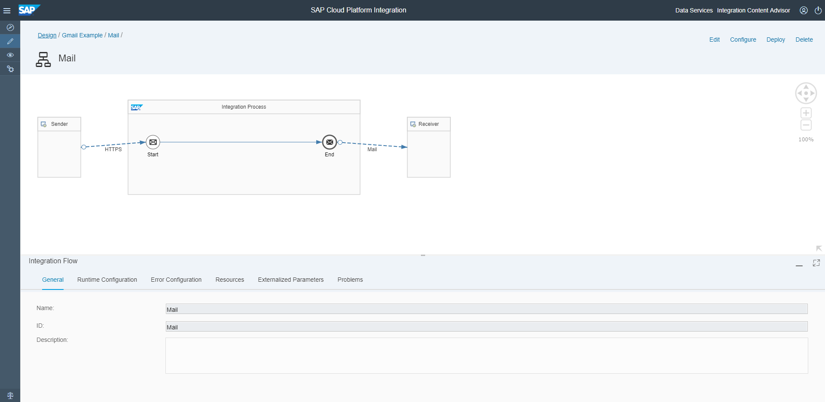

1. Click on “Edit” in the upper right corner of the Window to be able to make changes to this integration flow.

You will now need to make changes to your Receiver node for your Gmail account information. The email will come from Postman so make sure you download and install Postman if you want to test this scenario. You can download Postman here: https://www.getpostman.com/downloads/

1. Click in the dotted “HTTPS” line between the Sender and Integration Process nodes and then click on “Connection” at the bottom.

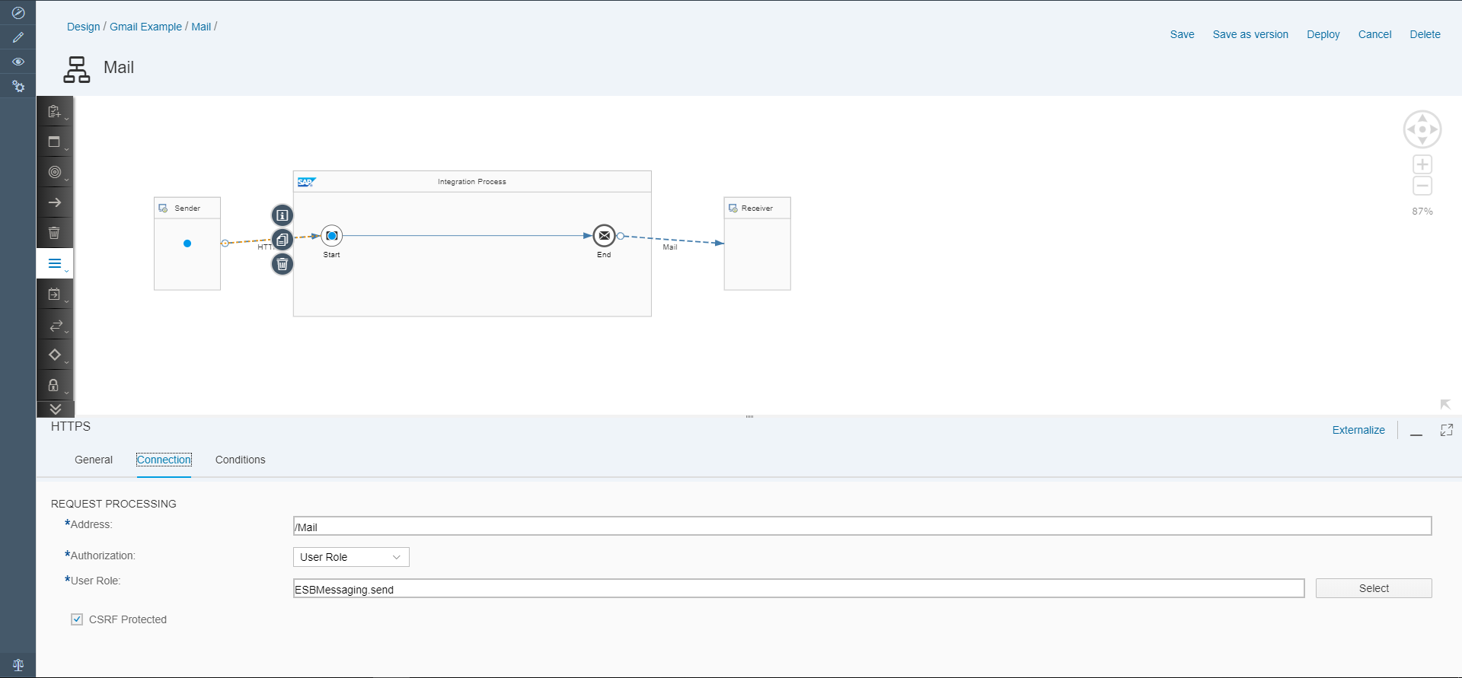

*Note the “Address” line = “/Mail”. This will be used in the endpoint in Postman.

1. Click on the “Mail” dotted line between the Integration Process and Receiver nodes. Verify the General opens match this window:

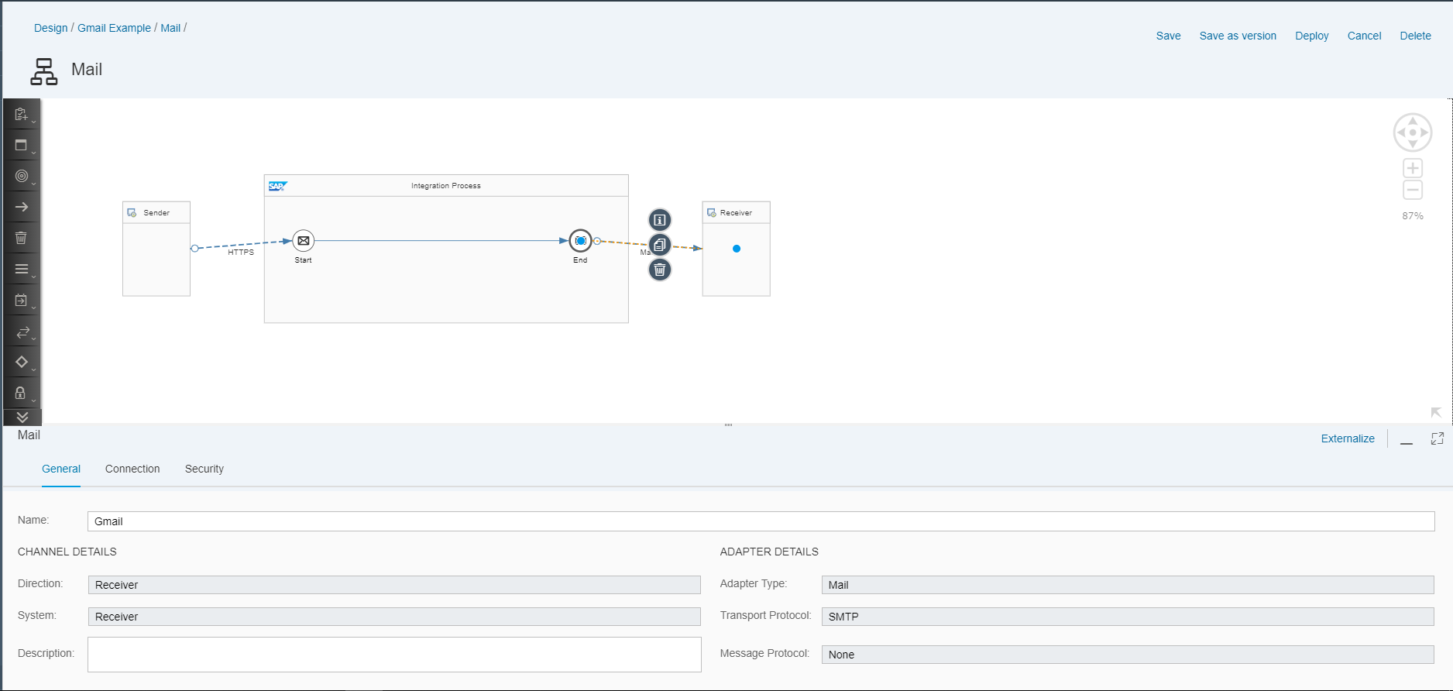

1. Click on “Connection”. Here you will need to enter:

Address: This is the SMTP address for Gmail. You can get this from your Gmail account.

Credential Name: this is the login user you will use for CPI – Security Material.

From: The Gmail account that you setup or want to test with.

To: The Gmail account that you setup or want to test with.

Subject: Enter a subject for your email to the Gmail account you setup.

Your entries should look similar to this window:

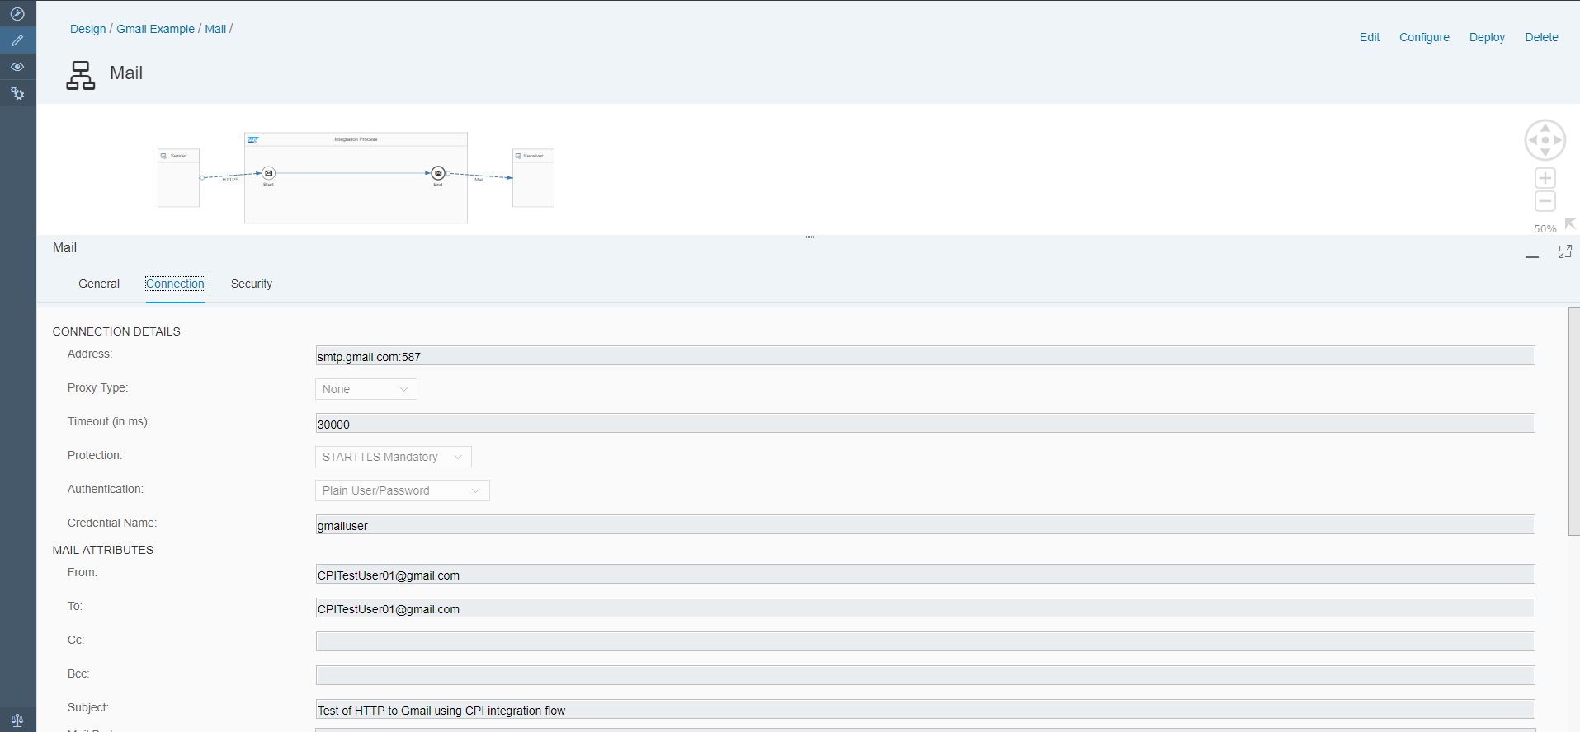

1. When finished click “Deploy” and on the Confirmation window click “Yes”. You will the receive a message that the scenario has been triggered for deployment. Click “OK”.
2. Click on the “Operations View” icon on the left tool bar .
3. Under the “Manage Security”, click the “Security Material” tile.

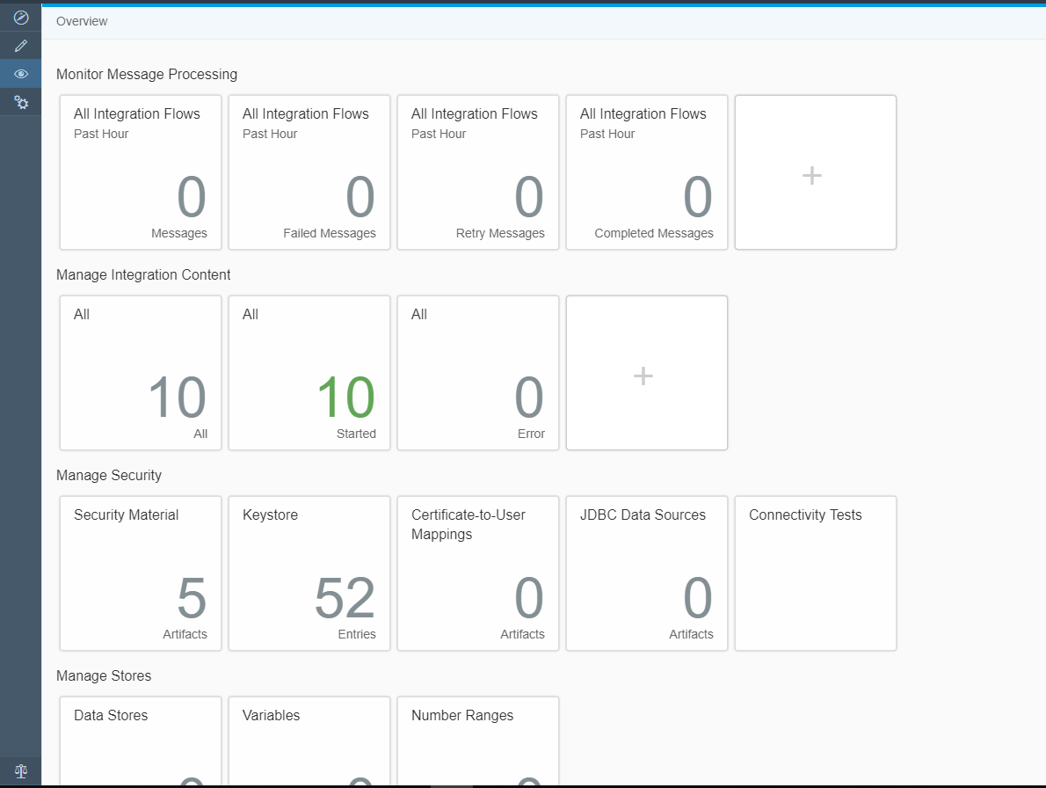

1. Click “Add” and choose “User Credentials”.

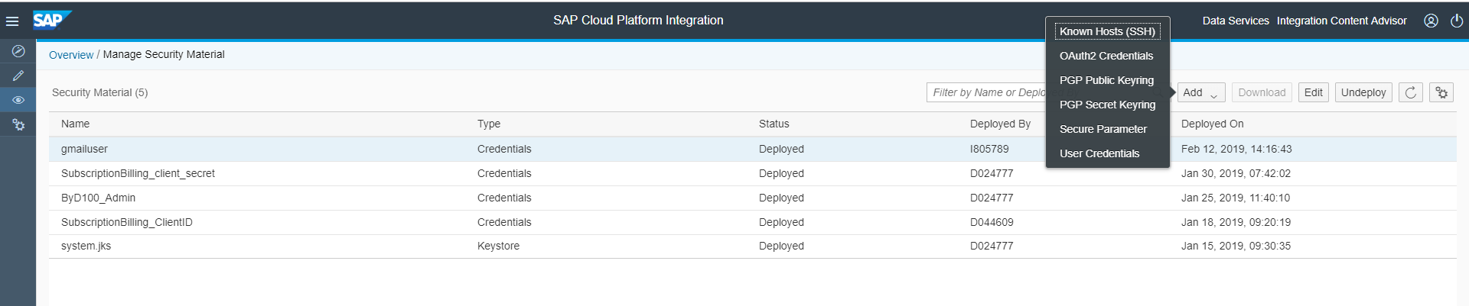

1. On the “User Credentials” screen enter:

Name: gmailuser

Description: anything you want

User: Enter the Gmail user that you want to send the email to i.e. <Gmail User Name>@gmail.com

Password: enter this Gmail’s account password.

Repeat password: enter the password again.

1. Click “Deploy”.
2. To get the endpoint to use in Postman … make sure you Deployed the Gmail Sample and then click on “Operations View” > “Manage Integration Content” > “All”. Click on the “Mail” scenario. You will see the “Endpoint” as shown in the window below. This is what you will use in Postman.

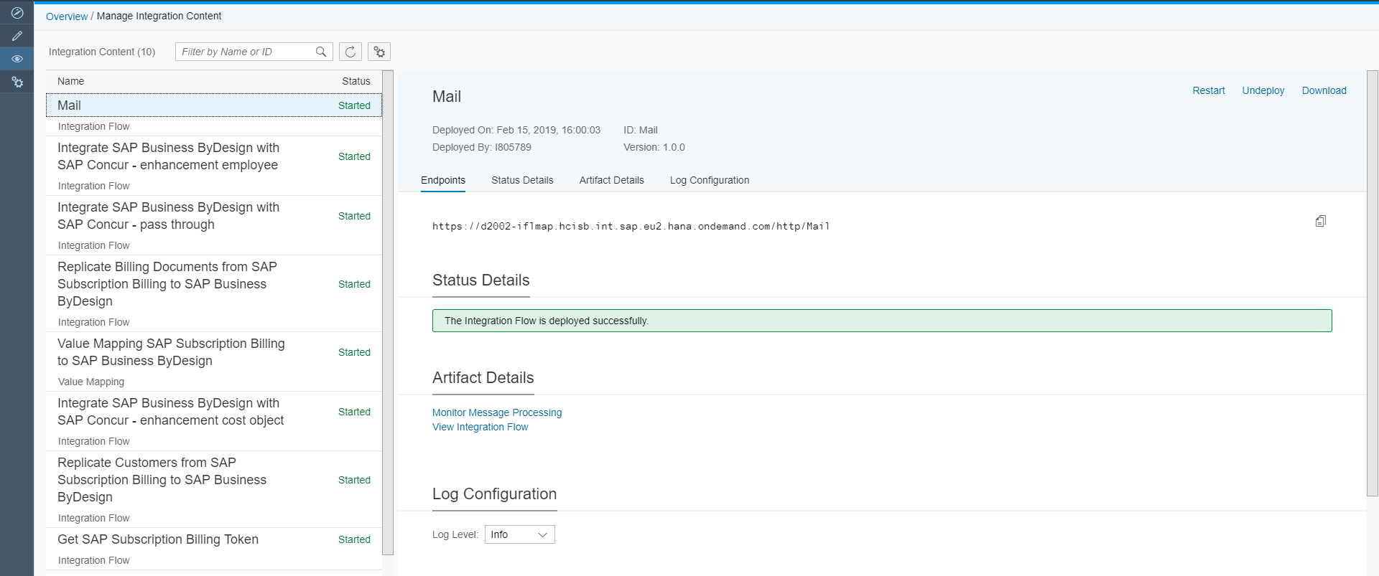

1. Postman should be installed. If it is not … install before continuing. When finished … launch Postman.
2. Open a new tab in Postman. Click on the drop down and choose “Post” and then past in the Endpoint you copied from CPI.
3. Click on “Body” and choose “Raw” and enter test for your email. Your windows should look something like this:

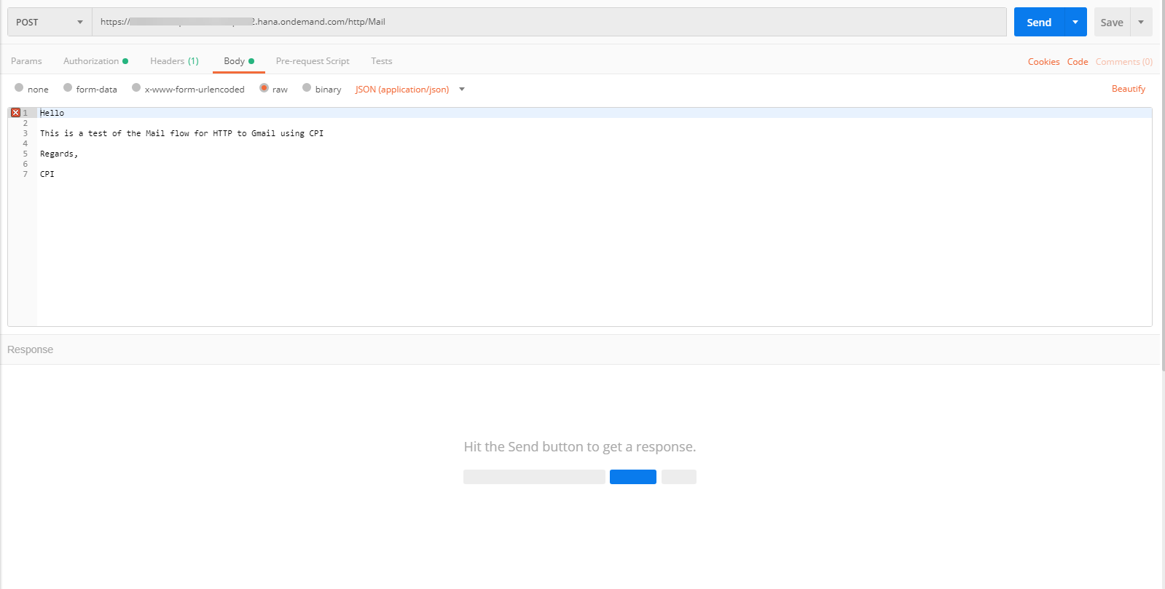

1. In the same Postman window, click on “Authorization” and enter your Cloud Platform server login and password.

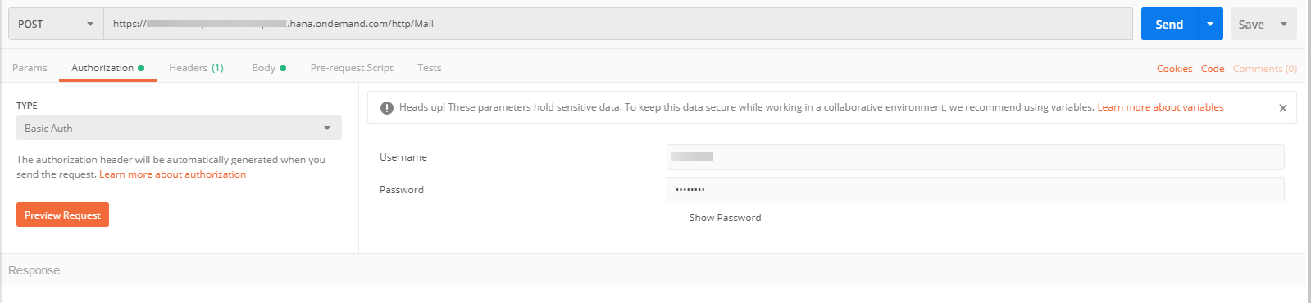

1. The final step is to click “Send”. You should receive a message stating your email was successfully sent. You can now open you Gmail account and verify a message was sent.