1. 測試內容：

測試 Switch最多可以加入幾個flow rules。

1. 測試環境架構：

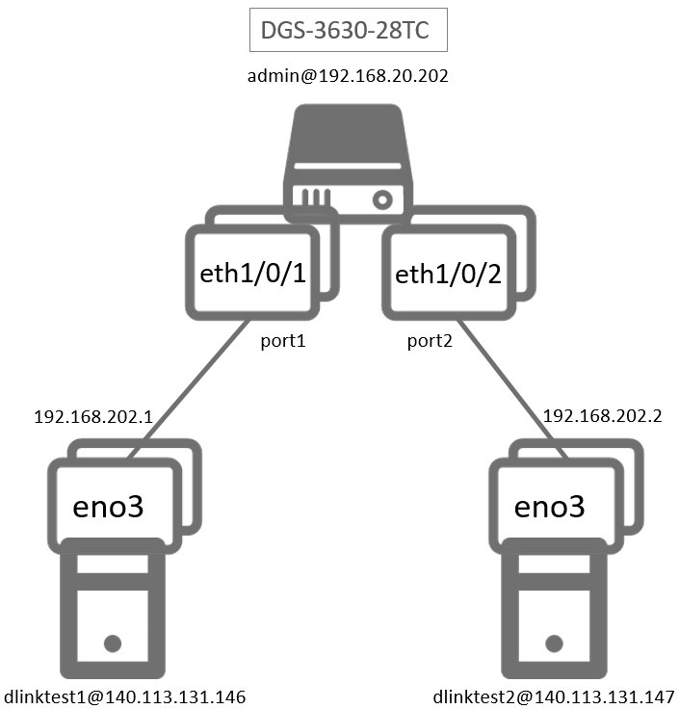

1. 測試環境組態：

* SDN controller: ONOS 1.15.0
* Switch: DGS-3630
* Hosts:
  + ubuntu 16.04.5 LTS
  + dlinktest1(實體機)
    - IP: 192.168.202.1
    - MAC: d0:94:66:5d:5e:08/64
    - Port: 1
  + dlinktest2(實體機)
    - IP: 192.168.202.2
    - MAC: d0:94:66:5c:45:20/64
    - Port: 2
* Apps:

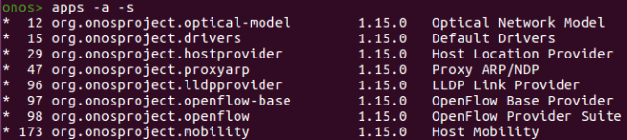

1. 使用之JSON文件：

* Flow Rule: (附檔：loopFlow.json)
  + ETH_TYPE為必填欄位

|  |
| --- |
| {  "flows": [  {  "priority": 40000,  "timeout": 0,  "isPermanent": true,  "deviceId": "of:000078321bdf4000",  "treatment": {  "instructions": [  {  "type": "OUTPUT",  "port": "2"  }  ]  },  "selector": {  "criteria": [  {  "type": "ETH_TYPE",  "ethType": "0x0800"  },  {  "type": "ETH_SRC",  "mac": "D0:94:66:5D:5E:08"  },  {  "type": "ETH_DST",  "mac": "D0:94:66:5C:45:20"  },  {  "type": "IP_PROTO",  "protocol": 1  },  {  "type": "IPV4_SRC",  "ip": "192.168.202.2/32"  },  {  "type": "IPV4_DST",  "ip": "192.168.202.1/32"  }  ]  }  }    ]  } |

* Flow Rule: (附檔：temp.json)
  + ETH_TYPE為必填欄位

|  |
| --- |
| {  "flows": [  {  "priority": 40000,  "timeout": 0,  "isPermanent": true,  "deviceId": "of:000078321bdf4000",  "treatment": {  "instructions": [  {  "type": "OUTPUT",  "port": "2"  }  ]  },  "selector": {  "criteria": [  {  "type": "ETH_TYPE",  "ethType": "0x0800"  },  {  "type": "ETH_SRC",  "mac": "D0:94:66:5D:5E:08"  },  {  "type": "ETH_DST",  "mac": "D0:94:66:5C:45:20"  },  {  "type": "IP_PROTO",  "protocol": 1  },  {  "type": "IPV4_SRC",  "ip": "192.168.9.13/32"  },  {  "type": "IPV4_DST",  "ip": "192.168.100.1/32"  }  ]  }  }    ]  } |

* Shell Script: (附檔：maxFlowEntries.sh)

|  |
| --- |
| #!/bin/bash  TAB=$'\t'  counter=0  for i in {1..8};  do # start of IP range: 192.168.1-8.j  for j in {1..254};  do # start of IP range: 192.168.i.1-254  sed -e "36s@.*192.168.202.2.*@${TAB}${TAB}${TAB}${TAB}${TAB}${TAB}\"ip\": \"192.168.$i.$j/32\"@" loopFlow.json > temp.json  ((counter+=1))  curl -X POST --user onos:rocks -H "content-type:application/json" http://localhost:8181/onos/v1/flows -d @temp.json  done # end of IP range: 192.168.i.1-254  done  for i in {1..13};  do  sed -e "36s@.*192.168.202.2.*@${TAB}${TAB}${TAB}${TAB}${TAB}${TAB}\"ip\": \"192.168.9.$i/32\"@" loopFlow.json > temp.json  ((counter+=1))  curl -X POST --user onos:rocks -H "content-type:application/json" http://localhost:8181/onos/v1/flows -d @temp.json  done  echo "Total add # of flow:" $counter |

1. 測試步驟：
2. ONOS GUI: Flow View

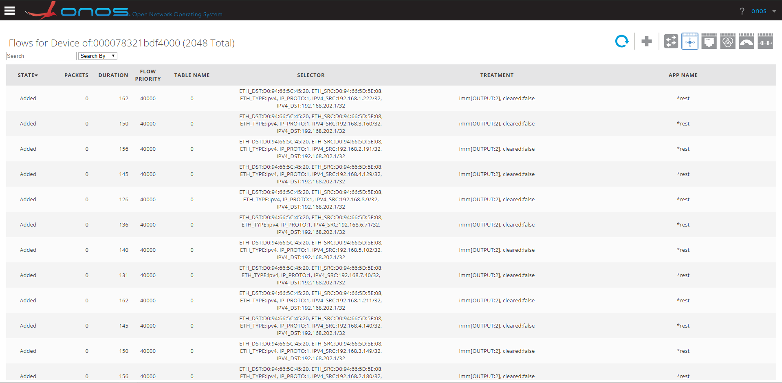

1. Switch CLI:

|  |
| --- |
| Switch# show openflow flows |

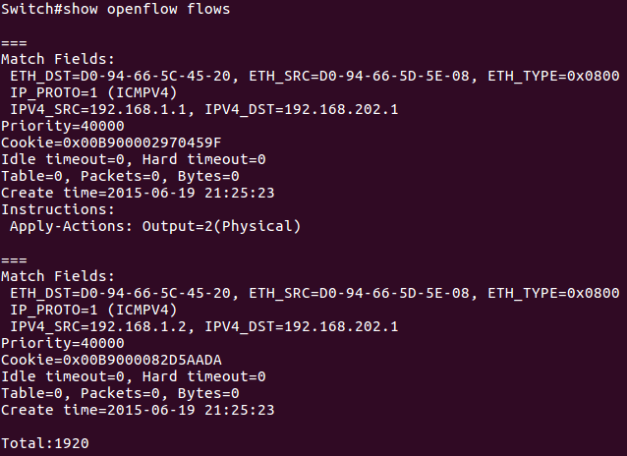

1. 測試結果：

Switch最多只能加入1920個flow rules。