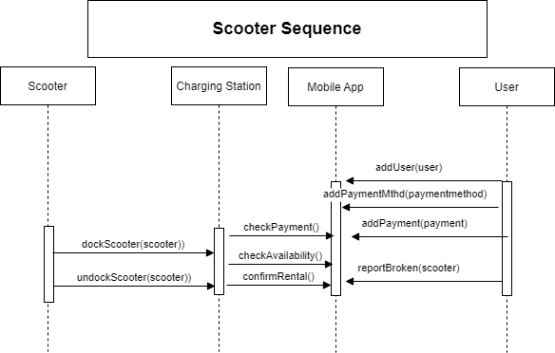

**Scooter Sequence**

Scooter

Charging Station

Charging Station

Mobile App

Mobile App

User

addUser(user)

addPayment Mthd(paymentmethod)

checkPayment)

addPayment(payment)

dockScooter(scooter))

checkAvailability.

reportBroken(scooter)

undockScooter(scooter))

confirmRental