Name: Omar Mohamed Adel Kamal

Section: 2

Bench Number: 33830

Steps

1. 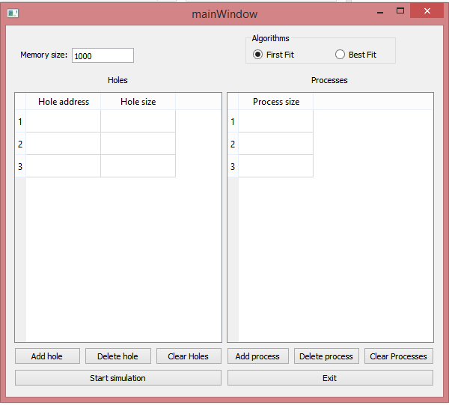Enter memory size then add the number of holes and processes you want.
2. 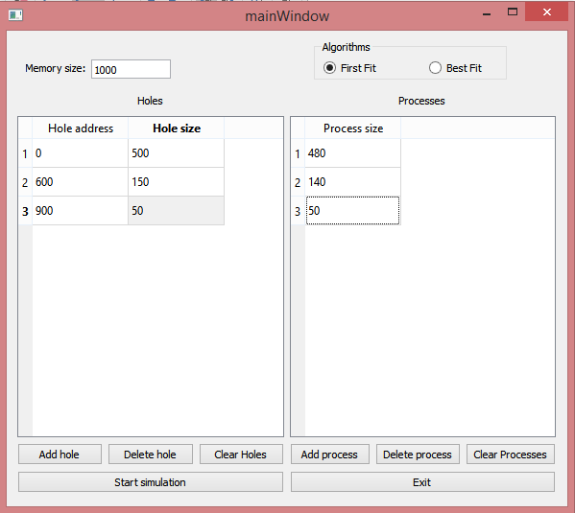Insert needed information of these holes and processes.
3. Choose desired algorithm
4. 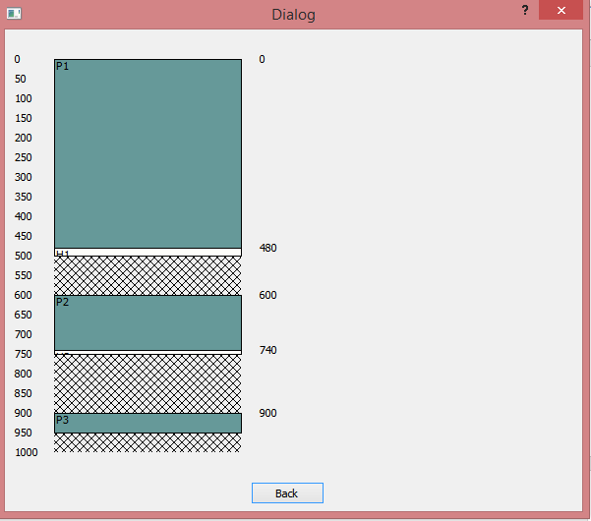Start simulation.  
     
     
     
     
     
     
     
     
     
     
     
     
     
     
     
     
     
     
     
     
     
     
   You will notice that processes have that greenish blue color and holes have an icy white color. Memory space that was not assigned to holes or processes have crossed diagonals as a background. On the left you will find kind of an address ruler and on the right you will find the starting address of the hole or the process.
5. 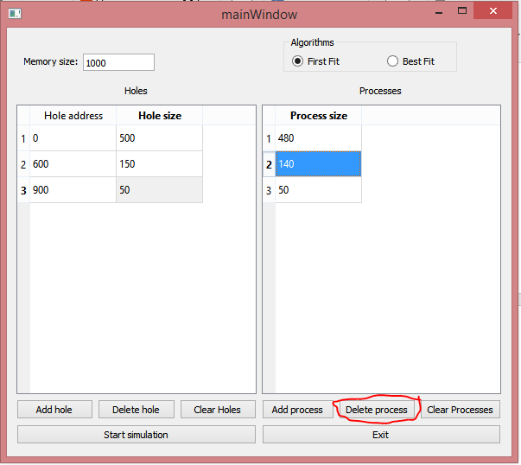If you want to de-allocate a process choose it then press delete process.  
     
     
     
     
     
     
     
     
     
     
     
     
     
     
     
     
     
     
     
     
     
     
     
   Then press start simulation.

