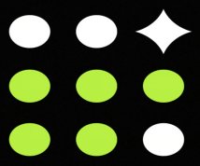

Hackathon: Multi-Agent DevOps Incident Analysis Suite

Roger Johnsrud
Carl Scott
Rizwan Qazi
Deven Yadav
George Hornberger
Sweety Kumari

Outskill

Mentors- Kartik & Team

Feb 14, 2026

Introduction
Modern IT systems generate large volumes of logs that contain early signs of failures and outages. Analyzing these logs and responding to incidents manually is time-consuming and delays resolution.
To address this, we developed a Multi-Agent DevOps Incident Analysis Suite using LangGraph. The system acts as a digital SRE team that automatically analyzes logs, identifies root causes, suggests fixes, generates documentation, and notifies engineers through Slack and JIRA.
By combining multi-agent orchestration with spec-driven development, the platform enables reliable and structured incident response for DevOps environments.

System Overview
The system automates the full lifecycle of an incident:
Log Parser Agent detects errors from logs
Remediation Agent determines fixes
Runbook Generator documents resolution
Integration Agent creates JIRA tickets and Slack alerts
The workflow is stateful and iterative, allowing re-analysis if needed and enabling human-in-the-loop approval.

Core Roles (Agents)
The architecture distributes responsibilities across specialized agents, each operating as a node in the LangGraph workflow:
Log Parser / Analyzer
Scans incoming server or application logs to detect error patterns (e.g., HTTP 500 errors) and extracts structured metadata such as timestamps, services, and severity.
Remediation Agent
Interprets the analyzed incident and identifies known fixes, configuration changes, or automated scripts that can resolve the issue.
Runbook Generator
Updates or creates operational documentation describing the incident, root cause, and remediation steps for future reference and knowledge retention.
Integration Agent
Handles external system communication by creating JIRA tickets for tracking and sending Slack notifications to alert engineers.

Workflow Pipeline
The incident response workflow is stateful and non-linear, enabling iterative analysis and recovery if a step fails or additional context is required.
1. Ingestion — Folder Watcher / API
An incident is triggered when a new error log is detected in monitored sources.
2. Analysis — Log Parser
The parser identifies the likely root cause. If insufficient information is available, the workflow can loop back for additional context.
3. Action — Remediation Agent
The system determines remediation steps while the Integration Agent simultaneously prepares a JIRA ticket.
4. Reporting — Runbook Generator
A post-incident report and resolution documentation are automatically generated.
5. Notification — Slack Agent
Engineers receive a summarized alert describing the incident and the actions taken.

Why LangGraph
Traditional linear LLM workflows are insufficient for real DevOps incidents, which are iterative and state dependent. LangGraph is used because it enables:
Persistence
Workflow state is preserved, allowing recovery and continuation if execution stops midway.
Cycles
The system can revisit earlier stages (e.g., re-analysis if remediation fails).
Human-in-the-Loop Control
Engineers can review or approve remediation actions before execution.

Spec-Driven Development Approach
The project applies spec-driven design principles to ensure reliability and production readiness.
Predictable State Schema
Each agent follows a defined input/output structure, preventing LLM drift and ensuring consistent data flow.
Modular Tool Specifications
Agents interact with external tools (JIRA, Slack) through defined interfaces, allowing components to be replaced without altering the overall workflow.
This approach improves maintainability, extensibility, and operational safety.
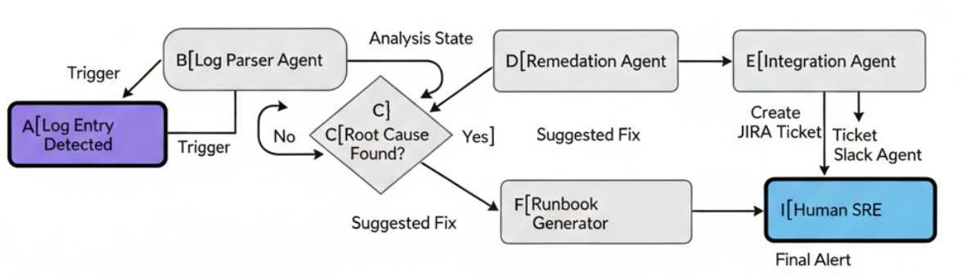

Project Resources
GitHub: https://github.com/rizwanqazi/LangGraph-Project
Project Video: Group_10_Hackathon.mp4
Welcome Video: G10_welcome.mp4
All features were implemented. Contact the Group for full demonstration. Not provided at the link above for team personal benefit.

Conclusion
The Multi-Agent DevOps Incident Analysis Suite shows how agent-based AI can automate incident detection, analysis, and response. Using LangGraph and spec-driven design ensures structured workflows, reliability, and easy integration with tools like Slack and JIRA.
This project demonstrates the potential of multi-agent AI systems to reduce operational effort, accelerate incident resolution, and improve reliability in modern DevOps and SRE operations.

