**SQLServer Lab5**

**Notes:**

* **Restore ITI and adventureworks2012 DBs to Server**

**Part-1: Use ITI DB**

1. Retrieve number of students who have a value in their age.
2. Get all instructors Names without repetition
3. Display student with the following Format (use isNull function)

|  |  |  |
| --- | --- | --- |
| Student ID | Student Full Name | Department name |
|  |  |  |

1. Display instructor Name and Department Name

Note: display all the instructors if they are attached to a department or not

1. Display student full name and the name of the course he is taking

For only courses which have a grade

1. Display number of courses for each topic name
2. Display max and min salary for instructors
3. Display instructors who have salaries less than the average salary of all instructors.
4. Display the Department name that contains the instructor who receives the minimum salary.
5. Select max two salaries in instructor table.
6. Select instructor name and his salary but if there is no salary display instructor bonus. “use one of coalesce Function”
7. Select Student first name and the data of his supervisor
8. Write a query to select the highest two salaries in Each Department for instructors who have salaries. “using one of Ranking Functions”
9. Write a query to select a random student from each department. “using one of Ranking Functions”
10. Delete all grades for the students whose Located in SD Department
11. Using Merge statement between the following two tables [User ID, Transaction Amount]

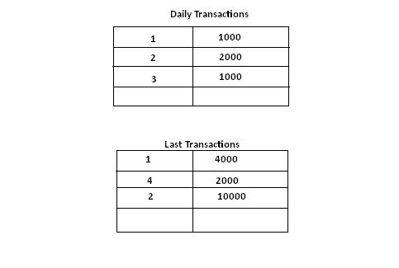

**Part-2: Use AdventureWorks DB**

1. Display the SalesOrderID, ShipDate of the SalesOrderHeader table (Sales schema) to designate SalesOrders that occurred within the period ‘7/28/2002’ and ‘7/29/2014’
2. Display only Products(Production schema) with a StandardCost below $110.00 (show ProductID, Name only)
3. Display ProductID, Name if its weight is unknown
4. Display all Products with a Silver, Black, or Red Color
5. Display any Product with a Name starting with the letter B
6. Run the following Query

UPDATE Production.ProductDescription

SET Description = 'Chromoly steel_High of defects'

WHERE ProductDescriptionID = 3

Then write a query that displays any Product description with underscore value in its description.

1. Calculate sum of TotalDue for each OrderDate in Sales.SalesOrderHeader table for the period between '7/1/2001' and '7/31/2014'
2. Display the Employees HireDate (note no repeated values are allowed)
3. Calculate the average of the unique ListPrices in the Product table
4. Display the Product Name and its ListPrice within the values of 100 and 120 the list should has the following format "The [product name] is only! [List price]" (the list will be sorted according to its ListPrice value)
5. Transfer the rowguid ,Name, SalesPersonID, Demographics from Sales.Store table in a newly created table named [store_Archive]

Note: Check your database to see the new table and how many rows in it?

1. Try the previous query but without transferring the data?
2. Using union statement, retrieve the today’s date in different styles

Part3:

Try to Create Login Named(ITIStud) who can access Only student and Course tablesfrom ITI DB then allow him to select and insert data into tables and deny Delete and update