Repository Class Diagram

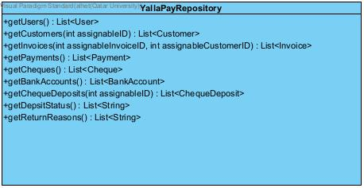

Repository Testing



