|  |  |
| --- | --- |
|  | **Mobile Project Phase 1 – UI Design and Implementation** |

# Application Design – Repositories or Providers Class Diagram

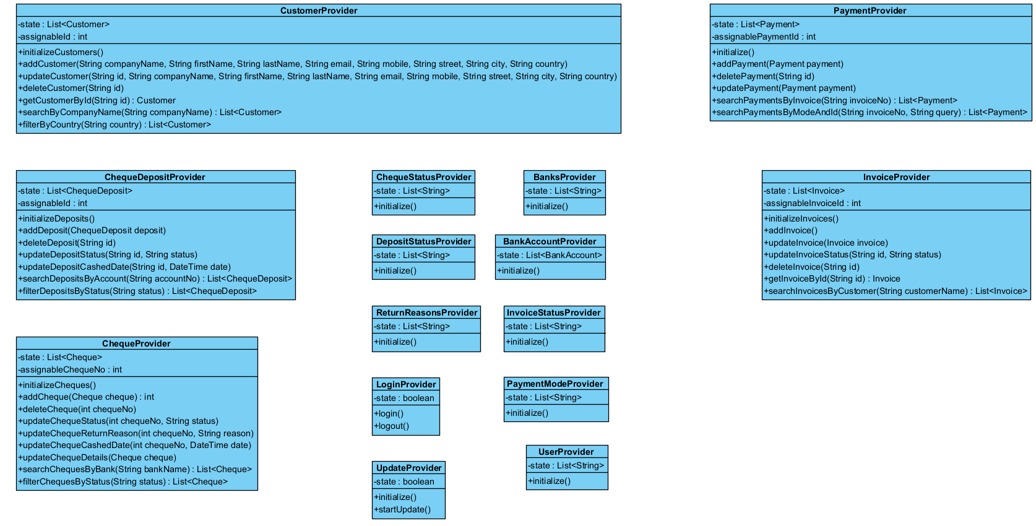

# Testing

# U1 – Login

# U2 - YalaPay Dashboard

# U3 - List/Search/Add/ Update and Delete a Customer

# List Customers

# Search Customers

# Add Customer

# Update Customer

# Delete Customer

# U4 - List/Search/Add/ Update and Delete an Invoice

# List Invoices

# Search Invoices

# Add Invoice

# Update Invoice

# Delete Invoice

# U5 - List/Search/Add/ Update and Delete payments for an invoice

# List Payments

# Search Payments

# Add Payment

# Update Payment

# U6 - Manage Cashing Cheques

# Add Cheques Deposit

# List Cheque Deposits

# Update Cheques Deposit

# U7 - Invoices Report

# U8 - Cheques Report

# Summary of team member contributions

|  |  |
| --- | --- |
| 1. **Member** | **Completed use cases / tasks** |
| Mohammad Ahmad | Responsible for main UI design implementation as well as logic implementation. Contributed to the completion of all use cases/tasks. |
| Aiman Alhetari | Responsible for creating entities and repositories. Helped in the implementation of login and shell screens. |
| Ahmed Alamoudi | Implemented app router and some providers’ logic. Helped in designing customer and invoice screens. |
| Faisal | Helped in designing payments and cheque deposit screens. |