Systolic Array CNN/GEMM Accelerator
Project Report — Design Overview and Explanation

1. Introduction
This project is a small hardware accelerator built in Verilog. Its job is to speed up the math used in Convolutional Neural Networks (CNNs) by turning a convolution into a matrix multiplication and computing that matrix multiplication very fast using a grid of small processing units working together at the same time.
The design is made of a few building blocks that each do one clear job: a grid of Processing Elements (PEs) that do the actual multiply and add math, a Systolic Array that connects those PEs together in a smart data flow pattern, a Control System that tells everything when to start, read, and stop, an img2col unit that turns image pixels into the right order for matrix multiplication, and FIFOs (memory queues) that safely move the results out of the array. This report explains each part in simple terms and why certain design choices were made.

2. The Processing Element (PE)
A Processing Element, or PE, is the smallest building block of the whole accelerator. Think of it as one tiny calculator. Every PE does the same simple job, over and over, every clock cycle:
- It takes in one number from the left (called A) and one number from the top (called B).
- It multiplies A and B together.
- It adds that result to a running total it keeps stored inside itself (this is called accumulation).
- It passes A to the right, to the next PE, and passes B downward, to the PE below it.
This is exactly how a matrix multiplication works by hand: each output value is the sum of a row multiplied by a column, one pair of numbers at a time. Instead of one calculator doing this one step at a time, many small PEs do many of these steps at once, which is what makes the design fast.
Each PE also listens to two control signals: valid, which tells it "the numbers on my inputs right now are real data, use them," and hold, which tells it "pause, don't update your total this cycle." These let the rest of the design control exactly when each PE should be working.

3. The Systolic Array
A systolic array is simply a grid of PEs (in this project, a 3-by-3 grid, so 9 PEs total) wired together so that data flows through them like a heartbeat pushing blood through the body that rhythmic, step-by-step flow is where the name "systolic" comes from.
Here we have a small image patch (a matrix A) and a small weight matrix (matrix B), and you want to multiply them. Instead of feeding the whole matrices in at once, you feed the rows of A in from the left and the columns of B in from the top, one number per clock cycle. Each number ripples through the grid, PE to PE, being multiplied and added along the way. By the time everything has flowed through, every PE holds one correct value of the final answer (the output matrix).
A very important trick is used to make this ripple work correctly: the numbers going into row 1 and row 2 of the array are deliberately delayed by 1 and 2 clock cycles (using small DELAY modules). This is called skewing. It makes sure that each number arrives at the correct PE at the correct time, lined up with the other numbers it's supposed to be multiplied with. Without this delay, the math would be wrong because numbers from different rows would arrive out of step with each other.
Once the PEs are done accumulating, the finished answers sit inside the out[row][col] wires of the array. A set of control signals (ctrl1, ctrl2, ctrl3) then choose which column of answers to read out to the next stage, one row of the output matrix at a time.

4. The Control System (FSM)
The control system is the "brain" of the whole design. It is a Finite State Machine (FSM) a piece of logic that moves through a fixed set of named states, one step at a time, and decides what should happen in each state. Its job is to make sure everything else (the PE array and the FIFOs) works together in the right order, at the right time.
In simple terms, the control system does the following, in order:
- Waits until it is told there is new data to process.
- Feeds the matrices into the systolic array and waits long enough for the PEs to finish multiplying and adding (this waiting period is counted with a timer).
- Once the math is done, it tells the array which column of results to output, one column at a time, using the ctrl1/ctrl2/ctrl3 signals.
- At the same time, for each column, it checks that the output FIFOs are not full, and only then signals a write (winc) so the finished result is safely stored.
- After all columns have been read out, it goes back to waiting for the next matrix, or stops if there is nothing left to do.
Here we firstly started by using a simple counter that goes through stages one by one and gets the output by order but here in order to use the image to col effciently we use
The reason a dedicated control system is needed, instead of just wiring things together directly, is timing. The PE array needs a fixed number of cycles to finish its math, the FIFOs need to be checked before writing so data is never lost, and the read-out needs to happen in the correct column order. The control system is what enforces all of these rules correctly and consistently, every single time, without needing a human or software to manage it.So this the reason we had to use an fsm machine and not a simple counter
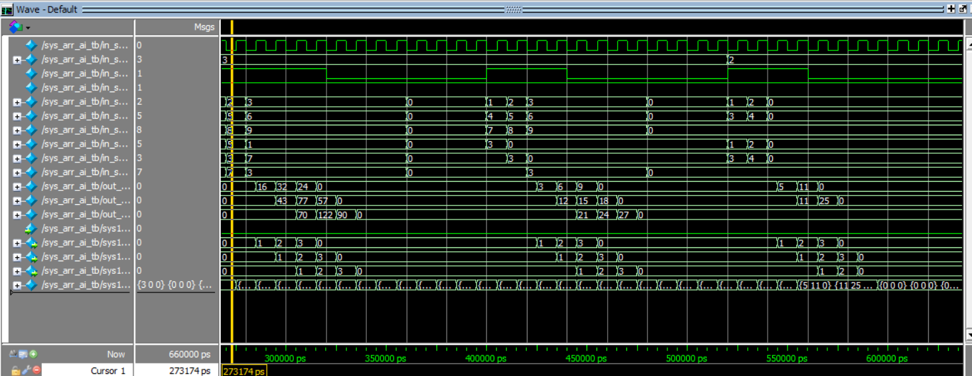

5. img2col (Image to Column)
img2col stands for "image to column." It is a classic and very common trick used to make convolution (the core operation in a CNN) fast on hardware that is good at matrix multiplication like our systolic array.
Normally, a convolution slides a small filter (say, 3x3) across an image and does a little patch of multiply-and-add math at each position. That sliding-window pattern doesn't map cleanly onto a matrix multiplier. The img2col trick solves this by rearranging the image data first: it takes every 3x3 patch the filter would slide over, and lays each patch out as a single column of numbers. Once every patch has been turned into a column like this, doing the whole convolution becomes a single, ordinary matrix multiplication between the rearranged image data and the filter weights something the systolic array is built to do efficiently.
In this project, the img2col control module is a small FSM of its own with three states: idle (waiting to start), calc (actively generating one memory address per clock cycle, walking through every pixel of every sliding window, in order), and done (finished, waiting to be told to reset). It uses four counters x and y track the current window's position on the image, while i and j track which pixel inside that window is currently being addressed. Every clock cycle in the calc state, it outputs one valid memory address, until every window and every pixel in every window has been covered, at which point it signals done.

6. FIFOs — Moving Data Safely Between Stages
A FIFO (First-In, First-Out) is a small memory queue. Data goes in one end (write) and comes out the other end (read) in the exact same order it went in like a line of people at a checkout counter. FIFOs are used here to safely hand results from the systolic array over to whatever reads them next, without either side having to wait on the other cycle-by-cycle.

6.1 Asynchronous (Async) FIFO
An asynchronous FIFO is designed for the case where the writing side and the reading side run on two different, unrelated clocks for example, if one part of a chip runs faster than another, or if data is coming from an entirely separate clock domain.
Because the two clocks are not related to each other, an async FIFO cannot simply compare a write pointer and a read pointer directly doing so is unsafe and can cause a hardware problem called metastability, where a signal is read at an unpredictable, invalid value because it changed at the exact wrong moment. To solve this safely, an async FIFO:
- Stores its read and write pointers in a special code called Gray code, where only one bit ever changes at a time between counts, which greatly reduces the risk of a wrong value being sampled.
- Passes each pointer through a small 2-stage synchronizer (two flip-flops in a row) before letting the other clock domain use it, giving the signal enough time to settle safely.
This makes an async FIFO very flexible it works no matter how the two clocks relate to each other but that safety comes at a cost: the synchronizers add extra clock cycles of delay before the read side finds out that new data has been written, and the Gray-code and synchronization logic itself adds extra circuitry and complexity.

This image shows one of the main problems in async fifo it takes more time to assert the output to read
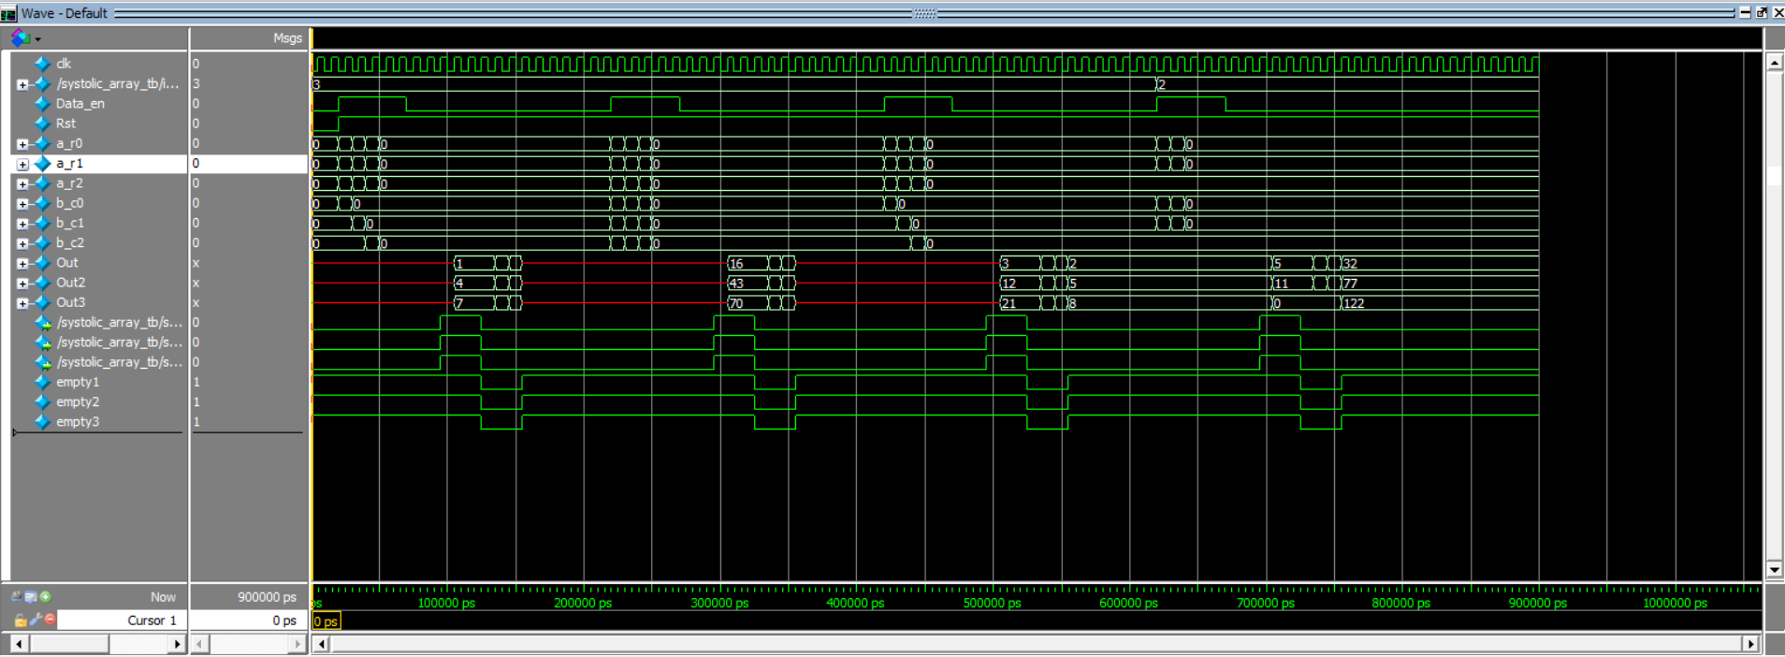

6.2 Synchronous (Sync) FIFO
A synchronous FIFO is simpler: both the write side and the read side use the exact same clock. Because there is only one clock, there is no risk of metastability between the write and read pointers, so no Gray-code conversion and no multi-stage synchronizers are needed. The pointers can be compared directly, the empty and full flags can be calculated immediately, and data that is written can be read back with far less delay.

6.3 Why This Project Uses a Sync FIFO for Speed
Every block in this design the PE array, the control system, and the FIFOs feeding the next stage already runs on the same single clock. There is no real clock-domain crossing happening between the systolic array and where its results are consumed next. Given that, a synchronous FIFO is the better choice, because:
- It avoids the extra latency of the 2-stage synchronizers that an async FIFO needs data written this cycle can be seen as available for reading sooner.
- It avoids the overhead of Gray-code pointer conversion, which is unnecessary work when both sides already share a clock.
- It uses less logic overall (no synchronizer flip-flops, no Gray-to-binary conversion), which saves area and can help the design run at a higher maximum clock frequency.
In short: the async FIFO's safety features exist purely to handle two different clocks correctly and since this design doesn't have two different clocks between these stages, using an async FIFO here would only add unnecessary delay and complexity. Choosing a sync FIFO instead gives the same correct, in-order data movement, but faster and with a simpler, smaller design.

- Here we also implemented a async fifo and we calculated the difference in clk cycles to be able to fully determine with certanity so here we choose the sync for this reason but also the async version was made and tested

7. Testbench
In this project, the testbench does a few standard jobs:
- Generates the clock. It creates a repeating signal that toggles high and low forever, standing in for the real clock the chip would receive, so every clocked block in the design (the PEs, the FIFOs, the control system) has something to work off of.
- Applies reset. At the very start, it pulses the reset signal so every register in the design starts from a known, clean state, instead of whatever random value it might power up with
- Drives the inputs. It feeds in the test data the image pixel values and the filter weight values into the design's input ports. Here we used a task to drive the inputs of the matrix in the array
- Watches the outputs. It observes the results coming out the other end (through the FIFOs) and lets us compare them against the values we expect, by watching thewaveform and comparing it to a golden refrence.
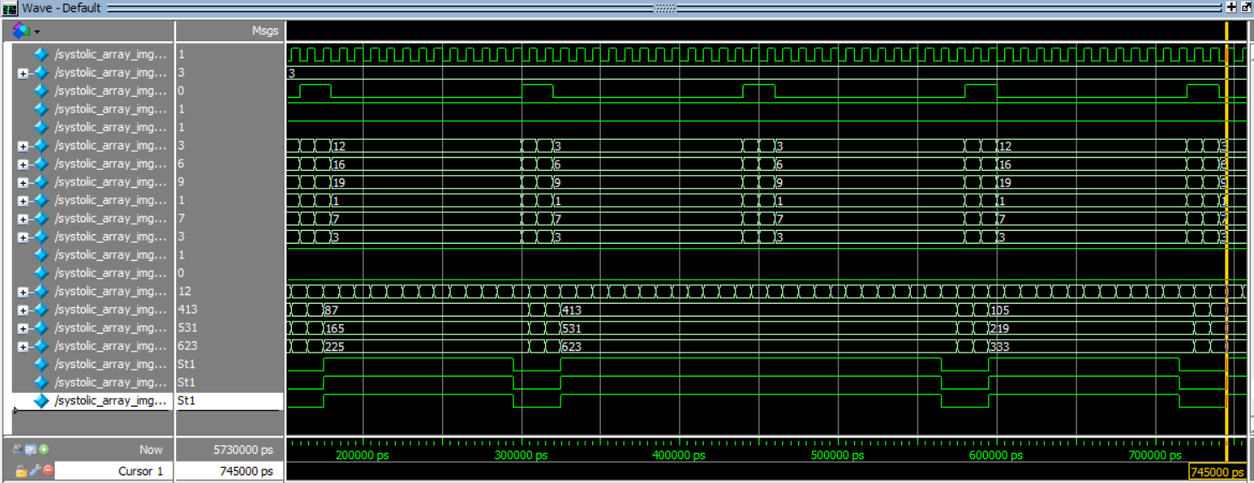

Software Refrence(Python)
Alongside the Verilog design, a Python program was written that performs the exact same calculation img2col followed by the matrix multiplication but in ordinary software, without any of the hardware timing, clocks, or FIFOs involved. This kind of program is usually called a golden model or reference model, because it represents the "known correct" answer that the hardware is supposed to match.
The reason this is done is simple: Verilog and hardware in general are hard to fully trust on their own, especially while a design is still being debugged (as this report's earlier sections show clock wiring bugs, reset polarity issues, and FIFO timing races were all found along the way). A Python model, using ordinary matrix and array operations (commonly with a library like NumPy), can compute the same convolution/matrix-multiplication result quickly and with very high confidence that it's correct, since it isn't exposed to any of the timing or synchronization problems that hardware designs are vulnerable to.
In practice, this reference model is used as follows:
- The same input data that is fed into the Verilog testbench is also fed into the Python model.
- The result from the Python model is then compared against the result produced by the Verilog simulation captured from the waveform
- If the two match exactly, that's strong evidence the hardware design is functionally correct. If they don't match, it immediately tells us there's a bug in the hardware without needing to guess whether the expected answer itself was wrong.

9. Summary
Put together, the design works like this: img2col generates the correct sequence of image addresses so the right pixel patches can be gathered; the systolic array, built from a grid of simple PEs, streams those patches and the filter weights through itself to compute the matrix multiplication that is equivalent to the convolution; the control system times and sequences every stage loading data in, waiting for the math to finish, and reading results out column by column; and the FIFOs safely carry the finished results onward, with a synchronous FIFO chosen over an asynchronous one because every part of the design shares a single clock, making the simpler and faster synchronous design the right choice.

